CPE301 – fall 2019

Design Assignment 2B

Student Name: Henry Mesa

Student #: 1008099273

Student Email: mesah1@unlv.nevada.edu

Primary Github address: https://github.com/mesah1

Directory: https://github.com/mesah1/submissions

1. **COMPONENTS LIST AND CONNECTION BLOCK DIAGRAM w/ PINS**

List of Components used:

Atmega328pb

Multifunction Shield

Block diagram with pins used in the Atmega328PB

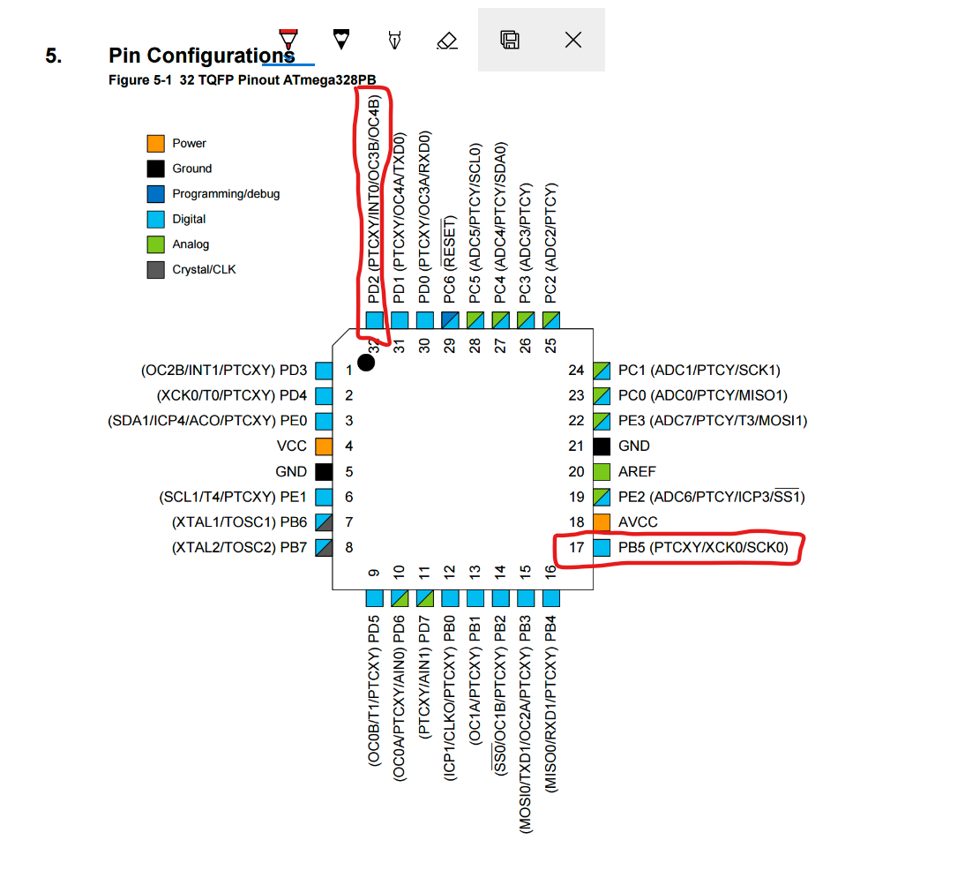

1. **INITIAL/MODIFIED/DEVELOPED CODE OF TASK 1/A**

ASM Code:

;

; EXT_INT0_IRQ.asm

;

; Created: 10/5/2019 6:03:27 PM

; Author : Henry M

;

;* This program will read the input from an interrupt connected

;* to PIND.2(INT0) and will toggle an LED connected to PORTB.2

;

.include "m328pbdef.inc"

.ORG 0 ;reset

JMP MAIN

.ORG 0x05 ;location of external interrupt

JMP EX0_ISR

MAIN:

LDI R16, HIGH(RAMEND)

OUT SPH, R16

LDI R20, LOW(RAMEND)

OUT SPL, R16 ;initilaize stack

LDI R16, 2 ;falling edge triggered

STS EICRA,R20

SBI DDRB, 5 ;set bit 5 in PORTB as output

SBI PORTD, 2 ;pull-up activated

LDI R16, 1 << INT0 ;enable interrupt INT0

OUT EIMSK, R16

SEI ;enable global interrupts

HERE: JMP HERE

;----------------------------------------------------------------------

EX0_ISR:

IN R17, PORTB

LDI R18, (1 << 5) ;toggle PORTB.5

EOR R17, R18

OUT PORTB, R17

CALL DELAY

RETI

;-----------------------------------------------------------------------

DELAY: ;1.333 s delay

ldi R19, 55

d0: ldi R20, 255

d1: ldi R21, 252

d2: dec R21

brne d2 //if R21 != 0 go to delay2 label

nop

dec R20

brne d1 //if R20 != 0 go to delay1 label

dec R19

brne d0 //if R19 != 0 go to delay0

ldi r22,255

d3: nop

nop

nop

nop

nop

dec r22

brne d3

ldi r23,255

d4: nop

nop

nop

nop

nop

dec r23

brne d4

ldi r24, 255

d5: nop

nop

nop

nop

nop

dec r24

brne d5

ret

1. **DEVELOPED MODIFIED CODE OF TASK 2/A from TASK 1/A**

C Code:

/*

* INTERRUPT.c

*

* Created: 10/4/2019 10:14:03 PM

* Author : Henry M

* This program will read the input from an interrupt connected

* to PIND.2(INT0) and will toggle an LED connected to PORTB.5

*/

#define *F_CPU* 16000000UL

#include <avr/io.h>

#include <avr/interrupt.h>

#include <util/delay.h>

int main()

{

DDRB |= (1 << 5); //set bit 5 in PORTB to output

PORTD |= (1 << 2); //pull-up activated

EICRA = 0x2; //falling edge triggered

EIMSK = (1 << INT0); //enable external INT0

sei(); //enable global interrupts

PORTB &= (0 << 5); //set PORTB.2 "OFF"

while (1) //wait here for interrupt to happen

{

}

}

ISR (INT0_vect) //ISR FOR EXTERNAL INTERRUPT 0

{

PORTB ^= (1 << 5); //when detected toggle PORTB.2 for 1s

*_delay_ms*(1000);

}

1. **SCHEMATICS**

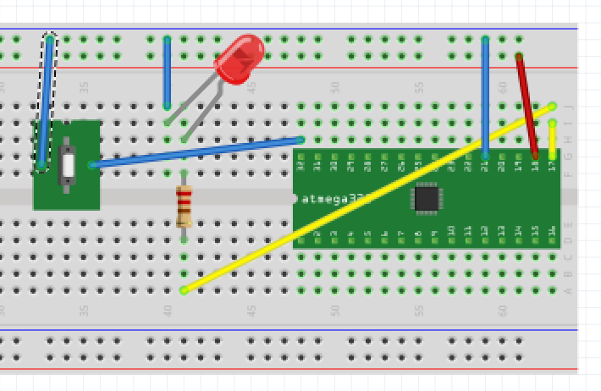

1. **SCREENSHOTS OF EACH TASK OUTPUT (ATMEL STUDIO OUTPUT)**

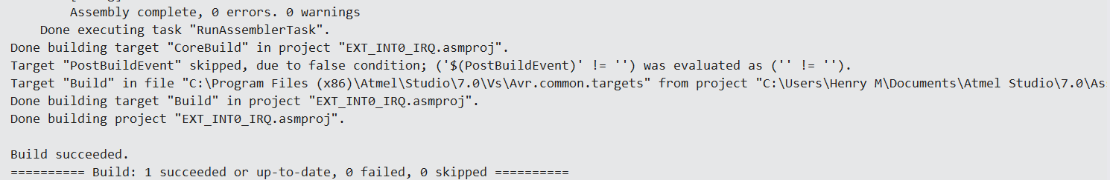

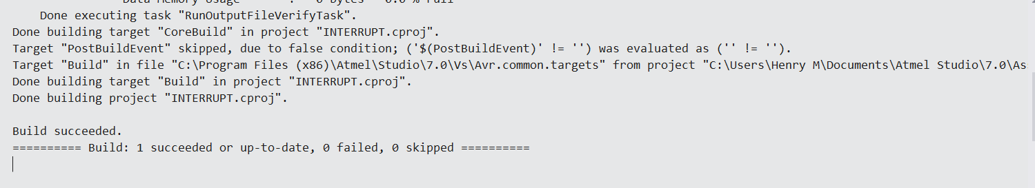

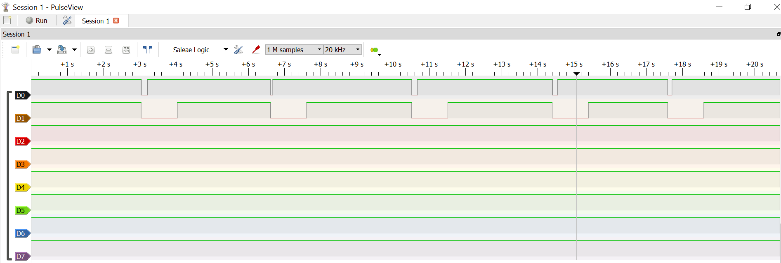

1. **SCREENSHOT OF EACH DEMO (BOARD SETUP)**

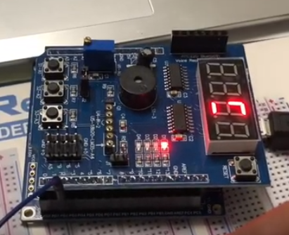

1. **VIDEO LINKS OF EACH DEMO**

<https://youtu.be/LfYZdeufH9k>

1. **GITHUB LINK OF THIS DA**

<https://github.com/mesah1/submissions/tree/master/DA2B>

**Student Academic Misconduct Policy**

<http://studentconduct.unlv.edu/misconduct/policy.html>

“This assignment submission is my own, original work”.

NAME OF THE STUDENT