CPE301 – fall 2019

Design Assignment 2C_A

Student Name: Henry Mesa

Student #: 1008099273

Student Email: mesah1@unlv.nevada.edu

Primary Github address: https://github.com/mesah1

Directory: https://github.com/mesah1/submissions

1. **COMPONENTS LIST AND CONNECTION BLOCK DIAGRAM w/ PINS**

Block diagram with pins used in the Atmega328PB

Part

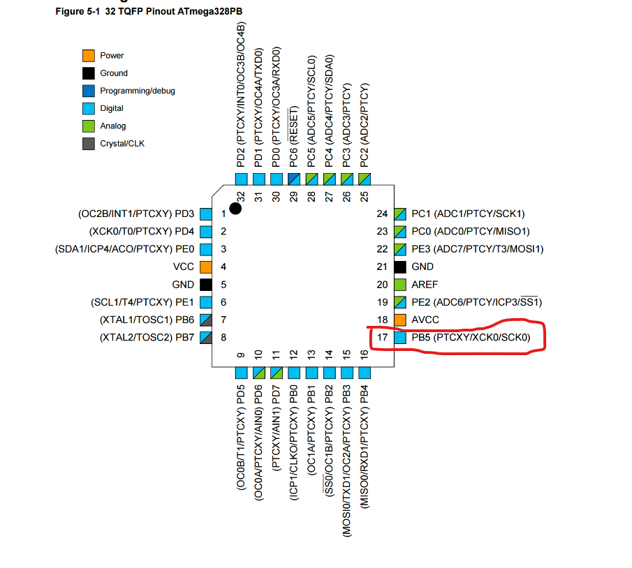

1. **INITIAL/MODIFIED/DEVELOPED CODE OF TASK 1/A**

/*

* Assignment_2C_PART_A.c

*

* Created: 10/14/2019 6:16:20 PM

* Author : Henry M

* THIS PROGRAM WILL USE TIMER 0 - NORMAL MODE

* TO CREATE A TIME DELAY OF 10ms

*/

#define F_CPU 16000000UL

#include <avr/io.h>

#include <util/delay.h>

int main(void)

{

DDRB |= (1 << DDB5); //set PORTB.5 as output

TCCR0A = 0; //normal operation

TCCR0B |= (1 << CS02) | (1 << CS00); //PS = 1024

TCNT0 = 99.75; //counter preset value = 99.75

PORTB &= ~(1 << DDB5);

while (1)

{

//wait for overflow event

while ((TIFR0 & 0x01)==0);

PORTB ^= (1 << DDB5 );

TCNT0 = 99.75; //counter preset value = 99.75

TIFR0 = 0x01; //reset the overflow flag

}

}

1. **DEVELOPED MODIFIED CODE OF TASK 2/A from TASK 1/A**

Insert only the modified sections here

1. **SCHEMATICS**

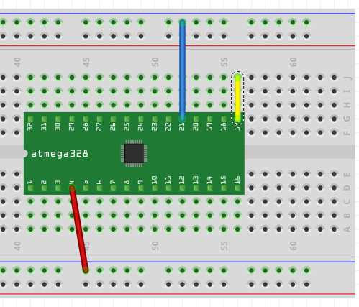

1. **SCREENSHOTS OF EACH TASK OUTPUT (ATMEL STUDIO OUTPUT)**

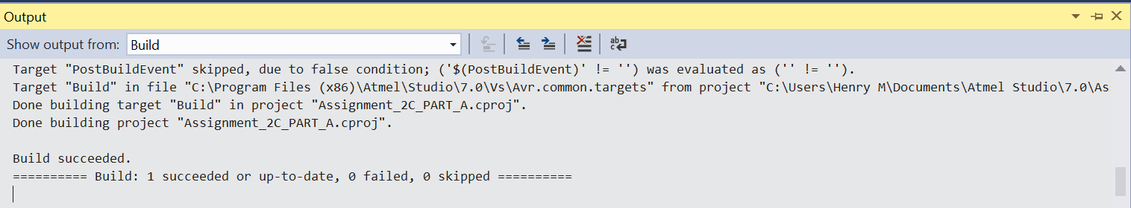

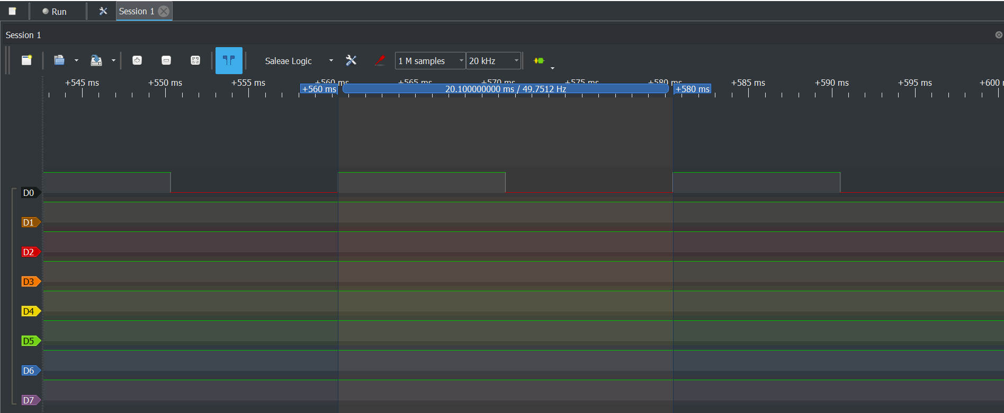

1. **SCREENSHOT OF EACH DEMO (BOARD SETUP)**
2. **VIDEO LINKS OF EACH DEMO**
3. **GITHUB LINK OF THIS DA**

<https://github.com/mesah1/submissions/tree/master/DA2C/Part_A>

**Student Academic Misconduct Policy**

<http://studentconduct.unlv.edu/misconduct/policy.html>

“This assignment submission is my own, original work”.

Henry Mesa