CPE301 – fall 2019

Design Assignment 2C_Part_B

Student Name: Henry Mesa

Student #: 1008099273

Student Email: mesah1@unlv.nevada.edu

Primary Github address: https://github.com/mesah1

Directory: https://github.com/mesah1/submissions

1. **COMPONENTS LIST AND CONNECTION BLOCK DIAGRAM w/ PINS**

Block diagram with pins used in the Atmega328PB

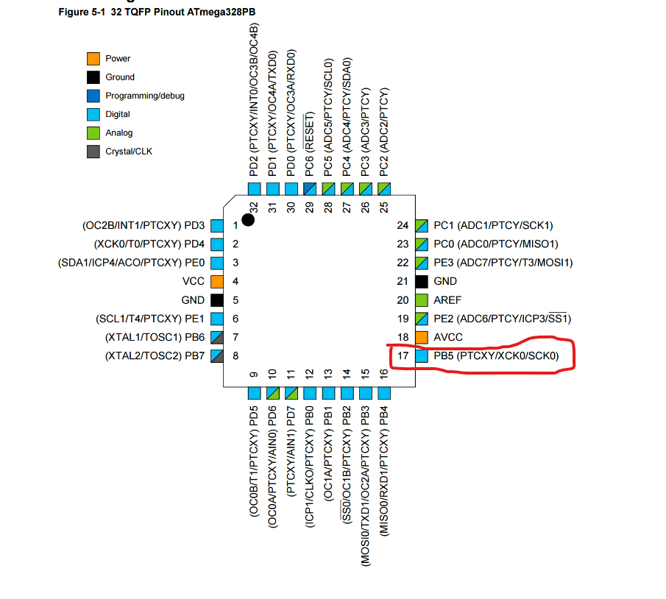

1. **DEVELOPED MODIFIED CODE OF TASK 2/A from TASK 1/A**

/*

* Assignment_2C_PART_B.c

*

* Created: 10/14/2019 9:46:41 PM

* Author: Henry M

* THIS PROGRAM WILL USE TIMER 1 - NORMAL MODE

* TO CREATE A TIME DELAY OF 1MS WITH AN INTERRUPT

*/

#define F_CPU 16000000UL

#include <avr/io.h>

#include <util/delay.h>

#include <avr/interrupt.h>

int main(void)

{

DDRB |= (1 << DDB5); //set PORTB.5 as output

TCCR0A = 0; //set timer control

TCCR0B |= 0x05; //PS = 1024

TCNT0 = 248; //load value

TIMSK0 = (1 << TOIE0); //time capture

sei(); //set global interrupt

while (1)

{

}

}

ISR (TIMER0_OVF_vect) //ISR

{

PORTB ^= (1 << 5); //toggle PORTB.5

TCNT0 = 248; //reset value

}

1. **SCHEMATICS**

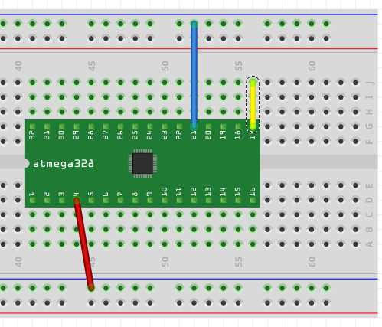

1. **SCREENSHOTS OF EACH TASK OUTPUT (ATMEL STUDIO OUTPUT)**

**Part B**

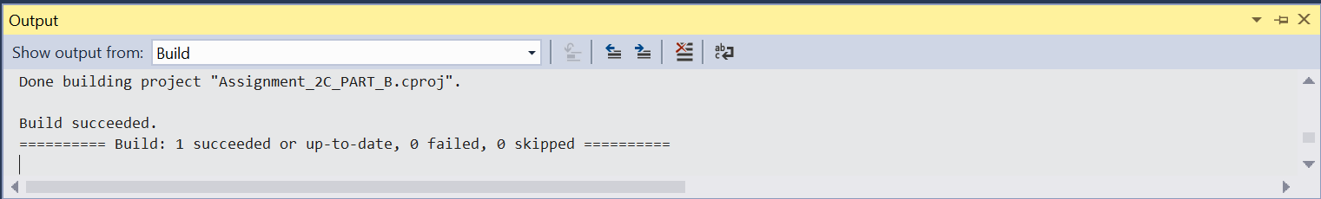

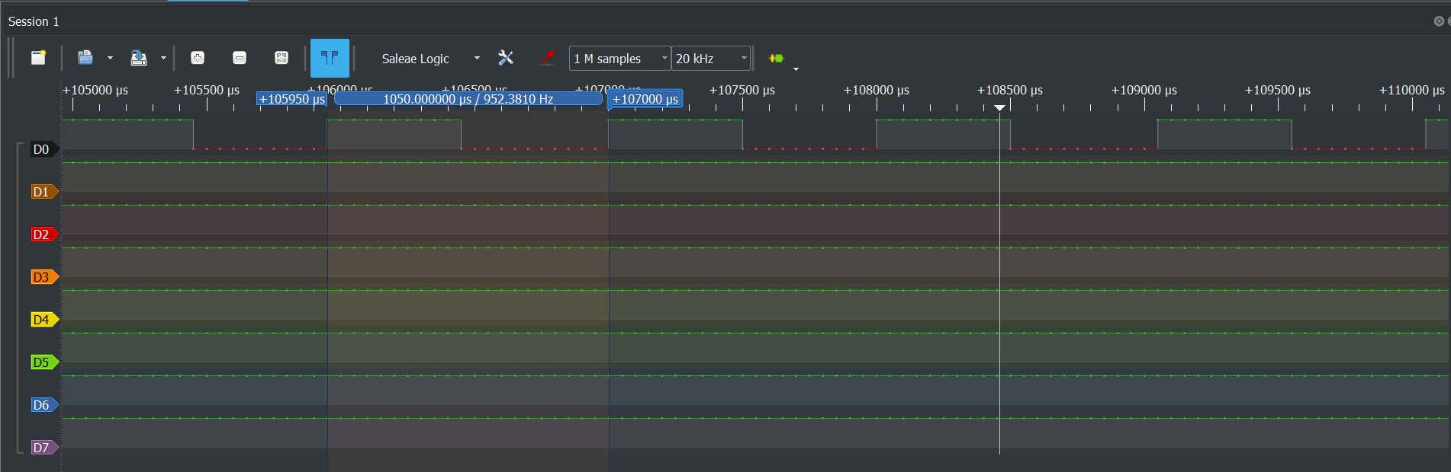

1. **SCREENSHOT OF EACH DEMO (BOARD SETUP)**
2. **VIDEO LINKS OF EACH DEMO**
3. **GITHUB LINK OF THIS DA**

<https://github.com/mesah1/submissions/tree/master/DA2C/Part_B>

**Student Academic Misconduct Policy**

<http://studentconduct.unlv.edu/misconduct/policy.html>

“This assignment submission is my own, original work”.

Henry Mesa