CPE301 – fall 2019

Design Assignment 2C_Part_C

Student Name: Henry Mesa

Student #: 1008099273

Student Email: mesah1@unlv.nevada.edu

Primary Github address: https://github.com/mesah1

Directory: https://github.com/mesah1/submissions

1. **COMPONENTS LIST AND CONNECTION BLOCK DIAGRAM w/ PINS**

Block diagram with pins used in the Atmega328PB

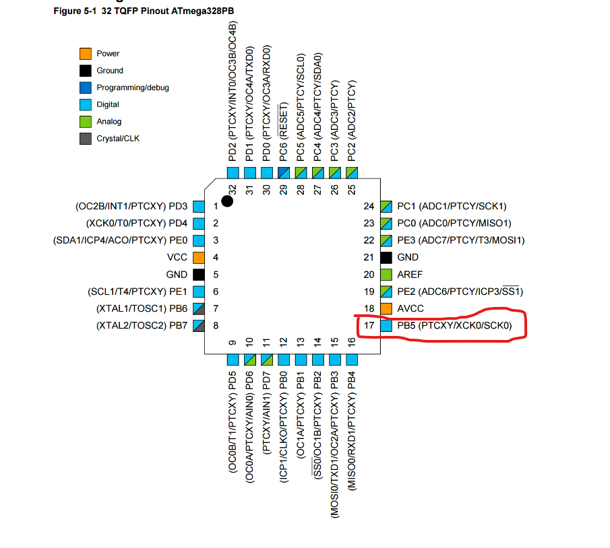

1. **DEVELOPED MODIFIED CODE OF TASK 3/A from TASK 2/A**

/*

* Assignment_2C_PART_C.c

*

* Created: 10/14/2019 11:09:57 PM

* Author: Henry M

* THIS PROGRAM WILL USE TIMER 0 - CTC MODE

* TO CREATE A TIME DELAY OF 10MS WITH AN INTERRUPT

*/

#define F_CPU 16000000UL

#include <avr/io.h>

#include <util/delay.h>

#include <avr/interrupt.h>

int main(void)

{

DDRB |= (1 << DDB5); //set PORTB.5 as output

TCCR0A |= (1 << WGM01); //set timer control CTC

TIMSK0 |= (1 << OCIE0A); //set interrupt on compare match

TCCR0B |= 0x05; //PS = 1024

OCR0A = 156; //load compare reg value

sei(); //set global interrupt

while (1)

{

}

}

ISR (TIMER0_COMPA_vect) //ISR

{

PORTB ^= (1 << 5); //toggle PORTB.5

}

1. **SCHEMATICS**

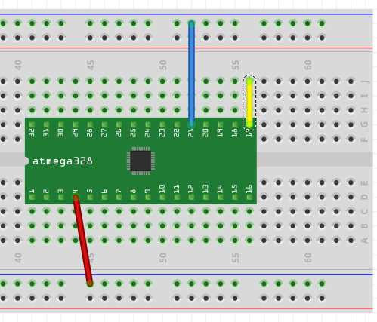

1. **SCREENSHOTS OF EACH TASK OUTPUT (ATMEL STUDIO OUTPUT)**

**Part C**

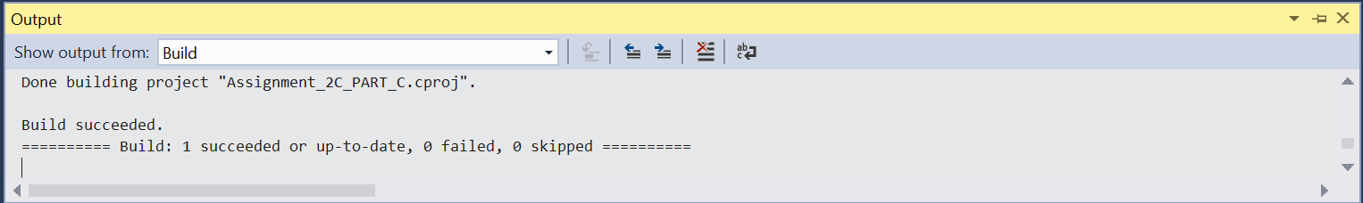

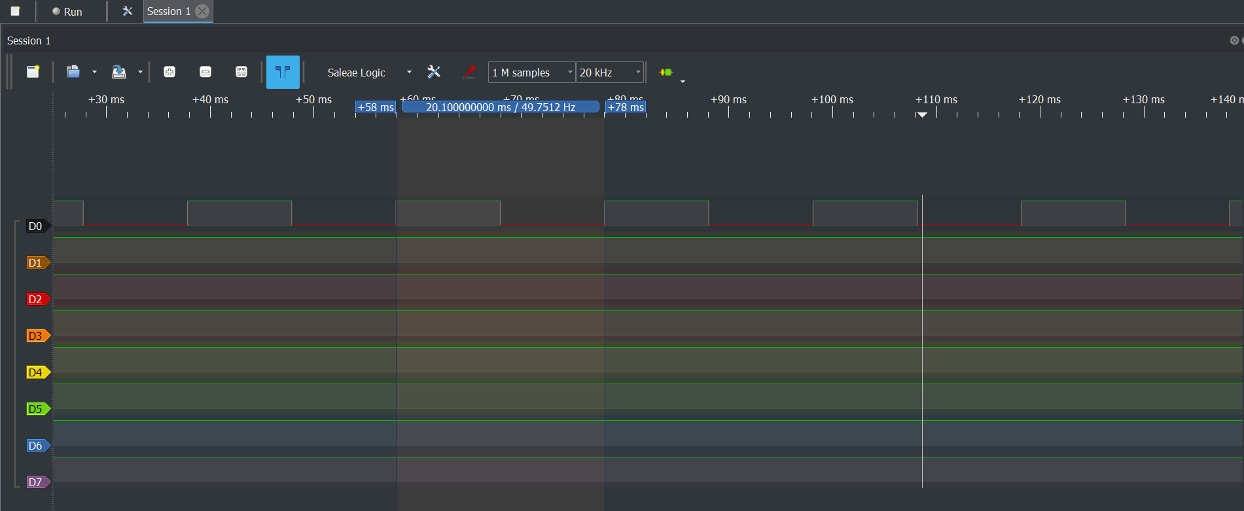

1. **SCREENSHOT OF EACH DEMO (BOARD SETUP)**
2. **VIDEO LINKS OF EACH DEMO**
3. **GITHUB LINK OF THIS DA**

<https://github.com/mesah1/submissions/tree/master/DA2C/Part_C>

**Student Academic Misconduct Policy**

<http://studentconduct.unlv.edu/misconduct/policy.html>

“This assignment submission is my own, original work”.

Henry Mesa