**Name**: Laura Malovich

**Title**: eCommerce Website

**Introduction**

There is no doubt that the advancement of technology has changed the definition of business and its processes in many ways. We now have ways to exchange our goods and services to a wider population from a distance at a lower cost. Electronic Commerce (eCommerce) merchants have brought significant societal changes by enabling unparalleled levels of convenience. Whether it's Amazon, eBay, or your favorite clothing company, they all take advantage of the eCommerce model. However, this convenience is not available for everyone. While we, in the USA, can order cheap gimmicks on Wish that are shipped from China for free across the Pacific Ocean and then to our doorstep, eCommerce Merchants and their convenience is not always accessible in developing countries.

Haiti is one of those countries. The capital city, Port-au-Prince, is where most Haitians must travel to do business. Haitians cannot take advantage of the main international eCommerce sites like Amazon because they are expensive, and eCommerce Merchants do not natively operate there. There currently is not an eCommerce platform that offers the convenience of selling and buying products on a national level for Haitians. This proposal is to implement an eCommerce system that works in Haiti while taking into account the limited internet connectivity of its populace.

**Aim 1:** The first aim of this project is to design a web system that will be used by people living in Haiti to sell their goods to anyone who is interested in buying them.

**Aim 2**: The second aim of this project allow anyone, Haitian or international citizen, to buy any product available in the system

**Features**

* Users should be able to browse the site, search for and add products to their carts without signing in.
* Users should be able to create a buyer account.
* Users should be able to create a seller account.
* Users should be able to see a list of products in their cart.
* Users should be able to remove products from their cart.
* Users should be able to edit product in their cart.
* Sellers should be able to add products to their store.
* Users should be able to see the profile of a seller.
* User should be able to checkout.
* Sellers should get a text and email message on their phone with the sales information once a user purchases a product from their store.
* Sellers must be able to get a summary of their sales via text when their internet access is limited .

**Technologies**

For this project the following technologies will be used:

**Database/models:** PostgreSQL, Flask-SQLAlchemy,

**Back-end:** Flask, Python

**Front-end/views:** HTML/Jinja, JavaScript, CSS

**Password hashing/security:** Flask-Bcrypt, XSRF Token

**APIs:** Twilio, Stripe and internal RESTFull API

**Other:** Heroku

**Mockup**

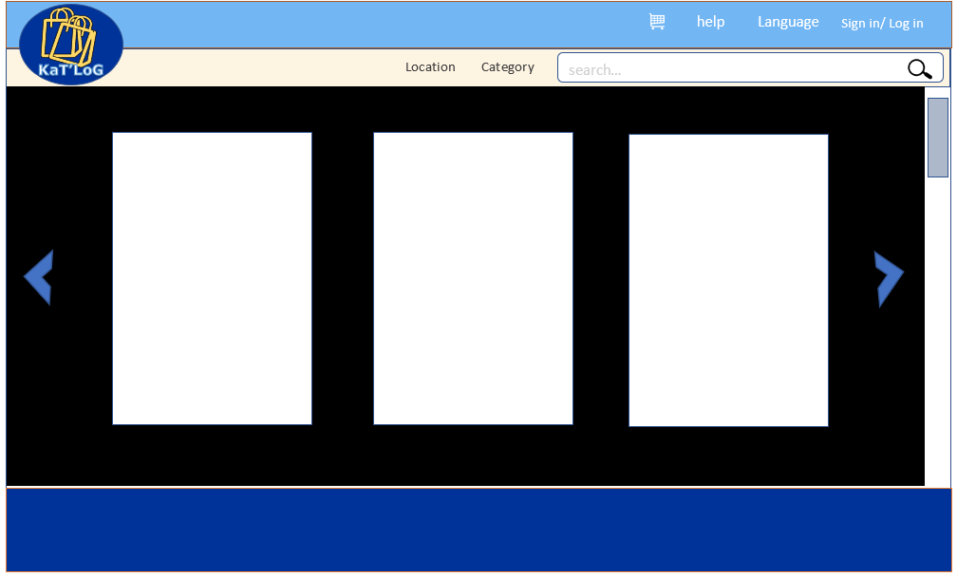

Figure 1: Home page

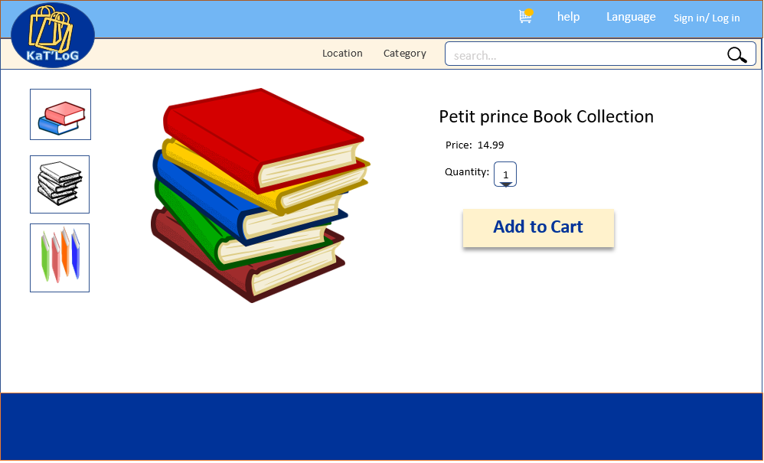

Figure 2: Single Product Page

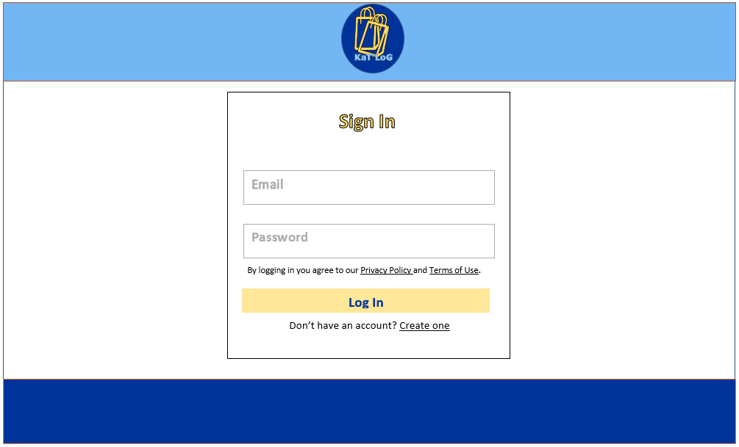

Figure 3: Login Page