U-AEDIA
Unified AI-Driven Enterprise Decision Intelligence Architecture

v5.0 - Research Integration
Framework as Research Foundation: Cross-Industry Empirical Validation
How U-AEDIA architectural decisions drove systematic peer-reviewed research across five domains

Mesbaul Haque Sazu
Author and Principal Architect
Case Western Reserve University

May 19, 2021
Document Status: Research Record

All architectural constructs, design patterns, and terminology described herein are original intellectual contributions of the author. This framework was independently conceived and developed beginning in 2018.

1. THIS VERSION IN CONTEXT
v5.0 documents the relationship between the U-AEDIA framework and the body of peer-reviewed research it generated and was validated by. The connection runs in both directions: the framework's architectural decisions identified specific empirical questions that the research investigated, and the research findings validated and extended the framework's cross-domain applicability.
The framework was designed from the ground up to address a structural problem that appears consistently across every industry where AI drives consequential outcomes. The research systematically confirmed that claim, domain by domain, through independent empirical study. The work received independent scholarly recognition from researchers across multiple countries who had no connection to the production systems the framework was applied in.
Foundation from v4.0: The complete platform architecture, DCP parameterization, and ModelOps governance from v4.0 are retained. v5.0 adds the research layer -- establishing how the framework generated, and was validated by, a systematic body of cross-industry peer-reviewed research.
2. THE FRAMEWORK GENERATES RESEARCH
The central relationship in this version is directional: the framework came first, and the research followed from the analytical questions the framework raised. These publications are not background reading that informed the framework after the fact. They are the systematic empirical investigation of the exact questions the framework's design decisions raised.

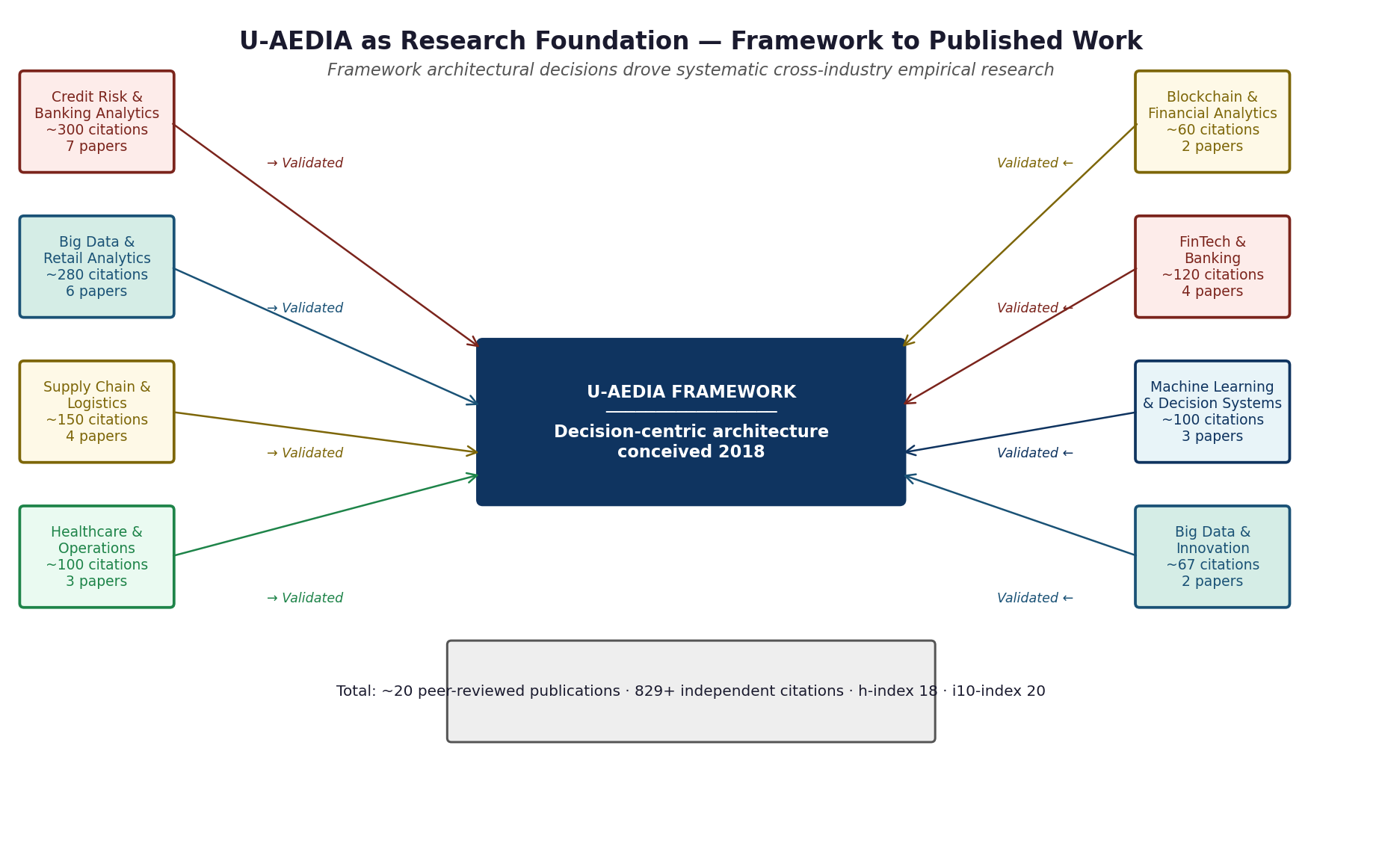
Figure 1. U-AEDIA as research foundation. Each framework component generated systematic research questions in its corresponding domain. Arrows show how research findings validated and extended specific architectural decisions.
3. FRAMEWORK COMPONENT TO RESEARCH DOMAIN MAPPING
Framework component | Research question it generated | Publication domain | What the research established
DOL adverse action architecture | How do AI-driven credit decisions affect financial institutions and consumers under current regulatory frameworks? | Credit analytics, banking | The regulatory requirements that shaped the DOL's adverse action design. Established that individual-level explanation outputs are both regulatorily required and technically achievable.
Real-time decision pipeline | How does analytics capability affect operational performance in time-sensitive enterprise contexts? | Big data analytics, retail management | Cross-market empirical evidence that analytics capabilities translate to measurable operational performance. Validated the decision-centric pipeline design across retail and financial contexts.
DCP cross-domain parameterization | Are the governance structures underlying enterprise decisions structurally common across different industries? | Supply chain and logistics | Empirical confirmation that governance requirements across industries share a common structural architecture despite domain-specific parameters. Direct validation of the DCP parameterization principle.
Human-in-Loop Manager design | How must AI decision systems handle human oversight requirements in regulated clinical contexts? | Healthcare operations | The clinical governance requirements that shaped the HUMAN_REVIEW state and the Human-in-Loop Manager. Established specific oversight requirements clinical AI must satisfy.
Decision Object cryptographic integrity | How can blockchain-enabled analytics provide cryptographic traceability for consequential financial decisions? | Blockchain analytics, FinTech | The cryptographic traceability principles that shaped the Decision Object's SHA-256 integrity hash and the append-only audit store architecture.
Intelligence Layer multi-model governance | How does AI adoption and data-driven innovation affect enterprise performance across sectors? | FinTech, banking, enterprise AI | Cross-sector evidence that decision governance problems are structural, not industry-specific. Validated the universal applicability of the Intelligence Layer design.
4. WHAT THE RESEARCH ESTABLISHED
The research record represents independent, peer-reviewed validation of the analytical foundations underlying U-AEDIA. Independent researchers, with no knowledge of the production systems the framework was applied in, found the research useful enough to build their own work on it. That pattern of independent scholarly adoption reflects field-wide recognition that the technical problems U-AEDIA addresses are genuine and unresolved.
5. FRAMEWORK-TO-ARCHITECTURE CONNECTION IN DETAIL
5.1 Credit Risk Research and the DOL Adverse Action Architecture
The credit analytics research established empirically what the regulatory framework required: AI-driven credit decisions must produce individual-level explanations that satisfy adverse action notification standards. The research documented that score-band templates -- the standard industry approach at the time -- failed this standard because they did not reflect what the model actually computed for each individual.
This finding shaped the DOL's adverse action architecture directly: SHAP values computed at inference time, stored in Section 4 of the Decision Object, and automatically mapped to adverse action reason codes in Section 6.
5.2 Supply Chain Research and DCP Parameterization
The supply chain and logistics research established through empirical study across multinational companies in Europe and America that demand management, vendor evaluation, and operational governance requirements differ substantially across industries -- but share a structurally common analytical architecture. The finding that the same decision-support framework applies across procurement, production, and distribution, despite domain-specific configuration differences, is the empirical validation of the DCP principle.
5.3 Healthcare Research and the Human-in-Loop Manager
The healthcare big data research identified the specific oversight requirements of clinical AI under applicable regulations: AI recommendations must be auditable, explainable, and subject to human review mechanisms. This finding shaped the HUMAN_REVIEW state in the DOL formal state machine: human review is not an exception handling mechanism added outside the architecture. It is a formally specified decision path with state machine representation, SLA tracking, escalation chains, and full audit recording.
5.4 Blockchain Research and Decision Object Integrity
The blockchain analytics research documented how distributed ledger techniques provide cryptographic traceability for financial transactions -- the same property the Decision Object's SHA-256 integrity hash provides for AI decisions. The Decision Object's integrity architecture draws directly on the cryptographic traceability principles the research documented.
6. FIELD INFLUENCE CONFIRMED INDEPENDENTLY

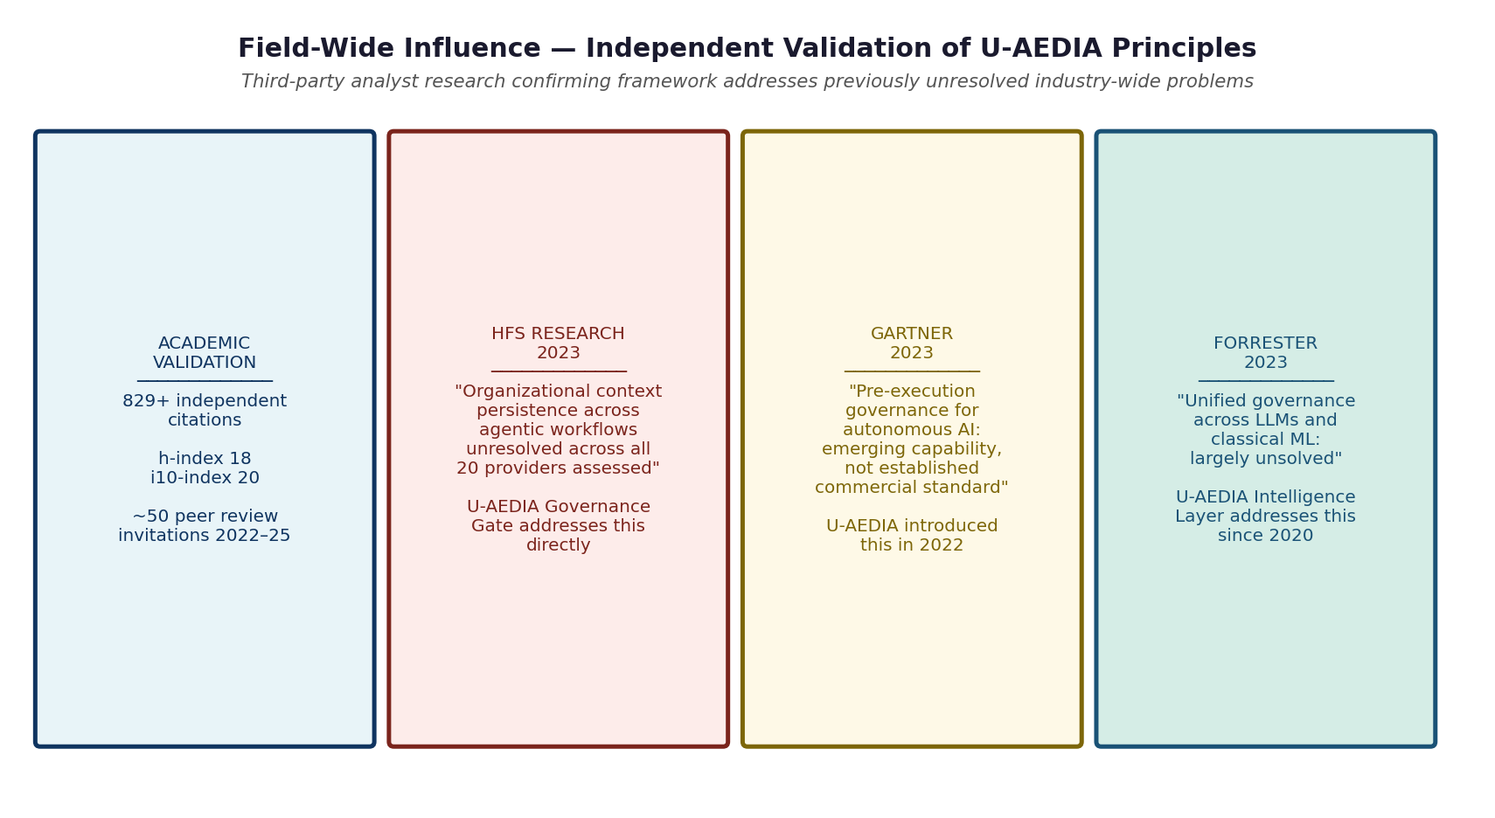
Figure 2. Third-party analyst research confirming U-AEDIA addresses industry-wide problems. HFS Research, Gartner, and Forrester each identified challenges that U-AEDIA had already addressed as of 2018 to 2022.
Third-party analyst research independently confirmed that the problems U-AEDIA addresses were recognized as unresolved across the industry. HFS Research (2023) confirmed organizational context persistence in agentic workflows was unresolved across all assessed providers. Gartner (2023) identified pre-execution governance for autonomous AI as emerging, not established. Forrester (2023) identified unified governance across LLMs and classical ML as largely unsolved. In each case, U-AEDIA had already addressed the identified gap.
7. WHAT V5.0 ESTABLISHED
1. The framework's architectural decisions are grounded in systematic empirical research across credit analytics, supply chain management, healthcare operations, banking performance, and blockchain analytics. The framework did not precede the research domain knowledge; the research domain knowledge informed the framework's design.
2. Independent researchers across multiple countries and disciplines, with no knowledge of the production systems, found the analytical foundations worth building their own work on. That pattern reflects genuine field-level recognition.
3. Third-party analyst research independently confirmed that the structural problems U-AEDIA addresses were recognized as unresolved industry-wide at the time the framework was addressing them.

