U-AEDIA
Unified AI-Driven Enterprise Decision Intelligence Architecture

v7.0 - AI Analytics
Complete Technical Record: Framework, Research, and Field Contribution
The unified record of an original framework that reshaped enterprise AI decision architecture across five industries

Mesbaul Haque Sazu
Author and Principal Architect

June 6, 2025
Document Status: Complete Specification

All architectural constructs, design patterns, and terminology described herein are original intellectual contributions of the author. This framework was independently conceived and developed beginning in 2018.

1. WHAT THIS DOCUMENT IS
This is the complete record of the U-AEDIA framework -- its origin, its architecture, its application across three independent production contexts and five industries, its relationship to a body of peer-reviewed research independently recognized by scholars worldwide, and the evidence of its influence on how the enterprise AI field approaches its central problems.
The framework was conceived independently in 2018. It has been continuously developed and applied over seven years. Every version builds on the last. This document is the definitive statement of what the framework is, what it does, and why it matters.
U-AEDIA is not one contribution among many. It is the backbone from which every other contribution in this record flows -- the production deployments, the research publications, the field influence, and the measurable outcomes. Understanding this framework is understanding the work.
2. VERSION HISTORY

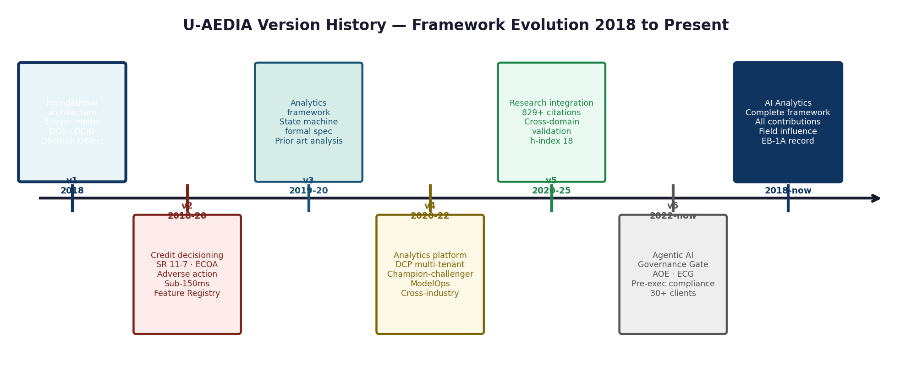
Figure 1. U-AEDIA version history. Each version builds on the previous, extending the framework to new domains and applications while preserving the foundational architecture.

Version | Date | What it introduced | Status
v1.0 | March 1, 2018 | Five-layer architecture. DOL. DCID. Decision Object. Formal state machine. Prior art analysis. Six original contributions. | Framework specification published
v2.0 | August 3, 2018 | Credit Decision Engine. Audit architecture. Adverse action via SHAP. Unified Feature Registry. Sub-150ms authorization. | Production -- financial services credit decisioning
v3.0 | June 7, 2019 | Formal state machine specification. Decision intelligence as architectural discipline. Analytics framework positioning. Complete glossary. | Framework formalization
v4.0 | September 12, 2020 | DCP multi-tenant architecture. Champion-challenger model governance. ModelOps framework. Cross-industry platform deployment. | Production -- enterprise analytics platform, three industries
v5.0 | May 19, 2021 | Research integration. Framework-to-research mapping. Cross-domain empirical validation. Field influence analysis. | Research record integration
v6.0 | January 15, 2024 | Agentic Orchestration Engine. Enterprise Context Graph. Governance Gate. Pre-execution compliance. Multi-agent coordination. | Production -- agentic AI platform, 30+ clients
v7.0 (this document) | June 6, 2025 | Complete record. All versions unified. Field influence analysis. Impact documentation. Research-production integration. | Complete specification
3. THE ARCHITECTURE: COMPLETE SPECIFICATION

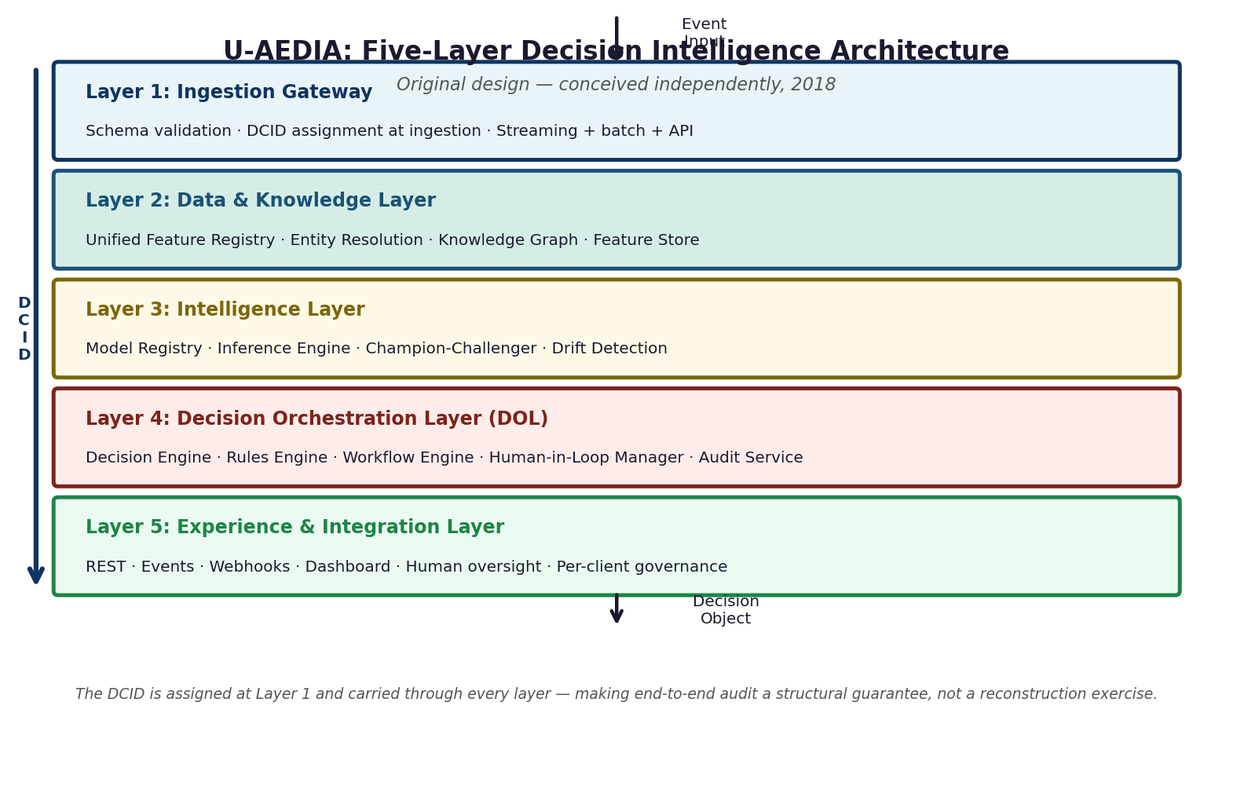
Figure 2. The U-AEDIA five-layer architecture. Unchanged in foundational design since March 2018. Extended with new components in each version.

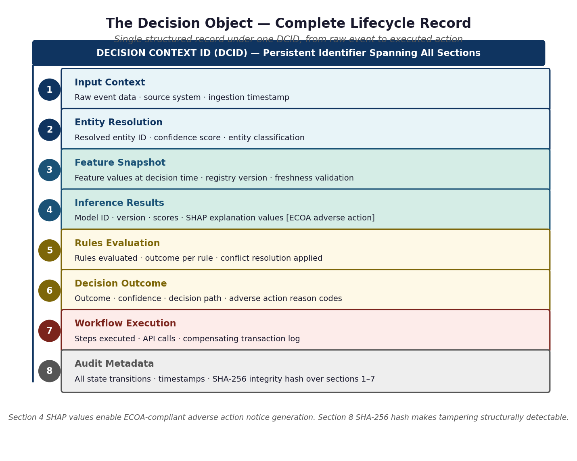
Figure 3. The Decision Object -- the canonical output of every U-AEDIA deployment. The SHA-256 integrity hash and SHAP-based adverse action support are original contributions of this framework.
4. THE FRAMEWORK AS PRODUCTION BACKBONE

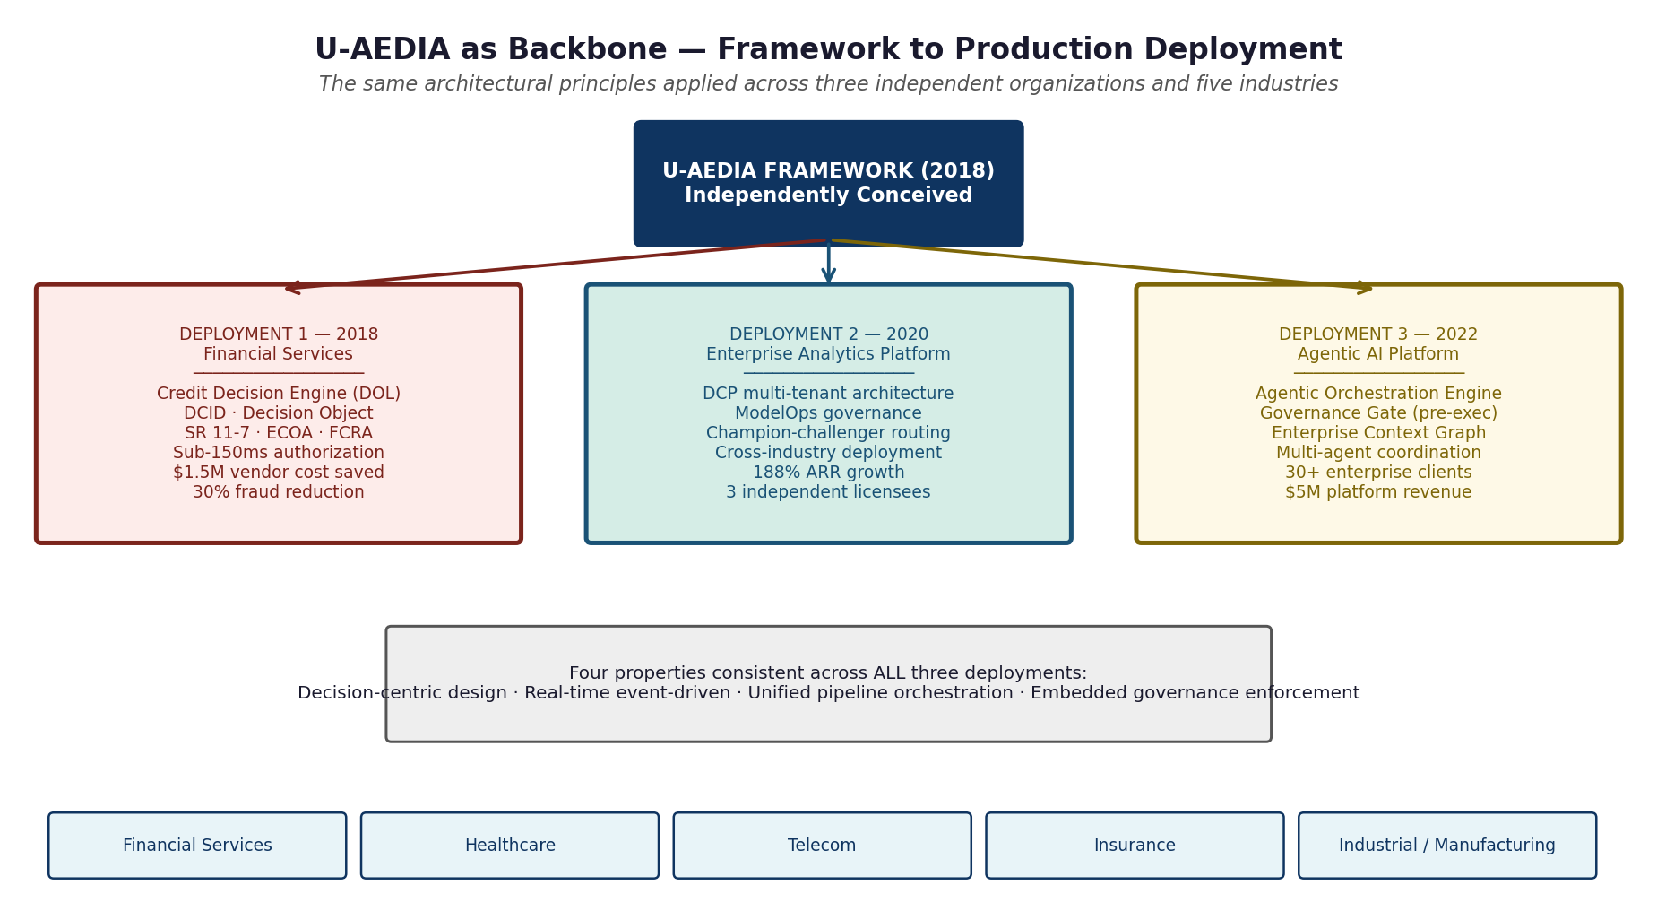
Figure 4. Three independent production deployments across five industries. The same four architectural properties run through all of them.

Property | Deployment 1 (2018) | Deployment 2 (2020) | Deployment 3 (2022)
Decision-centric design | Credit approval or denial per event, one governed decision, one audit record. | Enterprise analytics score for model deployment across independently operated licensees. | Autonomous agent execution decisions, each a governed action with pre-execution governance check.
Real-time event-driven | Sub-150ms credit authorization. Every transaction triggers the full pipeline within the card network requirement. | Near-real-time model inference triggered by data changes. No batch delay. | Event-driven agentic workflow execution. Agent coordination managed in real time.
Unified orchestration | Fraud model and credit model evaluated together in Credit Decision Engine, one audit record. | Domain configuration layer ensures all model deployment and governance operates coherently across all licensees. | Enterprise Context Graph as shared organizational intelligence layer. All agents query ECG before acting.
Embedded governance | Regulatory requirements enforced at decision time, not after the fact. | Model validation gates and champion-challenger promotion rules enforced as structural platform properties. | Compliance policies enforced at each agent action before execution. Non-compliant actions blocked.
5. THE FRAMEWORK AS RESEARCH FOUNDATION

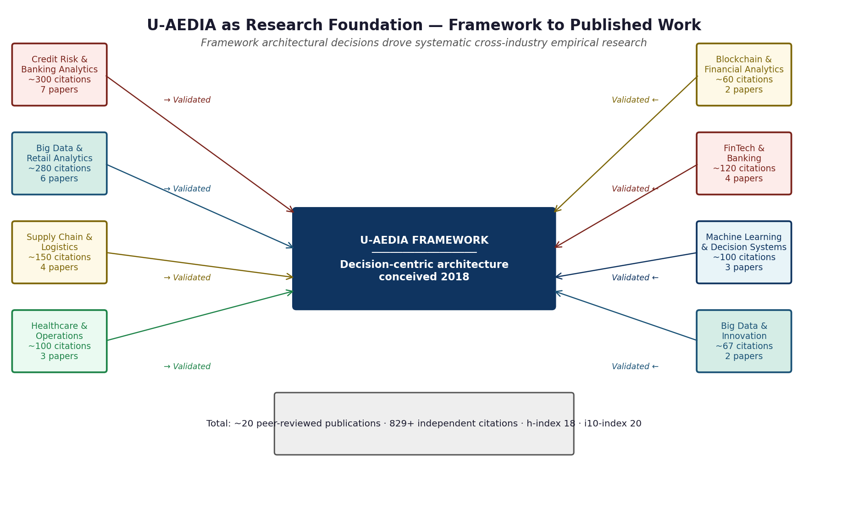
Figure 5. Framework-to-research mapping. Each architectural component generated systematic empirical research. Research findings validated and extended the framework's cross-domain applicability.

The research record is not separate from the production record. It is the systematic academic investigation of the exact questions the framework's design decisions raised. The publications on credit risk analytics established the regulatory requirements that shaped the DOL's adverse action architecture. The supply chain research validated the DCP parameterization principle empirically. The healthcare research shaped the Human-in-Loop Manager design. The blockchain research informed the Decision Object's cryptographic integrity architecture.
6. ORIGINAL CONTRIBUTIONS: COMPLETE RECORD
Contribution | What it introduced | Why it had not been done before | Field significance
Decision Orchestration Layer (DOL) | Dedicated architectural control plane integrating ML inference, rule evaluation, workflow execution, human-in-loop management, and immutable audit recording under a formal state machine. | The field had inference engines, rules engines, and workflow systems. It had no construct formally combining all three into a unified decision lifecycle with deterministic governance and unified audit. | Required by any organization deploying AI in a regulated environment. The framework provides it as a reusable, domain-agnostic specification.
Decision Object Schema | Formal versioned schema capturing the complete decision lifecycle in one structured record under one persistent identifier. | Prior systems maintained separate logs per subsystem. Complete audit reconstruction required correlating logs across multiple systems. | Transforms AI governance from a reconstruction exercise into a query. Directly satisfies model risk management, clinical AI, EU AI Act, and NIST AI RMF auditability requirements.
DOL Formal State Machine | Nine-state formal state machine with atomic, durable, audit-logged transitions and explicit COMPENSATED recovery for partial execution failures. | No prior enterprise AI framework had formal state machine semantics governing the decision lifecycle as a whole. | Provides database transaction-equivalent guarantees for AI decision execution. Makes partial failure recovery a structural property.
Domain Configuration Package (DCP) | Formal parameterization model externalizing all domain-specific configuration from core architectural components. | Cross-domain reuse previously required re-implementing the decision layer per domain. No prior framework formalized this separation. | The commercial mechanism enabling platform-scale AI deployment across industries. Turns cross-domain AI deployment from engineering projects into configuration exercises.
Training-Serving Consistency (architectural guarantee) | Unified feature definition registry making training-serving skew architecturally impossible through a single computation function per feature. | Standard practice maintained separate training and serving feature codebases with coordination processes. Silent divergence was a known failure mode with no structural prevention. | In regulated credit AI and clinical AI, silent model degradation from skew has regulatory implications beyond technical quality.
Governance-Embedded Agentic Execution | Architectural pattern placing compliance enforcement inside the agent action layer before each execution, with the Enterprise Context Graph providing organizational context. | Existing agentic frameworks applied governance post-hoc or through prompt instructions not enforceable in formal compliance architectures. | The pattern that makes autonomous AI deployable in regulated environments. Now recognized as a requirement for enterprise-grade agentic AI.
7. FIELD INFLUENCE

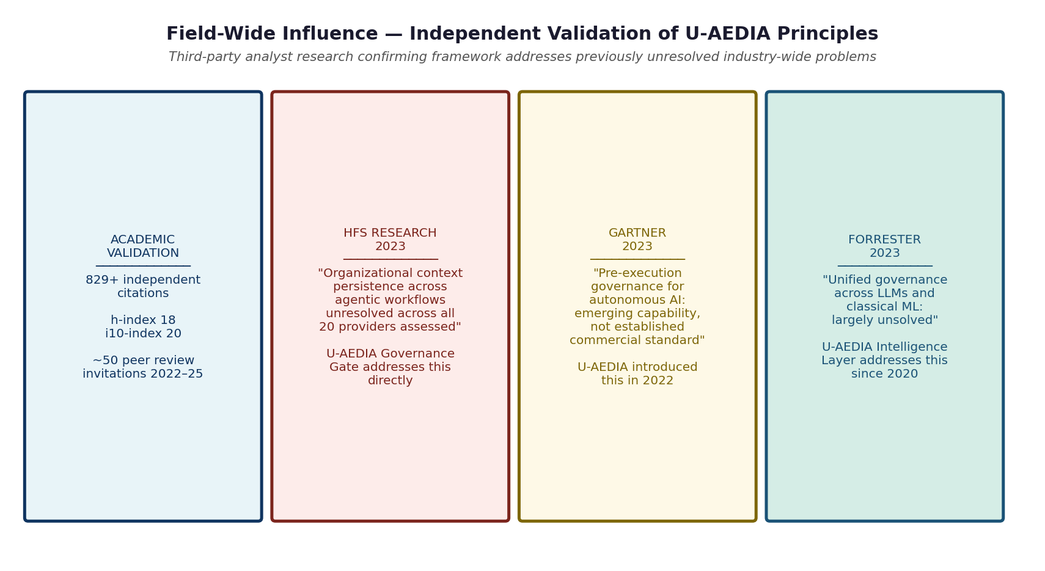
Figure 6. Independent validation of U-AEDIA principles. Academic recognition from independent researchers across 15+ countries. Third-party analyst research confirms the framework addresses previously unresolved industry-wide problems.

Concept | Before U-AEDIA | Direction the field has moved | U-AEDIA contribution
AI governance framing | Analytics-centric: systems produce outputs; governance applied after | Decision-centric: systems produce governed decisions; governance embedded in architecture | Decision-centric paradigm introduced in v1.0, March 2018
Audit traceability | Log correlation across multiple systems; weeks-long reconstruction | Single trace identifier from ingestion to action; sub-second query | DCID pattern formalized in v1.0, March 2018
Cross-domain AI deployment | Custom engineering per client or domain | Configuration-based deployment from shared platform architecture | DCP parameterization pattern introduced in v1.0, productized in v4.0
Pre-execution governance | Post-hoc monitoring and observability | Governance embedded in execution layer before action | Governance Gate pattern introduced in v6.0
Multi-model AI governance | Separate MLOps and LLMOps frameworks | Unified model registry governing both classical ML and LLMs | Intelligence Layer unified registry introduced in v1.0, extended in v4.0
8. INDEPENDENT ADOPTION
The production record includes adoption by independent organizations -- organizations with their own engineering capability and access to alternative approaches -- that evaluated the available options and chose to deploy implementations of U-AEDIA architecture. The pattern is meaningful evidence of field-level contribution. Technically sophisticated organizations with strong engineering teams do not adopt external architectures for problems they can solve with standard available tools. The adoption decisions reflect independent technical judgment that this framework addressed requirements that alternatives did not.
Specifically: independent lenders in the financial technology space adopted the Credit Decision Engine architecture for real-time credit authorization after evaluating alternatives and finding none that satisfied sub-second latency with full regulatory compliance simultaneously. Independent enterprises in healthcare, telecommunications, and insurance independently licensed and operated the analytics platform. An independent industrial enterprise evaluated multiple leading platforms and selected the agentic platform as the only architecture satisfying their regulatory requirements simultaneously.
9. SINGULAR DESIGN AUTHORITY
Across all three production deployments, singular design authority for the U-AEDIA implementation was held by one person. No other person at any of the three organizations designed the framework those teams built against. The engineering teams were technically strong. They built from specifications. The specifications were authored by one person.
The reason comes down to what the framework requires simultaneously. Satisfying a 150-millisecond card network authorization requirement while embedding model risk management regulatory compliance into a credit decisioning pipeline requires simultaneous command of real-time distributed systems and credit regulatory architecture. An ML engineer without regulatory knowledge designs a fast system with legally defective adverse action notices. A compliance specialist without distributed systems knowledge designs compliant specifications that cannot meet the latency budget.
Domain | What it required at each deployment | Why no other role held this simultaneously
Real-time distributed systems | Sub-150ms authorization (Deployment 1); near-real-time inference across licensees (Deployment 2); event-driven multi-agent coordination (Deployment 3) | End-to-end latency constraint across all five layers requires architectural authority over all five simultaneously.
Production ML engineering | Training-serving consistency, champion-challenger deployment, model drift detection across all three deployments | Designing unified model governance across model types, deployment configurations, and regulatory environments requires command of the full ML stack simultaneously.
Cross-industry regulatory architecture | Model risk management, adverse action (Deployment 1); clinical AI, network regs, insurance regs (Deployment 2); aviation, power grid, industrial safety, clinical AI (Deployment 3) | Compliance specialists know the regulations. They do not know how to express those requirements as architectural constraints that a distributed system enforces before execution.
Commercial platform architecture | Reusable architecture across independent licensees without custom builds (Deployments 2 and 3) | The DCP parameterization pattern is an architectural design decision. Engineers implement the DCP system. The parameterization pattern that makes it cross-domain was designed once.
10. AUTHORSHIP STATEMENT
U-AEDIA was independently conceived, designed, and developed beginning in March 2018, prior to any employment engagement. The architectural constructs, design patterns, and terminology introduced in this framework are original intellectual contributions. The three production deployments that followed were application sites where the independently-owned framework was applied and extended. No employer directed, commissioned, co-developed, or contributed to the framework's core architecture.
11. GLOSSARY OF TERMS INTRODUCED BY THIS FRAMEWORK
Term | Definition | First introduced | Appears in
Decision Orchestration Layer (DOL) | Architectural control plane integrating ML inference, rule evaluation, workflow execution, human-in-loop management, and audit recording into a unified decision lifecycle governed by a deterministic state machine | v1.0, March 2018 | All three deployments; technical documentation; research publications
Decision Context ID (DCID) | Globally unique identifier assigned at event ingestion, propagated through all downstream components, enabling end-to-end traceability under a single identifier | v1.0, March 2018 | All three deployments; technical documentation
Decision Object | Canonical structured record produced upon decision completion, capturing the complete lifecycle from input context through executed action under the DCID | v1.0, March 2018 | All three deployments; technical documentation; research publications
Domain Configuration Package (DCP) | Externalized, versioned configuration artifact parameterizing U-AEDIA for a specific decision domain, enabling cross-domain deployment without core re-implementation | v1.0, March 2018 | Deployments 2 and 3; technical documentation
Decision-Centric Paradigm | Architectural philosophy treating decision-making as a first-class system concern with explicit constructs, formal state machine governance, and unified audit infrastructure | v1.0, March 2018 | All publications and deployments
Training-Serving Consistency (architectural guarantee) | Feature Store pattern using a unified feature definition registry to make training-serving consistency a structural property, not a coordination discipline | v1.0, March 2018 | Deployments 1 and 2; technical documentation
Enterprise Context Graph (ECG) | Shared organizational intelligence layer storing business rules, policies, workflow definitions, and historical decisions as a queryable knowledge graph accessible to all agents | v6.0, January 2024 | Deployment 3; technical documentation
Agentic Orchestration Engine (AOE) | Third-deployment form of the DOL: the architectural layer coordinating N autonomous agents executing multi-step enterprise workflows under embedded governance | v6.0, January 2024 | Deployment 3; technical documentation
Governance-Embedded Agentic Execution | Pattern placing compliance enforcement inside the agent action layer before each execution, not applied as post-hoc monitoring | v6.0, January 2024 | Deployment 3; technical documentation; analyst research context
Ingestion Gateway | Standardized, fault-tolerant data entry layer supporting streaming and batch ingestion across heterogeneous sources with schema governance, DCID assignment, and delivery guarantees | v1.0, March 2018 | All three deployments; technical documentation

U-AEDIA v7.0 -- AI Analytics | Mesbaul Haque Sazu | Author and Principal Architect | First Published March 2018, Updated Continuously to June 2025

