U-AEDIA
Unified AI-Driven Enterprise Decision Intelligence Architecture

v6.0 - Agentic AI Platform
Third Application: Governance-Embedded Enterprise Agentic AI
Extending the decision-centric framework to autonomous multi-agent enterprise systems

Mesbaul Haque Sazu
Author and Principal Architect

January 15, 2024
Document Status: Production Deployment

All architectural constructs, design patterns, and terminology described herein are original intellectual contributions of the author. This framework was independently conceived and developed beginning in 2018.

1. THIS VERSION IN CONTEXT
v6.0 documents the third production application of U-AEDIA: an enterprise agentic AI platform deployed from 2022 onward. The technical challenge here is qualitatively different from both prior deployments: where v2.0 made AI-driven decisions in real time and v4.0 made the same architecture available across independent enterprise licensees, v6.0 enables autonomous AI agents to execute multi-step enterprise workflows without human triggering each step, while maintaining the governance guarantees that regulated environments require.
The central architectural problem: existing agentic AI frameworks in 2022 -- LangChain, AutoGPT, Semantic Kernel -- could decompose tasks and route between LLMs, but they had no enterprise governance, no organizational context, no pre-execution compliance enforcement, and no decision audit trail. Deploying an autonomous agent in a regulated environment required something they did not provide: governance embedded in the execution layer, before each action, not monitored after.
Foundation from v5.0: The complete framework from all prior versions -- five-layer architecture, DOL, Decision Object, DCP parameterization, feature registry, ModelOps, and research foundation -- is retained. v6.0 extends the DOL to the agentic execution context, introducing the Agentic Orchestration Engine, the Enterprise Context Graph, and the Governance Gate.
2. THE AGENTIC GOVERNANCE PROBLEM
Autonomous AI agents that execute enterprise workflows face a governance problem that does not exist for advisory AI systems: they take actions. An AI system that recommends a procurement order can have its recommendation rejected by a human. An autonomous agent that executes a procurement order has already spent the money. The difference between advisory and agentic AI is the difference between a recommendation and a consequence.
In regulated environments, this distinction has specific implications. Aviation maintenance under FAA standards requires governance documentation before maintenance actions are performed, not after. Power grid switching under NERC requires compliance verification before switching operations execute. Clinical AI under HIPAA requires accountability for AI-driven care decisions at the point of decision, not reconstructed afterward.
Post-execution governance monitoring is insufficient for these requirements. The architecture needed was governance embedded inside the agent action layer, evaluated before each action executes, with blocked actions returning structured failure results that the agent can incorporate into its planning.
3. THE AGENTIC ARCHITECTURE EXTENSION

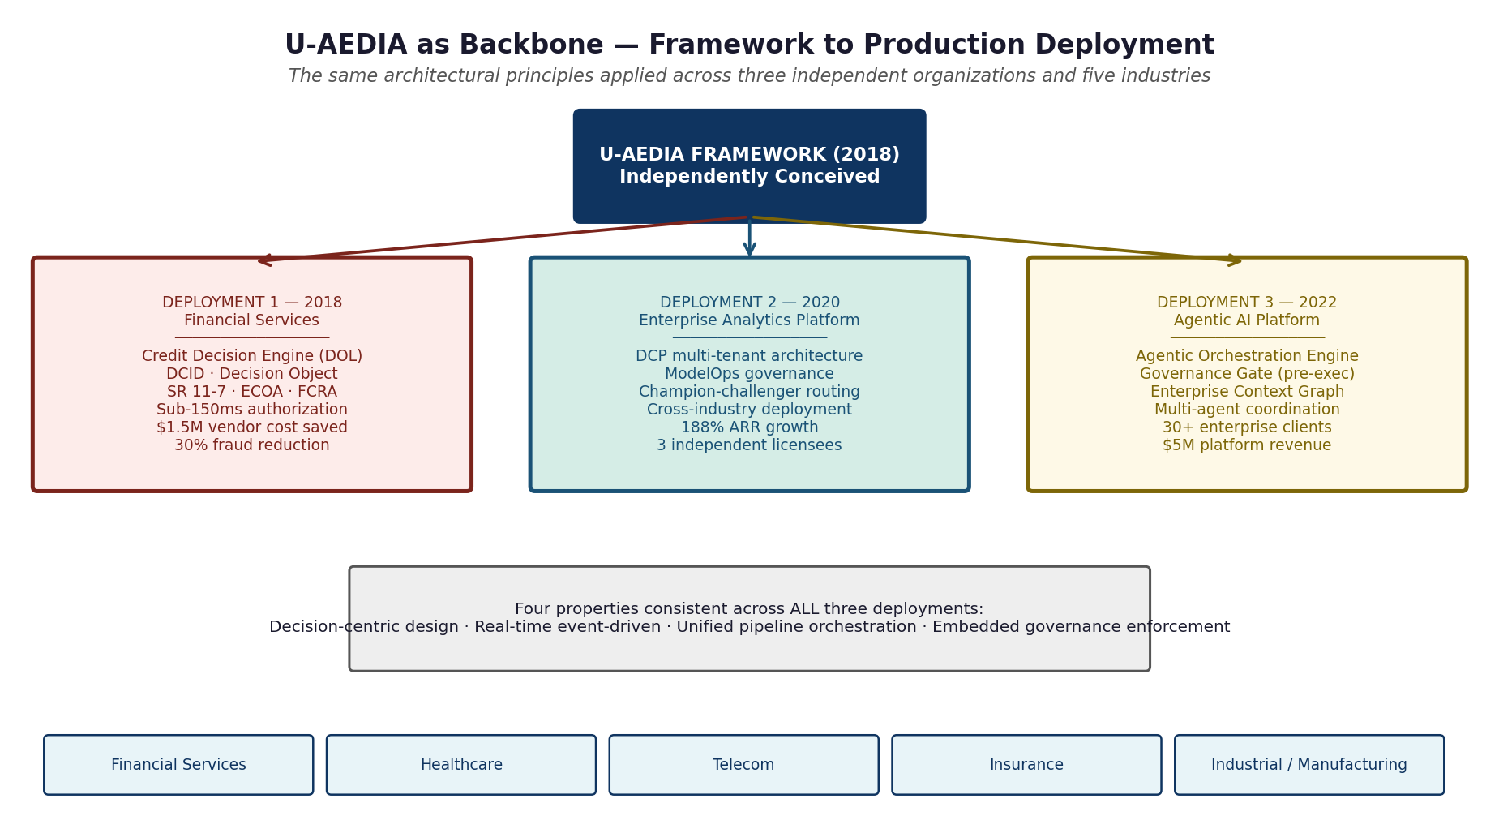
Figure 1. Three production deployments of the U-AEDIA framework. v6.0 is the third, extending the same four architectural properties to autonomous multi-agent execution.
3.1 Framework as Backbone

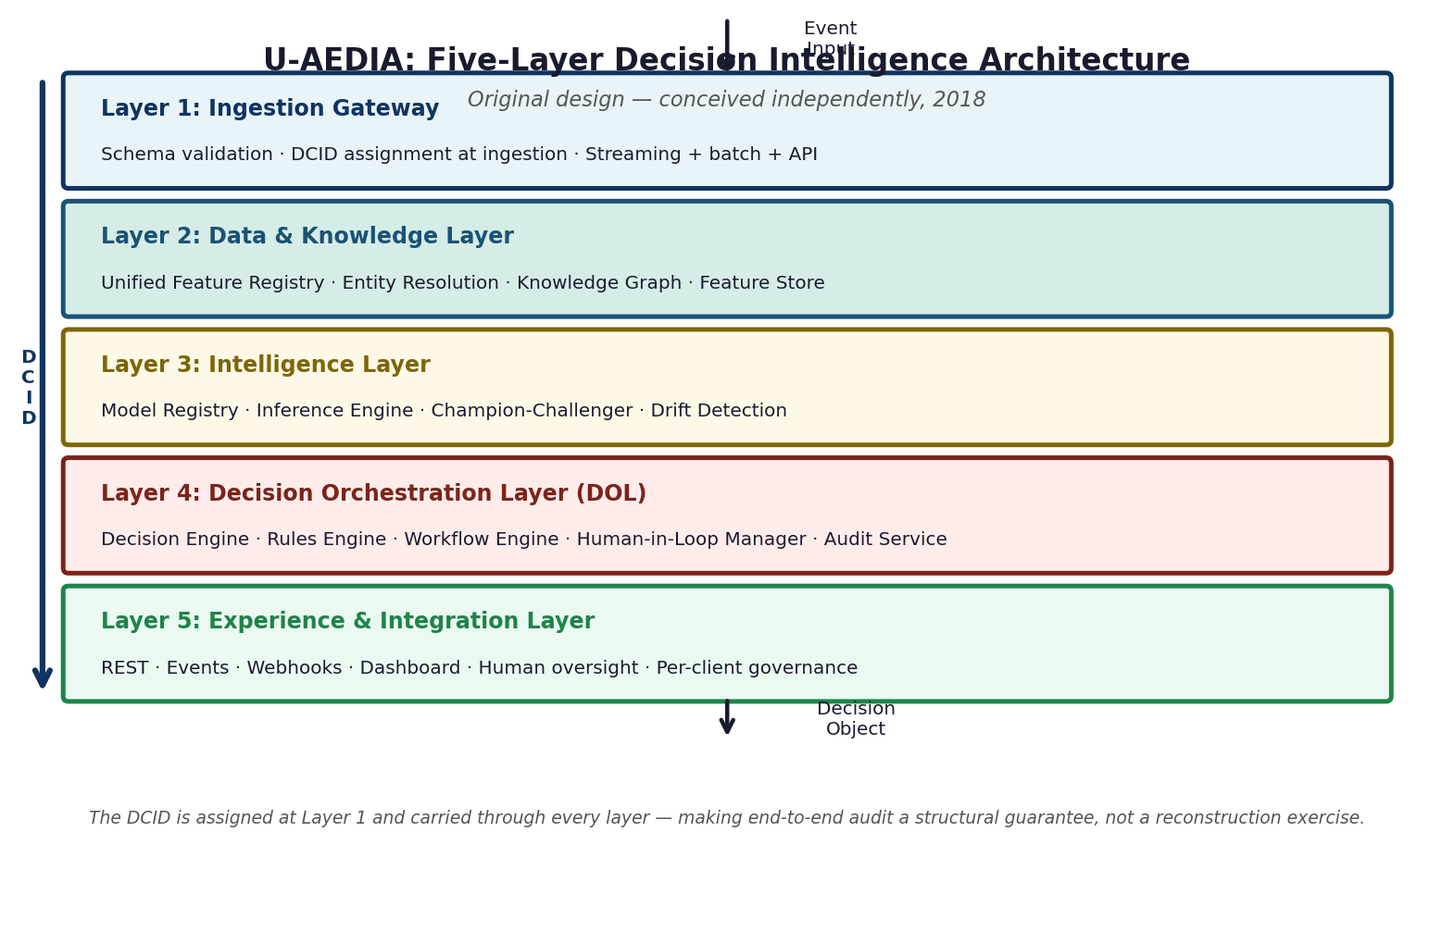
Figure 2. The five-layer architecture as backbone for agentic deployment. In v6.0, Layer 4 (DOL) is instantiated as the Agentic Orchestration Engine. Layer 2 is extended with the Enterprise Context Graph.
3.2 The Agentic Orchestration Engine (AOE)
The Agentic Orchestration Engine is the DOL instantiated for multi-agent coordination. It coordinates N autonomous agents executing multi-step enterprise workflows under embedded governance. The AOE inherits the DOL's formal state machine, unified audit recording, and Decision Object schema, extended for the agentic execution context.
Every agent action is a decision event. Every decision event produces an entry in the immutable audit store under the task DCID. The complete agent execution -- every action considered, every action taken, every action blocked -- is recorded as a structured audit trail that can be queried as a single unified record.
3.3 The Enterprise Context Graph (ECG)
The Enterprise Context Graph is the organizational intelligence layer that the Governance Gate consults before each agent action. It stores business rules, compliance policies, workflow definitions, historical decisions, and organizational context as a live, queryable knowledge graph accessible to all agents.
Enterprise Context Graph query (conceptual):
query = {
"action_type": "procurement_order",
"vendor_id": "VND-4471",
"amount_usd": 125000,
"category": "capital_equipment"
}
ecg_response = {
"compliance_policies": [
{ "policy_id": "PROC-001", "rule": "capital_equipment above threshold requires VP approval" },
{ "policy_id": "VENDOR-042", "rule": "this vendor is under procurement review" }
],
"governance_decision": "BLOCK",
"block_reasons": ["VP_APPROVAL_REQUIRED", "VENDOR_UNDER_REVIEW"],
"escalation_path": "procurement_vp_review_queue"
}
Figure 3. Enterprise Context Graph query (conceptual). Before executing a procurement order, the Governance Gate queries the ECG for applicable policies and prior decisions.
3.4 The Governance Gate
The Governance Gate is positioned inside the agent action execution layer. Before any agent executes any action, the Governance Gate queries the ECG, evaluates the pending action against applicable policies, and either permits execution or blocks it. A blocked action returns a structured governance failure result to the requesting agent.
Governance Gate execution flow (conceptual):
def execute_agent_action(action, dcid, ecg_client, audit_service):
# Step 1: Query ECG for applicable policies
context = ecg_client.get_governance_context(action)
# Step 2: Evaluate action against policies
governance_result = evaluate_governance(action, context)
if governance_result.decision == "BLOCK":
audit_service.record(dcid, action, "BLOCKED", governance_result)
return GovernanceFailureResult(
reasons=governance_result.block_reasons,
escalation_path=governance_result.escalation_path,
dcid=dcid
)
# Step 3: Execute (governance passed)
audit_service.record(dcid, action, "GOVERNANCE_PASSED", governance_result)
result = execute(action)
audit_service.record(dcid, action, "EXECUTED", result)
return result
Figure 4. Governance Gate execution flow (conceptual). Every action -- executed or blocked -- produces an audit record under the task DCID.
4. THE STATE MACHINE IN AGENTIC CONTEXT

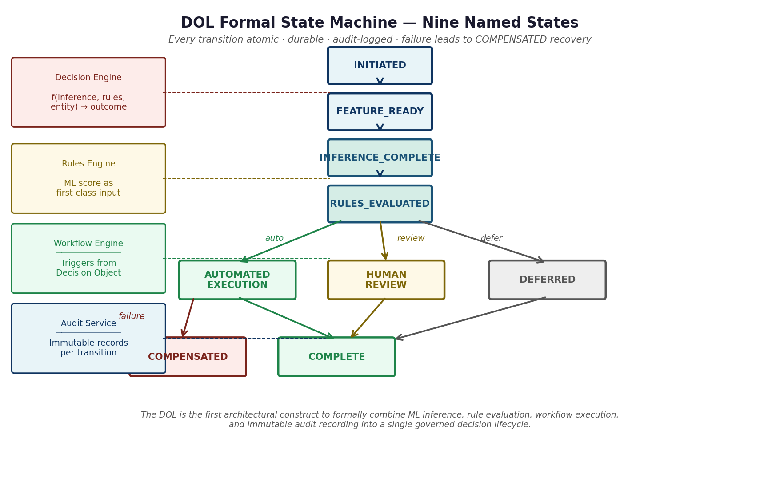
Figure 5. The DOL formal state machine extended for agentic execution. Every agent action is a transition. COMPENSATED handles failed agent actions and triggers compensating rollback transactions.
5. MULTI-AGENT COORDINATION ARCHITECTURE
Component | Role in agentic execution | Governance contribution
Agentic Orchestration Engine (AOE) | Coordinates task decomposition, agent assignment, and workflow sequencing across multiple autonomous agents | Maintains formal state machine governing overall task lifecycle; produces unified task Decision Object
Enterprise Context Graph (ECG) | Provides organizational intelligence: policies, prior decisions, business rules, workflow definitions | Single source of compliance truth; eliminates context drift across agents within a task
Governance Gate | Pre-execution compliance enforcement for every individual agent action | Prevents non-compliant actions before execution; records both permitted and blocked actions under DCID
Unified Feature Registry | Provides consistent entity features for all agents operating on the same entity within a task | Eliminates feature inconsistency between agents evaluating the same entity simultaneously
Audit and Traceability Service | Records every state transition, agent action, and governance decision under the task DCID | Produces unified audit trail spanning the entire multi-agent task execution
6. DCP PATTERN IN AGENTIC CONTEXT

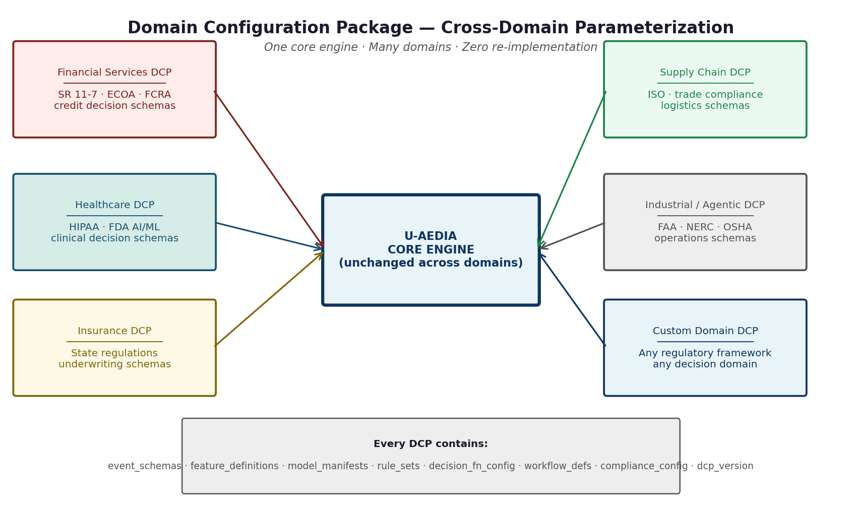
Figure 6. The DCP architecture applied to the agentic platform. Each enterprise client operates under their own DCP. The governance framework adapts to each client's regulatory environment through DCP configuration.
7. WHAT V6.0 ESTABLISHED
1. Governance-embedded agentic execution is technically achievable and commercially deployable at enterprise scale across materially different enterprise governance environments from a single platform architecture.
2. The DOL formal state machine is extensible to the multi-agent agentic execution context without modification to its core semantics. Every agent action is a decision event following the same state machine semantics.
3. The DCP parameterization pattern applied to agentic AI enables platform economics: delivery scales with client deployment, not with engineering headcount.

