U-AEDIA
Unified AI-Driven Enterprise Decision Intelligence Architecture

v2.0 - Credit Decisioning and Risk Analytics
First Production Application: Real-Time Credit Decision Engine
Applying the decision-centric framework to regulated financial credit decisioning

Mesbaul Haque Sazu
Author and Principal Architect
Temple University

August 3, 2018
Document Status: Production Deployment

All architectural constructs, design patterns, and terminology described herein are original intellectual contributions of the author. This framework was independently conceived and developed beginning in 2018.

1. THIS VERSION IN CONTEXT
v2.0 documents the first production application of the U-AEDIA framework: a real-time credit decisioning platform deployed in 2018. The framework described in v1.0 was applied here against one of the most technically demanding regulated use cases available: credit authorization subject to model risk management requirements, individual adverse action accuracy requirements, and consumer credit regulation -- simultaneously with a card network sub-150-millisecond authorization requirement.
This deployment validated the core thesis: a decision-centric architecture with a unified orchestration layer could satisfy real-time latency constraints and embedded regulatory compliance simultaneously. No prior framework had achieved this combination.
Foundation from v1.0: All five layers, the DOL, the Decision Object schema, and the DCID propagation pattern remain unchanged. v2.0 adds the financial services domain configuration and the specific regulatory compliance architecture built on that foundation.
2. THE PROBLEM: CREDIT DECISIONING AT SCALE
At the time of this deployment, the credit decisioning infrastructure was fragmented across three separate systems: fraud evaluation, credit risk scoring, and authorization. These systems shared no context. Each made its decision independently. The consequences were structural:
• Audit reconstruction required correlating logs across three systems -- a process taking weeks. Under model risk management frameworks, this is not a performance issue. It is a compliance failure.
• Adverse action notices sent to declined applicants came from generic score-band templates that did not reflect what the models actually computed for each individual. This violated individual-level adverse action accuracy standards.
• Fraud and credit risk models never shared signal. A customer with a high fraud score and a borderline credit score was evaluated by separate systems that could not see each other's outputs.
• Everything ran in batch cycles. Authorization requirements of sub-150 milliseconds were incompatible with batch architecture.
The U-AEDIA framework addressed all four simultaneously. The Credit Decision Engine was the DOL instantiated for financial services, with the DCP configured for applicable regulatory requirements.
3. THE CREDIT DECISION ENGINE ARCHITECTURE

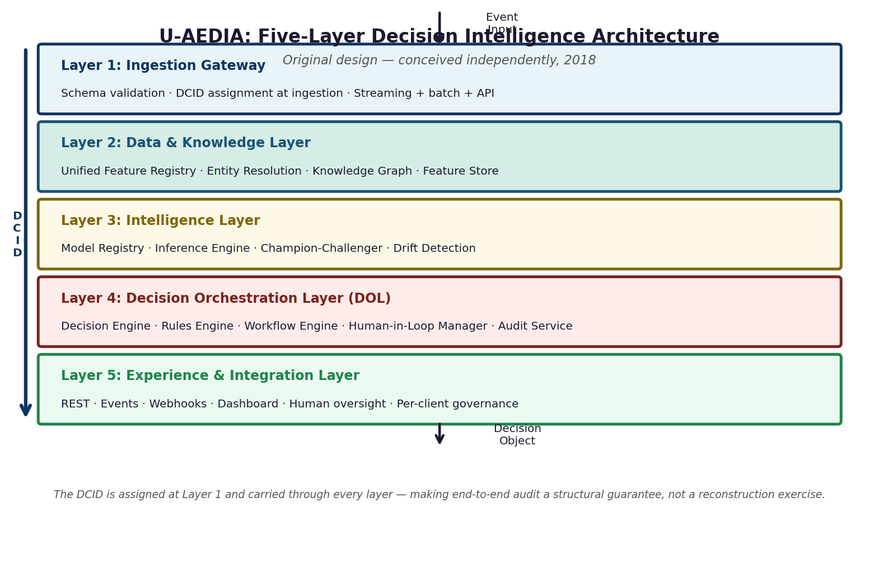
Figure 1. The five-layer architecture deployed as a credit decisioning platform. Layer 4 (DOL) is the Credit Decision Engine.
3.1 Regulatory Architecture Embedded in the Framework
Regulatory requirement | How it shaped the architecture | DOL component
Complete model decision audit trail | DCID assigned at ingestion, propagated through all layers. Every state transition produces an immutable audit record. Answerable in under two seconds. | Audit and Traceability Service
Individual adverse action reasons | SHAP values computed at inference time and stored in Decision Object Section 4. Adverse action reason codes auto-generated from Section 4 values. | Decision Engine and Inference Results
Training-serving consistency | Unified feature definition registry: one computation function per feature, applied identically to training and production serving. Training-serving skew architecturally impossible. | Data and Knowledge Layer
Sub-150ms end-to-end authorization | Single orchestration context: fraud model and credit model evaluated together. Eliminated 60 to 90ms of multi-system network overhead. | Decision Orchestration Layer
Consistent policy application | Rules Engine receives live ML inference score as first-class input. Policy rules applied consistently at decision time, not in post-processing. | Rules Engine
4. THE FEATURE REGISTRY
Why This Matters in Regulated Credit AI
In most ML deployments, training features and serving features are computed by separate codebases maintained by different teams. Coordination processes keep them aligned -- until they do not. When they diverge, the model deployed in production no longer operates on the features it was trained on. Model outputs degrade silently. Under model risk management frameworks, this is a regulatory violation, not just a technical problem.
The unified feature definition registry makes this class of failure architecturally impossible. One function definition per feature. Same function runs for offline training and online serving. Divergence is rejected at submission time, not discovered in production.

Feature Registry Entry (conceptual schema):
{
"feature_id": "bureau_utilization_ratio",
"version": "2.1.0",
"computation_fn": "calculate_utilization(revolving_balance, credit_limit)",
"freshness_sla_ms": 500,
"data_type": "float",
"effective_date": "2019-03-01",
"regulatory_flags": ["MODEL_RISK_MGMT", "ADVERSE_ACTION"]
}
Figure 2. Feature registry entry structure. The same computation_fn is called identically for training dataset generation and production inference serving.
5. THE CREDIT DECISION OBJECT

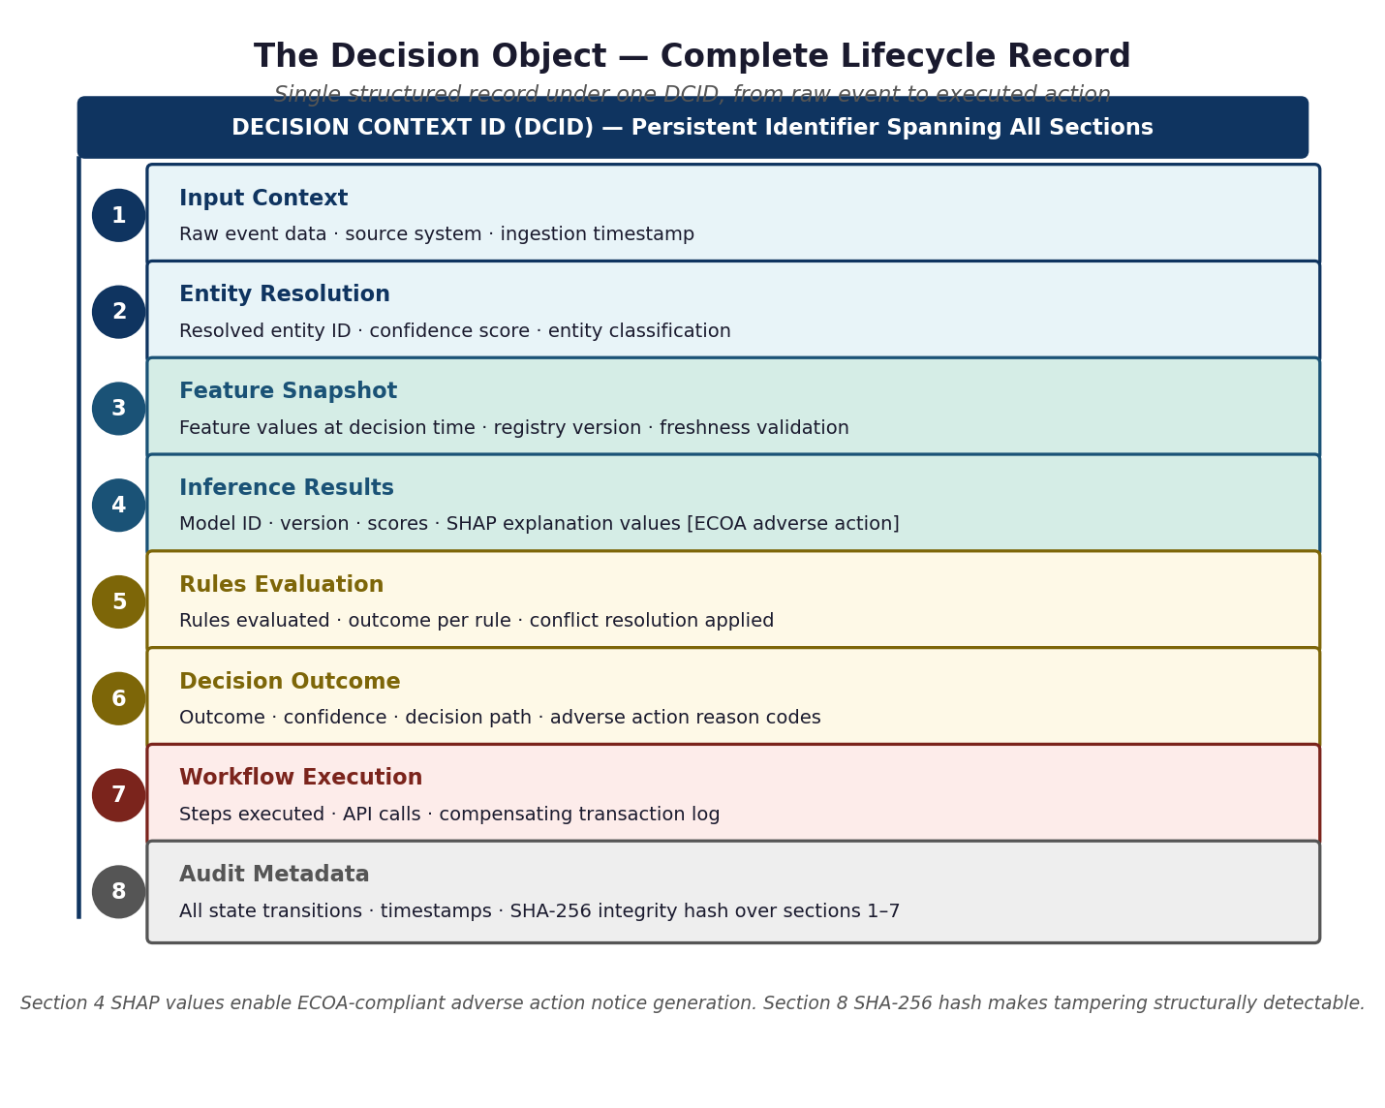
Figure 3. The Credit Decision Object schema. Section 4 SHAP values power adverse action notice generation. Section 8 SHA-256 hash satisfies audit integrity requirements.
Credit Decision Object -- Section 4 (Inference Results, conceptual):
{
"dcid": "CDE-2019-03-15T14:23:07.441Z-8d7f2a",
"section": 4,
"model_id": "credit_risk_ensemble_v4",
"model_version": "4.2.1",
"inference_score": 0.73,
"decision_threshold": 0.65,
"shap_values": {
"bureau_utilization_ratio": +0.18,
"payment_history_12m": -0.31,
"derogatory_marks": +0.24,
"income_to_debt_ratio": -0.09
},
"adverse_action_reasons": ["HIGH_UTILIZATION", "DEROGATORY_MARKS"],
"feature_registry_version": "2.1.0",
"inference_latency_ms": 23
}
Figure 4. Credit Decision Object Section 4 (conceptual). SHAP values are computed at inference time and stored directly. Adverse action reasons are derived automatically from SHAP values ranked by magnitude.
6. DOL STATE MACHINE IN CREDIT CONTEXT

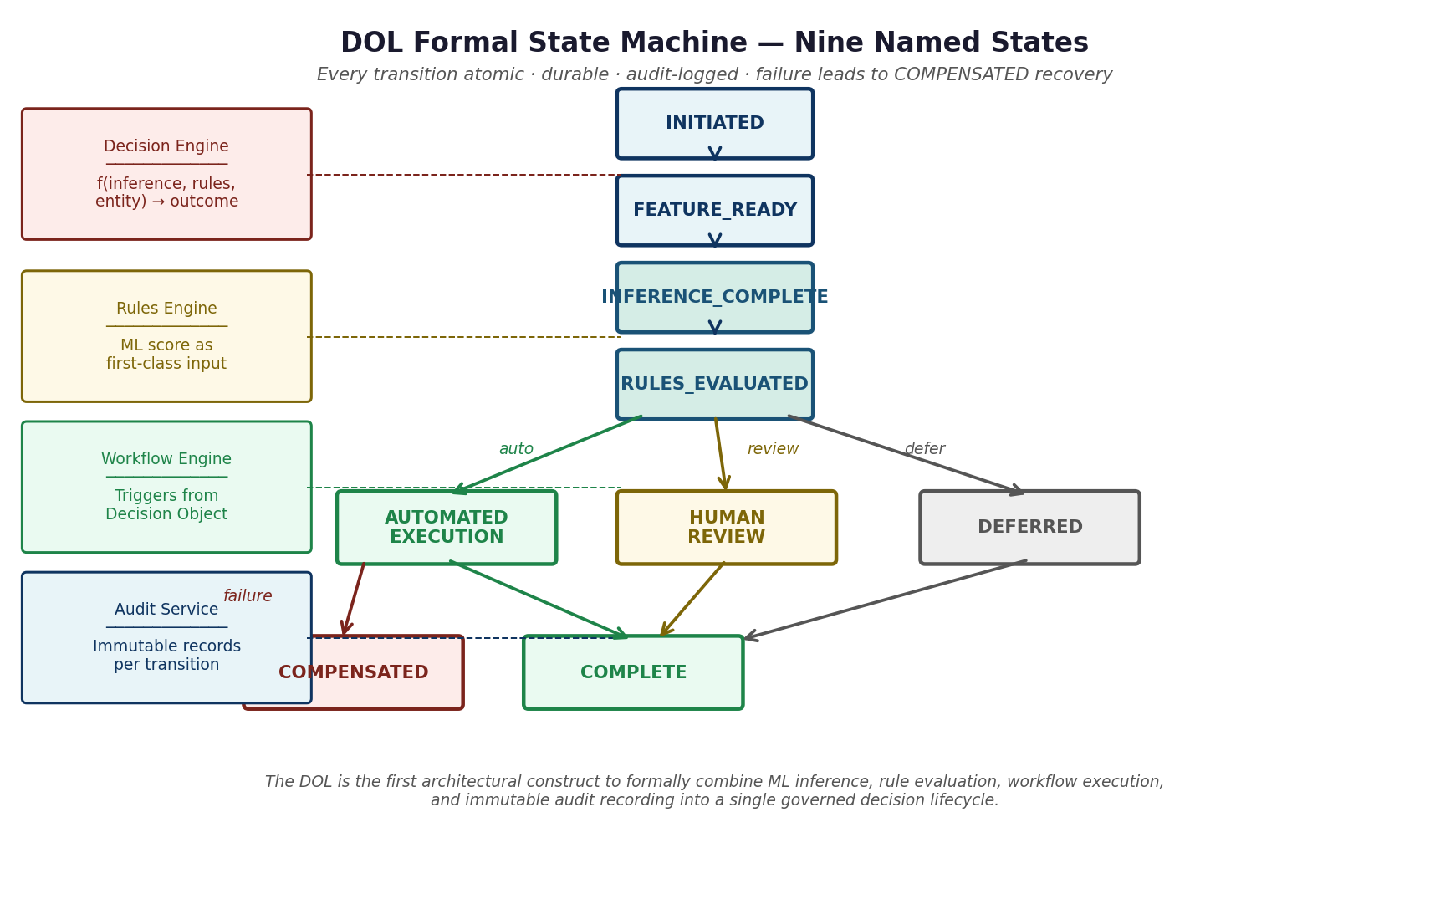
Figure 5. The DOL formal state machine as applied to credit decisioning. AUTOMATED_EXECUTION produces the authorization response and triggers adverse action workflow if applicable. COMPENSATED handles downstream system failures.
7. DEMONSTRATED OUTCOMES
The following outcomes are directly attributable to specific architectural decisions within U-AEDIA:
• Vendor dependency for core credit scoring logic was eliminated by the Credit Decision Engine. The decision to build the DOL in-house rather than maintain vendor dependency is the architectural cause.
• Fraud loss was reduced materially by unifying fraud and credit model signals within a single orchestration context. Before the Credit Decision Engine, fraud and credit systems never shared signal. The reduction follows from unified orchestration design, not from model improvement.
• Sub-150ms end-to-end credit authorization was achieved for the first time. Sequential API calls to three separate systems consume 60 to 90ms in network overhead alone, exhausting the latency budget before any ML inference runs. A single orchestration context is the only architecture satisfying this constraint.
• Audit query time for individual decisions dropped from weeks of log reconstruction to under two seconds. The DCID propagated from ingestion means every decision record is indexed under one identifier.
8. WHAT V2.0 ESTABLISHED
1. A decision-centric architecture can satisfy sub-150ms card network authorization requirements while embedding regulatory compliance as structural properties of the system, not as post-hoc compliance layers.
2. Training-serving consistency can be made an architectural guarantee rather than an operational discipline, with direct regulatory compliance implications.
3. Individual adverse action notice generation can be automated from the Decision Object without post-hoc data reconstruction, using SHAP values computed and stored at inference time.
4. Fraud and credit model signals, previously siloed, can be unified in a single decision lifecycle, producing measurable fraud loss reduction from architectural design alone.

