U-AEDIA
Unified AI-Driven Enterprise Decision Intelligence Architecture

v4.0 - Enterprise Analytics Platform
Second Application: Multi-Tenant Cross-Industry Analytics Platform
The DCP parameterization pattern at commercial scale across independent enterprise licensees

Mesbaul Haque Sazu
Author and Principal Architect
Case Western Reserve University

September 12, 2020
Document Status: Production Deployment

All architectural constructs, design patterns, and terminology described herein are original intellectual contributions of the author. This framework was independently conceived and developed beginning in 2018.

1. THIS VERSION IN CONTEXT
v4.0 documents the second production application of U-AEDIA: a multi-tenant enterprise analytics platform deployed from 2020 across independent enterprise licensees in healthcare, telecommunications, and insurance. The central architectural challenge was different from v2.0: where v2.0 required satisfying a single organization's regulatory constraints in real time, v4.0 required deploying the same core platform across organizations with materially different regulatory environments, operational constraints, and domain-specific requirements -- without custom engineering per licensee.
This is the problem the Domain Configuration Package was designed to solve. v4.0 is where that design was validated at commercial scale.
Foundation from v3.0: The five-layer architecture, the DOL, the Decision Object, and the formal state machine are unchanged. v4.0 extends the framework with the DCP multi-tenant architecture, champion-challenger model governance, and the ModelOps framework.
2. THE PLATFORM ARCHITECTURE PROBLEM
An enterprise analytics platform serving independent licensees across multiple industries faces a specific commercial and architectural tension: each licensee operates in a different regulatory environment, uses different domain-specific data schemas, requires different model governance frameworks, and has different workflow definitions. Building custom implementations for each licensee is a professional services model -- revenue scales with engineering headcount, not with software deployment.
The U-AEDIA framework resolves this tension through the Domain Configuration Package. The DCP externalizes all domain-specific configuration from core architectural components. The same core platform engine serves every licensee. What changes per licensee is the DCP artifact.

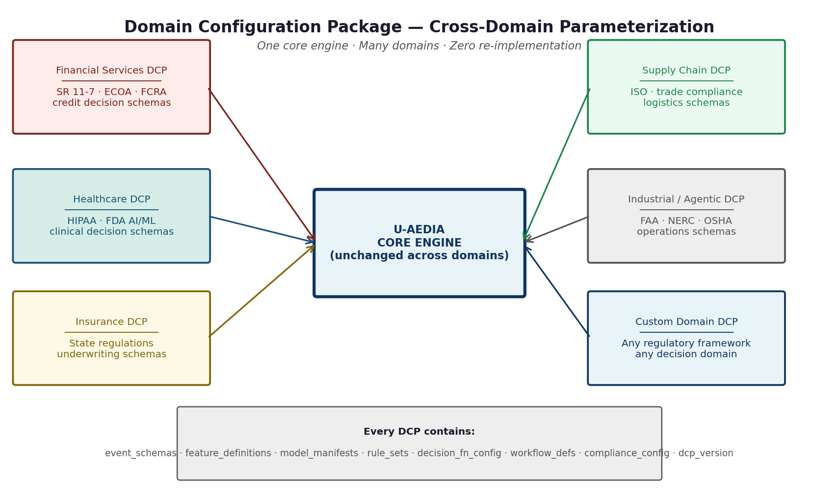
Figure 1. The Domain Configuration Package architecture. One core engine. One DCP per domain. Zero core re-implementation when onboarding a new domain.
The DCP Parameterization Pattern
Domain Configuration Package (DCP) schema (conceptual):
{
"dcp_id": "healthcare-platform-v3.2",
"dcp_version": "3.2.0",
"domain": "healthcare",
"event_schemas": {
"patient_admission": { "fields": [...], "validation_rules": [...] }
},
"feature_definitions": [
{ "feature_id": "patient_risk_score", "fn_ref": "compute_risk_v2", "freshness_sla_ms": 1000 }
],
"model_manifests": [
{ "model_id": "readmission_risk_v4", "version": "4.1.0", "champion_traffic_pct": 90 },
{ "model_id": "readmission_risk_v5", "version": "5.0.0-beta", "challenger_traffic_pct": 10 }
],
"compliance_config": { "frameworks": ["HIPAA", "FDA_AI_ML"], "audit_retention_days": 2555 },
"decision_fn_config": { "outcomes": ["DISCHARGE", "CONTINUE", "ESCALATE"] },
"workflow_defs": { "ESCALATE": ["notify_attending", "create_care_plan", "log_audit_record"] }
}
Figure 2. DCP schema (conceptual). Substituting this artifact for a different domain requires no modification to any core platform component.
3. CHAMPION-CHALLENGER MODEL GOVERNANCE
The multi-tenant platform required a model governance architecture that could satisfy each licensee's regulatory requirements independently without cross-licensee interference.

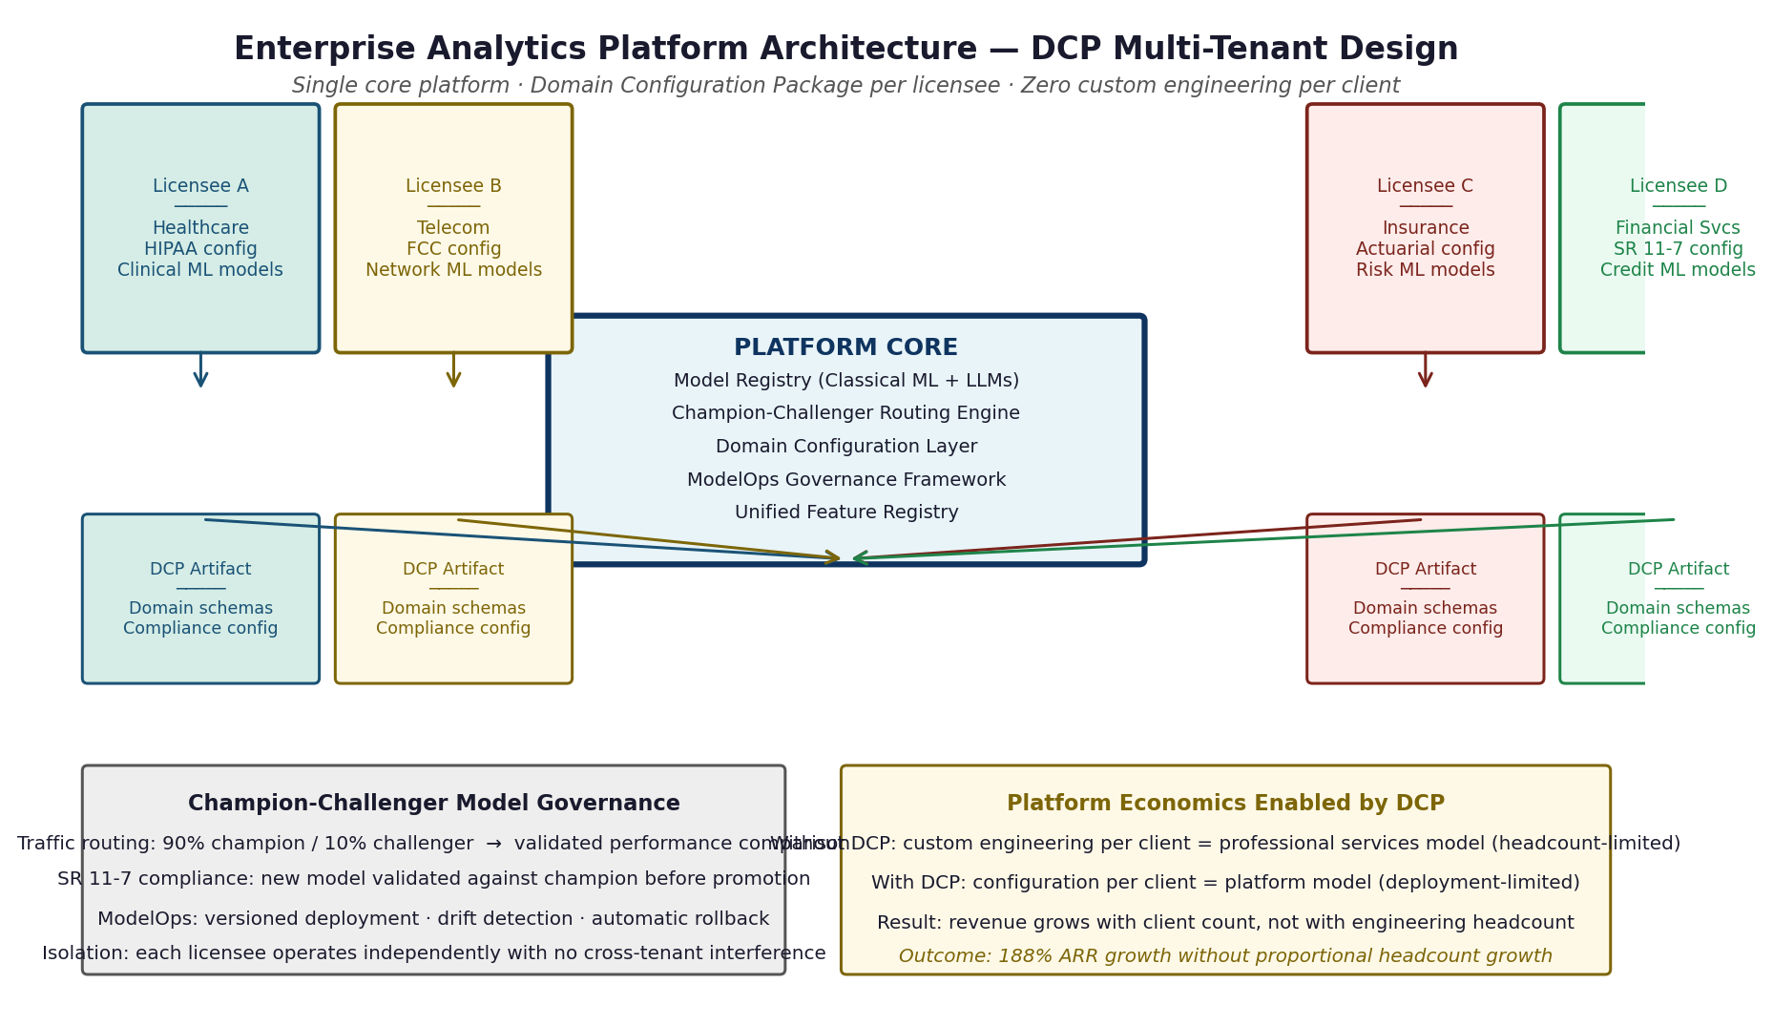
Figure 3. The enterprise analytics platform architecture. Each licensee operates under their own DCP. Champion-challenger routing is per-licensee and isolated.

Capability | What it provides | Regulatory significance
Champion-challenger routing | Configurable traffic split between validated champion and candidate challenger model. Default: 90% champion / 10% challenger. | Enables new model validation against live production traffic without exposing the full population to an unvalidated model.
Semantic versioning | Explicit version identifiers for every deployed model. Decision Object stores model version at inference time. | Enables audit reconstruction at any future point: which model version produced which decision.
Automated drift detection | Statistical monitoring of inference distribution against training baseline. Alerts when model behavior departs from validated envelope. | Satisfies ongoing model performance monitoring requirements in credit AI and clinical AI governance.
Controlled promotion | Champion promotion from challenger requires meeting configurable performance gates over minimum traffic volume. | Prevents premature deployment of undertested models. Audit trail of promotion decision and gates met.
Rollback with audit | Instantaneous rollback to previous champion version with full audit record of rollback decision. | Enables rapid response to model degradation without leaving a gap in decision records.
4. MODELOPS GOVERNANCE FRAMEWORK
ModelOps Lifecycle Stages (conceptual):
REGISTERED > VALIDATED > STAGED > CHALLENGER > CHAMPION > RETIRED
REGISTERED: Model artifact uploaded; metadata schema validated
VALIDATED: Performance metrics meet domain thresholds;
feature alignment verified against unified registry;
explainability metrics computed (SHAP baseline)
STAGED: Integration testing against domain DCP;
latency profiling under simulated load
CHALLENGER: Live traffic routing begins (configurable %);
real-time performance monitoring vs. champion
CHAMPION: Full production traffic; ongoing monitoring active
RETIRED: Traffic routing to zero; audit records preserved
Figure 4. ModelOps lifecycle stages. Every transition produces a governance record.
5. CROSS-INDUSTRY VALIDATION OF DCP PATTERN
Domain | Regulatory framework in DCP | Domain-specific configuration | Core engine modification required
Healthcare | HIPAA, FDA AI/ML guidance | Clinical event schemas, care pathway decision outcomes, human-in-loop mandatory for certain decision types | Zero
Telecommunications | FCC regulations, network SLA requirements | Network event schemas, service provisioning decision outcomes, near-real-time latency requirements | Zero
Insurance | State insurance regulations, actuarial standards | Policy event schemas, underwriting decision outcomes, actuarial model manifests | Zero
The DCP pattern is what turns U-AEDIA from a financial services architecture into an enterprise AI platform. Without it, each domain requires a custom implementation. With it, onboarding a new domain is a configuration exercise, not an engineering project.
6. WHAT V4.0 ESTABLISHED
1. The DCP parameterization pattern works across materially different regulatory environments -- healthcare, telecommunications, and insurance -- operating from a single platform architecture without core re-implementation. Domain-agnosticism is production-validated.
2. Champion-challenger model governance can be implemented as a platform-level property, isolating each licensee's model deployment and validation from others while maintaining unified governance standards across all licensees.
3. The platform economics that result from the DCP architecture -- delivery scaling with software deployment rather than engineering headcount -- are the commercial consequence of a specific architectural design decision.

