U-AEDIA
Unified AI-Driven Enterprise Decision Intelligence Architecture

v1.0 - Foundational Release
The Decision-Centric Architecture
A new architectural layer for governed AI decision execution

Mesbaul Haque Sazu
Author and Principal Architect

March 1, 2018
Document Status: First Publication

All architectural constructs, design patterns, and terminology described herein are original intellectual contributions of the author. This framework was independently conceived and developed beginning in 2018.

1. WHY THIS FRAMEWORK EXISTS
In 2018 I confronted a problem that had no clean solution in the available toolkit. Organizations deploying artificial intelligence were sitting on a fundamental architectural gap: they had excellent infrastructure for training models and serving inferences, but nothing that took those inferences and translated them into governed, auditable, executed decisions in real time. The gap was not a missing feature in any one tool. It was a missing layer between intelligence generation and operational consequence.
Every existing framework addressed a piece of it. Lambda and Kappa architectures handled data processing at scale. MLOps platforms managed model lifecycles. Business process management systems executed workflows. Rules engines evaluated policy. But none of them connected these concerns into a unified decision lifecycle, and none produced a single traceable record from the moment an event entered the system through to the action taken in response.
The consequence in practice: organizations deploying AI in regulated environments could not answer the question "why did this system make this decision?" without weeks of log reconstruction across multiple systems. For a financial institution needing to satisfy model risk management requirements, that is not a performance problem. It is a regulatory one.
I designed U-AEDIA to be that missing layer. The framework's central claim is simple: the decision, not the data or the model output, is the primary architectural unit. Everything else -- ingestion, feature computation, inference, rule evaluation, workflow execution, audit recording -- is organized around producing one complete, governed decision as its output.
2. THE DECISION-CENTRIC PARADIGM
Decision-centric design means the system is organized around producing governed decisions with complete audit records, not around producing analytical outputs that humans then interpret and act on separately.
Before this framework, enterprise AI was predominantly analytics-centric. Systems produced outputs -- model scores, predictions, classifications -- and the connection between those outputs and the operational actions they informed was left to application code, human judgment, or a combination of both. That connection was typically ad hoc, inconsistent across implementations, and impossible to audit as a unified record.
The decision-centric paradigm changes the question from "what did the model predict?" to "what decision did the system make, and can you show me the complete record?" It treats the decision as a first-class construct with explicit governance, formal state machine semantics, and a canonical data structure that captures the full lifecycle.
This is not an incremental improvement on the analytics-centric model. It is a different architectural philosophy that produces different systems -- systems that can satisfy model risk management audit requirements, adverse action documentation standards, clinical AI accountability requirements, and AI Act auditability mandates, because those capabilities are built into the architecture rather than retrofitted onto it.
3. THE FIVE-LAYER ARCHITECTURE
U-AEDIA organizes the decision lifecycle into five layers. Each has a defined responsibility and a defined interface. Together they produce the Decision Object: the canonical record of a complete decision.

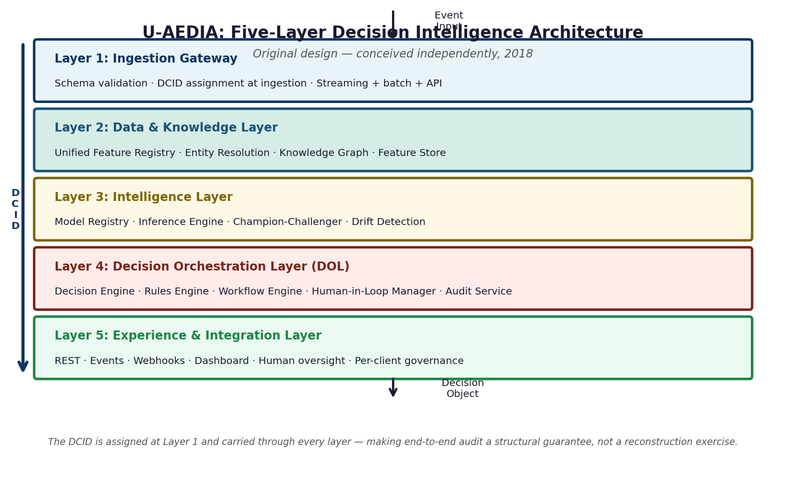
Figure 1. The U-AEDIA five-layer architecture. The DCID is assigned at Layer 1 and propagates through all layers, making end-to-end auditability a structural property of the system.
The Four Properties Every Implementation Shares
Across every application of this framework, regardless of industry or technical form, four architectural properties are present. These are specific design decisions, not aspirational goals.
Property | What it means | Why it matters
Decision-centric design | The decision is the primary architectural unit. The system produces governed decisions with complete audit records. | Eliminates the gap between AI output and operational action. Enables regulatory auditability as a structural property.
Real-time event-driven processing | All stages -- feature computation, inference, rule evaluation, execution -- happen within one latency budget in response to live events. | Required for credit authorization, clinical triage, industrial safety, and any use case where the value of a decision depends on its timing.
Unified pipeline orchestration | Every stage operates within a single orchestrated pipeline under one persistent identifier (DCID). | Makes end-to-end audit traceability a structural property. Directly satisfies model risk management, clinical AI, and AI Act auditability requirements.
Embedded governance enforcement | Compliance requirements are enforced within the execution pipeline before each action, not applied as post-hoc review. | Post-hoc governance detection is insufficient in regulated environments. Prevention before execution is the only architecturally sound answer.
4. THE DECISION ORCHESTRATION LAYER
The DOL is the component that had not been formalized as an architectural construct before U-AEDIA. It sits between intelligence generation and consumer interfaces, and it does something none of the existing frameworks had defined: it takes an inference output and turns it into a governed decision with a complete audit record, automatically, in real time.

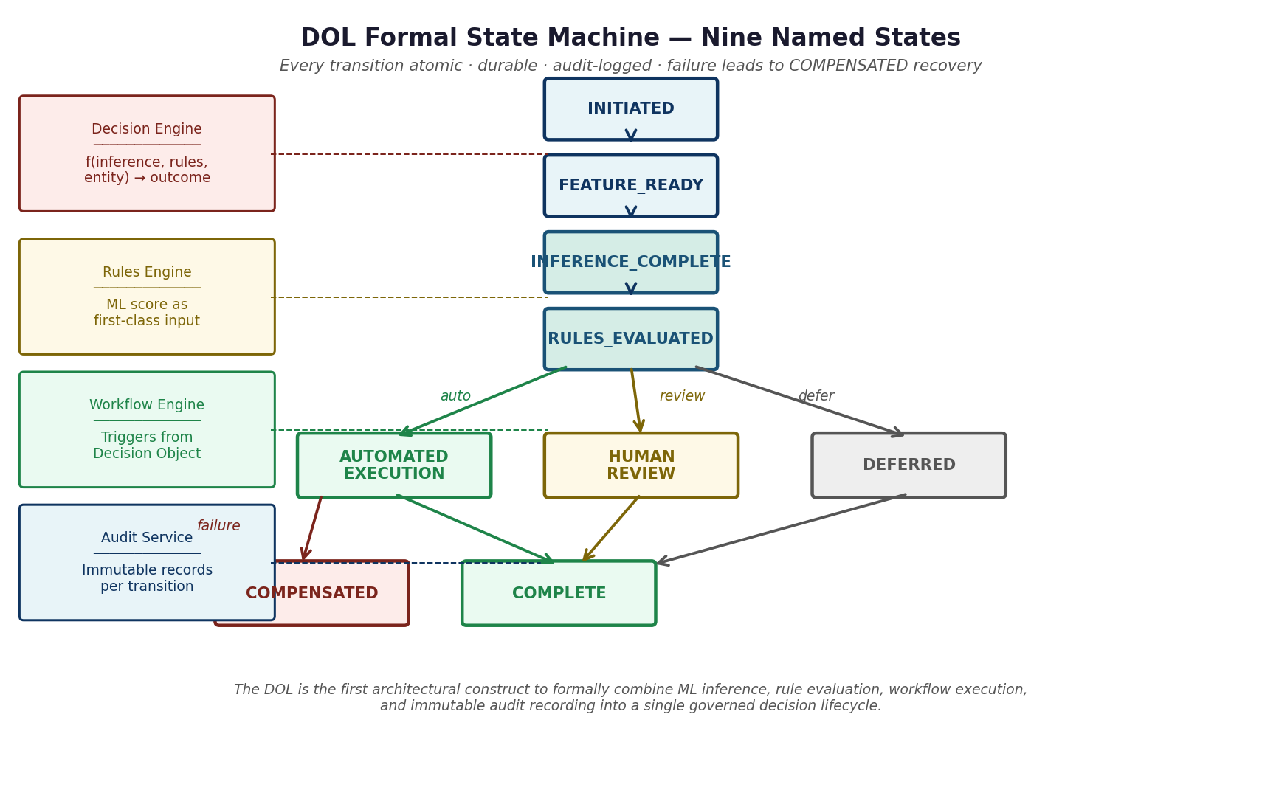
Figure 2. The DOL formal state machine. Nine named states. Every transition is atomic, durable, and audit-logged. Failure transitions lead to COMPENSATED recovery.
The DOL is not an improvement on a prior pattern. It is a new architectural category. The field had inference engines, rules engines, and workflow systems. It had no construct that formally combined all three into a coherent decision lifecycle with deterministic state machine governance and unified audit.
5. THE DECISION OBJECT
Every U-AEDIA implementation produces a Decision Object when a decision completes. This is the canonical record: input event, entity context, feature snapshot at decision time, model versions and outputs, rules evaluated and their results, decision outcome and confidence, workflow actions executed, and audit metadata with a cryptographic integrity hash.

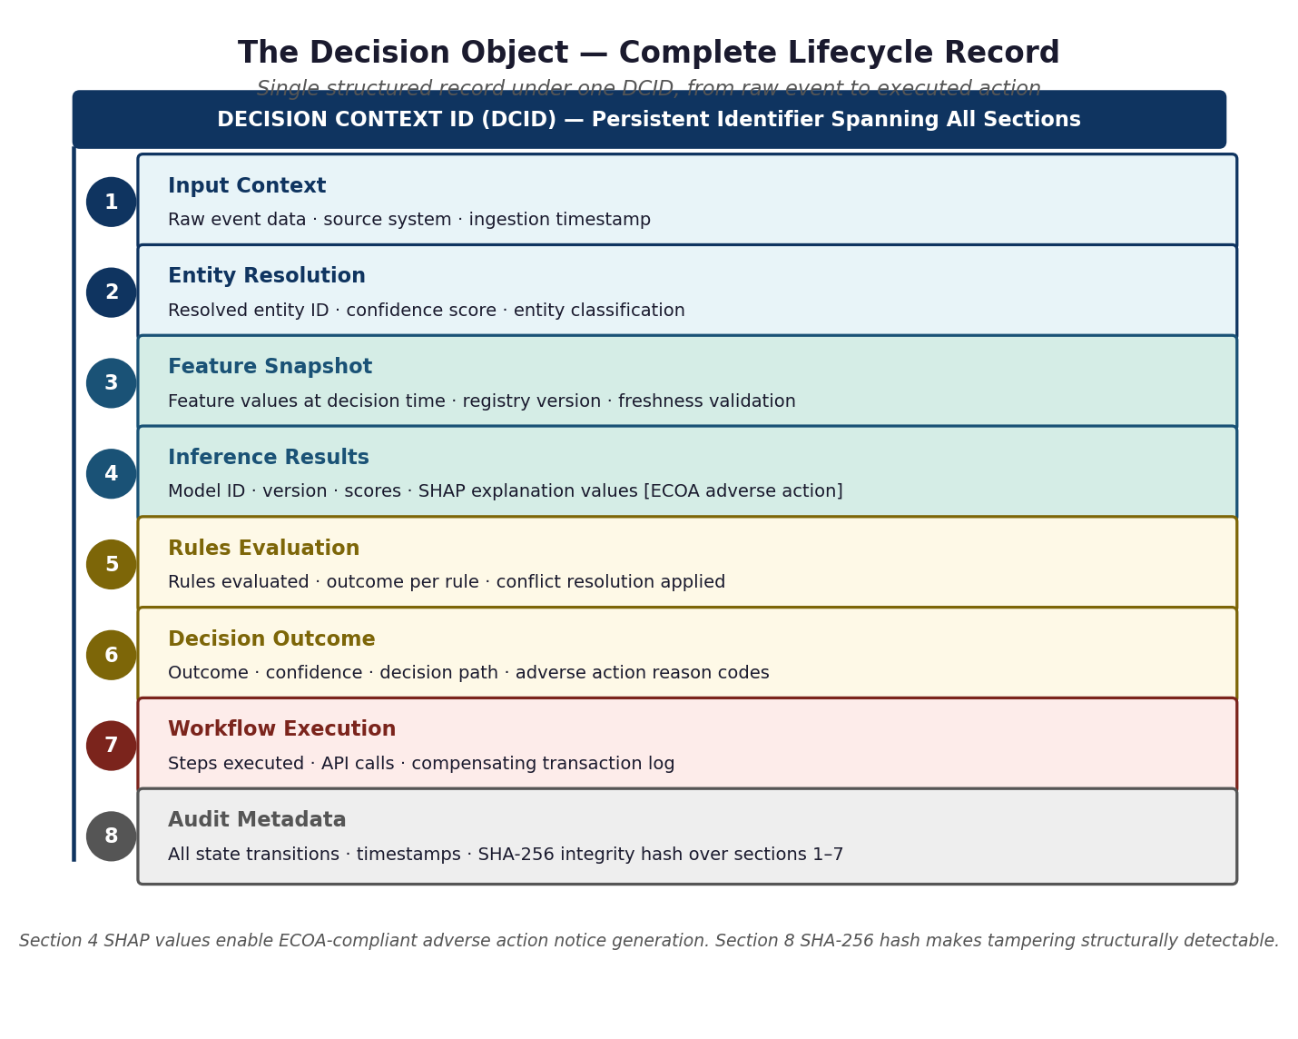
Figure 3. The Decision Object schema. Eight sections under one DCID. The SHA-256 hash over sections 1 through 7 makes tampering structurally detectable.
The practical consequence: "why did this system make this decision?" goes from a weeks-long log reconstruction exercise across three systems to a single-second query against an indexed, immutable store.
6. ORIGINAL CONTRIBUTIONS
The following are the specific original architectural constructs introduced in this framework. Each represents an intellectual contribution that had not been previously formalized as a unified, domain-agnostic architectural construct in the enterprise AI field.
1. Decision Orchestration Layer (DOL) -- A dedicated architectural control plane integrating ML inference, real-time rule evaluation, workflow execution, human-in-loop management, and immutable audit recording into a unified decision lifecycle governed by a deterministic state machine.
2. Decision Object Schema -- A formal, versioned data structure capturing the complete AI decision lifecycle as a single structured record under one persistent identifier, from raw event ingestion through executed action.
3. DOL Formal State Machine -- A formally specified state machine governing all decision lifecycle transitions, with atomic, durable, audit-logged state changes and explicit failure transitions to known recovery states.
4. Domain Configuration Package (DCP) -- A formal parameterization model externalizing all domain-specific configuration from core architectural components, enabling cross-domain deployment without re-implementation.
5. Training-Serving Consistency as an Architectural Guarantee -- A Feature Store design pattern using a unified feature definition registry to make training-serving consistency a structural property of the system rather than an operational discipline.
6. Governance-Embedded Agentic Execution -- An architectural pattern placing compliance enforcement inside the agent action layer before each execution, rather than applying post-hoc monitoring or observability.
7. PRIOR ART ANALYSIS
The following prior art frameworks were available at the time of this framework's conception. Each resolves a subset of the decision governance problem. None resolves all four simultaneously.

Framework | What it does | Decision capability | What U-AEDIA adds
Lambda Architecture (2011) | Scalable batch and speed-layer data processing | None. Produces queryable data states, not decisions. | The DOL: translates query outputs into governed decisions under a unified audit trail.
Kappa Architecture (2014) | Single streaming pipeline with reprocessing | None. Real-time data processing is not real-time decision execution. | Decision execution, governance enforcement, and unified audit within the streaming paradigm.
MLOps Platforms | ML model lifecycle: training, versioning, deployment, serving | Partial -- inference only. No downstream execution, no unified audit. | The DOL: completes the decision lifecycle that MLOps begins with inference.
BPM Systems | Workflow execution, human task management | None. No ML integration; inference scores not first-class inputs. | Workflow Engine triggered by Decision Object; Rules Engine with ML score as first-class input.
Rules Engines | Policy evaluation against entity attributes | None. Cannot receive live ML inference score as a rule input. | Rules Engine design where inference score is first-class input to rule conditions.
LangChain / AutoGPT (2022) | LLM agent task decomposition, prompt chaining | Partial -- execution without governance, no enterprise audit. | Governance-embedded agentic execution with organizational context and pre-action compliance enforcement.
8. AUTHORSHIP STATEMENT
U-AEDIA was independently conceived, designed, and developed by me. The framework was not derived from any prior published work, existing commercial platform, or collaborative effort. The architectural constructs, design patterns, and terminology introduced in this document are original intellectual contributions that I developed through my own research and production system design work beginning in 2018.

