U-AEDIA
Unified AI-Driven Enterprise Decision Intelligence Architecture

v3.0 - Analytics Framework Formalization
Formal Specification of Decision Analytics Architecture
Formalizing the analytical foundations and prior art analysis of the decision-centric paradigm

Mesbaul Haque Sazu
Author and Principal Architect
Temple University

June 7, 2019
Document Status: Framework Specification

All architectural constructs, design patterns, and terminology described herein are original intellectual contributions of the author. This framework was independently conceived and developed beginning in 2018.

1. PURPOSE OF THIS VERSION
v3.0 formalizes the analytical and architectural foundations of the U-AEDIA framework. Where v2.0 documented the first production application, v3.0 steps back to establish the framework's conceptual architecture with greater precision: a rigorous prior art analysis, formal specification of the state machine semantics, and a systematic account of the gaps in existing frameworks that U-AEDIA addresses.
Foundation from v2.0: The credit decisioning architecture, the Feature Registry design, and the regulatory compliance layer from v2.0 are retained and extended. v3.0 adds formal specification depth and the analytical framework documentation.
2. DECISION INTELLIGENCE AS AN ARCHITECTURAL DISCIPLINE
Enterprise AI architecture -- the design of systems that deploy artificial intelligence at production scale in regulated enterprise environments -- is a distinct discipline from AI research, data engineering, and AI application development.
Discipline | Primary concern | Output artifact | Governance relationship
AI Research | Model accuracy and algorithmic advance | Trained models, papers | Governance is external to the discipline
Data Engineering | Pipeline reliability and data quality | Pipelines, data products | Governance applied after delivery
MLOps | Model lifecycle management | Deployed inference endpoints | Governance through monitoring and rollback
Decision Intelligence (U-AEDIA) | Governed, auditable, executed decisions | Decision Objects with full audit records | Governance embedded in the execution architecture
3. FORMAL STATE MACHINE SPECIFICATION

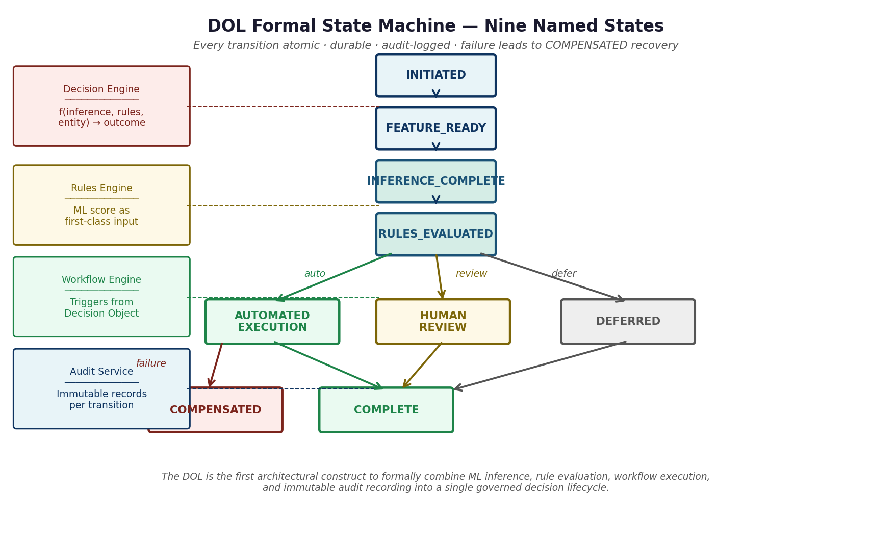
Figure 1. The DOL formal state machine. Every transition is atomic and durable. The COMPENSATED state enables recovery from partial execution failures without human intervention.

State | Entry condition | Exit transitions | Audit record produced
INITIATED | DCID assigned; event validated at ingestion | FEATURE_READY on successful feature computation | Event receipt, DCID assignment, schema validation result
FEATURE_READY | All feature values computed from unified registry | INFERENCE_COMPLETE on model output received | Feature snapshot with registry version at decision time
INFERENCE_COMPLETE | All model scores computed and associated with DCID | RULES_EVALUATED on rules engine completion | Model IDs, versions, scores, SHAP values
RULES_EVALUATED | All applicable policy rules evaluated | AUTOMATED_EXECUTION / HUMAN_REVIEW / DEFERRED | Rule IDs, outcomes per rule, conflict resolution applied
AUTOMATED_EXECUTION | Decision outcome confirmed; no human review required | COMPLETE on success; COMPENSATED on failure | Workflow steps, API calls, execution timestamps
HUMAN_REVIEW | Decision requires human judgment or regulatory threshold | COMPLETE on reviewer decision | Reviewer identity, review duration, decision, override rationale
DEFERRED | Decision requires additional context or time | COMPLETE on resolution | Deferral reason, expiry, resolution path
COMPLETE | All execution steps finished and recorded | Terminal state | SHA-256 integrity hash over all preceding sections
COMPENSATED | Failure during AUTOMATED_EXECUTION | Terminal state | Failure cause, compensating transactions executed, downstream system states restored
State Machine Invariants:
1. Every state transition is atomic and durable
2. Every transition produces an immutable audit record before completing
3. The DCID is present in every audit record under a single decision lifecycle
4. COMPENSATED is reachable only from AUTOMATED_EXECUTION
5. COMPLETE and COMPENSATED are terminal states
6. SHA-256 hash in COMPLETE is computed over all audit records from states 1 through 7
Figure 2. DOL state machine invariants. These properties are guaranteed by the architecture, not by operational discipline.
4. THE ANALYTICS ARCHITECTURE STACK
Layer | Analytics role | Decision intelligence role | Interface
Data and Knowledge Layer (L2) | Feature engineering, data persistence, knowledge graph | Unified feature registry ensures training-serving consistency | Feature values and knowledge context to L3
Intelligence Layer (L3) | Model inference, multi-model orchestration, drift detection | Produces inference scores as first-class decision inputs, not outputs | Inference scores to DOL Rules Engine as input variables
Decision Orchestration Layer (L4) | Integrates analytics outputs with policy and context | Produces governed decision with complete audit record | Decision Object to L5
Experience and Integration Layer (L5) | Distributes decision outputs to consumers | Decision Object as the interface artifact, not raw scores | REST, events, webhooks, dashboard
5. THE ANALYTICAL CASE FOR DECISION-CENTRIC DESIGN
Structural problem | Why analytics-centric design cannot solve it | How U-AEDIA solves it
AI outputs lack organizational context | Analytics systems produce statistically correct outputs. Whether those outputs are consistent with current organizational policies, prior decisions about this entity, and active regulatory constraints is outside the scope of an analytics system. | The Knowledge Graph in Layer 2 stores business rules, policies, and historical decisions. Every decision consults this context before execution.
No unified audit record | When analytics, ML inference, and workflow execution live in separate systems, producing a complete audit record requires correlating logs across all three -- a reconstruction exercise that is error-prone and time-consuming. | The DCID propagated from ingestion means every stage's outputs are associated with the same identifier. The Decision Object is the unified audit record.
Training-serving skew | When training and serving features are computed by separate codebases, silent divergence produces systematically biased model outputs. Analytics systems have no structural mechanism to prevent this. | The unified feature definition registry makes one computation function the single source of truth for both paths. Divergence is rejected at submission time.
Regulatory compliance requires pre-execution enforcement | Post-hoc monitoring discovers compliance violations after actions have executed. For irreversible actions in regulated environments, this is legally insufficient. | Rules Engine evaluation happens within the DOL before execution. Compliance is enforced before the action, not detected after.
6. PRIOR ART: ANALYTICAL POSITIONING

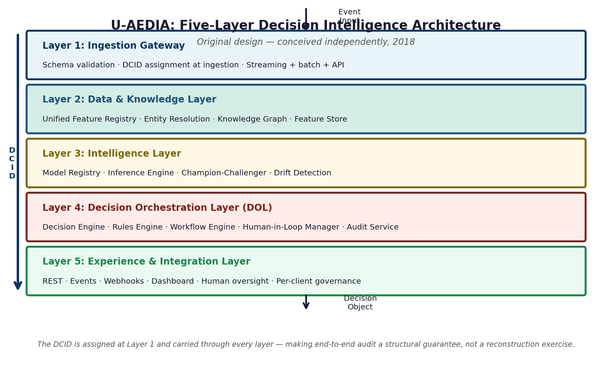
Figure 3. U-AEDIA is the decision intelligence layer that consumes outputs from data processing frameworks, model inference platforms, and policy systems, and produces governed Decision Objects.
7. GLOSSARY OF ORIGINAL TERMS
Term | Definition | First introduced
Decision Orchestration Layer (DOL) | Architectural control plane integrating ML inference, rule evaluation, workflow execution, human-in-loop management, and audit recording into a unified decision lifecycle governed by a deterministic state machine. | v1.0, March 2018
Decision Context ID (DCID) | Globally unique identifier assigned at event ingestion and propagated through all downstream components, enabling end-to-end traceability under a single identifier. | v1.0, March 2018
Decision Object | Canonical structured record produced upon decision completion, capturing the complete lifecycle from input context through executed action under the DCID. | v1.0, March 2018
Decision-Centric Paradigm | Architectural philosophy treating decision-making as a first-class system concern with explicit constructs, formal state machine governance, and unified audit infrastructure. | v1.0, March 2018
Domain Configuration Package (DCP) | Externalized, versioned configuration artifact parameterizing U-AEDIA for a specific decision domain, enabling cross-domain deployment without core re-implementation. | v1.0, March 2018
Training-Serving Consistency (architectural guarantee) | Feature Store pattern using a unified feature definition registry to make training-serving consistency a structural property, not a coordination discipline. | v1.0, March 2018

