**ASSIGNMENT 2**

**NAME : SRIJAN CHAKRABORTY**

**ROLL NUMBER : 39/CSE/17086/284**

**REG NO: 0000284**

**1. Create a table with the following attributes: employee**

**Column Name** **Type**

EMPNO Varchar 5

EMPNAME Varchar 10

Address Varchar 20

Dob(date of birth) Date

Doj(Date of join) Date

Salary Number 8

Step1: create database max;

Step2: use max;

Step3: create table employee(EMPNO VARCHAR(5), EMPNAME VARCHAR(10), ADDRESS VARCHAR(20), DOB DATE, DOJ DATE, SALARY INT(8), PRIMARY KEY(EMPNO));

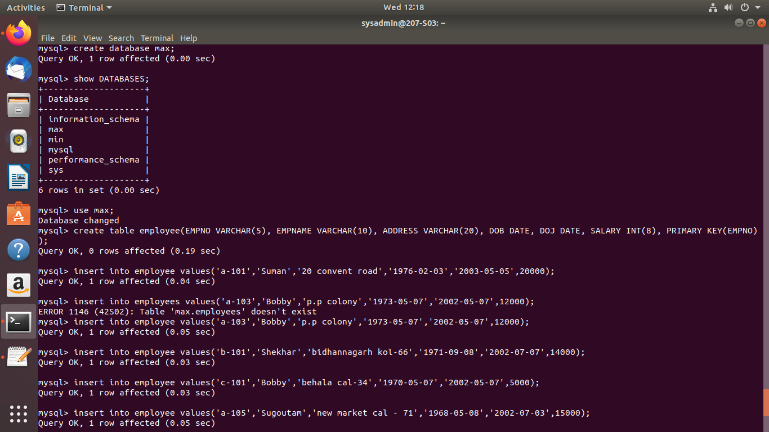

**2 Insert the following data in the table:**

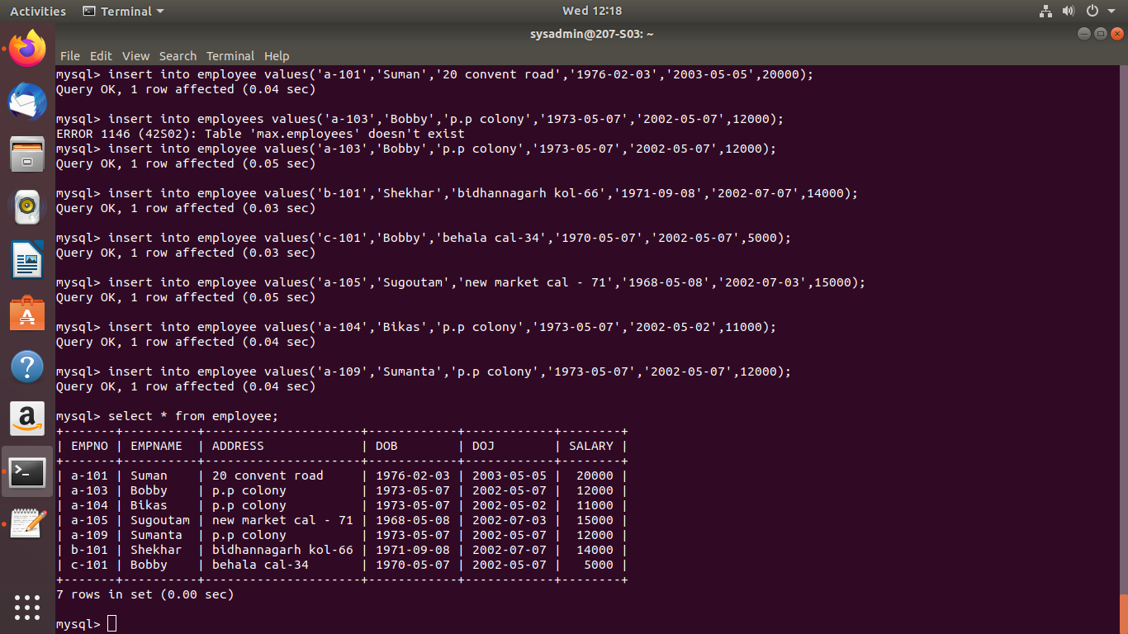query : insert into employee value(&empno,&empname,&address,&dpb,&doj,&salary);

**3. Write the Sql query to select all employee whose salary is greater than 12000.**

Query: select * from employee where salary > 12000;

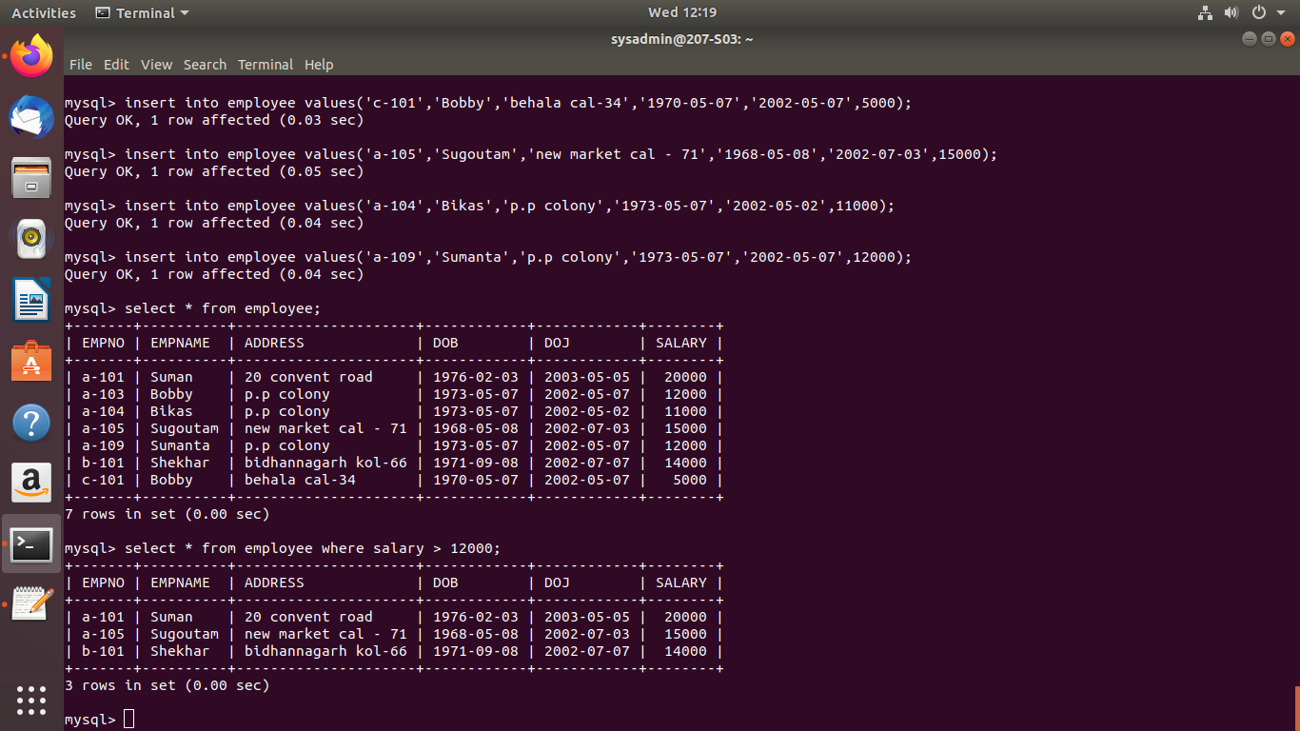

**4. Write sql query to see the all information of all employee.**

Query : select * from employee;

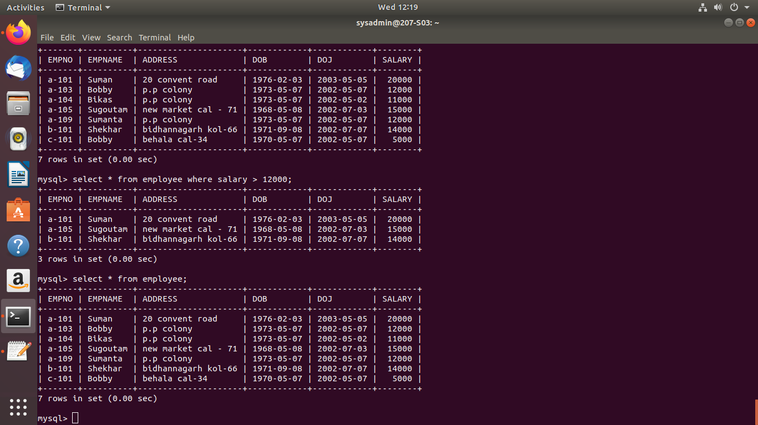

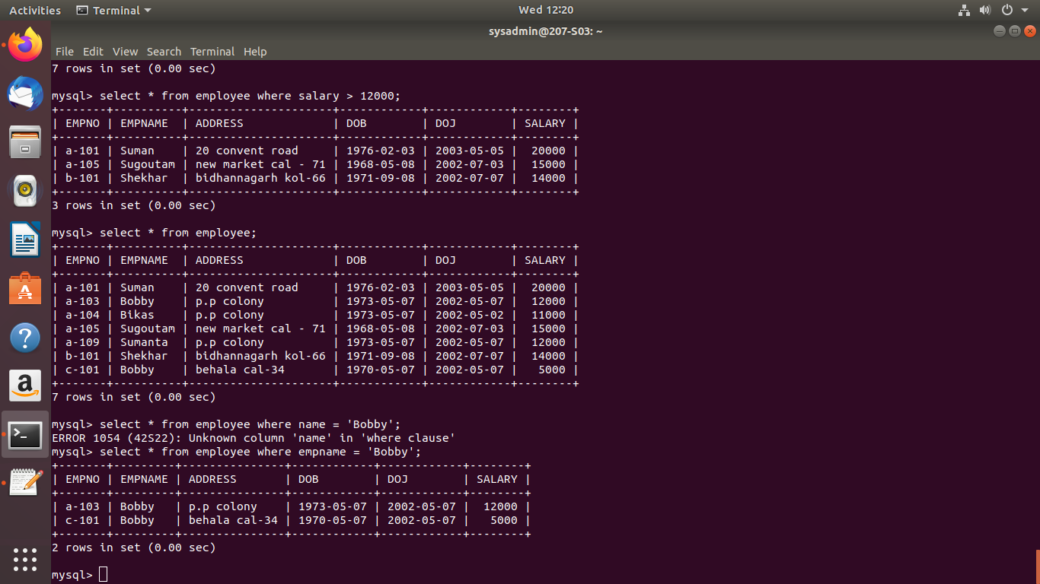**5. Write sql query to select all employee whose name is bobby.**

Query: select * from table where empname = ‘Bobby’;

**6. Write the sql query to change the salary of bikas to 15000.**

Query : update employee set salary = 15000 where empname = ‘Bikas’;

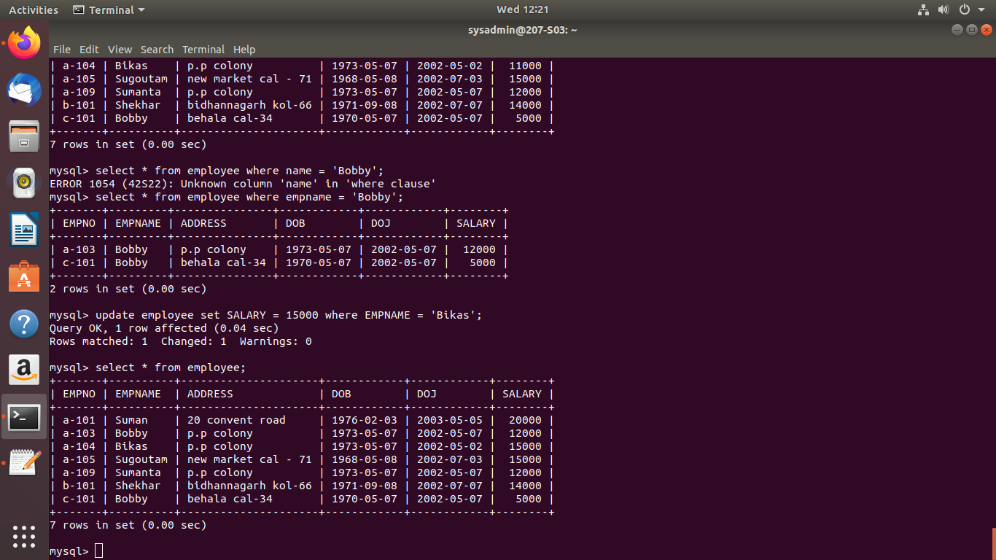

**7. Delete the record of the employee whose empno is a-109.**

Query: Delete from employee where empno = ‘a-109’;

