DBMS ASSIGNMENT 3

NAME : SRIJAN CHAKRABORTY

ROLL NUMBER: 39/CSE/17086/284

REG NO: 284

1)Add 5 rows in the employee and dept tables

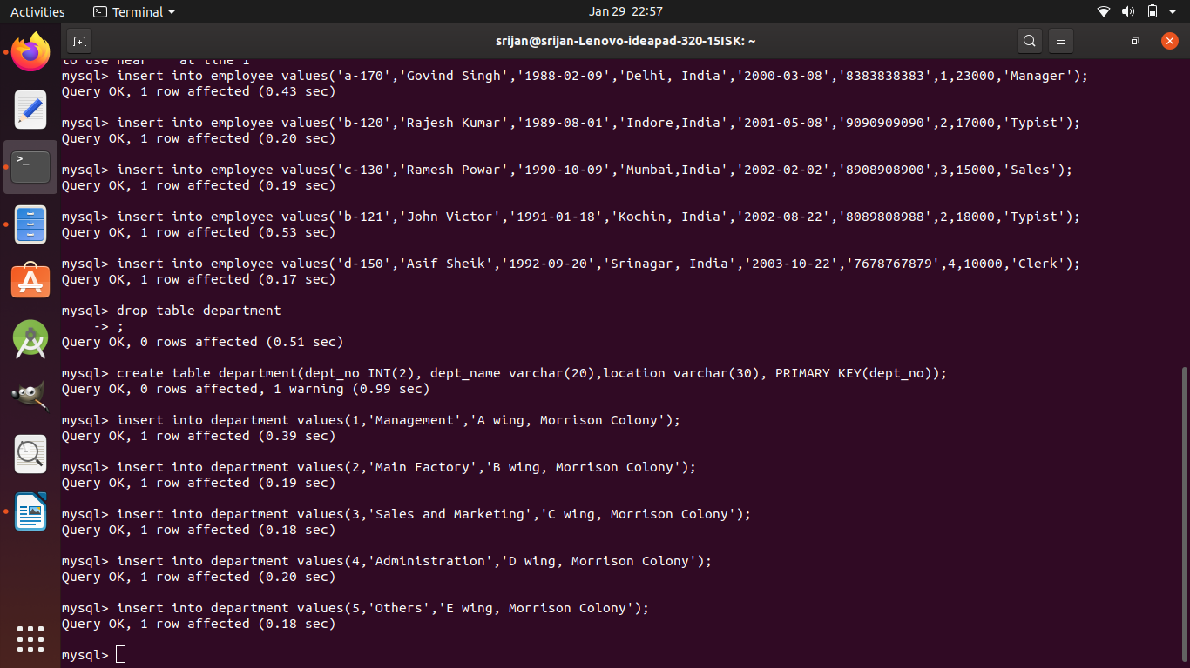

2) Display all the records from the above tables

select * from employee;

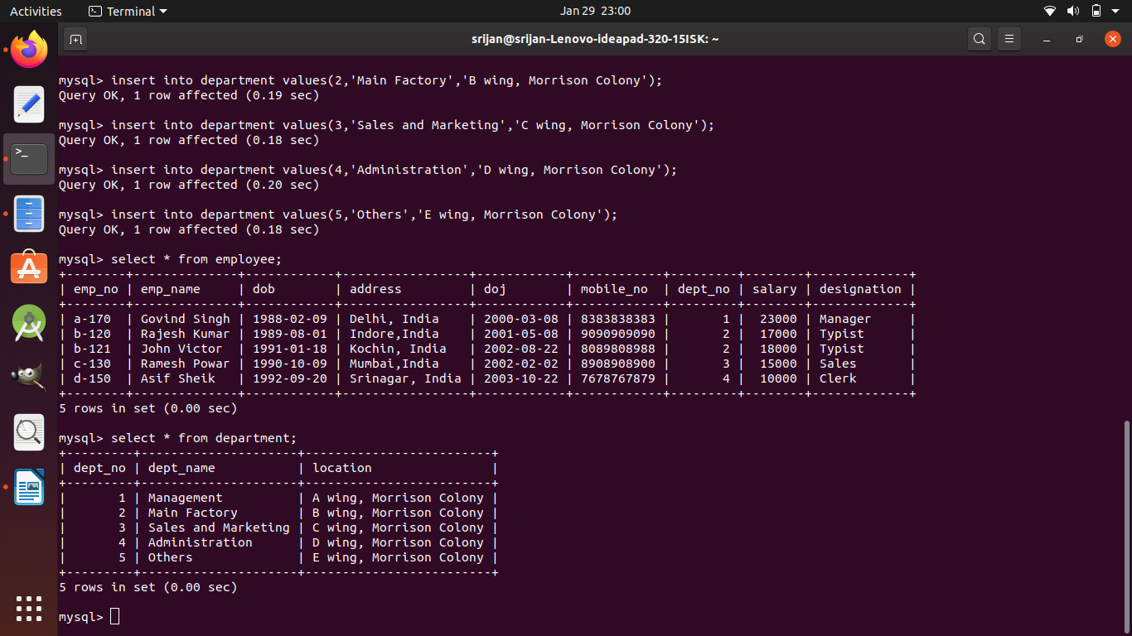

3) Display the empno and name of all the employee from department no2

select emp_no ,emp_name from employee where dept_no = 2;

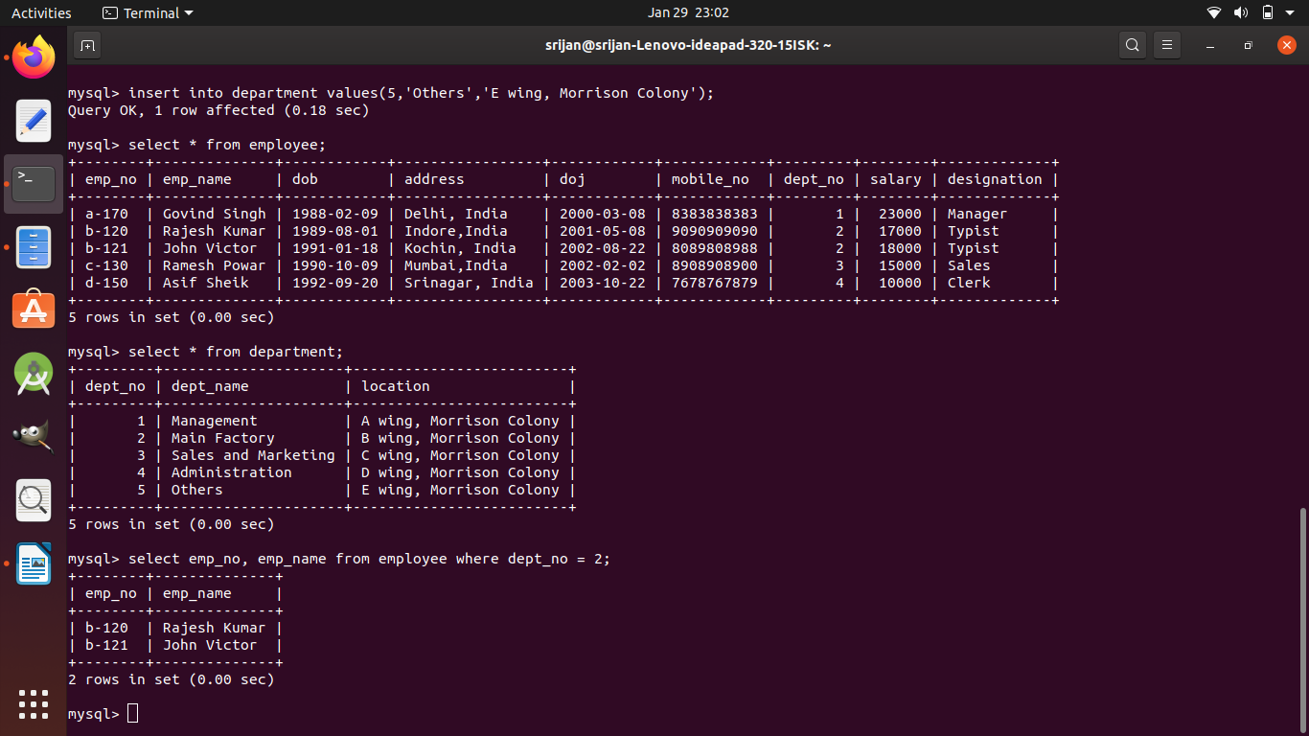

4) Display the empno, name, designation, dept_no and salary in the descending order of salary.

Select emp_no, emp_name,designation,dept_no,salary from employee order by salary desc;

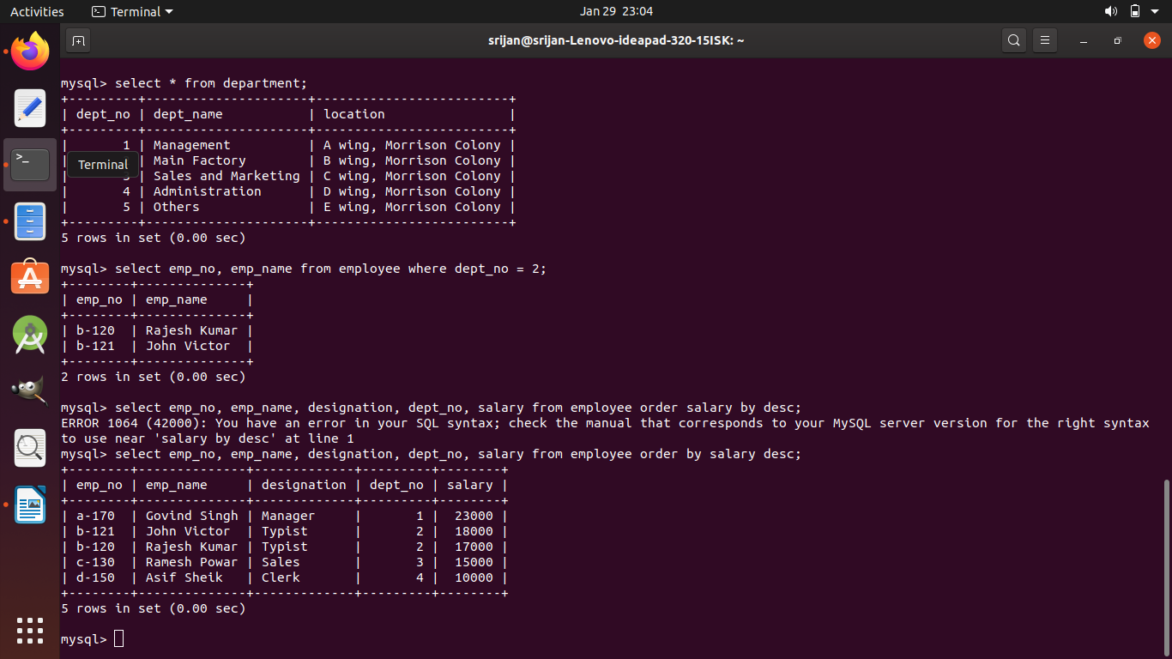

5) Display the emp_no and name of all employees whose salary is between is between 10000 and 15000.

select * from employee where salary >=10000 and salary <=15000

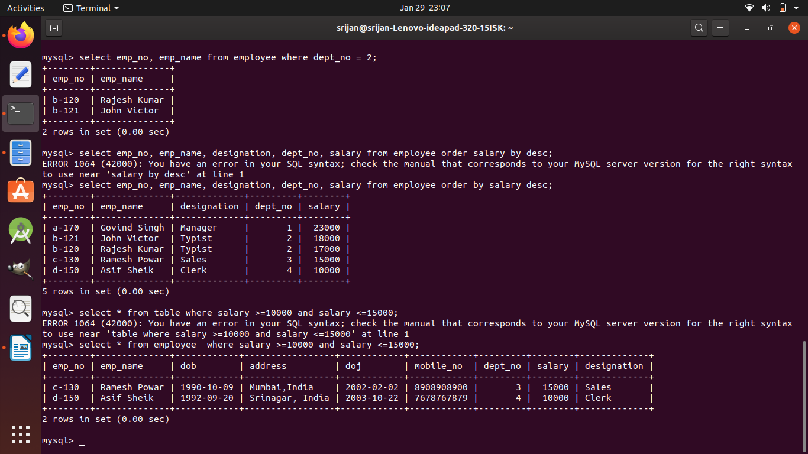

6) Display all the designations without duplicate values.

Select distinct designation from employee;

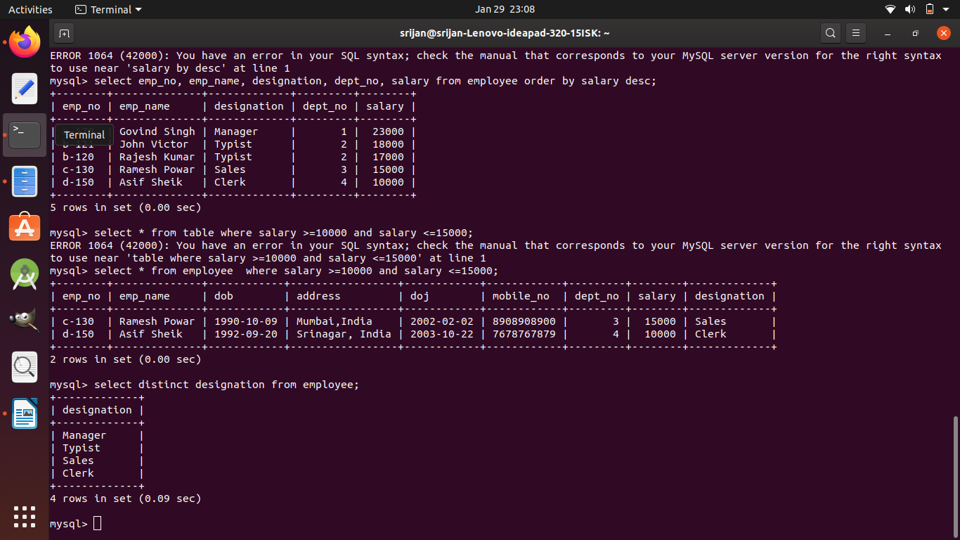

7)Display the dept name and total salary of employees of each department

create table temp select dept_no, sum(salary) as total from employee group by dept_no;

select department.dept_name,temp.total from department inner join temp on temp.dept_no = department.dept_no;

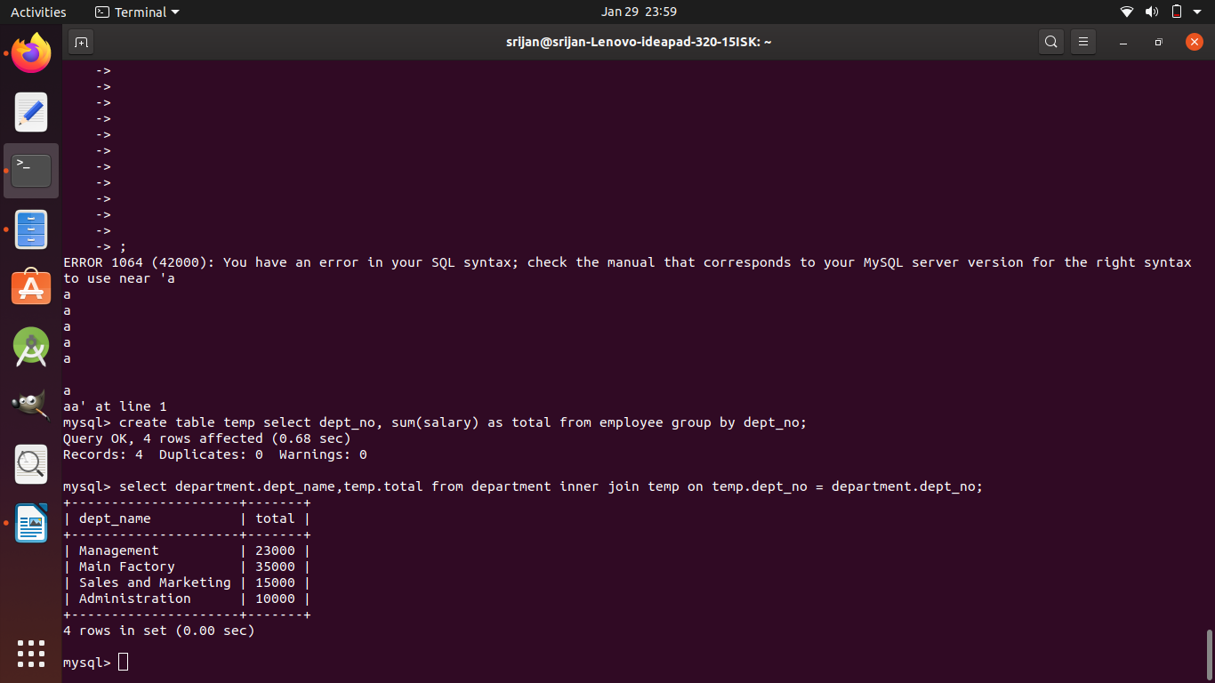

8)Change the salary of employees to 25000 whose designation is ‘Typist’

update employee set salary = 25000 where designation = 'Typist';

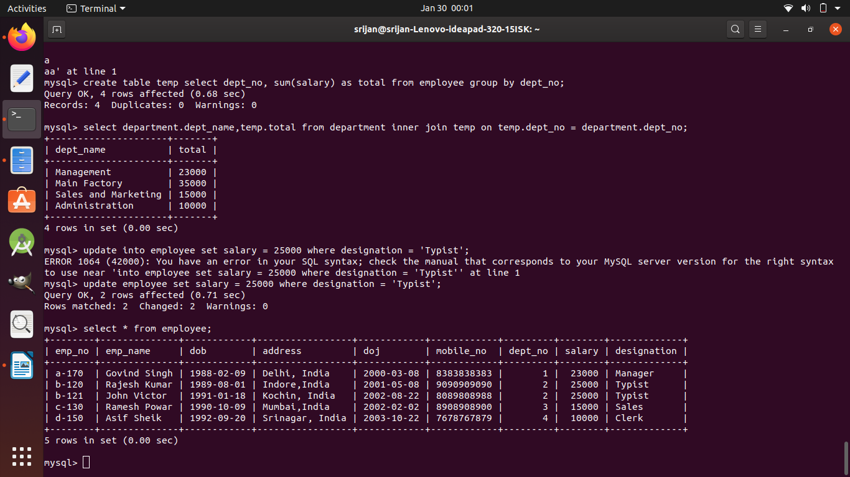

9) Change the mobile number of employee name ‘John Victor’

update employee set mobile_no = '8282827890' where emp_name = 'John Victor';

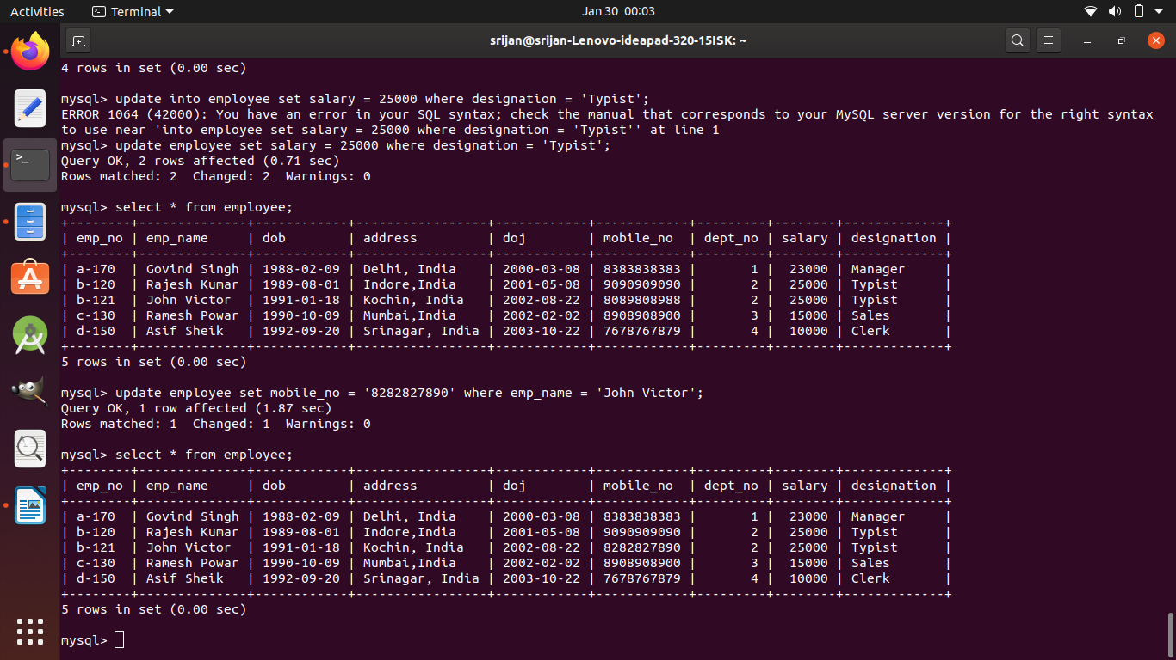

10) Delete all employees whose salaries are equal to 10000

delete from employee where salary = 10000;

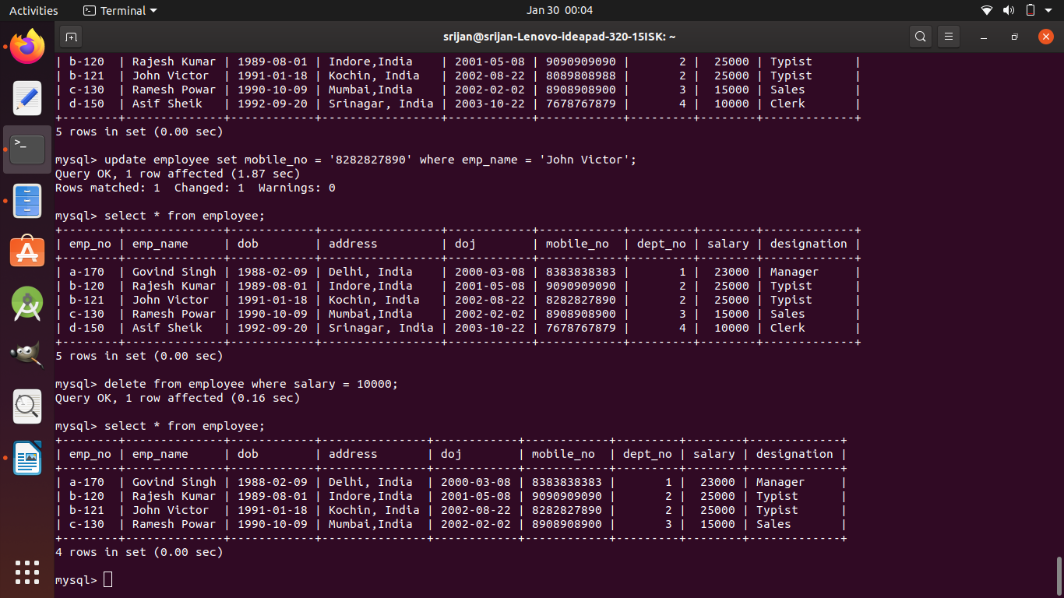

11) Select the department that has total salary paid for its employee more than 25000.

select department.dept_name, temp.total from department inner join temp on temp.dept_no =

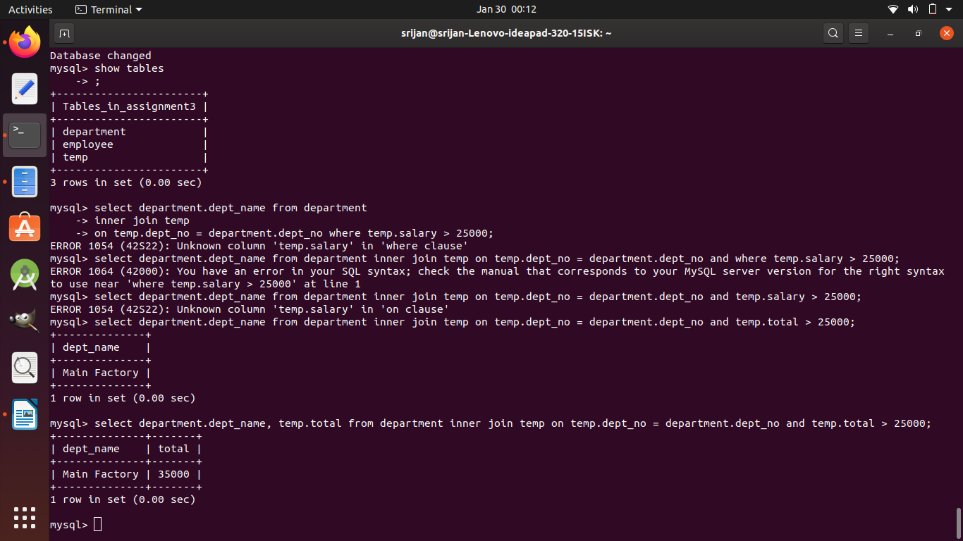 department.dept_no and temp.total > 25000;