

Development of a Web-Based Operations Management System with Purchasing, Inventory, Flower Processing, Sales, Event Catering, Distribution, and Business Analytics for Pullanans Fresh Flower Distributor

RESEARCHER
Bacasmot, Isaac James P. – 10
Buasa, John Micheal Nel C. – 01
Maandig, Medwin S. – 09
Olinan, Nathaniel G. – 10
Tulen, Alex John L. – 01

SEPTEMBER 2026

I. Title of the Study
Development of a Web-Based Operations Management System with Purchasing, Inventory, Flower Processing, Sales, Event Catering, Distribution, and Business Analytics for Pullanans Fresh Flower Distributor
II. Introduction
Information technology has become an important part of managing business operations. Businesses that handle products, customers, sales, inventory, and deliveries need an organized way to record information and monitor daily activities. A computerized system can help reduce manual work, improve the accuracy of records, and provide information that can help business owners make better decisions.
Pullanans Fresh Flower Distributor is a business that focuses on purchasing and distributing fresh flowers. The business acquires flowers from suppliers and prepares them by cutting, cleaning, arranging, and making them presentable before selling or distributing them. The business also adds its desired capital or markup to the cost of the flowers and other expenses when determining the selling price. Its products may be distributed to customers and resellers in different areas within the Philippines.
The business also handles shipments through different transportation methods such as buses, vessels, and airplanes. Because flowers are perishable products, proper inventory monitoring and timely processing and shipment are important. Delays, inaccurate inventory records, damaged flowers, or unrecorded wastage can affect the business’s operations and profitability.
Aside from flower distribution, Pullanans Fresh Flower Distributor may also accommodate event-related and catering requests that require flowers or flower arrangements. These may include events such as weddings, birthdays, corporate events, celebrations, and other special occasions. Managing these requests requires proper recording of event details, flower requirements, schedules, pricing, payments, and assigned staff.
When business information is handled mainly through manual records, separate files, messages, or spreadsheets, it can become difficult to monitor the complete process. Information may also become duplicated, outdated, or difficult to retrieve. Business owners may have limited visibility into sales performance, inventory movement, flower wastage, shipping activities, event orders, and other important information.
To address these concerns, the researchers propose the development of an Integrated Web-Based Flower Distribution and Event Catering Management System for Pullanans Fresh Flower Distributor. The proposed system will provide modules for supplier and purchasing management, inventory management, flower processing, product and pricing management, customer and reseller management, sales and order management, event catering management, shipping and logistics management, shipment tracking, payment monitoring, notifications, reports, and business analytics.
The system will also implement Role-Based Access Control (RBAC) so that users can only access the functions necessary for their assigned responsibilities. This can help protect business information and support the principle of least privilege.
Through the proposed system, Pullanans Fresh Flower Distributor can have a centralized platform for managing its operations and monitoring business performance. The system is intended to improve record accuracy, provide faster access to information, support shipment coordination, and provide useful analytics for business decision-making.
III. Statement of the Problem
Pullanans Fresh Flower Distributor handles various activities related to purchasing, processing, selling, distributing, and providing flowers for events. Managing these activities manually or through separate records can make it difficult to maintain accurate and updated information:
- How can the business improve the recording and monitoring of flower purchases and supplier information?
- How can the business efficiently monitor fresh flower inventory, processed flowers, available products, and wastage?
- How can the business manage customer, reseller, sales, and order information in a centralized system?
- How can the business efficiently manage event and catering requests, including event details, flower requirements, schedules, pricing, and payments?
- How can the business improve the coordination and monitoring of shipments through buses, vessels, and airplanes?
- How can the business monitor shipment status and provide customers with updated delivery information?
- How can the business generate reports and analytics related to sales, inventory, products, customers, events, shipments, and business performance?
- How can Role-Based Access Control be implemented to ensure that users only access information and functions appropriate to their responsibilities?
- How can the proposed system improve the overall efficiency, accuracy, and accessibility of the business’s operational records?
Thus, there is a need for a centralized and user-friendly web-based system that can improve purchasing, inventory management, flower processing, sales, event catering, distribution, and business analytics for Pullanans Fresh Flower Distributor.

IV. Objectives of the Study
General Objective:
To develop an integrated web-based management system for Pullanans Fresh Flower Distributor that will improve the management of purchasing, inventory, flower processing, sales, event catering, distribution, logistics, and business analytics.
Specific Objectives:
Specifically, the study aims:
1. Develop a supplier and purchasing management module for recording flower purchases and supplier information.
2. Develop an inventory management module for monitoring flowers, materials, products, stock movement, and wastage.
3. Develop a flower processing module for recording the preparation, cutting, cleaning, arranging, and availability of flowers.
4. Develop a product and pricing module for managing flower products, arrangements, costs, markup, and selling prices.
5. Develop a customer and reseller management module for maintaining customer information and order history.
6. Develop a sales and order management module for recording orders, payments, order status, and transaction information.
7. Develop an event catering management module for managing event schedules, venues, flower requirements, packages, costs, and assigned personnel.
8. Develop a shipping and logistics module for managing transportation through buses, vessels, and airplanes.
9. Develop a shipment tracking module for monitoring shipment status, tracking numbers, destinations, departure dates, and arrival information.
10. Develop a business analytics dashboard that provides information about sales, inventory, products, wastage, customers, events, shipments, and estimated profit.
11. Implement Role-Based Access Control to provide users with appropriate access based on their assigned roles.
12. Generate operational and management reports that can assist the business owner in making informed decisions.
V. Significance of the Study
The proposed system may benefit the following:
Business Owner - The system can provide the owner with a centralized view of business operations. Analytics and reports can help the owner monitor sales, inventory, expenses, shipments, events, and estimated profits.
Employees - Employees can access the information they need without manually searching through multiple records. This can help improve the efficiency of inventory, processing, sales, and shipping activities.
Sales Staff - The system can help sales personnel manage customers, orders, prices, payments, and transaction records.
Inventory Staff - Inventory personnel can monitor incoming flowers, available stock, processed quantities, damaged flowers, and wastage.
Logistics Staff - Logistics personnel can manage shipments, transportation methods, tracking numbers, destinations, and shipment statuses.
Event Staff - Personnel assigned to event-related activities can manage event details, flower requirements, schedules, packages, and assigned responsibilities.
Customers and Resellers - Customers and resellers can receive more organized order and shipment information and can monitor the status of their transactions.
Future Researchers - The study can serve as a reference for future researchers who plan to develop systems related to flower distribution, inventory management, logistics, event management, or business analytics.
VI. Scope and Delimitation
Scope:
The system will include:
- User and role management
- Supplier management
- Purchasing management
- Flower inventory management
- Flower processing management
- Product and bouquet management
- Pricing and markup management
- Customer and reseller management
- Sales and order management
- Payment monitoring
- Event and catering management
- Packaging management
- Shipping and logistics management
- Bus, vessel, and airplane shipment recording
- Shipment tracking
- Notifications
- Business analytics
- Reports
- Activity logs
- Role-Based Access Control
Delimitation:
- The system will not directly control the operations of bus companies, shipping companies, airlines, or other transportation providers. Shipment tracking will depend on the information entered or updated by authorized users.
- The system will not function as a transportation provider. It will only record and monitor shipment information.
- The system will also not automatically determine external transportation schedules unless the necessary information or integration is available.
- Real-time GPS tracking may be limited depending on the available technology, transportation provider, and implementation resources.
- Payment processing may be limited to recording and verifying payment information if direct payment gateway integration is not included in the final implementation.

VII. Methodology
The study will use a developmental research approach because the main purpose is to design, develop, test, and evaluate a web-based information system based on the operational requirements of Pullanans Fresh Flower Distributor.
The researchers will first identify the current business processes and problems. The gathered information will then be used as a basis for designing and developing the proposed system.
Planning - The researchers will identify the business requirements, users, problems, and expected system features.
Requirements Analysis - The researchers will gather information from the business through interviews, observation, and document analysis.
System Design -
The researchers will design:
- User interface
- Database
- System architecture
- Use case diagrams
- Data flow diagrams
- Entity relationship diagrams
- RBAC structure
Development - The system modules will be developed based on the approved requirements.
Testing -
The system will undergo:
- Unit testing
- Integration testing
- Functional testing
- Security testing
- User acceptance testing
Deployment - After testing and revisions, the system will be prepared for implementation and use by authorized personnel.
Evaluation - Users will evaluate the system based on functionality, usability, reliability, performance, security, and other applicable software quality criteria.

VIII. Review of Related Literature
Patriarca et al. (2020) examined inventory management for perishable products under uncertain demand. Their study presented an Economic Order Quantity (EOQ) inventory model that considered changing demand, product deterioration, product quality, and possible lost sales. The research emphasized the importance of maintaining appropriate inventory levels while managing the costs associated with unsold or deteriorating products.
Liew and Alduais (2022) proposed a web-based inventory and customer management system for an online retail bakery. Their study identified difficulties associated with manual inventory management, including human errors and challenges in predicting inventory requirements. The proposed system used web technologies and a database to automate repetitive management tasks. Although the study focused on a bakery, its findings are related to the management of products and materials that require regular stock monitoring.
De Carvalho et al. (2022) investigated blockchain-enabled supply chains and applied an optimization model to the fresh-cut flower industry. Their research examined how adopting technology can influence supply chain design, profitability, and prices. The study demonstrates the importance of information and coordination across the flower supply chain.
Malakar et al. (2023) reviewed recent post-harvest techniques for tropical cut flowers, with particular attention to their storage, handling, packaging, and transportation requirements. The authors discussed how flower characteristics and post-harvest conditions can affect flower quality and longevity. Their review highlights the importance of proper handling throughout the supply chain.
Utami et al. (2023) developed a web-based sales and inventory system for a stationery store. Their study addressed problems caused by incomplete sales records and unclear inventory movements, which made it difficult for the business to determine its stock availability and financial performance. The researchers developed an integrated system using the CodeIgniter framework and MySQL database.
Shah et al. (2023) developed a web-based Event Management System intended to provide a centralized platform for event planning. Their study described a system that allows event-related activities to be organized in one interface and tested the application from the perspectives of both client and administrator users.
Nurmiati and Cakrawali (2023) studied the design of a web-based catering ordering system for Katering Viona Bekasi. Their work described system functions related to ordering, product management, administrative activities, and report generation. Similarly, Rusli and Mohd Nawi (2022) presented the E-Budget Hira Catering System, which was developed to improve the booking and budgeting process by organizing information about available packages and generating reports. Although these studies focus on catering businesses, they provide related concepts for managing customer requests, package selection, event schedules, order costs, and preparation requirements.
Ragazou et al. (2023) reviewed research on business intelligence and its role in improving decision-making and competitiveness among small and medium-sized enterprises. Their study discussed how business intelligence can support organizations in using information to evaluate performance and make business decisions. The authors also considered the growing accessibility of integrated business intelligence solutions for smaller enterprises.
Reyna (2023) developed FlowerHub: An Online Flower Shop for local flower shops in Surigao City, Philippines. The study aimed to improve manual ordering processes by providing an online platform for flower shopping. Its described functions included inventory management and features intended to help flower shops improve their marketing reach.
Endrano et al. (2023) developed WeStack, a web-based ordering and inventory management system with sales forecasting for Everlife General Marketing. The system included online ordering, supplier management, production management, inventory monitoring, notifications, sales forecasting, and the generation of inventory, sales, and purchasing reports.
Mendoza et al. (2023) developed an Online Purchase Request Application System for Don Mariano Marcos Memorial State University South La Union Campus. The study aimed to improve the procurement process by providing a centralized platform for purchase requests, supplier information, purchase orders, and management records. It addressed delays and difficulties associated with manual procurement and report preparation. This study supports the purchasing module of the proposed system, particularly the recording of suppliers, purchase requests, order details, and received stock.
Panganiban (2023) developed a Sales and Inventory Management System with Sales Forecasting using Time Series Analysis at Manuel S. Enverga University Foundation. The study focused on monitoring product sales and inventory, maintaining user activity records, and forecasting future sales from historical data. It used time-series regression and moving-average techniques to examine forecasting accuracy.
Villanueva (2023) developed a computer store point-of-sale and inventory management system with RFID technology for Yannie Computer Store. The project included point-of-sale and inventory functions and addressed the need to manage transactions, stock levels, returns, and stock transfers. The study reported positive testing results regarding the system's operational effectiveness and technical performance.
Capuno et al. (2021) developed iReserve, an online event reservation system for Lipa City Cultural with SMS notifications. The study addressed scheduling conflicts associated with manual event reservations. Its web-based system allowed users to submit booking requests, check event schedules, and receive updates about reservation status. The system was evaluated using software quality criteria that included functionality, reliability, usability, efficiency, portability, and maintainability.
Baldonado et al. (2023) presented the Juan Kasal App, a web-based event planning and cost-estimation application. The study discussed how event planning can be affected by manual recordkeeping, communication difficulties, and inaccurate cost calculations. Its proposed application supported event customization and recorded details such as dates, locations, and equipment requirements.
IX. Expected Output
The expected output of this study is a Web-Based Operations Management System with Purchasing, Inventory, Flower Processing, Sales, Event Catering, Distribution, and Business Analytics for Pullanans Fresh Flower Distributor, developed using the Modified Waterfall approach. The system is expected to provide a centralized platform for managing the business's purchasing activities, supplier information, inventory records, flower processing, sales transactions, event orders, and distribution operations. It will support the recording of purchased flowers and supplies, monitoring of stock levels, tracking of damaged or spoiled flowers, and updating of inventory records to help maintain accurate and organized information.
The system is also expected to include a flower processing module for recording flower arrangements, materials used, and prepared products. The sales module will allow authorized personnel to record customer orders, quantities, prices, and transaction details. Once a sales order is finalized, the corresponding flower or product quantities will be deducted from the available inventory. The event catering module will support the recording of event bookings, customer requirements, flower arrangement requests, event schedules, and preparation details to help personnel organize orders and prepare the required materials.
Furthermore, the system will include distribution management features for recording delivery schedules, assigning delivery personnel, monitoring delivery status, and maintaining distribution records. A role-based access control feature will provide authorized users with access to the functions relevant to their responsibilities. The system will also provide a centralized dashboard displaying important operational information, including purchasing activities, available inventory, sales performance, upcoming events, and distribution progress.
Finally, the system is expected to generate purchasing, inventory, flower processing, sales, event catering, distribution, and business analytics reports to help management review business activities and make informed operational decisions. The completed system will be tested and evaluated in terms of functionality, usability, and efficiency to determine its effectiveness in addressing the identified operational and information management needs of Pullanans Fresh Flower Distributor.

X. References
Baldonado, J. C., Frivaldo, A. B., Macabata, M. T., & Centeno, C. J. (2023). Juan Kasal App: Web based application for event planning and cost estimation with linear regression. World Journal of Advanced Research and Reviews, 20(2), 1349–1362. https://doi.org/10.30574/wjarr.2023.20.2.2416
Capuno, M., Benigno, J., Reyes, R., & Tojino, K. C. M. (2021). iReserve: An online event reservation for Lipa City Cultural with SMS notification. JPAIR Multidisciplinary Research, 43(1), 146–165. https://doi.org/10.7719/jpair.v43i1.736
de Carvalho, P. R. V., Naoum-Sawaya, J., & Elhedhli, S. (2022). Blockchain-enabled supply chains: An application in fresh-cut flowers. Applied Mathematical Modelling, 110, 841–858. https://doi.org/10.1016/j.apm.2022.06.011
Endrano, M. L. L., Moleño, J. B., Mungcal, M. A. M., Rosauro, P. K. G., & Suarez, M. A. (2023). WeStack: A web-based ordering and inventory management system with sales forecasting using moving average and exponential smoothing algorithm for Everlife General Marketing. Mabalacat City College. https://mcc.edu.ph/downloads/view/academic-research/63
Liew, C. C., & Alduais, N. (2022). Development web-based inventory and customer management system for retail bakery online. Applied Information Technology and Computer Science, 3(2), 460–478. https://periodical.uthm.edu.my/index.php/aitcs/article/view/7643
Malakar, M., Paiva, P. D. O., Beruto, M., & Cunha Neto, A. R. (2023). Review of recent advances in post-harvest techniques for tropical cut flowers and future prospects: Heliconia as a case-study. Frontiers in Plant Science, 14, Article 1221346. https://doi.org/10.3389/fpls.2023.1221346
Mendoza, C. I., Algas, E. M., Ablaya, G. V., Carrera, M. E., & Halog, P. G. (2023). Online purchase request application system for Don Mariano Marcos Memorial State University South La Union Campus [Undergraduate thesis, Don Mariano Marcos Memorial State University]. https://lakasa.dmmmsu.edu.ph/handle/123456789/481
Nurmiati, S., & Cakrawali, H. (2023). Perancangan sistem pemesanan katering berbasis web pada Katering Viona Bekasii. Jurnal Rekayasa Informasi, 12(1), 41–47. https://journal.istn.ac.id/index.php/rekayasainformasi/article/view/1556
Panganiban, D. A. S. O. (2023). Design and development of sales and inventory management system with sales forecasting using time series analysis [Master's research, Manuel S. Enverga University Foundation]. https://portal.mseuf.edu.ph/research/index.php/search/details/1727
Patriarca, R., Di Gravio, G., Costantino, F., & Tronci, M. (2020). EOQ inventory model for perishable products under uncertainty. Production Engineering, 14, 601–612. https://doi.org/10.1007/s11740-020-00986-5
Ragazou, K., Passas, I., Garefalakis, A., & Zopounidis, C. (2023). Business intelligence model empowering SMEs to make better decisions and enhance their competitive advantage. Discover Analytics, 1, Article 2. https://doi.org/10.1007/s44257-022-00002-3
Reyna, A. C. (2023). FlowerHub: An online flower shop. International Journal of Advanced Research in Science, Communication and Technology, 3(2), 569–576. https://doi.org/10.48175/IJARSCT-12180
Rusli, N., & Mohd Nawi, N. (2022). E-Budget Hira Catering System. Applied Information Technology and Computer Science, 3(1), 1167–1185. https://periodical.uthm.edu.my/index.php/aitcs/article/view/2431
Shah, D. A., Vasudavan, H., & Razali, N. F. (2023). Event Management Systems (EMS). Journal of Applied Technology and Innovation, 7(2). https://doi.org/10.65136/jati.v7i1.122
Utami, C. C., Desanti, R. I., & Halim, F. A. (2023). The development of web-based sales and inventory system for a stationary store. Ultima InfoSys: Jurnal Ilmu Sistem Informasi, 14(2), 52–57. https://doi.org/10.31937/si.v14i2.3358
Villanueva, W. J. O. (2023). CS: Computer store point of sale and inventory management system with RFID technology using Flutter framework [Capstone/special project, University of the Philippines Open University]. https://hdl.handle.net/20.500.13073/1574

XI Appendices
Appendix A – Consolidated Data

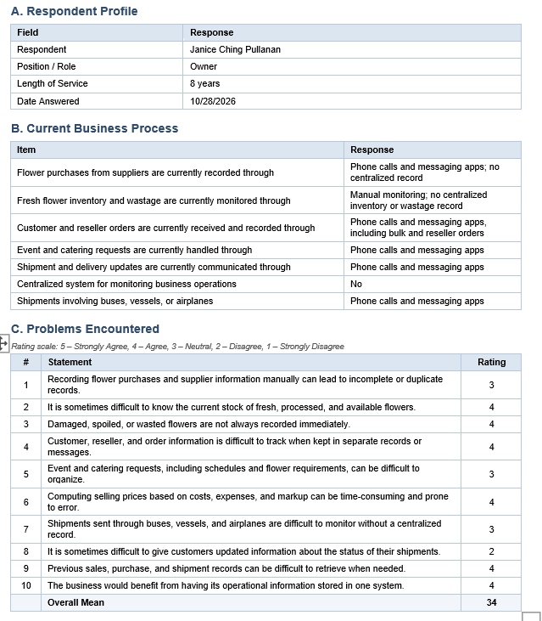

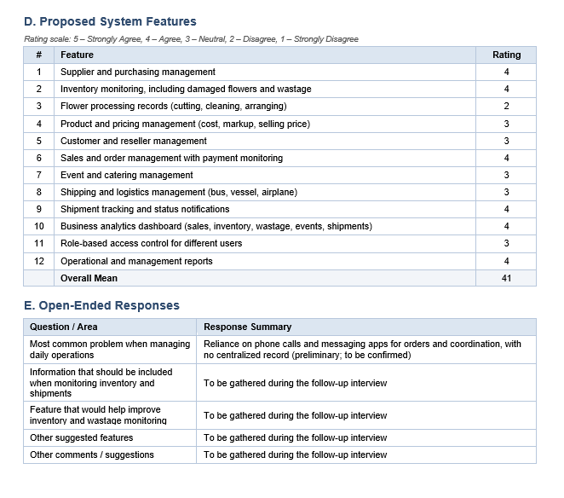

Appendix B – Use Case Diagram

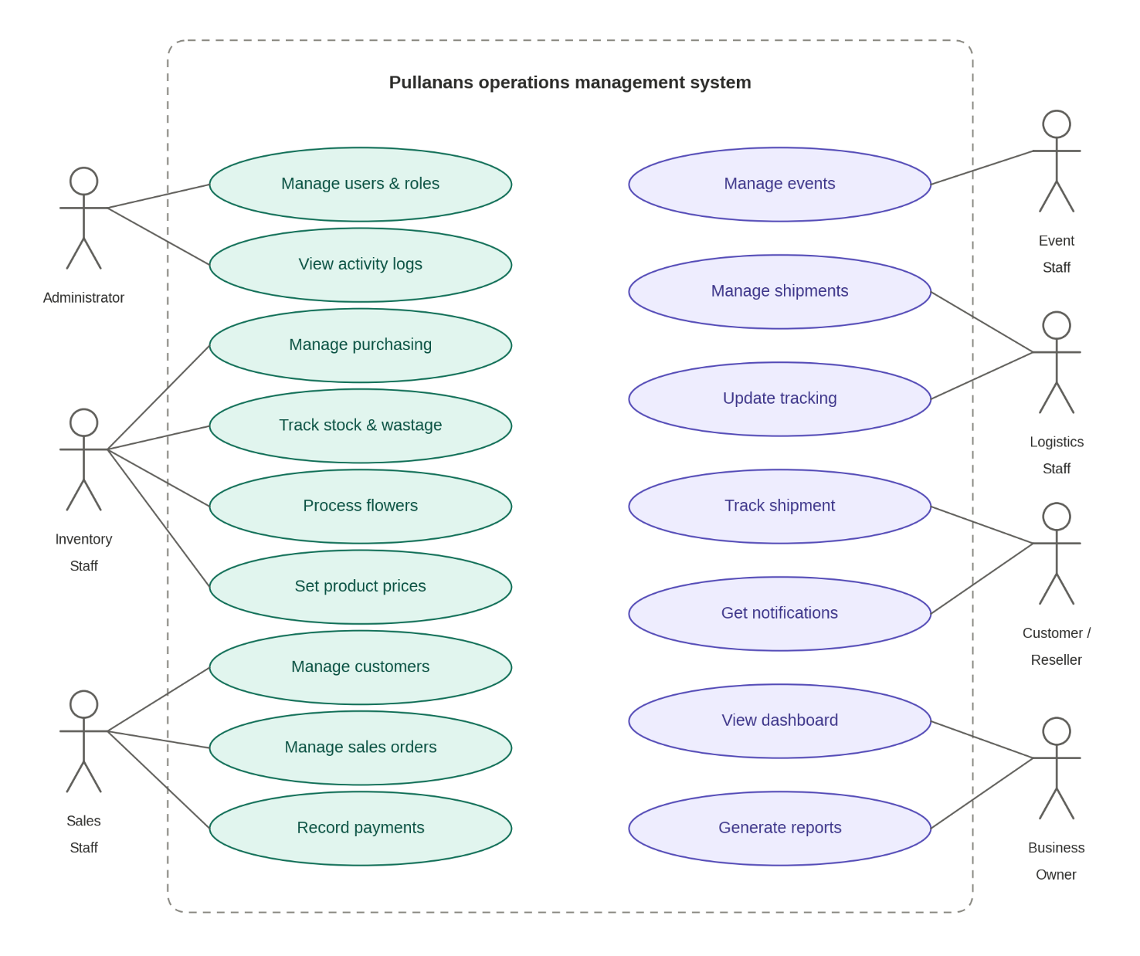

Appendix C – Entity-Relationship Diagram (ERD)

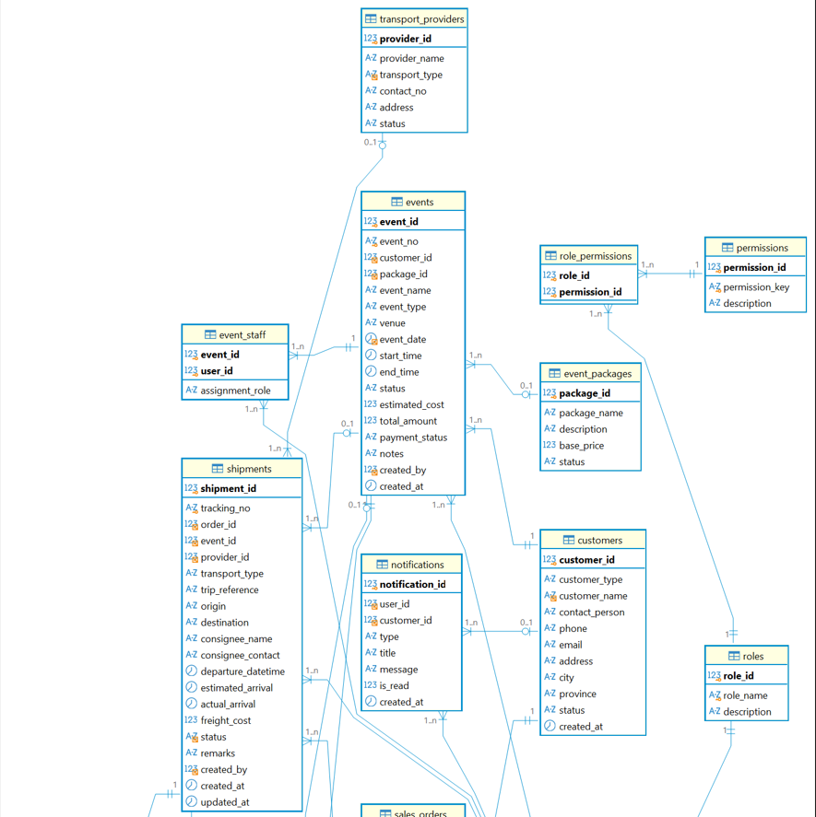

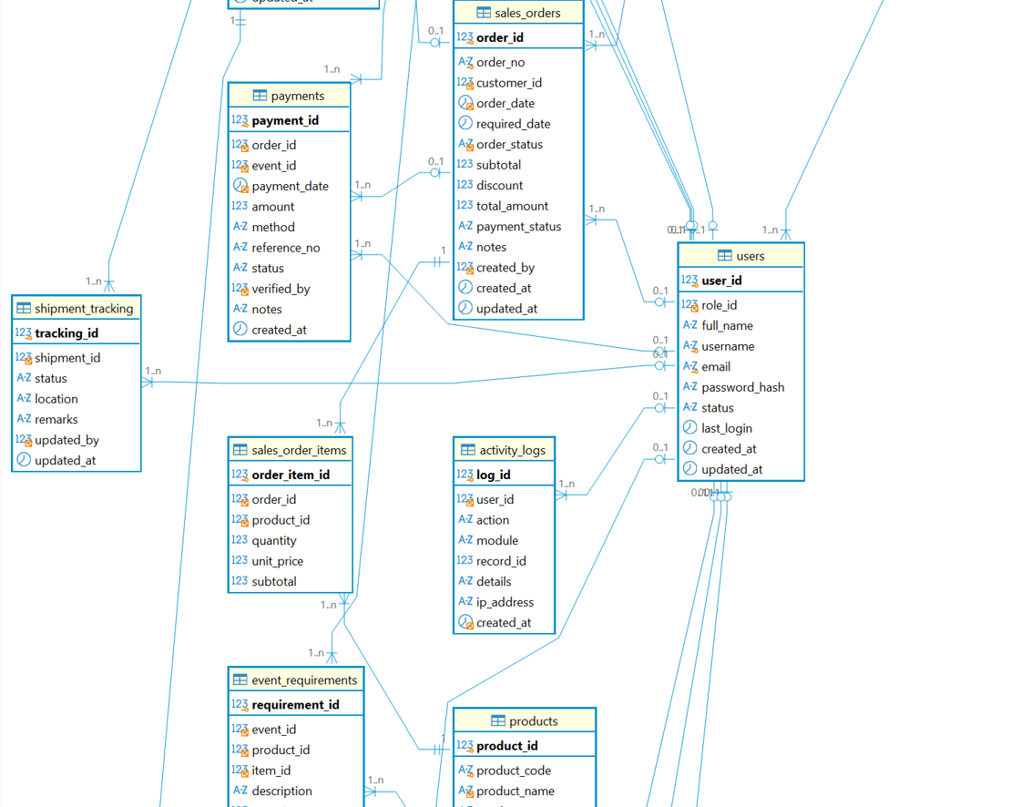

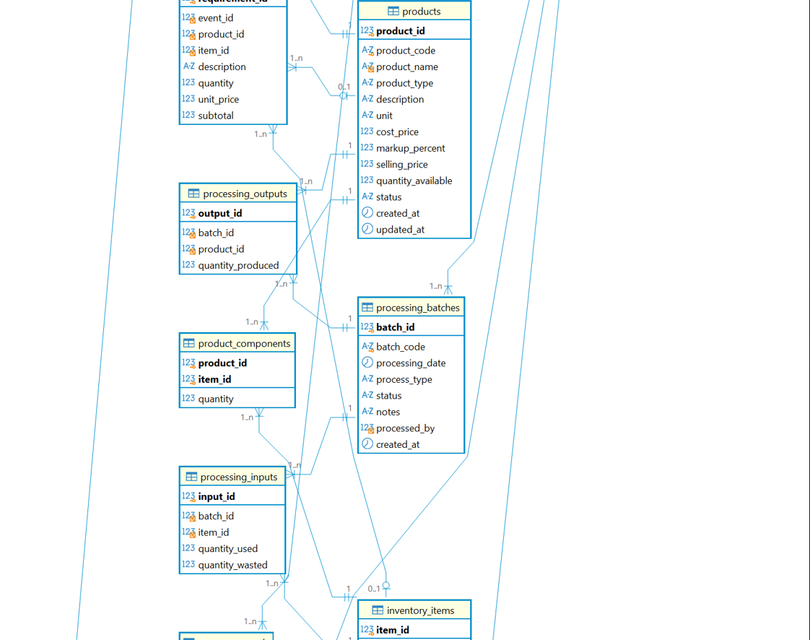

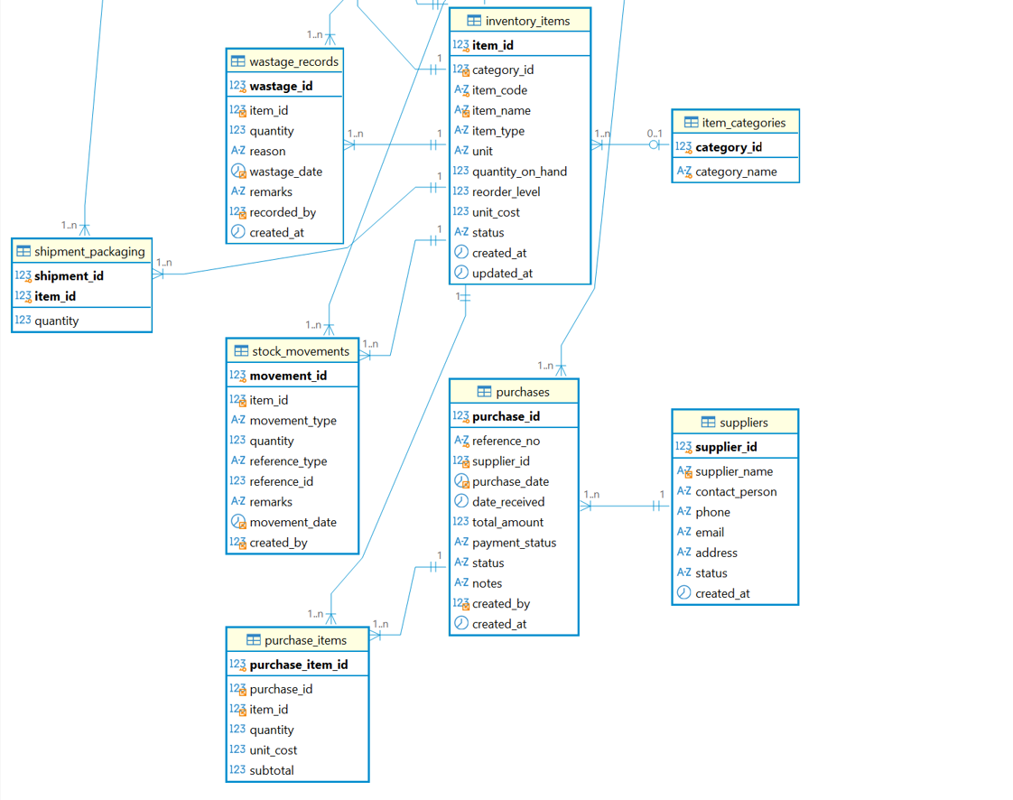

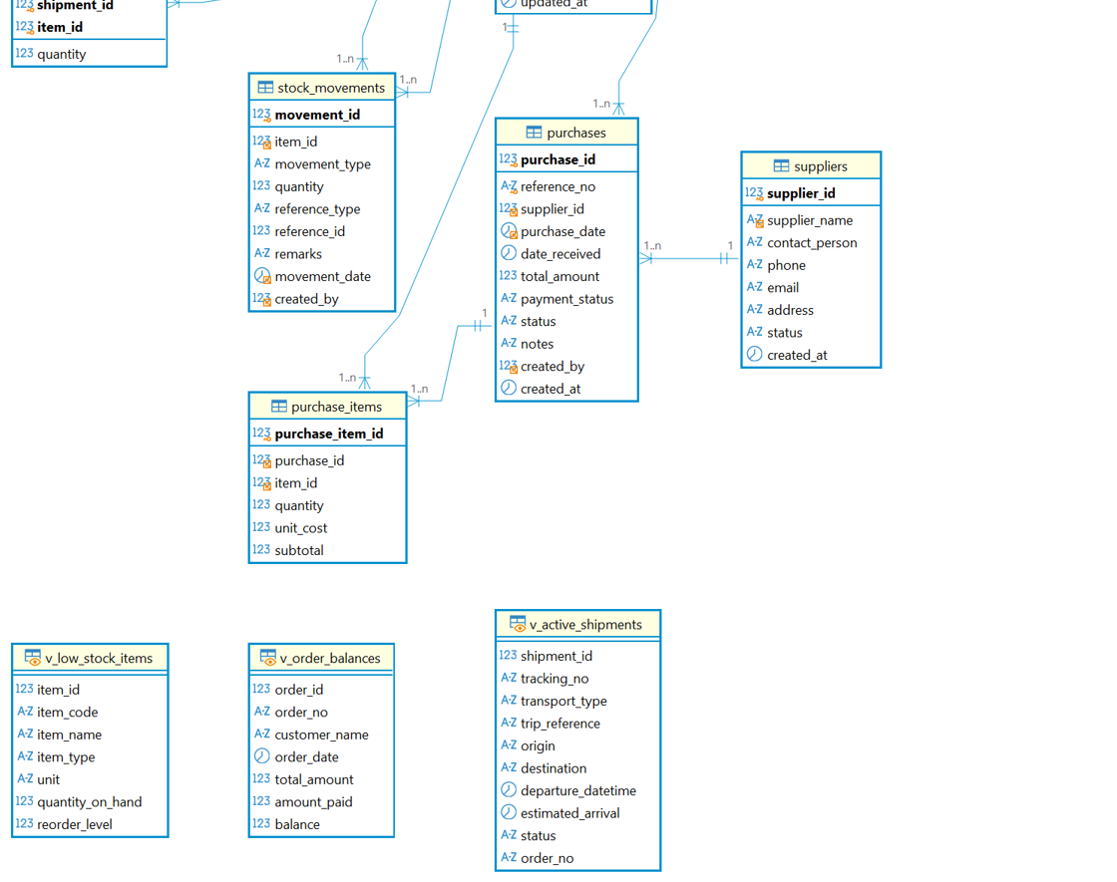

Appendix D – System Architecture

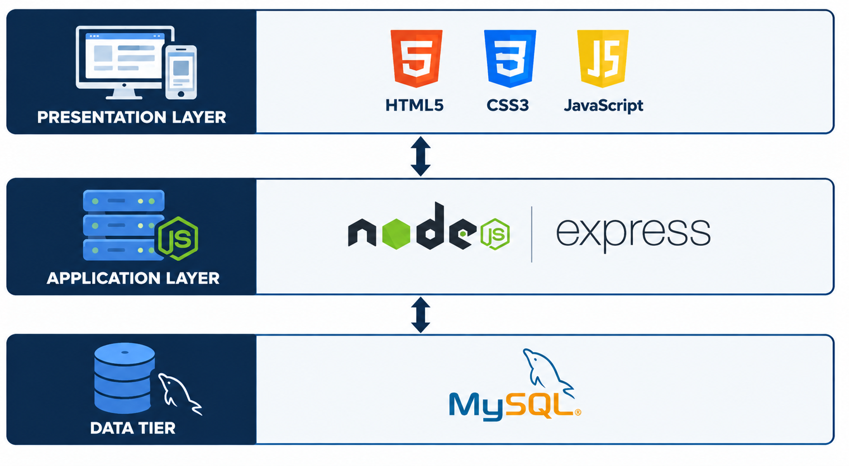

The 3-tier architecture was implemented to demonstrate the presentation logic layer that handles the user interface, communicates the delivery progress to the users via desktops and mobile devices by using HTML, CSS, and JavaScript, the application layer that handles scheduling, assigning truck and drivers to deliveries, tracking and recording the status of delivery, communicating with internal staff and notifying them, recording the shipment or vessel details, taking proof of delivery, and generating reports by using Node.js with Express, and the database layer that stores and retrieves the information using MySQL to ensure there is a separation of concerns in the system

Appendix E – Figma UI/UX Prototype

Appendix F – Testing Instruments (for later phases)

