Delete this text, then Insert > Pictures to add the DMU logo

Debre Markos University
Department of Software Engineering
Software Requirements Specification
Human Resource and Payroll Management System

Fifth-Year Graduation Project | Django REST API and React JS
Group members
No. | Full name | ID number
1 | [Student name 1] | [ID]
2 | [Student name 2] | [ID]
3 | [Student name 3] | [ID]
4 | [Student name 4] | [ID]

Document item | Value
Version | 1.0 (draft for advisor review)
Date | 13 October 2026
Advisor | [Advisor name]
Status | Draft

Revision history
Version | Date | Author | Description
0.1 | [date] | [name] | Initial outline
1.0 | 13 Oct 2026 | [name] | Complete draft for review

Table of contents
1. Introduction 4
1.1 Purpose 4
1.2 Scope 4
1.3 Definitions, acronyms and abbreviations 4
1.4 References 4
1.5 Document overview 5
2. Overall Description 6
2.1 Product perspective 6
2.2 Product functions 6
2.3 User classes and characteristics 6
2.4 Operating environment 6
2.5 Design and implementation constraints 6
2.6 Assumptions and dependencies 7
2.7 User documentation 7
3. Functional Requirements 8
3.1 Authentication and account management 8
3.2 Roles and permissions (RBAC) 8
3.3 Organization management 9
3.4 Employee management 9
3.5 Attendance management 10
3.6 Leave management 10
3.7 Payroll management 11
3.8 Notifications 12
3.9 Dashboards and reports 12
3.10 Audit log 12
4. External Interface Requirements 13
4.1 User interfaces 13
4.2 Hardware interfaces 14
4.3 Software interfaces 14
4.4 Communication interfaces 14
5. Non-Functional Requirements 15
6. Business Rules for Ethiopian Payroll 16
7. Use Cases 17
7.1 Use case list 17
7.2 Detailed use cases 18
8. System Models 20
8.1 System architecture 20
8.2 Payroll workflow 21
8.3 Entity relationship diagram 22
8.4 Data dictionary 23
9. Traceability and Acceptance 24
9.1 Requirements traceability matrix 24
9.2 Acceptance test scenarios 24
Appendix A. User Interface Prototype 25
Appendix B. Future Enhancements 34
Appendix C. Open Issues and Items to Verify 34

If the table above is empty or shows old page numbers, right-click it in Word and choose Update Field, then Update entire table.

1. Introduction

1.1 Purpose
This Software Requirements Specification (SRS) describes the requirements of the Human Resource and Payroll Management System (HRPMS). It is written for the project team, the project advisor, the examiners and the future users of the system. It states what the system must do and under which constraints, so that design, implementation and testing can follow one agreed document. The structure follows IEEE 830 and ISO/IEC/IEEE 29148 practice.

1.2 Scope
HRPMS is a web-based system that helps Ethiopian organizations manage employees and pay them correctly. It covers employee records, organization structure, attendance, leave management with an approval workflow, monthly payroll with Ethiopian income tax and pension rules, payslips, notifications, reports and an audit log. Access is controlled by four roles: Admin, Sub Admin, Manager and Employee.
In scope: user and role management, employee management, attendance, leave, payroll, payslips, dashboards, reports, audit log, English and Amharic interface.
Out of scope (first release): direct bank integration, biometric devices, mobile application, recruitment and performance appraisal modules, and e-filing of tax returns.

1.3 Definitions, acronyms and abbreviations
Term | Meaning
HRPMS | Human Resource and Payroll Management System (this product)
Admin | Super administrator with full control of the system
Sub Admin | HR or payroll officer whose permissions are delegated by the Admin
Manager | Department head or team lead who manages direct reports
RBAC | Role-Based Access Control
JWT | JSON Web Token used for authentication
API / REST | Application Programming Interface / Representational State Transfer
PAYE | Pay As You Earn: income tax withheld from salary by the employer
Pension | Employee 7% and employer 11% social security contribution (default rates)
TIN | Taxpayer Identification Number
ETB | Ethiopian Birr, the currency used by the system
Payroll run | The calculation and approval of salaries for one month
Payslip | Document that shows earnings, deductions and net pay of one employee for one month
SRS | Software Requirements Specification

1.4 References
- IEEE 830-1998 and ISO/IEC/IEEE 29148:2018, Software requirements specification practice.
- Labour Proclamation No. 1156/2019 (Federal Democratic Republic of Ethiopia): working hours, overtime and leave.
- Income Tax Proclamation No. 979/2016 and its amendments, including the 2025 amendment of employment income tax rates.
- Private Organization Employees' Pension Proclamation No. 715/2011 and amendments: pension contributions.
- Django, Django REST Framework, React and PostgreSQL official documentation.
- Note: legal rates in this document are defaults and must be checked against the current law and the Ministry of Revenues before deployment.

1.5 Document overview
Section 2 gives an overall description of the product and its users. Section 3 lists the functional requirements by module. Section 4 describes external interfaces and the UI prototype. Section 5 defines non-functional requirements. Section 6 states the business rules for Ethiopian payroll. Section 7 contains use cases. Section 8 presents system models and the data dictionary. Section 9 gives traceability and acceptance tests. Appendix A shows the user interface prototype screens.

2. Overall Description

2.1 Product perspective
HRPMS is a new, self-contained web system. A React single-page application runs in the user's browser and communicates over HTTPS with a Django REST API. The API applies authentication, role checks and business rules, and stores data in a PostgreSQL database. Documents and payslip PDF files are stored in file storage. The complete architecture is shown in Figure 4 (Section 8).

2.2 Product functions
- User, role and permission management (Admin, Sub Admin, Manager, Employee)
- Organization management: departments, positions, holidays
- Employee records, contracts, documents and salary history
- Attendance with check-in, check-out, lateness and overtime
- Leave management with Manager approval and HR confirmation
- Payroll with Ethiopian income tax, pension, overtime, allowances and deductions
- Payslip generation, bank transfer list and payroll reports
- Notifications, dashboards and reports with PDF and Excel export
- Audit log of all important actions

2.3 User classes and characteristics
User class | Description | Access level | Technical skill
Admin | Owner or senior manager of the HR function. Controls users, rules and final approvals. | Full access to all modules, settings, tax rules, audit log | Medium
Sub Admin | HR officer or payroll officer who does daily work. Permissions are set by Admin per module. | Employees, attendance, leave confirmation, payroll preparation (as delegated) | Medium
Manager | Department head or team lead. | Own team: attendance, leave approval, overtime approval, team reports | Low to medium
Employee | Any staff member. | Own profile, attendance, leave, payslips, notifications | Low

2.4 Operating environment
- Server: Linux (Ubuntu) or Windows with Python 3.11+, Django 5, PostgreSQL 14+; Docker deployment recommended.
- Client: current versions of Chrome, Edge and Firefox on desktop; responsive layout for tablets and phones.
- Network: works over a normal internet connection (4 Mbps or better) and over an organization intranet.

2.5 Design and implementation constraints
- Backend must use Python and Django with Django REST Framework; frontend must use React JS.
- Authorization must be enforced on the server for every request.
- Tax, pension and overtime rates must not be hard-coded; they are stored in editable tables.
- The system must keep an audit trail and use database transactions for payroll and leave operations.
- The project must be completed within the academic year by a team of four students.

2.6 Assumptions and dependencies
- Organizations provide correct employee and salary data at the start.
- Users have internet access and a modern browser.
- Legal rates are valid at the time of use; Admin updates them when the law changes.
- Email delivery depends on an external SMTP service.

2.7 User documentation
The project delivers a user manual per role, an administrator guide (installation, backup, configuration of rules) and online API documentation generated from the OpenAPI schema.

3. Functional Requirements
Priority levels: High = required for the first release; Medium = important and planned; Low = desirable. Each requirement has a unique ID used in the traceability matrix (Section 9).

3.1 Authentication and account management
ID | Requirement | Priority | Actor
FR-AUTH-01 | The system shall let users log in with email and password. | High | All users
FR-AUTH-02 | The system shall issue a short-lived access token and a refresh token (JWT) after a successful login. | High | All users
FR-AUTH-03 | The system shall lock an account for 15 minutes after 5 consecutive failed login attempts. | High | All users
FR-AUTH-04 | The system shall force a password change at the first login with a temporary password. | High | All users
FR-AUTH-05 | Users shall be able to change their password by entering the current password. | Medium | All users
FR-AUTH-06 | Users shall be able to request a password reset link by email; the link shall expire after 1 hour. | Medium | All users
FR-AUTH-07 | The system shall invalidate the refresh token on logout and end sessions inactive for 30 minutes (configurable). | High | All users
FR-AUTH-08 | Passwords shall be stored hashed and shall have at least 8 characters with letters and digits. | High | System

3.2 Roles and permissions (RBAC)
ID | Requirement | Priority | Actor
FR-RBAC-01 | Admin shall create, edit and deactivate Admin, Sub Admin, Manager and Employee accounts. | High | Admin
FR-RBAC-02 | A user shall have exactly one role; only Admin can assign or change roles. | High | Admin
FR-RBAC-03 | Admin shall define for each Sub Admin a permission set per module: view, create, edit, delete and approve. | High | Admin
FR-RBAC-04 | The system shall check permissions on the server for every API request; hiding buttons in the interface is not sufficient. | High | System
FR-RBAC-05 | A Manager shall access only data of their own department and direct reports. | High | Manager
FR-RBAC-06 | An Employee shall access only their own data. | High | Employee
FR-RBAC-07 | System settings, tax rules, final payroll approval, user management and the audit log shall be Admin-only and not delegable. | High | Admin
FR-RBAC-08 | No user shall be able to approve their own request. | High | System
FR-RBAC-09 | Deactivated users shall not log in, but their records and history shall remain. | Medium | Admin

The default role permissions are summarized below. Admin can narrow or widen the Sub Admin column through the permission matrix.
Module | Admin | Sub Admin | Manager | Employee
Users, roles, permissions | Full | None | None | None
System settings and tax rules | Full | None | None | None
Employees | Full | Create, edit, view | View team | View own
Attendance | Full | Create, edit, view | View and approve overtime (team) | Check in/out, view own
Leave | Full | Confirm, view | Approve (team) | Request, cancel, view own
Payroll | Approve, view | Prepare, review | None | View own payslips
Reports | All | As delegated | Own team | None
Audit log | Full | None | None | None

3.3 Organization management
ID | Requirement | Priority | Actor
FR-ORG-01 | Admin and Sub Admin shall manage departments (code, name, head, status). | High | Admin, Sub Admin
FR-ORG-02 | The system shall manage job positions with title, department and grade. | Medium | Admin, Sub Admin
FR-ORG-03 | The system shall manage a yearly public holiday calendar used by attendance, leave and overtime. | High | Admin, Sub Admin
FR-ORG-04 | The system shall prevent deleting a department or position that still has active employees. | Medium | System
FR-ORG-05 | The system shall support optional branches or work locations. | Low | Admin

3.4 Employee management
ID | Requirement | Priority | Actor
FR-EMP-01 | The system shall create an employee record with personal data: full name, gender, date of birth, phone, email, address and emergency contact. | High | Sub Admin
FR-EMP-02 | The system shall store employment data: unique employee number, department, position, manager (reports to), hire date and status. | High | Sub Admin
FR-EMP-03 | The system shall store payroll and legal data: TIN, pension number, bank name, bank account and basic salary. | High | Sub Admin
FR-EMP-04 | The system shall create a login account for each new employee with a temporary password. | High | System
FR-EMP-05 | The system shall allow upload of documents (ID, contract, certificates) as PDF or JPG up to 5 MB each. | Medium | Sub Admin
FR-EMP-06 | The system shall manage contracts (permanent, fixed-term, probation) and alert 30 days before contract expiry. | Medium | Sub Admin
FR-EMP-07 | The system shall keep a status history (Active, On leave, Suspended, Terminated) with date and reason. | Medium | Sub Admin
FR-EMP-08 | The system shall provide search, filter by department, position and status, and pagination for employee lists. | High | Sub Admin, Admin
FR-EMP-09 | The system shall export the employee list to Excel and CSV. | Medium | Sub Admin
FR-EMP-10 | Employees shall view their own profile and request changes to contact details; salary changes require Sub Admin or Admin. | Medium | Employee
FR-EMP-11 | The system shall record every salary change with an effective date and keep the history. | High | System

3.5 Attendance management
ID | Requirement | Priority | Actor
FR-ATT-01 | Employees shall check in and check out in the web application; the system records the server time. | High | Employee
FR-ATT-02 | Sub Admin shall enter or correct attendance manually with a mandatory reason; the change is audited. | High | Sub Admin
FR-ATT-03 | The system shall mark an employee Late after a configurable grace time and Absent when there is no record, no approved leave and the day is a working day. | High | System
FR-ATT-04 | The system shall calculate worked hours and overtime beyond the daily schedule. | High | System
FR-ATT-05 | Overtime shall require Manager approval before it is included in payroll. | High | Manager
FR-ATT-06 | Managers shall view the attendance of their team by day, week and month. | High | Manager
FR-ATT-07 | The system shall produce a monthly attendance summary per employee (present, late, absent, leave, overtime). | High | Sub Admin
FR-ATT-08 | The system shall flag work on rest days and public holidays so the correct overtime multiplier is applied. | Medium | System
FR-ATT-09 | The system shall export attendance data to Excel. | Low | Sub Admin

3.6 Leave management
ID | Requirement | Priority | Actor
FR-LEAVE-01 | Admin shall configure leave types: name, days per year, paid or unpaid, attachment required, gender restriction. | High | Admin
FR-LEAVE-02 | The system shall calculate annual leave entitlement (default 16 working days in the first year plus 1 day per 2 years of service, configurable). | High | System
FR-LEAVE-03 | The system shall keep a leave balance per employee, leave type and year, including carry-over rules. | High | System
FR-LEAVE-04 | Employees shall submit a leave request with type, start date, end date, reason and optional attachment. | High | Employee
FR-LEAVE-05 | The system shall count only working days, excluding weekends and public holidays. | High | System
FR-LEAVE-06 | The system shall reject requests with insufficient balance or overlapping an approved leave. | High | System
FR-LEAVE-07 | Managers shall approve or reject team leave requests with a comment; a Sub Admin (HR) then confirms; the balance is deducted only after confirmation. | High | Manager, Sub Admin
FR-LEAVE-08 | The system shall notify the employee at every step and allow cancellation before the start date, restoring the balance. | Medium | Employee
FR-LEAVE-09 | The system shall show a leave calendar per team and for the whole organization. | Medium | Manager, Sub Admin
FR-LEAVE-10 | Approved leave shall appear in attendance as On leave. | Medium | System
FR-LEAVE-11 | Approved unpaid leave days shall be sent to payroll as a deduction. | High | System

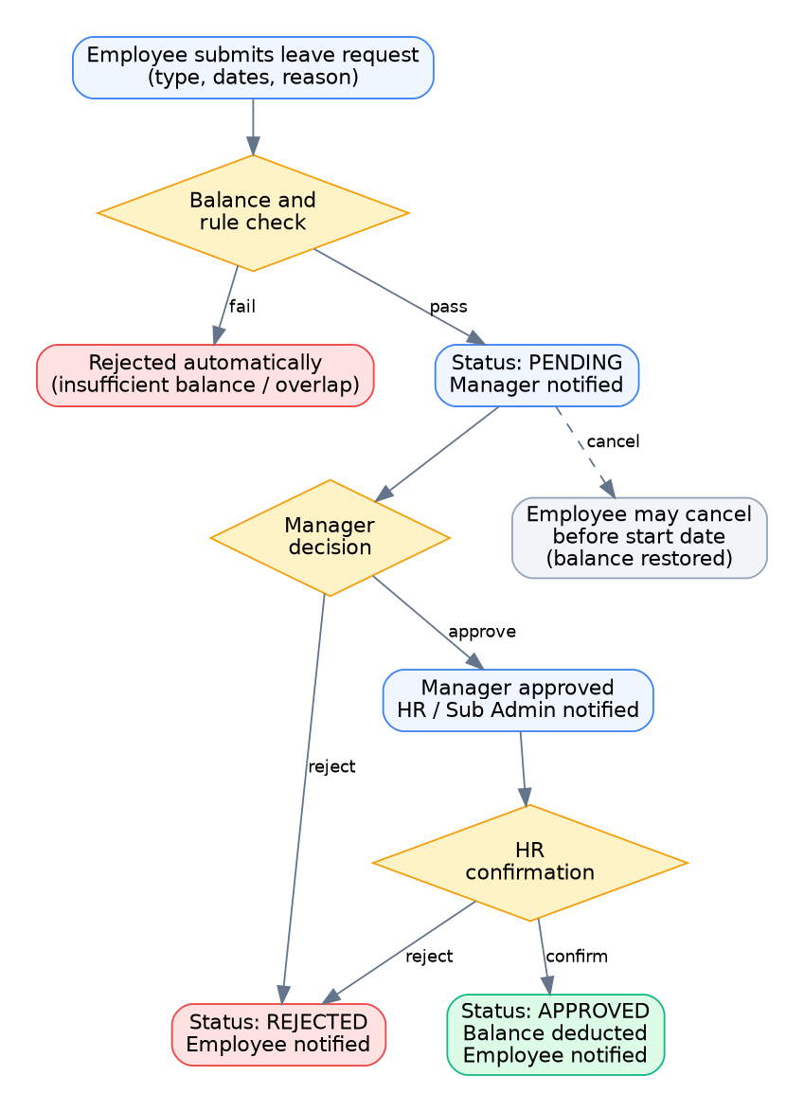
Figure 1: Leave approval workflow

3.7 Payroll management
ID | Requirement | Priority | Actor
FR-PAY-01 | The system shall maintain a salary structure per employee: basic salary, taxable allowances and non-taxable allowances. | High | Sub Admin
FR-PAY-02 | The system shall support recurring and one-time components: bonus, loan, advance and penalty, with installments. | High | Sub Admin
FR-PAY-03 | Sub Admin shall create one payroll run per month; the system shall prevent a duplicate run for the same month. | High | Sub Admin
FR-PAY-04 | For every active employee the system shall collect salary data, attendance, approved overtime, unpaid leave and components. | High | System
FR-PAY-05 | The system shall calculate gross pay, employee pension, employer pension, taxable income, income tax, other deductions and net pay using the business rules in Section 6. | High | System
FR-PAY-06 | A payroll run shall pass the statuses Draft, Reviewed, Approved and Paid, each transition allowed only to the permitted role. | High | System
FR-PAY-07 | Sub Admin shall edit lines of a Draft run with a reason and mark the run as Reviewed. | High | Sub Admin
FR-PAY-08 | Admin shall approve or return a Reviewed run; an Approved run is locked and corrected only by an adjustment in a later run. | High | Admin
FR-PAY-09 | After approval the system shall generate a payslip PDF for each employee, available for download by the employee. | High | System, Employee
FR-PAY-10 | The system shall export a bank transfer list (employee name, account, net pay) to Excel or CSV. | Medium | Sub Admin
FR-PAY-11 | The system shall provide payroll summary, department cost and monthly tax and pension remittance reports. | High | Admin, Sub Admin
FR-PAY-12 | All rates (tax brackets, pension, overtime) shall be stored in editable tables with effective dates so past payrolls can be recomputed. | High | Admin
FR-PAY-13 | The system shall prorate salary for employees hired or terminated during the month. | Medium | System
FR-PAY-14 | Payroll history shall be retained according to organization policy (default 10 years). | Medium | System

3.8 Notifications
ID | Requirement | Priority | Actor
FR-NOTIF-01 | The system shall provide an in-app notification center with an unread counter. | High | All users
FR-NOTIF-02 | Notifications shall be sent for: leave submitted, approved or rejected; payroll reviewed or approved; payslip available; contract expiry; account created. | High | System
FR-NOTIF-03 | The system shall optionally send an email for key events. | Low | System
FR-NOTIF-04 | Users shall mark notifications as read; notifications are kept for 90 days. | Low | All users

3.9 Dashboards and reports
ID | Requirement | Priority | Actor
FR-REP-01 | The system shall provide a separate dashboard for Admin, Sub Admin, Manager and Employee with real data. | High | All users
FR-REP-02 | The system shall provide reports: employee list, headcount, attendance summary, leave summary, payroll summary, tax and pension. | High | Admin, Sub Admin
FR-REP-03 | Reports shall be filterable by period and department. | Medium | Admin, Sub Admin
FR-REP-04 | Reports shall be exportable to PDF and Excel. | High | Admin, Sub Admin
FR-REP-05 | Managers shall see reports only for their own team. | High | Manager

3.10 Audit log
ID | Requirement | Priority | Actor
FR-AUD-01 | The system shall log every create, update, delete, approve and login event with user, time, entity, old value, new value and IP address. | High | System
FR-AUD-02 | Audit entries shall be immutable and viewable only by Admin. | High | Admin
FR-AUD-03 | Admin shall filter the audit log by user, action, entity and date. | Medium | Admin
FR-AUD-04 | Admin shall export the audit log. | Low | Admin

4. External Interface Requirements

4.1 User interfaces
The interface is a responsive web application with a dark side menu, a top bar and a content area. Menus depend on the role. Navigation between pages follows Figure 2. The full prototype is in the file HR_Payroll_Prototype.pdf and in Appendix A.
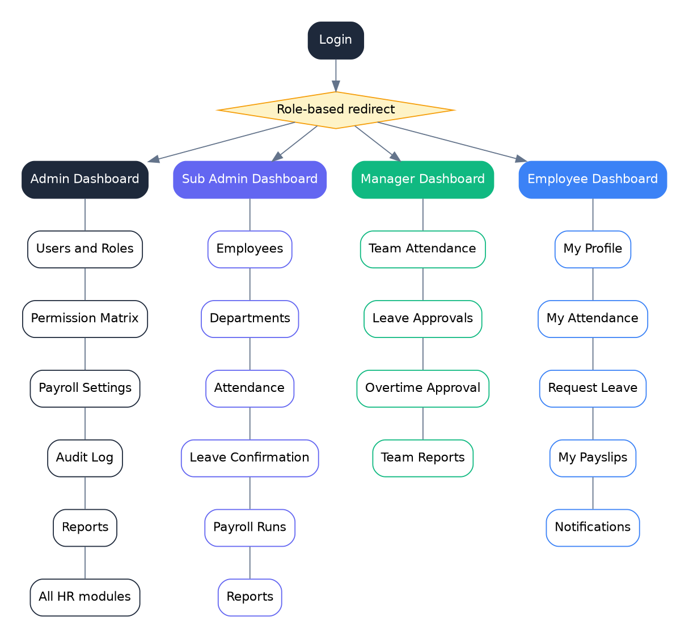
Figure 2: Site map and role-based navigation
Screen | Name | Main role | Description
01 | Login | All | Email and password, forgot password, language switch
02 | Admin dashboard | Admin | Headcount, attendance, payroll cost, pending approvals, activity
03 | Users and roles | Admin | List, filter, create and deactivate users, assign roles
04 | Permission matrix | Admin | Per-module view, create, edit, delete, approve for a Sub Admin
05 | Employee list | Sub Admin | Search, filter, paginate, export employees
06 | Add employee | Sub Admin | Personal, employment, payroll data and documents
07 | Payroll settings | Admin | Tax brackets, pension rates, overtime multipliers
08 | Attendance | Sub Admin | Daily attendance table and summary
09 | Request leave | Employee | Leave form, balances, request history
10 | Leave approvals | Manager | Pending requests, details, approve or reject
11 | Payroll runs | Sub Admin | List of monthly runs and their status
12 | Payroll run detail | Admin, Sub Admin | Calculated lines, totals, review and approval
13 | Payslip | Employee | Earnings, deductions, net pay, PDF download
14 | Manager dashboard | Manager | Team attendance, pending leave, team calendar
15 | Employee dashboard | Employee | Check-in, leave balance, latest payslip, notifications
16 | Reports | Admin | Report selection, filters, charts, export
17 | Audit log | Admin | Filter and view system changes

4.2 Hardware interfaces
The system has no special hardware interface. Users need a computer, tablet or phone with a web browser. Printing of payslips uses the browser or operating system print function.

4.3 Software interfaces
Component | Interface
PostgreSQL | Accessed through the Django ORM; stores all business data.
Web browsers | Chrome, Edge and Firefox, last two versions.
PDF and Excel libraries | ReportLab (payslip, reports) and openpyxl (Excel export).
SMTP server | Optional email notifications and password reset.
OpenAPI (drf-spectacular) | Machine-readable API documentation.

4.4 Communication interfaces
- All client-server communication uses HTTPS with JSON payloads.
- Authentication uses JWT access and refresh tokens sent in the Authorization header.
- The API follows REST conventions with standard status codes and paginated list responses.

5. Non-Functional Requirements
ID | Category | Requirement
NFR-PERF-01 | Performance | Typical list pages load in under 3 seconds on a 4 Mbps connection; 95% of API calls respond in under 500 ms with 100 concurrent users.
NFR-PERF-02 | Performance | A payroll run for 500 employees completes in under 60 seconds.
NFR-SEC-01 | Security | All traffic uses HTTPS; passwords are hashed; login is rate-limited.
NFR-SEC-02 | Security | Authorization is enforced on the server for every endpoint and every object (no access to other users' data).
NFR-SEC-03 | Security | Salary, bank and tax data are visible only to authorized roles.
NFR-SEC-04 | Security | The system protects against common web attacks (SQL injection, XSS, CSRF, insecure file upload).
NFR-REL-01 | Reliability | Target availability of 99% during working hours.
NFR-REL-02 | Reliability | Daily database backup; restore procedure is documented and tested.
NFR-REL-03 | Reliability | Payroll and leave operations use database transactions; a failed run leaves no partial data.
NFR-USA-01 | Usability | A new user can complete the main task of their role after short training; forms show clear validation messages.
NFR-USA-02 | Usability | The interface is responsive from 360 px width and uses sufficient color contrast and keyboard navigation.
NFR-USA-03 | Usability | The interface is available in English and Amharic.
NFR-MAI-01 | Maintainability | Code is organized in separate Django apps with a service layer; automated tests cover at least 80% of services.
NFR-MAI-02 | Maintainability | API documentation is generated automatically from the code.
NFR-POR-01 | Portability | The system runs on Linux and Windows and can be deployed with Docker.
NFR-LOC-01 | Localization | Currency is ETB with two decimals; text is UTF-8 so Amharic names are stored correctly; Ethiopian calendar display is optional.
NFR-SCA-01 | Scalability | The design supports at least 1,000 employees; the API is stateless so it can scale horizontally.

6. Business Rules for Ethiopian Payroll
The following rules are default values. They are stored in editable database tables and must be verified against the current law and the Ministry of Revenues. Sources consulted during analysis did not agree on every detail (for example the pension base and the tax-free threshold in older publications), which is the reason these values are configurable.
ID | Rule
BR-01 | Employee pension is 7% of the pension base (default: basic salary). Employer pension is 11% of the same base.
BR-02 | By default the employee pension does not reduce taxable income. A setting (pension_reduces_taxable_income) allows the opposite.
BR-03 | Taxable income = basic salary + taxable allowances + overtime + bonus.
BR-04 | Income tax is calculated with the monthly progressive brackets in the table below: tax = taxable income x rate - deduction.
BR-05 | Net pay = gross pay + non-taxable allowances - income tax - employee pension - other deductions (loans, advances, penalties, unpaid leave).
BR-06 | Hourly rate for overtime = basic salary / 208 (configurable hours per month).
BR-07 | Overtime multipliers (default): 1.25 normal day, 1.5 night, 2.0 weekly rest day, 2.5 public holiday.
BR-08 | Annual leave: 16 working days in the first year plus 1 day for every 2 years of service (configurable).
BR-09 | Maternity leave default 120 days (30 before and 90 after birth); paternity leave default 3 days; sick leave according to labour law. All configurable.
BR-10 | A request cannot be approved by the person who created it.
BR-11 | An approved payroll run is locked; corrections are made by adjustment in a later run.
BR-12 | Overtime is included in payroll only after Manager approval.

Monthly income tax brackets (default, ETB)
Taxable income per month | Rate | Deduction
0 to 2,000 | 0% | 0
2,001 to 4,000 | 15% | 300
4,001 to 7,000 | 20% | 500
7,001 to 10,000 | 25% | 850
10,001 to 14,000 | 30% | 1,350
Above 14,000 | 35% | 2,050

Worked example
Item | Calculation | Amount (ETB)
Basic salary |  | 12,000.00
Taxable allowance |  | 1,500.00
Overtime |  | 0.00
Gross / taxable income | 12,000 + 1,500 | 13,500.00
Employee pension (7%) | 12,000 x 7% | 840.00
Income tax | 13,500 x 30% - 1,350 | 2,700.00
Net pay | 13,500 - 840 - 2,700 | 9,960.00
Employer pension (11%) | 12,000 x 11% | 1,320.00 (paid by employer)

7. Use Cases
Figure 3 shows the actors and their use cases. Table 7.1 lists all use cases; key use cases are described in detail afterwards.
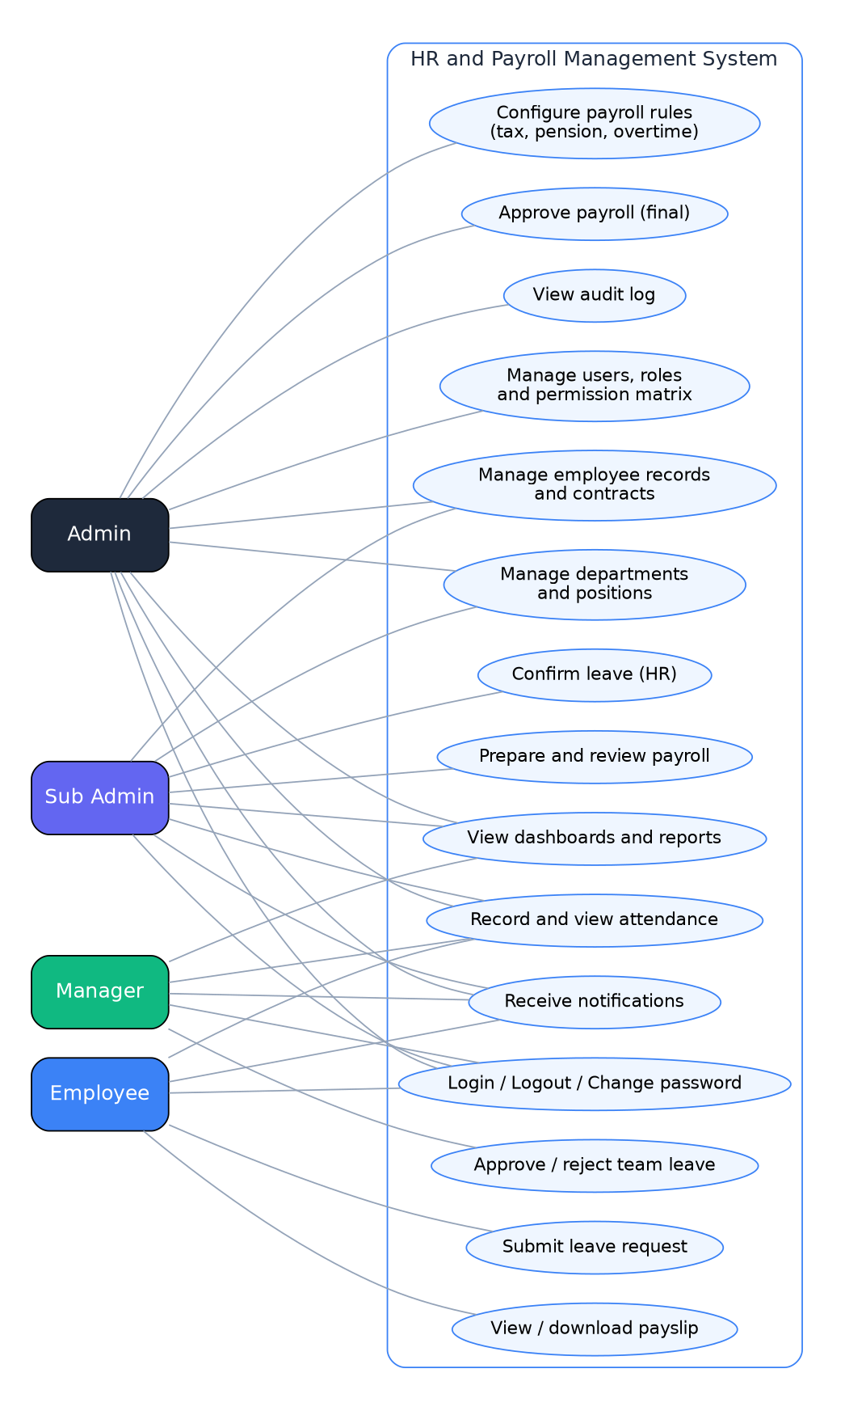
Figure 3: Use case diagram

7.1 Use case list
ID | Use case | Actor | Description
UC-01 | Login and logout | All users | Authenticate and open the role dashboard.
UC-02 | Manage users, roles and permissions | Admin | Create accounts, assign roles, edit Sub Admin permission matrix.
UC-03 | Configure payroll rules | Admin | Maintain tax brackets, pension and overtime settings.
UC-04 | Manage employees and contracts | Sub Admin, Admin | Create, edit, search and export employee records.
UC-05 | Record and review attendance | Employee, Sub Admin, Manager | Check in/out, correct entries, view summaries.
UC-06 | Submit leave request | Employee | Request leave and follow its status.
UC-07 | Approve or reject team leave | Manager | Decide on leave requests of direct reports.
UC-08 | Confirm leave (HR) | Sub Admin | Confirm manager-approved leave and update balances.
UC-09 | Prepare payroll run | Sub Admin | Create run, calculate, edit draft lines.
UC-10 | Review payroll | Sub Admin | Check calculations and mark run as Reviewed.
UC-11 | Approve payroll | Admin | Approve or return a reviewed payroll run.
UC-12 | View and download payslip | Employee | Open own payslips and download PDF.
UC-13 | View dashboards and reports | All users (by role) | See role dashboards and export reports.
UC-14 | View audit log | Admin | Search the history of system changes.

7.2 Detailed use cases

UC-01 Login and logout
Actor | All users
Preconditions | The user has an active account.
Main flow | 1. User opens the login page and enters email and password.  2. System validates the credentials.  3. System issues access and refresh tokens.  4. System redirects the user to the dashboard of their role.  5. User works; at the end the user selects Sign out and the token is invalidated.
Alternative flows | 2a. Wrong password: system shows an error and counts the attempt; after 5 failures the account is locked for 15 minutes.  3a. First login: system forces a password change before the dashboard.
Postconditions | User is authenticated and sees only the menus allowed for their role.

UC-06 Submit leave request
Actor | Employee
Preconditions | Employee is logged in and has a leave balance.
Main flow | 1. Employee opens Request Leave.  2. Employee selects leave type, dates and writes a reason; optionally attaches a file.  3. System calculates working days and shows the balance after the request.  4. Employee submits.  5. System creates the request with status Pending and notifies the Manager.
Alternative flows | 3a. Insufficient balance or overlapping leave: system rejects the request with a message.  5a. Employee cancels a pending request before the start date.
Postconditions | A Pending request exists; no balance is deducted yet.

UC-07 Approve or reject team leave
Actor | Manager
Preconditions | A Pending request of a direct report exists.
Main flow | 1. Manager opens Leave Approvals and selects a request.  2. System shows details, balance and team calendar.  3. Manager enters an optional comment and selects Approve.  4. System marks the request Manager approved and notifies HR (Sub Admin).
Alternative flows | 3a. Manager selects Reject: status becomes Rejected and the employee is notified.  1a. Manager tries to open a request of another department: system denies access.
Postconditions | Request moves to HR confirmation or is closed as Rejected.

UC-09 Prepare payroll run
Actor | Sub Admin
Preconditions | Salary structures exist; Sub Admin has payroll permission.
Main flow | 1. Sub Admin selects New payroll run and chooses month and year.  2. System checks that no run exists for that month.  3. System collects salary, attendance, approved overtime, unpaid leave, loans and allowances.  4. System calculates gross, pension, tax, deductions and net pay for each employee.  5. System shows the run in status Draft.  6. Sub Admin corrects lines if needed (reason required) and marks the run Reviewed.
Alternative flows | 2a. Run already exists: system opens the existing run.  4a. Missing data for an employee: system flags the line for correction.
Postconditions | Run is Reviewed and waits for Admin approval.

UC-11 Approve payroll
Actor | Admin
Preconditions | A Reviewed payroll run exists.
Main flow | 1. Admin opens the run and checks totals and exceptions.  2. Admin selects Approve payroll.  3. System locks the run and generates payslip PDFs.  4. System notifies employees that payslips are available.  5. After bank payment Admin marks the run Paid.
Alternative flows | 2a. Admin selects Return for correction: status goes back to Draft with a comment to the Sub Admin.
Postconditions | Run is Approved and locked; payslips are available; audit entries are written.

8. System Models
This section presents the architecture, the payroll workflow and the data model. The data dictionary follows the diagrams.

8.1 System architecture
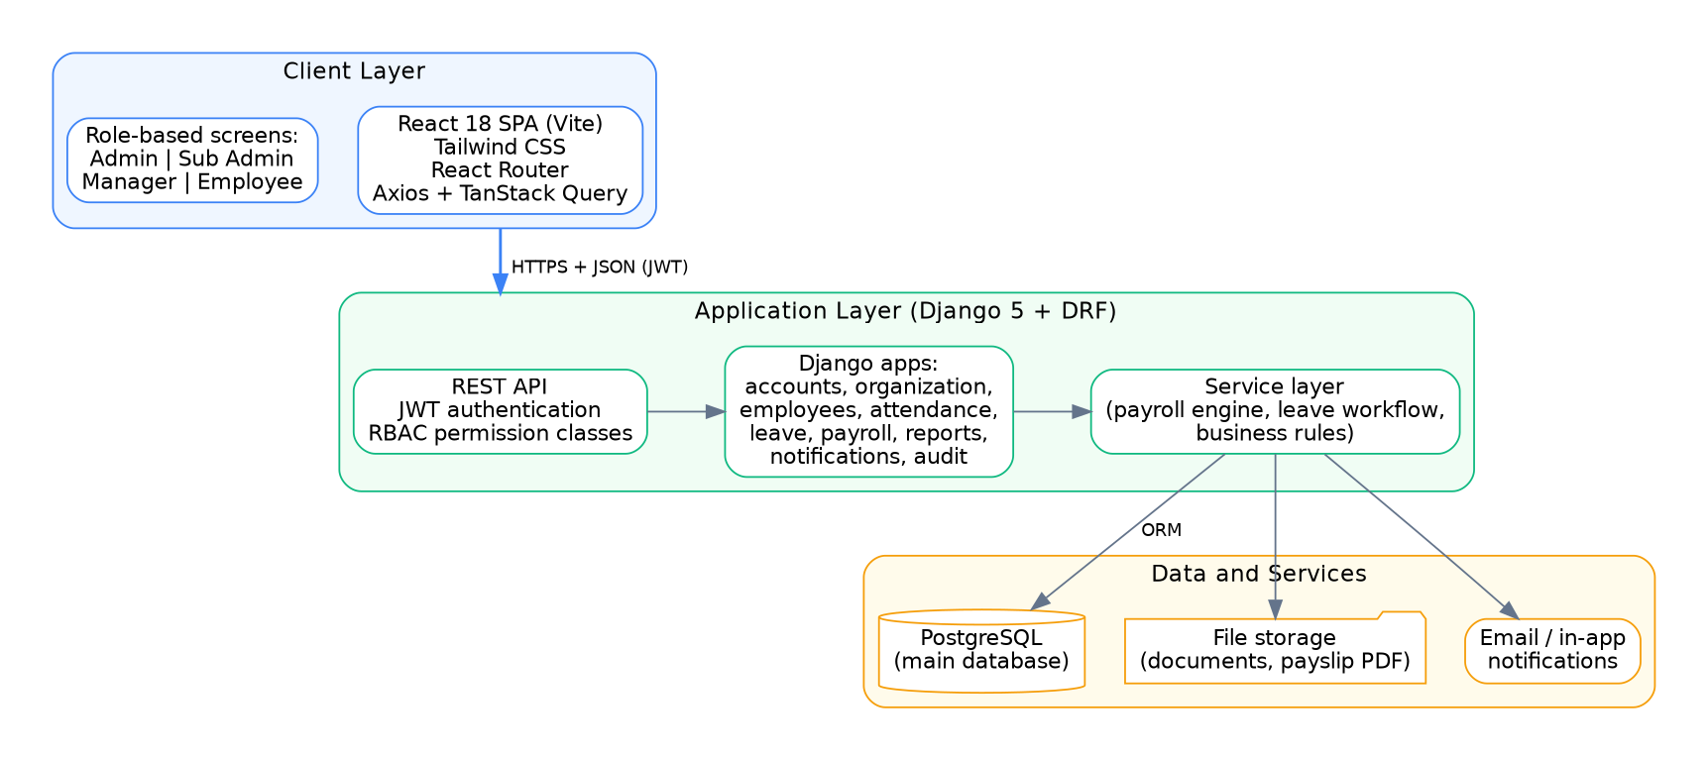
Figure 4: System architecture

8.2 Payroll workflow
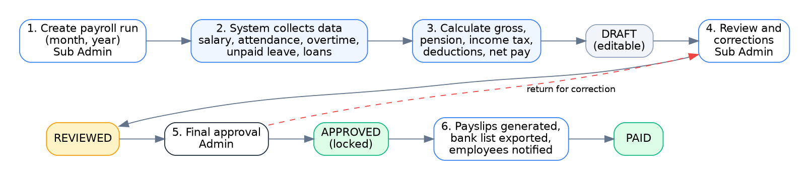
Figure 5: Payroll workflow and statuses

8.3 Entity relationship diagram
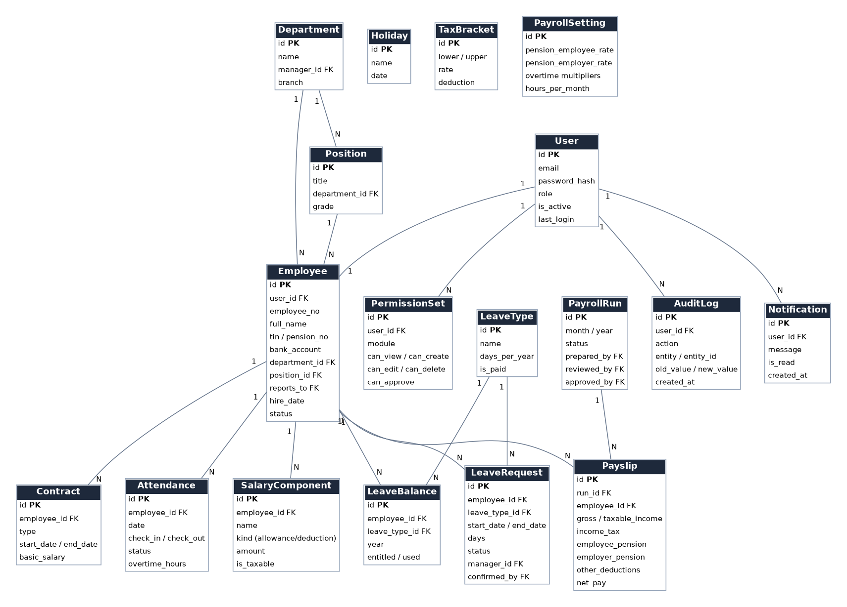
Figure 6: Entity relationship diagram

8.4 Data dictionary
Entity | Key attributes | Description
User | id, email, password_hash, role, is_active, last_login | Login account with exactly one role.
PermissionSet | user_id, module, can_view, can_create, can_edit, can_delete, can_approve | Delegated permissions for a Sub Admin per module.
Department | id, name, manager_id, branch | Organization unit.
Position | id, title, department_id, grade | Job title.
Employee | id, user_id, employee_no, full_name, tin, pension_no, bank_account, department_id, position_id, reports_to, hire_date, status | Employee master record.
Contract | employee_id, type, start_date, end_date, basic_salary | Employment contract and salary history.
Attendance | employee_id, date, check_in, check_out, status, overtime_hours | Daily attendance record.
Holiday | name, date | Public holiday.
LeaveType | name, days_per_year, is_paid | Configurable leave type.
LeaveBalance | employee_id, leave_type_id, year, entitled, used | Yearly balance per type.
LeaveRequest | employee_id, leave_type_id, start_date, end_date, days, status, manager_id, confirmed_by | Leave request with approval trail.
SalaryComponent | employee_id, name, kind, amount, is_taxable | Allowance or deduction item.
PayrollRun | month, year, status, prepared_by, reviewed_by, approved_by | Monthly payroll batch.
Payslip | run_id, employee_id, gross, taxable_income, income_tax, employee_pension, employer_pension, other_deductions, net_pay | Result for one employee in one run.
TaxBracket | lower, upper, rate, deduction | Editable income tax brackets.
PayrollSetting | pension rates, overtime multipliers, hours_per_month | Editable payroll parameters.
AuditLog | user_id, action, entity, entity_id, old_value, new_value, created_at | Immutable history of changes.
Notification | user_id, message, is_read, created_at | In-app message.

9. Traceability and Acceptance

9.1 Requirements traceability matrix
Module | Requirements | Use cases | Screens | Test cases
Authentication | FR-AUTH-01 to 08 | UC-01 | 01 | AT-01, AT-02
Roles and permissions | FR-RBAC-01 to 09 | UC-02 | 03, 04 | AT-03, AT-04
Organization | FR-ORG-01 to 05 | UC-04 | 05 | AT-05
Employees | FR-EMP-01 to 11 | UC-04 | 05, 06 | AT-05
Attendance | FR-ATT-01 to 09 | UC-05 | 08, 14, 15 | AT-06
Leave | FR-LEAVE-01 to 11 | UC-06, 07, 08 | 09, 10, 14 | AT-07, AT-08
Payroll | FR-PAY-01 to 14 | UC-03, 09, 10, 11, 12 | 07, 11, 12, 13 | AT-09, AT-10, AT-11
Notifications | FR-NOTIF-01 to 04 | UC-13 | 15 | AT-12
Dashboards and reports | FR-REP-01 to 05 | UC-13 | 02, 14, 15, 16 | AT-12
Audit log | FR-AUD-01 to 04 | UC-14 | 17 | AT-04

9.2 Acceptance test scenarios
ID | Scenario | Expected result
AT-01 | Login with correct and wrong credentials; fail 5 times. | Correct login opens role dashboard; wrong login shows error; 5th failure locks the account.
AT-02 | First login with temporary password. | System forces a password change.
AT-03 | Employee tries to open an admin URL or API endpoint. | Access denied (403); nothing is shown.
AT-04 | Admin changes a Sub Admin permission and an action is performed. | Permission is applied immediately; the action appears in the audit log.
AT-05 | Sub Admin creates, edits and searches an employee. | Record is saved, found by search and the change is logged.
AT-06 | Employee checks in late; manager views the team. | Status is Late; manager sees only own team.
AT-07 | Employee requests leave with insufficient balance. | Request is rejected with a clear message.
AT-08 | Full leave flow: submit, Manager approves, HR confirms. | Status Approved; balance deducted; employee notified at each step.
AT-09 | Prepare a payroll run for the example in Section 6. | Net pay equals 9,960.00 ETB; pension and tax match the rules.
AT-10 | Sub Admin tries to approve payroll. | Action denied; only Admin can approve.
AT-11 | Admin approves the run. | Run is locked; payslip PDFs are generated; employees are notified.
AT-12 | Open dashboards and export a report to PDF and Excel. | Dashboards show data for the role; files download correctly.

Appendix A. User Interface Prototype
The screens below are the high-fidelity prototype (1440 x 900). The same screens are provided as editable SVG files for Figma in HR_Payroll_Figma_SVG_Pack.zip and as a PDF in HR_Payroll_Prototype.pdf.
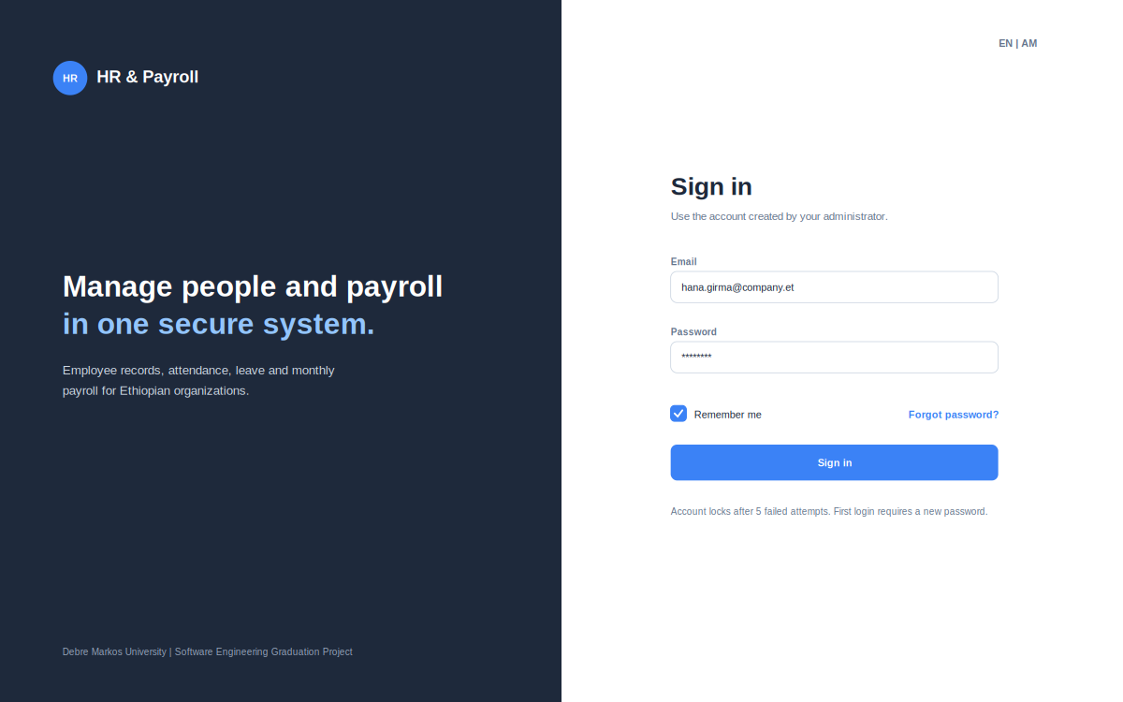
Figure A1: Screen 01 - Login
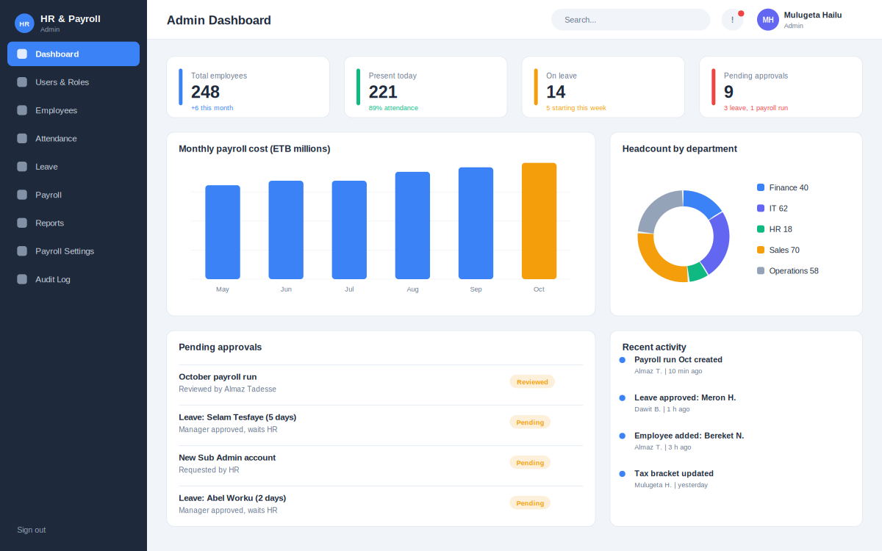
Figure A2: Screen 02 - Admin dashboard
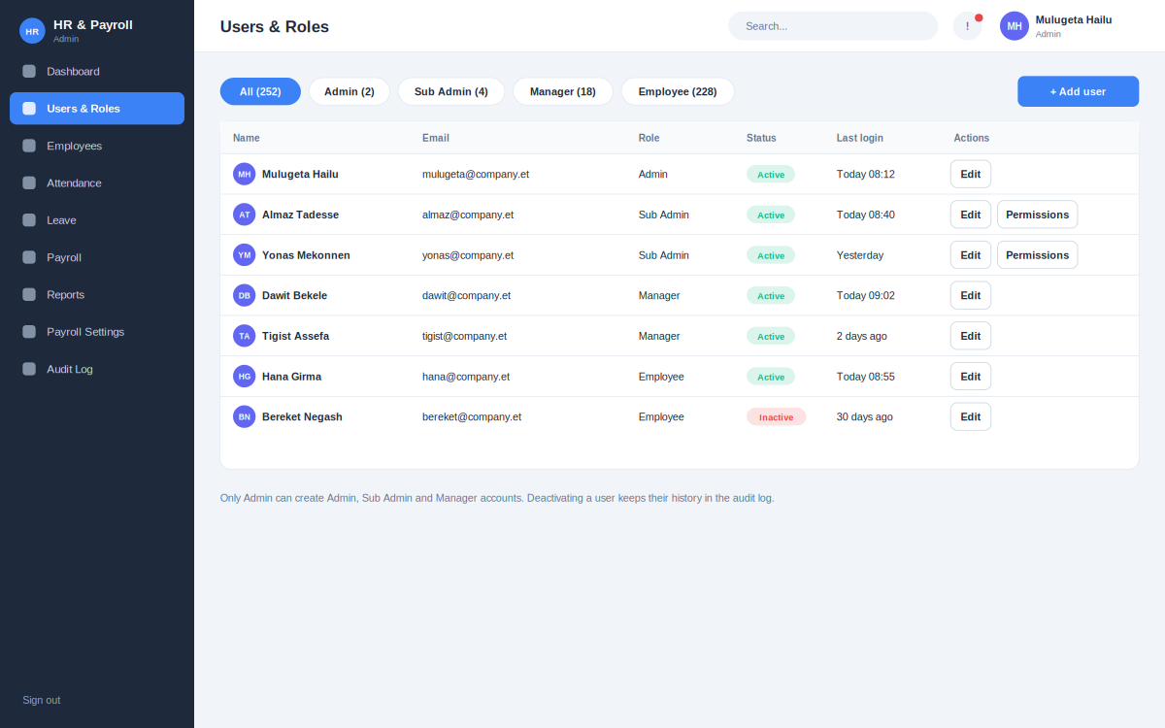
Figure A3: Screen 03 - Users and roles
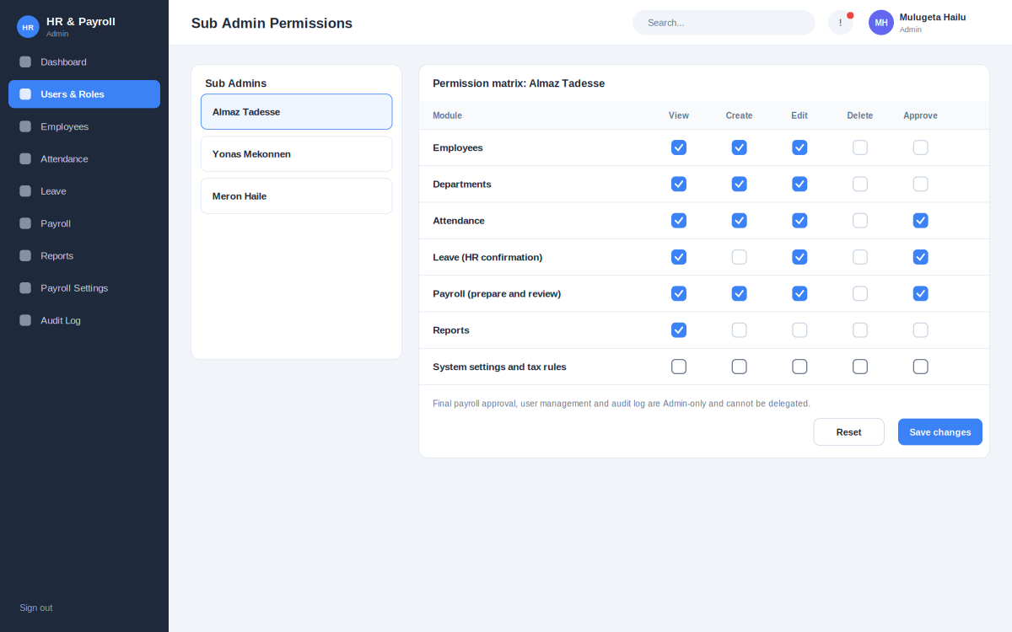
Figure A4: Screen 04 - Permission matrix
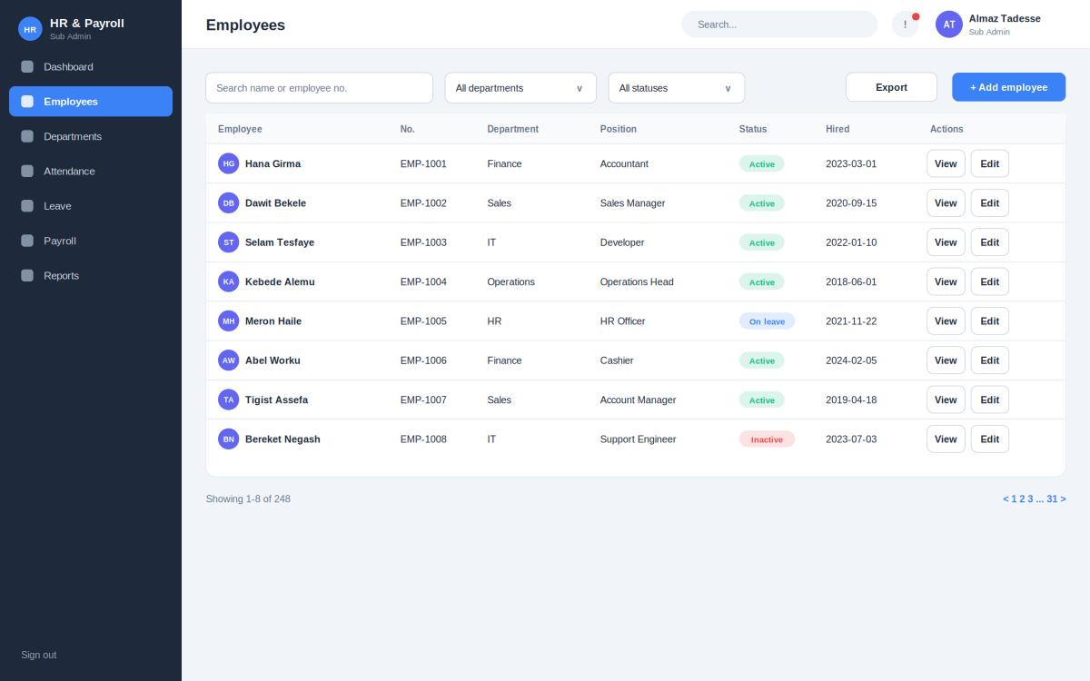
Figure A5: Screen 05 - Employee list
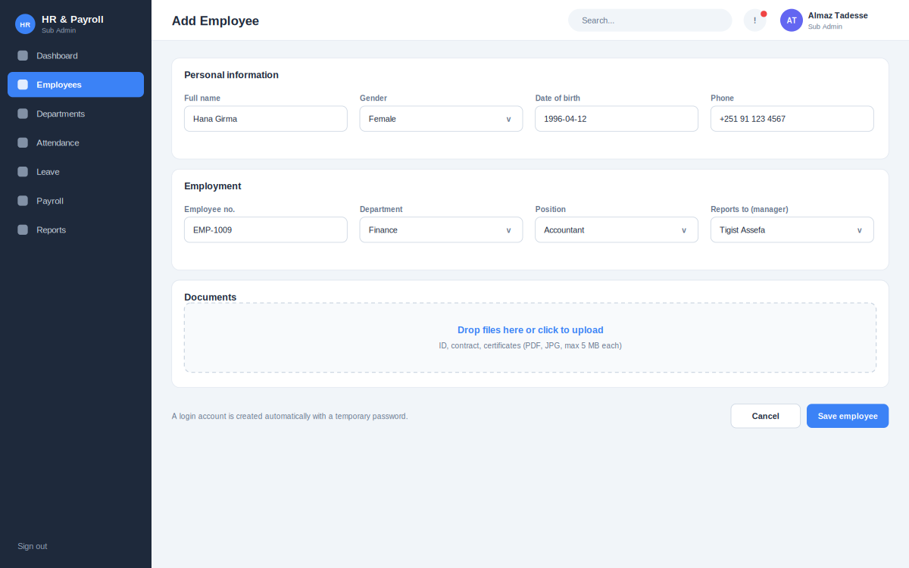
Figure A6: Screen 06 - Add employee
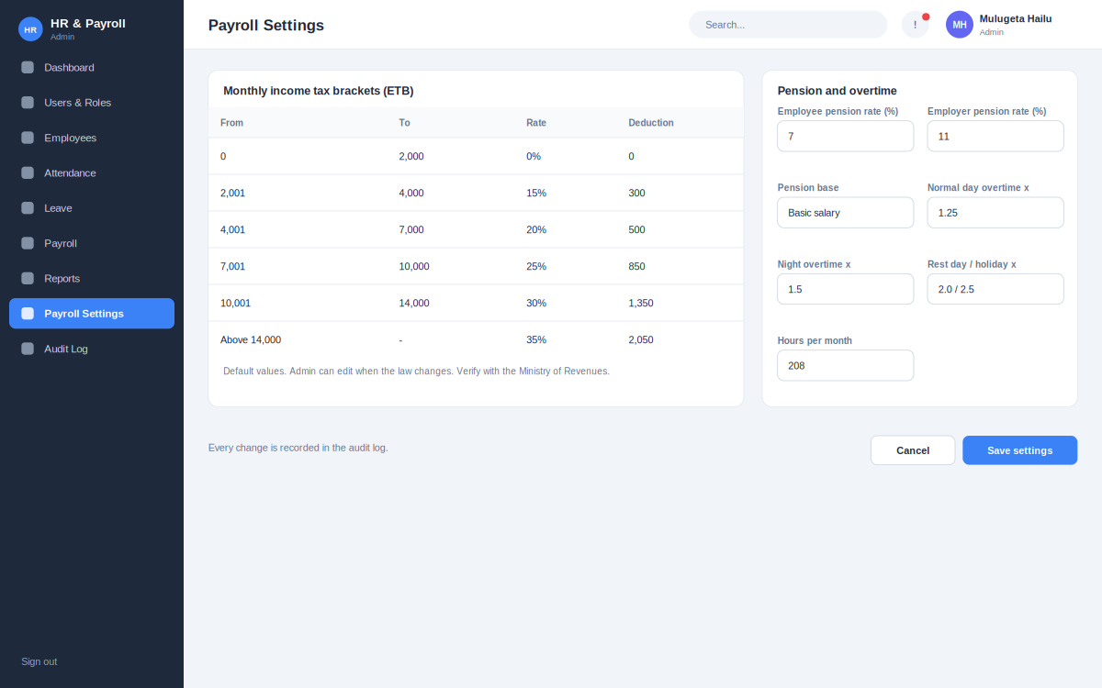
Figure A7: Screen 07 - Payroll settings
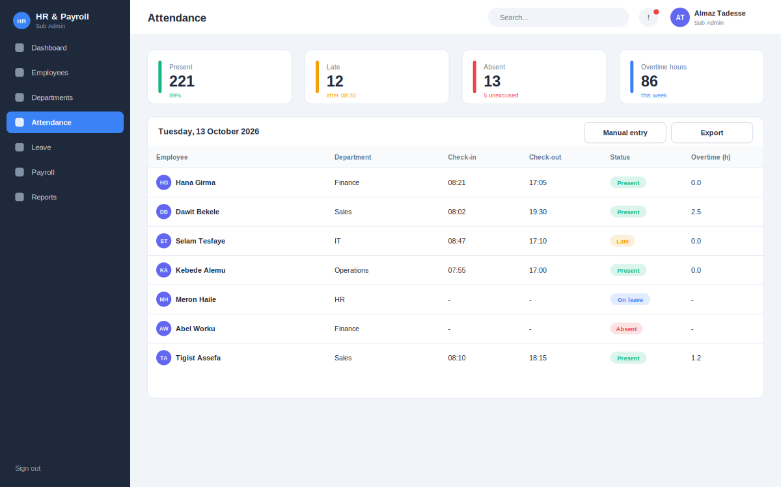
Figure A8: Screen 08 - Attendance
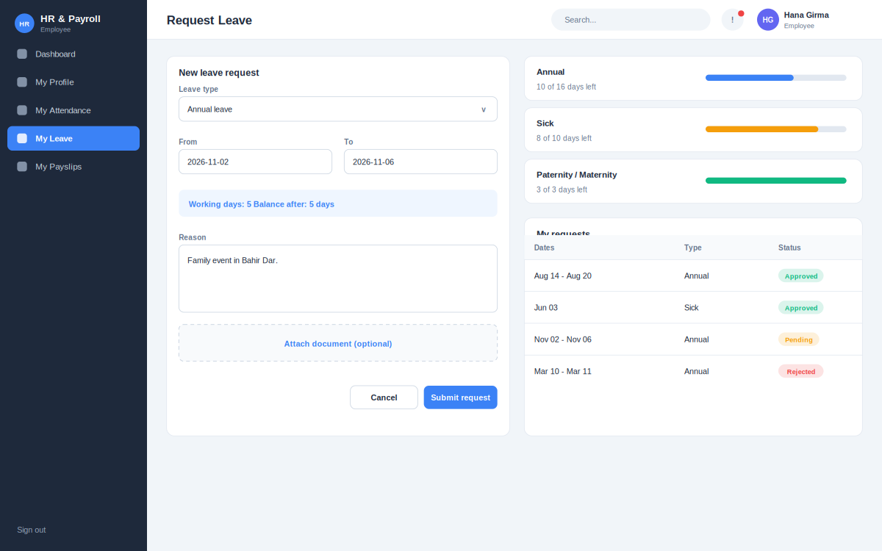
Figure A9: Screen 09 - Request leave
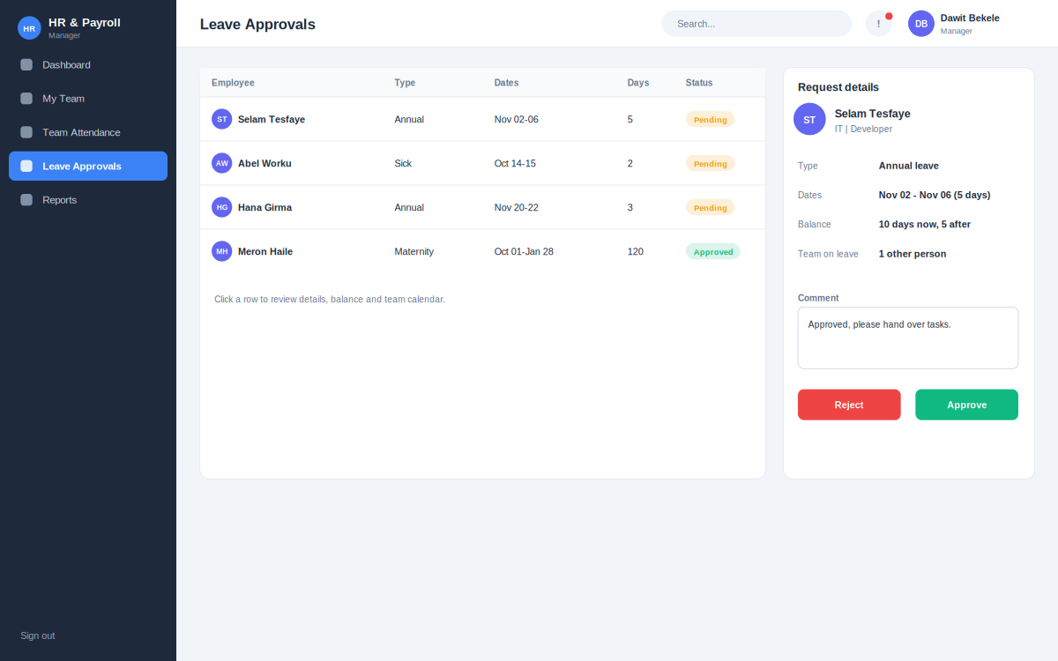
Figure A10: Screen 10 - Leave approvals
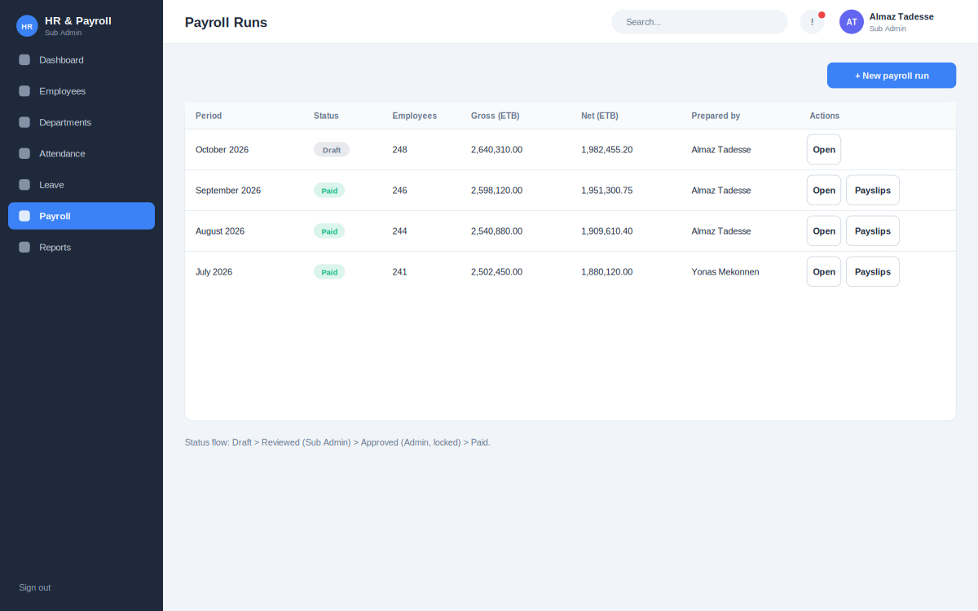
Figure A11: Screen 11 - Payroll runs
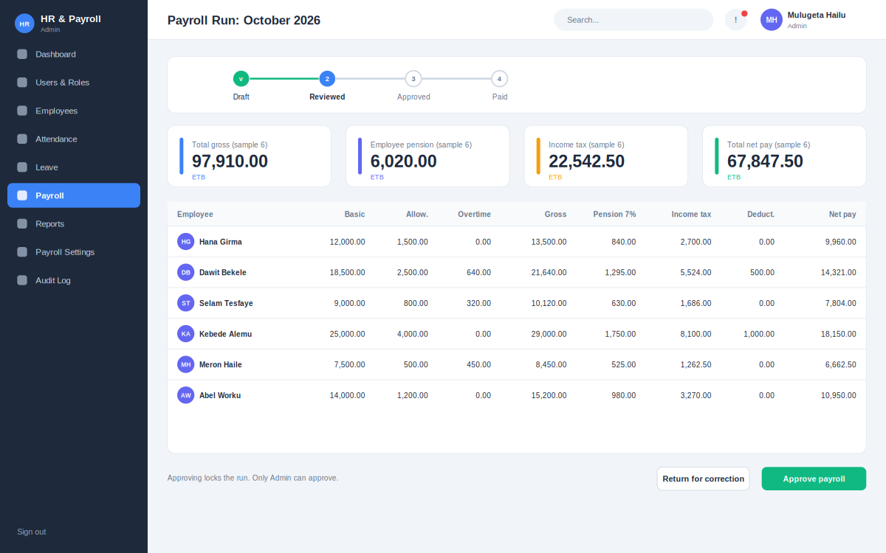
Figure A12: Screen 12 - Payroll run detail
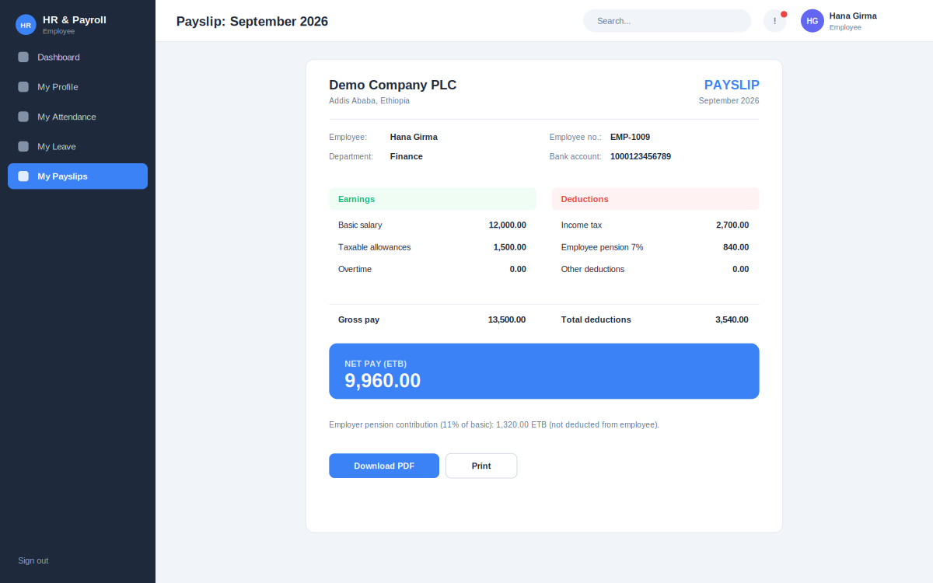
Figure A13: Screen 13 - Payslip
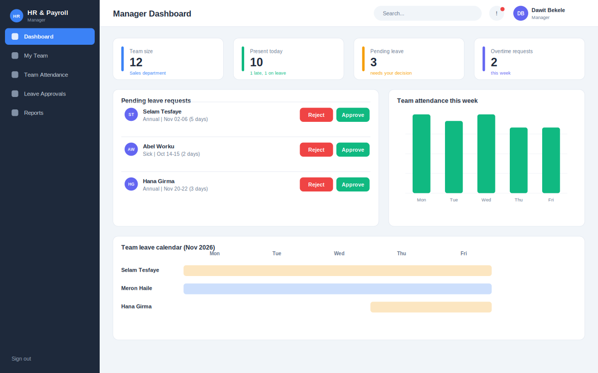
Figure A14: Screen 14 - Manager dashboard
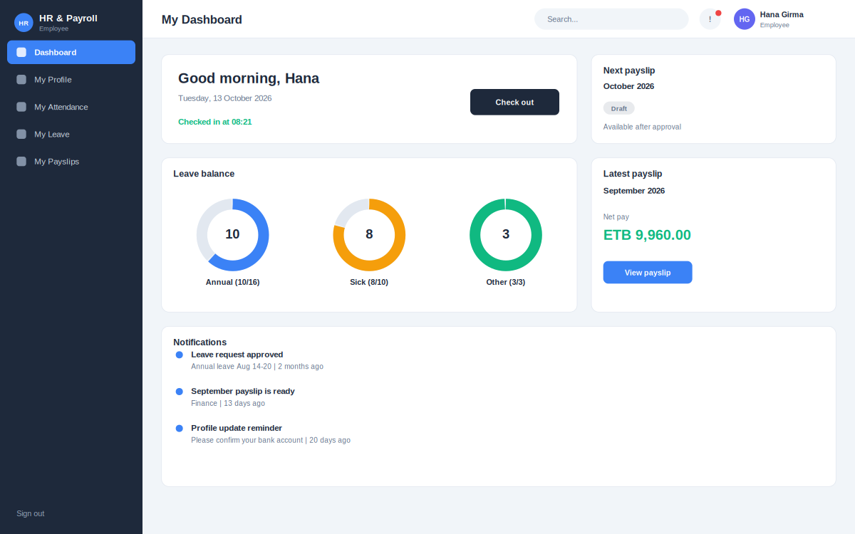
Figure A15: Screen 15 - Employee dashboard
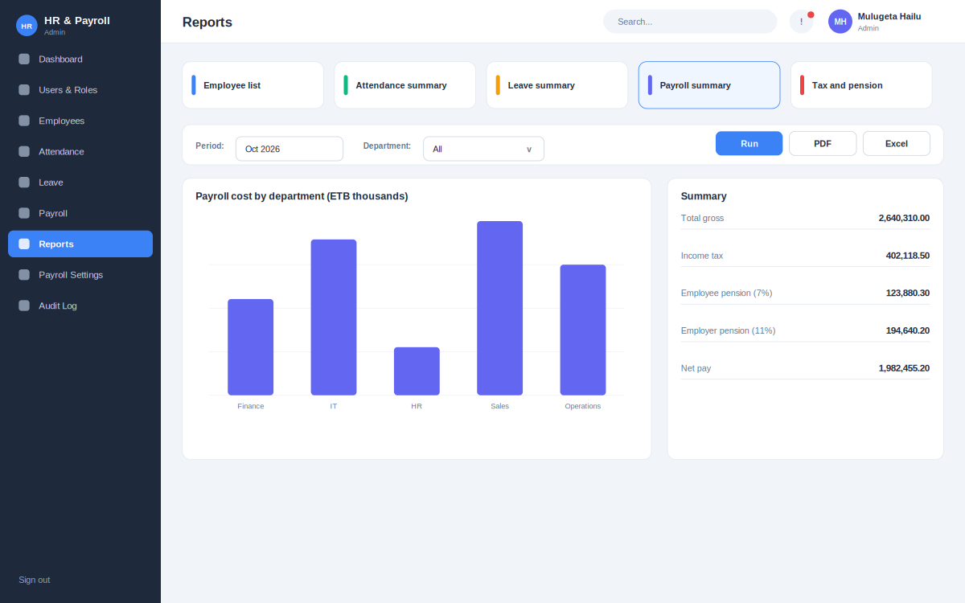
Figure A16: Screen 16 - Reports
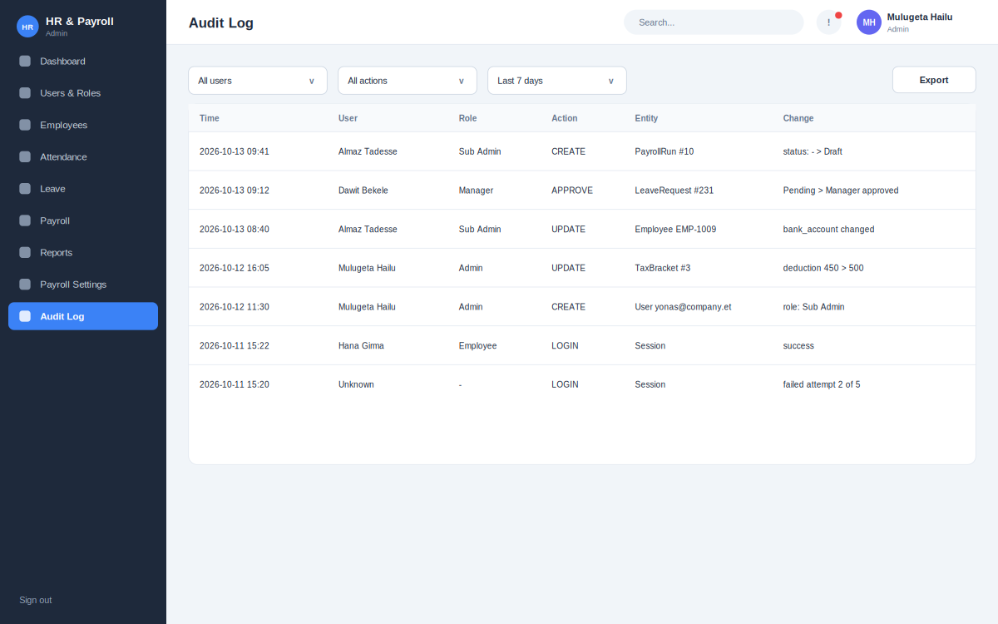
Figure A17: Screen 17 - Audit log

Appendix B. Future Enhancements
- Mobile application (Flutter) for check-in, leave and payslips.
- Biometric or GPS-based attendance.
- Direct bank payment file formats for Ethiopian banks and mobile money.
- Recruitment, onboarding and performance appraisal modules.
- Ethiopian calendar entry for all date fields.
- Export of monthly tax and pension declaration files.
- Electronic signature for contracts and approvals.

Appendix C. Open Issues and Items to Verify
No. | Item | Action
1 | Current income tax brackets and tax-free threshold | Confirm with the Ministry of Revenues before deployment.
2 | Pension base (basic salary or gross) and whether pension reduces taxable income | Confirm with the pension authority and the organization; set the configuration.
3 | Leave entitlements for sick, maternity and paternity leave | Confirm with Labour Proclamation No. 1156/2019 and company policy.
4 | Working hours per month and overtime multipliers | Confirm with company policy and labour law.
5 | Advisor feedback on scope of the first release | Discuss at the next review meeting.

