**Machine Learning**

**for Signal Processing**

**Homework 2**

**07.12.2020**

**Mehmet Şerbetçioğlu -- 040160056**

**Veli Bulur -- 040150051**

**SVD Exercise 1:**

For this exercise, an image of Tarantula Nebula is used. This image is loaded and can be shown as such.

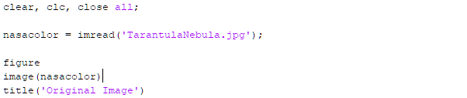

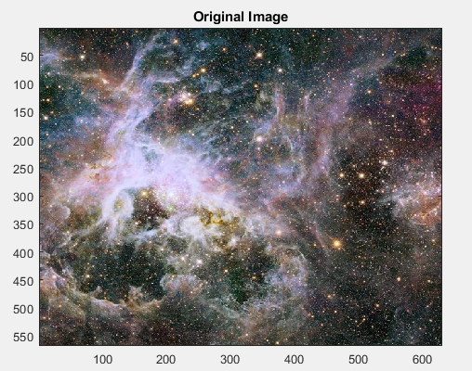

**____________________________________________________________________**

The original image contains three dimensions. Third dimension has three elements, which correspond to rgb scale of each pixel. For convenience, third dimension will be reduced to one element with grayscaling.

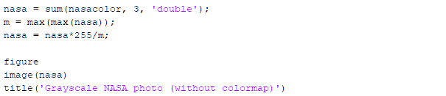 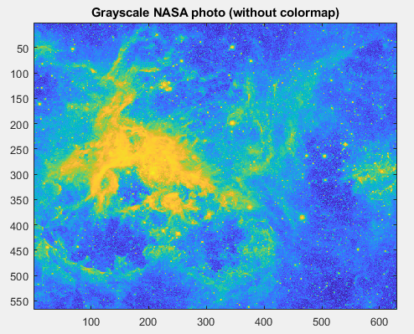

**____________________________________________________________________**

New image makes more sense when shown with a black and white filter. 

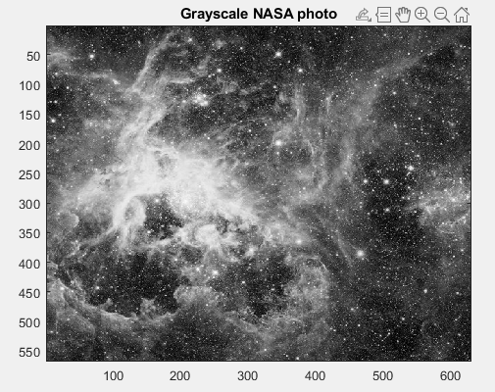

**____________________________________________________________________**

Now, singular value decomposition of the image matrix is taken. Columns of U matrix will be eigen vectors and corresponding diagonal elements of S matrix will be eigen values. Eigen values determine each eigen vectors energy.

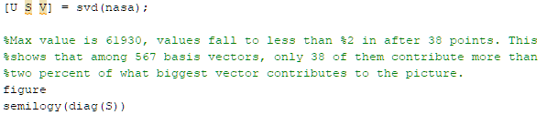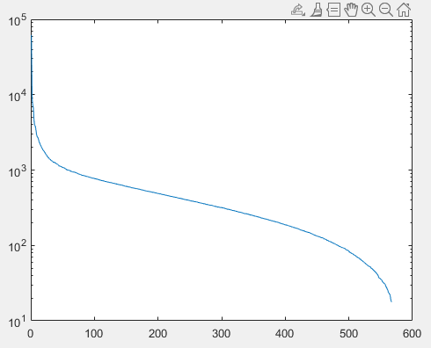

**____________________________________________________________________**

These eigen vectors are basis vectors of the image. By using high energy basis vectors, image can be recreated somewhat accurately. With more basis vectors, recreated image comes closer to the original image. This allows a big reduction in data size and is a standardized method in image compression. Recreations with 25, 50 and 100 basis vectors can be shown as such.



**____________________________________________________________________**

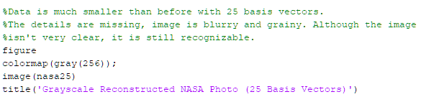

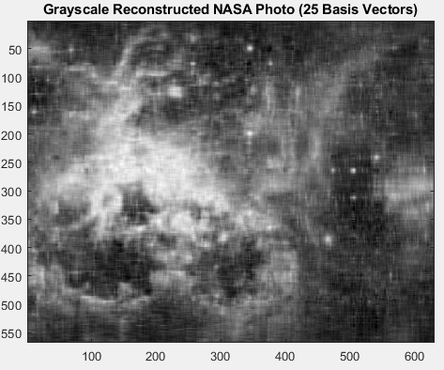

**____________________________________________________________________**

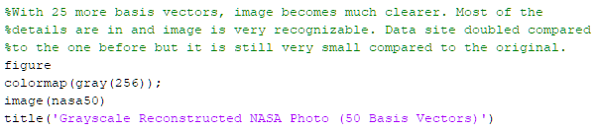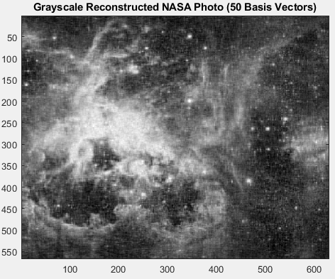

**____________________________________________________________________**

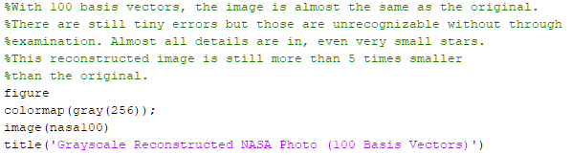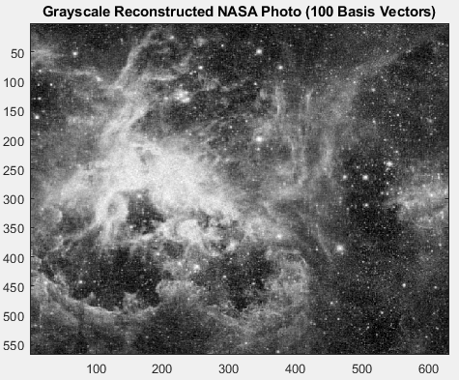**____________________________________________________________________**

**SVD Exercise 2:**

**Part 1:**

In this exercise, 32x32 grayscaled faces are loaded from ORL_32x32.mat file. There are 400 faces in the file. File also contains a gnd vector which represents classes of each face. For exercise’s purpose, each face in the file has been manipulated and given classes of smiling and neutral.

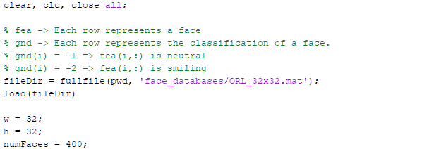

Next, training sets of smiling and neutral faces are initiated. These are selected from the first 40 faces. Also, faces are stored in a matrix called faces.

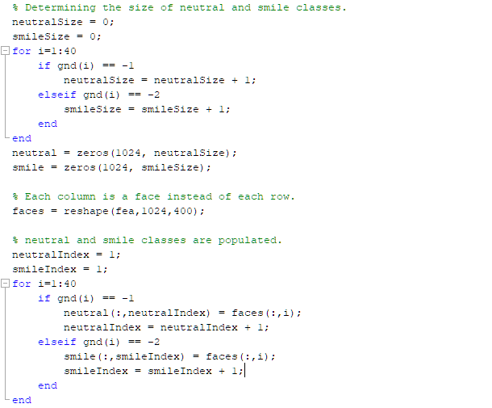

Each face is centralized by subtracting the mean value. With singular value decomposition of the faces, eigen vectors and eigen values are gathered. Mean face and eigen vectors with largest eigen values are plotted.

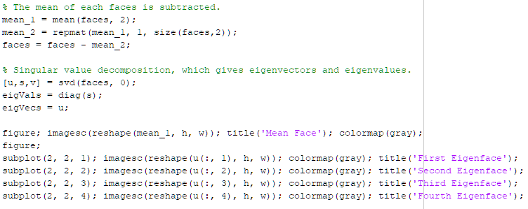

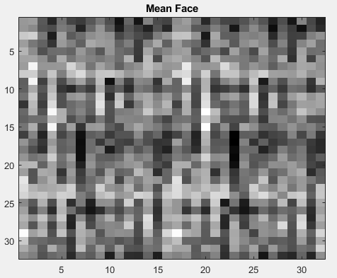

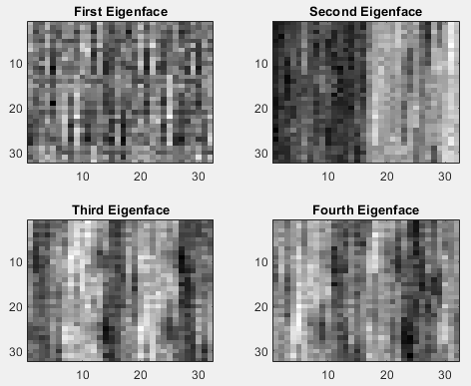**____________________________________________________________________**

SVD analysis is done on natural and smiling matrices. These basis vectors will be used to predict whether a face is smiling or not. Dominant vectors will have a higher chance of being from the right class.

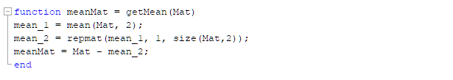

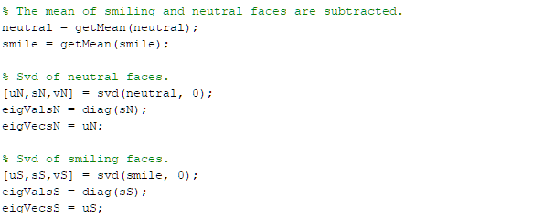**____________________________________________________________________**

Energies of basis vectors are calculated in order to select high energy vectors. For this exercise, energy threshold is selected as %90 of the highest energy vector.

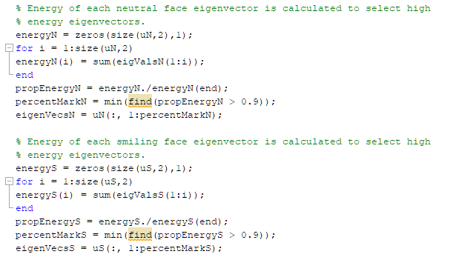**____________________________________________________________________**

Each eigen vector is normalized and projection of faces with vectors from smiling and neutral classes are calculated. These projections, or weights, will determine which class will be predicted for a face.

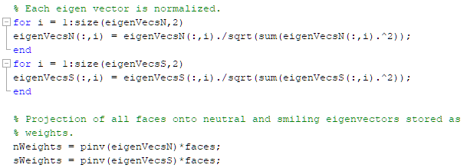**____________________________________________________________________**

Euclidian norm of each weight vector is calculated and subtracted. If the difference is in favor of neutral, face will be predicted to be natural. Otherwise, prediction will be smiling.

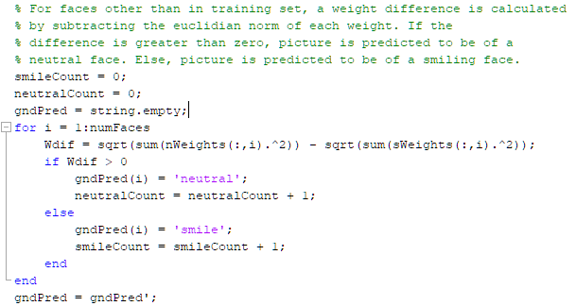**____________________________________________________________________**

While above %50, results are still not that great. While roughly half of the total faces were smiling, program predicted only 42 smiling faces and 13 of them were wrong predictions. Reason for this may be low count of smiling faces in the training set, which was 11, or low count of total faces in training set altogether. Not many basis vectors for smiling faces can be gathered from such a low amount of data. Another reason may be the resolution of faces, which was 32x32. With that resolution and not-that-clear difference between smiling and neutral faces, basis vectors may be less than healthy. Even with all the disadvantages, program was able to predict around %75 of faces accurately.



**SVD Exercise 2:**

**Part 2:**

With the previously established system, genders of different 36x36 faces will be predicted. For this part of the exercise, training set for men and women will consist of 2500 faces each and testing set will consist of 200 faces each. These faces are loaded into corresponding matrices. 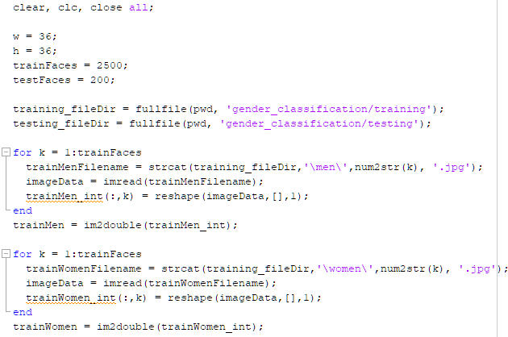 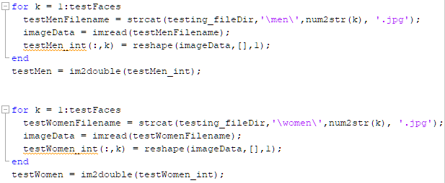

**____________________________________________________________________**Training sets are centralized and eigen vectors and values are gathered with SVD analysis.

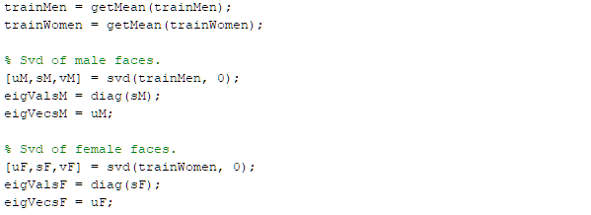

**____________________________________________________________________**

Later, high energy vectors are selected. Energy threshold is selected as %99.9 of the highest energy vector. This corresponds to 102 female vectors and 105 male vectors. 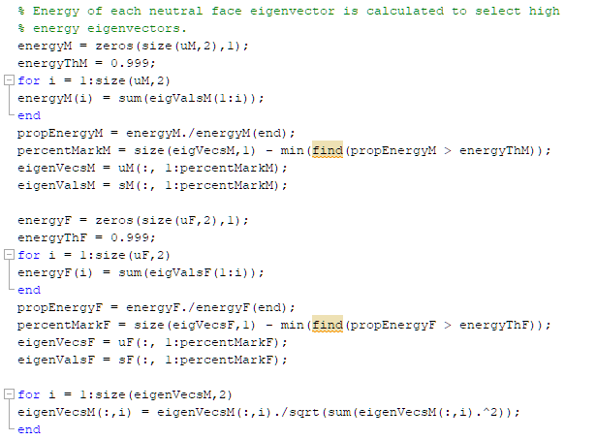**____________________________________________________________________**

Eigen vectors are normalized and projected on the testing set.

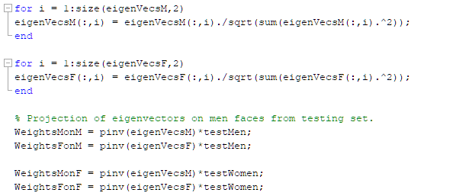**____________________________________________________________________**

After predicting through testing sets, around %82 of predictions are successful. Results are way more consistent compared to the previous part of the exercise. This is due to having a much bigger training set, having data with sharp, non-ambigious differences and having more data with 36x36 faces instead of 32x32.

More basis vectors may improve the results with the cost of more data space. Depending on application, energy threshold and even difference function may be altered to get better results.

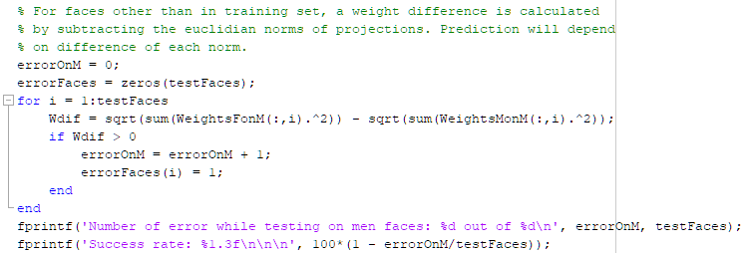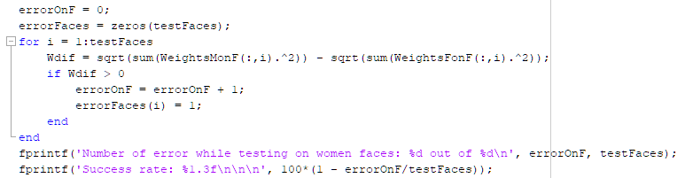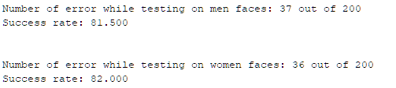**____________________________________________________________________**

As an extra example, energy threshold for basis vectors are changed for female vectors to %99.999 of the highest energy vector and %99.996 for males. With this, only one vector for female will be gathered and six vectors for males. The function for testing for male set is changed to difference between the average of sum of elements in weight vector. The function for female testing set is changed to average of sum of squared elements in weight vector. With all these manipulations, %100 of predictions are correct and with only 7 vectors in total. This solves the problem of data space and accuracy.

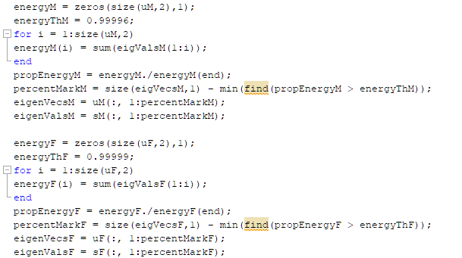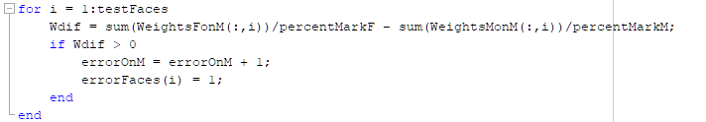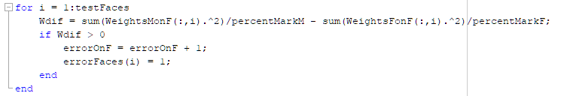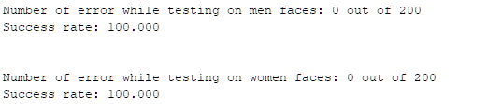

Codes used in this report can be found at https://github.com/meserbetcioglu/ehb328hw2