PGR111, Mandatory Coursework (hand-in)

This mandatory coursework has two parts- Part 1: The world database, and Part 2: Create your own database to be solved alone or in groups of 2.

If you choose to work in groups of 2, one of the group-members hands in the assignment for their group, and remembers to add the student they worked with on the hand-in.

The hand-in must be a pdf document.
Deadline for handing in the coursework is 10:00 on Friday the 17th of October.

Guideline
The hand-in should mark each task with its number. Write the SQL statement as text, then take a screenshot of the result (screenshot from DBeaver or MySQL Workbench).
If the result is large, its ok to just show the first page, but also get the total number of rows in the screenshot (or write total number of rows manually).
On Windows, the easy way to screenshot this is using the keys: [Win] + [Shift] + [s] (the “Windows snipping tool”).
Example: If task 0 was “List all city names”, the answer for task 0 would be: (total number of rows screenshotted in bottom right corner)
Task 0:
SELECT name
FROM city;
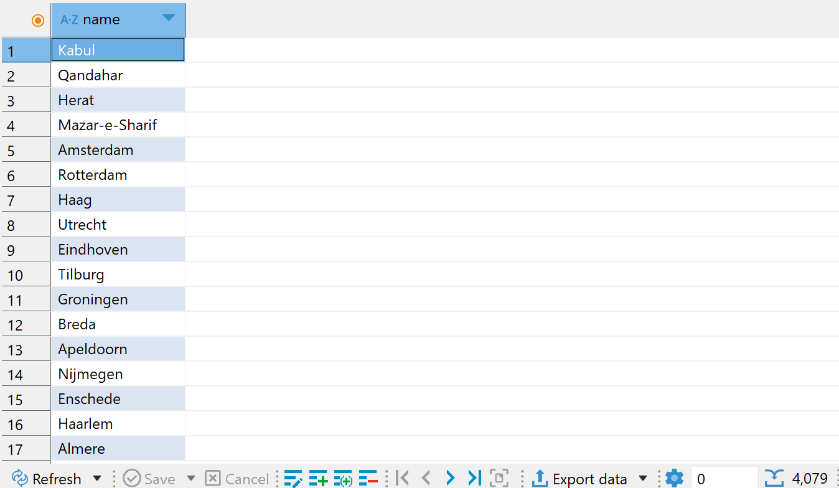

Hand-in taskset

Part 1: The world database
You will use the "world" database for the following tasks. The tasks cover a wide variety of what we have learned so far (lesson 1 to 5) but mixes and matches content from several lessons.

- List all cities (Id, CityName, CountryCode) plus their countries (CountryName), ordered by CountryName and then CityName.
- Extend task 1 and include countries that don’t have any cities.
- Extend task 2 and for the countries without cities, display {no city listed} for CityName instead of [NULL].
- Instead of listing column data, let's just do a SELECT that count country rows. Same criteria as for task 1, above but with no ordering- needless to say!
- Task 4 didn't make much sense! Let's do a count of rows for the task 2 dataset instead.
- Task 5 didn't make sense either. Let's change it to a count of cities per country (column headings: Code, CountryName, NumberOfCities). Note: 0 cities should be a valid result.
- Then a count of cities per country in continent ‘Europe’.
- Then, narrow task 7 down to showing counts for countries with 10 or more cities.
- Save the query in task 7 as a view (named citycounteurope_view) for easy, future use (column names for the view: Code, CountryName, NumberOfCities). Remember to test the view!
- Using the view in task 9, figure out its average number of cities. (In other words, “average number of cities per country in Europe with 10 or more cities”.)
- Let’s add a subquery: (still using the view in task 9) We only want to see the rows with a city count larger than the view's average city count.

Part 2: Create your own database
You will create your own database. Come up with a name (but not one we have used before) and a design yourself for the following tasks.

- Draw an ER model of your chosen database using UML and describe the model briefly in text. The model must result into - at least 2 tables, at least 10 columns in total, and a one-to-many relationship implemented with a primary key and a foreign key.
- Now implement the ER model you designed in Question 12. Write the SQL commands to create the database, including commands to drop the database if it already exists and then recreate it before creating the tables.
- Write SQL to insert data into both (“all”) your tables, at least 10 rows in total.
- Do an update to 1+ (but not all) rows in one of the tables.
- Write 3 SQL queries towards your own tables. 1 should be a regular (single table) query, 1 should be a JOIN query, and 1 should be a query containing a subquery.

