Parts 1 and 2
Part 2:
project ideas:
- Stortinget - party
- Artist - Album
- Client - Events
- Watch brands - Inventory
- Product - Category - Order
- Weather station - Measurement
- Movie - Review - Reviewer
- Party - Member - Committee
- Plant - Care log
- Author - Book - Loan - Member
- Item - Producer
- Investment - Fund - Investor
Part 1:
- List all cities (Id, CityName, CountryCode) plus their countries (CountryName), ordered by CountryName and then CityName.
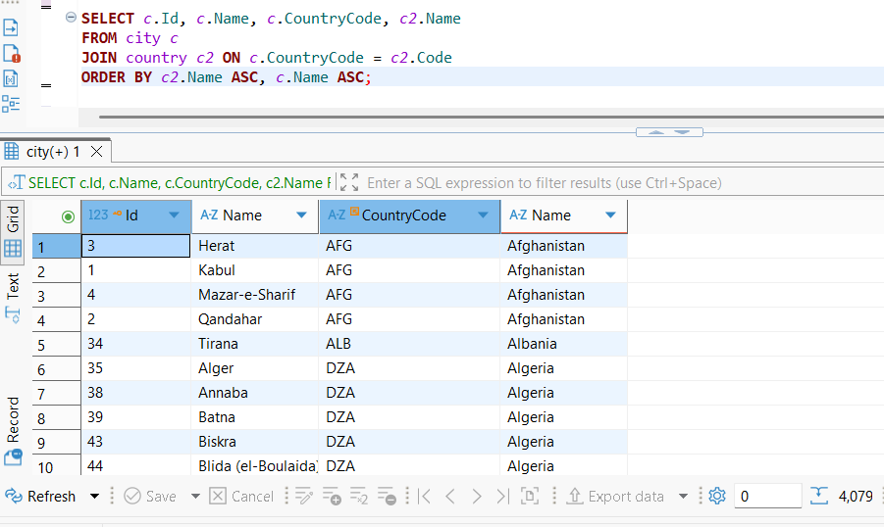

- Extend task 1 and include countries that don’t have any cities.
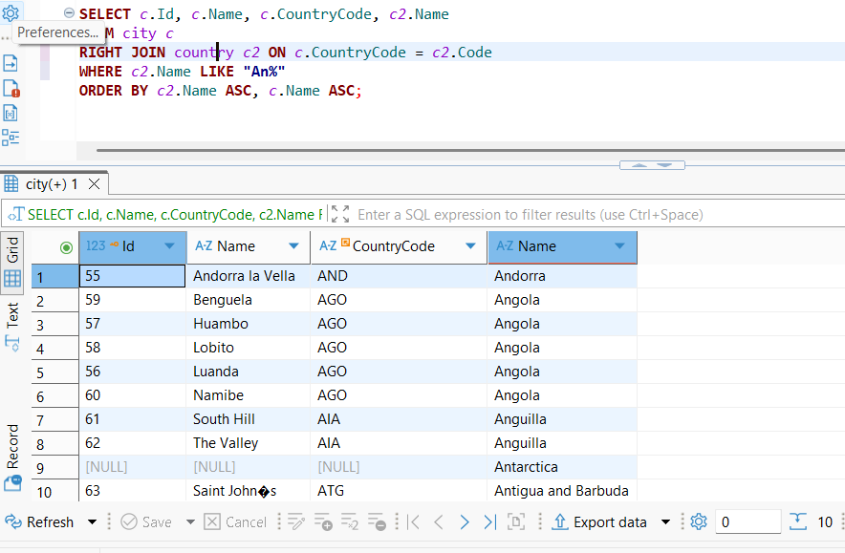

3. Extend task 2 and for the countries without cities, display {no city listed} for CityName instead of [NULL].
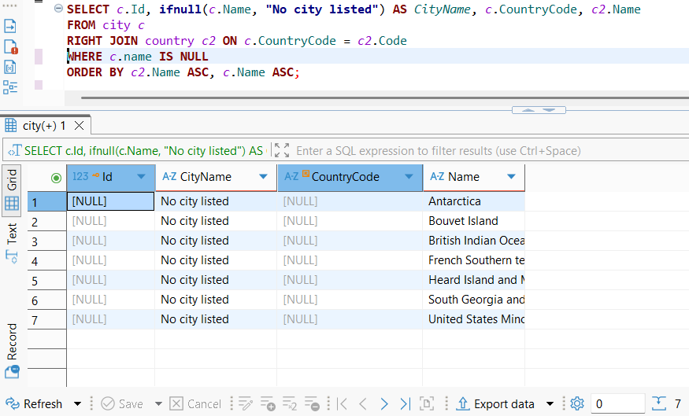
4. Instead of listing column data, let's just do a SELECT that count country rows. Same criteria as for task 1, above but with no ordering- needless to say!
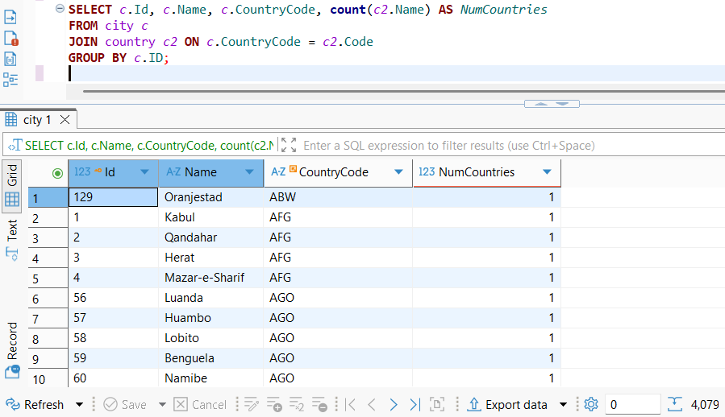
5. Task 4 didn't make much sense! Let's do a count of rows for the task 2 dataset instead.
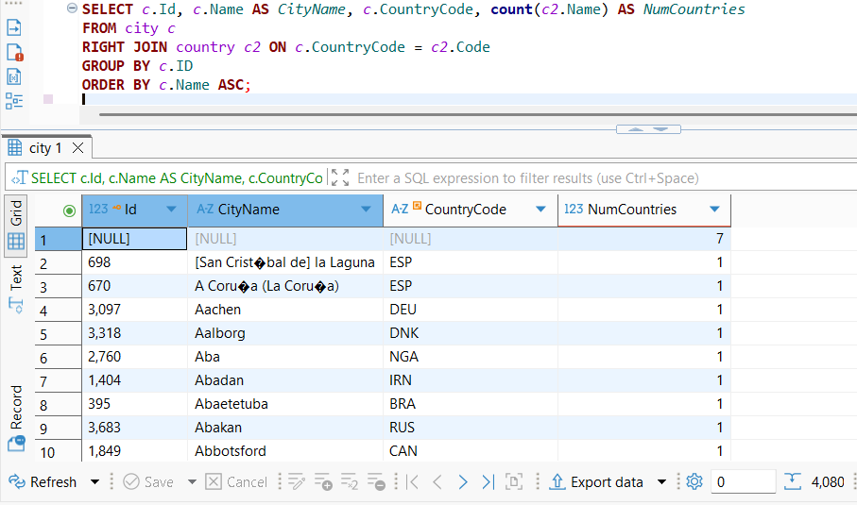
6. Task 5 didn't make sense either. Let's change it to a count of cities per country (column headings: Code, CountryName, NumberOfCities). Note: 0 cities should be a valid result.
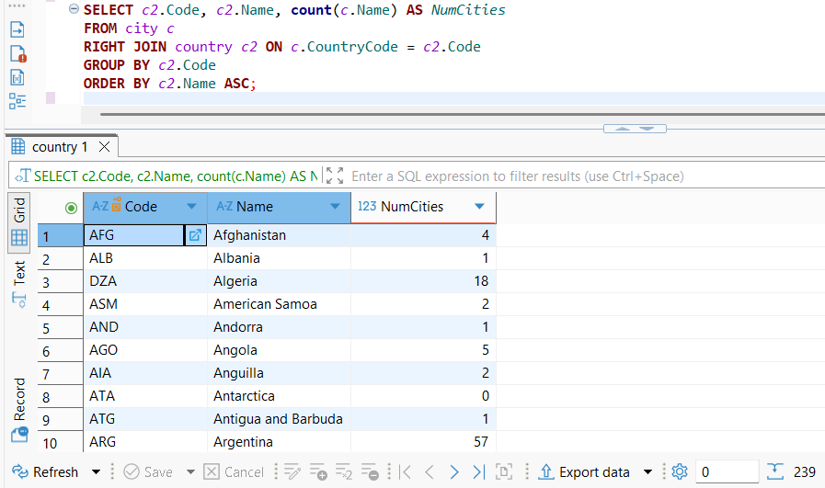
7. Then a count of cities per country in continent ‘Europe’.
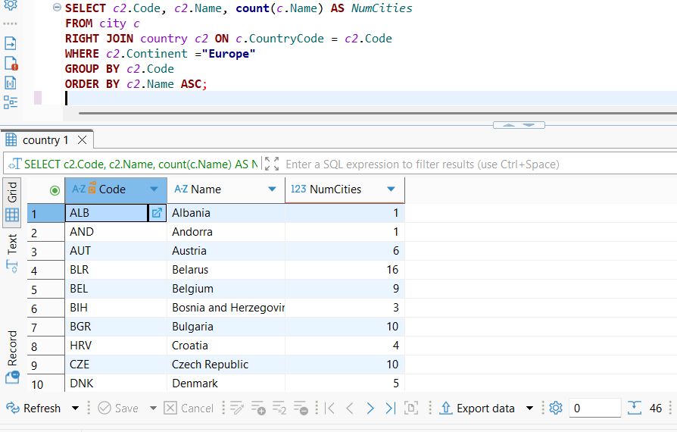
8. Then, narrow task 7 down to showing counts for countries with 10 or more cities.
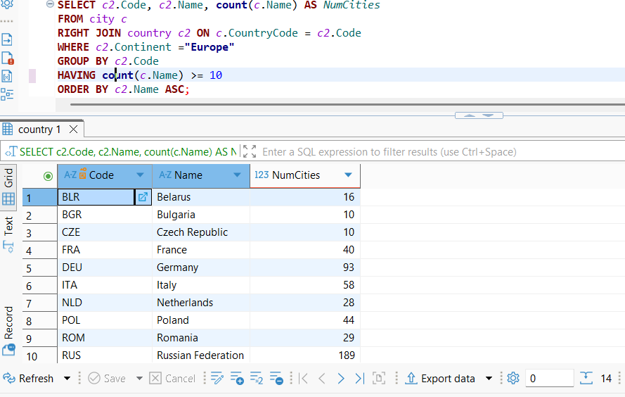
9. Save the query in task 7 as a view (named citycounteurope_view) for easy, future use (column names for the view: Code, CountryName, NumberOfCities). Remember to test the view!
CREATE VIEW citycounteurope_view AS
SELECT c2.Code, c2.Name AS CountryName, count(c.Name) AS NumberOfCities
FROM city c
RIGHT JOIN country c2 ON c.CountryCode = c2.Code
WHERE c2.Continent ="Europe"
GROUP BY c2.Code
ORDER BY c2.Name ASC;

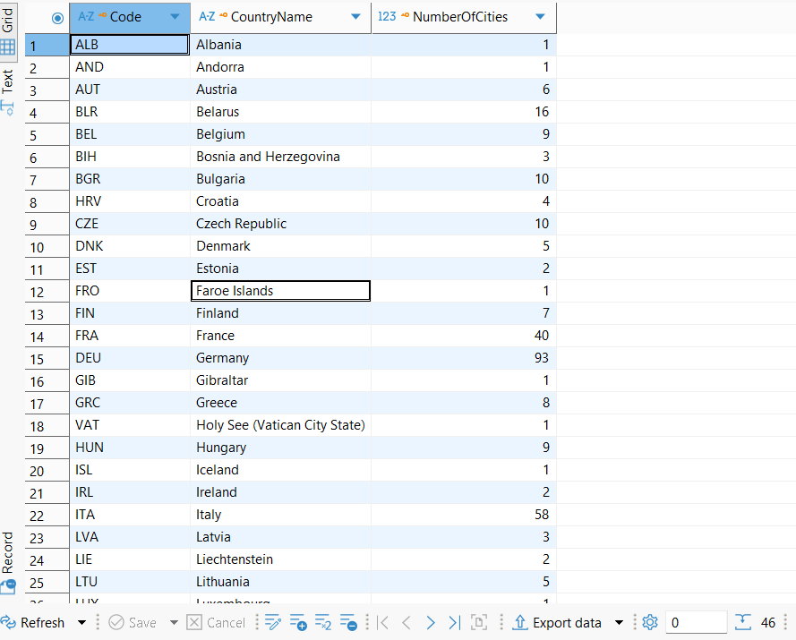
10. Using the view in task 9, figure out its average number of cities. (In other words, “average number of cities per country in Europe with 10 or more cities”.)
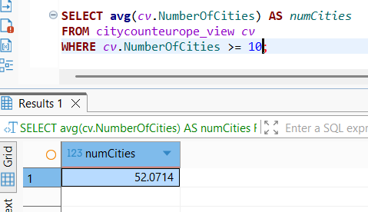
11. Let’s add a subquery: (still using the view in task 9) We only want to see the rows with a city count larger than the view's average city count.


