Today I take doctors through on the triage. All was good and they understand. They were some things, they were saying missing on the doctor’s dialysis including, doctor’s notes, doctors note monthly, Referral form Dialysis patient and Pre-procedural checklist dialysis access form

While here they say, the input for AVPU should be A, V, P, U and not AVPU1, AVPU2, AVPU3, AVPU4. They also say for Trauma part need to be remove and Oxygen supplementation need to be and input field and not drop down as they enter in terms of percentage.

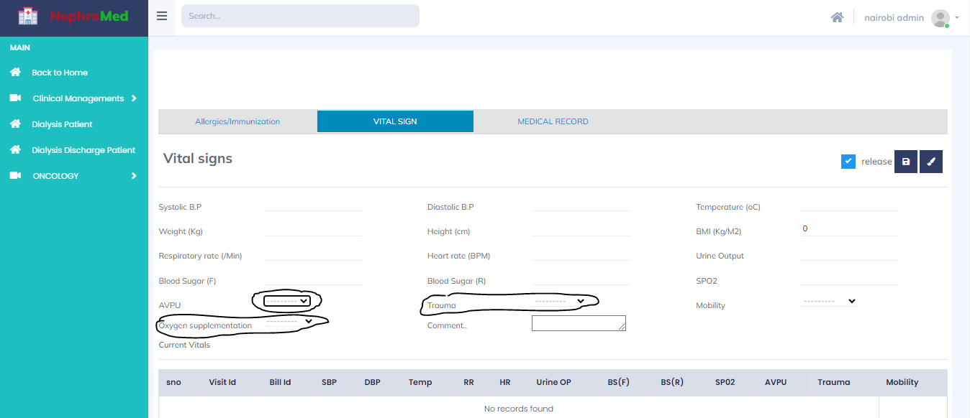

On the immunization part: check on the immunizations part I cycle below:

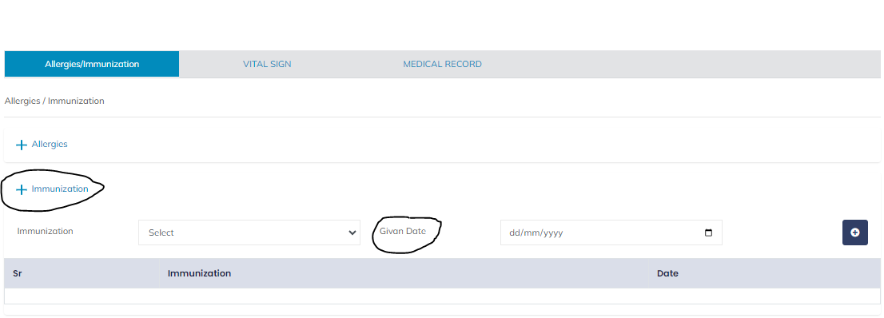

On these page below the doctors say ,recommends that the system examinations should include this also as they normal add on it :

respiratory system, Cardiovascular, Digestive system, genital system, musculoskeletal system, integumentary system and endocrine system:

The Vaginal Examination say it need to be change to genital system

The diagnosis also should come after the investigations/ procedure

They also want the D GRG-Code to be remove

On the prescription medicine they also wanted a part to write for the patients the medicine they do not have for patient to go and buy

