E-Commerce Database Management System.

Name: B Meshak Jebasraja
GitHub URL: meshak-22/Ecommerce_Database_Project

Table Schema:

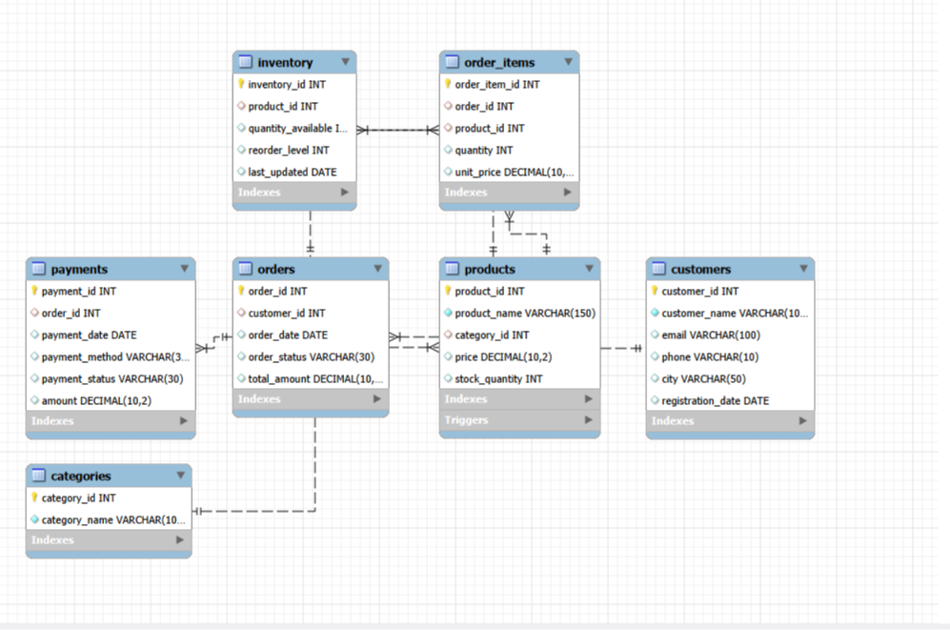

BASIC LEVEL

1. Write a query to retrieve all customer records.
2. Display the customer names, email addresses, and cities of all customers.
3. Find all customers who belong to Chennai.
4. Retrieve all products priced above ₹5,000.
5. Find products priced between ₹1,000 and ₹5,000.
6. Display all customers from Chennai or Bangalore.
7. Find all products whose names contain the word 'Phone'.
8. Retrieve all orders with status = 'Pending'.
9. Find all payments with status = 'Failed'.
10. Display the top 10 most expensive products.
11. Retrieve all customers sorted alphabetically by name.
12. Find the minimum, maximum, and average product price.
13. Find the total number of customers registered in the database.
14. Calculate the total order amount from all orders.
15. Find the total number of payments grouped by payment status.

INTERMEDIATE LEVEL

16. Find the total number of orders placed by each customer.
17. Retrieve customers who have placed more than one order.
18. Find the total purchase amount for each customer.
19. Calculate the average product price for each category.
20. Find payment methods used more than 10 times.
21. Display customer names alongside their order IDs and order amounts.
22. Retrieve product names, category names, and product prices.
23. Display each order with its payment method and payment status.
24. Retrieve order IDs, product names, quantities, and unit prices for all order items.
25. Find products that do not have a matching inventory record.
26. Retrieve products priced above the overall average product price.
27. Find the most expensive product or products in the database.
28. Find customers whose total order amount exceeds ₹50,000.
29. Use a CTE to calculate the total sales generated by each customer.
30. Find the three highest-value orders for each customer using a window function.

ADVANCED LEVEL

- Find the top five customers who generated the highest total sales.
- Retrieve customers who purchased products from multiple categories.
- Find the category generating the maximum revenue.
- Display products that have been ordered more than 20 times.
- Find the most frequently ordered product in the database.
- Retrieve products whose available inventory is below their reorder level.
- Find customers who have never placed an order.
- Retrieve duplicate customer records based on customer name and email.
- Calculate the percentage contribution of each customer to total sales.
- Calculate the percentage contribution of each product category to total revenue.
- Find the monthly revenue generated by the e-commerce store.
- Retrieve the number of orders placed in each month.
- Find the top five products that generated the highest revenue.
- Identify orders that have no corresponding payment record.
- Find customers who placed orders but have failed payments.
- Calculate the average order value for each customer.
- Find the products that contribute to the highest percentage of total revenue.
- Rank products within each category based on price using a window function.
- Calculate the running total of revenue by order date.
- Display customer performance rankings based on total spending, number of orders, and average order value

