**Hyundai Getz, aftermarked remote controlled central lock**

by [browsem](http://www.instructables.com/member/browsem/) in [cars](http://www.instructables.com/tag/type-id/category-workshop/channel-cars/)

[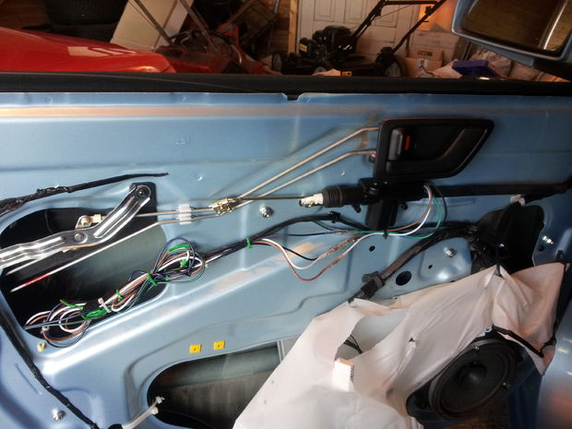](http://www.instructables.com/file/F1MLD3LH5EDU72E/)

So. i got me a Hyundai Getz. Nice little car. Central locking was installed, but not remote controlled.  
So i went and got me an aftermarket kit, and wanted to hack that onto the existing system. Something i have done 50 times or so.  
But that was not possible. I don't know if i should be mad or not, but the Getz hasn't actually GOT a normal central locking system, if it wasn't installed by the factory. Instead there is NO actuator in the drivers seat door, and NO electronic box that controls the other doors. There is instead, a relay INSIDE the driver side door lock, and when altering from locked to unlocked, this then sends the power to control the other doors, either one way, or the other. Smart, cheap, difficult to upgrade. Oh well, i guess that every thing cant be easy to exploit.  
The Hyundai kit, includes new relays, a new door lock, and pulling apart the center console and the driver seat door.  
we will only do the door.  
To see how you get into the door, without damaging it, look at this.  
http://myriadprojects.wordpress.com/2011/02/22/getz-to-remove-the-door-trim/  
Thats a nice blog about how to upgrade the cars sound system, and for doing this you also have to get into the door  
EDIT: There IS an even easier way, see the last page.

**Step 1: So what to do**

[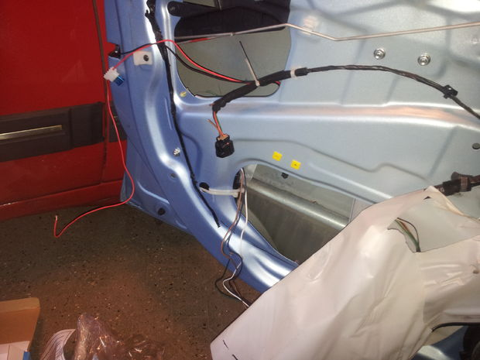](http://www.instructables.com/file/FOFMALZH5IRV2QB/)

[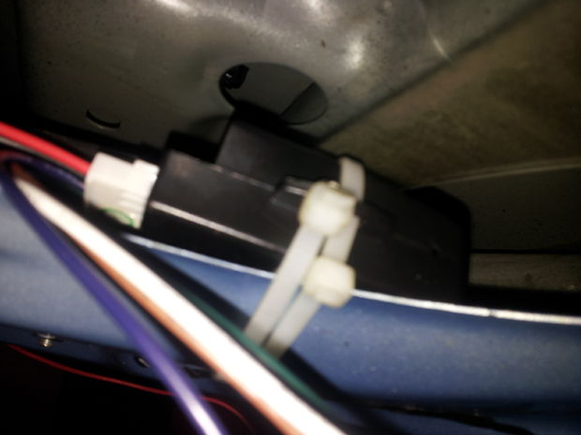](http://www.instructables.com/file/F222TDSH5JVOKIK/)

[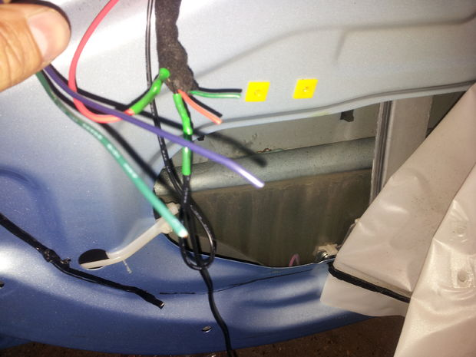](http://www.instructables.com/file/FG28C8FH5IRV2R7/)

Well, let me show you  
1. Place the controller, at a place where it wont be in the way of the windows, and other goodies. i choose the lower outer corner, and fixed it with a couple of strips  
the picture shows the power + ground cables pulled up to the original connector ( don't do like i did and cut the wire harness. cut the wires on the other side of the connector instead.  
I removed the fuse, as the schematics tell me, that the power wire is fused via a 20 amp fuse.  
EDIT: I have since had to realize, that the door is a place of much water, and a lot of bumps. This disabled my remote system on its 3. day. NOW i have the controlbox wrapped in foam (the kind you find in mattresses), and this i have then wrapped in a plastic bag. The wires i then feed in from the BOTTOM, so that any water, will fall OUT of the bag, instead of INTO it. NOW it works

**Step 2: Getting most of it to work**

[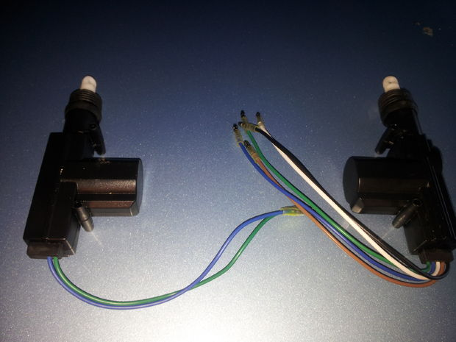](http://www.instructables.com/file/FYENZYDH5JVX03M/)

[](http://www.instructables.com/file/FG28C8FH5IRV2R7/)

[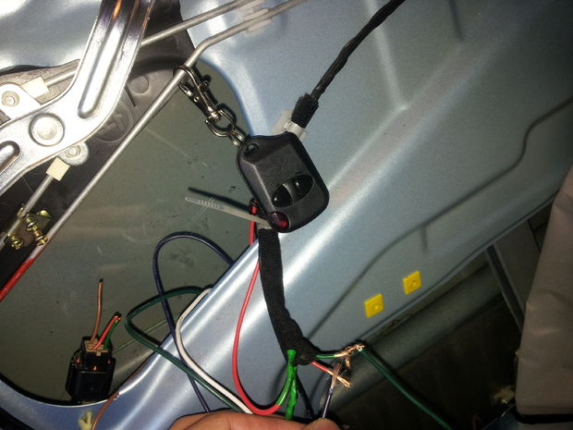](http://www.instructables.com/file/F23IZ5TH5IRV2RJ/)

So now we have power, we need to know witch wires to use, to control it all.  
Look at the schematics for the new box, or if there are 4 actuators, just use the wires as described in the picture.  
When this is done, most will work.

**Step 3: The really hard part.**

[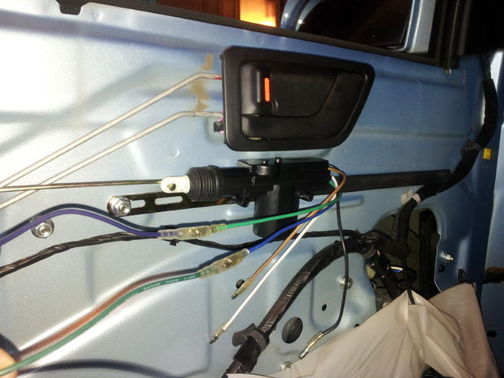](http://www.instructables.com/file/F6C2DKDH5ED7TBL/)

[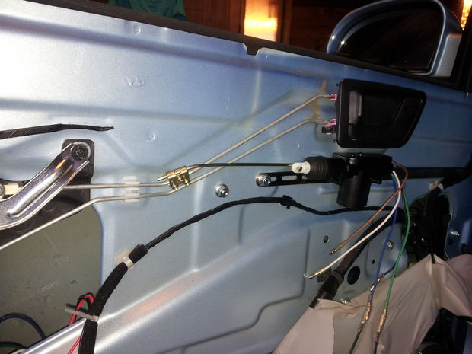](http://www.instructables.com/file/FDIFG9PH5JVOKIL/)

[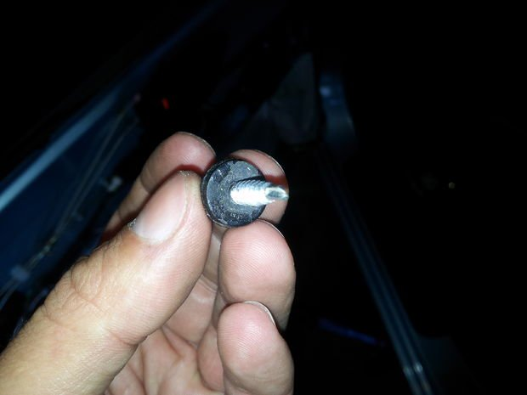](http://www.instructables.com/file/FU9KZ3LH5IRV2S3/)

So now we have 3 doors, and a boot working. The driver side doors not working, and the locks will only work in remote control mode.  
This is because of the missing actuator in the driver seat door.  
So we will have to install one( or get one from Hyunday, but that will be more expensive, than adding this one,as this one was in the kit).  
after the pictures i connected black to black, brown to white, and white to brown.  
That way, the polarity of the sensor matches the polarity of the actuators movement.  
  
Clean up the wires, redo the plastic for moisture. And your set.  
  
Now my placement, has me pushing the actuator and the door liner. Not a lot, but still.  
The setup worked for about 3 days, then the remote stopped working. perhaps, the box cant stand the jolting of the closing door.  
This i have still to fix ( could be its just a defective box)  
See page 1, where i tell you how i fixed that.  
  
HOW it works.  
The control box, electrically  controls the 3 doors + boot AND the extra actuator, that mechanically controls the driver side door.  
IF you use the key, to open the driver side door (or the inside handle) THAT mechanically pulls the actuator, sending a signal to the control box, making it electrically open the rest.  
  
  
THE EVEN EASIER ROUTE.  
OK, so instead of messing with the wiring system, just get the + and - from the connector.  
Connect this to the control box.  
Connect the control box, to the new after marked actuator, placed/connected as show.  
DONE.  
  
HOW this works.  
The control box, electrically  controls the extra actuator that mechanically controls the driver side door.  
The driver  side door original relay, then electrically drives the  3 doors + boot.  
IF you use the key, to open the driver side door (or the inside handle) THAT mechanically pulls the actuator, sending a signal to the control box, doing nothing, AND works like it always has, by electrically controlling the 3 doors + boot

**Step 4: The missing schematics**

[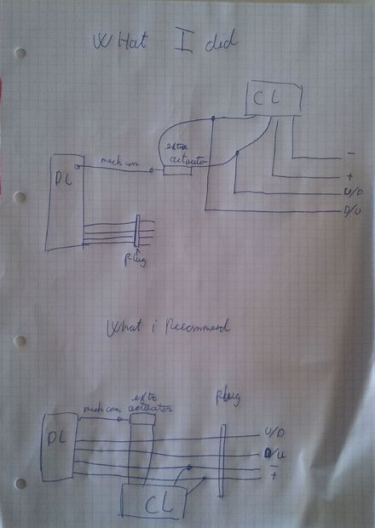](http://www.instructables.com/file/FJU46O1HIGFJT98/)

mahhhf asked me for some more details, and i agreed that the instructable, missed some schematics.  
Well.. here U go. hope its usefill