**Software requirement document**

Software Requirements Document for 3D excursion, in SDU.

Team: Sir Manas & Co.

Manas Sirkebay, Osman Zandarov, Ilshat Khairahun, Merrustam Merkarim

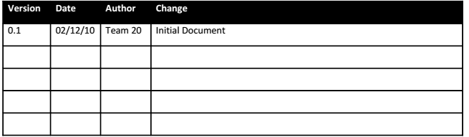

**Table of Contents**

Table of Contents...........................................................................................3

1 Introduction ............................................................................................... 4

1.1 Purpose ................................................................................................... 4

1.2 Scope ....................................................................................................... 4

1.3 Definitions, acronyms, abbreviations ...................................................... 4

1.4 References .............................................................................................. 4

1.5 Overview ................................................................................................. 4

2 Overall Description .....................................................................................5

2.1 Product Perspective ................................................................................ 5

2.2 Product functions .................................................................................... 6

2.3 User characteristics .................................................................................16

2.4 Constraints ..............................................................................................16

2.5 Assumptions and Dependencies .............................................................16

3 Specific Requirements ................................................................................17

3.1 External Interface Requirements ............................................................ 17

3.2 FEATURES ................................................................................................ 17

3.3 Performance requirements ..................................................................... 17

3.4 Design Constraints .................................................................................. 18

3.5 Software System Attributes .................................................................... 18

3.6 Other Requirements ............................................................................... 18

1. **Introduction**

**1.1 Purpose**

The purpose of this document is 3D guide for SDU to our guests or students who want to be accepted in SDU to study, and for every one who wanted to use the web-application.

**1.2 Scope**

This document will describe the use cases and features of the project.

* 1. **Definitions, acronyms, abbreviations**

**Admin ->** person who will add and change infos.

**User ->** person who will use the application. It can be anyone.

**Web-application ->** type of web-page which does some actions.

**Photo (3D) ->** some pictures which will help us to predict the place.

**Map ->** picture of any place in small size.

**GPS ->** some function which will help us to find our current place

**Information ->** it will be button which executes information about the application.

**Search->** function which helps to find something you want

**History ->** text of your all previous queries.

**1.4 References**

Wikipedia: <http://wikipedia.org>, <http://www.w3schools.com/>

**1.5 Overview**

[OMIT]

1. **Overall Description**

3D excursion is an web-application which helps any person who wants to see SDU’s building in small screen. And it can guide to see whole university and get information at the table not by walking.

**2.1 Product Perspective**

In the future, SDU will be very big university when building will over. Then it will be popular university. And new people can be lost in the territory. Then the application will be useful.

**2.1.1 Concept of Operations**

The system will run on web application which we are trying to do. The application will store in server (may be in computer).

**2.1.2 Major User Interfaces**

Example Screenshot and description

**2.1.3 Hardware Interfaces**

This software requires no more than standard personal computer peripherals.

**2.1.4 Software Interfaces**

OMIT for now.

**2.1.5 Communication Interfaces**

(OMIT for now)

**2.1.6 Memory Constraints**

OMIT for now)

**2.1.7 Operations**

OMIT for now

**2.1.8 Site Adaptation Requirements**

OMIT for now

**2.2 Product functions**

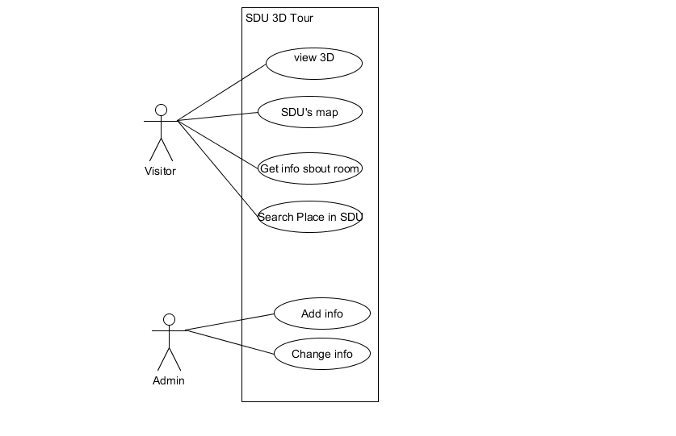

**Use Cases:**

**• User:**

o See 3D photos

o uses the map of SDU

o Get info about rooms, contacts, your current place and other

o Search places

**• Admin:**

o Add info

o Change info

**2.2.1 Example use case:**

**Get Info**

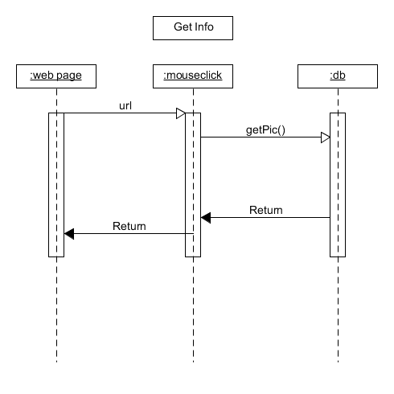

**a. Name of the use-case**

Get Info

**b. Brief description of the use case – include the goal**

to get info about project and developers, contacts and other

**c. Actors**

users and admin

**d. Main flow**

Enter the web –page and read only. That’s all

**e. Alternate flows**

none

**f. Preconditions (if any)**

none

**g. Post conditions (if any)**

none

**Map**

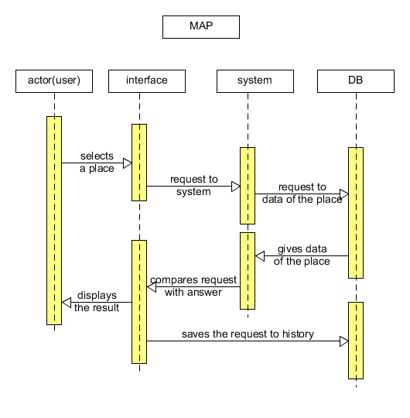

**a. Name of the use-case**

Map

**b. Brief description of the use case – include the goal**

Overall plan of excursion

**c. Actors**

admin and user

**d. Main flow**

Users visit the web-page and will orient with this case.

**e. Alternate flows**

none

**f. Preconditions (if any)**

none

**g. Post conditions (if any)**

none

**Search place**

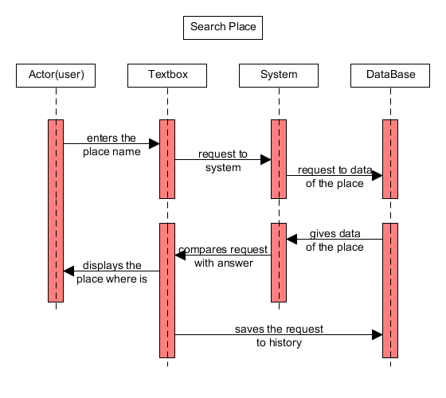

**a. Name of the use-case**

search place

**b. Brief description of the use case – include the goal**

to find places, rooms and other

**c. Actors**

users

**d. Main flow**

users will enter to this page and find places they want

**e. Alternate flows**

none

**f. Preconditions (if any)**

none

**g. Post conditions (if any)**

none

**View page**

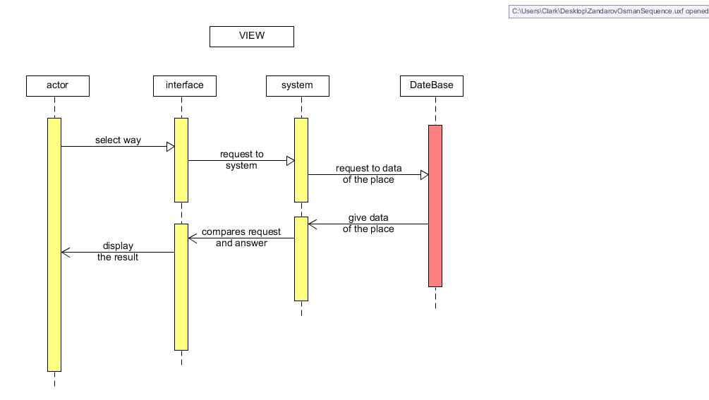

**a. Name of the use-case**

View page

**b. Brief description of the use case – include the goal**

page of excursion

**c. Actors**

users

**d. Main flow**

Users may enter to page and will see excursion in 3D.

**e. Alternate flows**

none

**f. Preconditions (if any)**

none

**g. Post conditions (if any)**

none

**2.3 User characteristics**

• User: A men who have internet and link to our web-page.

• Admin: Is a staff of project who can add changes to app.

**2.4 Constraints**

• The system is used mainly by enrollees, students, teachers and others.

• This is an web-application for university.

• This web application is used for tour in SDU.

**2.5 Assumptions and Dependencies**

1. Browser dependency.

2. Internet dependency.

**3 Specific Requirements**

**3.1 External Interface Requirements**

SDU’s network page for tour. That`s all.

**3.1.1 User Interfaces**

SDU’s network page for excursion. That`s all.

**3.1.2 Hardware Interfaces**

Computer, tablet.

**3.1.4 Software Interfaces**

Web-application which is opened by browser

**3.1.5 Communications Interfaces**

Internet connection

**3.2 FEATURES**

**3.3 Performance requirements**

We have to know WEB courses very well. And need security knowledge.

**3.4 Design Constraints**

As we studied in CSI, everything is obvious. And there is no extra design object.

**3.5 Software System Attributes**

Network

**3.5.1 Reliability**

Reliability is on simplicity. The simple project has less count of bugs.

**3.5.2 Availability**

We will not have availability.

**3.5.3 Security**

Security level is not low.

**3.5.4 Maintainability**

Developers study in SDU. They will fix if there will be errors.

**3.5.5 Portability**

As we planned, server will be PC or laptop. Portability is exists.

**3.6 Other Requirements**

There is no other requirements.