SQL QUERIES:

Members :

1. create table Department(department_name varchar(20) NOT NULL,Department_code varchar(20) NOT NULL,Primary key(Department_code));
2. create table medicine(medicine_name varchar(20) NOT NULL,medicine_cost double,medicine_code varchar(20) NOT NULL,PRIMARY KEY(medicine_code));
3. create table person(first_name varchar(20) NOT NULL,middle_name varchar(20) ,sur_name varchar(20) NOT NULL,person_id int NOT NULL,date_of_birth date,status varchar(20),gender varchar(20) NOT NULL,contact varchar(20),PRIMARY KEY(person_id));
4. alter table medicine modify medicine_cost decimal(18,2) default 0.00;
5. create table disease(disease_name varchar(20) NOT NULL,disease_code varchar(20) NOT NULL,Department_code varchar(20) NOT NULL references Department(Department_code));
6. create table doctor(doctor_code varchar(20) not null,disease_code varchar(20) NOT NULL references disease(disease_code),person_id int not null UNIQUE REFERENCES person(person_id));
7. create table patient(patient_id varchar(20) not null ,person_id int not null UNIQUE REFERENCES person(person_id),date_of_admission datetime,disease_code varchar(20) NOT NULL references disease(disease_code),date_of_discharge datetime,inpatient varchar(5),PRIMARY KEY(patient_id));
8. create table transaction(transaction_code varchar(20) not null,payment_mode varchar(20) not null, amount decimal(18,2) default 0.00,patient_id varchar(20) not null references patient(patient_id),

PRIMARY KEY(transaction_code));

1. create table prescription(patient_id varchar(20) not null references patient(patient_id),medicine_code varchar(20) REFERENCES medicine(medicine_code))
2. ALTER TABLE patient ADD FOREIGN KEY (person_id) REFERENCES person (person_id);
3. ALTER TABLE disease ADD FOREIGN KEY (department_code) REFERENCES department(department_code);
4. ALTER TABLE doctor ADD FOREIGN KEY (disease_code) REFERENCES disease (disease_code);
5. ALTER TABLE doctor ADD FOREIGN KEY (person_id) REFERENCES person(person_id);
6. ALTER TABLE patient ADD FOREIGN KEY (disease_code) REFERENCES disease(disease_code);
7. ALTER TABLE transaction ADD FOREIGN KEY (patient_id) REFERENCES patient (patient_id);
8. ALTER TABLE prescription ADD FOREIGN KEY (patient_id) REFERENCES patient (patient_id);
9. ALTER TABLE prescription ADD FOREIGN KEY (medicane_code) REFERENCES medicane (medicane_code);

1. Insert query

INSERT INTO prescription( patient_id,medicane_code,quantity)

VALUES(‘pt_10’,’104’,’20’);

INSERT INTO prescription

VALUES('pt_113','199','8');

INSERT INTO transaction

VALUES('xyz123','m-pesa','200','pt_113');

INSERT INTO transaction

VALUES('uuynbsye','m-pesa','1000','pt_113'),('abcdzyxw','m-pesa','1200','pt_151');

1. .select query

SELECT * FROM `person`

SELECT medicane_name,medicane_cost FROM medicane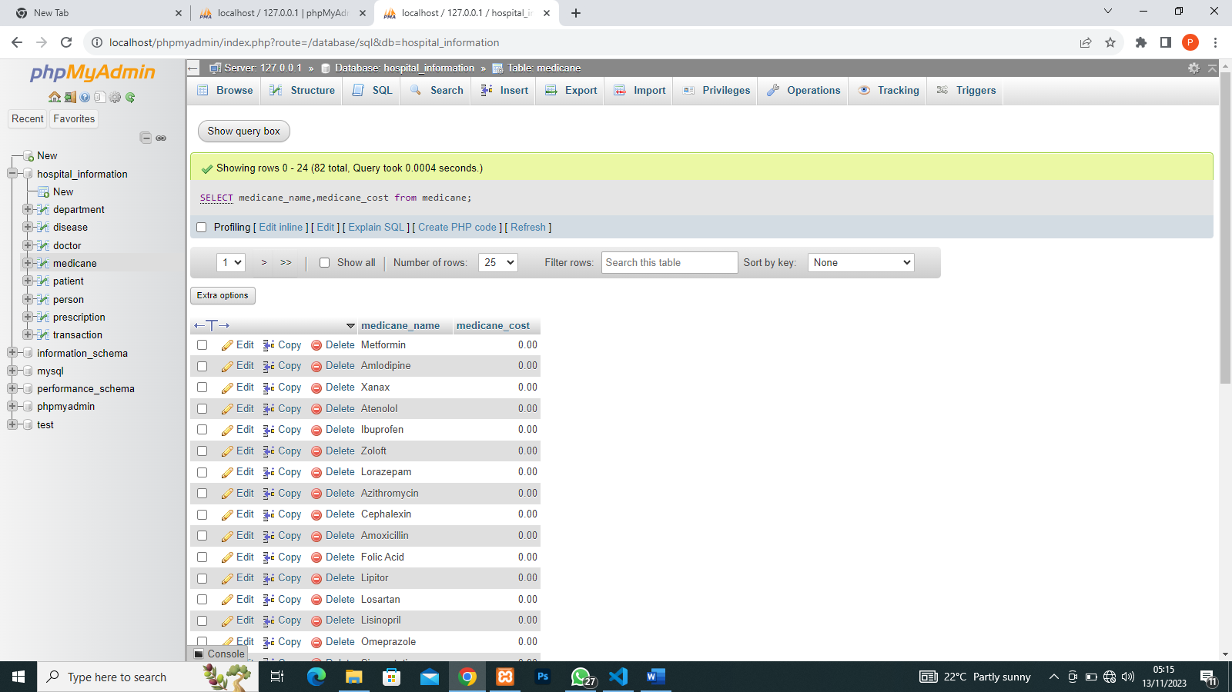

1. SQL WHERE CLAUSE

SELECT * FROM `person` WHERE gender='female'

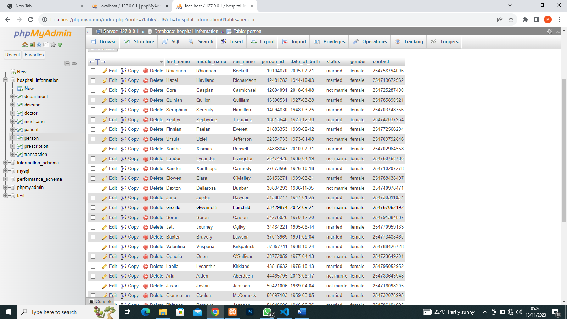

1. SQL AND and OR operators

SELECT * FROM `person` WHERE gender='male' AND status='married'

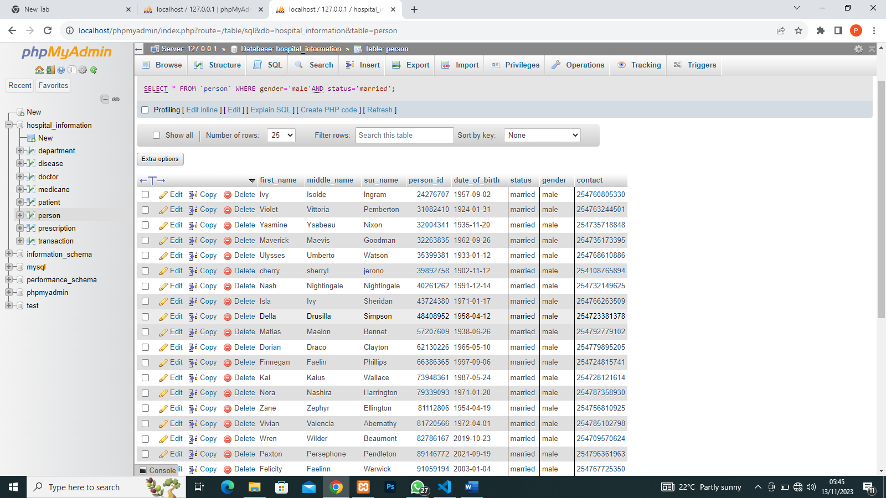

SELECT * FROM `person` WHERE gender='male' OR status='married'

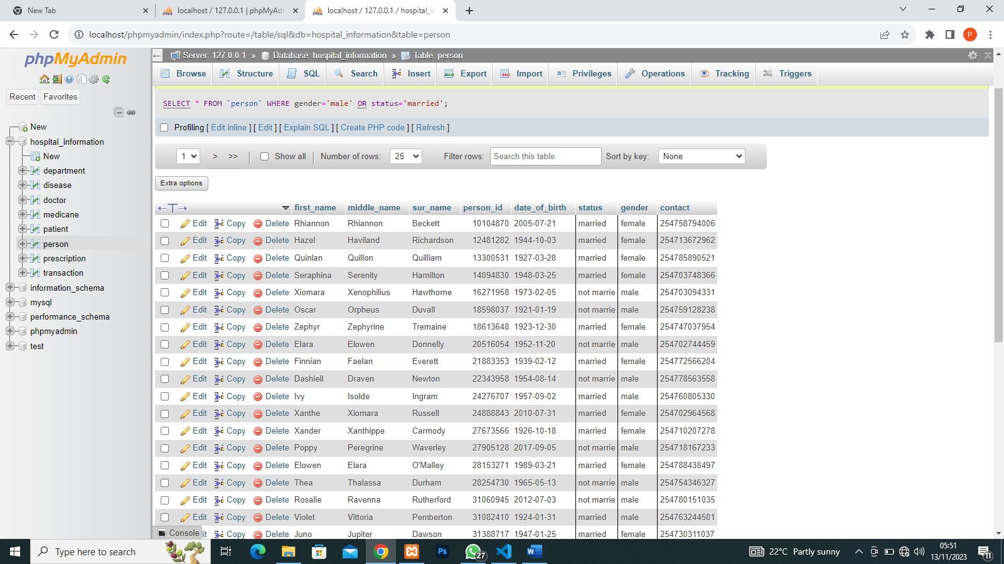

1. UPDATE QUERY

UPDATE `medicane` SET medicane_cost='100'

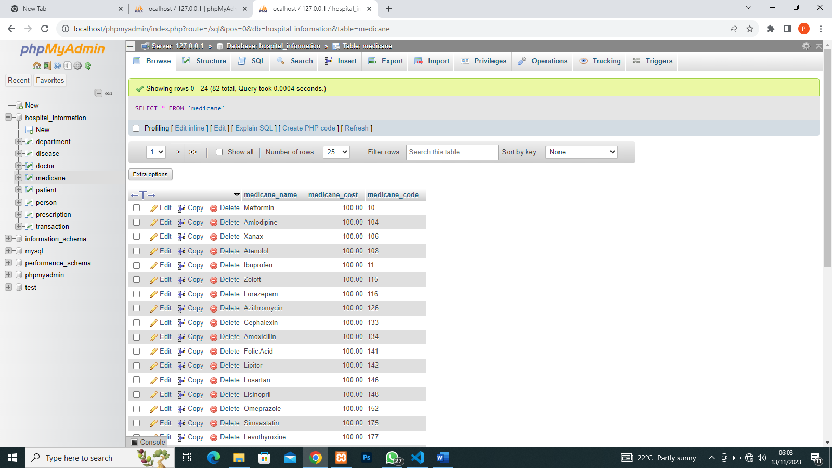

UPDATE `person`SET status='not married' WHERE status='not marrie'

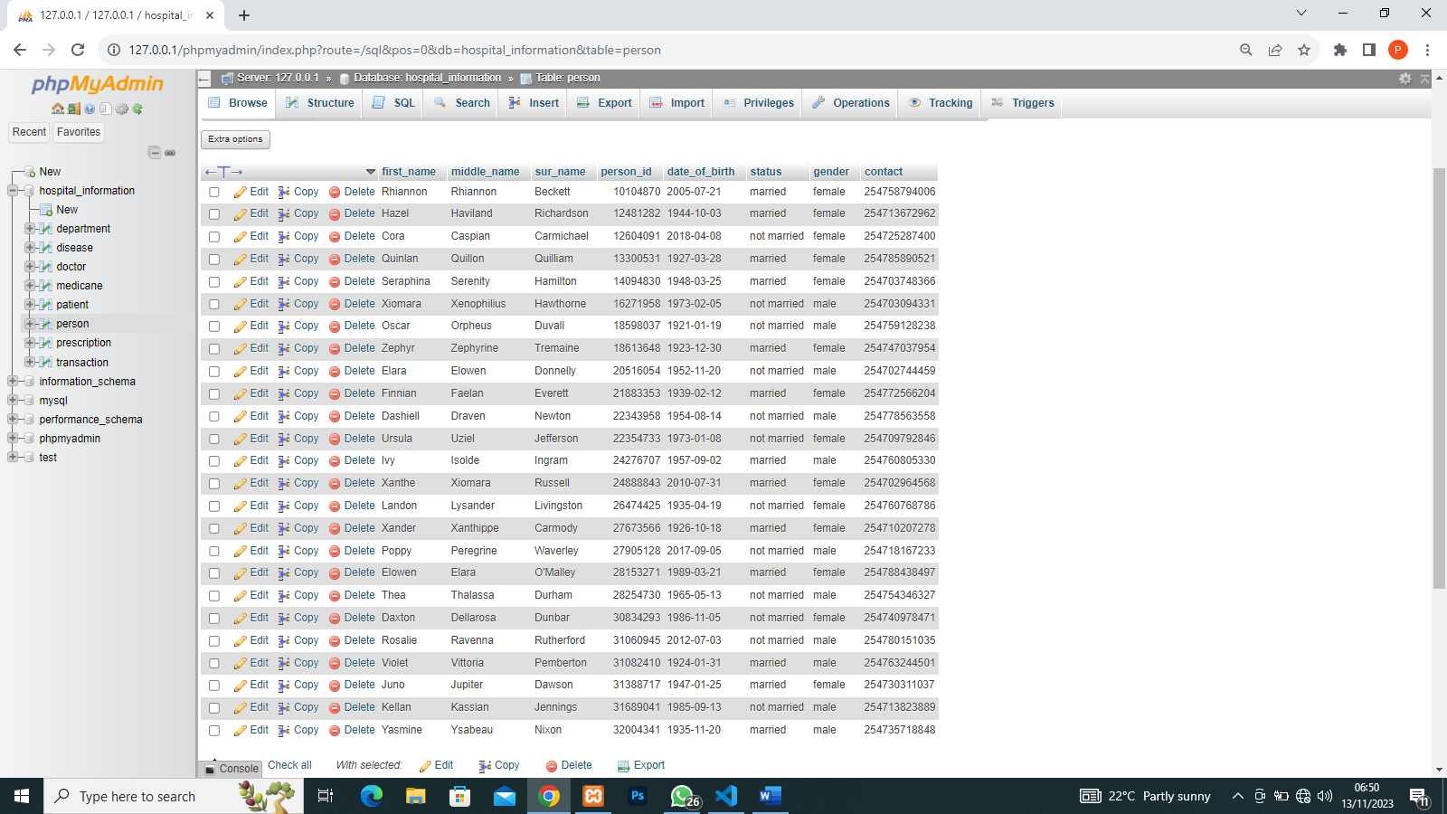

1. DELETE QUERY

DELETE FROM medicane WHERE medicane_name=’100’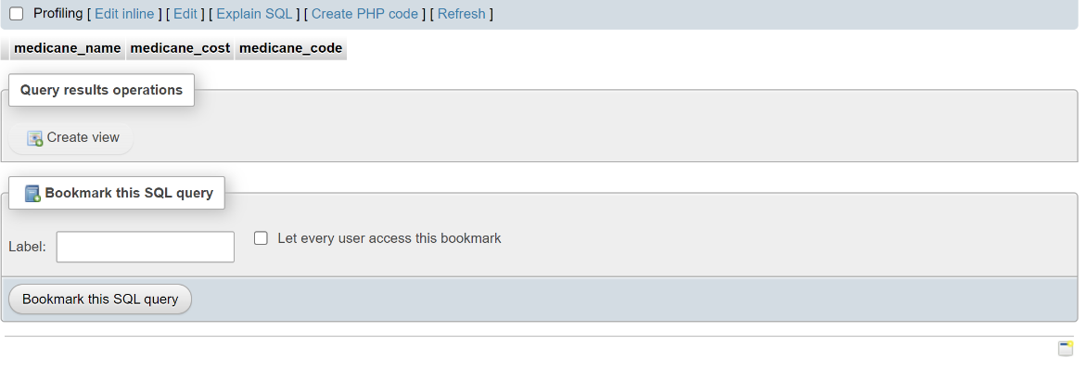

1. SQL LIKE QUERY

SELECT * FROM ‘patient’ WHERE date_Of_admission LIKE ‘2023%’

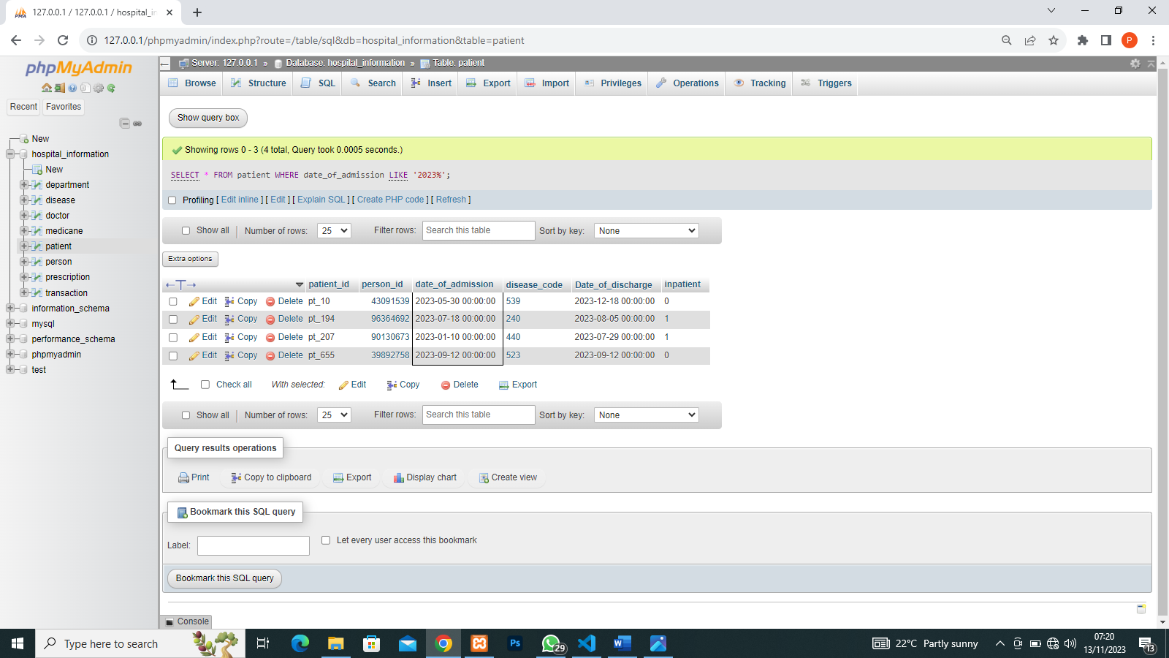

1. SQL TOP CLAUSE

SELECT * FROM doctor LIMIT 5

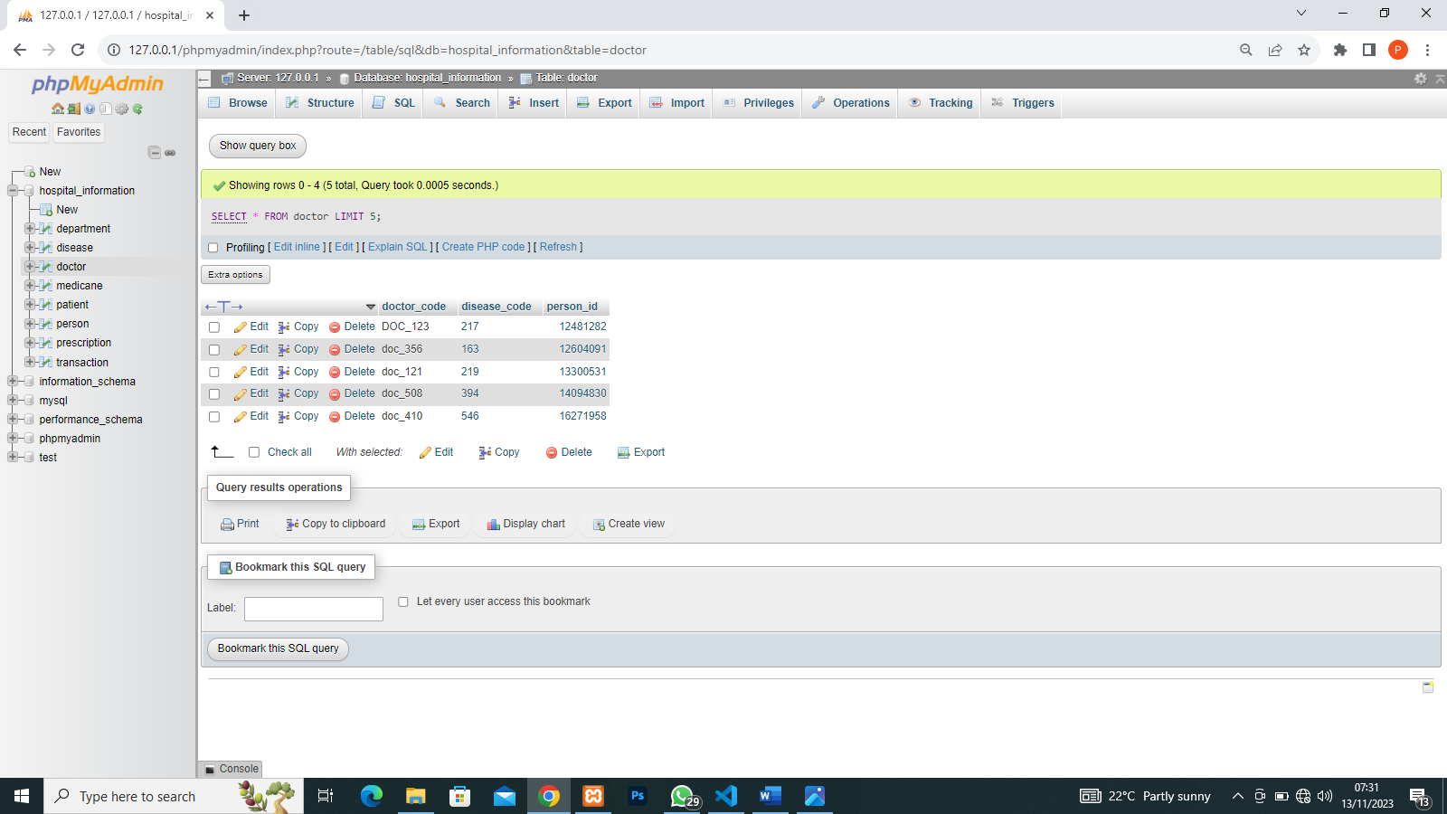

1. SQL ORDER BY CLAUSE

SELECT * FROM `disease` ORDER BY disease_code DESC LIMIT 5

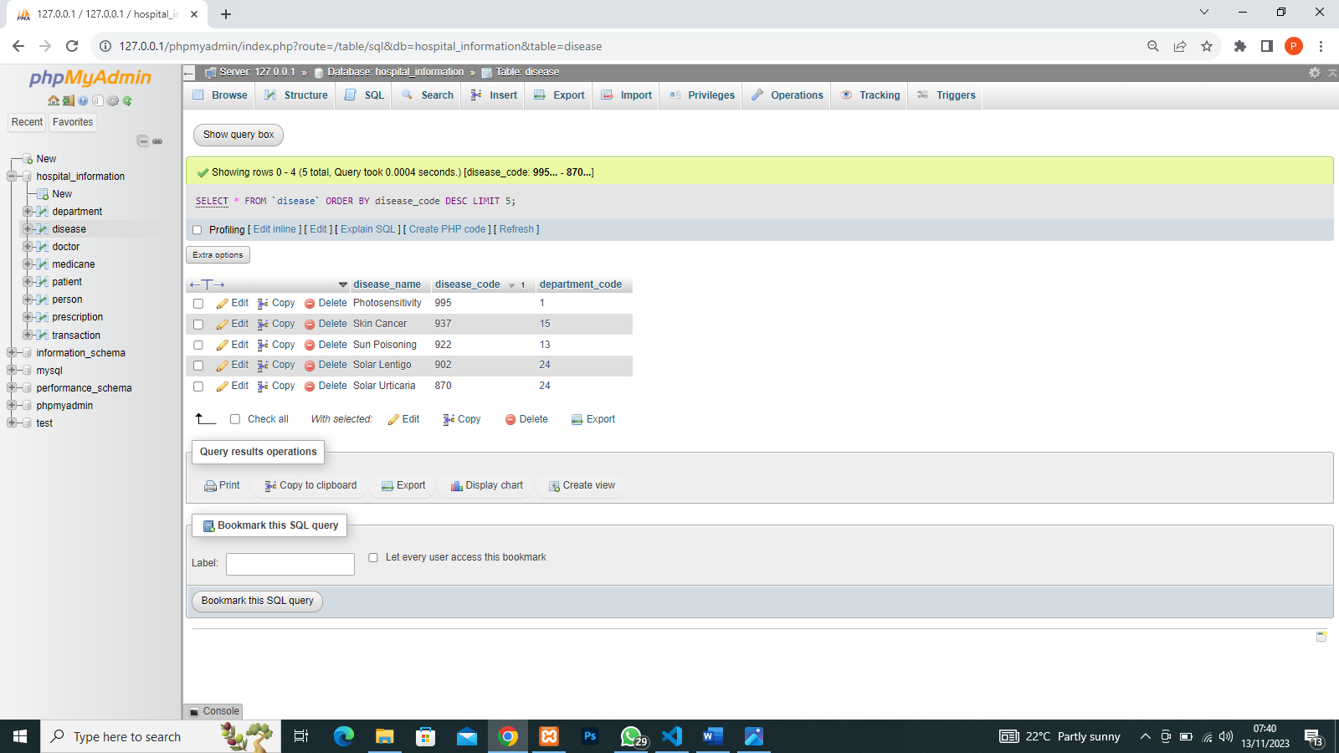

1. GROUP BY

SELECT patient_id, SUM(amount) as amount_payed FROM transaction GROUP BY patient_id

