RESEARCH REPORT
ON
“IOT IN REAL LIFE:
HEALTHCARE MONITORING SYSTEM”

PREPARED BY:
NAME: DISHA VIKAS MESHRAM
Date
1 june 2026
Introduction to the Topic
This research report presents a detailed study on the applications of the Internet of Things (IoT) in real-life healthcare monitoring systems. It explains how smart devices, sensors, wearable technologies, and cloud computing are transforming modern healthcare by enabling real-time patient monitoring, remote medical support, health data analysis, and emergency healthcare Services
Purpose of the Report
The main purpose of this report is to understand the importance of IoT technology in healthcare systems and how it improves patient safety, medical efficiency, remote monitoring, and quality healthcare services in daily life.

“Technology connects devices, IoT connects healthcare and human lives.”

Report Year:
2026– 2027
Introduction
The Internet of Things (IoT) in healthcare refers to a network of connected medical devices, wearable sensors, software systems, and cloud platforms that collect, transmit, and analyze patient health data in real time. IoT has transformed healthcare from traditional hospital-based treatment into a connected, patient-centric ecosystem.
Healthcare IoT is also known as the Internet of Medical Things (IoMT). It includes smart watches, ECG monitors, glucose sensors, wearable patches, smart hospital equipment, and remote patient monitoring systems.
1. What is IoT in Healthcare Monitoring?
IoT healthcare monitoring involves:
- Sensors collecting patient data
- Communication networks transmitting the data
- Cloud platforms storing and processing data
- AI and analytics systems interpreting the data
5. Doctors and caregivers receiving alerts and reports
The goal is:
- Continuous patient monitoring
- Early disease detection
- Reduced hospital visits
2. Basic Architecture of IoT Healthcare Monitoring
Working Process
Sensors → Microcontroller → Gateway → Internet/Cloud →
Doctor/Hospital
Step | Description
Data Collection | Sensors measure heart rate, BP, glucose, oxygen
Data Transmission | Bluetooth/Wi-Fi/5G sends data
Cloud Storage | Data stored securely online
Analytics | AI checks abnormalities
Notification | Alerts sent to doctors/patients
3. Architecture of IoT Healthcare Monitoring System
Basic Architecture
The healthcare IoT system contains several layers:
1. Perception Layer
Includes:
- Sensors
- Medical devices
- Wearable gadgets
2. Network Layer
Responsible for communication.
Technologies:
- Wi-Fi
- Bluetooth
- ZigBee
- 5G
3. Processing Layer
Processes data using:
- Cloud computing
- Edge computing
- Artificial intelligence
4. Application Layer
Provides:
- Mobile apps
- Hospital dashboards
- Alert systems
- Doctor interfaces

4.IoT Healthcare Architecture Diagram
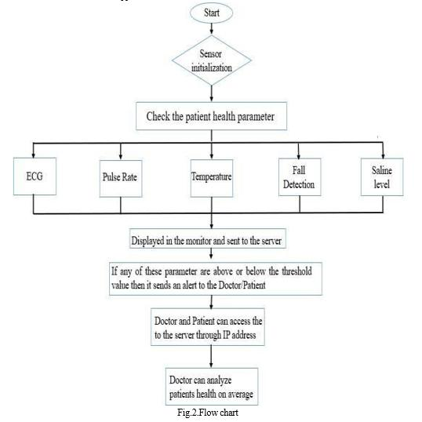

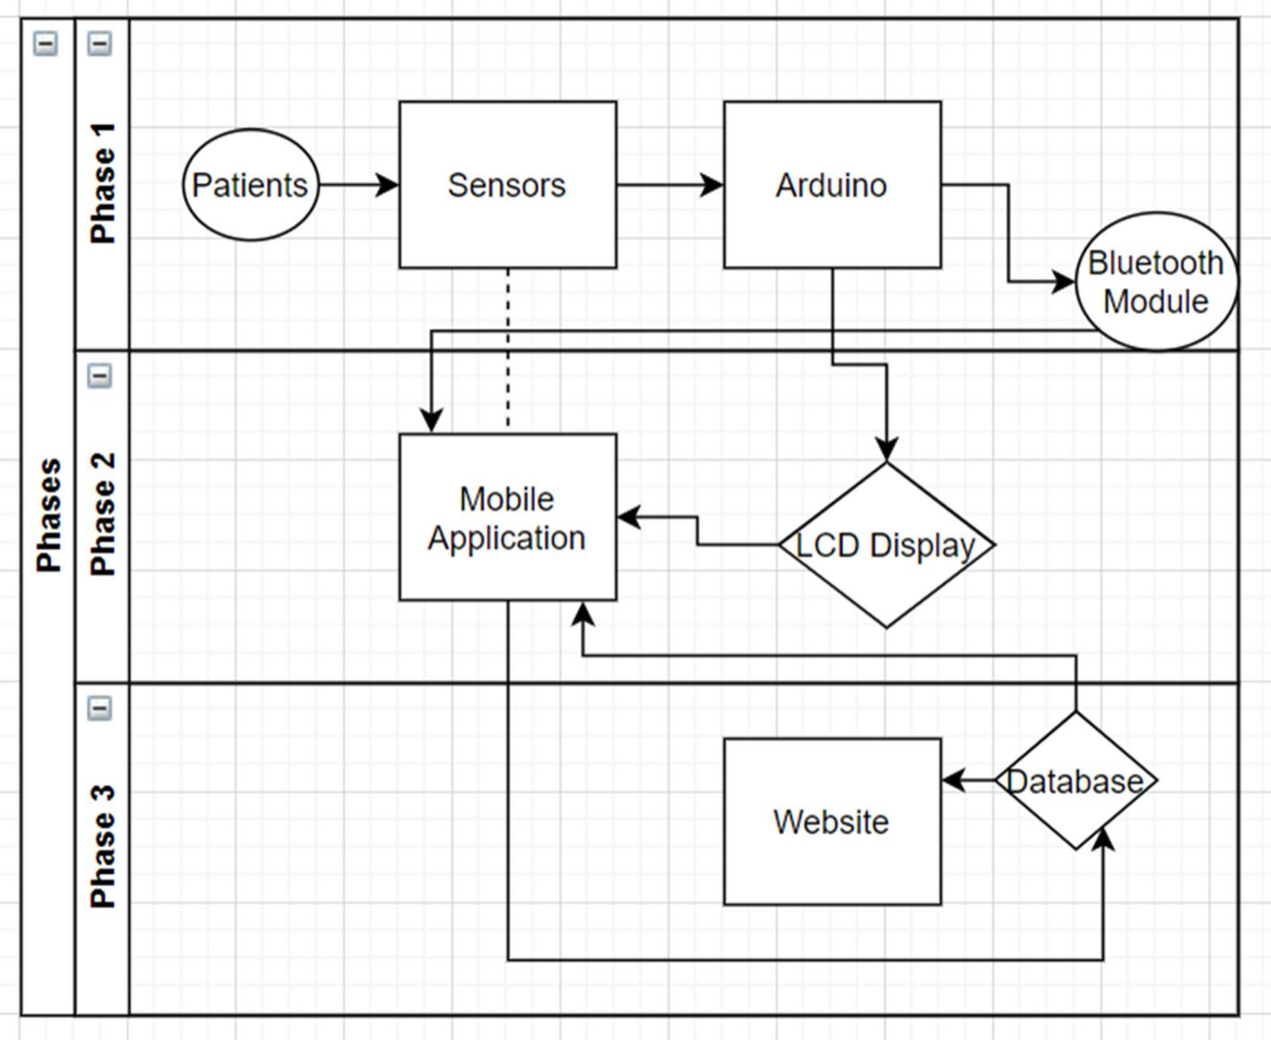
5. Working Principle of IoT Healthcare Monitoring
Step-by-Step Process
Step 1: Data Collection
Sensors attached to patients collect:
- Heartbeat
- Temperature
- Blood pressure
- Oxygen level
- Glucose level
Step 2: Data Transmission
Data is transmitted using:
- Bluetooth
- Wi-Fi
- Cellular networks
Step 3: Cloud Storage
Patient information is stored securely in cloud servers.
Step 4: Data Analysis
AI algorithms analyze:
- Abnormal heart rate
- Fever
- Oxygen drop
- Health risks
Step 5: Alerts and Notifications
Doctors and caregivers receive:
- Emergency alerts
- Real-time reports
- Notifications
6.Components of Healthcare IoT System
Component | Function
Sensors | Collect health data
Gateway Devices | Transfer sensor data
Cloud Servers | Store patient records
AI Engine | Analyze medical conditions
Mobile Apps | Display patient status
Databases | Maintain medical history

7. Types of Sensors Used in Healthcare IoT
A. Temperature Sensors
Monitor body temperature continuously.
Uses:
- Fever detection
- COVID-19 monitoring
B. ECG Sensors
Measure heart electrical signals.
Uses:
- Cardiac monitoring
- Arrhythmia detection
C. Pulse Oximeter Sensors
Measure oxygen saturation.
Uses:
- Respiratory monitoring
- ICU care
D. Blood Pressure Sensors
Track systolic and diastolic pressure.
Uses:
- Hypertension management
E. Glucose Sensors
Monitor blood sugar levels.
Uses:
- Diabetes management
F. Motion Sensors
Detect movement and falls.
Uses:
- Elderly care
- Fall detection systems
8. Communication Technologies in IoT Healthcare
Technology | Features | Applications
Bluetooth | Low power | Wearables
Wi-Fi | High speed | Home healthcare
ZigBee | Energy efficient | Sensor networks
5G | Ultra-low latency | Remote surgery
LoRaWAN | Long range | Rural healthcare
NFC | Short-range communication | Medical records

9. Wearable Healthcare Devices
Wearables are the most common IoT healthcare devices.
Examples
Smartwatches
Functions:
- Heart rate tracking
- ECG monitoring
- Sleep analysis
Fitness Bands
Functions:
- Activity tracking
- Calories monitoring
- Stress analysis
Smart Patches
Functions:
- Continuous ECG monitoring
- Wireless data transmission
Smart Clothing
Embedded sensors monitor:
- Muscle activity
- Respiration
- Body temperature
10. Real-Life Applications of IoT in Healthcare
A. Remote Patient Monitoring (RPM)
Doctors monitor patients remotely.
Benefits:
- Reduced hospital visits
- Continuous supervision
- Faster medical response
Applications:
- Cardiac patients
- Diabetic patients
- Hypertension patients
B. Elderly Monitoring System
Features:
- Fall detection
- Emergency alarms
- Medication reminders
Benefits:
- Independent living
- Improved safety
C. Smart ICU
Smart ICUs use:
- Connected ventilators
- Smart infusion pumps
- Real-time dashboards
Benefits:
- Reduced medical errors
- Better patient monitoring
D. Smart Ambulance
Functions:
- Real-time patient data transmission
- GPS tracking
- Emergency communication
E. COVID-19 Healthcare Monitoring
IoT was used during COVID-19 for:
- Temperature scanning
- Oxygen monitoring
- Contact tracing
- Remote consultation

11. Smart Hospital System
Features
Automated Patient Monitoring
Continuous vital sign tracking.
Asset Tracking
Tracks:
- Wheelchairs
- Ventilators
- Medical equipment
Smart Beds
Detect:
- Patient movement
- Pressure levels
- Sleep patterns
Medicine Management
Automated medicine dispensing systems.
12. Images of Smart Healthcare Systems
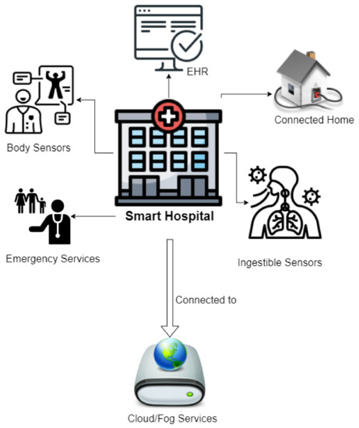

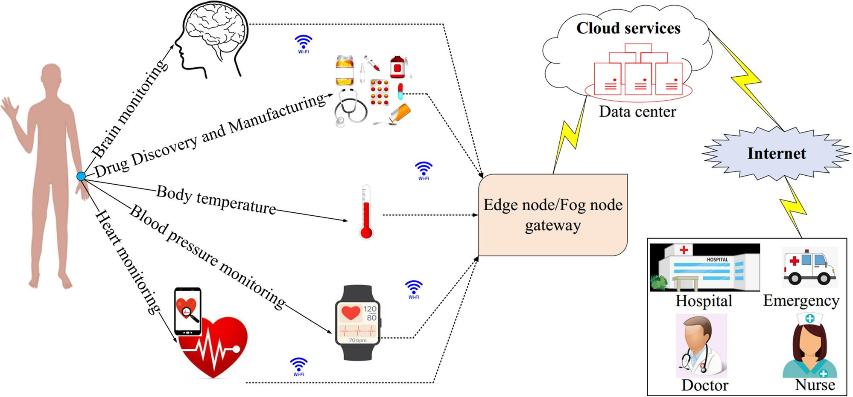

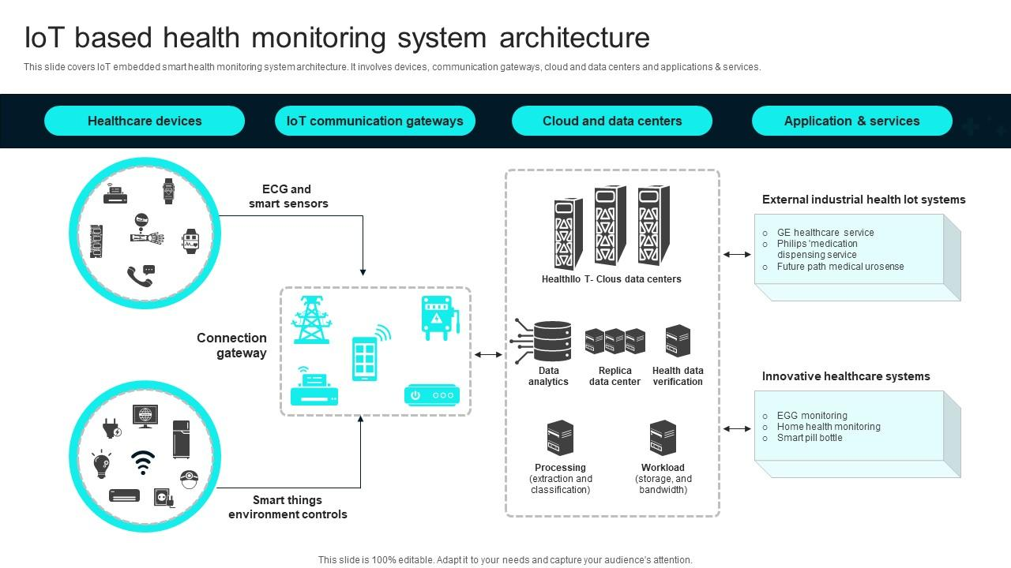
13. Role of Big Data Analytics
IoT devices generate huge amounts of data.
Big Data helps:
- Medical research
- Disease trend analysis
- Personalized medicine
- Public health monitoring
14. Security Issues in Healthcare IoT
Main Threats
Data Breach:
Hackers may steal patient records.
Device Hacking:
Medical devices can be attacked.
Unauthorized Access:
Weak authentication risks privacy.
15. Security Solutions
Encryption:
Protects transmitted data.
Multi-Factor Authentication:
Adds extra login security.
Blockchain:
Improves data integrity.
AI Cybersecurity:
Detects unusual network activities.

16. Advantages of IoT in Healthcare
Advantage | Explanation
Real-Time Monitoring | Continuous patient observation
Early Detection | Detect diseases early
Lower Cost | Fewer hospital admissions
Better Treatment | Personalized care
Remote Access | Rural healthcare support
Fast Emergency Response | Automatic alerts

17. Disadvantages of IoT in Healthcare
Problem | Description
Privacy Risks | Sensitive data exposure
High Cost | Expensive infrastructure
Connectivity Issues | Internet dependency
Battery Problems | Wearable charging limitations
Compatibility Issues | Device interoperability challenges

18. Future of IoT in Healthcare
Emerging Technologies
5G Healthcare
Enables:
- Remote surgery
- Ultra-fast communication
Digital Twins:
Virtual patient models for treatment simulation.
Smart Implants:
Implanted IoT devices monitor internal organs.
Edge Computing:
Processes data closer to devices for faster response.
19. Ethical Issues
Privacy Concerns:
Patient data confidentiality is critical.
Consent Management:
Patients must approve data usage.
AI Transparency:
AI decisions should be explainable.
20.References
- Springer Nature – Survey on Sensors and Smart Devices for IoT Enabled Intelligent Healthcare System
- PubMed – Recent Advances on IoT-Assisted Wearable Sensor Systems for Healthcare Monitoring
- PMC – IoT-Assisted Wearable Sensor Systems in Healthcare
- PubMed – IoT-Based Healthcare Monitoring System towards Improving Quality of Life
- ScienceDirect – IoT-based Vital Sign Monitoring
- ScienceDirect – The Internet of Things in Healthcare: Taking Stock and Moving Forward
- Manipal University – Smart Healthcare System Using IoT, Cloud and AI/ML
- ScienceDirect – Role of Artificial Intelligence in Health Monitoring Using IoT Based Wearable Sensors
- arXiv – Context Aware Framework for IoT Based Healthcare Monitoring Systems
- arXiv – Human Activity Recognition Using Wearable Sensors
- arXiv – IoT-based Wearables: A Comprehensive Survey

