**Opening Range Break Out Trading System**

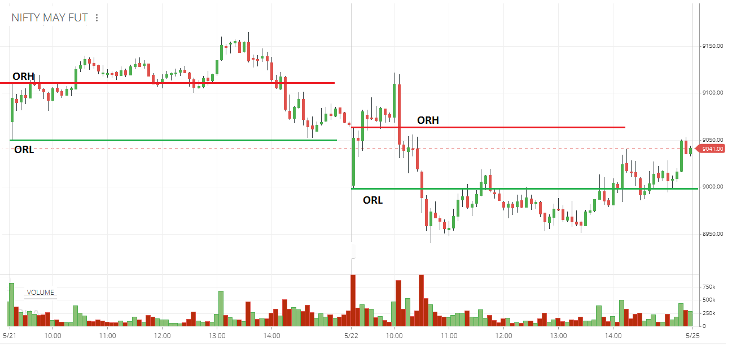

**The Opening Range (OR) is the difference between the first high and low of the day.**

* **Introduction**

The Opening Range Breakout (ORB) Trading System is an automated trading solution designed to capitalize on price movements that occur after the market opens. This system integrates real-time market data, algorithmic trading logic, and automated order execution to implement a sophisticated intraday trading strategy. By leveraging the AliceBlue trading platform and Excel for data management, this project aims to provide traders with a powerful tool for executing ORB strategies efficiently and consistently.

* **Features**
* Real-time market data integration via WebSocket.
* Dynamic calculation of opening range (high and low) for multiple instruments by creating two different DataFrame in single code.
* Automated breakout detection and trade signal generation.
* Scaling-in strategy with increasing position sizes on subsequent breakouts.
* Dynamic profit target setting based on breakout direction and count.
* Automated order placement and management
* Intraday square-off mechanism.
* Excel-based data visualization and management.
* Risk management through predefined investment limits and leverage controls.
* **Technologies Used**
* Programming Language: Python
* Trading API: AliceBlue (pya3 library)
* Excel Integration: xlwings library
* Data Handling: pandas for data manipulation.
* Real-time Communication: WebSocket for live market data
* Data Storage: Excel for input/output and visualization
* Date and Time Handling: datetime module
* Debugging: pdb module
* **Code Structure**

The code is structured into several main components:

1. **Initialization and Setup:**

• AliceBlue login and Excel workbook setup

• Time-based constraints and trading parameters definition

1. **WebSocket Implementation:**

* Socket connection handlers (open, close, error)
* Real-time data feed processing

**c. Instrument Management:**

* Reading instrument list from Excel
* Creating subscription list for market data

**d. Trading Logic:**

* Opening range calculation
* Breakout detection
* Position sizing and order quantity calculation
* Target price calculation
* Trade status management

**e. Order Execution:**

* Place order function for executing trades

**f. Main Loop:**

* Continuous data update and trading logic execution
* **Usage: To use the system:**

1. Ensure all required libraries are installed (pya3, xlwings, pandas, alice_credentials)
2. Set up the Excel file 'Opening_Range_Break_Out.xlsx' with the list of instruments
3. Configure AliceBlue credentials in 'alice_credentials.py'
4. Run the Python script
5. The system will automatically:
   * Connect to AliceBlue and start receiving market data
   * Calculate opening ranges after-market open
   * Detect breakouts and execute trades
   * Update Excel with real-time data and trade information

* **Future Enhancements:**

a. Implementation of more advanced risk management features (e.g., dynamic stop-loss)

b. Addition of multiple timeframe analysis for confirming trends

c. Integration of machine learning models for predictive analytics

d. Development of a user-friendly GUI for easier monitoring and control

e. Expansion to include multi-day strategies and portfolio management

f. Implementation of back testing functionality for strategy optimization

g. Addition of real-time performance metrics and reporting

h. Integration with multiple brokers for increased flexibility

* **Conclusion:**
* The Opening Range Breakout Trading System represents a sophisticated approach to automated intraday trading. By combining real-time market data, algorithmic decision-making, and seamless integration with both trading platforms and data visualization tools, this system offers traders a powerful solution for implementing ORB strategies.
* The project showcases the potential of combining various technologies to create a comprehensive trading solution. While currently focused on a specific strategy, the modular nature of the code allows for future expansions and enhancements. As with any trading system, users should thoroughly understand the strategy and risks involved before deploying it in a live trading environment.
* This project not only serves as a functional trading tool but also as a framework for further development in the field of algorithmic trading, providing a solid foundation for more advanced trading systems in the future.