Supplementary Information for Nature’s paper:

PREDICTION OF CENTRAL NERVOUS SYSTEM EMBRYONAL TUMOUR OUTCOME BASED ON GENE EXPRESSION

Scott L. Pomeroy, Pablo Tamayo, Michelle Gaasenbeek, Lisa M. Sturla, Michael Angelo, Margaret E. McLaughlin, John Y.H. Kim, Liliana C. Goumnerova, Peter McL. Black, Ching Lau, Jeffrey C. Allen, David Zagzag, James M.Olson, Tom Curran, Cynthia Wetmore, Jaclyn A. Biegel, Tomaso Poggio, Shayan Mukherjee, Ryan Rifkin, Andrea Califano, Gustavo Stolovitzky, David N. Louis, Jill P. Mesirov, Eric S. Lander and Todd R. Golub

www.genome.wi.mit.edu/MPR/CNS
November 14, 2001

Contents:

Section I: expanded methods 2
Patient data and tumor bank 2
Microarray hybridization 2
Preprocessing and re-scaling 3
Clustering. 3
Supervised learning. 4
Gene marker selection 5
Permutation-based neighborhood analysis for marker gene selection and screening. 6
Permutation Test for Outcome Predictor 12
Algorithms 13
Proportional chance criterion. 14
Survival analysis and Kaplan-Meier plots 14
PCA and multidimensional-scaling of Brain tumor samples 14
Combined classifiers. 15
Section II: datasets and clinical attributes 17
List of all samples 17
Dataset A, A1, A2 - multiple tumor samples 19
Dataset B - MD classic-desmoplastic 23
Dataset C - MD outcome 24
Section III: detailed analysis results 26
Multiple tumor PCA 26
Multiple tumor class markers 42
Multiple tumor clustering 56
Multiple tumor classes predictions (k-NN) 57
Classic vs. desmoplastic MD markers 59
Classic vs. desmoplastic MD prediction results (k-NN). 69
SOM clustering of treatment outcome samples. 71
SOM-discovered C0 vs. C1 class gene markers 74
Treatment outcome markers 75
k-nearest neighbors treatment outcome prediction results 79
Permutation test for k-nearest neighbor outcome predictor 81
Weighted voting treatment outcome prediction results 82
SVM treatment outcome prediction results 84
SPLASH treatment outcome prediction results 86
TrkC treatment outcome prediction results 88
Staging treatment outcome prediction results 90
Combined treatment outcome predictors 92
Summary of medulloblastoma treatment outcome predictions 96
Improvements of multi-gene prediction algorithm (k-NN) over staging and TrkC. 97
k-NN predictions in subgroup treated with vincristine, cisplatin and cytoxan. 98
Comparison between signal-to-noise and t-test statistic metrics 99
References 101

Section I: expanded methods

This document provides supplementary and detailed analysis information not included in the paper. Other sources of information and the original datasets can be found in our web site www.genome.wi.mit.edu/MPR/CNS.

Patient data and tumor bank
The complete cohort for these studies consists of 68 children with medulloblastomas, 10 young adults with malignant gliomas (WHO grades III and IV), 5 children with AT/RT, 5 with renal/extrarenal rhabdoid tumors, and 8 children with supratentorial PNETs. A summary of the clinical data for the patients can be found in the List of all samples section of the document. All patients with medulloblastomas were treated with craniospinal irradiation to 2400 - 3600 centiGray (cGy) with a tumor dose of 5300 - 7200 cGy. All patients with medulloblastomas were treated with chemotherapy consisting of cisplatin and vincristine, and combinations of carboplatin, etoposide, cyclophosphamide, procarbor lomustine (CCNU). Two patients received high dose chemotherapy at relapse, including methotrexate and thiotepa, followed by autologous bone marrow transplantation. Thirty-five of the children with medulloblastomas were part of a cohort described in previous publications (Segal et al 1994, Kim et al 1999). All tumor samples were obtained at the time of initial surgery prior to treatment. The samples were snap frozen in liquid nitrogen and stored at -80°C. The studies were done with approval of the Committee for Clinical Investigation of Boston Children's Hospital. The data were organized into three sets: Dataset A (42 samples containing: 10 medulloblastomas, 10 malignant gliomas, 5 AT/RT and 5 renal/extrarenal rhabdoid tumors, 8 supratentorial PNETs and 4 normal cerebella), Dataset B (34 samples, containing 9 desmoplastic medulloblastoma and 25 classic medulloblastoma), and Dataset C (60 samples, containing 39 medulloblastoma survivors and 21 treatment failures). There are two additional variants of Dataset A called A1 and A2 described in the second section of this document. A description of each dataset is available in the Datasets and clinical attributes section of this document.

Microarray hybridization
For a detailed protocol, see http://www.genome.mit.edu/MPR/CNS. Briefly, tissue samples were homogenized (Polytron, Kinematica, Lucerne) in guanidinium isothiocyanate and RNA was isolated by centrifugation over a CsCl gradient. RNA integrity was assessed either by northern blotting (Kim et al 1999) or by gel electrophoresis. The amount of starting total RNA for each reaction varied between 10 and 12 μg. First strand cDNA synthesis was generated using a T7-linked oligo-dT primer, followed by second strand synthesis. An in vitro transcription reaction was done to generate the cRNA containing biotinylated UTP and CTP, which was subsequently chemically fragmented at 95°C for 35 minutes. Ten micrograms of the fragmented, biotinylated cRNA was hybridized in MES buffer (2-[N-Morpholino]ethansulfonic acid) containing 0.5 mg/ml acetylated bovine serum albumin (Sigma, St. Louis) to Affymetrix (Santa Clara, CA) HuGeneFL arrays at 45°C for 16 hours. HuGeneFL arrays contain 5920 known genes and 897 expressed sequence tags. Arrays were washed and stained with streptavidin-phycoerythrin (SAPE, Molecular Probes). Signal amplification was performed using a biotinylated anti-streptavidin antibody (Vector Laboratories, Burlingame, CA) at 3 μg/ml. This was followed by a second staining with SAPE. Normal goat IgG (2 mg/ml) was used as a blocking agent. Scans were performed on Affymetrix scanners and the expression value for each gene was calculated using Affymetrix GENECHIP software. Minor differences in microarray intensity were corrected using a linear scaling method as detailed in the next section.

Preprocessing and re-scaling
The raw expression data as obtained from Affymetrix's GeneChip is re-scaled to account for different chip intensities. Each column (sample) in the dataset was multiplied by 1/slope of a least squares linear fit of the sample vs. the reference (the first sample in the dataset). This linear fit is done using only genes that have 'Present' calls in both the sample being re-scaled and the reference. The sample chosen as reference is a typical one (i.e. one with the number of "P" calls closer to the average over all samples in the dataset). Scans were rejected if the scaling factor exceeded a factor of 3, fewer than 1000 genes received ‘Present’ calls, or microarray artifacts were visible.

A ceiling of 16,000 units was chosen for all experiments because it is at this level that we observe fluorescence saturation of the scanner; values above this cannot be reliably measured. For classification problems that are very robust (e.g. distinguishing different types of brain tumors), we used a threshold of 100 units because there was a sufficiently large number of genes correlated with the distinction that the threshold could be set high, thereby minimizing noise, and maximizing potential biological interpretation of the marker genes. For the more subtle distinctions (e.g. outcome prediction), few correlates of the distinction are found, and for this reason the threshold was set at a lower level (20 units) so as to avoid missing any potentially informative marker genes.

These numbers are Affymetrix’s scanner “average difference” units. After this preprocessing gene expression values were subjected to a variation filter which excluded genes showing minimal variation across the samples being analyzed. The variation filter tests for a fold-change and absolute variation over samples (comparing max/min and max-min with predefined values and excluding genes not obeying both conditions). The precise parameters of the variation filters for each dataset are provided in each analysis section of this document. Different thresholds and variation filters were used according to the purpose of the analysis (e.g. select weak marker genes for treatment outcome, strong robust marker genes for morphology, highly varying genes for PCA etc.).
For example, if the maximum and minimum values of a gene across samples were max and min then the variation filter excluded those where max/min < 5 and max – min < 500. In some cases more or less stringent values were used.

Clustering.
Self Organizing Maps were performed using our GeneCluster clustering package available at www.genome.wi.mit.edu/MPR/Software. Self-Organizing Maps (SOMs). The Self Organizing Map is a method for performing unsupervised learning (i.e., learning models for classifying data where the true class for the data samples is assumed to be unknown prior to model training) where a grid of 2D nodes (clusters) is iteratively adjusted to reflect the global structure in the expression dataset (Tamayo et al 1999). In general, unsupervised learning presents a more difficult problem than supervised learning methods (such as weighted voting or k-NN) but is useful for discovering new classes during exploratory analysis. With the SOM, one randomly chooses the geometry of the grid (e.g., a 3 x 2 grid) and maps it into the k-dimensional feature space. Initially the features are randomly mapped to the grid but during training the mapping is iteratively adjusted to reflect the data structure. The data were first normalized by standardizing each column (sample) to mean 0 and variance 1. The SOM results for the clustering of samples can be found in the Multiple tumor clustering for multiple tumor samples and in the SOM clustering of treatment outcome samples. section for the clustering of medulloblastomas.

Hierarchical Clustering is another unsupervised learning method useful for dividing data into natural groups. Data is clustered hierarchically by organizing the data into a tree structure based upon the degree of similarity between features. We used the Cluster and TreeView software (Eisen et al 1998) to perform average linkage clustering, which organizes all of the data elements into a single tree with the highest levels of the tree representing the discovered classes. The detailed clustering results can be accessed in the Multiple tumor clustering section.

Supervised learning.

This is the methodology for building a supervised classifier that we followed.

- define a target class based on morphology, tumor class or treatment outcome clinical information;
- select the “marker” genes with the highest correlation with the target class using a class separation statistic (signal-to-noise ratio). A permutation test is also applied to the top ranked genes to assess their class-correlation statistical significance.
- build a classifier in cross-validation (leave-one-out) by removing one sample and then used the rest as a training set
- several models are built using different number of marker genes and the final chosen model is the one that minimizes the total error in cross-validation
- evaluate prediction results, compute confusion matrices and produce Kaplan-Meier survival plots.

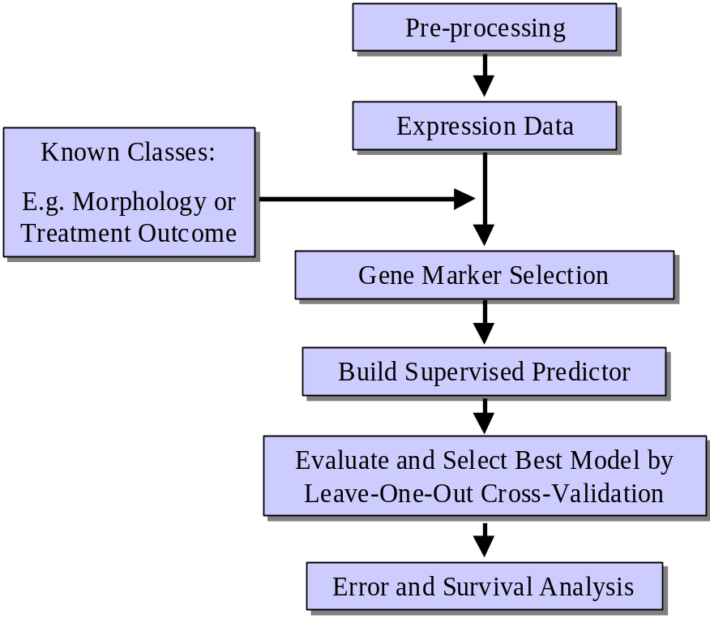

This methodology was used with the following algorithms: k-nearest neighbors, weighted voting, support vector machines, SPLASH, metastatic staging, TrkC gene expression and two combined predictors. The details for each algorithm are described below.

Gene marker selection
Genes correlated with a particular class distinctions (e.g. class 0 and class 1) were identified by sorting all of the genes on the array according the signal-to-noise statistic (Golub et al 1999, Slonim et al 2000) (μclass 0 - μclass 1)/(σ class 0 + σclass1) where μ and σ represent the mean (or median) and standard deviation of expression, respectively, for each class. Permutation of the column (sample) labels was performed to compare these correlations to what would be expected by chance (see the next section). These marker genes were used to build the k-nearest neighbor and weighted voting classifiers. SVM and SPLASH use different methods to select marker genes.

In Section III we described marker genes for several classifications:

- multi tumor classes (Multiple tumor class markers).
- classic vs. desmoplastic medulloblastoma morphology (Classic vs. desmoplastic MD markers)
- SOM-discovered medulloblastoma classes (SOM-discovered C0 vs. C1 class gene markers) and,
- medulloblastoma treatment outcome (Treatment outcome markers).

Permutation-based neighborhood analysis for marker gene selection and screening.

Before we describe the method in detail we provide some motivation for use of the technique and put it in context with other multiple comparison and permutation test approaches.

There are two interrelated problems that we have addressed with our permutation-based neighborhood analysis first introduced in Golub et al 1999 and Slonim et al 2000. One is the problem of feature (gene) selection in terms of how many and which genes to input to a supervised learning classifier. This process is a necessary step in a supervised learning methodology as many classifier algorithms cannot deal with thousands of input variables and require some type of dimensionality reduction or prior selection. The other problem is to choose statistically significant molecular markers or differentially expressed genes that deserve more detailed biological study. For example, the ones that one may choose for further validation using a different technology or experimental technique (e.g. RT-PCR, immunochemistry, etc.).

It is important to point out that in these two problems one is basically interested in selecting the subset of genes more likely to be useful in discriminating the phenotype of interest either as single markers or in combination with others. In other words we are interested in a ranking and screening process that identifies enough of the relevant features. One can easily tolerate some amount of false positive errors in exchange for higher sensitivity. Most of the current molecular classification problems of interest, such as morphological or lineage distinction, treatment outcome prediction, drug resistance etc. fit this scenario. These problems involve the presence of a potentially weak signal, for example a few marker genes in a background of technical variation and noise, and therefore favor marker selection methods that are very sensitive and have enough statistical power to produce non-empty results. One can tolerate some number of false positive errors because the selected marker genes are usually weighted or further selected by the classifier. This is also the case in determining biological significance/relevance; in any serious follow up study the markers would have to be further validated. This need for higher sensitivity and adaptability to the dataset being analyzed is one of the main motivations behind our approach as originally applied to Leukemia subtype distinction in Golub et al 1999 and in its current form in this paper.

Marker gene selection, with the characteristics described in the previous paragraph, can be seen as an example of a Multiple Comparison Procedure (MCP) where multiple hypotheses (genes) are tested simultaneously and then accepted or rejected according to a testing procedure. For recent reviews on MCP see Hochberg and Tamhane1997, Bender and Lange 2001, and the special issue on Multiple Comparisons of the Journal of Statistical Planning and Inference (vol. 82, 1999). In our case, each statistical test of a gene can be seen as testing a null hypothesis on the equivalence of the phenotype classes. In this way rejecting a subset of the hypotheses corresponds to selecting a set of statistically significant differentially expressed genes at a given significance level. A global null hypothesis would assert that no gene expression changes are significant and therefore that there is no significant difference between the biological classes as measured by the entire set of microarrays. Notice that this situation of all null hypotheses being true is not likely to be realistic because in practice most microarrays experiments are done with biological classes with known differences that are usually reflected in multiple genes. A more realistic situation is one in which a subset of the hypotheses are false corresponds to the usual problem of selecting between a few dozens and few hundred genes. Traditional approaches to the MCP assume that all, or almost all, of the null hypotheses are true. They also control for the Family Wise Error Rate (FWER), i.e., the probability that exactly one, or at least one, type I (false positive) error occurs. In the marker selection problem this would be the case where there was only one wrong marker gene in the determined marker set. However, the models we construct are not really sensitive to a small number of false positives in the selected marker set. Thus, controlling the FWER is an overly conservative approach that does not provide enough statistical power for the purposes of marker selection and may actually yield no candidate marker genes. This situation of partial rejection is actually quite common in exploratory data analysis and in recent years alternative less conservative and more sensitive formulations of the MCP have been introduced. These methods control the False Discovery Rate (FDR) rather than the FWER (Benjamini and Hochberg 1995). The FDR is the total number of type I, or false positive errors, that are made by the MCP. Controlling for this quantity moves the MCP closer to the type of approaches used in machine learning feature selection and leads to methods with higher statistical power. Statistically the FDR is a compromise between an ultra conservative correction a la Bonferroni and making no correction at all (Benjamini et al 2001). This type of approach is clearly more appropriate for gene selection.

Regardless of the assumption on the number of true hypotheses, or the emphasis on FWER or FDR, the real problem in multiple comparisons is that the hypotheses (genes) are correlated in complex ways reflecting the structure of genetic pathways and interactions. This makes the dependence structure of the data quite difficult to analyze or capture in a test. Traditional corrections, such as Bonferroni, are too conservative and produce essentially no marker genes except for cases where the differences are overwhelming (e.g. dead tissue vs. live tissue). Less conservative approaches attempt to solve this problem by using close testing step-wise methods where the hypotheses can be tested in a specific order and decisions made in a step-wise manner. Decisions on earlier hypotheses may affect later decisions and in this way the dependent structure can be taken into account (see for example Tamhane 1996, Tamhane and Dunnett 1999, Somerville 1999, Troendle 2000). On a parallel track, MCP methods to increase the statistical power by resampling (bootstrap) have also been introduced (Westfall and Young 1993). These methods control the FWER but resample the empirical null distribution to provide less conservative corrections for the p-values. Some of these methods are included in the PROC MULTTEST procedure in SAS (Westfall and Wolfinger 1999).

The comparison of FWER vs. FDR, step-wise vs. single step, resampling vs. analytical p-value adjustments, and in general the assessment of the virtues or applicability of different MCP methods, continues today. It has generated a healthy debate in the statistics community (see for Benjamini et al 1999, Bender and Lang 2001). Another perspective on the MCP can be obtained by Bayesian methods (See Berry and Hochberg 1999 for a review).

From the perspective of machine learning and pattern recognition, the problem of optimal feature selection is intractable and one has to be content with empirical approximations that may have to be tailored to fit the application (Duda, Hart and Stork 2001). Two common approaches are based on the use of filters and wrappers (Kohavi and John 1998). Filter approaches select the best features using a score function that measures the discrimination power of the feature with respect with to the target in a way similar to the test statistic is used in MCP. Typical score functions are, for example, the mutual information, signal to noise ratios, Naïve Bayes posteriors, inner products, linear transformation (e.g. eigenvectors of the covariance matrix), or bounds on the Bayes error such as the Bhattacharyya distance. Wrapper methods involve the use of the actual classifier in the selection process and can be seen as non-linear optimization problems. For more details see Kohavi and John 1998, Cherkassky and Mulier 1998, Fukunaga 1990, Kearns and Vazirani 1997 and Duda, Hart and Stork 2001.

Our permutation based neighborhood analysis method is a direct attempt to solve the multiple hypothesis problem by comparing the actual distribution of markers (i.e. neighbors of an ideal marker separating the classes) with a reference empirical distribution obtained by permuting the phenotype class labels. It is based on a standard global permutation test (Fisher 1935, Lehman 1986, Good 1994) of the phenotype levels keeping the gene correlation information. A histogram of scores for each of the marker genes of each permutation (neighborhood) is kept and the significance of an actual gene marker is obtained by finding the appropriate percentile in the histogram of the correspondingly ranked marker (i.e. the one with the same rank, e.g. best match, second best match etc.). This empirical distribution-free method is simple, intuitive and adapts itself to the correlation structure of the data providing higher statistical power. It minimizes the total number of false positives and uses the empirical reference distribution in a similar way as FDR-based and resampling methods do. Recently general MCP methods have been proposed to combine both resampling and control of the FDR (Yekuteli and Benjamini 1999).

The application of permutation tests has also been introduced in the structural analysis of genetic linkage and detection of QTL (Quantitative Trait Linkage). In these methods (Churchill and Doerge 1994, Doerge and Churchill 1996) the traits are randomly permuted to create data sets that have random genotype-phenotype association. Those methods and ours are conceptually quite similar although in our case we consider expression “functional” rather than genotype data.

After we introduced our method in Golub et al 1999 other methods have been introduced in the literature. For example the SAM method of Tusher et al 2001 is similar to ours but includes a user-adjustable threshold to provide estimates of the FDR. Dudoit et al 2001 have introduced a method based on step-down adjusted p-values using Westfall and Young’s approach in the context of replicated cDNA experiments. Ideker et al 2000 used generalized likelihood tests to assess the statistical significance of differentially expressed genes in the context of two channel cDNA microarrays. Newton et al 2001 and Baldi and Long 2001 use empirical Bayes hierarchical models to assess significance of differential expression. Lee et al 2000 combine the data from replicates to estimate posterior probabilities and identify differentially expressed genes. No systematic comparison of the error rates and statistical power of all these different methods has been published yet. It will be interesting to develop a better understanding of the different trade offs between sensitivity and specificity, number of false positives vs. statistical power to guide the development of future analysis methodologies.

Description of the permutation test-based neighborhood analysis method.

Permutation test based (Golub et al 1999) neighborhood analysis is used to select and screen marker genes with respect to biologically meaningful phenotypes (morphology and treatment outcome) and to assess their statistical significance. To accomplish this we compare the top signal-to-noise scores of top marker genes with the corresponding ones from data obtained by randomly permuting the class labels. Typically 500 global random permutations were used to build histograms. Based on these histograms we determined the 50% (median), 5% and 1% significance levels and compared them with the values obtained for the real dataset. As described above this procedure is motivated by considering the following question: what is the likelihood that a given set of markers genes, for example selected by signal to noise, of a phenotype of interest represent chance correlations and not biologically significant matches? If one looks down the list of markers, how many should one consider as input to a classifier or for further study? In this list of selected markers what is the best way to minimize the number of false positives but retain enough sensitivity to select a non-empty set?

In detail the permutation test procedure for a given comparison of interest (e.g. markers high in class 0 and low in class 1) is as follows:

- Generate signal-to-noise (μclass 0 - μclass 1)/(σ class 0 + σclass 1) scores for all genes that pass a variation filter using the actual class labels (phenotype) and sort them accordingly. The best match (k=1) is the gene “closer” or more correlated to the phenotype using the signal to noise as a correlation function. In fact one can imagine the reciprocal of the signal to noise as a “distance” between the “phenotype” and each gene as shown in the figure (see next page). One can also use a t-statistic (μclass 0 - μclass 1)/√(σ²class 0 + σ²class 1) and obtain very similar results.

- Generate 500 or more random permutations of the class labels (phenotype). For each case of randomized class labels generate signal-to-noise scores and sort genes accordingly.

- Build a histogram of signal to noise scores for each value of k. For example one for all the 500 top markers (k=1), another one for the 500 second best (k=2) etc. These histograms represent a reference statistic for the best match, second best, etc. and, for a given value of k, different genes contribute to it. Notice that the correlation structure of the data is preserved by this procedure. For each value of k, determine different percentiles (1%, 5%, 50% etc.) of the corresponding histogram. (See the bottom diagrams in the figure.)

- Compare the actual signal to noise scores with the different significance levels obtained for the histograms of permuted class labels for each value of k. This test helps to assess the statistical significance of gene markers in terms of the distribution of class-gene scores using permuted labels.

In the results section the values for permutation tests of marker genes are reported in tables with this format:

Distinction | Distance | Perm 1% | Perm 5% | Median 50% | Feature | Desc
class 0 | 0.96694607 | 1.0144908 | 0.8333578 | 0.6280173 | M93119_at | INSM1 Insulinoma-associated 1
class 0 | 0.9096911 | 0.8600172 | 0.7669801 | 0.5740431 | M30448_s_at | Casein kinase II beta subunit
class 0 | 0.90010124 | 0.85051423 | 0.7251496 | 0.5494933 | S82240_at | RhoE
class 0 | 0.832689 | 0.84354156 | 0.7071885 | 0.5292253 | U44060_at | Homeodomain protein (Prox 1)
class 0  …………. | 0.83225346 | 0.8009565 | 0.68034023 | 0.5169537 | D80004_at | KIAA0182 gene
class 1 | 1.6520017 | 0.9831643 | 0.84544426 | 0.6230137 | X86693_at | High endothelial venule
class 1 | 1.2436218 | 0.88150144 | 0.7559189 | 0.5795857 | M93426_at | PTPRZ Protein tyrosine phosphatase
class 1 | 1.2317128 | 0.86047184 | 0.70928395 | 0.5539352 | U48705_rna1_s_at | Receptor tyrosine kinase DDR gene
class 1 | 1.2259983 | 0.8433512 | 0.68909335 | 0.5358038 | X86809_at | Major astrocytic phosphoprotein PEA-15
class 1 | 1.214929 | 0.8281318 | 0.6849929 | 0.5217813 | U45955_at | Neuronal membrane glycoprotein M6b
class 1  ……. | 1.2095517 | 0.79365546 | 0.6711517 | 0.510208 | U53204_at | Plectin (PLEC1)

The distinction column represents the class for which the markers are high (low in the other classes). The Distance column is the signal to noise to the actual phenotype. The Perm. 1%, 5% and 50% columns represent the percentiles (significance levels) in the histograms of signal to noise scores for permuted labels for a given value of k. The Feature column is the gene accession number and the Description column is the gene name. Permutation test results are reported in the gene markers sections: Multiple tumor class markers, Classic vs. desmoplastic MD markers, SOM-discovered C0 vs. C1 class gene markers, and Treatment outcome markers.
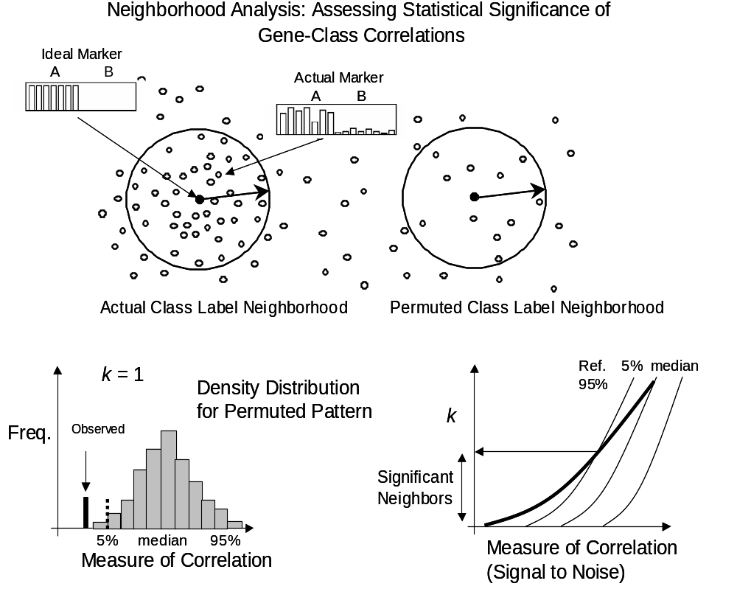
5% Median 95%

Additional Notes:

- This test helps to assess the significance of gene markers in terms of class-gene correlations but if a group of genes fails to pass the test that by itself does not necessarily imply that they cannot be used to build an effective classifier (Huberty 1994, Kearns and Vazirani 1997). For example, in contrast with the case of morphological distinctions, for treatment outcome prediction the top marker genes do not show overwhelming statistical significance (they are "weak" markers) and yet they are effective when used in combination as input to a classifier.
- The choice of the signal to noise distance is somewhat ad hoc but not unreasonable. The reason the signal to noise ratio was chosen instead of a t-statistic or other class distance measure was mainly historical and empirical: it performed slightly better in a previous study of gene expression (Leukemia) feature selection combined with a weighted voting classifier.
- In terms of feature selection our approach can be considered a filter method based on signal to noise ratios but it is important to keep in mind that when the genes selected by this method are feed to a supervised classifier there is an additional number of genes selection process based on error rates (see the Algorithms and Permutation test for outcome predictor sections of this document).
- The advantages of performing a permutation test are multiple:
- It is a distribution-free, direct empirical method to test the significance of the matching of a given phenotype to a particular set of genes (dataset).
- It does not assume a particular functional form for the distribution or correlation structure of genes.
- As the permutation test is done on the entire distribution of genes (as scored by signal to noise from the phenotype) the gene-to-gene correlation structure is taken into account.
- Another more geometrical, and sometimes more intuitive, way to look at this procedure is to consider the figure above as a hypothetical projection of normalized gene expression space where each dimension represents an experiment and each data point a gene. The entire dataset of filtered genes will be represented by a collection of data points distributed in that space. Each gene is represented by a point and the closer two points are, the more correlated they are (i.e. across the set of experiments being considered). Now imagine projecting a point that corresponds to an ideal marker gene that perfectly represents the phenotype of interest. This is for example a marker gene that is high in one of the classes and low in the other. This gene will be a perfect classifier to distinguish the two classes. We are interested in finding marker genes that are, if not equal, at least similar to this ideal marker. This can be accomplished by computing a distance or correlation measure between the class labels (phenotype) and the genes. In this sense we are looking at the “neighborhood” of a phenotype in gene expression space trying to find “close” neighbors. A permutation test in this context is equivalent to moving the ideal gene marker point at random (as the labels are permuted) and obtaining a distribution of neighbors each time it lands to a new reference point (random phenotype) in expression space. By building a histogram of distance distributions to these random reference locations one can assess how “typical” the actual neighborhood of the actual phenotype is compared to random phenotypes. For example, if only once in a thousand random tries we found a set of top 10 markers as correlated as in the actual neighborhood, then we would consider those markers to be significant. In this interpretation, the permutation test resembles a spatial correlation Mantel test in which one measures the significance of finding excess “density” of neighbors (genes) around a point (ideal marker) that represents the phenotype of interest when compared with the density at random phenotype classes.

Permutation Test for Outcome Predictor
There is an additional permutation test (Fisher 1935, Lehman 1986, Good 1994) that was developed to assess the statistical significance of the k-nearest neighbor predictor algorithm. In this test the phenotype (treatment outcome) labels are randomly permuted 1000 times and for each instance a set of models are build using the same set of parameters (e.g. k = number of neighbors, ng = number of features/genes) as the ones used in finding the actual model. Once this is done one selects the best error rate, from the results corresponding to the selected set of parameters, for each of these 1000 random predictors and makes a histogram. The significance of the predictor is assessed by the area of the histogram corresponding to random predictors with better error rates (see figure below). The results of this procedure for the k-nearest neighbor predictor of treatment outcome are reported in the Permutation test for k-nearest neighbor outcome predictor section.
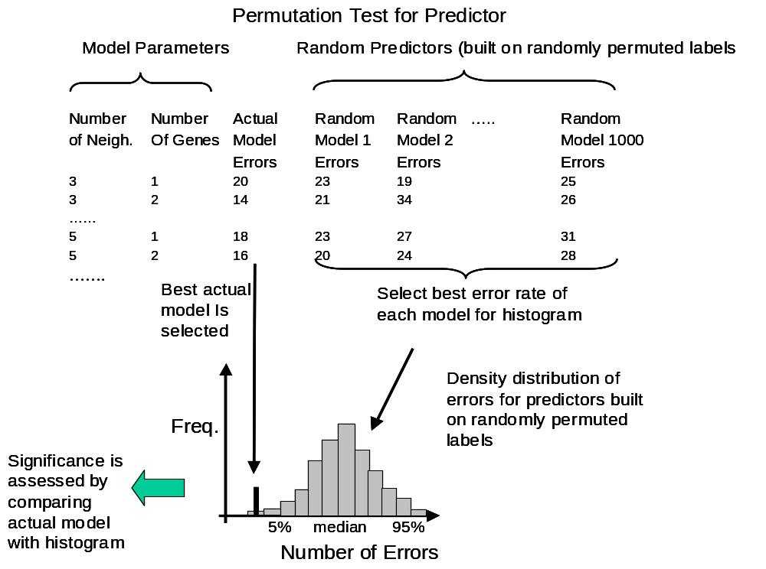

Algorithms
k-Nearest Neighbors (k-NN)
We developed a weighted implementation of the k-NN algorithm (Dasarathy 1991) that predicts the class of a new sample by calculating the Euclidean distance (d) of this sample to the k "nearest neighbor" standardized samples in "expression" space in the training set, and by selecting the predicted class to be that of the majority of the k samples (the method is defined in terms of Euclidean distances over standardized vectors so it is equivalent to using inner products: a . b / |a||b|).We performed the marker gene selection process by which we feed the k-NN algorithm only the features with higher correlation with the target class. This feature selection is done by sorting the features according to the signal-to-noise statistic (Golub 1999, Slonim 2000) (μ_{class 0} - μ_{class 1})/(σ_{class 0} + σ_{class 1}). In our version of the algorithm the weight of each of the k neighbors was weighted according to 1/d. For our medulloblastoma outcome experiments, the k-NN models were evaluated by 60-fold leave-one-out cross-validation whereby a training set of 59 samples was used to predict the class of a randomly withheld sample. This was repeated for all samples and the cumulative error rate was recorded. Models with variable numbers of genes (1-200, selected according to their correlation with the survivor vs. treatment failure distinction in the training set) were tested in this manner. The detailed results of applying this algorithm to the different datasets can be found in the , Classic vs. desmoplastic MD and k-nearest neighbors treatment outcome prediction results sections.

Weighted Voting.
The weighted voting algorithm (Golub 1999, Slonim 2000) makes a weighted linear combination of relevant “marker” or “informative” genes obtained in the training set to provide a classification scheme for new samples. The selection of features (marker genes) is accomplished by computing the signal-to-noise statistic S_{x} (described above). The class predictor is uniquely defined by the initial set of samples and marker genes. In addition to computing S_{x}, the algorithm also finds the decision boundaries (half way) between the class means: b_{x} = (μ_{class0} + μ_{class1})/2 for each gene. To predict the class of a test sample y, each gene x in the feature set casts a vote: V_{x} = S_{x} (g_{x}^{y} - b_{x}) and the final vote for class 0 or 1 is sign (Σ_{x} V_{x}). The strength or confidence in the prediction of the winning class is (V_{win}-V_{lose})/(V_{win}+V_{lose}) (i.e., the relative margin of victory for the vote). The detailed prediction results are the Weighted voting treatment outcome prediction results.

Support Vector Machines.
The Support Vector Machine (SVM) for classification minimizes the generalization error rather than the training error. The basic idea behind SVMs is to construct an optimal separating hyperplane by mapping the gene expression data to a high-dimensional space (Mukherjee et al 1999, Brown et al 2000). Linear separation in this higher dimensional space corresponds to a nonlinear decision boundary in the original space. A new feature selection algorithm was developed to scale the input features to minimize the ratio of the radius around the support vectors and the margin. The detailed results are in the SVM treatment outcome prediction results section.

SPLASH.
The Splash algorithm (Califano et al 1999) discovers efficiently and deterministically all statistically significant gene expression patterns in a target class of interest. Statistical significance is evaluated based on the probability of a “pattern,” (i.e. a subset of genes and experiments within a narrow interval of expression values) to occur by chance in the control target class. A greedy set covering algorithms is used to select an optimal subset of statistically significant patterns. These patterns are accumulated and form the basis for a likelihood ratio classification scheme to predict new samples. The detailed results are in the SPLASH treatment outcome prediction results section.

Predictors using metastatic staging and TrkC.
These classifiers were constructed by finding the decision boundary half way between the classes: (μ_{class 0} + μ_{class 1})/2 (using the staging values 0 vs. 1,2,3,4 or the continuous TrkC gene expression) and then predicting the unknown sample according to its gene expression value location with respect to that boundary. The detailed results can be found in the TrkC treatment outcome prediction results and Staging treatment outcome prediction results sections.

Proportional chance criterion.
In order to compute p-values for non-survival predictions, for example the p-val=4 x10⁻⁷ for the Classic vs. Desmoplastic classifier reported in the paper (33 out of 34 samples correctly classified) we used a “proportional chance criterion” to evaluate the probability that a random predictor will produce a confusion matrix with the same row and column counts as the gene expression predictor. For example, for a binary class (A vs. B) problem, if α is the prior probability of a sample being in class A and p is the true proportion of samples in class A then C_{p} = p α + (1-p) (1-α) is the proportion of the overall sample that is expected to receive correct classification by chance alone. Then if C_{model} is the proportion of correct classifications achieved by the gene expression predictor one can estimate its significance by using a Z statistic of the form: (C_{model} – C_{p})/Sqrt(C_{p} (1-C_{p})/n), where n is the total sample count. For more details see chapter VII of Huberty 1994.

Survival analysis and Kaplan-Meier plots
The Kaplan-Meier survival analysis plots are computed using the S-Plus (http://www.insightful.com/products/splus/) statistical software package: S-Plus 2000, Guide to Statistics Volume 2, chapter 9. The p-values for the prediction of outcome groups are computed using a log-rank test (Mantel-Haenszel method, chapter 9 in the same reference). The Kaplan Meier plots and associated rank test p-values are included at the end of each of the outcome prediction sections starting in the k-nearest neighbors treatment outcome prediction results section.

PCA and multidimensional-scaling of Brain tumor samples
Datasets of large dimensionality (i.e. large number of variables e.g. genes) are in general difficult to visualize due to the intrinsic difficulty of reducing and projecting the dataset to a small number of dimensions where standard visualization techniques are applicable. The main problem of performing a projection of that sort is that of preserving the “relevant” or “interesting” structure in the data. In our case this structure corresponds to the intrinsic similarities or the natural clustering of brain samples in the space of gene expression.
A commonly used technique for data reduction, projection and visualization is Principal Component Analysis (PCA). In this approach one finds standardized linear combinations of variables, the “principal components,’ which are orthogonal and explain all of the variance in the original dataset. For more details see for example ref. 3. A typical method to obtain a simple projection (multi-dimensional scaling) of the dataset is to plot the top 2 or 3 principal components, which may account for a significant fraction of the variance, in a 2 or 3D scatter plot.
To study the natural clustering of the Brain tumor samples we performed PCA analysis and projected the top three components in 3D and 2D scatter plots (some shown in the paper as part of Figure 1). We considered two subsets of genes: highly varying, those with highest variation across samples that passed a variation filter (1,065 genes) and, marker genes, the top 10 marker genes of each tumor class by using the signal-to-noise statistics as described in the statistical analysis and prediction section. For the highest variation genes the values were thresholded to 100 from below and 16,000 from above and the variation filter selected genes with at least a 12-fold and 1,200 absolute units of variation between the minimum and maximum values across samples. This produced a subset of 1,065 highly varying genes. For the marker genes the values were thresholded to 20 from below and 16,000 from above and a variation filter selected genes with at least a 5-fold and 500 absolute units of variation between the minimum and maximum values across samples. The genes that passed this filter were ranked according to signal to noise (using medians) and the top 10 markers for each class were selected. This produced a total of 50 genes.
Once the appropriate subset of highly varying or maker genes was selected we computed the 3 principal components using the S-Plus statistical software package using default settings (S-Plus statistical software package: S-Plus 2000, Guide to Statistics Volume 2, chapter 1, http://www.splus.mathsoft.com/products/splus/splusintro.html). These three components were then plotted in 3D scatter plots. Figure 1 in the paper shows these plots for highly varying and marker genes where each type of brain tumor is shown in a different color. The plots show the ‘natural” clustering of brain tumor samples in these two subspaces of gene expression. The components and plots can also be seen in the Multiple tumor PCA section. Besides the 2D and 3D plots of the top 3 components we also include bar graphs showing the relative importance of the top components and the loadings of the top 6 genes for each component.

Combined classifiers.
The fact that sometimes the prediction algorithms make mistakes in different samples and that the class structure of the confusion matrices is different for each algorithm motivated us to combine some of them to see if the predictions can be improved in this way. We choose a simple scheme combining three algorithms according to majority. For example if the outputs of the three algorithms for a given sample are Survivor, failure, and Survivor, then the output of the combined predictor will be Survivor. The results for two types of model combinations: using a simple majority rule: Staging, k-NN and TrkC and SVM, k-NN and TrkC can be seen in the Combined treatment outcome predictors section.

Section II: datasets and clinical attributes

The following sections of this document describe the samples, clinical attributes and datasets in detail.

List of all samples
Number | Sample name | Type | Subtype | Chang | Sex | Age at diagnosis | Followup | Current status | Chemotherapy
 |  |  |  | Stage |  | [years/months] | [Months] | [Alive/Dead]
1 | Brain_MD_1 | Medulloblastoma | Classic | T4M1 | M | 8m | 11 | D | V,C,Cx,VP
2 | Brain_MD_2 | Medulloblastoma | Classic | T2M0 | M | 8yr10m | 5 | D | V,C,Cx,VP
3 | Brain_MD_3 | Medulloblastoma | Classic | T3M0 | M | 6yr | 7 | D | V,C,Cx
4 | Brain_MD_4 | Medulloblastoma | Classic | T3M3 | M | 5yr 3m | 7 | D | V,C,Cx,VP
5 | Brain_MD_5 | Medulloblastoma | Classic | M3 | M | 38yr 2m | 7 | D | V,C
6 | Brain_MD_6 | Medulloblastoma | Classic | T4M0 | F | 7m | 9 | D | V,C,Cx
7 | Brain_MD_7 | Medulloblastoma | Classic | T1M0 | M | 6yr 5m | 14 | D | V,C,Cx
8 | Brain_MD_8 | Medulloblastoma | Classic | T3bM1 | M | 6yr 1m | 16 | D | V,C,Cx
9 | Brain_MD_9 | Medulloblastoma | Classic | M0 | M | 8yr | 18 | D | V,C,Cx,VP
10 | Brain_MD_10 | Medulloblastoma | Classic | M0 | M | 3yr 10m | 18 | D | V,C,Cx
11 | Brain_MD_11 | Medulloblastoma | Classic | T2M1 | M | 8yr 2m | 19 | D | V,C,Cx,VP,Ca,T,M
12 | Brain_MD_12 | Medulloblastoma | Classic | M0 | F | 3yr 9m | 25 | D | V,C,Cx
13 | Brain_MD_13 | Medulloblastoma | Classic | T3M3 | M | 14yr 5m | 26 | D | V,C,Cx
14 | Brain_MD_14 | Medulloblastoma | Desmoplastic | M0 | M | 6yr 3m | 33 | D | V,C,CC
15 | Brain_MD_15 | Medulloblastoma | Desmoplastic | T2MO | F | 11yr 7m | 38 | D | V,C,Cx,VP
16 | Brain_MD_16 | Medulloblastoma | Desmoplastic | T3M3 | F | 11yr 5m | 39 | D | V,C,VP
17 | Brain_MD_17 | Medulloblastoma | Classic | T3bM3 | F | 3yr 3m | 39 | D | V,C,Cx
18 | Brain_MD_18 | Medulloblastoma | Classic | T2M3 | M | 4yr 4m | 42 | D | V,C,Cx
19 | Brain_MD_19 | Medulloblastoma | Classic | M2 | F | 26yr 1m | 65 | D | V,C,Cx,VP
20 | Brain_MD_20 | Medulloblastoma | Classic | T3bM0 | M | 20yr 6m | 92 | D | V,C
21 | Brain_MD_21 | Medulloblastoma | Classic | T2M0 | F | 23yr 3m | 102 | D | V,C
22 | Brain_MD_22 | Medulloblastoma | Desmoplastic | M0 | F | 5yr 7m | 24 | A | V,C,CC
23 | Brain_MD_23 | Medulloblastoma | Desmoplastic | T4M0 | M | 1yr 4m | 25 | A | V,C,Cx
24 | Brain_MD_24 | Medulloblastoma | Classic | T3M0 | M | 10yr 10m | 27 | A | V,C,Cx
25 | Brain_MD_25 | Medulloblastoma | Classic | M0 | F | 5yr 4m | 28 | A | V,C,Cx,VP
26 | Brain_MD_26 | Medulloblastoma | Classic | T2M3 | M | 1yr | 33 | A | V,C,Cx,VP
27 | Brain_MD_27 | Medulloblastoma | Classic | M0 | M | 5yr 10m | 34 | A | V,C,Cx
28 | Brain_MD_28 | Medulloblastoma | Desmoplastic | T4M0 | M | 6yr 1m | 35 | A | V,C,Cx
29 | Brain_MD_29 | Medulloblastoma | Classic | T3M0 | F | 7yr 5m | 35 | A | V,C,Cx
30 | Brain_MD_30 | Medulloblastoma | Desmoplastic | T3M0 | F | 11yr 9m | 36 | A | V,C,Cx
31 | Brain_MD_31 | Medulloblastoma | Classic | M0 | M | 7yr 4m | 39 | A | V,C,Cx
32 | Brain_MD_32 | Medulloblastoma | Desmoplastic | T2M0 | M | 10yr 11m | 39 | A | V,C,Cx
33 | Brain_MD_33 | Medulloblastoma | Classic | T3bM0 | M | 12yr 9m | 41 | A | V,C,Cx
34 | Brain_MD_34 | Medulloblastoma | Classic | T3M1 | M | 8yr 2m | 42 | A | V,C,Cx
35 | Brain_MD_35 | Medulloblastoma | Desmoplastic | T3M0 | F | 2yr 3m | 45 | A | V,C,Cx
36 | Brain_MD_36 | Medulloblastoma | Classic | T3M0 | M | 5yr 6m | 46 | A | V,C,Cx
37 | Brain_MD_37 | Medulloblastoma | Classic | T3M0 | F | 12yr 7m | 51 | A | V,C,Cx
38 | Brain_MD_38 | Medulloblastoma | Desmoplastic | T3M1 | F | 7m | 52 | A | V,C,Cx
39 | Brain_MD_39 | Medulloblastoma | Classic | T3M0 | M | 10yr 9m | 53 | A | V,C,Cx
40 | Brain_MD_40 | Medulloblastoma | Desmoplastic | T4M3 | M | 3yr 4m | 57 | A | V,C,Cx
41 | Brain_MD_41 | Medulloblastoma | Classic | T4M0 | F | 4yr 8m | 60 | A | V,C,Cx,VP
42 | Brain_MD_42 | Medulloblastoma | Classic | T3M3 | M | 6yr | 62 | A | V,C,Cx,VP
43 | Brain_MD_43 | Medulloblastoma | Classic | T3M0 | M | 9yr 3m | 64 | A | V,C,Cx
44 | Brain_MD_44 | Medulloblastoma | Classic | T3M0 | M | 5yr 3m | 66 | A | V,C,Cx
45 | Brain_MD_45 | Medulloblastoma | Classic | T4M0 | M | 3yr 6m | 68 | A | V,C,Cx,P
46 | Brain_MD_46 | Medulloblastoma | Classic | T3M0 | M | 2yr 4m | 68 | A | V,C,Cx
47 | Brain_MD_47 | Medulloblastoma | Classic | T4M0 | F | 10yr 6m | 70 | A | V,C,Cx
48 | Brain_MD_48 | Medulloblastoma | Classic | T3bM0 | M | 5yr 5m | 72 | A | V,C,Cx,VP,Ca
49 | Brain_MD_49 | Medulloblastoma | Classic | T2M0 | F | 12yr 11m | 74 | A | V,C,Cx
50 | Brain_MD_50 | Medulloblastoma | Classic | T3bM0 | M | 9yr 11m | 79 | A | V,C,Cx
51 | Brain_MD_51 | Medulloblastoma | Classic | T3bM0 | M | 13yr 8m | 79 | A | V,C,Cx
52 | Brain_MD_52 | Medulloblastoma | Classic | T2M0 | M | 1yr 8m | 80 | A | V,C,Cx
53 | Brain_MD_53 | Medulloblastoma | Desmoplastic | T2M0 | F | 5yr 2m | 84 | A | V,C,Cx
54 | Brain_MD_54 | Medulloblastoma | Classic | T4M4 | F | 1yr 5m | 85 | A | V,C,Cx,VP,Ca,T,M
55 | Brain_MD_55 | Medulloblastoma | Classic | T3bM2 | M | 10yr 4m | 87 | A | V,C,Cx,VP
56 | Brain_MD_56 | Medulloblastoma | Desmoplastic | T2M0 | F | 28yr | 87 | A | V,C
57 | Brain_MD_57 | Medulloblastoma | Classic | T2M3 | M | 2yr 7m | 97 | A | V,C,Cx
58 | Brain_MD_58 | Medulloblastoma | Classic | T1M0 | M | 3yr 7m | 108 | A | V,C,Cx,VP
59 | Brain_MD_59 | Medulloblastoma | Classic | T3bM0 | M | 9yr 9m | 130 | A | V,C
60 | Brain_MD_60 | Medulloblastoma | Desmoplastic | T3M0 | F | 2yr | 24 | A | V,C,Cx
61 | Brain_MD_61 | Medulloblastoma
62 | Brain_MD_62 | Medulloblastoma |  |  |  |  |  |  | V,C,Cx
63 | Brain_MD_63 | Medulloblastoma
64 | Brain_MD_64 | Medulloblastoma |  |  |  |  |  |  | V,C,Cx
65 | Brain_MD_65 | Medulloblastoma |  |  |  |  |  |  | V,C,Cx
66 | Brain_MD_66 | Medulloblastoma |  |  |  |  |  |  | V,C
67 | Brain_MD_67 | Medulloblastoma |  |  |  |  |  |  | V,C,Cx,VP
68 | Brain_MGlio_1 | Malignant Glioma
69 | Brain_MGlio_2 | Malignant Glioma |  |  |  |  |  |  | V= vincristine
70 | Brain_MGlio_3 | Malignant Glioma |  |  |  |  |  |  | C= cisplatin
71 | Brain_MGlio_4 | Malignant Glioma |  |  |  |  |  |  | Cx= cytoxan
72 | Brain_MGlio_5 | Malignant Glioma |  |  |  |  |  |  | VP= etoposide
73 | Brain_MGlio_6 | Malignant Glioma |  |  |  |  |  |  | CC= CCNU
74 | Brain_MGlio_7 | Malignant Glioma |  |  |  |  |  |  | Ca= carboplatin
75 | Brain_MGlio_8 | Malignant Glioma |  |  |  |  |  |  | P= procarbazine
76 | Brain_MGlio_9 | Malignant Glioma |  |  |  |  |  |  | M= methotrexate
77 | Brain_MGlio_10 | Malignant Glioma |  |  |  |  |  |  | T= thiotepa
78 | Brain_Rhab_1 | AT/RT (Brain)
79 | Brain_Rhab_2 | AT/RT (Renal)
80 | Brain_Rhab_3 | AT/RT (Renal)
81 | Brain_Rhab_4 | AT/RT (Brain)
82 | Brain_Rhab_5 | AT/RT (Extra Renal)
83 | Brain_Rhab_6 | AT/RT (Extra Renal)
84 | Brain_Rhab_7 | AT/RT (Renal)
85 | Brain_Rhab_8 | AT/RT (Brain)
86 | Brain_Rhab_9 | AT/RT (Brain)
87 | Brain_Rhab_10 | AT/RT (Brain)
88 | Brain_Ncer_1 | Normal cerebellum
89 | Brain_Ncer_2 | Normal cerebellum
90 | Brain_Ncer_3 | Normal cerebellum
91 | Brain_Ncer_4 | Normal cerebellum
92 | Brain_PNET_1 | PNET
93 | Brain_PNET_2 | PNET
94 | Brain_PNET_3 | PNET
95 | Brain_PNET_4 | PNET
96 | Brain_PNET_5 | PNET
97 | Brain_PNET_6 | PNET
98 | Brain_PNET_7 | PNET (pineoblastoma)
99 | Brain_PNET_8 | PNET (pineoblastoma)

Dataset A, A1, A2 - multiple tumor samples

Dataset A: 10 medulloblastomas, 10 malignant gliomas, 10 AT/RT (5 CNS, 5 renal-extrarenal), 4 normal cerebellums and 8 supratentorial PNETs.

Two of the supratentorial PNETs are pineoblastomas, which historically have been inconsistently included in the PNET category. The analysis was repeated excluding these 2 pineoblastomas.

Dataset A1: 10 medulloblastomas, 10 malignant gliomas, 10 AT/RT (5 CNS, 5 renal-extrarenal), 4 normal cerebellums and 6 supratentorial PNETs.

To test whether inclusion of a larger number of medulloblastomas might lessen the distinctions noted in Dataset A, 50 more medulloblastoma samples were added and the PCA analysis repeated.

Dataset A2: 60 medulloblastomas, 10 malignant gliomas, 10 AT/RT (5 CNS, 5 renal-extrarenal), 4 normal cerebellums and 6 supratentorial PNETs.

Dataset A
Sample number | Sample name | Type
1 | Brain_MD_12 | Medulloblastoma
2 | Brain_MD_61 | Medulloblastoma
3 | Brain_MD_15 | Medulloblastoma
4 | Brain_MD_57 | Medulloblastoma
5 | Brain_MD_33 | Medulloblastoma
6 | Brain_MD_64 | Medulloblastoma
7 | Brain_MD_17 | Medulloblastoma
8 | Brain_MD_62 | Medulloblastoma
9 | Brain_MD_63 | Medulloblastoma
10 | Brain_MD_32 | Medulloblastoma
11 | Brain_MGlio_1 | Malignant Glioma
12 | Brain_MGlio_2 | Malignant Glioma
13 | Brain_MGlio_3 | Malignant Glioma
14 | Brain_MGlio_4 | Malignant Glioma
15 | Brain_MGlio_5 | Malignant Glioma
16 | Brain_MGlio_6 | Malignant Glioma
17 | Brain_MGlio_7 | Malignant Glioma
18 | Brain_MGlio_8 | Malignant Glioma
19 | Brain_MGlio_9 | Malignant Glioma
20 | Brain_MGlio_10 | Malignant Glioma
21 | Brain_Rhab_1 | AT/RT (Brain)
22 | Brain_Rhab_2 | AT/RT (Renal)
23 | Brain_Rhab_3 | AT/RT (Renal)
24 | Brain_Rhab_4 | AT/RT (Brain)
25 | Brain_Rhab_5 | AT/RT (Extra Renal)
26 | Brain_Rhab_6 | AT/RT (Extra Renal)
27 | Brain_Rhab_7 | AT/RT (Renal)
28 | Brain_Rhab_8 | AT/RT (Brain)
29 | Brain_Rhab_9 | AT/RT (Brain)
30 | Brain_Rhab_10 | AT/RT (Brain)
31 | Brain_Ncer_1 | Normal cerebellum
32 | Brain_Ncer_2 | Normal cerebellum
33 | Brain_Ncer_3 | Normal cerebellum
34 | Brain_Ncer_4 | Normal cerebellum
35 | Brain_PNET_1 | PNET
36 | Brain_PNET_2 | PNET
37 | Brain_PNET_3 | PNET
38 | Brain_PNET_4 | PNET
39 | Brain_PNET_5 | PNET
40 | Brain_PNET_6 | PNET
41 | Brain_PNET_7 | PNET (pineoblastoma)
42 | Brain_PNET_8 | PNET (pineoblastoma)

Dataset A1
Sample number | Sample name | Type
1 | Brain_MD_12 | Medulloblastoma
2 | Brain_MD_61 | Medulloblastoma
3 | Brain_MD_15 | Medulloblastoma
4 | Brain_MD_57 | Medulloblastoma
5 | Brain_MD_33 | Medulloblastoma
6 | Brain_MD_64 | Medulloblastoma
7 | Brain_MD_17 | Medulloblastoma
8 | Brain_MD_62 | Medulloblastoma
9 | Brain_MD_63 | Medulloblastoma
10 | Brain_MD_32 | Medulloblastoma
11 | Brain_MGlio_1 | Malignant Glioma
12 | Brain_MGlio_2 | Malignant Glioma
13 | Brain_MGlio_3 | Malignant Glioma
14 | Brain_MGlio_4 | Malignant Glioma
15 | Brain_MGlio_5 | Malignant Glioma
16 | Brain_MGlio_6 | Malignant Glioma
17 | Brain_MGlio_7 | Malignant Glioma
18 | Brain_MGlio_8 | Malignant Glioma
19 | Brain_MGlio_9 | Malignant Glioma
20 | Brain_MGlio_10 | Malignant Glioma
21 | Brain_Rhab_1 | AT/RT (Brain)
22 | Brain_Rhab_2 | AT/RT (Renal)
23 | Brain_Rhab_3 | AT/RT (Renal)
24 | Brain_Rhab_4 | AT/RT (Brain)
25 | Brain_Rhab_5 | AT/RT (Extra Renal)
26 | Brain_Rhab_6 | AT/RT (Extra Renal)
27 | Brain_Rhab_7 | AT/RT (Renal)
28 | Brain_Rhab_8 | AT/RT (Brain)
29 | Brain_Rhab_9 | AT/RT (Brain)
30 | Brain_Rhab_10 | AT/RT (Brain)
31 | Brain_Ncer_1 | Normal cerebellum
32 | Brain_Ncer_2 | Normal cerebellum
33 | Brain_Ncer_3 | Normal cerebellum
34 | Brain_Ncer_4 | Normal cerebellum
35 | Brain_PNET_1 | PNET
36 | Brain_PNET_2 | PNET
37 | Brain_PNET_3 | PNET
38 | Brain_PNET_4 | PNET
39 | Brain_PNET_5 | PNET
40 | Brain_PNET_6 | PNET

Dataset A2
Sample number | Sample name | Type
1 | Brain_MD_1 | Medulloblastoma
2 | Brain_MD_2 | Medulloblastoma
3 | Brain_MD_3 | Medulloblastoma
4 | Brain_MD_4 | Medulloblastoma
5 | Brain_MD_5 | Medulloblastoma
6 | Brain_MD_6 | Medulloblastoma
7 | Brain_MD_7 | Medulloblastoma
8 | Brain_MD_8 | Medulloblastoma
9 | Brain_MD_9 | Medulloblastoma
10 | Brain_MD_10 | Medulloblastoma
11 | Brain_MD_11 | Medulloblastoma
12 | Brain_MD_12 | Medulloblastoma
13 | Brain_MD_13 | Medulloblastoma
14 | Brain_MD_14 | Medulloblastoma
15 | Brain_MD_15 | Medulloblastoma
16 | Brain_MD_16 | Medulloblastoma
17 | Brain_MD_17 | Medulloblastoma
18 | Brain_MD_18 | Medulloblastoma
19 | Brain_MD_19 | Medulloblastoma
20 | Brain_MD_20 | Medulloblastoma
21 | Brain_MD_21 | Medulloblastoma
22 | Brain_MD_22 | Medulloblastoma
23 | Brain_MD_23 | Medulloblastoma
24 | Brain_MD_24 | Medulloblastoma
25 | Brain_MD_25 | Medulloblastoma
26 | Brain_MD_26 | Medulloblastoma
27 | Brain_MD_27 | Medulloblastoma
28 | Brain_MD_28 | Medulloblastoma
29 | Brain_MD_29 | Medulloblastoma
30 | Brain_MD_30 | Medulloblastoma
31 | Brain_MD_31 | Medulloblastoma
32 | Brain_MD_32 | Medulloblastoma
33 | Brain_MD_33 | Medulloblastoma
34 | Brain_MD_34 | Medulloblastoma
35 | Brain_MD_35 | Medulloblastoma
36 | Brain_MD_36 | Medulloblastoma
37 | Brain_MD_37 | Medulloblastoma
38 | Brain_MD_38 | Medulloblastoma
39 | Brain_MD_39 | Medulloblastoma
40 | Brain_MD_40 | Medulloblastoma
41 | Brain_MD_41 | Medulloblastoma
42 | Brain_MD_42 | Medulloblastoma
43 | Brain_MD_43 | Medulloblastoma
44 | Brain_MD_44 | Medulloblastoma
45 | Brain_MD_45 | Medulloblastoma
46 | Brain_MD_46 | Medulloblastoma
47 | Brain_MD_47 | Medulloblastoma
48 | Brain_MD_48 | Medulloblastoma
49 | Brain_MD_49 | Medulloblastoma
50 | Brain_MD_50 | Medulloblastoma
51 | Brain_MD_51 | Medulloblastoma
52 | Brain_MD_52 | Medulloblastoma
53 | Brain_MD_53 | Medulloblastoma
54 | Brain_MD_54 | Medulloblastoma
55 | Brain_MD_55 | Medulloblastoma
56 | Brain_MD_56 | Medulloblastoma
57 | Brain_MD_57 | Medulloblastoma
58 | Brain_MD_58 | Medulloblastoma
59 | Brain_MD_59 | Medulloblastoma
60 | Brain_MD_60 | Medulloblastoma
61 | Brain_MGlio_1 | Malignant Glioma
62 | Brain_MGlio_2 | Malignant Glioma
63 | Brain_MGlio_3 | Malignant Glioma
64 | Brain_MGlio_4 | Malignant Glioma
65 | Brain_MGlio_5 | Malignant Glioma
66 | Brain_MGlio_6 | Malignant Glioma
67 | Brain_MGlio_7 | Malignant Glioma
68 | Brain_MGlio_8 | Malignant Glioma
69 | Brain_MGlio_9 | Malignant Glioma
70 | Brain_MGlio_10 | Malignant Glioma
71 | Brain_Rhab_1 | AT/RT (Brain)
72 | Brain_Rhab_2 | AT/RT (Renal)
73 | Brain_Rhab_3 | AT/RT (Renal)
74 | Brain_Rhab_4 | AT/RT (Brain)
75 | Brain_Rhab_5 | AT/RT (Extra Renal)
76 | Brain_Rhab_6 | AT/RT (Extra Renal)
77 | Brain_Rhab_7 | AT/RT (Renal)
78 | Brain_Rhab_8 | AT/RT (Brain)
79 | Brain_Rhab_9 | AT/RT (Brain)
80 | Brain_Rhab_10 | AT/RT (Brain)
81 | Brain_Ncer_1 | Normal cerebellum
82 | Brain_Ncer_2 | Normal cerebellum
83 | Brain_Ncer_3 | Normal cerebellum
84 | Brain_Ncer_4 | Normal cerebellum
85 | Brain_PNET_1 | PNET
86 | Brain_PNET_2 | PNET
87 | Brain_PNET_3 | PNET
88 | Brain_PNET_4 | PNET
89 | Brain_PNET_5 | PNET
90 | Brain_PNET_6 | PNET

Dataset B - MD classic-desmoplastic

Dataset B: 25 classic and 9 desmoplastic medulloblastomas.
Number | Sample name | Type | Subtype
1 | Brain_MD_7 | Medulloblastoma | Classic
2 | Brain_MD_59 | Medulloblastoma | Classic
3 | Brain_MD_20 | Medulloblastoma | Classic
4 | Brain_MD_21 | Medulloblastoma | Classic
5 | Brain_MD_50 | Medulloblastoma | Classic
6 | Brain_MD_49 | Medulloblastoma | Classic
7 | Brain_MD_45 | Medulloblastoma | Classic
8 | Brain_MD_43 | Medulloblastoma | Classic
9 | Brain_MD_8 | Medulloblastoma | Classic
10 | Brain_MD_42 | Medulloblastoma | Classic
11 | Brain_MD_1 | Medulloblastoma | Classic
12 | Brain_MD_4 | Medulloblastoma | Classic
13 | Brain_MD_55 | Medulloblastoma | Classic
14 | Brain_MD_41 | Medulloblastoma | Classic
15 | Brain_MD_37 | Medulloblastoma | Classic
16 | Brain_MD_3 | Medulloblastoma | Classic
17 | Brain_MD_34 | Medulloblastoma | Classic
18 | Brain_MD_29 | Medulloblastoma | Classic
19 | Brain_MD_13 | Medulloblastoma | Classic
20 | Brain_MD_24 | Medulloblastoma | Classic
21 | Brain_MD_65 | Medulloblastoma | Classic
22 | Brain_MD_5 | Medulloblastoma | Classic
23 | Brain_MD_66 | Medulloblastoma | Classic
24 | Brain_MD_67 | Medulloblastoma | Classic
25 | Brain_MD_58 | Medulloblastoma | Classic
26 | Brain_MD_53 | Medulloblastoma | Desmoplastic
27 | Brain_MD_56 | Medulloblastoma | Desmoplastic
28 | Brain_MD_16 | Medulloblastoma | Desmoplastic
29 | Brain_MD_40 | Medulloblastoma | Desmoplastic
30 | Brain_MD_35 | Medulloblastoma | Desmoplastic
31 | Brain_MD_30 | Medulloblastoma | Desmoplastic
32 | Brain_MD_23 | Medulloblastoma | Desmoplastic
33 | Brain_MD_28 | Medulloblastoma | Desmoplastic
34 | Brain_MD_60 | Medulloblastoma | Desmoplastic

Dataset C - MD outcome
Dataset C: 39 medulloblastomas survivors and 21 treatment failures (non-survivors)

Number | Sample name | Type | Subtype | Chang | Sex | Age at diagnosis | Followup | Current status | Chemotherapy
 |  |  |  | Stage |  | [years/months] | [Months] | [Alive/Dead]
1 | Brain_MD_1 | Medulloblastoma | Classic | T4M1 | M | 8m | 11 | D | V,C,Cx,VP
2 | Brain_MD_2 | Medulloblastoma | Classic | T2M0 | M | 8yr10m | 5 | D | V,C,Cx,VP
3 | Brain_MD_3 | Medulloblastoma | Classic | T3M0 | M | 6yr | 7 | D | V,C,Cx
4 | Brain_MD_4 | Medulloblastoma | Classic | T3M3 | M | 5yr 3m | 7 | D | V,C,Cx,VP
5 | Brain_MD_5 | Medulloblastoma | Classic | M3 | M | 38yr 2m | 7 | D | V,C
6 | Brain_MD_6 | Medulloblastoma | Classic | T4M0 | F | 7m | 9 | D | V,C,Cx
7 | Brain_MD_7 | Medulloblastoma | Classic | T1M0 | M | 6yr 5m | 14 | D | V,C,Cx
8 | Brain_MD_8 | Medulloblastoma | Classic | T3bM1 | M | 6yr 1m | 16 | D | V,C,Cx
9 | Brain_MD_9 | Medulloblastoma | Classic | M0 | M | 8yr | 18 | D | V,C,Cx,VP
10 | Brain_MD_10 | Medulloblastoma | Classic | M0 | M | 3yr 10m | 18 | D | V,C,Cx
11 | Brain_MD_11 | Medulloblastoma | Classic | T2M1 | M | 8yr 2m | 19 | D | V,C,Cx,VP,Ca,T,M
12 | Brain_MD_12 | Medulloblastoma | Classic | M0 | F | 3yr 9m | 25 | D | V,C,Cx
13 | Brain_MD_13 | Medulloblastoma | Classic | T3M3 | M | 14yr 5m | 26 | D | V,C,Cx
14 | Brain_MD_14 | Medulloblastoma | Desmoplastic | M0 | M | 6yr 3m | 33 | D | V,C,CC
15 | Brain_MD_15 | Medulloblastoma | Desmoplastic | T2MO | F | 11yr 7m | 38 | D | V,C,Cx,VP
16 | Brain_MD_16 | Medulloblastoma | Desmoplastic | T3M3 | F | 11yr 5m | 39 | D | V,C,VP
17 | Brain_MD_17 | Medulloblastoma | Classic | T3bM3 | F | 3yr 3m | 39 | D | V,C,Cx
18 | Brain_MD_18 | Medulloblastoma | Classic | T2M3 | M | 4yr 4m | 42 | D | V,C,Cx
19 | Brain_MD_19 | Medulloblastoma | Classic | M2 | F | 26yr 1m | 65 | D | V,C,Cx,VP
20 | Brain_MD_20 | Medulloblastoma | Classic | T3bM0 | M | 20yr 6m | 92 | D | V,C
21 | Brain_MD_21 | Medulloblastoma | Classic | T2M0 | F | 23yr 3m | 102 | D | V,C
22 | Brain_MD_22 | Medulloblastoma | Desmoplastic | M0 | F | 5yr 7m | 24 | A | V,C,CC
23 | Brain_MD_23 | Medulloblastoma | Desmoplastic | T4M0 | M | 1yr 4m | 25 | A | V,C,Cx
24 | Brain_MD_24 | Medulloblastoma | Classic | T3M0 | M | 10yr 10m | 27 | A | V,C,Cx
25 | Brain_MD_25 | Medulloblastoma | Classic | M0 | F | 5yr 4m | 28 | A | V,C,Cx,VP
26 | Brain_MD_26 | Medulloblastoma | Classic | T2M3 | M | 1yr | 33 | A | V,C,Cx,VP
27 | Brain_MD_27 | Medulloblastoma | Classic | M0 | M | 5yr 10m | 34 | A | V,C,Cx
28 | Brain_MD_28 | Medulloblastoma | Desmoplastic | T4M0 | M | 6yr 1m | 35 | A | V,C,Cx
29 | Brain_MD_29 | Medulloblastoma | Classic | T3M0 | F | 7yr 5m | 35 | A | V,C,Cx
30 | Brain_MD_30 | Medulloblastoma | Desmoplastic | T3M0 | F | 11yr 9m | 36 | A | V,C,Cx
31 | Brain_MD_31 | Medulloblastoma | Classic | M0 | M | 7yr 4m | 39 | A | V,C,Cx
32 | Brain_MD_32 | Medulloblastoma | Desmoplastic | T2M0 | M | 10yr 11m | 39 | A | V,C,Cx
33 | Brain_MD_33 | Medulloblastoma | Classic | T3bM0 | M | 12yr 9m | 41 | A | V,C,Cx
34 | Brain_MD_34 | Medulloblastoma | Classic | T3M1 | M | 8yr 2m | 42 | A | V,C,Cx
35 | Brain_MD_35 | Medulloblastoma | Desmoplastic | T3M0 | F | 2yr 3m | 45 | A | V,C,Cx
36 | Brain_MD_36 | Medulloblastoma | Classic | T3M0 | M | 5yr 6m | 46 | A | V,C,Cx
37 | Brain_MD_37 | Medulloblastoma | Classic | T3M0 | F | 12yr 7m | 51 | A | V,C,Cx
38 | Brain_MD_38 | Medulloblastoma | Desmoplastic | T3M1 | F | 7m | 52 | A | V,C,Cx
39 | Brain_MD_39 | Medulloblastoma | Classic | T3M0 | M | 10yr 9m | 53 | A | V,C,Cx
40 | Brain_MD_40 | Medulloblastoma | Desmoplastic | T4M3 | M | 3yr 4m | 57 | A | V,C,Cx
41 | Brain_MD_41 | Medulloblastoma | Classic | T4M0 | F | 4yr 8m | 60 | A | V,C,Cx,VP
42 | Brain_MD_42 | Medulloblastoma | Classic | T3M3 | M | 6yr | 62 | A | V,C,Cx,VP
43 | Brain_MD_43 | Medulloblastoma | Classic | T3M0 | M | 9yr 3m | 64 | A | V,C,Cx
44 | Brain_MD_44 | Medulloblastoma | Classic | T3M0 | M | 5yr 3m | 66 | A | V,C,Cx
45 | Brain_MD_45 | Medulloblastoma | Classic | T4M0 | M | 3yr 6m | 68 | A | V,C,Cx,P
46 | Brain_MD_46 | Medulloblastoma | Classic | T3M0 | M | 2yr 4m | 68 | A | V,C,Cx
47 | Brain_MD_47 | Medulloblastoma | Classic | T4M0 | F | 10yr 6m | 70 | A | V,C,Cx
48 | Brain_MD_48 | Medulloblastoma | Classic | T3bM0 | M | 5yr 5m | 72 | A | V,C,Cx,VP,Ca
49 | Brain_MD_49 | Medulloblastoma | Classic | T2M0 | F | 12yr 11m | 74 | A | V,C,Cx
50 | Brain_MD_50 | Medulloblastoma | Classic | T3bM0 | M | 9yr 11m | 79 | A | V,C,Cx
51 | Brain_MD_51 | Medulloblastoma | Classic | T3bM0 | M | 13yr 8m | 79 | A | V,C,Cx
52 | Brain_MD_52 | Medulloblastoma | Classic | T2M0 | M | 1yr 8m | 80 | A | V,C,Cx
53 | Brain_MD_53 | Medulloblastoma | Desmoplastic | T2M0 | F | 5yr 2m | 84 | A | V,C,Cx
54 | Brain_MD_54 | Medulloblastoma | Classic | T4M4 | F | 1yr 5m | 85 | A | V,C,Cx,VP,Ca,T,M
55 | Brain_MD_55 | Medulloblastoma | Classic | T3bM2 | M | 10yr 4m | 87 | A | V,C,Cx,VP
56 | Brain_MD_56 | Medulloblastoma | Desmoplastic | T2M0 | F | 28yr | 87 | A | V,C
57 | Brain_MD_57 | Medulloblastoma | Classic | T2M3 | M | 2yr 7m | 97 | A | V,C,Cx
58 | Brain_MD_58 | Medulloblastoma | Classic | T1M0 | M | 3yr 7m | 108 | A | V,C,Cx,VP
59 | Brain_MD_59 | Medulloblastoma | Classic | T3bM0 | M | 9yr 9m | 130 | A | V,C
60 | Brain_MD_60 | Medulloblastoma | Desmoplastic | T3M0 | F | 2yr | 24 | A | V,C,Cx

Section III: detailed analysis results

This section presents the results of applying the methods of section I to the datasets of section II. A brief comment precedes each table of results.

Multiple tumor PCA

This section contains the PCA projections of highly varying and marker genes for datasets A, A1 and A2. The genes were filtered as described in the section.

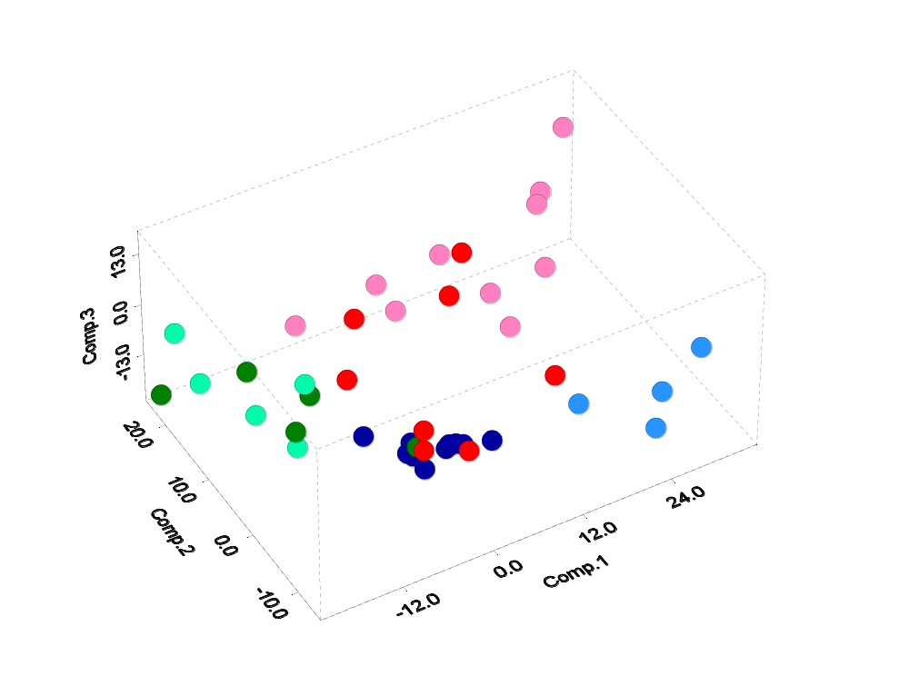
Dataset A (42 samples) – highly varying genes

AT/RT CNS
Ncer
MD
MGlio
PNET
AT/RT Renal/Extrarenal

Highly varying genes were selected by using a stringent variation filter (see parameters in table below). The plot above shows the projection of the first 3 components. Notice the relative clustering of tumor samples according to tissue type. The MD samples cluster tightly while the PNET and M. Glio. appear to scatter much more. The AR/RT renal/extra-renal and CNS varieties cluster closer to each other much more than to other types.

The next two plots show 2D projections of the first vs. second and second vs. third components.
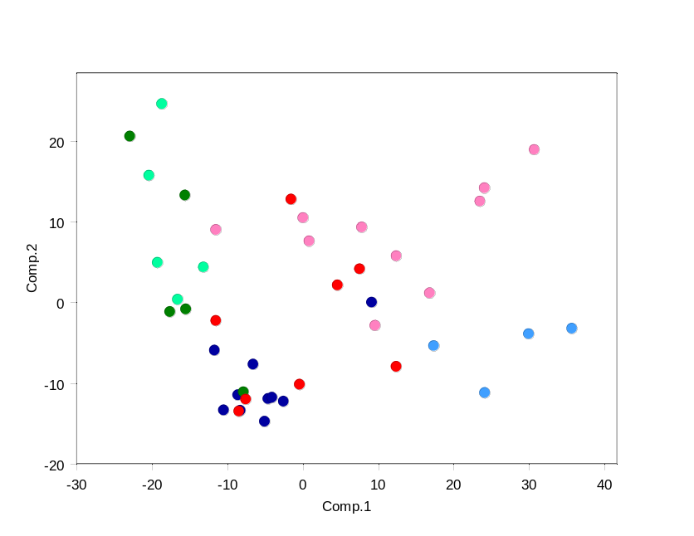

AT/RT CNS
Ncer
MD
MGlio
PNET
AT/RT Renal/Extrarenal
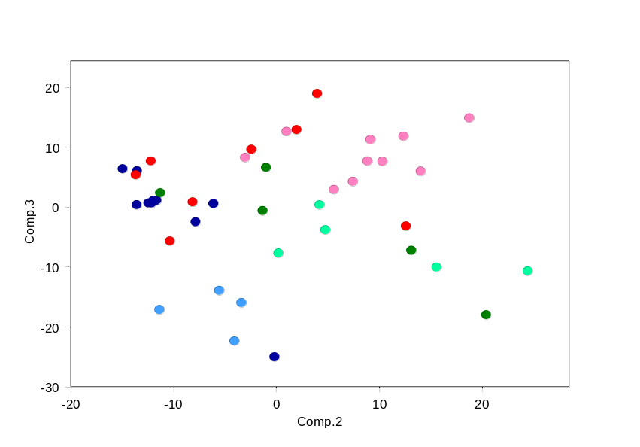

The next bar graph shows the relative importance of the first components. The first three components account for 42.5% of the variance of the highly varying genes.

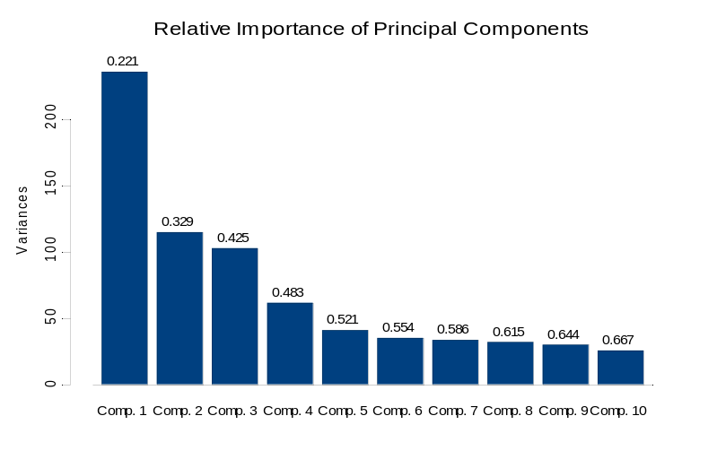

The bar graph below shows the contribution of the top 6 genes for each of the three principal components. Notice the almost equal weight given to multiple genes.

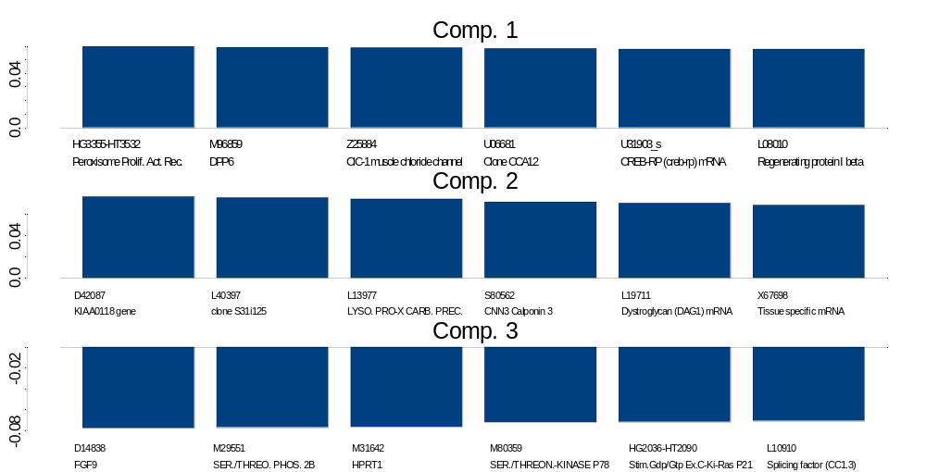

PCA of Multiple Tumor Samples
Dataset A
Part I: Genes with High Variation:
Values thresholded to 100 from below and 16000 from above
Variation filter: max/min > 12 (12-fold), max-min= 1200 absolute units
Number of features (genes) = 1065
 |  | PCA Components
Sample | class | C1 | C2 | C3
Brain_MD_12 | 0 | -11.5892 | -6.03135 | 0.440673
Brain_MD_61 | 0 | -2.4498 | -12.3523 | 0.541948
Brain_MD_15 | 0 | -4.50062 | -12.0282 | 0.534799
Brain_MD_57 | 0 | -8.18619 | -13.4928 | 0.255259
Brain_MD_33 | 0 | -4.96798 | -14.8525 | 6.25611
Brain_MD_64 | 0 | -6.47181 | -7.76031 | -2.60217
Brain_MD_17 | 0 | -8.49966 | -11.5705 | 0.990409
Brain_MD_62 | 0 | 9.224503 | -0.09585 | -25.1327
Brain_MD_63 | 0 | -10.4064 | -13.4434 | 5.931149
Brain_MD_32 | 0 | -3.99145 | -11.8767 | 0.990155
Brain_MGlio_1 | 1 | 9.679457 | -2.95242 | 8.168946
Brain_MGlio_2 | 1 | 30.79565 | 18.83608 | 14.74503
Brain_MGlio_3 | 1 | 23.58435 | 12.43997 | 11.68188
Brain_MGlio_4 | 1 | 12.51082 | 5.673459 | 2.789562
Brain_MGlio_5 | 1 | 7.913009 | 9.232989 | 11.14407
Brain_MGlio_6 | 1 | 0.940745 | 7.517246 | 4.158792
Brain_MGlio_7 | 1 | 0.124103 | 10.39103 | 7.501235
Brain_MGlio_8 | 1 | -11.4252 | 8.928279 | 7.558252
Brain_MGlio_9 | 1 | 24.17954 | 14.10684 | 5.865164
Brain_MGlio_10 | 1 | 16.90079 | 1.072724 | 12.49571
Brain_Rhab_1 | 2 | -22.8312 | 20.49559 | -18.1079
Brain_Rhab_2 | 3 | -16.4952 | 0.282439 | -7.79654
Brain_Rhab_3 | 3 | -20.2866 | 15.65098 | -10.1592
Brain_Rhab_4 | 2 | -15.4183 | -0.91765 | 6.466784
Brain_Rhab_5 | 3 | -19.1736 | 4.851007 | -3.92123
Brain_Rhab_6 | 3 | -18.5824 | 24.52529 | -10.7888
Brain_Rhab_7 | 3 | -13.0583 | 4.269002 | 0.225192
Brain_Rhab_8 | 2 | -17.5284 | -1.24629 | -0.73811
Brain_Rhab_9 | 2 | -7.77349 | -11.2075 | 2.246888
Brain_Rhab_10 | 2 | -15.5038 | 13.20266 | -7.3608
Brain_Ncer_1 | 4 | 17.45483 | -5.47981 | -14.059
Brain_Ncer_2 | 4 | 24.21633 | -11.2845 | -17.2432
Brain_Ncer_3 | 4 | 30.04492 | -4.00302 | -22.484
Brain_Ncer_4 | 4 | 35.79165 | -3.31034 | -16.0721
Brain_PNET_1 | 5 | -8.35903 | -13.5797 | 5.241555
Brain_PNET_2 | 5 | -11.4161 | -2.351 | 9.501429
Brain_PNET_3 | 5 | 7.634704 | 4.054882 | 18.81268
Brain_PNET_4 | 5 | -1.46068 | 12.68868 | -3.29885
Brain_PNET_5 | 5 | -7.45764 | -12.1163 | 7.544325
Brain_PNET_6 | 5 | -0.34124 | -10.2635 | -5.81399
Brain_PNET_7 | 5 | 12.47783 | -8.04875 | 0.715326
Brain_PNET_8 | 5 | 4.700972 | 2.045522 | 12.7752

Dataset A (42 samples) – class marker genes

The top 10 marker genes per class were seleted as described in the Gene marker selection section. The top 3 components for that set of 50 genes are shown below. Notice how the clustering and separation by tissue type is now more pronounced than in the case og highly varying genes. This is not surprising because the marker genes are some of the best class separator variabless and therefore will produce one of the “cleanest” projections). Notice how the MD and PNET classestend to occupy different areas of expression space. This was not as evident in the highly varying genes projection. The fact that the samples separate so well also implies that one should be able to build a classifier that separates the classes with low probability of error (see the results in the Multiple tumor classes predictions (k-NN) section).
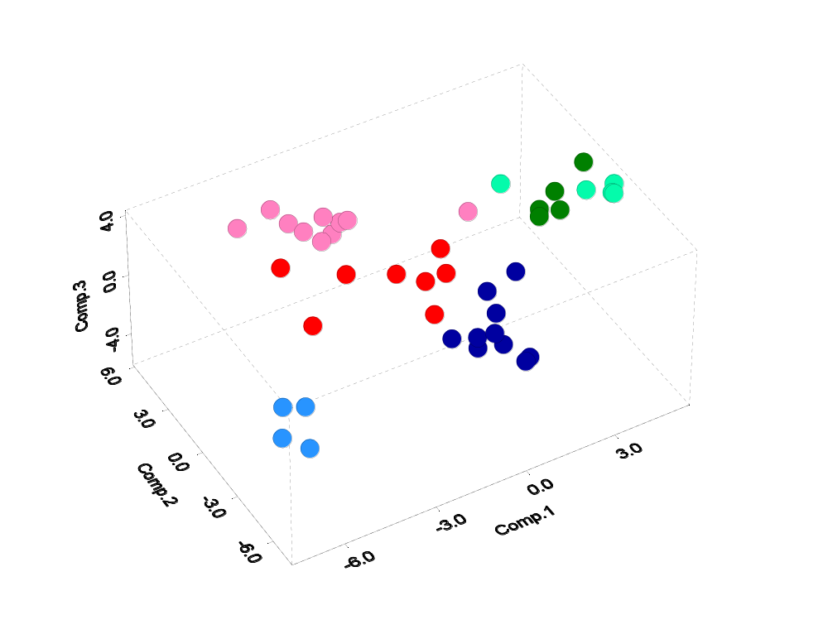

AT/RT CNS
Ncer
MD
MGlio
PNET
AT/RT Renal/Extrarenal

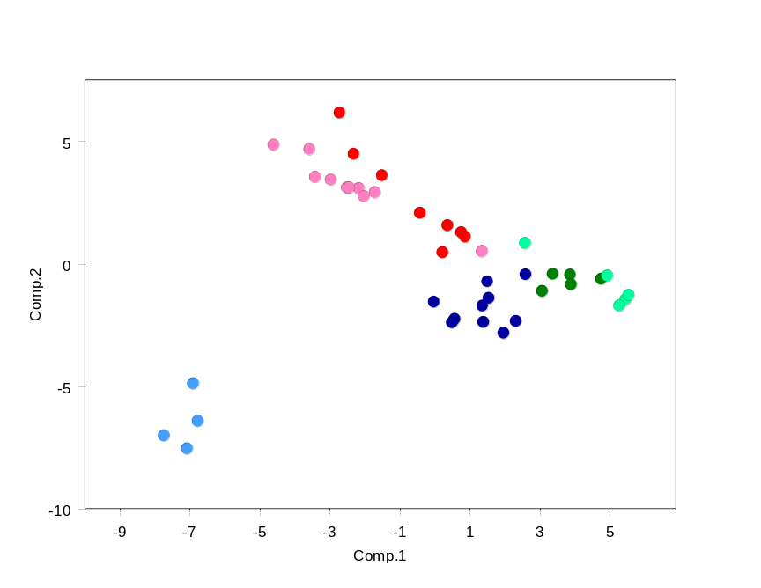
The next two plots show 2D projections of the first vs. second and second vs. third components.

AT/RT CNS
Ncer
MD
MGlio
PNET
AT/RT Renal/Extrarenal

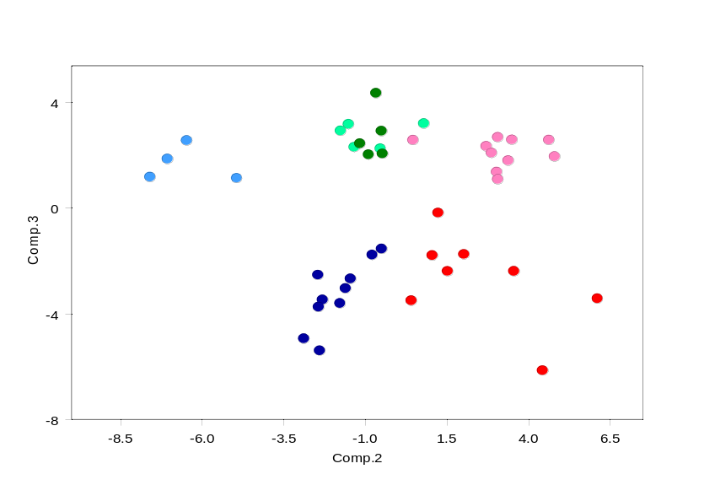

The next bar graph shows the relative importance of the first components. The first three components account for 60.6% of the variance of the marker genes.

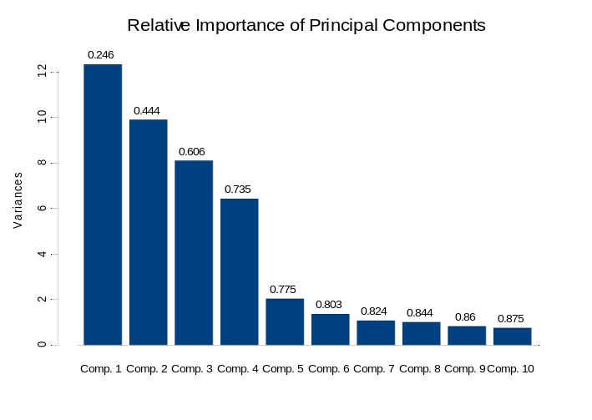

The bar graph below shows the contribution of the top 6 genes for each of the three principal components. The different combination of signs in each component is presumably a consequence of the fact that the marker genes behave as a group of correlated genes but also almost orthogonal across classes.

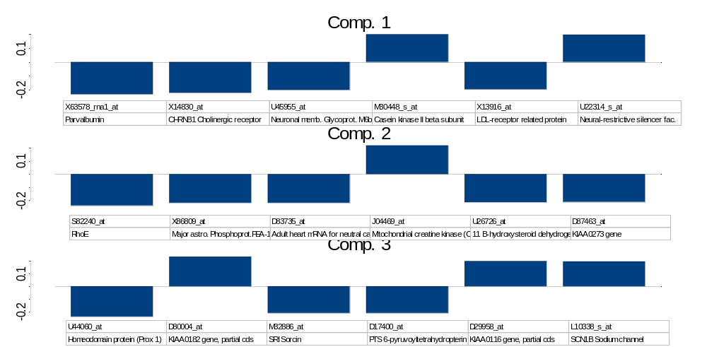

Part I: Top 10 Marker genes for each class (total 50 genes)
Values thresholded to 20 from below and 16000 from above
Variation filter: max/min > 5 (5-fold), max-min= 500 absolute units
Number of features (genes) = 50
 |  | PCA Components
Sample | class | C1 | C2 | C3
Brain_MD_12 | 0 | 2.61456 | -0.47658 | -1.56685
Brain_MD_61 | 0 | 0.589267 | -2.28945 | -3.49189
Brain_MD_15 | 0 | 0.514632 | -2.42775 | -2.55942
Brain_MD_57 | 0 | 1.407238 | -2.40925 | -3.76104
Brain_MD_33 | 0 | 1.383655 | -1.74997 | -3.62516
Brain_MD_64 | 0 | 2.335573 | -2.37497 | -5.41547
Brain_MD_17 | 0 | 1.560329 | -1.43053 | -2.69519
Brain_MD_62 | 0 | 3.96E-05 | -1.58512 | -3.06371
Brain_MD_63 | 0 | 1.527174 | -0.76173 | -1.79533
Brain_MD_32 | 0 | 1.986229 | -2.85936 | -4.95683
Brain_MGlio_1 | 1 | -2.15129 | 3.04742 | 1.340331
Brain_MGlio_2 | 1 | -3.55696 | 4.648686 | 2.546523
Brain_MGlio_3 | 1 | -3.39718 | 3.514346 | 2.550463
Brain_MGlio_4 | 1 | -2.48527 | 3.081104 | 1.062452
Brain_MGlio_5 | 1 | -2.00525 | 2.728528 | 2.310731
Brain_MGlio_6 | 1 | -2.41915 | 3.08049 | 2.653129
Brain_MGlio_7 | 1 | -1.6897 | 2.889009 | 2.059978
Brain_MGlio_8 | 1 | 1.365032 | 0.481712 | 2.542437
Brain_MGlio_9 | 1 | -4.58491 | 4.822834 | 1.92024
Brain_MGlio_10 | 1 | -2.95011 | 3.399331 | 1.769402
Brain_Rhab_1 | 2 | 5.464601 | -1.49409 | 3.144224
Brain_Rhab_2 | 3 | 5.292179 | -1.73967 | 2.896035
Brain_Rhab_3 | 3 | 5.55369 | -1.31506 | 2.274904
Brain_Rhab_4 | 2 | 2.600889 | 0.814271 | 3.167324
Brain_Rhab_5 | 3 | 4.950201 | -0.51508 | 2.221833
Brain_Rhab_6 | 3 | 4.77626 | -0.64909 | 4.316053
Brain_Rhab_7 | 3 | 3.392867 | -0.45345 | 2.021606
Brain_Rhab_8 | 2 | 3.910798 | -0.87741 | 1.990972
Brain_Rhab_9 | 2 | 3.089461 | -1.14414 | 2.409917
Brain_Rhab_10 | 2 | 3.888992 | -0.48271 | 2.882512
Brain_Ncer_1 | 4 | -6.87929 | -4.91617 | 1.099918
Brain_Ncer_2 | 4 | -7.05358 | -7.5747 | 1.151357
Brain_Ncer_3 | 4 | -7.71348 | -7.0406 | 1.830991
Brain_Ncer_4 | 4 | -6.74515 | -6.45202 | 2.529409
Brain_PNET_1 | 5 | 0.38724 | 1.541391 | -2.41529
Brain_PNET_2 | 5 | 0.774589 | 1.253634 | -0.21386
Brain_PNET_3 | 5 | -2.69406 | 6.137626 | -3.44386
Brain_PNET_4 | 5 | -0.40094 | 2.043733 | -1.7762
Brain_PNET_5 | 5 | 0.893357 | 1.073953 | -1.81399
Brain_PNET_6 | 5 | 0.242446 | 0.431521 | -3.51943
Brain_PNET_7 | 5 | -2.29284 | 4.453621 | -6.16835
Brain_PNET_8 | 5 | -1.48216 | 3.575675 | -2.41087

Dataset A1 (40 samples) – highly varying genes

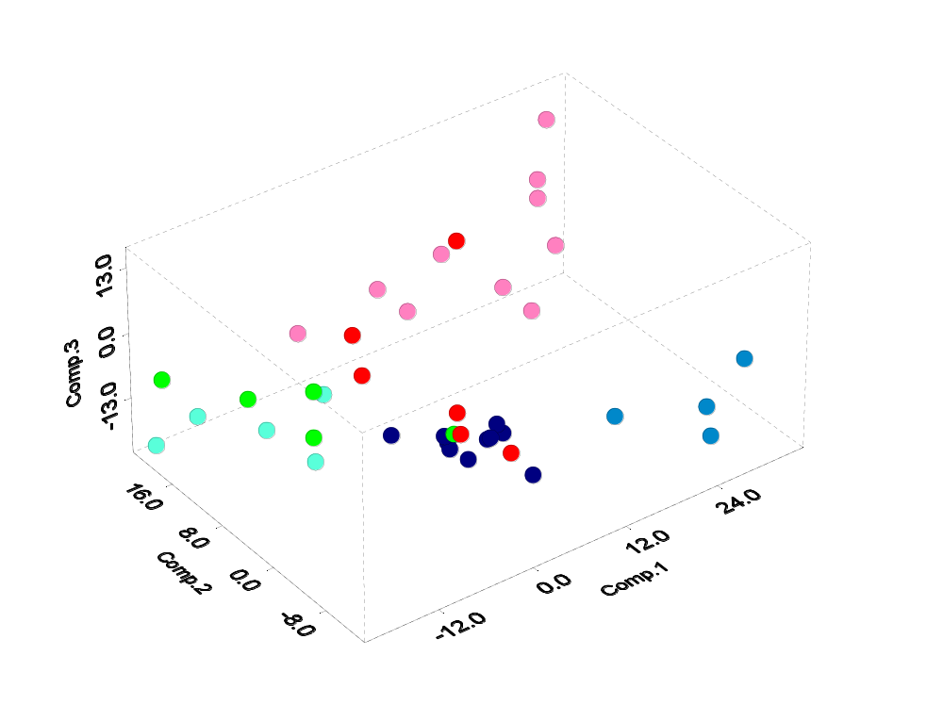
Two of the supratentorial PNETs are pineoblastomas, which historically have been inconsistently included in the PNET category. To study the difference it will make to exclude them we repeated the same PCA analysis of highly varying and marker genes but with the 2 pineoblastomas excluded (6 rather than 8 PNETs: dataset A1). The results are very similar as before.

AT/RT CNS
Ncer
MD
MGlio
PNET
AT/RT Renal/Extrarenal

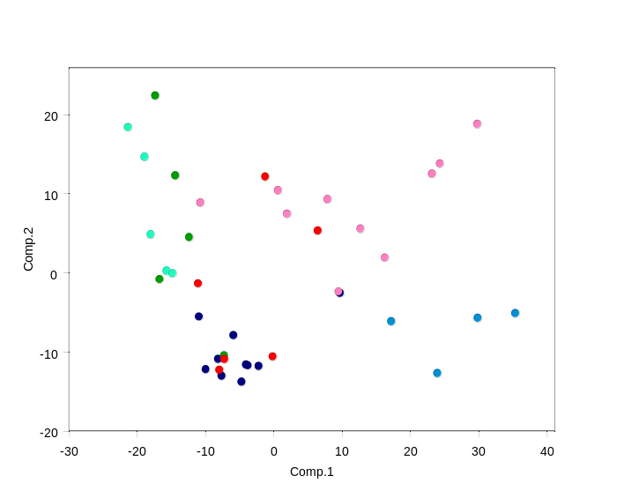

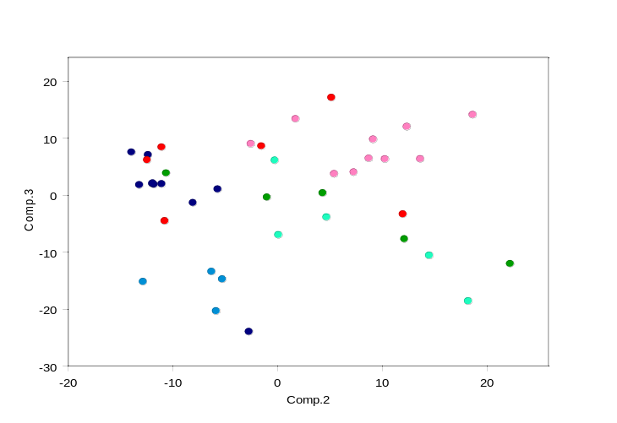

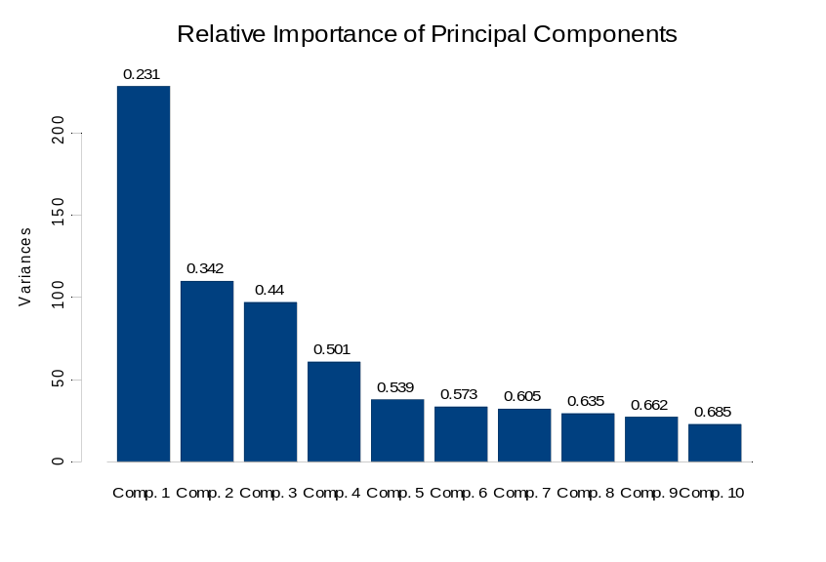

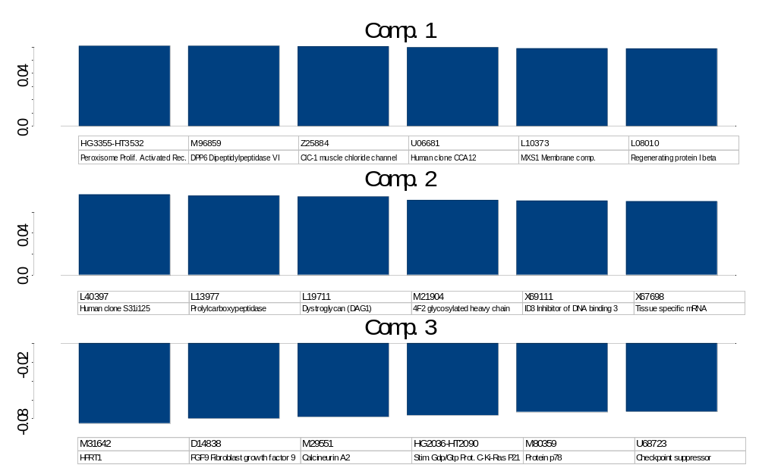
Dataset A1 (40 samples) – class marker genes
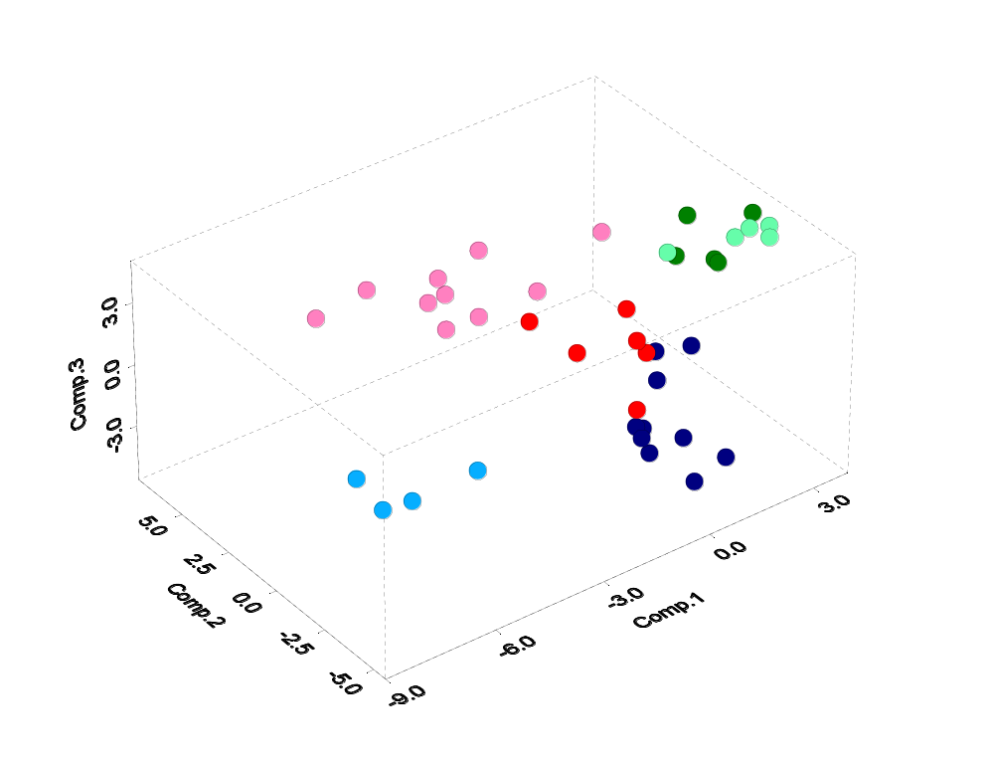

AT/RT CNS
Ncer
MD
MGlio
PNET
AT/RT Renal/Extrarenal

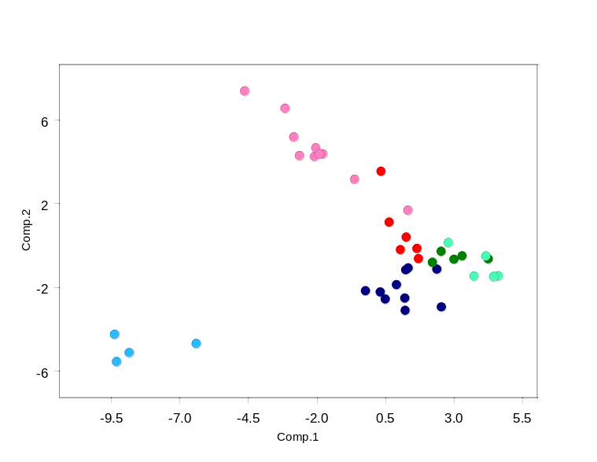
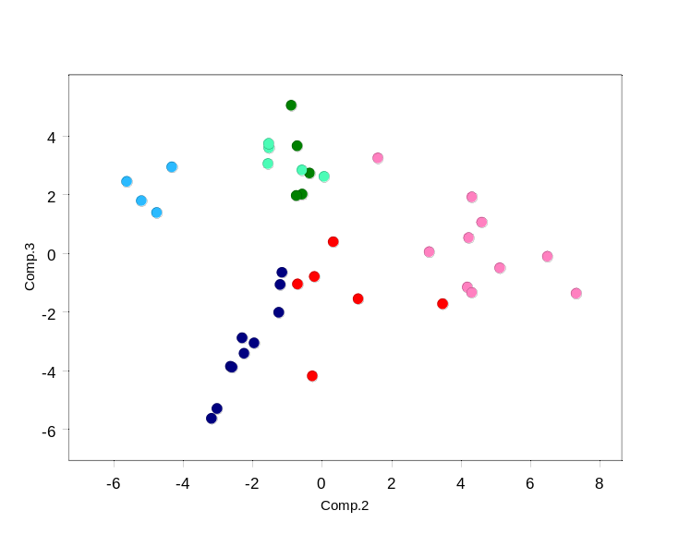

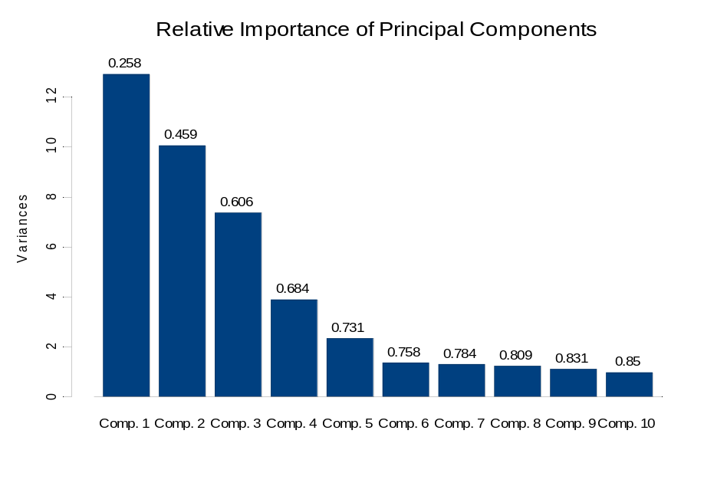
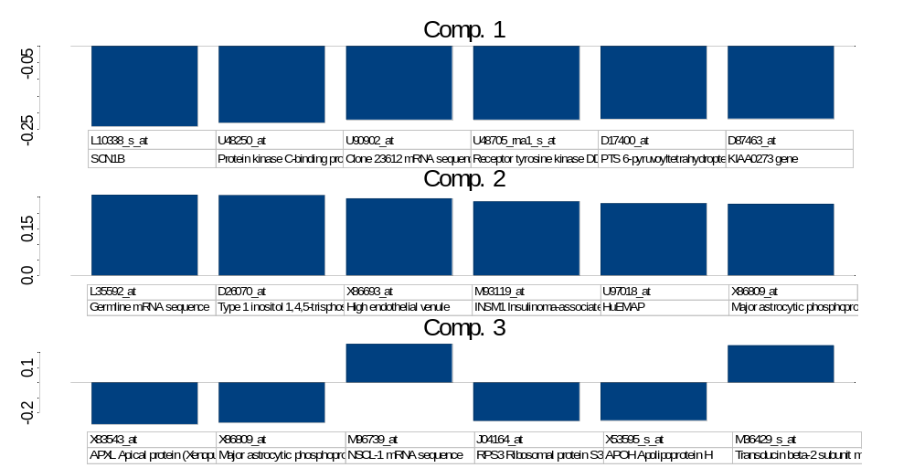
Dataset A2 (90 samples) – highly varying genes

To test whether inclusion of a larger number of medulloblastomas might lessen the distinctions noted in Dataset A, 50 more medulloblastoma samples were added and the PCA analysis for highly varying and marker genes repeated.

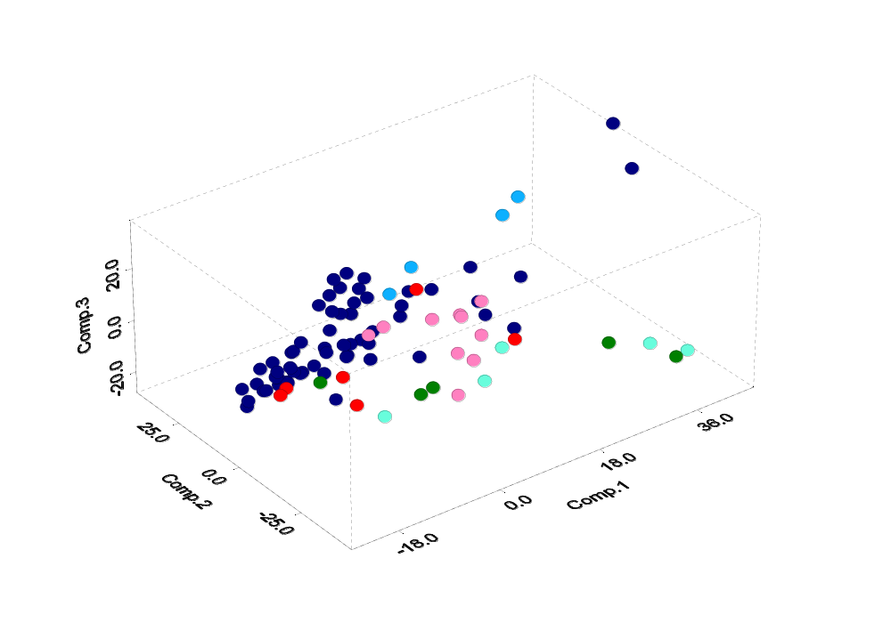

AT/RT CNS
Ncer
MD
MGlio
PNET
AT/RT Renal/Extrarenal

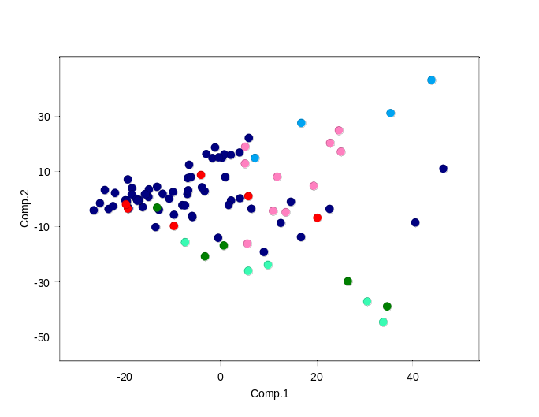
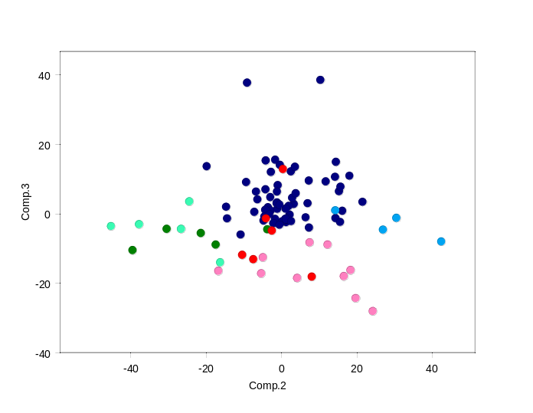

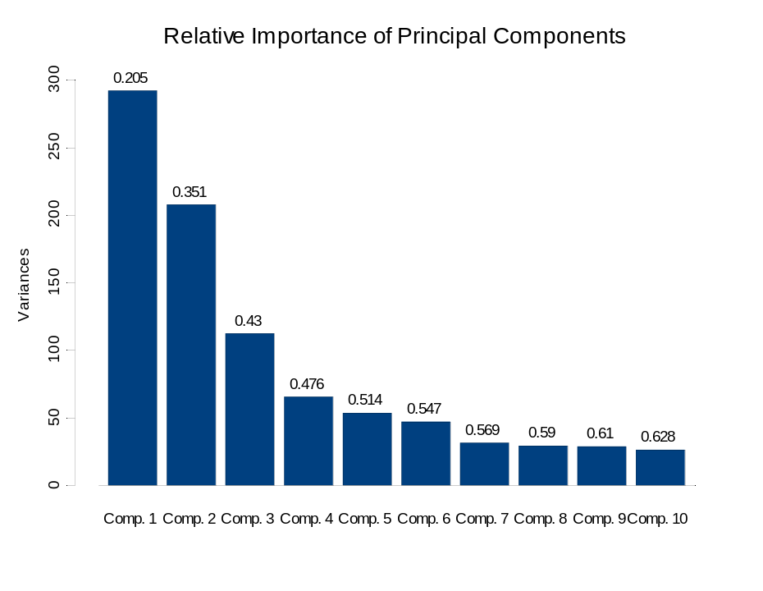
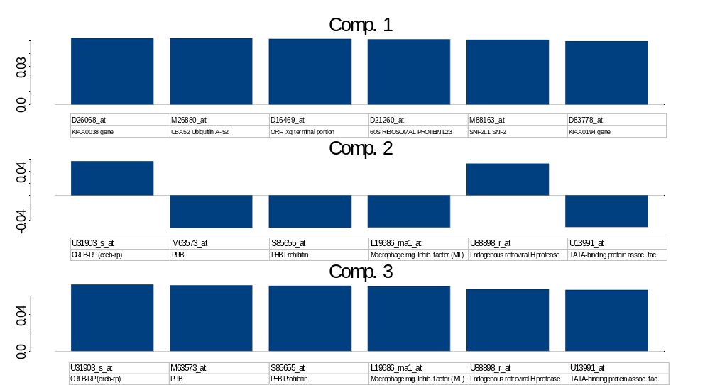
Dataset A2 (90 samples) – class marker genes

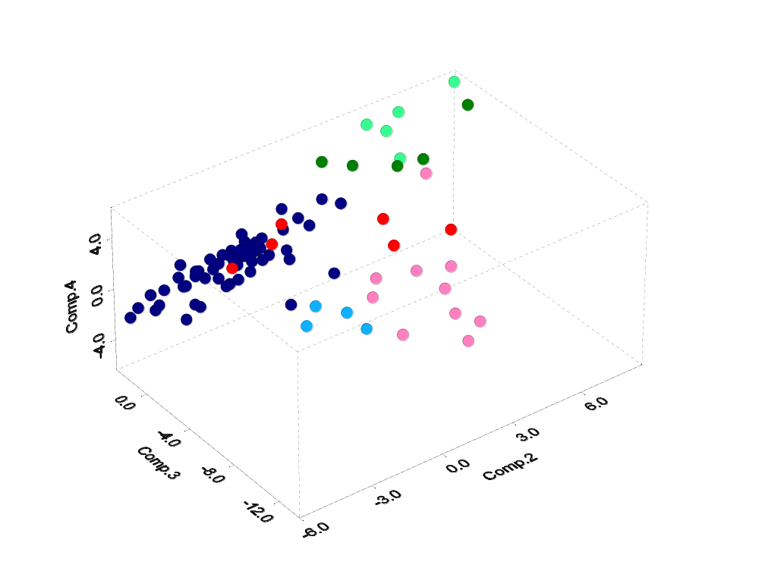

AT/RT CNS
Ncer
MD
MGlio
PNET
AT/RT Renal/Extrarenal

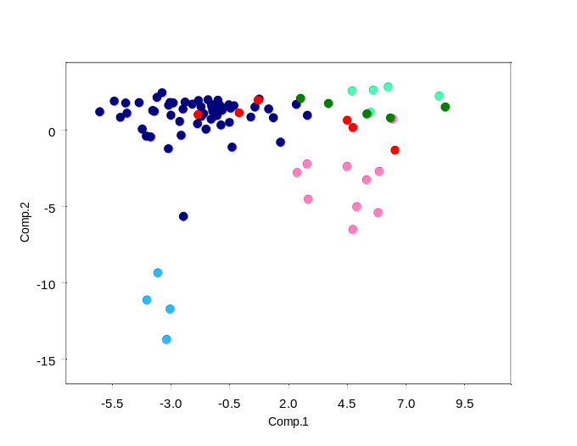
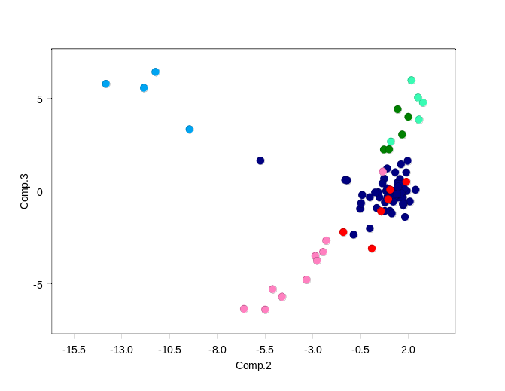

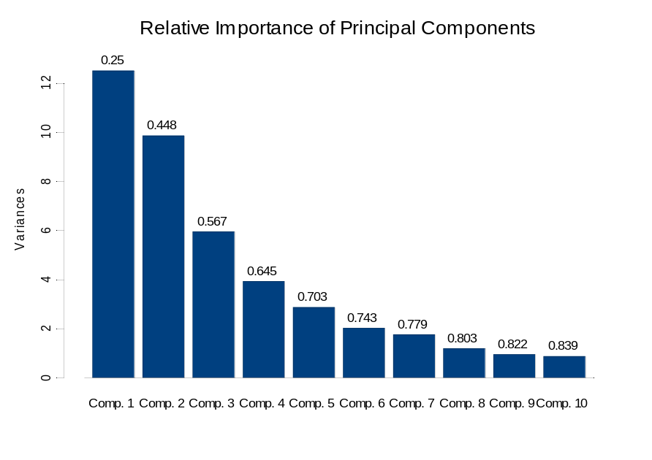
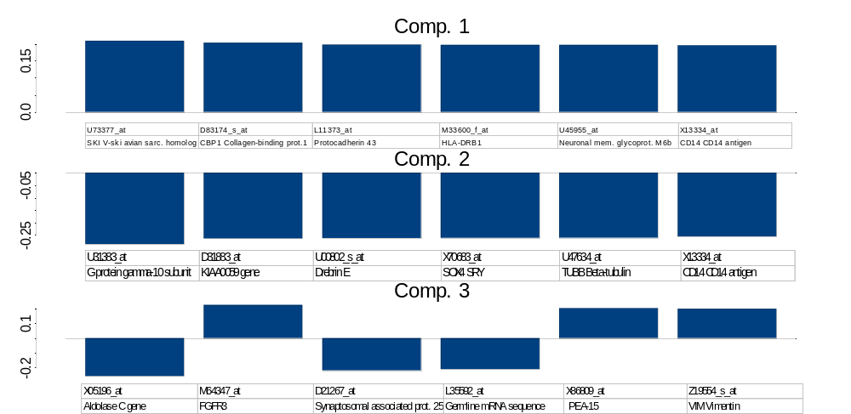

Multiple tumor class markers
This picture shows the top 10 markers per class as sorted by their signal to noise ratios as described in Gene marker selection section. The table below shows the top 100 markers for each tumor class including the permutation test values (see Permutation-based neighborhood analysis for marker gene).

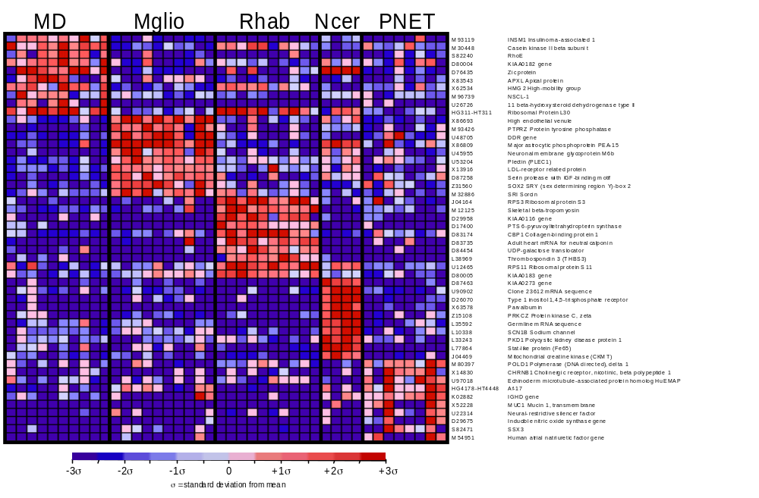

To 100 Marker Genes for each Tumor Class
Seleted by signal-to-noise (median) ratio
Values thresholded to 20 from below and 16000 from above
Variation filter: max/min > 5 (5-fold), max-min= 500 absolute units
Dataset A
Class 0 = High in Medulloblastoma, low in others
Class 1 = High in Malignant Glioma, low in others
Class 2 = High in AT/RT (renal-extrarenal), low in others
Class 3 = High in Normal Cerebellum, Low in others
Class 4 = High in PNET, low in others
 |  | Permutation test |  |  | Marker genes
Distinction | Distance | Perm 1% | Perm 5% | Median 50% | Feature | Desc
class 0 | 0.96694607 | 1.0144908 | 0.8333578 | 0.6280173 | M93119_at | INSM1 Insulinoma-associated 1 (symbol provisional)
class 0 | 0.9096911 | 0.8600172 | 0.7669801 | 0.5740431 | M30448_s_at | Casein kinase II beta subunit mRNA
class 0 | 0.90010124 | 0.85051423 | 0.7251496 | 0.5494933 | S82240_at | RhoE
class 0 | 0.832689 | 0.84354156 | 0.7071885 | 0.5292253 | U44060_at | Homeodomain protein (Prox 1) mRNA
class 0 | 0.83225346 | 0.8009565 | 0.68034023 | 0.5169537 | D80004_at | KIAA0182 gene, partial cds
class 0 | 0.7492524 | 0.7835767 | 0.6664746 | 0.5046996 | D76435_at | Zic protein
class 0 | 0.7383032 | 0.77384007 | 0.6535448 | 0.4954919 | X83543_at | APXL Apical protein (Xenopus laevis-like)
class 0 | 0.73376894 | 0.7426002 | 0.6453689 | 0.48881397 | X62534_s_at | HMG2 High-mobility group (nonhistone chromosomal) protein 2
class 0 | 0.73127395 | 0.73893577 | 0.637871 | 0.48173288 | M96739_at | NSCL-1 mRNA sequence
class 0 | 0.71544206 | 0.7368223 | 0.63101006 | 0.4792574 | U26726_at | 11 beta-hydroxysteroid dehydrogenase type II mRNA
class 0 | 0.70604366 | 0.7280188 | 0.6192388 | 0.47128072 | HG311-HT311_at | Ribosomal Protein L30
class 0 | 0.66780347 | 0.7201379 | 0.6169249 | 0.4645534 | X53331_at | MGP Matrix protein gla
class 0 | 0.6607844 | 0.7197015 | 0.6104924 | 0.46066648 | M14483_rna1_s_at | PTMA gene extracted from Human prothymosin alpha mRNA
class 0 | 0.6518439 | 0.707669 | 0.6029651 | 0.4572201 | Z69915_at | mRNA (clone ICRFp507L1876)
class 0 | 0.64655346 | 0.7015992 | 0.59863406 | 0.45266396 | L00022_s_at | IG EPSILON CHAIN C REGION
class 0 | 0.64252174 | 0.6809993 | 0.5968048 | 0.4494678 | U31382_at | G protein gamma-4 subunit mRNA
class 0 | 0.63783944 | 0.6795276 | 0.59584016 | 0.4467352 | Z23064_at | HNRPG Heterogeneous nuclear ribonucleoprotein G
class 0 | 0.6361946 | 0.67848146 | 0.5931882 | 0.44210848 | D82345_at | NB thymosin beta
class 0 | 0.60254765 | 0.6678708 | 0.5887515 | 0.43895075 | U05012_s_at | NTRK3 Neurotrophic tyrosine kinase, receptor, type 3 (TrkC)
class 0 | 0.5855725 | 0.6635907 | 0.58740836 | 0.43586975 | X87852_at | SEX gene
class 0 | 0.5815485 | 0.6612682 | 0.58239955 | 0.43329534 | HG1612-HT1612_at | Macmarcks
class 0 | 0.5815067 | 0.65672636 | 0.58039063 | 0.43086103 | U32315_at | Syntaxin 3 mRNA
class 0 | 0.5648414 | 0.65436137 | 0.5758365 | 0.42883328 | X05855_s_at | EEF1G Translation elongation factor 1 gamma
class 0 | 0.56469566 | 0.653728 | 0.5696867 | 0.4266686 | X13546_rna1_at | Put. HMG-17 protein gene extracted from Human HMG-17 gene for non-histone chromosomal protein HMG-17
class 0 | 0.5588449 | 0.6535496 | 0.56948066 | 0.4244893 | M19720_rna2_at | L-myc gene (L-myc protein) extracted from Human L-myc protein gene
class 0 | 0.5560505 | 0.65252143 | 0.56585836 | 0.4232427 | L33930_s_at | CD24 signal transducer mRNA and 3' region
class 0 | 0.550244 | 0.6516489 | 0.56495583 | 0.4211157 | L06797_s_at | PROBABLE G PROTEIN-COUPLED RECEPTOR LCR1 HOMOLOG
class 0 | 0.53802216 | 0.6500193 | 0.5646127 | 0.41931587 | M23613_at | NPM1 Nucleophosmin (nucleolar phosphoprotein B23, numatrin)
class 0 | 0.53711265 | 0.64934963 | 0.558147 | 0.41818365 | X02404_at | CALCB Calcitonin-related polypeptide, beta
class 0 | 0.53183836 | 0.6488311 | 0.5571701 | 0.41529867 | L10838_at | PRE-MRNA SPLICING FACTOR SRP20
class 0 | 0.5283321 | 0.6434776 | 0.5570184 | 0.41269392 | S82024_at | SCG10
class 0 | 0.5268076 | 0.64197075 | 0.55182576 | 0.411174 | M11433_at | RBP1 Cellular retinol-binding protein
class 0 | 0.51967216 | 0.64013463 | 0.5506556 | 0.4098725 | HG3088-HT3263_at | Splicing Factor Sc35, Alt Splice Form 3
class 0 | 0.5175459 | 0.63753295 | 0.5503224 | 0.40737128 | U28686_at | Putative RNA binding protein RNPL mRNA
class 0 | 0.50714874 | 0.6362442 | 0.5472199 | 0.40469232 | L40386_s_at | DP2 (Humdp2) mRNA
class 0 | 0.5039181 | 0.6355672 | 0.5450284 | 0.4028947 | Z11502_at | ANNEXIN XIII
class 0 | 0.50178665 | 0.6329165 | 0.54309994 | 0.40131387 | X55733_at | EUKARYOTIC INITIATION FACTOR 4B
class 0 | 0.50157803 | 0.6304573 | 0.54162425 | 0.4005091 | HG4318-HT4588_s_at | Lim-Domain Transcription Factor Lim-1
class 0 | 0.5009597 | 0.6291464 | 0.54044646 | 0.39848644 | U30521_at | FRAP FK506 binding protein 12-rapamycin associated protein
class 0 | 0.5009336 | 0.623241 | 0.53552544 | 0.39617687 | X74330_at | PRIM1 DNA primase polypeptide 1 (49kD)
class 0 | 0.5008229 | 0.62009233 | 0.535334 | 0.3954302 | X74262_at | RETINOBLASTOMA BINDING PROTEIN P48
class 0 | 0.49198747 | 0.61935806 | 0.5346635 | 0.39358965 | U70862_at | Nuclear factor I B3 mRNA
class 0 | 0.48500997 | 0.618592 | 0.5344887 | 0.3920796 | U79255_at | X11 protein mRNA, partial cds
class 0 | 0.48494342 | 0.6179998 | 0.5340308 | 0.390908 | HG613-HT613_at | Ribosomal Protein S12
class 0 | 0.4806928 | 0.61442095 | 0.5297601 | 0.38958547 | X07438_s_at | DNA for cellular retinol binding protein (CRBP) exons 3 and 4
class 0 | 0.47977164 | 0.61286503 | 0.52914625 | 0.38840055 | X56465_at | Znf6 mRNA for zinc finger transcription factor
class 0 | 0.47824362 | 0.61250454 | 0.52643156 | 0.38764188 | U47414_at | Cyclin G2 mRNA
class 0 | 0.4758209 | 0.6121982 | 0.5250884 | 0.38578293 | L37043_at | CSNK1E Casein kinase 1, epsilon
class 0 | 0.47532186 | 0.6104803 | 0.5240915 | 0.38462755 | U02031_at | Sterol regulatory element binding protein-2 mRNA
class 0 | 0.4750675 | 0.60672534 | 0.52364206 | 0.38363606 | U21090_at | DNA polymerase delta small subunit mRNA
class 0 | 0.4699813 | 0.5989572 | 0.5215285 | 0.3821684 | U26312_s_at | Heterochromatin protein HP1Hs-gamma mRNA
class 0 | 0.46889964 | 0.5977149 | 0.51875275 | 0.38159114 | M96740_at | HELIX-LOOP-HELIX PROTEIN 2
class 0 | 0.46830228 | 0.59540033 | 0.51809573 | 0.38079777 | D55716_at | DNA REPLICATION LICENSING FACTOR CDC47 HOMOLOG
class 0 | 0.467083 | 0.5951792 | 0.5178332 | 0.37955925 | X52966_at | RPL35A Ribosomal protein L35a
class 0 | 0.4641961 | 0.5948711 | 0.51752603 | 0.37854284 | Y09836_at | 3'UTR of unknown protein
class 0 | 0.45807302 | 0.59466755 | 0.5157532 | 0.37741286 | U43885_at | Grb2-associated binder-1 mRNA
class 0 | 0.45774597 | 0.5933097 | 0.5148932 | 0.37650257 | X69398_at | CD47 CD47 antigen (Rh-related antigen, integrin-associated signal transducer)
class 0 | 0.45630834 | 0.58962584 | 0.5139473 | 0.37543085 | X76029_at | NEUROMEDIN U-25 PRECURSOR
class 0 | 0.45350492 | 0.5884134 | 0.5138038 | 0.3743853 | M13241_at | N-MYC PROTO-ONCOGENE PROTEIN
class 0 | 0.4528938 | 0.5882923 | 0.5130492 | 0.37293357 | D28423_at | Pre-mRNA splicing factor SRp20, 5'UTR (sequence from the 5'cap to the start codon)
class 0 | 0.45122162 | 0.58495116 | 0.5122993 | 0.3718915 | U73304_rna1_at | CB1 cannabinoid receptor (CNR1) gene
class 0 | 0.4486972 | 0.5828123 | 0.5106254 | 0.37171924 | U17195_at | A-kinase anchor protein (AKAP100) mRNA
class 0 | 0.44740826 | 0.58226925 | 0.5075315 | 0.3709006 | M93415_at | ACVR2 Activin A receptor, type II
class 0 | 0.44720528 | 0.58122206 | 0.50601745 | 0.36981982 | M93650_at | Paired box gene (PAX6) homologue
class 0 | 0.44666263 | 0.5794936 | 0.50538707 | 0.3680578 | X85545_at | Protein kinase, PKX1
class 0 | 0.44536316 | 0.5779683 | 0.50191903 | 0.36731505 | S76475_at | NTRK3 Neurotrophic tyrosine kinase, receptor, type 3 (TrkC)
class 0 | 0.44418713 | 0.5775526 | 0.5014425 | 0.366797 | U00802_s_at | Drebrin E
class 0 | 0.44110203 | 0.57679415 | 0.49992916 | 0.36611393 | M60299_at | Alpha-1 collagen type II gene, exons 1, 2 and 3
class 0 | 0.43829215 | 0.5762043 | 0.49976385 | 0.36523366 | U16954_at | (AF1q) mRNA
class 0 | 0.43407452 | 0.5753858 | 0.49807757 | 0.36481872 | X99657_at | Protein containing SH3 domain, SH3GL2
class 0 | 0.43262523 | 0.5744567 | 0.49757218 | 0.3631796 | X76132_at | DCC Deleted in colorectal carcinoma
class 0 | 0.43084678 | 0.5735875 | 0.4974876 | 0.36188462 | U85193_at | Nuclear factor I-B2 (NFIB2) mRNA
class 0 | 0.43024966 | 0.5730583 | 0.4963776 | 0.36167425 | M82919_at | GABRB3 Gamma-aminobutyric acid (GABA) A receptor, beta 3
class 0 | 0.42832303 | 0.5729875 | 0.4960867 | 0.36009976 | M27691_at | CAMP-RESPONSE ELEMENT BINDING PROTEIN
class 0 | 0.42654628 | 0.57097447 | 0.4958619 | 0.3594544 | L22005_at | UBIQUITIN-CONJUGATING ENZYME E2-CDC34 COMPLEMENTING
class 0 | 0.42234343 | 0.56863326 | 0.49558508 | 0.35884386 | L76159_at | FRG1 mRNA
class 0 | 0.41938537 | 0.56803626 | 0.4927454 | 0.35822877 | U39226_at | Myosin VIIA (USH1B) mRNA
class 0 | 0.41719937 | 0.5676926 | 0.49170917 | 0.3565564 | U38810_at | Mab-21 cell fate-determining protein homolog (CAGR1) mRNA
class 0 | 0.41676784 | 0.5640895 | 0.49088645 | 0.35503575 | U25034_s_at | Neuronatin alpha mRNA
class 0 | 0.41542533 | 0.56285304 | 0.48999164 | 0.35428312 | U24576_at | Breast tumor autoantigen mRNA, complete sequence
class 0 | 0.4132539 | 0.5625111 | 0.4890851 | 0.35347974 | U23803_at | Heterogeneous ribonucleoprotein A0 mRNA
class 0 | 0.4109598 | 0.56244606 | 0.48815268 | 0.35334146 | M83822_at | Beige-like protein (BGL) mRNA, partial cds
class 0 | 0.4100799 | 0.562175 | 0.48733872 | 0.3529259 | U09087_s_at | Thymopoietin beta mRNA
class 0 | 0.4079055 | 0.5613772 | 0.48599333 | 0.35199758 | M91670_at | Ubiquitin carrier protein (E2-EPF) mRNA
class 0 | 0.4040995 | 0.5606459 | 0.48535928 | 0.350769 | U25789_at | Ribosomal protein L21 mRNA
class 0 | 0.40371194 | 0.5600623 | 0.48488784 | 0.35030034 | M62843_at | PARANEOPLASTIC ENCEPHALOMYELITIS ANTIGEN HUD
class 0 | 0.40356442 | 0.55962336 | 0.483534 | 0.34974435 | U09953_at | RPL9 Ribosomal protein L9
class 0 | 0.40279832 | 0.5594289 | 0.48338398 | 0.34923753 | U31814_at | Transcriptional regulator homolog RPD3 mRNA
class 0 | 0.4027233 | 0.55762196 | 0.48283297 | 0.34894606 | X64229_at | DEK PROTEIN
class 0 | 0.40206712 | 0.55735785 | 0.4824586 | 0.34788424 | U54999_at | LGN protein mRNA
class 0 | 0.40179467 | 0.5565962 | 0.48214018 | 0.34594992 | X70683_at | SOX4 SRY (sex determining region Y)-box 4
class 0 | 0.3995434 | 0.55561066 | 0.48126557 | 0.34553674 | U07919_at | ALDH6 Aldehyde dehydrogenase 6
class 0 | 0.39766783 | 0.5554421 | 0.48065114 | 0.34511587 | M64358_at | Rhom-3 gene, exon
class 0 | 0.39684495 | 0.5548959 | 0.48008677 | 0.3444539 | U19878_at | Transmembrane protein mRNA
class 0 | 0.39449787 | 0.55458045 | 0.47979704 | 0.3438485 | AFFX-HUMRGE/M10098_M_at | AFFX-HUMRGE/M10098_M_at (endogenous control)
class 0 | 0.39352742 | 0.5533359 | 0.47933868 | 0.342717 | J03827_at | DbpB-like protein mRNA
class 0 | 0.39003983 | 0.5530556 | 0.4786078 | 0.3423478 | U61145_at | Enhancer of zeste homolog 2 (EZH2) mRNA
class 0 | 0.38979462 | 0.5514548 | 0.47775155 | 0.34202746 | HG662-HT662_at | Epstein-Barr Virus Small Rna-Associated Protein
class 0 | 0.38538435 | 0.55026263 | 0.4775768 | 0.34102225 | M73047_at | TPP2 Tripeptidyl peptidase II
class 0 | 0.38463777 | 0.5502042 | 0.4763407 | 0.34075052 | D85131_s_at | Myc-associated zinc-finger protein of human islet
class 1 | 1.6520017 | 0.9831643 | 0.84544426 | 0.6230137 | X86693_at | High endothelial venule
class 1 | 1.2436218 | 0.88150144 | 0.7559189 | 0.5795857 | M93426_at | PTPRZ Protein tyrosine phosphatase, receptor-type, zeta polypeptide
class 1 | 1.2317128 | 0.86047184 | 0.70928395 | 0.5539352 | U48705_rna1_s_at | Receptor tyrosine kinase DDR gene
class 1 | 1.2259983 | 0.8433512 | 0.68909335 | 0.5358038 | X86809_at | Major astrocytic phosphoprotein PEA-15
class 1 | 1.214929 | 0.8281318 | 0.6849929 | 0.5217813 | U45955_at | Neuronal membrane glycoprotein M6b mRNA, partial cds
class 1 | 1.2095517 | 0.79365546 | 0.6711517 | 0.510208 | U53204_at | Plectin (PLEC1) mRNA
class 1 | 1.2026114 | 0.7930142 | 0.6636111 | 0.50219953 | X13916_at | LDL-receptor related protein
class 1 | 1.1869695 | 0.77752584 | 0.65392506 | 0.49156818 | D87258_at | Cancellous bone osteoblast mRNA for serin protease with IGF-binding motif
class 1 | 1.1676904 | 0.7709572 | 0.6380772 | 0.48596418 | Z31560_s_at | SOX2 SRY (sex determining region Y)-box 2
class 1 | 1.1604098 | 0.76437885 | 0.63309973 | 0.47967565 | M32886_at | SRI Sorcin
class 1 | 1.1558465 | 0.761579 | 0.62335235 | 0.47505242 | D16181_at | PMP2 Peripheral myelin protein 2
class 1 | 1.1461633 | 0.76131815 | 0.61996907 | 0.4696402 | U48250_at | Protein kinase C-binding protein RACK17 mRNA, partial cds
class 1 | 1.1236995 | 0.748406 | 0.61082774 | 0.46480379 | D63878_at | PROBABLE PROTEIN DISULFIDE ISOMERASE ER-60 PRECURSOR
class 1 | 1.0904534 | 0.74650514 | 0.6089377 | 0.46025795 | K03189_f_at | Chorionic gonadotropin (hcg) beta subunit mRNA
class 1 | 1.0883032 | 0.74052924 | 0.6014309 | 0.4566901 | U52155_at | Inward rectifier potassium channel Kir1.2 (Kir1.2) mRNA, partial cds
class 1 | 1.0646937 | 0.73030424 | 0.598755 | 0.45272368 | L11373_at | Protocadherin 43 mRNA for abbreviated PC43
class 1 | 1.0544381 | 0.72683483 | 0.5921049 | 0.4487451 | M21551_rna1_at | Neuromedin B mRNA
class 1 | 1.0439421 | 0.7250801 | 0.5877407 | 0.4458085 | Z50022_at | Surface glycoprotein
class 1 | 1.0364326 | 0.7139357 | 0.58473366 | 0.44330922 | HG620-HT620_at | Tyrosine Phosphatase, Epsilon
class 1 | 1.0299566 | 0.7118054 | 0.5835643 | 0.4414981 | M21904_at | MDU1 Antigen identified by monoclonal antibodies 4F2, TRA1.10, TROP4, and T43
class 1 | 1.026406 | 0.70610374 | 0.58319974 | 0.44004935 | D38522_at | KIAA0080 gene, partial cds
class 1 | 1.0112586 | 0.7057017 | 0.5741648 | 0.4358882 | Z50781_at | Leucine zipper protein
class 1 | 1.0110288 | 0.703144 | 0.5740614 | 0.43265316 | X54673_at | SLC6A1 Solute carrier family 6 (neurotransmitter transporter, GABA), member 1
class 1 | 0.9994149 | 0.6964176 | 0.5672535 | 0.43000817 | M63623_at | MOG Myelin oligodendrocyte glycoprotein
class 1 | 0.99073607 | 0.68848604 | 0.56642866 | 0.42853382 | M97796_s_at | ID2 Inhibitor of DNA binding 2, dominant negative helix-loop-helix protein
class 1 | 0.98774695 | 0.68189645 | 0.56605524 | 0.4269275 | L22214_at | ADORA1 Adenosine receptor A1
class 1 | 0.9855738 | 0.6807615 | 0.564807 | 0.42519456 | M23254_at | CAPN2 Calpain, large polypeptide L2
class 1 | 0.98304486 | 0.6677363 | 0.5630516 | 0.42373672 | S80905_f_at | PRB2 locus salivary proline-rich protein mRNA, clone cP7
class 1 | 0.9786299 | 0.6667506 | 0.56217647 | 0.4208039 | M32304_s_at | TIMP2 Tissue inhibitor of metalloproteinase 2
class 1 | 0.97468305 | 0.66582626 | 0.5576709 | 0.41835085 | U79272_at | Clone 23720 mRNA sequence
class 1 | 0.9741546 | 0.6632827 | 0.5567529 | 0.4152393 | D25217_at | KIAA0027 gene, partial cds
class 1 | 0.97182816 | 0.6625792 | 0.5549602 | 0.41295442 | U59877_s_at | Low-Mr GTP-binding protein (RAB31) mRNA
class 1 | 0.9682741 | 0.6590203 | 0.5520322 | 0.4113537 | U07807_at | Metallothionein IV (MTIV) gene
class 1 | 0.9622625 | 0.6580188 | 0.54826355 | 0.4092988 | D14689_at | NUCLEAR PORE COMPLEX PROTEIN NUP214
class 1 | 0.9585737 | 0.6577229 | 0.5479787 | 0.4066317 | X98085_at | TNR Tenascin R (restrictin, janusin)
class 1 | 0.9569103 | 0.65765256 | 0.547915 | 0.40562418 | D49817_at | Fructose 6-phosphate,2-kinase/fructose 2,6-bisphosphatase
class 1 | 0.95592564 | 0.6532676 | 0.543061 | 0.40421706 | M16424_at | BETA-HEXOSAMINIDASE ALPHA CHAIN PRECURSOR
class 1 | 0.94691986 | 0.6528938 | 0.54168797 | 0.40255094 | M62302_at | Growth/differentiation factor 1 (GDF-1) mRNA
class 1 | 0.9426242 | 0.65049857 | 0.5364322 | 0.4010224 | L32961_at | 4-AMINOBUTYRATE AMINOTRANSFERASE, MITOCHONDRIAL PRECURSOR
class 1 | 0.9419619 | 0.65049285 | 0.53504795 | 0.4002328 | S56151_s_at | HMFG
class 1 | 0.93842375 | 0.6503094 | 0.53349763 | 0.3990202 | U90547_at | Ro/SSA ribonucleoprotein homolog (RoRet) mRNA
class 1 | 0.9366897 | 0.6481403 | 0.5331684 | 0.39706725 | U76388_at | Steroidogenic factor 1 mRNA
class 1 | 0.93209916 | 0.64719605 | 0.53102833 | 0.39576787 | L24559_at | POLA DNA polymerase alpha subunit
class 1 | 0.92833 | 0.64508885 | 0.5292084 | 0.39434457 | D79999_at | KIAA0177 gene, partial cds
class 1 | 0.92812437 | 0.64227355 | 0.5264592 | 0.3926984 | S73591_at | Brain-expressed HHCPA78 homolog [human, HL-60 acute promyelocytic leukemia cells, mRNA, 2704 nt]
class 1 | 0.9218112 | 0.64078844 | 0.52606547 | 0.39150074 | X54637_at | TYK2 Protein-tyrosine kinase tyk2 (non-receptor)
class 1 | 0.92119294 | 0.63995963 | 0.5255806 | 0.39071545 | U12707_s_at | WAS Wiskott-Aldrich syndrome (ecezema-thrombocytopenia)
class 1 | 0.9184531 | 0.6391437 | 0.5252529 | 0.38848042 | X75958_at | TrkB {alternatively spliced} [human, brain, mRNA, 1870 nt]
class 1 | 0.9155559 | 0.6370653 | 0.5248767 | 0.38763252 | X04828_at | GNAI2 Guanine nucleotide binding protein (G protein), alpha inhibiting activity polypeptide 2
class 1 | 0.90545046 | 0.63566005 | 0.52347106 | 0.38607994 | S82297_at | BETA-2-MICROGLOBULIN PRECURSOR
class 1 | 0.8919348 | 0.63485956 | 0.52277017 | 0.384728 | S45630_at | CRYAB Crystallin alpha-B
class 1 | 0.8909992 | 0.63345426 | 0.51961327 | 0.38367814 | D13631_s_at | KIAA0006 gene
class 1 | 0.8867211 | 0.6329042 | 0.5160313 | 0.38311574 | U80226_s_at | Gamma-aminobutyric acid transaminase mRNA, partial cds
class 1 | 0.8820352 | 0.63253194 | 0.5158146 | 0.3825838 | L40407_at | Thyroid receptor interactor (TRIP9) gene
class 1 | 0.87914836 | 0.6318433 | 0.514657 | 0.38108054 | U38980_at | PMS8 mRNA (yeast mismatch repair gene PMS1 homologue), partial cds (C-terminal region)
class 1 | 0.87837005 | 0.6309211 | 0.5133504 | 0.37988254 | Y00796_at | ITGAL Integrin, alpha L (antigen CD11A (p180), lymphocyte function-associated antigen 1; alpha polypeptide)
class 1 | 0.87823164 | 0.62923473 | 0.5121836 | 0.37843332 | J03040_at | SPARC SPARC/osteonectin
class 1 | 0.8760671 | 0.6286636 | 0.5113878 | 0.37749302 | X55740_at | NT5 5' nucleotidase (CD73)
class 1 | 0.8760668 | 0.62734014 | 0.51018846 | 0.37679052 | X92475_at | ITBA1 protein
class 1 | 0.87513036 | 0.6266346 | 0.5089304 | 0.3758733 | U69263_at | Matrilin-2 precursor mRNA, partial cds
class 1 | 0.8745863 | 0.6246063 | 0.5083398 | 0.3742895 | U55258_at | HBRAVO/Nr-CAM precursor (hBRAVO/Nr-CAM) gene
class 1 | 0.86930543 | 0.62451684 | 0.5073476 | 0.37309632 | S50017_s_at | CNP 2',3'-cyclic nucleotide 3' phosphodiesterase
class 1 | 0.8662232 | 0.6241277 | 0.50710213 | 0.37164986 | X76717_at | MT1L Metallothionein 1L
class 1 | 0.84933835 | 0.6234191 | 0.5067336 | 0.37121156 | U28368_at | ID4 Inhibitor of DNA binding 4, dominant negative helix-loop-helix protein
class 1 | 0.8469514 | 0.62305886 | 0.5062817 | 0.37057114 | X74794_at | CDC21 HOMOLOG
class 1 | 0.84659636 | 0.6230239 | 0.50575304 | 0.36982706 | X75861_at | TEGT Testis enhanced gene transcript
class 1 | 0.8460863 | 0.6192708 | 0.50347847 | 0.36910838 | M83233_at | TCF12 Transcription factor 12 (HTF4, helix-loop-helix transcription factors 4)
class 1 | 0.8459389 | 0.61905175 | 0.5014394 | 0.36789283 | U73328_at | DLX7 Distal-less homeobox 7
class 1 | 0.8424674 | 0.6189927 | 0.5009286 | 0.36755785 | M95936_s_at | AKT2 V-akt murine thymoma viral oncogene homolog 2
class 1 | 0.8386806 | 0.6188733 | 0.49939558 | 0.36682224 | X85786_at | BINDING REGULATORY FACTOR
class 1 | 0.8372769 | 0.61818075 | 0.49734905 | 0.36528903 | U14394_at | METALLOPROTEINASE INHIBITOR 3 PRECURSOR
class 1 | 0.8356367 | 0.6158615 | 0.49629536 | 0.36451015 | D63486_at | KIAA0152 gene
class 1 | 0.83225477 | 0.6150287 | 0.4945158 | 0.36395043 | Z68280_cds2_s_at | Erythrocyte adducin alpha subunit gene extracted from Human DNA sequence from cosmid L25A3, Huntington's Disease Region, chromosome 4p16.3 contains Human tetracycline transporter-like protein and erythrocyte adducin alpha subunit, multiple ESTs and a putative CpG island
class 1 | 0.83206296 | 0.6120459 | 0.4930411 | 0.36299255 | U89335_cds2_at | NOTCH4 gene (notch4) extracted from Human HLA class III region containing notch4 (NOTCH4) gene, complete sequence
class 1 | 0.8239408 | 0.61198014 | 0.49286792 | 0.36167002 | U00928_at | RNA-BINDING PROTEIN FUS/TLS
class 1 | 0.8234844 | 0.61135525 | 0.49238437 | 0.36087698 | X00274_at | HLA CLASS II HISTOCOMPATIBILITY ANTIGEN, DR ALPHA CHAIN PRECURSOR
class 1 | 0.82109606 | 0.6106854 | 0.49044895 | 0.36035484 | M80244_at | INTEGRAL MEMBRANE PROTEIN E16
class 1 | 0.81676286 | 0.61059463 | 0.48990437 | 0.3597854 | D49410_at | IL3RA Interleukin 3 receptor, alpha (low affinity)
class 1 | 0.8108157 | 0.6101961 | 0.48990065 | 0.35875112 | L14813_at | CELL Carboxyl ester lipase like protein
class 1 | 0.80911857 | 0.61003023 | 0.48817563 | 0.35794193 | M77016_at | TMOD Tropomodulin
class 1 | 0.8083867 | 0.60995644 | 0.48780048 | 0.35718402 | Y08265_s_at | DAN26 protein, partial
class 1 | 0.80540043 | 0.6097752 | 0.48703083 | 0.35631403 | M69023_at | Globin gene
class 1 | 0.8024884 | 0.6077933 | 0.4849392 | 0.35507387 | M11749_at | THY-1 MEMBRANE GLYCOPROTEIN PRECURSOR
class 1 | 0.8011927 | 0.60732687 | 0.48423845 | 0.35416168 | X59892_at | TRYPTOPHANYL-TRNA SYNTHETASE
class 1 | 0.7992353 | 0.6069737 | 0.48395756 | 0.3537728 | HG987-HT987_at | Mac25
class 1 | 0.79868704 | 0.6057914 | 0.48377454 | 0.35269728 | X83863_at | PTGER3 Prostaglandin E receptor 3 (subtype EP3) {alternative products}
class 1 | 0.7985791 | 0.6057221 | 0.48315245 | 0.35175043 | X55666_at | Usf mRNA for late upstream transcription factor
class 1 | 0.7961344 | 0.604588 | 0.48308864 | 0.3515281 | U30930_at | CGT UDP-galactose ceramide galactosyl transferase
class 1 | 0.79439163 | 0.6007642 | 0.4818679 | 0.35095778 | U19261_at | Epstein-Barr virus-induced protein mRNA
class 1 | 0.79308397 | 0.59980625 | 0.48032397 | 0.35053596 | L42601_f_at | KERATIN, TYPE II CYTOSKELETAL 6D
class 1 | 0.79107213 | 0.5997507 | 0.48028195 | 0.35026234 | U46023_at | Xq28 mRNA
class 1 | 0.79009724 | 0.5991178 | 0.4783936 | 0.34935814 | M10612_at | APOC2 Apolipoprotein C-II
class 1 | 0.78904396 | 0.5987258 | 0.4782325 | 0.34850967 | U79528_s_at | Sigma receptor mRNA
class 1 | 0.788058 | 0.5983545 | 0.4774304 | 0.34845862 | Z49825_s_at | HEPATOCYTE NUCLEAR FACTOR 4
class 1 | 0.7867659 | 0.59789264 | 0.4762901 | 0.34749532 | D84145_at | WS-3 mRNA
class 1 | 0.78471535 | 0.59755576 | 0.47509775 | 0.34661785 | Z11899_s_at | POU5F1 Octamer binding protein 3
class 1 | 0.7831359 | 0.59647435 | 0.47479355 | 0.34539047 | D63135_at | ETS-like 30 kDa protein
class 1 | 0.78272295 | 0.5960181 | 0.47357324 | 0.3446057 | U32680_at | CLN3 Ceroid-lipofuscinosis, neuronal 3, juvenile (Batten, Spielmeyer-vogt disease)
class 1 | 0.78065175 | 0.594793 | 0.4729738 | 0.34366468 | X55079_rna1_at | GAA gene extracted from Human lysosomal alpha-glucosidase gene exon 1
class 1 | 0.7805558 | 0.5940042 | 0.47264746 | 0.34325802 | U94747_at | WD repeat protein HAN11 mRNA
class 2 | 1.5964093 | 0.9486641 | 0.8495439 | 0.62064433 | J04164_at | RPS3 Ribosomal protein S3
class 2 | 1.5496515 | 0.87290615 | 0.777105 | 0.5718508 | M12125_at | Skeletal beta-tropomyosin
class 2 | 1.5152686 | 0.827159 | 0.73881376 | 0.5467952 | D17400_at | PTS 6-pyruvoyltetrahydropterin synthase
class 2 | 1.4285764 | 0.8085277 | 0.71054107 | 0.5315226 | D29958_at | KIAA0116 gene, partial cds
class 2 | 1.406929 | 0.7890778 | 0.69446135 | 0.5199787 | D84454_at | UDP-galactose translocator
class 2 | 1.3972126 | 0.771632 | 0.6803573 | 0.5063799 | D83174_s_at | CBP1 Collagen-binding protein 1
class 2 | 1.3882682 | 0.7628288 | 0.6654627 | 0.4983154 | D83735_at | Adult heart mRNA for neutral calponin
class 2 | 1.3158283 | 0.7600643 | 0.65747064 | 0.48707137 | L38969_at | Thrombospondin 3 (THBS3) gene
class 2 | 1.2211796 | 0.75861675 | 0.6480409 | 0.47926977 | U12465_at | RPS11 Ribosomal protein S11
class 2 | 1.2204406 | 0.74606985 | 0.64249825 | 0.47334 | U47621_at | Nucleolar autoantigen No55 mRNA
class 2 | 1.2186558 | 0.744558 | 0.6345838 | 0.46700227 | D80005_at | KIAA0183 gene, partial cds
class 2 | 1.2145118 | 0.7413605 | 0.6255762 | 0.4635181 | X79683_s_at | LAMB2 Laminin, beta 2 (laminin S)
class 2 | 1.1926116 | 0.73349786 | 0.62487775 | 0.45888507 | U73377_at | SKI V-ski avian sarcoma viral oncogene homolog
class 2 | 1.1885384 | 0.7101549 | 0.6203104 | 0.4543584 | L21954_at | PERIPHERAL-TYPE BENZODIAZEPINE RECEPTOR
class 2 | 1.1789806 | 0.70968467 | 0.61982125 | 0.45166668 | D85418_at | Phosphatidylinositol-glycan-class C (PIG-C)
class 2 | 1.1726408 | 0.7075023 | 0.6164542 | 0.4459662 | U50523_at | BRCA2 region, mRNA sequence CG037
class 2 | 1.1627295 | 0.6977533 | 0.60977054 | 0.44309354 | U13991_at | TATA-binding protein associated factor 30 kDa subunit (tafII30) mRNA
class 2 | 1.1177913 | 0.6966777 | 0.60499704 | 0.4403641 | L41066_at | NF-AT3 mRNA
class 2 | 1.1161832 | 0.69525945 | 0.6020127 | 0.43546635 | S80343_at | RARS Arginyl-tRNA synthetase
class 2 | 1.1063769 | 0.6934489 | 0.6001345 | 0.43275866 | D78586_at | CAD PROTEIN
class 2 | 1.100164 | 0.68982345 | 0.59710175 | 0.43011752 | X54304_at | Myosin regulatory light chain mRNA
class 2 | 1.0985785 | 0.6834978 | 0.59472984 | 0.4265189 | X94910_at | ERp31 protein
class 2 | 1.0931795 | 0.68134505 | 0.59273076 | 0.42424324 | U31383_at | G protein gamma-10 subunit mRNA
class 2 | 1.0755527 | 0.67965597 | 0.5872831 | 0.42292687 | D30755_at | VIM Vimentin
class 2 | 1.0685377 | 0.67405325 | 0.5853282 | 0.42069253 | U70439_s_at | PHAPI2b protein
class 2 | 1.0646288 | 0.6734994 | 0.5838599 | 0.41816902 | M19645_at | 78 KD GLUCOSE REGULATED PROTEIN PRECURSOR
class 2 | 1.0563896 | 0.67214715 | 0.58231425 | 0.41704497 | D45248_at | Proteasome activator hPA28 subunit beta
class 2 | 1.0528408 | 0.6703584 | 0.5772028 | 0.4129843 | M14338_at | PROS1 Plasma protein S
class 2 | 1.0516357 | 0.6697295 | 0.57507044 | 0.41167092 | D31888_at | KIAA0071 gene, partial cds
class 2 | 1.0499836 | 0.6691372 | 0.57322055 | 0.41046417 | D79996_at | KIAA0174 gene
class 2 | 1.0487297 | 0.66673857 | 0.5681988 | 0.40736142 | U34683_at | GSS Glutathione synthetase
class 2 | 1.0459839 | 0.65853596 | 0.56721437 | 0.40508857 | L12535_at | RSU-1/RSP-1 mRNA
class 2 | 1.0183622 | 0.65781057 | 0.5650841 | 0.40312052 | X61587_at | ARHG Ras homolog gene family, member G (rho G)
class 2 | 1.0072109 | 0.6538323 | 0.56382716 | 0.40154344 | X53777_at | 60S RIBOSOMAL PROTEIN L23
class 2 | 0.99361455 | 0.6530042 | 0.56308913 | 0.39934984 | X06700_s_at | COL3A1 Alpha-1 type 3 collagen
class 2 | 0.98622197 | 0.6510077 | 0.56030434 | 0.3967915 | U41515_at | Deleted in split hand/split foot 1 (DSS1) mRNA
class 2 | 0.9862092 | 0.6501271 | 0.5597317 | 0.3955185 | L14565_at | PERIPHERIN
class 2 | 0.9861108 | 0.65010846 | 0.5552204 | 0.3940714 | M63573_at | PPIB Peptidylprolyl isomerase B (cyclophilin B)
class 2 | 0.9772656 | 0.64656097 | 0.55292964 | 0.39343733 | Z23090_at | HSPB1 Heat shock 27kD protein 1
class 2 | 0.9681267 | 0.64562047 | 0.5525739 | 0.39118996 | L25085_at | PROTEIN TRANSPORT PROTEIN SEC61 BETA SUBUNIT
class 2 | 0.963596 | 0.644272 | 0.551029 | 0.38998803 | U72514_at | C2f mRNA
class 2 | 0.9609764 | 0.6431171 | 0.5493531 | 0.3888596 | X15187_at | TRA1 Homologue of mouse tumor rejection antigen gp96
class 2 | 0.95701075 | 0.6428692 | 0.5473165 | 0.3870365 | M29971_at | MGMT 6-O-methylguanine-DNA methyltransferase (MGMT)
class 2 | 0.95551085 | 0.6414765 | 0.54465944 | 0.3854772 | D79997_at | KIAA0175 gene
class 2 | 0.9548831 | 0.64113075 | 0.54276997 | 0.38295317 | Y07604_at | Nucleoside-diphosphate kinase
class 2 | 0.95175433 | 0.63506126 | 0.54169023 | 0.38189143 | D78611_at | MEST Mesoderm specific transcript (mouse) homolog
class 2 | 0.9498536 | 0.6342157 | 0.54131114 | 0.380591 | U84720_at | mRNA export protein Rae1 (RAE1) mRNA
class 2 | 0.9433024 | 0.63139164 | 0.54059446 | 0.37891367 | U72263_s_at | EXT2 Exostoses (multiple) 2
class 2 | 0.94292474 | 0.63092226 | 0.5366494 | 0.37772393 | X85373_at | Sm protein G
class 2 | 0.94150615 | 0.6304973 | 0.5353541 | 0.37663063 | X98296_at | Ubiquitin hydrolase
class 2 | 0.9404326 | 0.6302717 | 0.534726 | 0.37519532 | U28811_at | Cysteine-rich fibroblast growth factor receptor (CFR-1) mRNA
class 2 | 0.93543696 | 0.62990934 | 0.5340427 | 0.37421787 | U41387_at | Gu protein mRNA, partial cds
class 2 | 0.9310851 | 0.62937075 | 0.5334321 | 0.37231687 | L38951_at | Importin beta subunit mRNA
class 2 | 0.9302329 | 0.62831765 | 0.53228664 | 0.37106973 | M11718_at | COL5A2 Collagen, type V, alpha
class 2 | 0.9218427 | 0.6272878 | 0.5308931 | 0.37046224 | X02152_at | LDHA Lactate dehydrogenase A
class 2 | 0.91466784 | 0.6263975 | 0.5304401 | 0.36923638 | X13839_at | LCAT Lecithin-cholesterol acyltransferase
class 2 | 0.91358876 | 0.6234602 | 0.53026843 | 0.3675315 | Z25749_rna1_at | Ribosomal protein S7
class 2 | 0.9135651 | 0.62286264 | 0.52784836 | 0.36692485 | D00763_at | GAPD Glyceraldehyde-3-phosphate dehydrogenase
class 2 | 0.91283256 | 0.6222702 | 0.52783066 | 0.36592916 | L25270_at | XE169 PROTEIN
class 2 | 0.9052988 | 0.6209669 | 0.5276215 | 0.3650857 | M64098_at | High density lipoprotein binding protein (HBP) mRNA
class 2 | 0.90166676 | 0.619184 | 0.52735156 | 0.36361563 | D42041_at | KIAA0088 gene, partial cds
class 2 | 0.8969863 | 0.6182318 | 0.5259541 | 0.362975 | D14043_at | PUTATIVE MUCIN CORE PROTEIN PRECURSOR 24
class 2 | 0.89683557 | 0.616351 | 0.52503 | 0.3620421 | D82348_at | 5-aminoimidazole-4-carboxamide-1-beta-D-ribonucleoti de transformylase/inosinicase
class 2 | 0.8967383 | 0.6154521 | 0.5231539 | 0.3603715 | U09587_at | GARS Glycyl-tRNA synthetase
class 2 | 0.89605194 | 0.6140075 | 0.5227674 | 0.3598843 | D78275_at | Proteasome subunit p42
class 2 | 0.8807301 | 0.61248505 | 0.52253556 | 0.35895807 | U15655_at | Ets domain protein ERF mRNA
class 2 | 0.8791751 | 0.6105275 | 0.52134347 | 0.3578664 | M33308_at | VCL Vinculin
class 2 | 0.87861866 | 0.6101475 | 0.5194662 | 0.3572384 | J04456_at | LGALS1 Ubiquinol-cytochrome c reductase core protein II
class 2 | 0.8758852 | 0.6092619 | 0.51829946 | 0.3564762 | M24069_at | DNA-BINDING PROTEIN A
class 2 | 0.8756332 | 0.60834265 | 0.5160915 | 0.3562142 | X66945_at | FGFR1 Basic fibroblast growth factor (bFGF) receptor (shorter form)
class 2 | 0.8730137 | 0.6069743 | 0.51504296 | 0.35525343 | M22382_at | HSPD1 Heat shock 60 kD protein 1 (chaperonin)
class 2 | 0.871905 | 0.6060964 | 0.513713 | 0.3543604 | J03191_at | Profilin mRNA
class 2 | 0.8703043 | 0.603569 | 0.51317245 | 0.35314965 | U47926_at | Unknown protein B mRNA
class 2 | 0.86565924 | 0.6020561 | 0.5128095 | 0.35230598 | M85289_at | HSPG2 Heparan sulfate proteoglycan
class 2 | 0.864009 | 0.6016002 | 0.51181066 | 0.3514165 | M14636_at | PYGL Glycogen phosphorylase L (liver form)
class 2 | 0.854852 | 0.6013029 | 0.5113688 | 0.35065523 | S78187_at | M-PHASE INDUCER PHOSPHATASE 2
class 2 | 0.85385114 | 0.5993562 | 0.5086435 | 0.34998524 | S71018_at | Cyclophilin C [human, kidney, mRNA, 883 nt]
class 2 | 0.8520942 | 0.5992366 | 0.5079732 | 0.34953746 | M14949_at | RAS-RELATED PROTEIN R-RAS
class 2 | 0.8491951 | 0.5989905 | 0.5072743 | 0.3484389 | X99920_at | S100 calcium-binding protein A13
class 2 | 0.8471685 | 0.5982197 | 0.5060602 | 0.34780023 | J03824_at | UROS Uroporphyrinogen III synthase
class 2 | 0.8435629 | 0.598039 | 0.50526935 | 0.3470213 | L35240_at | Enigma gene
class 2 | 0.8416742 | 0.59718853 | 0.5044416 | 0.3458508 | X62691_at | 40S RIBOSOMAL PROTEIN S15A
class 2 | 0.84077215 | 0.59648985 | 0.5040173 | 0.34466365 | L07758_at | IEF SSP 9502 mRNA
class 2 | 0.8404173 | 0.59592414 | 0.50253683 | 0.3441604 | U35139_at | NECDIN related protein mRNA
class 2 | 0.8322671 | 0.59347093 | 0.5013147 | 0.34315905 | U91985_at | DNA fragmentation factor-45 mRNA
class 2 | 0.83103186 | 0.59304476 | 0.49816543 | 0.34257925 | D14533_at | XPA Xeroderma pigmentosum, complementation group A
class 2 | 0.83078337 | 0.59284073 | 0.49728844 | 0.34181342 | D37965_at | PDGF receptor beta-like tumor suppressor (PRLTS)
class 2 | 0.8286705 | 0.5926845 | 0.49725458 | 0.341386 | U72621_at | LOT1 mRNA
class 2 | 0.82835925 | 0.59190524 | 0.4970425 | 0.3410285 | HG1153-HT1153_at | Nucleoside Diphosphate Kinase Nm23-H2s
class 2 | 0.8277117 | 0.59029454 | 0.49623272 | 0.3406979 | M16938_s_at | Homeo box c8 protein, mRNA
class 2 | 0.8266656 | 0.5901575 | 0.49541354 | 0.34014606 | D15057_at | DEFENDER AGAINST CELL DEATH 1
class 2 | 0.8260545 | 0.58884704 | 0.49504972 | 0.3398025 | L40393_at | (clone S171) mRNA
class 2 | 0.8255064 | 0.58706975 | 0.49395016 | 0.3389208 | U40572_at | Beta2-syntrophin (SNT B2) mRNA
class 2 | 0.82378906 | 0.58681875 | 0.4934995 | 0.33787978 | U07550_at | HSPE1 Heat shock 10 kD protein 1 (chaperonin 10)
class 2 | 0.8221365 | 0.5852637 | 0.49296644 | 0.33739457 | U94855_at | Translation initiation factor 3 47 kDa subunit mRNA
class 2 | 0.8211939 | 0.58489823 | 0.49241668 | 0.33726045 | L13278_at | CRYZ Crystallin zeta (quinone reductase)
class 2 | 0.8211335 | 0.5832674 | 0.4924099 | 0.33619076 | D00591_at | CHC1 Chromosome condensation 1
class 2 | 0.8189326 | 0.58308315 | 0.49072617 | 0.33576697 | X70991_at | MADER mRNA
class 2 | 0.81821126 | 0.5828148 | 0.49018598 | 0.3352356 | X97074_at | EEF2 Eukaryotic translation elongation factor 2
class 2 | 0.8171171 | 0.5811897 | 0.48924693 | 0.33457905 | U68105_s_at | PABPL1 Poly(A)-binding protein-like 1
class 3 | 4.298069 | 1.8113496 | 1.542546 | 0.99697 | D87463_at | KIAA0273 gene
class 3 | 3.7472157 | 1.5923314 | 1.3552583 | 0.88737005 | U90902_at | Clone 23612 mRNA sequence
class 3 | 3.690101 | 1.5091044 | 1.2780975 | 0.8364649 | D26070_at | Type 1 inositol 1,4,5-trisphosphate receptor
class 3 | 3.6179547 | 1.4561309 | 1.2265519 | 0.79228497 | X63578_rna1_at | Parvalbumin
class 3 | 3.5801797 | 1.3800497 | 1.1935662 | 0.76851 | Z15108_at | PRKCZ Protein kinase C, zeta
class 3 | 3.1552649 | 1.3531709 | 1.1540082 | 0.7488579 | L35592_at | Germline mRNA sequence
class 3 | 2.98379 | 1.3402475 | 1.1488526 | 0.7350318 | L10338_s_at | SCN1B Sodium channel, voltage-gated, type I, beta polypeptide
class 3 | 2.9386811 | 1.3199779 | 1.1085008 | 0.7183979 | L33243_at | PKD1 Polycystic kidney disease protein 1
class 3 | 2.8076477 | 1.3121926 | 1.0983416 | 0.70677555 | L77864_at | Stat-like protein (Fe65) mRNA
class 3 | 2.7285392 | 1.3062973 | 1.0917186 | 0.6917782 | J04469_at | Mitochondrial creatine kinase (CKMT) gene
class 3 | 2.5989084 | 1.2814465 | 1.0786043 | 0.6817148 | U92457_s_at | Metabotropic glutamate receptor 4 mRNA
class 3 | 2.5474255 | 1.2378745 | 1.0633833 | 0.67317224 | D21267_at | SYNAPTOSOMAL ASSOCIATED PROTEIN 25
class 3 | 2.4580472 | 1.2305647 | 1.0299538 | 0.66360885 | U79288_at | Clone 23682 mRNA sequence
class 3 | 2.3459284 | 1.2142801 | 1.0283259 | 0.65945446 | D63479_s_at | DAGK4 Diacylglycerol kinase delta
class 3 | 2.342861 | 1.2094874 | 1.0197432 | 0.65128297 | L07807_s_at | DNM1 Dynamin 1
class 3 | 2.280001 | 1.2006655 | 1.0105054 | 0.6466257 | D31883_at | KIAA0059 gene
class 3 | 2.2601855 | 1.1856893 | 1.0029721 | 0.6399636 | L13266_s_at | GRIN1 Glutamate receptor, ionotropic, N-methyl D-aspartate 1
class 3 | 2.2338665 | 1.1824055 | 0.99219334 | 0.63467205 | U33632_at | Two P-domain K+ channel TWIK-1 mRNA
class 3 | 2.187364 | 1.1767278 | 0.9869156 | 0.6280837 | X06956_at | TUBULIN ALPHA-4 CHAIN
class 3 | 2.1791985 | 1.1758486 | 0.9814895 | 0.62358665 | U52827_at | Cri-du-chat region mRNA, clone NIBB11
class 3 | 2.1489515 | 1.1723996 | 0.96380335 | 0.6196844 | U16296_at | TIAM1 T-cell lymphoma invasion and metastasis 1
class 3 | 2.1310797 | 1.1686139 | 0.9591985 | 0.61347145 | U79289_at | Clone 23695 mRNA sequence
class 3 | 2.1222842 | 1.1660343 | 0.9513746 | 0.60739744 | L47738_at | Inducible protein mRNA
class 3 | 2.0701365 | 1.1609877 | 0.94285935 | 0.60494643 | U39412_at | Platelet alpha SNAP mRNA
class 3 | 2.0604408 | 1.1502872 | 0.93769294 | 0.59993637 | M13577_at | MBP Myelin basic protein
class 3 | 2.0528634 | 1.147987 | 0.934068 | 0.5970684 | M65066_at | PRKAR1B Protein kinase, cAMP-dependent, regulatory, type I, beta
class 3 | 2.0507598 | 1.1448451 | 0.9319095 | 0.59396625 | X51956_rna1_at | ENO2 gene for neuron specific (gamma) enolase
class 3 | 2.0365791 | 1.1420877 | 0.9278926 | 0.5918934 | X80818_at | GRM4 Glutamate receptor, metabotropic 4
class 3 | 2.0284941 | 1.1411111 | 0.9187019 | 0.5886168 | U67963_at | Lysophospholipase homolog (HU-K5) mRNA
class 3 | 2.02188 | 1.1368862 | 0.91659665 | 0.5841766 | D87074_at | KIAA0237 gene
class 3 | 2.0109 | 1.130213 | 0.9079699 | 0.581688 | D87465_at | KIAA0275 gene
class 3 | 2.004002 | 1.1282408 | 0.9066855 | 0.5797237 | S72493_s_at | KERATIN, TYPE I CYTOSKELETAL 17
class 3 | 1.959235 | 1.1278926 | 0.8963888 | 0.57711166 | D63851_at | Unc-18 homologue
class 3 | 1.9334141 | 1.1088517 | 0.88973886 | 0.57648414 | U90907_at | Clone 23907 mRNA sequence
class 3 | 1.9277046 | 1.1050158 | 0.8885025 | 0.5740537 | U13616_at | ANK3 Ankyrin G
class 3 | 1.9067957 | 1.1016182 | 0.8826693 | 0.5693379 | U79245_at | Clone 23586 mRNA sequence
class 3 | 1.8848716 | 1.1010174 | 0.8821242 | 0.565312 | X64838_at | RSN Restin (Reed-Steinberg cell-expressed intermediate filament-associated protein)
class 3 | 1.8844064 | 1.099194 | 0.8803771 | 0.5631035 | D83542_at | Cadherin-15
class 3 | 1.878876 | 1.0981528 | 0.8715951 | 0.5604119 | U81607_at | GRAVIN
class 3 | 1.8755924 | 1.0932494 | 0.8671489 | 0.55765635 | M64925_at | MPP1 Membrane protein, palmitoylated 1 (55kD)
class 3 | 1.8585938 | 1.090932 | 0.866664 | 0.5553793 | D78577_s_at | YWHAH Tyrosine 3-monooxygenase/tryptophan 5-monooxygenase activation protein, eta polypeptide
class 3 | 1.8582501 | 1.0852915 | 0.8653905 | 0.55245095 | U47928_at | Protein A alternatively spliced form 2 (A-2) mRNA
class 3 | 1.8516157 | 1.0834761 | 0.86097085 | 0.5506602 | M96859_at | DPP6 Dipeptidylpeptidase VI
class 3 | 1.8367375 | 1.0826322 | 0.85773826 | 0.5468505 | U76421_at | DsRNA adenosine deaminase DRADA2b (DRADA2b) mRNA
class 3 | 1.8268647 | 1.0788103 | 0.85618746 | 0.5450503 | HG2259-HT2348_s_at | Tubulin, Alpha 1, Isoform 44
class 3 | 1.8232589 | 1.0724745 | 0.8504435 | 0.54230773 | X14766_at | GABRA1 Gamma-aminobutyric acid (GABA) A receptor, alpha 1
class 3 | 1.8144729 | 1.0702177 | 0.8499052 | 0.5412158 | U07139_at | CAB3b mRNA for calcium channel beta3 subunit
class 3 | 1.8111364 | 1.0686209 | 0.8456019 | 0.53755283 | L76627_at | Metabotropic glutamate receptor 1 alpha (mGluR1alpha) mRNA
class 3 | 1.7889462 | 1.0664026 | 0.8448219 | 0.53580296 | M37400_at | GOT1 Glutamic-oxaloacetic transaminase 1, soluble (aspartate aminotransferase 1)
class 3 | 1.7856433 | 1.0653843 | 0.84243757 | 0.5344206 | U27193_at | Protein-tyrosine phosphatase mRNA
class 3 | 1.7796848 | 1.063558 | 0.84091395 | 0.53190583 | D63477_at | KIAA0143 gene, partial cds
class 3 | 1.759171 | 1.0625236 | 0.83884305 | 0.53067225 | X92493_s_at | STM-7 protein
class 3 | 1.7583526 | 1.061523 | 0.8383003 | 0.5297999 | X70940_s_at | EEF1A2 Eukaryotic translation elongation factor 1 alpha 2
class 3 | 1.7429492 | 1.0588214 | 0.83477515 | 0.52727365 | D29013_at | POLB DNA polymerase beta subunit
class 3 | 1.7351419 | 1.0561141 | 0.8308162 | 0.52565986 | D79998_at | KIAA0176 gene, partial cds
class 3 | 1.733765 | 1.0514225 | 0.83047813 | 0.5235324 | U25029_at | GRL Glucocorticoid receptor alpha {alternative products}
class 3 | 1.7079235 | 1.0505984 | 0.8300135 | 0.52023715 | J04046_s_at | CALMODULIN
class 3 | 1.7047126 | 1.0464945 | 0.8288378 | 0.5191814 | M33653_at | COL4A2 Collagen, type IV, alpha 2
class 3 | 1.6961877 | 1.0404369 | 0.82708424 | 0.5182239 | M58583_at | CEREBELLIN 1 PRECURSOR
class 3 | 1.6901898 | 1.034222 | 0.82666314 | 0.51679677 | M32313_at | SRD5A1 Steroid-5-alpha-reductase, alpha polypeptide 1 (3-oxo-5 alpha-steroid delta 4-dehydrogenase alpha 1)
class 3 | 1.6850768 | 1.0337527 | 0.82482046 | 0.51418847 | D82347_at | NEUROD1 Neurogenic differentiation 1
class 3 | 1.6842928 | 1.0330929 | 0.8175216 | 0.5133849 | D83777_at | KIAA0193 gene
class 3 | 1.6828924 | 1.0288644 | 0.8172416 | 0.5115587 | Z31695_at | 43 kDa inositol polyphosphate 5-phosphatase
class 3 | 1.6768361 | 1.0284845 | 0.81461614 | 0.51045823 | X90824_s_at | USF2a & USF2b, clone P2
class 3 | 1.6749456 | 1.0247817 | 0.8121015 | 0.50901747 | D43636_at | KIAA0096 gene, partial cds
class 3 | 1.674618 | 1.0209516 | 0.80982834 | 0.5089023 | L10373_at | MXS1 Membrane component, X chromosome, surface marker 1
class 3 | 1.6696235 | 1.0166084 | 0.8096402 | 0.5065178 | X56411_rna1_at | ADH4 gene for class II alcohol dehydrogenase (pi subunit), exon 1
class 3 | 1.6669358 | 1.0154912 | 0.80860317 | 0.5050052 | U67171_at | Selenoprotein W (selW) mRNA
class 3 | 1.6513395 | 1.0122768 | 0.80841583 | 0.5046859 | Y09392_s_at | WSL-LR, WSL-S1 and WSL-S2 proteins
class 3 | 1.6431793 | 1.0100572 | 0.8075384 | 0.50179076 | U85707_at | Leukemogenic homolog protein (MEIS1) mRNA
class 3 | 1.6431123 | 1.0041083 | 0.8070719 | 0.50103754 | Y00067_rna1_at | Neurofilament subunit M (NF-M)
class 3 | 1.6419501 | 1.0011116 | 0.8067552 | 0.49965492 | U87223_at | Contactin associated protein (Caspr) mRNA
class 3 | 1.6394771 | 0.9955323 | 0.80538327 | 0.49950275 | L10333_s_at | Neuroendocrine-specific protein A (NSP) mRNA
class 3 | 1.6353047 | 0.98837924 | 0.7981355 | 0.49779063 | U17838_at | Zinc finger protein RIZ mRNA
class 3 | 1.6318842 | 0.9861097 | 0.7980577 | 0.49699193 | U46901_at | SNCA Synuclein, alpha (non A4 component of amyloid precursor)
class 3 | 1.6295244 | 0.97382015 | 0.79276174 | 0.4967051 | X79888_at | AUH mRNA
class 3 | 1.6287894 | 0.97215784 | 0.79182774 | 0.49586895 | U07620_at | JNK3 alpha2 protein kinase (JNK3A2) mRNA
class 3 | 1.6147838 | 0.9710149 | 0.7907015 | 0.49469632 | U24152_at | P21-activated protein kinase (Pak1) gene
class 3 | 1.6119615 | 0.966481 | 0.78996116 | 0.49367088 | S72043_rna1_at | GIF=growth inhibitory factor [human, brain, Genomic, 2015 nt]
class 3 | 1.6035154 | 0.9626293 | 0.78644234 | 0.49325758 | D87464_at | KIAA0274 gene
class 3 | 1.5985726 | 0.9546146 | 0.7859533 | 0.4915498 | U32439_at | Regulator of G-protein signaling similarity (RGS7) mRNA, partial cds
class 3 | 1.5867528 | 0.94753075 | 0.7855334 | 0.49130288 | L02950_at | CRYM Crystallin Mu
class 3 | 1.5784372 | 0.94672173 | 0.78228825 | 0.48999268 | M88279_at | FKBP4 FK506-binding protein 4 (59kD)
class 3 | 1.5764623 | 0.94641775 | 0.77991027 | 0.48929474 | X76648_at | GLRX Glutaredoxin (thioltransferase)
class 3 | 1.5748655 | 0.94637823 | 0.77925485 | 0.48841372 | X05196_at | Aldolase C gene
class 3 | 1.5744048 | 0.9456003 | 0.7786697 | 0.48784614 | D83407_at | ZAKI-4 mRNA in human skin fibroblast
class 3 | 1.5715562 | 0.94528913 | 0.7786567 | 0.48684633 | D38024_at | Facioscapulohumeral muscular dystrophy (FSHD) gene region, D4Z4 tandem repeat unit
class 3 | 1.570073 | 0.94405437 | 0.776268 | 0.4850091 | M98539_at | Prostaglandin D2 synthase gene
class 3 | 1.5688661 | 0.9425145 | 0.775566 | 0.48369113 | M99063_at | KERATIN, TYPE II CYTOSKELETAL 2 ORAL
class 3 | 1.5683391 | 0.939959 | 0.77452576 | 0.4827068 | U06681_at | Clone CCA12 mRNA containing CCA trinucleotide repeat
class 3 | 1.5661842 | 0.93824065 | 0.7729135 | 0.4820274 | M22976_at | CYB5 Cytochrome b-5
class 3 | 1.5626711 | 0.9377882 | 0.7699611 | 0.4809086 | S77410_at | AGTR1 Angiotensin receptor 1
class 3 | 1.5524818 | 0.93469095 | 0.7696227 | 0.4793128 | M29551_at | SERINE/THREONINE PROTEIN PHOSPHATASE 2B CATALYTIC SUBUNIT, BETA ISOFORM
class 3 | 1.5440252 | 0.93378896 | 0.76802355 | 0.47835198 | U51477_at | Diacylglycerol kinase zeta mRNA
class 3 | 1.5358244 | 0.93254817 | 0.7675914 | 0.4776862 | M92303_at | DIHYDROPRYRIDINE-SENSITIVE L-TYPE, CALCIUM CHANNEL BETA-1-B1 SUBUNIT
class 3 | 1.5323644 | 0.9281277 | 0.7668785 | 0.4765654 | U79251_at | OPCML Opioid-binding cell adhesion molecule
class 3 | 1.5293515 | 0.9264165 | 0.766238 | 0.47640666 | D86970_at | KIAA0216 gene
class 3 | 1.5226866 | 0.9237222 | 0.7658018 | 0.47434324 | L39833_at | K+ channel beta 1a subunit mRNA, alternatively spliced
class 3 | 1.5180973 | 0.9220966 | 0.7589294 | 0.47297105 | U18937_at | Histidyl-tRNA synthetase homolog (HO3) mRNA
class 3 | 1.516081 | 0.9166196 | 0.75824547 | 0.47195733 | U45975_at | Phosphatidylinositol (4,5)bisphosphate 5-phosphatase homolog mRNA, partial cds
class 4 | 0.8734975 | 1.134452 | 0.9411052 | 0.67896336 | M80397_s_at | POLD1 Polymerase (DNA directed), delta 1, catalytic subunit (125kD)
class 4 | 0.8119233 | 0.963902 | 0.8420816 | 0.6297001 | X14830_at | CHRNB1 Cholinergic receptor, nicotinic, beta polypeptide 1 (muscle)
class 4 | 0.81055194 | 0.9483548 | 0.8026216 | 0.6025905 | K02882_cds1_s_at | IGHD gene (immunoglobulin delta-chain) extracted from Human germline IgD chain gene, C-region, C-delta-1 domain
class 4 | 0.79492754 | 0.9124361 | 0.7859309 | 0.5878106 | HG4178-HT4448_at | Af-17
class 4 | 0.7530036 | 0.8959806 | 0.7669699 | 0.56836367 | U97018_at | Echinoderm microtubule-associated protein homolog HuEMAP mRNA
class 4 | 0.7159336 | 0.88823646 | 0.7476684 | 0.55669653 | X52228_at | MUC1 Mucin 1, transmembrane
class 4 | 0.7055104 | 0.87415504 | 0.73530275 | 0.54636556 | L18920_f_at | MELANOMA-ASSOCIATED ANTIGEN 2
class 4 | 0.6556214 | 0.87129426 | 0.72525615 | 0.53645986 | D29675_at | Inducible nitric oxide synthase gene, promoter and exon 1
class 4 | 0.6340733 | 0.8697119 | 0.71343136 | 0.5269011 | S82471_s_at | SSX3=Kruppel-associated box containing SSX gene [human, testis, mRNA Partial, 675 nt]
class 4 | 0.6339644 | 0.84462005 | 0.707733 | 0.52023065 | U22314_s_at | Neural-restrictive silencer factor, splice variant mRNA, partial cds
class 4 | 0.6246593 | 0.83731145 | 0.7006627 | 0.51330495 | X74987_s_at | 2-5A binding protein
class 4 | 0.61529684 | 0.82780534 | 0.6935719 | 0.50730973 | M17466_at | F12 Coagulation factor XII (Hageman factor)
class 4 | 0.60239977 | 0.82662934 | 0.68776125 | 0.50441134 | M29610_s_at | GYPE Glycophorin E
class 4 | 0.5956711 | 0.82629377 | 0.68068653 | 0.4996151 | M54951_at | ATRIAL NATRIURETIC FACTOR PRECURSOR
class 4 | 0.5904324 | 0.825621 | 0.6763503 | 0.4960944 | K02766_at | C9 Complement component C9
class 4 | 0.58323526 | 0.8113131 | 0.6684805 | 0.49252754 | M36429_s_at | Transducin beta-2 subunit mRNA
class 4 | 0.58193743 | 0.8040995 | 0.6674828 | 0.4896936 | M95623_cds1_at | PBGD gene (hydroxymethylbilane synthase) extracted from Homo sapiens hydroxymethylbilane synthase gene
class 4 | 0.579044 | 0.8023006 | 0.6626152 | 0.48392293 | U57592_at | Jumonji putative protein (jumonji) mRNA
class 4 | 0.5783975 | 0.7968204 | 0.6584121 | 0.4814893 | U40223_at | Uridine nucleotide receptor (UNR) gene
class 4 | 0.5780785 | 0.79416245 | 0.65169525 | 0.47840923 | K02777_s_at | T-cell receptor active alpha-chain mRNA from Jurkat cell line
class 4 | 0.5670055 | 0.7924286 | 0.64660954 | 0.47577995 | U79302_at | Clone 23855 mRNA, partial cds
class 4 | 0.5656941 | 0.7891743 | 0.6452447 | 0.47280827 | U40462_at | Ikaros/LyF-1 homolog (hIk-1) mRNA
class 4 | 0.56489813 | 0.78810704 | 0.63897216 | 0.46992204 | X59842_rna1_s_at | PBX2 mRNA
class 4 | 0.56000954 | 0.77741265 | 0.63788915 | 0.46515974 | K02405_f_at | HLA CLASS II HISTOCOMPATIBILITY ANTIGEN, DQ(1) BETA CHAIN PRECURSOR
class 4 | 0.55480826 | 0.7769049 | 0.6332759 | 0.4604109 | D25539_at | KIAA0040 gene
class 4 | 0.5504693 | 0.76869243 | 0.63192195 | 0.45713758 | X57110_s_at | CBL Cas-Br-M (murine) ecotropic retroviral transforming sequence
class 4 | 0.5433172 | 0.767859 | 0.6289676 | 0.45595473 | M77140_at | GALN Galanin
class 4 | 0.5420265 | 0.7672204 | 0.6266064 | 0.45416942 | M91669_s_at | Bullous pemphigoid autoantigen BP180 gene, 3' end
class 4 | 0.5415517 | 0.7625079 | 0.6263098 | 0.45194966 | X93921_at | Protein-tyrosine-phosphatase (tissue type: testis)
class 4 | 0.5387575 | 0.75851834 | 0.62277097 | 0.44980803 | U61276_s_at | Transmembrane protein Jagged 1 (HJ1) mRNA
class 4 | 0.53783655 | 0.75743777 | 0.6212576 | 0.44735184 | X53595_s_at | APOH Apolipoprotein H
class 4 | 0.53758186 | 0.754692 | 0.61968046 | 0.44606307 | X16135_at | HETEROGENEOUS NUCLEAR RIBONUCLEOPROTEIN L
class 4 | 0.53244615 | 0.75203496 | 0.61582357 | 0.4445306 | X98178_s_at | MACH-beta-4 protein
class 4 | 0.53053224 | 0.74949163 | 0.6133881 | 0.44177684 | M81829_at | Somatostatin receptor isoform 1 gene
class 4 | 0.5266541 | 0.73750824 | 0.61149806 | 0.4408685 | M21389_at | KRT5 Keratin 5 (epidermolysis bullosa simplex, Dowling-Meara/Kobner/Weber-Cockayne types)
class 4 | 0.5265538 | 0.7358704 | 0.60937744 | 0.43847492 | HG2147-HT2217_r_at | Mucin 3, Intestinal (Gb:M55405)
class 4 | 0.52553517 | 0.73483276 | 0.6050042 | 0.4369384 | M64572_at | PTPN3 Protein tyrosine phosphatase, non-receptor type 3
class 4 | 0.52480435 | 0.7332647 | 0.6033811 | 0.43495926 | D88155_s_at | Steroidogenic factor 1 mRNA
class 4 | 0.52309185 | 0.7292017 | 0.6027077 | 0.43228412 | U88964_at | HEM45 mRNA
class 4 | 0.5213507 | 0.7290054 | 0.60209686 | 0.4313736 | Z84721_cds1_at | Zeta-globin 1 gene extracted from Human DNA sequence from cosmid GG1 from a contig from the tip of the short arm of chromosome 16, spanning 2Mb of 16p13.3 Contains alpha and zeta globin genes and ESTs
class 4 | 0.5202241 | 0.72878873 | 0.5992238 | 0.42955112 | X91103_at | Hr44 protein
class 4 | 0.51837975 | 0.72774935 | 0.5977254 | 0.4274839 | U49082_at | Transporter protein (g17) mRNA
class 4 | 0.5167581 | 0.7269519 | 0.5975571 | 0.425647 | U05255_at | GLYCOPHORIN B PRECURSOR
class 4 | 0.511345 | 0.7261254 | 0.59631515 | 0.42395902 | D42039_at | KIAA0081 gene, partial cds
class 4 | 0.51000273 | 0.72500247 | 0.59339905 | 0.42339996 | U45448_s_at | P2x1 receptor mRNA
class 4 | 0.5078437 | 0.72347194 | 0.5933299 | 0.42207658 | HG3914-HT4184_s_at | Cell Division Cycle Protein 2-Related Protein Kinase (Pisslre)
class 4 | 0.5066535 | 0.7224339 | 0.5908667 | 0.4204116 | D88422_at | CYSTATIN A
class 4 | 0.5016486 | 0.72010094 | 0.5878204 | 0.41856045 | HG2255-HT2344_f_at | Phosphoribosyl Pyrophosphate Synthetase, Subunit Iii
class 4 | 0.49719426 | 0.7200707 | 0.5878162 | 0.4177429 | U20760_at | CASR Calcium-sensing receptor (hypocalciuric hypercalcemia 1, severe neonatal hyperparathyroidism)
class 4 | 0.49097803 | 0.7180478 | 0.5869554 | 0.41703936 | U51096_at | Homeobox protein Cdx2 mRNA
class 4 | 0.48994532 | 0.7152811 | 0.5867968 | 0.41594544 | Y00318_at | IF I factor (complement)
class 4 | 0.48947743 | 0.714268 | 0.5866425 | 0.4146865 | M76180_at | DDC Dopa decarboxylase (aromatic L-amino acid decarboxylase)
class 4 | 0.4875335 | 0.71361583 | 0.5847286 | 0.4133012 | M29696_at | IL7R Interleukin 7 receptor
class 4 | 0.48321855 | 0.71123636 | 0.58444405 | 0.41136318 | L13197_at | PAPPA Pregnancy-associated plasma protein A
class 4 | 0.48314202 | 0.709341 | 0.583089 | 0.40934148 | M83664_at | HLA-DPB1 Major histocompatibility complex, class II, DP beta 1
class 4 | 0.48295903 | 0.70909935 | 0.5790559 | 0.40833262 | X93996_rna1_at | AFX protein
class 4 | 0.48157865 | 0.7063981 | 0.5782582 | 0.4079157 | HG537-HT537_at | Collagen, Type Viii, Alpha 2
class 4 | 0.48118794 | 0.7061022 | 0.57807314 | 0.40636182 | M92432_at | GUC2D Guanylate cyclase 2D, membrane (retina-specific)
class 4 | 0.4810371 | 0.70342964 | 0.57601345 | 0.4028365 | HG2149-HT2219_at | Mucin (Gb:M57417)
class 4 | 0.48017803 | 0.7025353 | 0.5742331 | 0.40200925 | V00532_rna1_f_at | IFNA gene (interferon alpha-i) extracted from Human gene for leukocyte (alpha) interferon C
class 4 | 0.47445068 | 0.70189375 | 0.57402205 | 0.40101275 | X03363_s_at | ERBB2 V-erb-b2 avian erythroblastic leukemia viral oncogene homolog 2 (neuro/glioblastoma derived oncogene homolog)
class 4 | 0.47439837 | 0.70042795 | 0.5727844 | 0.40050083 | M16276_at | HLA-DQB1 Major histocompatibility complex, class II, DQ beta 1
class 4 | 0.4743872 | 0.69863063 | 0.57177055 | 0.3994889 | M32598_at | RPS11 Ribosomal protein S11
class 4 | 0.47178313 | 0.6959429 | 0.57023054 | 0.39857152 | U50383_at | Retinoic acid-responsive protein (NN8-4AG) mRNA
class 4 | 0.4714457 | 0.69539475 | 0.56962925 | 0.39810398 | U62966_at | Na+/nucleoside cotransporter (hCNT1c) mRNA
class 4 | 0.47041702 | 0.6917778 | 0.56895816 | 0.3967692 | X69950_s_at | WT1 Wilms tumor 1
class 4 | 0.46828622 | 0.69176567 | 0.5689231 | 0.39595485 | M64269_s_at | Mast cell chymase gene
class 4 | 0.46722797 | 0.69092834 | 0.56770706 | 0.39445558 | L07868_at | ERBB4 V-erb-a avian erythroblastic leukemia viral oncogene homolog-like 4
class 4 | 0.4666462 | 0.69058037 | 0.56759816 | 0.3939125 | U66661_at | GABA-A receptor epsilon subunit mRNA
class 4 | 0.4662564 | 0.68824685 | 0.5647112 | 0.39127818 | HG4677-HT5102_s_at | Oncogene Ret/Ptc2, Fusion Activated
class 4 | 0.46033314 | 0.6872949 | 0.5642959 | 0.39101368 | J04599_at | BGN Biglycan
class 4 | 0.45942208 | 0.6856201 | 0.56342113 | 0.39028785 | HG4236-HT4506_f_at | Zinc Finger Protein Znf138
class 4 | 0.4591495 | 0.685429 | 0.5624474 | 0.38855514 | HG3264-HT3441_at | Af-6 (Gb:U02478)
class 4 | 0.45771 | 0.683483 | 0.56229144 | 0.3877895 | D86965_at | KIAA0210 gene
class 4 | 0.457108 | 0.6824125 | 0.56183857 | 0.387533 | M33987_at | CA1 Carbonic anhydrase I
class 4 | 0.45677373 | 0.6816408 | 0.56127465 | 0.3865487 | L43576_at | (clone EST02946) mRNA
class 4 | 0.45494822 | 0.6806515 | 0.56029445 | 0.38604084 | A28102_at | GABAa receptor alpha-3 subunit
class 4 | 0.45359454 | 0.6804817 | 0.5579805 | 0.38481084 | M11726_at | PPY Pancreatic polypeptide
class 4 | 0.45104054 | 0.6794522 | 0.55785537 | 0.38300934 | X59770_at | INTERLEUKIN-1 RECEPTOR, TYPE II PRECURSOR
class 4 | 0.45097542 | 0.6782299 | 0.5546474 | 0.382007 | L11372_at | Protocadherin 43 mRNA, 3' end of cds for alternative splicing PC43-12
class 4 | 0.45055133 | 0.6776299 | 0.5546461 | 0.38108552 | X07496_at | APOA1 Apolipoprotein A-I
class 4 | 0.45006305 | 0.67592806 | 0.55318505 | 0.38004473 | U51241_at | CMKBR3 Chemokine (C-C) receptor 3
class 4 | 0.4486073 | 0.6751799 | 0.5531416 | 0.37975523 | L29306_s_at | Tryptophan hydroxylase (Tph) mRNA
class 4 | 0.4483117 | 0.6738043 | 0.5521731 | 0.37970376 | L07738_at | DIHYDROPRYRIDINE-SENSITIVE L-TYPE, SKELETAL MUSCLE CALCIUM CHANNEL GAMMA SUBUNIT
class 4 | 0.44712317 | 0.67320645 | 0.5497038 | 0.3794417 | X99140_at | Hair keratin, hHb5
class 4 | 0.44642755 | 0.6727433 | 0.5485155 | 0.3787492 | HG3502-HT3696_at | Homeotic Protein Hox5.4
class 4 | 0.44479564 | 0.6722694 | 0.5476115 | 0.37755352 | U56244_at | HIG-1 mRNA
class 4 | 0.44423437 | 0.67023844 | 0.5466597 | 0.3766933 | X82200_at | Staf50 mRNA
class 4 | 0.44366303 | 0.668862 | 0.5444793 | 0.37616846 | U10323_at | Nuclear factor NF45 mRNA
class 4 | 0.44355562 | 0.6666349 | 0.5439289 | 0.37465096 | X00437_s_at | TCRB T-cell receptor, beta cluster
class 4 | 0.44308597 | 0.66651595 | 0.5437791 | 0.3744109 | L38707_at | Diacylglycerol kinase (DAGK) mRNA
class 4 | 0.44278786 | 0.6659957 | 0.54239744 | 0.3734854 | Z29481_at | 3-HYDROXYANTHRANILATE 3,4-DIOXYGENASE
class 4 | 0.4408863 | 0.66582125 | 0.5416646 | 0.37182057 | S78873_s_at | Guanine nucleotide exchange factor mss4 mRNA
class 4 | 0.43914822 | 0.66549075 | 0.5409329 | 0.37104592 | X75342_at | SHB SHB adaptor protein (a Src homology 2 protein)
class 4 | 0.43772706 | 0.66497093 | 0.53880125 | 0.3705083 | U62433_at | CHRNA4 Cholinergic receptor, nicotinic, alpha polypeptide 4
class 4 | 0.43764022 | 0.66314214 | 0.5384878 | 0.36978632 | AB002559_at | Hunc18b2
class 4 | 0.4371058 | 0.66192573 | 0.5379855 | 0.3691347 | X91809_at | GAIP protein
class 4 | 0.43608817 | 0.66024655 | 0.537967 | 0.3691051 | Y09980_rna4_at | HOXD3 gene
class 4 | 0.43561712 | 0.6573707 | 0.537837 | 0.36905307 | HG2028-HT2082_at | Laminin, A Polypeptide
class 4 | 0.43479303 | 0.6573559 | 0.5359841 | 0.3681883 | U81262_at | EPLG5 Eph-related receptor tyrosine kinase ligand 5

Multiple tumor clustering

The results of clustering the multi-tumor dataset A are shown below. Two clustering methods were used as described in the Clustering. section. Notice how except for the PNETs the samples cluster mostly along tissue types. The AR/RT sample cluster together despite coming from different locations (renal, extra renal and CNS).

Hierarchical Clustering of Multiple Tumor Samples
Michael Eisen's clustering algorithm
Dataset A
Values thresholded to 100 from below and 16000 from above
Variation filter: max/min > 12 (12-fold), max-min= 1200 absolute units
Number of features (genes) = 1065

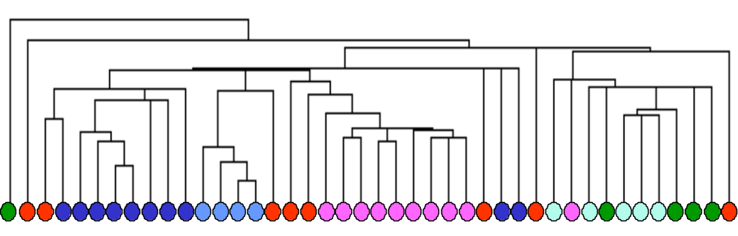
AT/RT CNS
Ncer
MD
MGlio
PNET
AT/RT Renal/Extrarenal

SOM Clustering of Multiple Tumor Samples
GeneCluster algorithm
Dataset A
Values thresholded to 100 from below and 16000 from above
Variation filter: max/min > 12 (12-fold), max-min= 1200 absolute units
Number of features (genes) = 1065

AT/RT CNS
Ncer
MD
MGlio
PNET
AT/RT Renal/Extrarenal

Multiple tumor classes predictions (k-NN)
This section contains the detailed sample predictions and error rates of predicting the different tumor types with a k-nearest neighbor algorithm in leave-one-out cross-validation.

The model predicts 35 out of 42 samples correctly and it is clearly highly significant (P-val < 10E-10, see the calculation below and the Proportional chance criterion.)

Multiple tumor classes prediction
k-nearest neighbors algorithm
Dataset A
Values thresholded to 20 from below and 16000 from above
Variation filter: max/min > 5 (5-fold), max-min= 500 absolute units
Number of features (genes) = 10. K=3, 1/distance weighting
Confusion Matrix
 | Predicted
Actual | MD | MGlio | Rhab | Ncer | PNET
MD | 8 | 0 | 1 | 0 | 1 | 10
MGlio | 0 | 10 | 0 | 0 | 0 | 10
Rhab | 0 | 0 | 9 | 0 | 1 | 10
Ncer | 0 | 0 | 0 | 4 | 0 | 4
PNET | 3 | 0 | 1 | 0 | 4 | 8
 | 11 | 10 | 11 | 4 | 6 | 42
Proportional chance criterion (see chapter VII of Huberty's Applied Discriminant Analysis)
Cpro= | (10/42)*(10/42)+(10/42)*(10/42)+(10/42)*(10/42)+(4/42)*(4/42)+(8/42)*(8/42)
Cpro= | 0.21542
Pcc= | 35/42= | 0.833333
(Pcc - Cpro)/Sqrt(Cpro(1-Cpro)/n) |  | = | Z= | 9.740725 |  | p-val < 10E-10
Datapoint | Predicted Class | Confidence | True Class | Error?
Brain_MD_12 | 2 | 2.80E-04 | 0 | *
Brain_MD_61 | 4 | 0.002653 | 0 | *
Brain_MD_15 | 0 | 0.006245 | 0
Brain_MD_57 | 0 | 0.64436 | 0
Brain_MD_33 | 0 | 0.429685 | 0
Brain_MD_64 | 0 | 0.258694 | 0
Brain_MD_17 | 0 | 0.252698 | 0
Brain_MD_62 | 0 | 0.008015 | 0
Brain_MD_63 | 0 | 0.008603 | 0
Brain_MD_32 | 0 | 0.591491 | 0
Brain_MGlio_1 | 1 | 0.050383 | 1
Brain_MGlio_2 | 1 | 0.443027 | 1
Brain_MGlio_3 | 1 | 0.654818 | 1
Brain_MGlio_4 | 1 | 0.184817 | 1
Brain_MGlio_5 | 1 | 0.51099 | 1
Brain_MGlio_6 | 1 | 0.229628 | 1
Brain_MGlio_7 | 1 | 0.600702 | 1
Brain_MGlio_8 | 1 | 0.01971 | 1
Brain_MGlio_9 | 1 | 0.519792 | 1
Brain_MGlio_10 | 1 | 0.213082 | 1
Brain_Rhab_1 | 2 | 0.609684 | 2
Brain_Rhab_2 | 2 | 0.401608 | 2
Brain_Rhab_3 | 2 | 0.107676 | 2
Brain_Rhab_4 | 2 | 0.257616 | 2
Brain_Rhab_5 | 2 | 0.488417 | 2
Brain_Rhab_6 | 2 | 0.50804 | 2
Brain_Rhab_7 | 2 | 0.333809 | 2
Brain_Rhab_8 | 4 | 0.055136 | 2 | *
Brain_Rhab_9 | 2 | 0.391122 | 2
Brain_Rhab_10 | 2 | 0.042137 | 2
Brain_Ncer_1 | 3 | 0.136345 | 3
Brain_Ncer_2 | 3 | 0.02372 | 3
Brain_Ncer_3 | 3 | 0.204818 | 3
Brain_Ncer_4 | 3 | 0.021819 | 3
Brain_PNET_1 | 0 | 2.82E-06 | 4 | *
Brain_PNET_2 | 2 | 0.538158 | 4 | *
Brain_PNET_3 | 4 | 0.001226 | 4
Brain_PNET_4 | 0 | 4.01E-04 | 4 | *
Brain_PNET_5 | 4 | 0.090692 | 4
Brain_PNET_6 | 0 | 0.251837 | 4 | *
Brain_PNET_7 | 4 | 0.003098 | 4
Brain_PNET_8 | 4 | 0.110559 | 4

Classic vs. desmoplastic MD markers
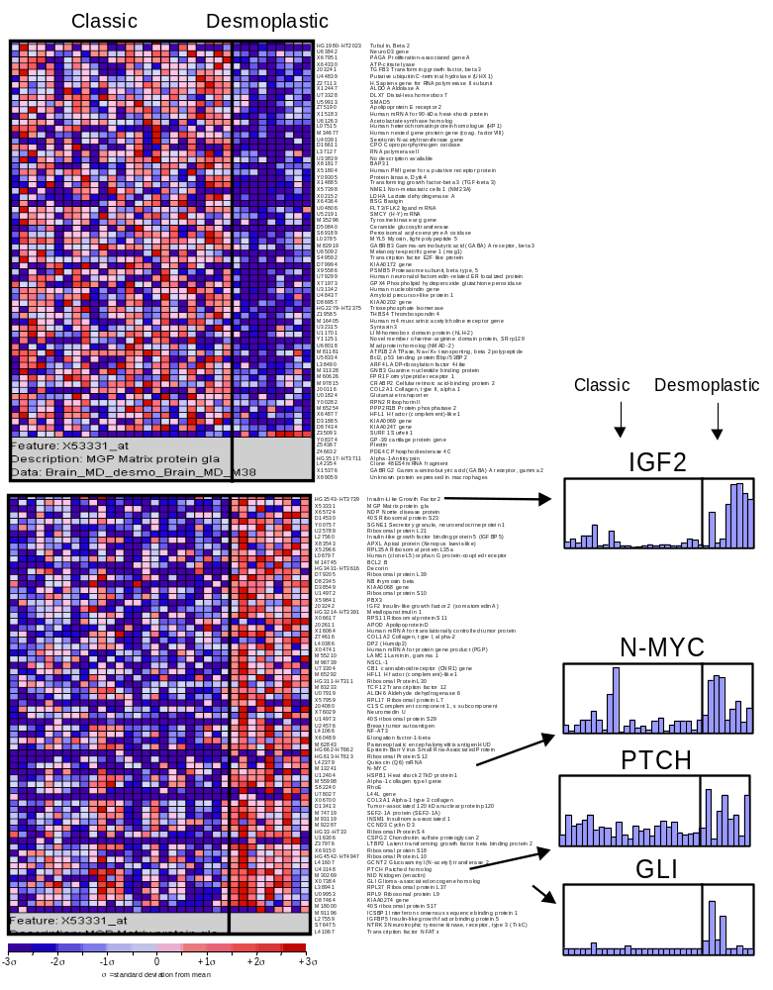
This picture shows some of the top markers of the classic vs. desmoplastic distinction sorted by signal to noise ratios as described in Gene marker selection section. The table below shows the top 200 markers including the permutation test values (see Permutation-based neighborhood analysis for marker gene). Some of the genes regulated by Shh are shown at right.

Top 200/200 Marker Genes for Classic vs Desmoplastic Medulloblastoma Distintion
Seleted by signal-to-noise (mean) ratio
Values thresholded to 20 from below and 16000 from above
Variation filter: max/min > 3 (3-fold), max-min= 100 absolute units
Dataset B
Class 0 = High in Classic, low in Desmoplastic
Class 1 = High in Desmoplastic, low in Classic
 |  | Permutation test |  |  | Marker genes
Distinction | Distance | Perm 1% | Perm 5% | Median 50% | Feature | Desc
Distinction | Distance | Perm 1% | Perm 5% | Perm (user) | Feature | Desc
class 0 | 0.9927214 | 1.100922 | 0.97285044 | 0.80008066 | HG1980-HT2023 | Tubulin, Beta 2
class 0 | 0.85944515 | 0.992591 | 0.91319513 | 0.7389958 | U63842 | Neurogenic basic-helix-loop-helix protein (neuroD3) gene
class 0 | 0.85575306 | 0.9546853 | 0.85402167 | 0.70865357 | X67951 | PAGA Proliferation-associated gene A
class 0 | 0.84818983 | 0.9064097 | 0.82473946 | 0.68806636 | X64330 | ATP-citrate lyase
class 0 | 0.81497514 | 0.8919678 | 0.8098986 | 0.66982466 | J03241 | TGFB3 Transforming growth factor, beta 3
class 0 | 0.80149823 | 0.85871273 | 0.78207725 | 0.6551903 | U44839 | Putative ubiquitin C-terminal hydrolase (UHX1) mRNA
class 0 | 0.7977331 | 0.85563594 | 0.77035093 | 0.64376813 | Z27113 | DNA-DIRECTED RNA POLYMERASE II 14.4 KD POLYPEPTIDE
class 0 | 0.77652156 | 0.8363159 | 0.75971323 | 0.6344267 | X12447 | ALDOA Aldolase A
class 0 | 0.7726323 | 0.8361712 | 0.7545372 | 0.6262046 | U73328 | DLX7 Distal-less homeobox 7
class 0 | 0.76898795 | 0.8337848 | 0.7440253 | 0.6194606 | U59913 | SMAD5 (Smad5) mRNA
class 0 | 0.7608277 | 0.8256053 | 0.7385865 | 0.6139341 | Z75190 | Apolipoprotein E receptor 2
class 0 | 0.7566224 | 0.8161263 | 0.7309519 | 0.60611314 | X15183 | 60S RIBOSOMAL PROTEIN L13
class 0 | 0.75550735 | 0.8065621 | 0.72232366 | 0.60053813 | U61263 | Acetolactate synthase homolog mRNA
class 0 | 0.75087696 | 0.8001862 | 0.71438277 | 0.59579366 | L07515 | HETEROCHROMATIN PROTEIN 1 HOMOLOG
class 0 | 0.7489568 | 0.7779621 | 0.70930177 | 0.5898725 | M34677 | FACTOR VIII INTRON 22 PROTEIN
class 0 | 0.74733686 | 0.7772034 | 0.70585626 | 0.58594066 | U40391 | Serotonin N-acetyltransferase gene
class 0 | 0.7389886 | 0.77309155 | 0.6958213 | 0.5822117 | D16611 | CPO Coproporphyrinogen oxidase
class 0 | 0.72759986 | 0.77139044 | 0.692992 | 0.57899344 | L37127 | (clone mf.18) RNA polymerase II mRNA
class 0 | 0.72445315 | 0.77077353 | 0.6906138 | 0.574035 | U33839 | No description available for U33839
class 0 | 0.7202563 | 0.76765144 | 0.6882062 | 0.5697634 | X81817 | 6C6-Ag mRNA
class 0 | 0.7089169 | 0.7658038 | 0.6853358 | 0.56685334 | X51804 | PUTATIVE RECEPTOR PROTEIN
class 0 | 0.7087572 | 0.75293714 | 0.68298733 | 0.5636675 | Y09305 | Protein kinase, Dyrk4, partial
class 0 | 0.70606977 | 0.7528129 | 0.6785786 | 0.5611313 | X14885 | Transforming growth factor-beta 3 (TGF-beta 3) exon 1
class 0 | 0.70567566 | 0.75150484 | 0.67536324 | 0.55880284 | X57398 | NME1 Non-metastatic cells 1, protein (NM23A) expressed in
class 0 | 0.7001394 | 0.74915314 | 0.67155474 | 0.5559985 | X02152 | LDHA Lactate dehydrogenase A
class 0 | 0.6914374 | 0.7464208 | 0.66720957 | 0.5522619 | X64364 | BSG Basigin
class 0 | 0.69114035 | 0.7378829 | 0.663854 | 0.54998326 | U04806 | FLT3/FLK2 ligand mRNA
class 0 | 0.68837094 | 0.7366576 | 0.6583117 | 0.5470333 | U52191 | SMCY (H-Y) mRNA
class 0 | 0.6863416 | 0.7331688 | 0.6526042 | 0.5439266 | M35296 | Tyrosine kinase arg gene mRNA
class 0 | 0.68461454 | 0.7283306 | 0.652604 | 0.54087377 | D50840 | Ceramide glucosyltransferase
class 0 | 0.68362164 | 0.72296304 | 0.64872414 | 0.53737545 | S69189 | Peroxisomal acyl-coenzyme A oxidase
class 0 | 0.6747787 | 0.7211591 | 0.64778924 | 0.53378457 | L03785 | MYL5 Myosin, light polypeptide 5, regulatory
class 0 | 0.67238975 | 0.71856 | 0.64576083 | 0.53147835 | M82919 | GABRB3 Gamma-aminobutyric acid (GABA) A receptor, beta 3
class 0 | 0.67033887 | 0.71758395 | 0.6423796 | 0.5288971 | U65092 | Melanocyte-specific gene 1 (msg1) mRNA
class 0 | 0.6700922 | 0.7157754 | 0.6378237 | 0.5273885 | S49592 | Transcription factor E2F like protein [human, mRNA, 2492 nt]
class 0 | 0.6688998 | 0.71575814 | 0.63683856 | 0.5247664 | D79994 | KIAA0172 gene, partial cds
class 0 | 0.6687492 | 0.71367145 | 0.63496286 | 0.52286 | X95586 | PSMB5 Proteasome (prosome, macropain) subunit, beta type, 5
class 0 | 0.6678679 | 0.710983 | 0.63297284 | 0.52204216 | U79299 | Neuronal olfactomedin-related ER localized protein mRNA, partial cds
class 0 | 0.6640316 | 0.70800865 | 0.6318244 | 0.5205372 | X71973 | GPX4 Phospholipid hydroperoxide glutathione peroxidase
class 0 | 0.66357356 | 0.7065394 | 0.6283764 | 0.5172761 | U31342 | NUCLEOBINDIN PRECURSOR
class 0 | 0.66107285 | 0.70190495 | 0.6281764 | 0.515169 | U48437 | Amyloid precursor-like protein 1 mRNA
class 0 | 0.6580634 | 0.6977007 | 0.6270069 | 0.5130206 | D86957 | KIAA0202 gene, partial cds
class 0 | 0.65573317 | 0.69658804 | 0.6243827 | 0.5114963 | HG2279-HT2375 | Triosephosphate Isomerase
class 0 | 0.65531886 | 0.696354 | 0.6234574 | 0.50935465 | Z19585 | THBS4 Thrombospondin 4
class 0 | 0.6551901 | 0.69216716 | 0.62214273 | 0.50791293 | M16405 | MUSCARINIC ACETYLCHOLINE RECEPTOR M4
class 0 | 0.65306026 | 0.6912271 | 0.61901563 | 0.5059022 | U32315 | Syntaxin 3 mRNA
class 0 | 0.65265644 | 0.69054705 | 0.61688703 | 0.50412107 | U11701 | LIM-homeobox domain protein (hLH-2) mRNA
class 0 | 0.6510852 | 0.6855266 | 0.61317533 | 0.50281054 | Y11251 | Novel member of serine-arginine domain protein, SRrp129
class 0 | 0.6451833 | 0.68519264 | 0.611776 | 0.5011752 | U68018 | Mad protein homolog (hMAD-2) mRNA
class 0 | 0.6440936 | 0.6840746 | 0.6099985 | 0.50011754 | M81181 | ATP1B2 ATPase, Na+/K+ transporting, beta 2 polypeptide
class 0 | 0.6436302 | 0.68304396 | 0.6083414 | 0.49924028 | U58334 | Bcl2, p53 binding protein Bbp/53BP2 (BBP/53BP2) mRNA
class 0 | 0.643048 | 0.6821534 | 0.6073584 | 0.4981423 | L38490 | ARF4L ADP-ribosylation factor 4-like
class 0 | 0.6426204 | 0.6800001 | 0.6052271 | 0.49671668 | M31328 | GNB3 Guanine nucleotide binding protein (G protein), beta polypeptide 3
class 0 | 0.64044315 | 0.67821306 | 0.6023743 | 0.49373135 | M60626 | FPR1 Formyl peptide receptor 1
class 0 | 0.64043903 | 0.67730945 | 0.6007907 | 0.49323085 | M97815 | CRABP2 Cellular retinoic acid-binding protein 2
class 0 | 0.63726294 | 0.675323 | 0.6001975 | 0.492158 | J00116 | COL2A1 Collagen, type II, alpha 1
class 0 | 0.63437486 | 0.6752639 | 0.5996651 | 0.49088508 | U01824 | Glutamate transporter
class 0 | 0.6297416 | 0.67464525 | 0.59895456 | 0.4887451 | Y00282 | RPN2 Ribophorin II
class 0 | 0.62950456 | 0.6733761 | 0.597548 | 0.48699924 | M65254 | PPP2R1B Protein phosphatase 2
class 0 | 0.6293974 | 0.6712747 | 0.59523857 | 0.4854714 | X64877 | HFL1 H factor (complement)-like 1
class 0 | 0.62750775 | 0.6657862 | 0.5950493 | 0.48436904 | D31885 | KIAA0069 gene, partial cds
class 0 | 0.6274157 | 0.66216063 | 0.5922815 | 0.48317143 | D87434 | KIAA0247 gene
class 0 | 0.6269861 | 0.6615893 | 0.5897296 | 0.48150828 | Z35093 | SURF1 Surfeit 1
class 0 | 0.6243887 | 0.6592147 | 0.588642 | 0.48062748 | Y08374 | GP-39 cartilage protein gene
class 0 | 0.6233924 | 0.6570888 | 0.5881375 | 0.4795098 | Z54367 | Plectin
class 0 | 0.6214661 | 0.6567585 | 0.58764184 | 0.4782393 | Z46632 | PDE4C Phosphodiesterase 4C
class 0 | 0.6162652 | 0.6550915 | 0.58412486 | 0.47714055 | HG3517-HT3711 | Alpha-1-Antitrypsin, 5' End
class 0 | 0.6158576 | 0.65411603 | 0.58396286 | 0.4756748 | L42354 | (clone 48ES4) mRNA fragment
class 0 | 0.61513585 | 0.65381086 | 0.58363634 | 0.47443134 | X15376 | GABRG2 Gamma-aminobutyric acid (GABA) A receptor, gamma 2
class 0 | 0.6136919 | 0.65283734 | 0.5821644 | 0.47330046 | X89059 | Unknown protein expressed in macrophages
class 0 | 0.6111451 | 0.65236974 | 0.5786961 | 0.4725207 | U40998 | Retinal protein (HRG4) mRNA
class 0 | 0.60864455 | 0.65140575 | 0.57764935 | 0.47161415 | S72904 | APK1 antigen
class 0 | 0.60758764 | 0.6513788 | 0.5764717 | 0.4703356 | M28439 | KERATIN, TYPE I CYTOSKELETAL 17
class 0 | 0.6052617 | 0.6509427 | 0.57584333 | 0.4691536 | HG3319-HT3496 | Split Gene 1 Enhancer, Tup1-Like
class 0 | 0.6025101 | 0.6475502 | 0.5743594 | 0.46873093 | L20971 | PDE4B Phosphodiesterase 4B
class 0 | 0.60209996 | 0.64595795 | 0.5726682 | 0.46801984 | U53174 | PPP1CA Protein phosphatase 1, catalytic subunit, alpha isoform
class 0 | 0.60148424 | 0.6452151 | 0.5725452 | 0.46681368 | X12791 | SRP19 Signal recognition particle 19 kD protein
class 0 | 0.59986407 | 0.64400727 | 0.572293 | 0.46536174 | M86808 | Pyruvate dehydrogenase complex (PDHA2) gene
class 0 | 0.59955007 | 0.64397943 | 0.5716659 | 0.4651167 | U49250 | Putative cerebral cortex transcriptional regulator T-Brain-1 (Tbr-1) mRNA
class 0 | 0.59948987 | 0.64273274 | 0.5710794 | 0.46377957 | U70735 | 34 kDa Mov34 homolog mRNA
class 0 | 0.59938246 | 0.6419605 | 0.5697817 | 0.4631461 | U36448 | Ca2+-dependent activator protein for secretion mRNA
class 0 | 0.5992474 | 0.64148456 | 0.5664956 | 0.46178034 | U67963 | Lysophospholipase homolog (HU-K5) mRNA
class 0 | 0.59904045 | 0.6412486 | 0.564561 | 0.4611744 | U61981 | MSH3 MutS (E. coli) homolog 3
class 0 | 0.59882957 | 0.6405094 | 0.5638733 | 0.45987302 | U94585 | Requiem homolog (hsReq) mRNA
class 0 | 0.5963293 | 0.6375841 | 0.5611557 | 0.45866847 | Y09216 | Protein kinase, Dyrk2
class 0 | 0.59433 | 0.63753694 | 0.56094676 | 0.45810974 | X72790 | Endogenous retrovirus mRNA for ORF
class 0 | 0.5938023 | 0.63601726 | 0.5596878 | 0.45745686 | D16593 | HPCA Hippocalcin
class 0 | 0.5936155 | 0.6337328 | 0.5571045 | 0.45668325 | L25876 | Protein tyrosine phosphatase (CIP2)mRNA
class 0 | 0.59203666 | 0.63306457 | 0.55586565 | 0.45624977 | X77197 | CLCN4 Chloride channel 4
class 0 | 0.5918071 | 0.6329611 | 0.55581313 | 0.45501217 | M88279 | FKBP4 FK506-binding protein 4 (59kD)
class 0 | 0.5912278 | 0.6317565 | 0.5549752 | 0.45395684 | X66087 | MYBL1 V-myb avian myeloblastosis viral oncogene homolog-like 1
class 0 | 0.5896591 | 0.63113517 | 0.55333066 | 0.45320654 | U63455 | SUR Sulfonylurea receptor (hyperinsulinemia)
class 0 | 0.58764905 | 0.63048935 | 0.5528846 | 0.4522073 | S81003 | L-UBC
class 0 | 0.58715725 | 0.63013744 | 0.55262655 | 0.4510834 | M12959_s | TCRA T cell receptor alpha-chain
class 0 | 0.5870895 | 0.6294 | 0.5509657 | 0.4502766 | U82310 | Unknown protein mRNA, partial cds
class 0 | 0.5868637 | 0.627622 | 0.55062884 | 0.44969308 | M28879 | GRANZYME B PRECURSOR
class 0 | 0.58671856 | 0.6271133 | 0.5484541 | 0.4487445 | U29607 | EIF-2-associated p67 homolog mRNA
class 0 | 0.585308 | 0.62496793 | 0.5479123 | 0.44770333 | X69962_s | FMR1 Fragile X mental retardation 1
class 0 | 0.58297056 | 0.6241309 | 0.5472998 | 0.44696727 | U09607 | JAK3 Janus kinase 3 (a protein tyrosine kinase, leukocyte)
class 0 | 0.5828922 | 0.6234299 | 0.54680544 | 0.44528863 | U51587 | Golgi complex autoantigen golgin-97 mRNA
class 0 | 0.5822135 | 0.62112784 | 0.5465898 | 0.44471288 | U04270 | Putative potassium channel subunit (h-erg) mRNA
class 0 | 0.58068085 | 0.6209773 | 0.5451401 | 0.44420785 | D45371 | ApM1 mRNA for GS3109 (novel adipose specific collagen-like factor)
class 0 | 0.5791186 | 0.6202937 | 0.5446089 | 0.44336843 | U79528_s | Sigma receptor mRNA
class 0 | 0.5788491 | 0.62027115 | 0.54382896 | 0.44273722 | U52112_rna5 | RbP gene (renin-binding protein) extracted from Human Xq28 genomic DNA in the region of the L1CAM locus containing the genes for neural cell adhesion molecule L1 (L1CAM), arginine-vasopressin receptor (AVPR2), C1 p115 (C1), ARD1 N-acetyltransferase related protein (TE2), renin-binding protein (RbP), host cell factor 1 (HCF1), and interleukin-1 receptor-associated kinase (IRAK) genes, and Xq28lu2 gene
class 0 | 0.5769936 | 0.6195113 | 0.5428214 | 0.44138107 | AB002314 | KIAA0316 gene
class 0 | 0.57692134 | 0.6191036 | 0.54082024 | 0.44056216 | U36341_rna1 | SLC6A8 gene (creatine transporter) extracted from Human Xq28 cosmid, creatine transporter (SLC6A8) gene, and CDM gene, partial cds
class 0 | 0.57615805 | 0.61866623 | 0.5405354 | 0.43898973 | X97544 | TIM17 preprotein translocase
class 0 | 0.57606333 | 0.61844265 | 0.53912455 | 0.4380664 | U31628 | IL15RA Interleukin 15 receptor alpha chain
class 0 | 0.57538915 | 0.61622304 | 0.5377508 | 0.43786755 | AB003102 | Proteasome subunit p44.5
class 0 | 0.5750055 | 0.6160982 | 0.53766185 | 0.43737975 | L00058 | MYC V-myc avian myelocytomatosis viral oncogene homolog
class 0 | 0.5747552 | 0.61550885 | 0.5372219 | 0.436866 | L35249_s | ATP6B2 ATPase, H+ transporting, lysosomal (vacuolar proton pump), beta polypeptide, 56/58kD, isoform 2
class 0 | 0.57380915 | 0.6145756 | 0.5359526 | 0.43563268 | M81933 | CDC25A Cell division cycle 25A
class 0 | 0.5736341 | 0.61447406 | 0.53550535 | 0.43463433 | D13666_s | Osteoblast specific factor 2 (OSF-2os)
class 0 | 0.57303506 | 0.6129059 | 0.5350379 | 0.43410015 | M37457_s | Na+,K+ -ATPase catalytic subunit alpha-III isoform gene
class 0 | 0.5719543 | 0.6121835 | 0.5343064 | 0.4337287 | J04027 | Adenosine triphosphatase mRNA
class 0 | 0.5713075 | 0.6111451 | 0.53332496 | 0.43279478 | L19058 | Glutamate receptor (GLUR5) mRNA
class 0 | 0.57126564 | 0.6107866 | 0.53288037 | 0.43174514 | U33821 | Tax1-binding protein TXBP151 mRNA
class 0 | 0.57023346 | 0.61025316 | 0.53199846 | 0.43114722 | Y10807_s | Suppressor for yeast mutant
class 0 | 0.570124 | 0.6099161 | 0.53194267 | 0.43112728 | L10955_cds1_s | Carbonic anhydrase IV gene extracted from Human carbonic anhydrase IV gene, promoter region and
class 0 | 0.569515 | 0.607602 | 0.53076357 | 0.4303349 | U32324 | Interleukin 11 receptor isoform (incomplete)
class 0 | 0.56919754 | 0.6072801 | 0.52994424 | 0.4296401 | M28882_s | CELL SURFACE GLYCOPROTEIN MUC18 PRECURSOR
class 0 | 0.56461215 | 0.6062743 | 0.5283741 | 0.42871588 | U96629_rna2 | 2A8.3 gene (hereditary multiple exostoses gene isolog) extracted from Human chromosome 8 BAC clone CIT987SK-2A8 complete sequence
class 0 | 0.56319255 | 0.6061561 | 0.52635425 | 0.42734823 | L40395 | (clone S20iii15) mRNA, 3' end of cds
class 0 | 0.5631556 | 0.6061188 | 0.5262581 | 0.4266111 | D82343 | AMY
class 0 | 0.5628468 | 0.6055819 | 0.5256596 | 0.4263719 | M74491 | ARF3 ADP-ribosylation factor 3
class 0 | 0.5626699 | 0.60536665 | 0.52549785 | 0.42572156 | U20758_rna1 | Osteopontin gene
class 0 | 0.5626479 | 0.60445035 | 0.5245646 | 0.42506737 | D26528 | RNA helicase
class 0 | 0.56226707 | 0.60398006 | 0.52378994 | 0.42434895 | X85750 | Transcript associated with monocyte to macrophage differentiation
class 0 | 0.56212807 | 0.6039531 | 0.5228068 | 0.4232765 | X92762 | Tafazzins protein
class 0 | 0.56127095 | 0.6039013 | 0.522677 | 0.42294946 | U03397_s | Receptor protein 4-1BB mRNA
class 0 | 0.56082225 | 0.60215974 | 0.5224149 | 0.42230636 | D79984_s | KIAA0162 gene
class 0 | 0.5607825 | 0.6020119 | 0.52201355 | 0.42194042 | X15341 | CYTOCHROME C OXIDASE POLYPEPTIDE VIA-LIVER PRECURSOR
class 0 | 0.5607145 | 0.6019508 | 0.52181506 | 0.42124954 | U52155 | Inward rectifier potassium channel Kir1.2 (Kir1.2) mRNA, partial cds
class 0 | 0.5601084 | 0.60187197 | 0.52122813 | 0.4205988 | U70323 | SCA2 Spinocerebellar ataxia 2 (olivopontocerebellar ataxia 2, autosomal dominant)
class 0 | 0.5591348 | 0.60052645 | 0.5201653 | 0.42014632 | U89336_cds3 | RAGE gene (receptor for advanced glycosylation end products) extracted from Human HLA class III region containing NOTCH4 gene, partial sequence, homeobox PBX2 (HPBX) gene, receptor for advanced glycosylation end products (RAGE) gene, and 6 unidentified cds, complete sequence
class 0 | 0.55810887 | 0.59824055 | 0.51929057 | 0.4197526 | U79734 | Huntingtin interacting protein (HIP1) mRNA
class 0 | 0.5563211 | 0.59629256 | 0.5186152 | 0.41924495 | J04823_rna1 | Cytochrome c oxidase subunit VIII (COX8) mRNA
class 0 | 0.554648 | 0.59499043 | 0.5172463 | 0.41886258 | X96506_s | NC2 alpha subunit
class 0 | 0.5546377 | 0.59397686 | 0.5169297 | 0.4185497 | X95073 | Translin associated protein X
class 0 | 0.55415726 | 0.592642 | 0.5165416 | 0.41753975 | M37457 | Na+,K+ -ATPase catalytic subunit alpha-III isoform gene
class 0 | 0.5532569 | 0.5926305 | 0.5156605 | 0.41711715 | HG2797-HT2905 | Clathrin, Light Polypeptide B, Alt. Splice 1
class 0 | 0.5528954 | 0.59211236 | 0.515271 | 0.41627023 | Y09980_rna4 | HOXD3 gene
class 0 | 0.5528874 | 0.5918755 | 0.51416284 | 0.415643 | L08485 | GABRA5 Gamma-aminobutyric acid (GABA) A receptor, alpha 5)
class 0 | 0.55221575 | 0.5918504 | 0.5131231 | 0.41515335 | HG2797-HT2906_s | Clathrin, Light Polypeptide B, Alt. Splice 2
class 0 | 0.5518999 | 0.591169 | 0.512098 | 0.4149368 | M99435 | TRANSDUCIN-LIKE ENHANCER PROTEIN 1
class 0 | 0.5515173 | 0.5907996 | 0.5111602 | 0.4138937 | X92720 | Phosphoenolpyruvate carboxykinase
class 0 | 0.55130094 | 0.58944005 | 0.5108808 | 0.41327104 | M96995_s | GRB2 Growth factor receptor-bound protein 2
class 0 | 0.55055606 | 0.58905005 | 0.50878483 | 0.413232 | U38904 | Zinc finger protein C2H2-25 mRNA
class 0 | 0.5502738 | 0.5887711 | 0.50823826 | 0.41261023 | Y11174 | RP3 gene
class 0 | 0.5501896 | 0.5877102 | 0.5071817 | 0.41216868 | U59321 | DEAD-box protein p72 (P72) mRNA
class 0 | 0.5500676 | 0.5870229 | 0.50688064 | 0.4114269 | X60592 | CD40 CD40 antigen
class 0 | 0.54953444 | 0.5865171 | 0.50673527 | 0.41095555 | U78524 | Gu binding protein mRNA, partial cds
class 0 | 0.5494719 | 0.5863608 | 0.50618243 | 0.41064388 | X17648 | GRANULOCYTE-MACROPHAGE COLONY-STIMULATING FACTOR RECEPTOR ALPHA CHAIN PRECURSOR
class 0 | 0.54937106 | 0.5850061 | 0.50587565 | 0.40965393 | U15932 | Protein tyrosine phosphatase mRNA
class 0 | 0.5493632 | 0.58423793 | 0.50495315 | 0.40887225 | X06389 | SYP Synaptophysin
class 0 | 0.5488799 | 0.58391607 | 0.5047827 | 0.40855095 | U20499 | Estrogen sulfotransferase mRNA
class 0 | 0.5484502 | 0.58388555 | 0.50416595 | 0.40830544 | U21049 | DD96 mRNA
class 0 | 0.5463388 | 0.5823978 | 0.5032712 | 0.407351 | AB002380 | KIAA0382 gene, partial cds
class 0 | 0.546322 | 0.5818097 | 0.5023653 | 0.40690655 | Y07565_s | RIN Ric (Drosophila)-like (expressed in neurons)
class 0 | 0.5454462 | 0.5815752 | 0.5009951 | 0.40647876 | X72632_s | Rev-ErbAalpha protein (hRev gene)
class 0 | 0.54503894 | 0.58104753 | 0.49995357 | 0.4060531 | M16801 | MLR Mineralocorticoid receptor (aldosterone receptor)
class 0 | 0.5444173 | 0.58083797 | 0.49962866 | 0.40523773 | M60922 | Surface antigen mRNA
class 0 | 0.5433324 | 0.5802529 | 0.49946222 | 0.40488547 | D88213 | Retina-specific amine oxidase
class 0 | 0.54245716 | 0.57975286 | 0.49915946 | 0.40433422 | L07548 | ACY1 Aminoacylase 1
class 0 | 0.54151386 | 0.5794049 | 0.49902466 | 0.40362412 | M25269 | ELK1 ELK1, member of ETS oncogene family
class 0 | 0.5409097 | 0.57867557 | 0.4990148 | 0.40250564 | J02645 | EIF2A Eukaryotic translation initiation factor 2A
class 0 | 0.5405903 | 0.57867485 | 0.49736193 | 0.40202776 | M86933_s | AMELY Amelogenin (chromosome Y encoded)
class 0 | 0.54021716 | 0.5782 | 0.4971733 | 0.40150848 | S43646 | KERATIN, TYPE II CYTOSKELETAL 2 EPIDERMAL
class 0 | 0.54005593 | 0.5776254 | 0.49683756 | 0.4008628 | AF009368 | Luman mRNA
class 0 | 0.5399942 | 0.5769982 | 0.49621394 | 0.40025672 | X01630 | ASS Argininosuccinate synthetase
class 0 | 0.53959274 | 0.5767422 | 0.495073 | 0.39979956 | U78735 | ABC3 ATP-binding cassette 3
class 0 | 0.5386063 | 0.57520956 | 0.49495786 | 0.39922723 | U01038 | PLK mRNA
class 0 | 0.5366796 | 0.5748313 | 0.4945322 | 0.39906326 | M55040 | ACHE Acetylcholinesterase (YT blood group)
class 0 | 0.5362463 | 0.574607 | 0.49252602 | 0.39807323 | Z48541 | Protein tyrosine phosphatase
class 0 | 0.53534234 | 0.57422996 | 0.4920491 | 0.3976656 | X54637 | TYK2 Protein-tyrosine kinase tyk2 (non-receptor)
class 0 | 0.53511363 | 0.574129 | 0.49168175 | 0.39719057 | K02777_s | T-cell receptor active alpha-chain mRNA from Jurkat cell line
class 0 | 0.5336789 | 0.5738576 | 0.49123472 | 0.39659634 | U64197 | CC chemokine LARC precursor
class 0 | 0.5328535 | 0.57379687 | 0.49086955 | 0.3959535 | X52426_s | KRT13 Keratin 13
class 0 | 0.53211504 | 0.5699487 | 0.490195 | 0.39569798 | X99459 | Sigma 3B protein
class 0 | 0.53210926 | 0.56966376 | 0.48971868 | 0.39414003 | L11573 | Surfactant protein B mRNA
class 0 | 0.532053 | 0.56789446 | 0.4893898 | 0.3937184 | HG4668-HT5083_s | Transcription Factor Mef2, Alt. Splice 2
class 0 | 0.53199273 | 0.56780976 | 0.48924723 | 0.39327776 | U82979 | Immunoglobulin-like transcript-3 mRNA
class 0 | 0.53159195 | 0.56724167 | 0.48922685 | 0.39241347 | M27281 | VEGF Vascular endothelial growth factor
class 0 | 0.5308711 | 0.56693166 | 0.48836374 | 0.3918192 | M76559 | Neuronal DHP-sensitive, voltage-dependent, calcium channel alpha-2b subunit mRNA
class 0 | 0.53077525 | 0.56625986 | 0.4882309 | 0.39136678 | X59892 | TRYPTOPHANYL-TRNA SYNTHETASE
class 0 | 0.52997464 | 0.56559825 | 0.4878811 | 0.39132828 | D16688_s | LTG9/MLLT3 mRNA, C-terminal
class 0 | 0.528599 | 0.5648617 | 0.48774076 | 0.39066023 | U10439 | ADAR Double-stranded RNA adenosine deaminase
class 0 | 0.5282795 | 0.56396955 | 0.48766053 | 0.39063936 | X86779 | FAST kinase
class 0 | 0.52772367 | 0.5631641 | 0.4875238 | 0.390095 | U08998 | TAR RNA binding protein (TRBP) mRNA
class 0 | 0.5259058 | 0.56073135 | 0.48746073 | 0.38921615 | U00944 | Clone A9A2BRB6 (CAC)n/(GTG)n repeat-containing mRNA
class 0 | 0.52554536 | 0.56066585 | 0.48733485 | 0.38901442 | U44799_s | U1-snRNP binding protein homolog mRNA
class 0 | 0.52523357 | 0.5604787 | 0.48671508 | 0.38824853 | X76228 | ATP6E ATPase, H+ transporting, lysosomal (vacuolar proton pump) 31kD
class 0 | 0.5247069 | 0.5601869 | 0.48609465 | 0.3877893 | AFFX-HUMRGE/M10098_5 | AFFX-HUMRGE/M10098_5 (endogenous control)
class 0 | 0.524563 | 0.5596961 | 0.48504826 | 0.38749382 | L43579 | L43579 Soares fetal liver spleen 1NFLS Homo sapiens cDNA clone 110298, mRNA sequence
class 0 | 0.52441233 | 0.5587105 | 0.48397085 | 0.38674313 | HG2797-HT2905_s | Clathrin, Light Polypeptide B, Alt. Splice 1
class 0 | 0.5241388 | 0.55815023 | 0.48341292 | 0.3864582 | X83416_s | PrP gene, exon 2
class 0 | 0.5238535 | 0.5580398 | 0.48227537 | 0.38593346 | X06268 | COL2A1 Collagen, type II, alpha 1 (primary osteoarthritis, spondyloepiphyseal dysplasia, congenital)
class 0 | 0.52373844 | 0.55795956 | 0.48225394 | 0.38527587 | U66619 | SWI/SNF complex 60 KDa subunit (BAF60c) mRNA
class 0 | 0.52261454 | 0.5571336 | 0.48142985 | 0.38485435 | X56494 | PKM2 Pyruvate kinase, muscle
class 1 | 0.9920165 | 1.1499524 | 1.0030181 | 0.75236905 | HG3543-HT3739 | Insulin-Like Growth Factor 2
class 1 | 0.97661066 | 0.9616979 | 0.86222804 | 0.691033 | X53331 | MGP Matrix protein gla
class 1 | 0.9585667 | 0.8834012 | 0.81371576 | 0.6553457 | X65724 | NDP Norrie disease (pseudoglioma) protein
class 1 | 0.88205796 | 0.84205025 | 0.78712994 | 0.6343712 | D14530 | 40S RIBOSOMAL PROTEIN S23
class 1 | 0.880672 | 0.8215255 | 0.7616048 | 0.620643 | Y00757 | SGNE1 Secretory granule, neuroendocrine protein 1 (7B2 protein)
class 1 | 0.8662454 | 0.794612 | 0.7433427 | 0.6053828 | U25789 | Ribosomal protein L21 mRNA
class 1 | 0.81006235 | 0.7840071 | 0.73380023 | 0.59553546 | L27560 | Insulin-like growth factor binding protein 5 (IGFBP5) mRNA
class 1 | 0.8061057 | 0.7732427 | 0.71599203 | 0.5836112 | X83543 | APXL Apical protein (Xenopus laevis-like)
class 1 | 0.7963144 | 0.7665661 | 0.7039129 | 0.5745494 | X52966 | RPL35A Ribosomal protein L35a
class 1 | 0.7821859 | 0.76450706 | 0.69823205 | 0.56959337 | L06797 | PROBABLE G PROTEIN-COUPLED RECEPTOR LCR1 HOMOLOG
class 1 | 0.7820521 | 0.75147885 | 0.6901111 | 0.5607618 | M14745 | BCL2 B cell lymphoma protein 2
class 1 | 0.7767357 | 0.7358279 | 0.6859018 | 0.5550981 | HG3431-HT3616 | Decorin, Alt. Splice 1
class 1 | 0.77340704 | 0.7356313 | 0.6778774 | 0.548212 | D79205 | Ribosomal protein L39
class 1 | 0.7371966 | 0.72674626 | 0.6712165 | 0.5430719 | D82345 | NB thymosin beta
class 1 | 0.7175167 | 0.72600675 | 0.66350347 | 0.53756976 | D38549 | KIAA0068 gene, partial cds
class 1 | 0.71659106 | 0.7239192 | 0.65854394 | 0.53445965 | U14972 | Ribosomal protein S10 mRNA
class 1 | 0.71585566 | 0.71054196 | 0.651889 | 0.5302352 | X59841 | PRE-B-CELL LEUKEMIA TRANSCRIPTION FACTOR-3
class 1 | 0.7044602 | 0.70438224 | 0.65061134 | 0.5265213 | J03242 | IGF2 Insulin-like growth factor 2 (somatomedin A)
class 1 | 0.7026445 | 0.70189273 | 0.6452029 | 0.5213764 | HG3214-HT3391 | Metallopanstimulin 1
class 1 | 0.69295913 | 0.7003029 | 0.6411657 | 0.51902276 | X06617 | RPS11 Ribosomal protein S11
class 1 | 0.69290376 | 0.6944331 | 0.6401815 | 0.515944 | J02611 | APOD Apolipoprotein D
class 1 | 0.6838895 | 0.6939349 | 0.6379803 | 0.51201856 | X16064 | TRANSLATIONALLY CONTROLLED TUMOR PROTEIN
class 1 | 0.6776533 | 0.69227374 | 0.632398 | 0.5075445 | Z74616 | COL1A2 Collagen, type I, alpha-2
class 1 | 0.67510426 | 0.6836942 | 0.6293568 | 0.5051634 | L40386 | DP2 (Humdp2) mRNA
class 1 | 0.67472875 | 0.6825732 | 0.6266333 | 0.5020662 | X04741 | UBIQUITIN CARBOXYL-TERMINAL HYDROLASE ISOZYME L1
class 1 | 0.6703414 | 0.6777735 | 0.6220077 | 0.49927366 | M55210 | LAMC1 Laminin, gamma 1 (formerly LAMB2)
class 1 | 0.66915506 | 0.6772996 | 0.6169228 | 0.49835536 | M96739 | NSCL-1 mRNA sequence
class 1 | 0.66442496 | 0.67441475 | 0.6109734 | 0.4961448 | U73304 | CB1 cannabinoid receptor (CNR1) gene
class 1 | 0.6633565 | 0.67025864 | 0.6074427 | 0.49294007 | M65292 | HFL1 H factor (complement)-like 1
class 1 | 0.66297793 | 0.66304475 | 0.6040194 | 0.49020073 | HG311-HT311 | Ribosomal Protein L30
class 1 | 0.6621168 | 0.6628506 | 0.60389394 | 0.4881786 | M83233 | TCF12 Transcription factor 12
class 1 | 0.65106505 | 0.6614697 | 0.6003128 | 0.4862768 | U07919 | ALDH6 Aldehyde dehydrogenase 6
class 1 | 0.6483891 | 0.660038 | 0.5960164 | 0.48381075 | X57959 | RPL17 Ribosomal protein L7
class 1 | 0.64783746 | 0.6586179 | 0.5918964 | 0.482616 | J04080 | C1S Complement component 1, s subcomponent
class 1 | 0.6444846 | 0.6569774 | 0.5899946 | 0.4810916 | X76029 | NEUROMEDIN U-25 PRECURSOR
class 1 | 0.6431463 | 0.6527849 | 0.5874605 | 0.47882786 | U14973 | 40S RIBOSOMAL PROTEIN S29
class 1 | 0.64175445 | 0.64769405 | 0.5862101 | 0.47660354 | U24576 | Breast tumor autoantigen mRNA, complete sequence
class 1 | 0.63975364 | 0.6461164 | 0.58385 | 0.47526005 | L41066 | NF-AT3 mRNA
class 1 | 0.63081163 | 0.6454896 | 0.58339643 | 0.47360942 | X60489 | Elongation factor-1-beta
class 1 | 0.62705797 | 0.6454799 | 0.5795754 | 0.4714921 | M62843 | PARANEOPLASTIC ENCEPHALOMYELITIS ANTIGEN HUD
class 1 | 0.6269411 | 0.6337208 | 0.5765729 | 0.4702747 | HG662-HT662 | Epstein-Barr Virus Small Rna-Associated Protein
class 1 | 0.62111175 | 0.63143706 | 0.5743106 | 0.46925655 | HG613-HT613 | Ribosomal Protein S12
class 1 | 0.6195382 | 0.630508 | 0.57252336 | 0.46820134 | L42379 | Quiescin (Q6) mRNA, partial cds
class 1 | 0.6190998 | 0.62700677 | 0.5705358 | 0.46622977 | M13241 | N-MYC PROTO-ONCOGENE PROTEIN
class 1 | 0.6153043 | 0.62574947 | 0.5684561 | 0.46493605 | U12404 | HSPB1 Heat shock 27kD protein 1
class 1 | 0.6119269 | 0.62252253 | 0.56778365 | 0.4618914 | M55998 | Alpha-1 collagen type I gene, 3' end
class 1 | 0.6047074 | 0.6202116 | 0.5667907 | 0.46059835 | S82240 | RhoE
class 1 | 0.5998984 | 0.61648834 | 0.5644458 | 0.45931065 | U78027 | L44L gene
class 1 | 0.5997888 | 0.61597705 | 0.56125534 | 0.457502 | X06700 | COL3A1 Alpha-1 type 3 collagen
class 1 | 0.5986623 | 0.6130399 | 0.55806524 | 0.45596722 | D13413 | Tumor-associated 120 kDa nuclear protein p120
class 1 | 0.59865105 | 0.6114418 | 0.556301 | 0.4549787 | M74719 | SEF2-1A protein (SEF2-1A) mRNA, 5' end
class 1 | 0.5893714 | 0.60740095 | 0.5559502 | 0.45420048 | M93119 | INSM1 Insulinoma-associated 1 (symbol provisional)
class 1 | 0.5881829 | 0.6069417 | 0.55419403 | 0.45310345 | M92287 | CCND3 Cyclin D3
class 1 | 0.5843839 | 0.60632783 | 0.5535847 | 0.4518154 | HG33-HT33 | Ribosomal Protein S4, X-Linked
class 1 | 0.58205545 | 0.60504496 | 0.55251557 | 0.4503006 | U16306 | CSPG2 Chondroitin sulfate proteoglycan 2 (versican)
class 1 | 0.57964575 | 0.60460865 | 0.55130297 | 0.44919688 | Z37976 | LTBP2 Latent transforming growth factor beta binding protein 2
class 1 | 0.57818264 | 0.6033843 | 0.548655 | 0.4471849 | X69150 | Ribosomal protein S18
class 1 | 0.5697472 | 0.6027349 | 0.54859287 | 0.44544208 | HG4542-HT4947 | Ribosomal Protein L10
class 1 | 0.56644344 | 0.60101384 | 0.54806477 | 0.4440113 | L41607 | GCNT2 Glucosaminyl (N-acetyl) transferase 2, I-branching enzyme
class 1 | 0.56627625 | 0.5981668 | 0.54536986 | 0.44266245 | U43148 | PTCH Patched (Drosophila) homolog
class 1 | 0.56476176 | 0.5980047 | 0.54293185 | 0.4405897 | M30269 | NID Nidogen (enactin)
class 1 | 0.5646692 | 0.5970898 | 0.54111236 | 0.4390807 | X07384 | GLI Glioma-associated oncogene homolog (zinc finger protein)
class 1 | 0.5645039 | 0.5934657 | 0.5405502 | 0.4387671 | L38941 | RPL37 Ribosomal protein L37
class 1 | 0.5623646 | 0.5929238 | 0.5385063 | 0.436879 | U09953 | RPL9 Ribosomal protein L9
class 1 | 0.5605586 | 0.59292054 | 0.5378748 | 0.43572348 | D87464 | KIAA0274 gene
class 1 | 0.5601569 | 0.5907391 | 0.53619635 | 0.43403146 | M18000 | 40S RIBOSOMAL PROTEIN S17
class 1 | 0.55792636 | 0.5882164 | 0.53568417 | 0.43313977 | M91196 | ICSBP1 Interferon consensus sequence binding protein 1
class 1 | 0.5550686 | 0.5858174 | 0.5354681 | 0.432014 | L27559 | IGFBP5 Insulin-like growth factor binding protein 5
class 1 | 0.5531683 | 0.5847639 | 0.5341864 | 0.4305753 | S76475 | NTRK3 Neurotrophic tyrosine kinase, receptor, type 3 (TrkC)
class 1 | 0.5519678 | 0.5820916 | 0.5326356 | 0.4299089 | L41067 | Transcription factor NFATx mRNA
class 1 | 0.5519046 | 0.5801515 | 0.53112125 | 0.42853457 | X15940 | RPL31 Ribosomal protein L31
class 1 | 0.54831284 | 0.57951117 | 0.5298944 | 0.42775545 | M13934 | RPS14 gene (ribosomal protein S14)
class 1 | 0.54646355 | 0.57748485 | 0.52962327 | 0.42654306 | J04164 | RPS3 Ribosomal protein S3
class 1 | 0.5452459 | 0.5765971 | 0.5289784 | 0.4260657 | D14678 | Kinesin-related protein, partial cds
class 1 | 0.54087687 | 0.57616264 | 0.52835536 | 0.425178 | M31520 | Ribosomal protein S24
class 1 | 0.53762615 | 0.57376033 | 0.52642053 | 0.42397496 | Z25749 | Ribosomal protein S7
class 1 | 0.53477347 | 0.5735111 | 0.5255214 | 0.42304212 | D87735 | CAG-isl 7 {trinucleotide repeat-containing sequence}
class 1 | 0.5327469 | 0.57256067 | 0.5238885 | 0.42232138 | X74295 | ITGA7 Integrin, alpha 7B
class 1 | 0.5313974 | 0.56816363 | 0.5215355 | 0.42137793 | M77232 | Ribosomal protein S6 gene and flanking regions
class 1 | 0.52145535 | 0.5667701 | 0.5209896 | 0.42066354 | U29195 | NPTX2 Neuronal pentraxin II
class 1 | 0.51958996 | 0.565056 | 0.5194922 | 0.4199424 | X67734 | AXONIN-1 PRECURSOR
class 1 | 0.5176871 | 0.56338716 | 0.51761514 | 0.41912028 | HG4319-HT4589 | Ribosomal Protein L5
class 1 | 0.51742566 | 0.5625303 | 0.51681256 | 0.4180165 | M14764 | NGFR Nerve growth factor receptor
class 1 | 0.515282 | 0.5620647 | 0.5142898 | 0.41645116 | X69391 | RPL6 Ribosomal protein L6
class 1 | 0.5145462 | 0.5597948 | 0.5122884 | 0.41600755 | L37043 | CSNK1E Casein kinase 1, epsilon
class 1 | 0.51452804 | 0.5585209 | 0.5122436 | 0.4148983 | HG3364-HT3541 | Ribosomal Protein L37
class 1 | 0.5133517 | 0.55822176 | 0.50993776 | 0.41432607 | D82348 | 5-aminoimidazole-4-carboxamide-1-beta-D-ribonucleoti de transformylase/inosinicase
class 1 | 0.51271385 | 0.55787575 | 0.50949436 | 0.41301724 | M64716 | RPS25 Ribosomal protein S25
class 1 | 0.5108828 | 0.55782914 | 0.50928015 | 0.4125411 | M81757 | 40S RIBOSOMAL PROTEIN S19
class 1 | 0.5108767 | 0.557722 | 0.50865674 | 0.41186035 | X79234 | Ribosomal protein L11
class 1 | 0.5083245 | 0.5567942 | 0.5078859 | 0.41117817 | D13627 | KIAA0002 gene
class 1 | 0.5066584 | 0.555303 | 0.5063182 | 0.41037014 | M17254 | TRANSFORMING PROTEIN ERG
class 1 | 0.50393724 | 0.55510676 | 0.50627005 | 0.40977025 | D63476 | KIAA0142 gene
class 1 | 0.5006533 | 0.55366576 | 0.5056975 | 0.40813982 | Z46629 | SOX9 SRY (sex-determining region Y)-box 9 (campomelic dysplasia, autosomal sex-reversal)
class 1 | 0.4997523 | 0.5518851 | 0.5054221 | 0.40693 | X53777 | 60S RIBOSOMAL PROTEIN L23
class 1 | 0.49702138 | 0.55170476 | 0.50420064 | 0.4063421 | M98045 | Folylpolyglutamate synthetase mRNA
class 1 | 0.49669904 | 0.55143607 | 0.5025265 | 0.40599987 | D23660 | RPL4 Ribosomal protein L4
class 1 | 0.4962502 | 0.55131245 | 0.502122 | 0.40507796 | X17254 | GATA1 Transcription factor Eryf1
class 1 | 0.495279 | 0.550734 | 0.5010209 | 0.4050369 | D79989 | KIAA0167 gene
class 1 | 0.49403584 | 0.5506776 | 0.49984783 | 0.4037516 | U25165 | Fragile X mental retardation protein 1 homolog FXR1 mRNA
class 1 | 0.49375808 | 0.55031294 | 0.49885884 | 0.40304828 | U02031 | Sterol regulatory element binding protein-2 mRNA
class 1 | 0.49297127 | 0.5496973 | 0.49817213 | 0.4027928 | HG3510-HT3704 | V-Erba Related Ear-3 Protein
class 1 | 0.4915902 | 0.54927313 | 0.49810657 | 0.40183237 | Z74615 | COL1A1 Collagen, type I, alpha 1
class 1 | 0.4908611 | 0.5478711 | 0.49570867 | 0.4006703 | U58682 | RPS28 Ribosomal protein S28
class 1 | 0.4892058 | 0.54716134 | 0.49524176 | 0.39926985 | HG384-HT384 | Ribosomal Protein L26
class 1 | 0.48803678 | 0.5469765 | 0.49498755 | 0.39867598 | X67247_rna1 | RpS8 gene for ribosomal protein S8
class 1 | 0.48778662 | 0.5467125 | 0.49310726 | 0.39855596 | L37868_s | POU-domain transcription factor (N-Oct-3)
class 1 | 0.4868394 | 0.5464856 | 0.49219152 | 0.3974036 | Y09836 | 3'UTR of unknown protein
class 1 | 0.48679835 | 0.5445919 | 0.49152628 | 0.39659202 | U03105 | B4-2 protein mRNA
class 1 | 0.48197228 | 0.54264337 | 0.49125198 | 0.39608747 | X80909 | Alpha NAC mRNA
class 1 | 0.48074037 | 0.5422034 | 0.490522 | 0.39525136 | D86982 | KIAA0229 gene, partial cds
class 1 | 0.47754747 | 0.54169583 | 0.49043605 | 0.39439687 | M64099 | GAMMA-GLUTAMYLTRANSPEPTIDASE 5 PRECURSOR
class 1 | 0.47734782 | 0.54160315 | 0.48973796 | 0.39351916 | D15050 | Transcription factor AREB6
class 1 | 0.47724903 | 0.54061115 | 0.487093 | 0.39287397 | U38846 | Stimulator of TAR RNA binding (SRB) mRNA
class 1 | 0.47694737 | 0.5393285 | 0.4867437 | 0.39244702 | U26726 | 11 beta-hydroxysteroid dehydrogenase type II mRNA
class 1 | 0.47501153 | 0.53837866 | 0.48582202 | 0.39175433 | U43901_rna1_s | 37 kD laminin receptor precursor/p40 ribosome associated protein gene
class 1 | 0.47327766 | 0.537135 | 0.48561665 | 0.3909066 | M30448_s | Casein kinase II beta subunit mRNA
class 1 | 0.47271132 | 0.53606623 | 0.48516303 | 0.38992578 | HG821-HT821 | Ribosomal Protein S13
class 1 | 0.47148794 | 0.53591806 | 0.48515683 | 0.38910928 | X56932 | LCAT Lecithin-cholesterol acyltransferase
class 1 | 0.47017133 | 0.5355234 | 0.48478094 | 0.38841477 | D87433 | KIAA0246 gene, partial cds
class 1 | 0.46981534 | 0.53283656 | 0.48465174 | 0.38810182 | L77886 | Protein tyrosine phosphatase mRNA
class 1 | 0.46942267 | 0.5318093 | 0.48331326 | 0.38732716 | X04325 | GJB1 Gap junction protein, beta 1, 32kD (connexin 32, Charcot-Marie-Tooth neuropathy, X-linked)
class 1 | 0.46733344 | 0.53141624 | 0.4826737 | 0.3858285 | X62691 | 40S RIBOSOMAL PROTEIN S15A
class 1 | 0.46700636 | 0.52987796 | 0.4821765 | 0.38530836 | M23613 | NPM1 Nucleophosmin (nucleolar phosphoprotein B23, numatrin)
class 1 | 0.46547055 | 0.52970636 | 0.4814417 | 0.3844768 | HG2994-HT4850_s | Elastin, Alt. Splice 2
class 1 | 0.46264017 | 0.52904475 | 0.480897 | 0.3832074 | HG2873-HT3017 | Ribosomal Protein L30 Homolog
class 1 | 0.461879 | 0.528705 | 0.48009557 | 0.38286644 | U80628 | Thymidine kinase 2 (TK2) mRNA
class 1 | 0.46098718 | 0.5282426 | 0.48005548 | 0.3827526 | X55715 | RPS3 Ribosomal protein S3
class 1 | 0.45965302 | 0.5280224 | 0.47943622 | 0.3822391 | X07173 | INTER-ALPHA-TRYPSIN INHIBITOR COMPLEX COMPONENT II PRECURSOR
class 1 | 0.45465934 | 0.52741534 | 0.47873193 | 0.381494 | Z11793 | Selenoprotein P
class 1 | 0.4498619 | 0.5268396 | 0.47792363 | 0.38107353 | M14058 | C1R Complement component C1r
class 1 | 0.44982657 | 0.52639043 | 0.47577056 | 0.38061887 | X56997_rna1 | UbA52 gene coding for ubiquitin-52 amino acid fusion protein
class 1 | 0.44927323 | 0.5257839 | 0.47518098 | 0.3798872 | M31520_rna1_s | Unknown protein gene extracted from Human ribosomal protein S24 mRNA
class 1 | 0.44878542 | 0.5257578 | 0.4742035 | 0.37922156 | HG4716-HT5158 | Guanosine 5'-Monophosphate Synthase
class 1 | 0.44854823 | 0.5250102 | 0.47346252 | 0.3788581 | U29943_s | ELAV-like neuronal protein-2 Hel-N2 mRNA
class 1 | 0.44723308 | 0.52477926 | 0.47323424 | 0.37794998 | X03342 | RPL32 Ribosomal protein L32
class 1 | 0.446246 | 0.5233783 | 0.47306406 | 0.37778178 | D86961 | KIAA0206 gene, partial cds
class 1 | 0.4457633 | 0.5233542 | 0.47277132 | 0.3767854 | M87789_s | (hybridoma H210) anti-hepatitis A IgG variable region, constant region, complementarity-determining regions mRNA
class 1 | 0.44380325 | 0.52199423 | 0.47275352 | 0.37630454 | X12671_rna1 | Hnrnp a1 protein gene extracted from Human gene for heterogeneous nuclear ribonucleoprotein (hnRNP) core protein A1
class 1 | 0.44341132 | 0.52142936 | 0.47238418 | 0.3753195 | M62402 | IGFBP6 Insulin-like growth factor binding protein 6
class 1 | 0.44313014 | 0.52122724 | 0.47210145 | 0.37470126 | D42123 | ESP1/CRP2
class 1 | 0.4424557 | 0.5204168 | 0.4712368 | 0.37411138 | M13450 | ESD Esterase D/formylglutathione hydrolase
class 1 | 0.44135985 | 0.52034736 | 0.47011894 | 0.37278944 | L41349 | PLCB4 Phospholipase C, beta 4
class 1 | 0.4395942 | 0.52032745 | 0.46904048 | 0.37265533 | U27655 | RGP3 mRNA
class 1 | 0.43931964 | 0.52012825 | 0.46877444 | 0.37242573 | Y08915 | Alpha 4 protein
class 1 | 0.43852326 | 0.5195769 | 0.46851683 | 0.37194404 | J03507 | C7 Complement component 7
class 1 | 0.43827492 | 0.5183492 | 0.467564 | 0.37121144 | D13370 | DNA-(APURINIC OR APYRIMIDINIC SITE) LYASE
class 1 | 0.43730646 | 0.5180041 | 0.46579874 | 0.37099004 | D87460 | KIAA0270 gene, partial cds
class 1 | 0.43694746 | 0.5175007 | 0.4651442 | 0.3703059 | U14970 | RPS5 Ribosomal protein S5
class 1 | 0.43632242 | 0.51683414 | 0.46464762 | 0.3700658 | X99325 | Alpha-tubulin mRNA
class 1 | 0.4341169 | 0.51539576 | 0.46385196 | 0.36979818 | S79522 | UBA52 Ubiquitin A-52 residue ribosomal protein fusion product 1
class 1 | 0.43373224 | 0.51529187 | 0.46378323 | 0.36874855 | U83411 | Carboxypeptidase Z precursor, mRNA
class 1 | 0.43370542 | 0.5148967 | 0.46348524 | 0.3684767 | U13616 | ANK3 Ankyrin G
class 1 | 0.43326634 | 0.514756 | 0.4634733 | 0.36746866 | L04483_s | RPS21 Ribosomal protein S21
class 1 | 0.4322948 | 0.513936 | 0.46344924 | 0.3671752 | J00314 | mRNA fragment encoding beta-tubulin. (from clone D-beta-1)
class 1 | 0.42978635 | 0.51332444 | 0.46247655 | 0.36685425 | X04347_s | Liver mRNA fragment DNA binding protein UPI homologue (C-terminus)
class 1 | 0.42779183 | 0.5132742 | 0.4624057 | 0.36615053 | U08096 | Peripheral myelin protein-22 (PMP22) gene, non-coding exon 1B
class 1 | 0.4273552 | 0.5130134 | 0.4621326 | 0.36527485 | U31814 | Transcriptional regulator homolog RPD3 mRNA
class 1 | 0.42513227 | 0.51109487 | 0.46213248 | 0.36480188 | D13988 | Rab GDI mRNA
class 1 | 0.42448258 | 0.51027435 | 0.4615859 | 0.3641077 | HG1515-HT1515_f | Transcription Factor Btf3b
class 1 | 0.4230558 | 0.51021904 | 0.4607458 | 0.3631419 | M84711 | RPS3A Ribosomal protein S3A
class 1 | 0.42282543 | 0.5098846 | 0.45967656 | 0.36288628 | L13698 | GAS1 Growth arrest-specific 1
class 1 | 0.4221029 | 0.5096207 | 0.45967004 | 0.36251333 | L07919 | Homeodomain protein DLX-2 mRNA, 3' end
class 1 | 0.4207693 | 0.50906163 | 0.45930198 | 0.36156428 | L06505 | RPL12 Ribosomal protein L12
class 1 | 0.4203779 | 0.5077076 | 0.45851415 | 0.36111102 | L07648 | MXI1 mRNA
class 1 | 0.42026496 | 0.5075645 | 0.45740777 | 0.360508 | X07438_s | DNA for cellular retinol binding protein (CRBP) exons 3 and 4
class 1 | 0.41933295 | 0.5074675 | 0.45598942 | 0.36015892 | HG2383-HT4824_s | Cystathionine Beta Synthase, Alt. Splice 3
class 1 | 0.41929802 | 0.5062536 | 0.45589927 | 0.3594407 | M86667 | HnRNP C2 protein mRNA
class 1 | 0.41805196 | 0.50479084 | 0.45509034 | 0.3591927 | S77094 | Muscle acetylcholine receptor alpha-subunit
class 1 | 0.41662169 | 0.50435406 | 0.45392206 | 0.35893115 | U18422 | DP2 (Humdp2) mRNA
class 1 | 0.41592053 | 0.5040681 | 0.45345718 | 0.35854766 | X58529 | IGHM Immunoglobulin mu
class 1 | 0.41580322 | 0.503959 | 0.452932 | 0.35770673 | M60854 | RPS16 Ribosomal protein S16
class 1 | 0.4155998 | 0.5024803 | 0.45250317 | 0.3574924 | D87292 | Rhodanese
class 1 | 0.41409877 | 0.5021771 | 0.4519568 | 0.3567802 | M22382 | HSPD1 Heat shock 60 kD protein 1 (chaperonin)
class 1 | 0.4123219 | 0.50217485 | 0.45182624 | 0.35641807 | X64707 | 60S RIBOSOMAL PROTEIN L13
class 1 | 0.4120609 | 0.5017571 | 0.4515104 | 0.3557218 | D90209 | ATF4 CAMP-dependent transcription factor ATF-4 (CREB2)
class 1 | 0.4119028 | 0.5017274 | 0.45102918 | 0.35539606 | D61391 | Phosphoribosypyrophosphate synthetase-associated protein 39
class 1 | 0.4078506 | 0.5014528 | 0.45040438 | 0.3544836 | L29008 | SORD Sorbitol dehydrogenase
class 1 | 0.40782854 | 0.50134575 | 0.44985783 | 0.3539076 | S69265_s | Neuron-specific RNA recognition motifs (RRMs)-containing protein [human, hippocampus, mRNA, 1992 nt]
class 1 | 0.407235 | 0.50109625 | 0.44926503 | 0.35373962 | X86570 | Acidic hair keratin 1
class 1 | 0.40639907 | 0.5003693 | 0.44891816 | 0.3526457 | U31556 | E2F5 E2F transcription factor 5, p130-binding
class 1 | 0.40480205 | 0.49891683 | 0.4488706 | 0.35251245 | U09937_rna1_s | Urokinase-type plasminogen activator receptor gene extracted from Human urokinase-type plasminogen receptor
class 1 | 0.40304074 | 0.498528 | 0.44867498 | 0.35219634 | Z26653 | LAMA2 Laminin, alpha 2 (merosin, congenital muscular dystrophy)
class 1 | 0.40300912 | 0.4983526 | 0.44849887 | 0.35170025 | HG3039-HT3200 | Adp-Ribosylation-Like Factor
class 1 | 0.40173146 | 0.49770778 | 0.4484872 | 0.35161403 | J04621 | SDC2 Syndecan 2 (heparan sulfate proteoglycan 1, cell surface-associated, fibroglycan)
class 1 | 0.40006796 | 0.4975498 | 0.4481869 | 0.35051855 | U77846_rna1_s | Elastin gene, partial cds and partial 3'UTR
class 1 | 0.39813024 | 0.49706382 | 0.44777563 | 0.35011983 | X03689_s | mRNA fragment for elongation factor TU (N-terminus)
class 1 | 0.3974015 | 0.4966702 | 0.4467744 | 0.3493167 | L22548 | COL18A1 Collagen, type XVIII, alpha 1
class 1 | 0.39731237 | 0.49588135 | 0.44673792 | 0.34877178 | U53445 | Ovarian cancer downregulated myosin heavy chain homolog (Doc1) mRNA
class 1 | 0.39550346 | 0.49571368 | 0.4466238 | 0.34861916 | HG3549-HT3751 | Wilm'S Tumor-Related Protein
class 1 | 0.39484447 | 0.4953815 | 0.44644707 | 0.34847924 | M55409_s | EEF1G Translation elongation factor 1 gamma
class 1 | 0.3947713 | 0.4953512 | 0.44526893 | 0.34809443 | X03100_cds2 | HLA-SB alpha gene (class II antigen) extracted from Human HLA-SB(DP) alpha gene
class 1 | 0.3944759 | 0.49516183 | 0.44511965 | 0.34766483 | K03430 | C1QB Complement component 1, q subcomponent, beta polypeptide
class 1 | 0.39365962 | 0.49513546 | 0.44488803 | 0.3471049 | X65867 | ADENYLOSUCCINATE LYASE
class 1 | 0.3936173 | 0.4951319 | 0.4441889 | 0.34675756 | D50926 | KIAA0136 gene, partial cds
class 1 | 0.39248642 | 0.49410003 | 0.4416117 | 0.346463 | M17863_s | IGF2 Insulin-like growth factor 2 (somatomedin A)
class 1 | 0.39113295 | 0.4940771 | 0.44132063 | 0.34596905 | X63527 | GAPD Glyceraldehyde-3-phosphate dehydrogenase
class 1 | 0.39072797 | 0.49286294 | 0.44131553 | 0.3458115 | HG2686-HT2782 | Ryanodine Receptor 3
class 1 | 0.38937965 | 0.49171317 | 0.44126588 | 0.34559935 | U94855 | Translation initiation factor 3 47 kDa subunit mRNA
class 1 | 0.3876931 | 0.4914396 | 0.4409931 | 0.34535253 | X95876 | G-protein coupled receptor

Classic vs. desmoplastic MD prediction results (k-NN).

This section contains the detailed sample predictions and error rates of predicting classic vs. desmoplastic in leave-one-out cross-validation with a k-nearest neighbor algorithm.

The model predicts 33 out of 34 samples correctly and it is clearly highly significant (P-val = 0.0000008630, see the calculation below and the Proportional chance criterion.).

Classic vs. desmoplastic medulloblastoma prediction
k-nearest neighbors algorithm
Dataset B
Values thresholded to 20 from below and 16000 from above
Variation filter: max/min > 3 (3-fold), max-min= 100 absolute units
Confusion Matrix
 | Predicted
Actual | Classic | Desmoplastic
Classic | 24 | 1 | 25
Desmoplastic | 0 | 9 | 9
 | 24 | 10 | 34
Proportional chance criterion (see chapter VII of Huberty's Applied Discriminant Analysis)
Cpro= | (25/34)*(25/34) + (9/34)*(9/34)
Cpro= | 0.610727
Pcc= | 33/34= | 0.970588
(Pcc - Cpro)/Sqrt(Cpro(1-Cpro)/n) |  | = | Z= | 4.783099 |  | P-val = 0.0000008630
Num Data | Num Right | Num Wrong | Threshold | Num Abstain | Abs Error | ROC Error
34 | 33 | 1 | 0 | 0 | 0.029412 | 0.02
34 | 5
Datapoint | Predicted Class | Confidence | True Class | Error?
Brain_MD_7 | 0 | 0.302768 | 0
Brain_MD_59 | 0 | 0.548534 | 0
Brain_MD_20 | 0 | 0.61025 | 0
Brain_MD_21 | 0 | 0.283638 | 0
Brain_MD_50 | 0 | 0.149308 | 0
Brain_MD_49 | 1 | 0.09796 | 0 | *
Brain_MD_45 | 0 | 0.369326 | 0
Brain_MD_43 | 0 | 0.59691 | 0
Brain_MD_8 | 0 | 0.41708 | 0
Brain_MD_42 | 0 | 0.233207 | 0
Brain_MD_1 | 0 | 0.012653 | 0
Brain_MD_4 | 0 | 0.014019 | 0
Brain_MD_55 | 0 | 0.321458 | 0
Brain_MD_41 | 0 | 0.511905 | 0
Brain_MD_37 | 0 | 0.33274 | 0
Brain_MD_3 | 0 | 0.042915 | 0
Brain_MD_34 | 0 | 0.364898 | 0
Brain_MD_29 | 0 | 0.599312 | 0
Brain_MD_13 | 0 | 0.546489 | 0
Brain_MD_24 | 0 | 0.438043 | 0
Brain_MD_65 | 0 | 0.706403 | 0
Brain_MD_5 | 0 | 0.249954 | 0
Brain_MD_66 | 0 | 0.398238 | 0
Brain_MD_67 | 0 | 0.464782 | 0
Brain_MD_58 | 0 | 0.576908 | 0
Brain_MD_53 | 1 | 2.22E-04 | 1
Brain_MD_56 | 1 | 0.079909 | 1
Brain_MD_16 | 1 | 0.033374 | 1
Brain_MD_40 | 1 | 0.008221 | 1
Brain_MD_35 | 1 | 0.35569 | 1
Brain_MD_30 | 1 | 0.141191 | 1
Brain_MD_23 | 1 | 0.307987 | 1
Brain_MD_28 | 1 | 6.87E-04 | 1
Brain_MD_60 | 1 | 0.269587 | 1

SOM clustering of treatment outcome samples.

In order to study the unsupervised intrinsic structure of the medulloblastoma data we clustered the samples using a SOM algorithm. We performed multiple clusterings to make the sure the results were robust and reproducible and selected the most common clustering results as a representative. This is the 2-cluster scheme shown below that separates the medulloblastomas in two groups: C0 with 23 and C1 with 37 samples.

The only clinical attribute or observation that appears to correlate with this discovered classes is the abundance of ribosomal protein-encoding genes. See for example the list of marker genes for these classes in the SOM-discovered C0 vs. C1 class gene markers section.

There is a correlation of these C0 and C1 groups with outcome but it is barely significant and it does not provide an accurate predictor of outcome (confusion matrix Fisher test P-value=0.104 and survival rank-log test P-value=0.027, see calculations below). The error rate of such a predictor will be worse than the corresponding to multi-gene models, staging or TrkC (see Summary of medulloblastoma treatment outcome predictions section.)

At the same time it is clear these unsupervised classes provide a background on which the outcome markers behave differently (see the Treatment outcome markers section).

Medulloblastoma Treatment outcome Clustering
Values thresholded to 100 from below and 16000 from above
Variation filter: max/min > 5 (5-fold), max-min= 500 absolute units
SOM 2x1 250,000 iterations
(most common clustering of samples in 10 independent clusterings)
 | C0 |  | C1
A | 18 |  | 21 | 39
D | 5 |  | 16 | 21
 | 23 |  | 37 | 60
Fisher exact test | p-value = 0.1042
Proportional chance criterion (see chapter VII of Huberty's Applied Discriminant Analysis)
Cpro= | (39/60)*(39/60) + (21/60)*(21/60)
Cpro= | 0.545
Pcc= | 34/60= |  | 0.5666667
(Pcc - Cpro)/Sqrt(Cpro(1-Cpro)/n) |  |  | = | Z= | 0.281976 |  | p-val = | 0.388980856
Datapoint | C0=0/C1=1 |  | distance | Outcome (1=D,0=A)
Brain_MD_1 | 1 |  | 46686.465 | 1
Brain_MD_2 | 1 |  | 62372.953 | 1
Brain_MD_3 | 1 |  | 53835.16 | 1
Brain_MD_4 | 1 |  | 38884.28 | 1
Brain_MD_5 | 0 |  | 89883.66 | 1
Brain_MD_6 | 1 |  | 40543.027 | 1
Brain_MD_7 | 1 |  | 46187.44 | 1
Brain_MD_8 | 0 |  | 51966.36 | 1
Brain_MD_9 | 1 |  | 42860.812 | 1
Brain_MD_10 | 1 |  | 51593.727 | 1
Brain_MD_11 | 1 |  | 33562.94 | 1
Brain_MD_12 | 1 |  | 58727.18 | 1
Brain_MD_13 | 1 |  | 52192.195 | 1
Brain_MD_14 | 0 |  | 99314.85 | 1
Brain_MD_15 | 1 |  | 44546.17 | 1
Brain_MD_16 | 1 |  | 40649.52 | 1
Brain_MD_17 | 1 |  | 51659.758 | 1
Brain_MD_18 | 1 |  | 53809.836 | 1
Brain_MD_19 | 1 |  | 51028.08 | 1
Brain_MD_20 | 0 |  | 49023.414 | 1
Brain_MD_21 | 0 |  | 59584.203 | 1
Brain_MD_22 | 1 |  | 77951.586 | 0
Brain_MD_23 | 1 |  | 49253.03 | 0
Brain_MD_24 | 1 |  | 43594.652 | 0
Brain_MD_25 | 0 |  | 80744.79 | 0
Brain_MD_26 | 0 |  | 71646.86 | 0
Brain_MD_27 | 0 |  | 45744.094 | 0
Brain_MD_28 | 0 |  | 59030.145 | 0
Brain_MD_29 | 0 |  | 52226.234 | 0
Brain_MD_30 | 1 |  | 48958.145 | 0
Brain_MD_31 | 0 |  | 48885.035 | 0
Brain_MD_32 | 1 |  | 60523.902 | 0
Brain_MD_33 | 1 |  | 42020.992 | 0
Brain_MD_34 | 1 |  | 44006.707 | 0
Brain_MD_35 | 1 |  | 59958.125 | 0
Brain_MD_36 | 1 |  | 40265.812 | 0
Brain_MD_37 | 0 |  | 71715.74 | 0
Brain_MD_38 | 0 |  | 73755.11 | 0
Brain_MD_39 | 0 |  | 45035.742 | 0
Brain_MD_40 | 1 |  | 51523.34 | 0
Brain_MD_41 | 0 |  | 54920.566 | 0
Brain_MD_42 | 1 |  | 44616.004 | 0
Brain_MD_43 | 0 |  | 49523.766 | 0
Brain_MD_44 | 1 |  | 47706.28 | 0
Brain_MD_45 | 0 |  | 41383.582 | 0
Brain_MD_46 | 1 |  | 74529.46 | 0
Brain_MD_47 | 1 |  | 44987.453 | 0
Brain_MD_48 | 0 |  | 50744.977 | 0
Brain_MD_49 | 1 |  | 43264.297 | 0
Brain_MD_50 | 0 |  | 50196.22 | 0
Brain_MD_51 | 0 |  | 74102.5 | 0
Brain_MD_52 | 1 |  | 73643.53 | 0
Brain_MD_53 | 1 |  | 33567.434 | 0
Brain_MD_54 | 0 |  | 54177.47 | 0
Brain_MD_55 | 1 |  | 45652.695 | 0
Brain_MD_56 | 1 |  | 47614.305 | 0
Brain_MD_57 | 1 |  | 45471.82 | 0
Brain_MD_58 | 0 |  | 63106.32 | 0
Brain_MD_59 | 0 |  | 104183.734 | 0
Brain_MD_60 | 1 |  | 62373.688 | 0

Survival Analysis
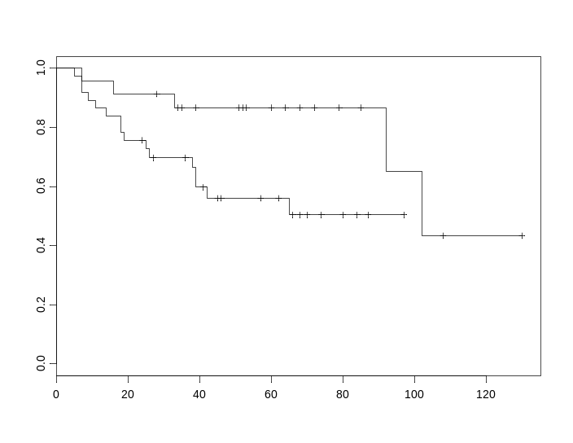

Time [months]
Survival

SOM-discovered C0 vs. C1 class gene markers
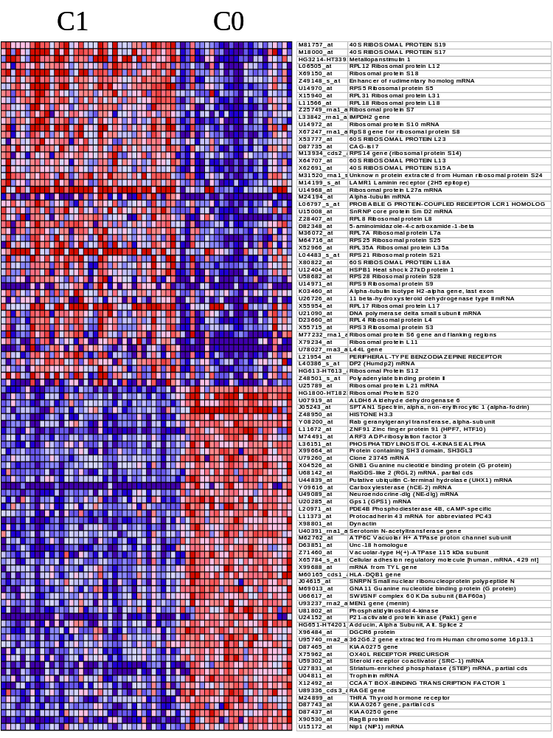
This picture shows some of the top markers that differentiate the C0 and C1 discovered classes sorted by their signal to noise ratios as described in the Gene marker selection section.

Treatment outcome markers
This picture shows some of the top 50 markers of the treatment failure vs. survival distinction. The genes are sorted by their signal to noise ratios as described in Gene marker selection section. The table below shows the top 100 markers for each tumor class including the permutation test values (see Permutation-based neighborhood analysis for marker gene). The samples are sorted according to treatment outcome status and then by membership to the unsupervised SOM-discovered classes C0 and C1. Notice the different behavior of markers according to the sample membership in those classes. For example the low in failures/high in survivors markers do not distinguish very well the failure samples that belong to the C0 class.
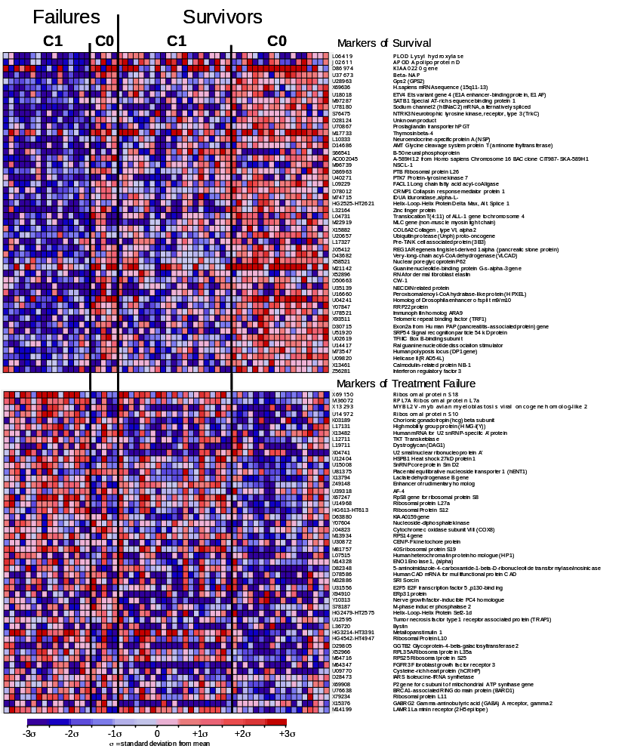

Values thresholded to 100 from below and 16000 from above
Variation filter: max/min > 5 (5-fold), max-min= 500 absolute units
 |  |  |  |  | Dataset C
class 0 = High in failure class, low in survivors class
class 1 = High in survivors class, low in failure class
Class | Distance | Perm 1% | Perm 5% | Median (50%) | Feature | Desc
class0 | 0.79 | 0.8575851 | 0.7458573 | 0.57256466 | X69150_at | Ribosomal protein S18
class0 | 0.58 | 0.7196305 | 0.6636454 | 0.5213177 | M36072_at | RPL7A Ribosomal protein L7a
class0 | 0.52 | 0.6967163 | 0.62734157 | 0.49769974 | X13293_at | MYBL2 V-myb avian myeloblastosis viral oncogene homolog-like 2
class0 | 0.43 | 0.6554627 | 0.6037056 | 0.48016676 | U14972_at | Ribosomal protein S10 mRNA
class0 | 0.39 | 0.6267573 | 0.5743042 | 0.4491265 | K03189_f_at | Chorionic gonadotropin (hcg) beta subunit mRNA
class0 | 0.37 | 0.6124803 | 0.5631084 | 0.44041193 | L17131_rna1_at | High mobility group protein (HMG-I(Y)) gene exons 1-8
class0 | 0.37 | 0.6079583 | 0.5574408 | 0.4283559 | X13482_at | U2 SMALL NUCLEAR RIBONUCLEOPROTEIN A'
class0 | 0.36 | 0.5920371 | 0.5417171 | 0.42088938 | L12711_s_at | TKT Transketolase (Wernicke-Korsakoff syndrome)
class0 | 0.36 | 0.5873178 | 0.5382286 | 0.41427517 | L19711_at | Dystroglycan (DAG1) mRNA
class0 | 0.35 | 0.5774571 | 0.5246414 | 0.40221128 | X04741_at | UBIQUITIN CARBOXYL-TERMINAL HYDROLASE ISOZYME L1
class0 | 0.35 | 0.5691193 | 0.52006763 | 0.39952728 | U12404_at | HSPB1 Heat shock 27kD protein 1
class0 | 0.35 | 0.564594 | 0.5123353 | 0.39575094 | U15008_at | SnRNP core protein Sm D2 mRNA
class0 | 0.34 | 0.5508108 | 0.5075411 | 0.39274555 | U81375_at | Placental equilibrative nucleoside transporter 1 (hENT1) mRNA
class0 | 0.34 | 0.545049 | 0.5041218 | 0.3862151 | X13794_rna1_at | Lactate dehydrogenase B gene exon 1 and 2 (EC 1.1.1.27) (and joined CDS)
class0 | 0.33 | 0.5437621 | 0.4992256 | 0.38400882 | Z49148_s_at | Enhancer of rudimentary homolog mRNA
class0 | 0.33 | 0.5414132 | 0.49528137 | 0.380192 | U39318_at | AF-4 mRNA
class0 | 0.33 | 0.5383373 | 0.49330828 | 0.37714508 | X67247_rna1_at | RpS8 gene for ribosomal protein S8
class0 | 0.33 | 0.5350176 | 0.4877165 | 0.37104735 | U14968_at | Ribosomal protein L27a mRNA
class0 | 0.33 | 0.5349308 | 0.48364687 | 0.36859724 | HG613-HT613_at | Ribosomal Protein S12
class0 | 0.32 | 0.5341373 | 0.48146704 | 0.36665422 | D63880_at | KIAA0159 gene
class0 | 0.32 | 0.5304447 | 0.47949836 | 0.3642997 | Y07604_at | Nucleoside-diphosphate kinase
class0 | 0.32 | 0.5302321 | 0.47619662 | 0.3608576 | J04823_rna1_at | Cytochrome c oxidase subunit VIII (COX8) mRNA
class0 | 0.31 | 0.5268929 | 0.47357216 | 0.35861334 | M13934_cds2_at | RPS14 gene (ribosomal protein S14) extracted from Human ribosomal protein S14 gene
class0 | 0.3 | 0.5230379 | 0.4727932 | 0.35644948 | U30872_at | CENP-F kinetochore protein mRNA
class0 | 0.3 | 0.517165 | 0.471055 | 0.3537757 | M81757_at | 40S RIBOSOMAL PROTEIN S19
class0 | 0.3 | 0.510794 | 0.46896455 | 0.35145545 | L07515_at | HETEROCHROMATIN PROTEIN 1 HOMOLOG
class0 | 0.3 | 0.5095285 | 0.46605366 | 0.35070398 | M14328_s_at | ENO1 Enolase 1, (alpha)
class0 | 0.29 | 0.508716 | 0.46462357 | 0.34898144 | D82348_at | 5-aminoimidazole-4-carboxamide-1-beta-D-ribonucleoti de transformylase/inosinicase
class0 | 0.29 | 0.508341 | 0.46285483 | 0.3464003 | D78586_at | CAD PROTEIN
class0 | 0.29 | 0.5031112 | 0.46092945 | 0.34413984 | M32886_at | SRI Sorcin
class0 | 0.28 | 0.5001085 | 0.45781645 | 0.3421644 | U31556_at | E2F5 E2F transcription factor 5, p130-binding
class0 | 0.27 | 0.4985688 | 0.4531834 | 0.34044018 | X94910_at | ERp31 protein
class0 | 0.27 | 0.4967446 | 0.45302796 | 0.33841276 | Y10313_at | Nerve growth factor-inducible PC4 homologue
class0 | 0.27 | 0.4962007 | 0.45097864 | 0.3369098 | S78187_at | M-PHASE INDUCER PHOSPHATASE 2
class0 | 0.26 | 0.4961145 | 0.4478716 | 0.3364148 | HG2479-HT2575_s_at | Helix-Loop-Helix Protein Sef2-1d
class0 | 0.26 | 0.4889722 | 0.44644976 | 0.334412 | U12595_at | Tumor necrosis factor type 1 receptor associated protein (TRAP1) mRNA, partial cds
class0 | 0.26 | 0.4863545 | 0.44478703 | 0.33138537 | L36720_at | Bystin mRNA
class0 | 0.26 | 0.4863338 | 0.444101 | 0.32964143 | HG3214-HT3391_at | Metallopanstimulin 1
class0 | 0.26 | 0.4848765 | 0.44319925 | 0.3288533 | HG4542-HT4947_at | Ribosomal Protein L10
class0 | 0.25 | 0.4844726 | 0.44242045 | 0.32686168 | D29805_at | GGTB2 Glycoprotein-4-beta-galactosyltransferase 2
class0 | 0.25 | 0.4840101 | 0.4404198 | 0.32587272 | X52966_at | RPL35A Ribosomal protein L35a
class0 | 0.25 | 0.4818713 | 0.43920797 | 0.3253415 | M64716_at | RPS25 Ribosomal protein S25
class0 | 0.25 | 0.4806192 | 0.4372189 | 0.3233852 | M64347_at | FGFR3 Fibroblast growth factor receptor 3 (achondroplasia, thanatophoric dwarfism)
class0 | 0.25 | 0.4799493 | 0.4344101 | 0.32173064 | U09770_at | Cysteine-rich heart protein (hCRHP) mRNA
class0 | 0.24 | 0.478935 | 0.43330073 | 0.32071036 | D28473_s_at | IARS Isoleucine-tRNA synthetase
class0 | 0.24 | 0.4770883 | 0.43237802 | 0.319521 | X69908_rna1_at | P2 gene for c subunit of mitochondrial ATP synthase gene extracted from H.sapiens gene for mitochondrial ATP synthase c subunit (P2 form)
class0 | 0.24 | 0.4735355 | 0.43201992 | 0.31852308 | U76638_at | BRCA1-associated RING domain protein (BARD1) mRNA
class0 | 0.24 | 0.4734543 | 0.4286573 | 0.31740758 | X79234_at | Ribosomal protein L11
class0 | 0.24 | 0.4714663 | 0.42765373 | 0.31620368 | X15376_at | GABRG2 Gamma-aminobutyric acid (GABA) A receptor, gamma 2
class0 | 0.24 | 0.4707498 | 0.42616725 | 0.31488287 | M14199_s_at | LAMR1 Laminin receptor (2H5 epitope)
class1 | 0.68 | 0.8203825 | 0.71479475 | 0.54178566 | L06419_at | PLOD Lysyl hydroxylase
class1 | 0.68 | 0.6813562 | 0.61684877 | 0.4866072 | J02611_at | APOD Apolipoprotein D
class1 | 0.62 | 0.6525392 | 0.5892669 | 0.46121535 | D86974_at | KIAA0220 gene, partial cds
class1 | 0.58 | 0.6052752 | 0.55940294 | 0.4377526 | U37673_at | Neuron-specific vesicle coat protein and cerebellar degeneration antigen (beta-NAP) mRNA
class1 | 0.54 | 0.5903411 | 0.5472241 | 0.4268065 | U28963_at | Gps2 (GPS2) mRNA
class1 | 0.53 | 0.5833272 | 0.5351269 | 0.41475436 | X69636_at | mRNA sequence (15q11-13)
class1 | 0.52 | 0.5681573 | 0.5214865 | 0.40589228 | U18018_at | ETV4 Ets variant gene 4 (E1A enhancer-binding protein, E1AF)
class1 | 0.51 | 0.5620877 | 0.5118141 | 0.39511982 | M97287_at | SATB1 Special AT-rich sequence binding protein 1 (binds to nuclear matrix/scaffold-associating DNA's)
class1 | 0.51 | 0.5489072 | 0.5050725 | 0.3881474 | U78180_at | Sodium channel 2 (hBNaC2) mRNA, alternatively spliced
class1 | 0.5 | 0.5460772 | 0.49833363 | 0.38249692 | S76475_at | NTRK3 Neurotrophic tyrosine kinase, receptor, type 3 (TrkC)
class1 | 0.49 | 0.5402584 | 0.49208724 | 0.37573755 | D28124_at | Unknown product
class1 | 0.47 | 0.5376918 | 0.49007148 | 0.37205702 | U70867_at | Prostaglandin transporter hPGT mRNA
class1 | 0.47 | 0.5376203 | 0.48863164 | 0.36825827 | M17733_at | Thymosin beta-4 mRNA
class1 | 0.47 | 0.5331166 | 0.48450905 | 0.36425692 | L10333_s_at | Neuroendocrine-specific protein A (NSP) mRNA
class1 | 0.46 | 0.5309144 | 0.47723606 | 0.35968268 | D14686_at | AMT Glycine cleavage system protein T (aminomethyltransferase)
class1 | 0.46 | 0.5209687 | 0.47456706 | 0.35637328 | S66541_s_at | B-50=neural phosphoprotein [human, Genomic, 778 nt, segment 3 of 3]
class1 | 0.46 | 0.5196613 | 0.47301164 | 0.3522324 | AC002045_xpt2_s_at | A-589H1.2 from Homo sapiens Chromosome 16 BAC clone CIT987-SKA-589H1 ~complete genomic sequence, complete sequence./ntype=DNA /annot=mRNA
class1 | 0.46 | 0.5092424 | 0.47074348 | 0.34869587 | M96739_at | NSCL-1 mRNA sequence
class1 | 0.45 | 0.502768 | 0.46288192 | 0.3469092 | D86963_at | PTB Ribosomal protein L26
class1 | 0.44 | 0.5001023 | 0.46171203 | 0.3424973 | U40271_s_at | PTK7 Protein-tyrosine kinase 7
class1 | 0.44 | 0.4967905 | 0.4602382 | 0.34013447 | L09229_s_at | FACL1 Long chain fatty acid acyl-coA ligase
class1 | 0.43 | 0.4930968 | 0.457573 | 0.33526275 | D78012_at | CRMP1 Collapsin response mediator protein 1
class1 | 0.43 | 0.4905391 | 0.455364 | 0.33248144 | M74715_s_at | IDUA Iduronidase, alpha-L-
class1 | 0.43 | 0.4900592 | 0.45425656 | 0.32911295 | HG2525-HT2621_at | Helix-Loop-Helix Protein Delta Max, Alt. Splice 1
class1 | 0.43 | 0.4890777 | 0.4522365 | 0.32650998 | L32164_at | Zinc finger protein mRNA, 3' end
class1 | 0.42 | 0.4890256 | 0.44947585 | 0.32418716 | L04731_at | Translocation T(4:11) of ALL-1 gene to chromosome 4
class1 | 0.42 | 0.4885243 | 0.44821537 | 0.32321975 | M22919_rna2_at | MLC gene (non-muscle myosin light chain) extracted from Human nonmuscle/smooth muscle alkali myosin light chain gene
class1 | 0.42 | 0.4878781 | 0.44515502 | 0.3214133 | X15882_at | COL6A2 Collagen, type VI, alpha 2
class1 | 0.42 | 0.484461 | 0.4439538 | 0.3199113 | U20657_at | Ubiquitin protease (Unph) proto-oncogene mRNA
class1 | 0.42 | 0.4837765 | 0.442202 | 0.31707913 | L17327_at | Pre-T/NK cell associated protein (3B3) mRNA, 3' end
class1 | 0.41 | 0.4793581 | 0.4388235 | 0.3152247 | J05412_at | REG1A Regenerating islet-derived 1 alpha (pancreatic stone protein, pancreatic thread protein)
class1 | 0.41 | 0.4784921 | 0.43725225 | 0.3134606 | D43682_s_at | Very-long-chain acyl-CoA dehydrogenase (VLCAD)
class1 | 0.41 | 0.4770678 | 0.43665424 | 0.3111634 | X58521_at | NUCLEAR PORE GLYCOPROTEIN P62
class1 | 0.41 | 0.4761319 | 0.43582407 | 0.3108418 | M21142_cds2_s_at | Guanine nucleotide-binding protein G-s-alpha-3 gene extracted from Human guanine nucleotide-binding protein alpha-subunit gene (G-s-alpha)
class1 | 0.4 | 0.4710167 | 0.43269396 | 0.30824196 | X52896_s_at | RNA for dermal fibroblast elastin
class1 | 0.4 | 0.4703343 | 0.43064603 | 0.30662587 | D50663_at | CW-1 mRNA
class1 | 0.4 | 0.4676111 | 0.42923966 | 0.30482316 | U35139_at | NECDIN related protein mRNA
class1 | 0.4 | 0.4663965 | 0.4282913 | 0.30239248 | U16660_at | Peroxisomal enoyl-CoA hydratase-like protein (HPXEL) mRNA
class1 | 0.4 | 0.464419 | 0.42767128 | 0.30059886 | U04241_at | Homolog of Drosophila enhancer of split m9/m10 mRNA
class1 | 0.4 | 0.4624396 | 0.42370704 | 0.29999858 | Y07847_at | RRP22 protein
class1 | 0.4 | 0.4604367 | 0.4224223 | 0.2977264 | U78521_at | Immunophilin homolog ARA9 mRNA
class1 | 0.39 | 0.4591597 | 0.4217393 | 0.29728124 | X93511_s_at | Telomeric repeat binding factor (TRF1) mRNA
class1 | 0.39 | 0.4569826 | 0.4172285 | 0.2956864 | D30715_xpt5_s_at | Exon2a from Human PAP (pancreatitis-associated protein) gene, 5'-flanking region./ntype=DNA /annot=exon
class1 | 0.39 | 0.4565771 | 0.4171863 | 0.2946754 | U51920_at | SRP54 Signal recognition particle 54 kD protein
class1 | 0.39 | 0.4550281 | 0.41622347 | 0.29249102 | U02619_at | TFIIIC Box B-binding subunit mRNA
class1 | 0.39 | 0.454998 | 0.41258836 | 0.2910374 | U14417_at | Ral guanine nucleotide dissociation stimulator mRNA, partial cds
class1 | 0.39 | 0.4549076 | 0.41155508 | 0.28867468 | M73547_at | POLYPOSIS LOCUS PROTEIN 1
class1 | 0.39 | 0.4530375 | 0.41020757 | 0.28755918 | U09820_s_at | Helicase II (RAD54L) mRNA
class1 | 0.39 | 0.4513509 | 0.40929455 | 0.2865325 | X13461_s_at | CALMODULIN-RELATED PROTEIN NB-1
class1 | 0.39 | 0.4505063 | 0.40849882 | 0.28548497 | Z56281_at | Interferon regulatory factor 3

k-nearest neighbors treatment outcome prediction results
This section contains the detailed sample predictions, error rates and survival analysis results for the k-nearest neighbor algorithm.

Medulloblastoma Treatment outcome prediction
k-Nearest Neighbors Algorithm
Values thresholded to 100 from below and 16000 from above
Variation filter: max/min > 5 (5-fold), max-min= 500 absolute units
Number of features (genes) = 8. Median based feature selection. K=5, 1/distance weighting
4459 genes pass the filter.
Dataset C
Confusion Matrix
 | Predicted
Actual | Survivors | Failures
Survivors | 37 | 2 | 39
Failures | 11 | 10 | 21
 | 48 | 12 | 60
Fisher exact test | P-val= | 0.0002
Proportional chance criterion (see chapter VII of Huberty's Applied Discriminant Analysis)
Cpro= | (39/60)*(39/60) + (21/60)*(21/60)
Cpro= | 0.545
Pcc= | 47/60= | 0.783333
(Pcc - Cpro)/Sqrt(Cpro(1-Cpro)/n) |  | = | Z= | 3.101741 |  | p-val = | 0.000962000
Num Data | Num Right | Num Wrong | Threshold | Num Abstain | Abs Error | ROC Error
60 | 47 | 13 | 0 | 0 | 0.21667 | 0.288
60 | 5
Datapoint | Predicted Class | Confidence | True Class | Error?
Brain_MD_1 | 0 | 0 | 0
Brain_MD_2 | 1 | 0.014714 | 0 | *
Brain_MD_3 | 1 | 0.051905 | 0 | *
Brain_MD_4 | 0 | 0.016268 | 0
Brain_MD_5 | 1 | 0.244053 | 0 | *
Brain_MD_6 | 0 | 0.00339 | 0
Brain_MD_7 | 1 | 0.174131 | 0 | *
Brain_MD_8 | 1 | 0.021684 | 0 | *
Brain_MD_9 | 0 | 0 | 0
Brain_MD_10 | 0 | 0.077769 | 0
Brain_MD_11 | 0 | 0.238361 | 0
Brain_MD_12 | 0 | 0.395321 | 0
Brain_MD_13 | 1 | 0.117485 | 0 | *
Brain_MD_14 | 1 | 0.621401 | 0 | *
Brain_MD_15 | 0 | 0.163458 | 0
Brain_MD_16 | 0 | 0.001465 | 0
Brain_MD_17 | 0 | 0.368863 | 0
Brain_MD_18 | 1 | 0.196423 | 0 | *
Brain_MD_19 | 1 | 0.083515 | 0 | *
Brain_MD_20 | 1 | 0.131556 | 0 | *
Brain_MD_21 | 1 | 0.236 | 0 | *
Brain_MD_22 | 1 | 0.119483 | 1
Brain_MD_23 | 1 | 0.449442 | 1
Brain_MD_24 | 1 | 0.087128 | 1
Brain_MD_25 | 1 | 0.002469 | 1
Brain_MD_26 | 1 | 0.004054 | 1
Brain_MD_27 | 1 | 0.229156 | 1
Brain_MD_28 | 1 | 0.214794 | 1
Brain_MD_29 | 1 | 0.132556 | 1
Brain_MD_30 | 1 | 0.004142 | 1
Brain_MD_31 | 1 | 0.071982 | 1
Brain_MD_32 | 1 | 0.15699 | 1
Brain_MD_33 | 1 | 0.070619 | 1
Brain_MD_34 | 1 | 0.086266 | 1
Brain_MD_35 | 1 | 0.095713 | 1
Brain_MD_36 | 0 | 0.134619 | 1 | *
Brain_MD_37 | 1 | 0.115611 | 1
Brain_MD_38 | 1 | 1.27E-04 | 1
Brain_MD_39 | 1 | 0.085404 | 1
Brain_MD_40 | 1 | 0.175227 | 1
Brain_MD_41 | 0 | 0.001709 | 1 | *
Brain_MD_42 | 1 | 0.434137 | 1
Brain_MD_43 | 1 | 0.042809 | 1
Brain_MD_44 | 1 | 0.038684 | 1
Brain_MD_45 | 1 | 0.012557 | 1
Brain_MD_46 | 1 | 0.190361 | 1
Brain_MD_47 | 1 | 0.078001 | 1
Brain_MD_48 | 1 | 0.028872 | 1
Brain_MD_49 | 1 | 0.209988 | 1
Brain_MD_50 | 1 | 0.440045 | 1
Brain_MD_51 | 1 | 0.186536 | 1
Brain_MD_52 | 1 | 0.32828 | 1
Brain_MD_53 | 1 | 0.01044 | 1
Brain_MD_54 | 1 | 0.096563 | 1
Brain_MD_55 | 1 | 0.00146 | 1
Brain_MD_56 | 1 | 0.310485 | 1
Brain_MD_57 | 1 | 0 | 1
Brain_MD_58 | 1 | 0.00709 | 1
Brain_MD_59 | 1 | 0.010633 | 1
Brain_MD_60 | 1 | 0.059727 | 1

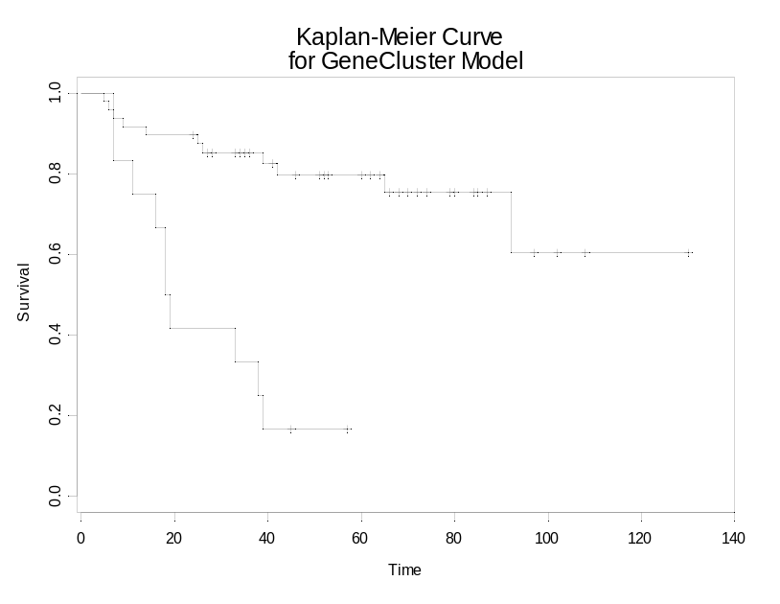
p-val=3.3e-06
Survival

Time [months]
Kaplan Meier Plot

Permutation test for k-nearest neighbor outcome predictor

The picture below shows the permutation test for the k-nearest neighbor predictor using the method described in the Permutation Test for Outcome Predictor section.

Number of genes parameter (ng) values: 1,2,3,4,5,6,7,8,9,10,15,25,50,100
Number of neighbors (k) parameter values: 3, 5
Number of random permutations was 1000

There are 9 k-NN random models better (lower error rates) than the actual k-NN model (k=5, ng=8) that achieves 13 errors. The significance is 9/1000 = 0.009.

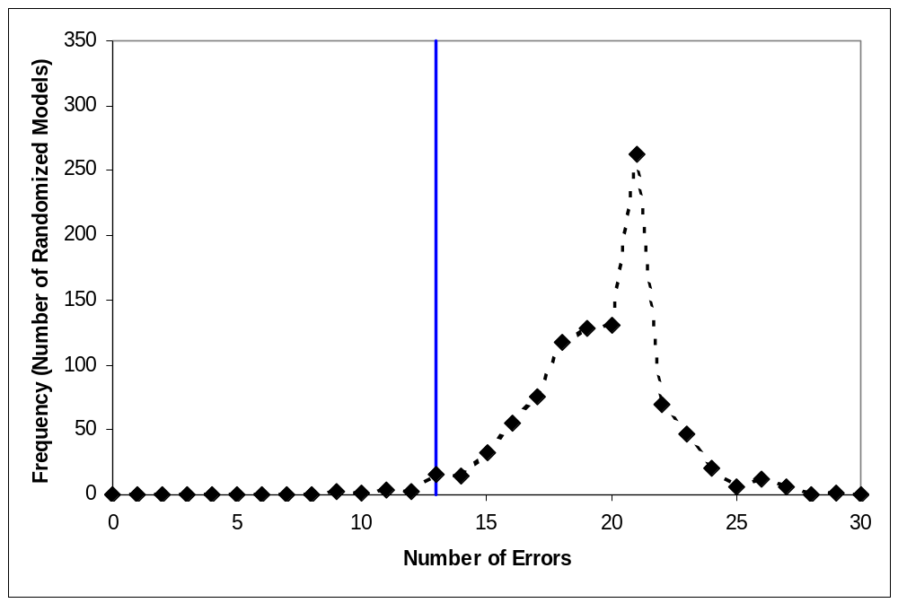
Actual
k-NN
Model

Weighted voting treatment outcome prediction results
This section contains the detailed sample predictions, error rates and survival analysis results for the weighted voting algorithm.

Medulloblastoma treatment outcome prediction
Weighted voting algorithm
Values thresholded to 100 from below and 16000 from above
Variation filter: max/min > 5 (5-fold), max-min= 500 absolute units
4459 genes pass the filter.
Dataset C
Confusion Matrix
 | Predicted
Actual | Survivors | Failures
Survivors | 35 | 4 | 39
Failures | 10 | 11 | 21
 | 45 | 15 | 60
Datapoint | Predicted Class | Confidence | True Class | Error? | Final Pred | Thres=0.3
Brain_MD_1 | 0 | 0.3952327 | 0 |  | 0
Brain_MD_2 | 1 | 0.4901857 | 0 | * | 1 | *
Brain_MD_3 | 0 | 0.7813152 | 0 |  | 0
Brain_MD_4 | 0 | 0.5952852 | 0 |  | 0
Brain_MD_5 | 1 | 0.3449895 | 0 | * | 1 | *
Brain_MD_6 | 0 | 0.6714032 | 0 |  | 0
Brain_MD_7 | 1 | 0.0853546 | 0 | * | 1 | *
Brain_MD_8 | 1 | 0.0744516 | 0 | * | 1 | *
Brain_MD_9 | 1 | 0.339672 | 0 | * | 1 | *
Brain_MD_10 | 0 | 0.8249887 | 0 |  | 0
Brain_MD_11 | 0 | 0.4271654 | 0 |  | 0
Brain_MD_12 | 0 | 0.1754278 | 0 |  | 1 | *
Brain_MD_13 | 0 | 0.3934312 | 0 |  | 0
Brain_MD_14 | 1 | 0.7060123 | 0 | * | 1 | *
Brain_MD_15 | 1 | 0.2107395 | 0 | * | 1 | *
Brain_MD_16 | 0 | 0.3573091 | 0 |  | 0
Brain_MD_17 | 0 | 0.3510691 | 0 |  | 0
Brain_MD_18 | 0 | 0.4114339 | 0 |  | 0
Brain_MD_19 | 0 | 0.3019681 | 0 |  | 0
Brain_MD_20 | 1 | 0.5024587 | 0 | * | 1 | *
Brain_MD_21 | 1 | 0.4159824 | 0 | * | 1 | *
Brain_MD_22 | 1 | 0.0565264 | 1 |  | 1
Brain_MD_23 | 1 | 0.3096231 | 1 |  | 1
Brain_MD_24 | 1 | 0.0712419 | 1 |  | 1
Brain_MD_25 | 1 | 0.3827674 | 1 |  | 1
Brain_MD_26 | 0 | 0.3012823 | 1 | * | 0 | *
Brain_MD_27 | 1 | 0.3565034 | 1 |  | 1
Brain_MD_28 | 1 | 0.2837476 | 1 |  | 1
Brain_MD_29 | 1 | 0.1805679 | 1 |  | 1
Brain_MD_30 | 0 | 0.2770377 | 1 | * | 1
Brain_MD_31 | 0 | 0.0251648 | 1 | * | 1
Brain_MD_32 | 1 | 0.2175978 | 1 |  | 1
Brain_MD_33 | 0 | 0.4701843 | 1 | * | 0 | *
Brain_MD_34 | 1 | 0.6038642 | 1 |  | 1
Brain_MD_35 | 0 | 0.2912066 | 1 | * | 1
Brain_MD_36 | 0 | 0.6073407 | 1 | * | 0 | *
Brain_MD_37 | 1 | 0.0385693 | 1 |  | 1
Brain_MD_38 | 1 | 0.1748749 | 1 |  | 1
Brain_MD_39 | 1 | 0.1087455 | 1 |  | 1
Brain_MD_40 | 1 | 0.0164151 | 1 |  | 1
Brain_MD_41 | 1 | 0.0581653 | 1 |  | 1
Brain_MD_42 | 1 | 0.0824984 | 1 |  | 1
Brain_MD_43 | 1 | 0.0644064 | 1 |  | 1
Brain_MD_44 | 1 | 0.0228837 | 1 |  | 1
Brain_MD_45 | 1 | 0.4116783 | 1 |  | 1
Brain_MD_46 | 1 | 0.3631051 | 1 |  | 1
Brain_MD_47 | 1 | 0.4536451 | 1 |  | 1
Brain_MD_48 | 1 | 0.3325118 | 1 |  | 1
Brain_MD_49 | 0 | 0.3832514 | 1 | * | 0 | *
Brain_MD_50 | 1 | 0.3337134 | 1 |  | 1
Brain_MD_51 | 1 | 0.6800034 | 1 |  | 1
Brain_MD_52 | 1 | 0.5439253 | 1 |  | 1
Brain_MD_53 | 0 | 0.2974122 | 1 | * | 1
Brain_MD_54 | 1 | 0.166894 | 1 |  | 1
Brain_MD_55 | 0 | 0.0892733 | 1 | * | 1
Brain_MD_56 | 1 | 0.1744895 | 1 |  | 1
Brain_MD_57 | 1 | 0.0187014 | 1 |  | 1
Brain_MD_58 | 1 | 0.1895063 | 1 |  | 1
Brain_MD_59 | 1 | 0.6713425 | 1 |  | 1
Brain_MD_60 | 1 | 0.2848721 | 1 |  | 1
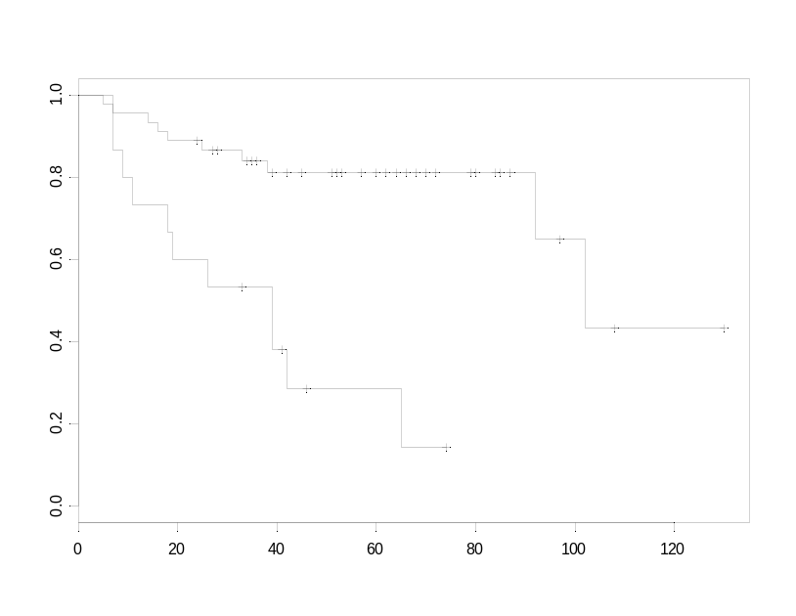
p-val=0.0000487
Survival
Time [months]
Kaplan Meier Plot

SVM treatment outcome prediction results
This section contains the detailed sample predictions, error rates and survival analysis results for the SVM algorithm.

Medulloblastoma treatment outcome prediction
SVM algorithm
150 genes
Dataset C
Confusion Matrix
 | Predicted
Actual | Survivors | Failures
Survivors | 33 | 6 | 39
Failures | 9 | 12 | 21
 | 42 | 18 | 60
Datapoint | Predicted Class | Confidence | True Class | Error?
Brain_MD_1 | 0 | -0.793188 | 0
Brain_MD_2 | 1 | 1.35161 | 0 | *
Brain_MD_3 | 0 | -0.0212459 | 0
Brain_MD_4 | 1 | 0.349387 | 0 | *
Brain_MD_5 | 1 | 2.80968 | 0 | *
Brain_MD_6 | 0 | -0.0663716 | 0
Brain_MD_7 | 0 | -0.442181 | 0
Brain_MD_8 | 0 | -0.155642 | 0
Brain_MD_9 | 0 | -0.259622 | 0
Brain_MD_10 | 0 | -0.82724 | 0
Brain_MD_11 | 0 | -0.921629 | 0
Brain_MD_12 | 0 | -0.267656 | 0
Brain_MD_13 | 1 | 1.08133 | 0 | *
Brain_MD_14 | 1 | 1.50771 | 0 | *
Brain_MD_15 | 0 | -0.338922 | 0
Brain_MD_16 | 1 | 0.460525 | 0 | *
Brain_MD_17 | 0 | -0.587502 | 0
Brain_MD_18 | 1 | 1.04191 | 0 | *
Brain_MD_19 | 0 | -0.303932 | 0
Brain_MD_20 | 1 | 0.472321 | 0 | *
Brain_MD_21 | 1 | 2.14838 | 0 | *
Brain_MD_22 | 0 | -0.908658 | 1 | *
Brain_MD_23 | 1 | 1.6444 | 1
Brain_MD_24 | 1 | 0.290781 | 1
Brain_MD_25 | 1 | 0.991721 | 1
Brain_MD_26 | 0 | -0.850044 | 1 | *
Brain_MD_27 | 1 | 0.786961 | 1
Brain_MD_28 | 1 | 2.54499 | 1
Brain_MD_29 | 1 | 0.305534 | 1
Brain_MD_30 | 1 | 1.18804 | 1
Brain_MD_31 | 1 | 0.692038 | 1
Brain_MD_32 | 1 | 0.0597337 | 1
Brain_MD_33 | 0 | -0.601687 | 1 | *
Brain_MD_34 | 1 | 0.660088 | 1
Brain_MD_35 | 0 | -0.557487 | 1 | *
Brain_MD_36 | 0 | -1.30296 | 1 | *
Brain_MD_37 | 1 | 1.46924 | 1
Brain_MD_38 | 1 | 1.02544 | 1
Brain_MD_39 | 1 | 0.547241 | 1
Brain_MD_40 | 1 | 0.391706 | 1
Brain_MD_41 | 1 | 0.0201054 | 1
Brain_MD_42 | 1 | 1.87217 | 1
Brain_MD_43 | 1 | 0.440148 | 1
Brain_MD_44 | 1 | 1.07468 | 1
Brain_MD_45 | 1 | 0.70975 | 1
Brain_MD_46 | 1 | 0.92651 | 1
Brain_MD_47 | 1 | 1.06011 | 1
Brain_MD_48 | 1 | 0.443325 | 1
Brain_MD_49 | 1 | 1.0668 | 1
Brain_MD_50 | 1 | 0.610242 | 1
Brain_MD_51 | 1 | 1.65304 | 1
Brain_MD_52 | 1 | 1.09599 | 1
Brain_MD_53 | 0 | -0.166939 | 1 | *
Brain_MD_54 | 1 | 0.481764 | 1
Brain_MD_55 | 1 | 0.522411 | 1
Brain_MD_56 | 1 | 1.1148 | 1
Brain_MD_57 | 1 | 0.445794 | 1
Brain_MD_58 | 1 | 0.00549191 | 1
Brain_MD_59 | 1 | 0.5419 | 1
Brain_MD_60 | 1 | 0.820917 | 1
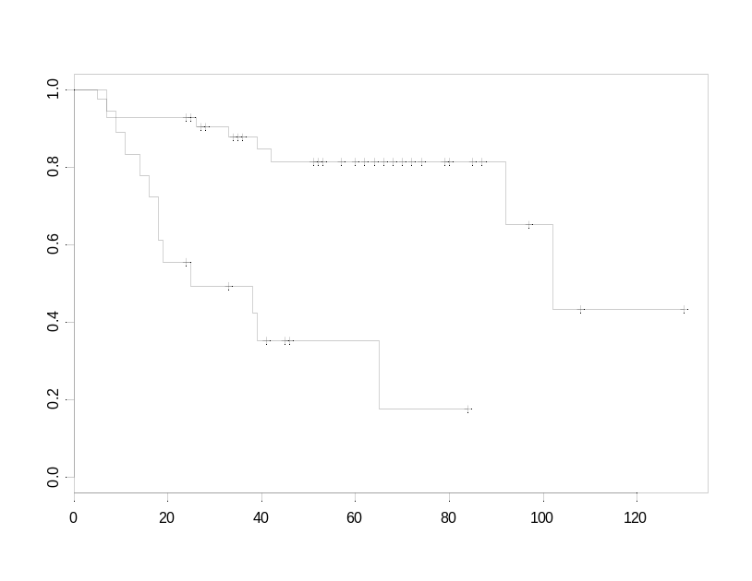
p-val= 0.0000271
Survival
Time [months]
Kaplan Meier Plot
p-val=1.1e-06
Survival
Time [months]

SPLASH treatment outcome prediction results
This section contains the detailed sample predictions, error rates and survival analysis results for the SPLASH algorithm.

Medulloblastoma treatment outcome prediction
SPLASH algorithm
Dataset C
Confusion Matrix
 | Predicted
Actual | Survivors | Failures
Survivors | 32 | 7 | 39
Failures | 8 | 13 | 21
 | 40 | 20 | 60
Datapoint | Predicted Class | Confidence | True Class | Error?
Brain_MD_1 | 0 | 0.778 | 0
Brain_MD_2 | 0 | 1.382 | 0
Brain_MD_3 | 0 | 0.451 | 0
Brain_MD_4 | 0 | 1.017 | 0
Brain_MD_5 | 0 | 1.516 | 0
Brain_MD_6 | 0 | 1.854 | 0
Brain_MD_7 | 1 | 0.114 | 0 | *
Brain_MD_8 | 1 | -0.731 | 0 | *
Brain_MD_9 | 0 | 1.41 | 0
Brain_MD_10 | 0 | 1.582 | 0
Brain_MD_11 | 0 | 0.385 | 0
Brain_MD_12 | 0 | 1.293 | 0
Brain_MD_13 | 1 | -0.363 | 0 | *
Brain_MD_14 | 1 | -0.307 | 0 | *
Brain_MD_15 | 0 | 1.116 | 0
Brain_MD_16 | 1 | -0.101 | 0 | *
Brain_MD_17 | 0 | 2.622 | 0
Brain_MD_18 | 1 | -0.057 | 0 | *
Brain_MD_19 | 0 | 0.795 | 0
Brain_MD_20 | 1 | -0.859 | 0 | *
Brain_MD_21 | 1 | -1.609 | 0 | *
Brain_MD_22 | 0 | 0.428 | 1 | *
Brain_MD_23 | 0 | 0.599 | 1 | *
Brain_MD_24 | 1 | -1.198 | 1
Brain_MD_25 | 0 | 2.303 | 1 | *
Brain_MD_26 | 1 | -0.061 | 1
Brain_MD_27 | 1 | -1.265 | 1
Brain_MD_28 | 1 | -0.843 | 1
Brain_MD_29 | 1 | -1.033 | 1
Brain_MD_30 | 1 | -0.137 | 1
Brain_MD_31 | 1 | -0.967 | 1
Brain_MD_32 | 1 | -1.013 | 1
Brain_MD_33 | 0 | 2.019 | 1 | *
Brain_MD_34 | 1 | -1.526 | 1
Brain_MD_35 | 1 | -0.516 | 1
Brain_MD_36 | 0 | 3.17 | 1 | *
Brain_MD_37 | 1 | 0.238 | 1
Brain_MD_38 | 1 | 0.068 | 1
Brain_MD_39 | 1 | 0.211 | 1
Brain_MD_40 | 1 | -0.714 | 1
Brain_MD_41 | 1 | -1.248 | 1
Brain_MD_42 | 0 | 0.725 | 1 | *
Brain_MD_43 | 1 | -0.419 | 1
Brain_MD_44 | 1 | -1.157 | 1
Brain_MD_45 | 1 | -0.333 | 1
Brain_MD_46 | 1 | 0.142 | 1
Brain_MD_47 | 1 | -1.403 | 1
Brain_MD_48 | 1 | -1.849 | 1
Brain_MD_49 | 1 | -0.628 | 1
Brain_MD_50 | 1 | 0.232 | 1
Brain_MD_51 | 1 | -0.622 | 1
Brain_MD_52 | 1 | -0.473 | 1
Brain_MD_53 | 1 | 0.284 | 1
Brain_MD_54 | 0 | 0.44 | 1 | *
Brain_MD_55 | 1 | -0.719 | 1
Brain_MD_56 | 1 | -1.287 | 1
Brain_MD_57 | 1 | -0.631 | 1
Brain_MD_58 | 1 | 0.263 | 1
Brain_MD_59 | 1 | -0.97 | 1
Brain_MD_60 | 1 | -0.828 | 1
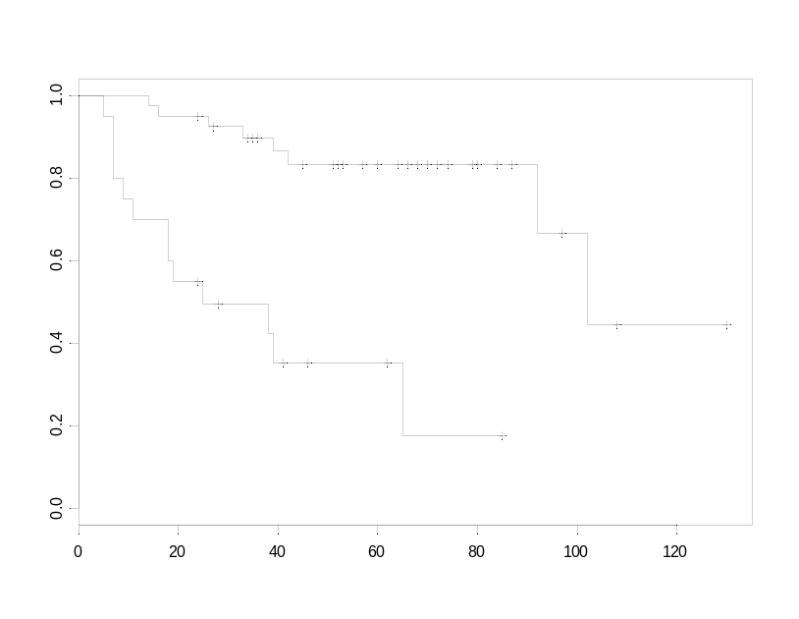
Survival
Time [months]
Kaplan Meier Plot
p-val= 2.89e-006

TrkC treatment outcome prediction results
This section contains the detailed sample predictions, error rates and survival analysis results for the single-gene TrkC predictor.

TrkC single-gene predictor
Values thresholded to 100 from below and 16000 from above
Variation filter: max/min > 5 (5-fold), max-min= 500 absolute units
Number of features (genes) = 1 = TrkC
Dataset C
Confusion Matrix
 | Predicted
Actual | Survivors | Failures
Survivors | 23 | 16 | 39
Failures | 4 | 17 | 21
 | 27 | 33 | 60
Num Data | Num Right | Num Wrong | Threshold | Num Abstain | Abs Error | ROC Error
60 | 40 | 20 | 0 | 0 | 0.333333 | 0.300366
60 | 5
Datapoint | Predicted Class | Confidence | True Class | Error?
Brain_MD_1 | 0 | 1 | 0
Brain_MD_2 | 0 | 1 | 0
Brain_MD_3 | 0 | 1 | 0
Brain_MD_4 | 0 | 1 | 0
Brain_MD_5 | 1 | 1 | 0 | *
Brain_MD_6 | 0 | 1 | 0
Brain_MD_7 | 0 | 1 | 0
Brain_MD_8 | 0 | 1 | 0
Brain_MD_9 | 0 | 1 | 0
Brain_MD_10 | 0 | 1 | 0
Brain_MD_11 | 1 | 1 | 0 | *
Brain_MD_12 | 0 | 1 | 0
Brain_MD_13 | 0 | 1 | 0
Brain_MD_14 | 0 | 1 | 0
Brain_MD_15 | 0 | 1 | 0
Brain_MD_16 | 0 | 1 | 0
Brain_MD_17 | 0 | 1 | 0
Brain_MD_18 | 0 | 1 | 0
Brain_MD_19 | 1 | 1 | 0 | *
Brain_MD_20 | 0 | 1 | 0
Brain_MD_21 | 1 | 1 | 0 | *
Brain_MD_22 | 0 | 1 | 1 | *
Brain_MD_23 | 1 | 1 | 1
Brain_MD_24 | 0 | 1 | 1 | *
Brain_MD_25 | 1 | 1 | 1
Brain_MD_26 | 0 | 1 | 1 | *
Brain_MD_27 | 0 | 1 | 1 | *
Brain_MD_28 | 1 | 1 | 1
Brain_MD_29 | 1 | 1 | 1
Brain_MD_30 | 0 | 1 | 1 | *
Brain_MD_31 | 0 | 1 | 1 | *
Brain_MD_32 | 1 | 1 | 1
Brain_MD_33 | 0 | 1 | 1 | *
Brain_MD_34 | 0 | 1 | 1 | *
Brain_MD_35 | 1 | 1 | 1
Brain_MD_36 | 0 | 1 | 1 | *
Brain_MD_37 | 1 | 1 | 1
Brain_MD_38 | 1 | 1 | 1
Brain_MD_39 | 1 | 1 | 1
Brain_MD_40 | 1 | 1 | 1
Brain_MD_41 | 1 | 1 | 1
Brain_MD_42 | 1 | 1 | 1
Brain_MD_43 | 0 | 1 | 1 | *
Brain_MD_44 | 0 | 1 | 1 | *
Brain_MD_45 | 1 | 1 | 1
Brain_MD_46 | 1 | 1 | 1
Brain_MD_47 | 0 | 1 | 1 | *
Brain_MD_48 | 1 | 1 | 1
Brain_MD_49 | 1 | 1 | 1
Brain_MD_50 | 1 | 1 | 1
Brain_MD_51 | 0 | 1 | 1 | *
Brain_MD_52 | 1 | 1 | 1
Brain_MD_53 | 1 | 1 | 1
Brain_MD_54 | 1 | 1 | 1
Brain_MD_55 | 0 | 1 | 1 | *
Brain_MD_56 | 1 | 1 | 1
Brain_MD_57 | 1 | 1 | 1
Brain_MD_58 | 0 | 1 | 1 | *
Brain_MD_59 | 0 | 1 | 1 | *
Brain_MD_60 | 1 | 1 | 1
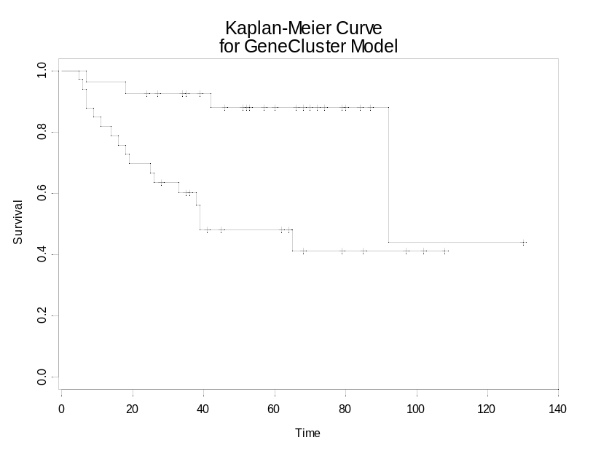
p-val= 0.00242
Survival
Time [months]
Kaplan Meier Plot

Staging treatment outcome prediction results
This section contains the detailed sample predictions, error rates and survival analysis results for staging as a predictor.

Staging predictor
M0 = no metastases, Mx = the following, M1 is positive CSF cytology, M2 is local metastases, M3 is metastases throughout the central nervous system, M4 is metastases beyond the central nervous system

Dataset C
Confusion Matrix
 | Predicted
Actual | Survivors | Failures
Survivors | 31 | 8 | 39
Failures | 11 | 10 | 21
 | 42 | 18 | 60
Datapoint | Predicted Class | Confidence | True Class | Error? | Chang stage
Brain_MD_1 | 0 |  | 0 |  | T4M1
Brain_MD_2 | 1 |  | 0 | * | T2M0
Brain_MD_3 | 1 |  | 0 | * | T3M0
Brain_MD_4 | 0 |  | 0 |  | T3M3
Brain_MD_5 | 0 |  | 0 |  | M3
Brain_MD_6 | 1 |  | 0 | * | T4M0
Brain_MD_7 | 1 |  | 0 | * | T1M0
Brain_MD_8 | 0 |  | 0 |  | T3bM1
Brain_MD_9 | 1 |  | 0 | * | M0
Brain_MD_10 | 1 |  | 0 | * | M0
Brain_MD_11 | 0 |  | 0 |  | T2M1
Brain_MD_12 | 1 |  | 0 | * | M0
Brain_MD_13 | 0 |  | 0 |  | T3M3
Brain_MD_14 | 1 |  | 0 | * | M0
Brain_MD_15 | 1 |  | 0 | * | T2MO
Brain_MD_16 | 0 |  | 0 |  | T3M3
Brain_MD_17 | 0 |  | 0 |  | T3bM3
Brain_MD_18 | 0 |  | 0 |  | T2M3
Brain_MD_19 | 0 |  | 0 |  | M2
Brain_MD_20 | 1 |  | 0 | * | T3bM0
Brain_MD_21 | 1 |  | 0 | * | T2M0
Brain_MD_22 | 1 |  | 1 |  | M0
Brain_MD_23 | 1 |  | 1 |  | T4M0
Brain_MD_24 | 1 |  | 1 |  | T3M0
Brain_MD_25 | 1 |  | 1 |  | M0
Brain_MD_26 | 0 |  | 1 | * | T2M3
Brain_MD_27 | 1 |  | 1 |  | M0
Brain_MD_28 | 1 |  | 1 |  | T4M0
Brain_MD_29 | 1 |  | 1 |  | T3M0
Brain_MD_30 | 1 |  | 1 |  | T3M0
Brain_MD_31 | 1 |  | 1 |  | M0
Brain_MD_32 | 1 |  | 1 |  | T2M0
Brain_MD_33 | 1 |  | 1 |  | T3bM0
Brain_MD_34 | 0 |  | 1 | * | T3M1
Brain_MD_35 | 1 |  | 1 |  | T3M0
Brain_MD_36 | 1 |  | 1 |  | T3M0
Brain_MD_37 | 1 |  | 1 |  | T3M0
Brain_MD_38 | 0 |  | 1 | * | T3M1
Brain_MD_39 | 1 |  | 1 |  | T3M0
Brain_MD_40 | 0 |  | 1 | * | T4M3
Brain_MD_41 | 1 |  | 1 |  | T4M0
Brain_MD_42 | 0 |  | 1 | * | T3M3
Brain_MD_43 | 1 |  | 1 |  | T3M0
Brain_MD_44 | 1 |  | 1 |  | T3M0
Brain_MD_45 | 1 |  | 1 |  | T4M0
Brain_MD_46 | 1 |  | 1 |  | T3M0
Brain_MD_47 | 1 |  | 1 |  | T4M0
Brain_MD_48 | 1 |  | 1 |  | T3bM0
Brain_MD_49 | 1 |  | 1 |  | T2M0
Brain_MD_50 | 1 |  | 1 |  | T3bM0
Brain_MD_51 | 1 |  | 1 |  | T3bM0
Brain_MD_52 | 1 |  | 1 |  | T2M0
Brain_MD_53 | 1 |  | 1 |  | T2M0
Brain_MD_54 | 0 |  | 1 | * | T4M4
Brain_MD_55 | 0 |  | 1 | * | T3bM2
Brain_MD_56 | 1 |  | 1 |  | T2M0
Brain_MD_57 | 0 |  | 1 | * | T2M3
Brain_MD_58 | 1 |  | 1 |  | T1M0
Brain_MD_59 | 1 |  | 1 |  | T3bM0
Brain_MD_60 | 1 |  | 1 |  | T3M0
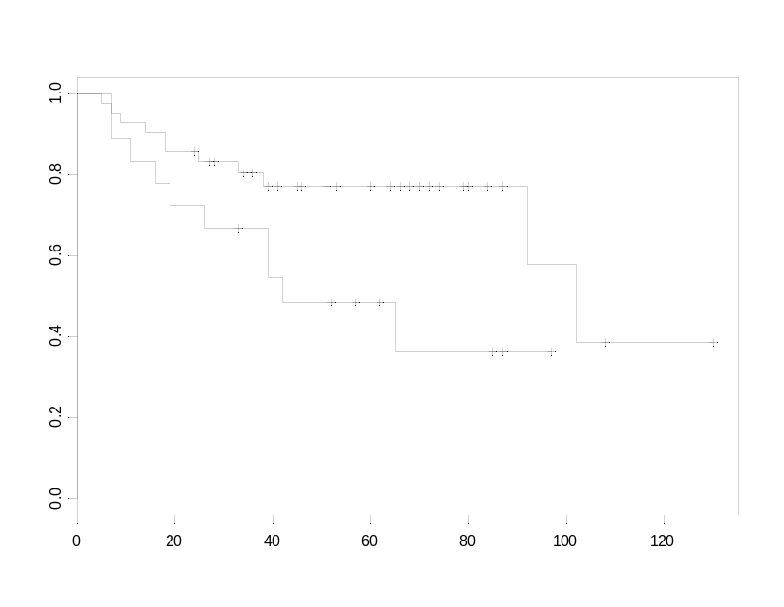
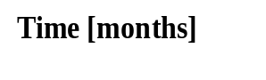
p-val= 0.0303
Survival
Kaplan Meier Plot

Combined treatment outcome predictors

This section describes the results for two combinations of models using a simple majority voting rule. The two combinations are Staging + k-NN + TrkC and SVM + k-NN + TrkC. These combinations achieve better performance than any single method alone.

Combined model I: staging, k-NN and TrkC

Medulloblastoma treatment outcome prediction
Combined predictor: Staging, k-NN and TrkC
Dataset C
Confusion Matrix
 | Predicted
Actual | Survivors | Failures
Survivors | 35 | 4 | 39
Failures | 8 | 13 | 21
 | 43 | 17 | 60
Datapoint | Staging | k-NN pred. | TrkC | True Class | Combined majority predictor | error?
Brain_MD_1 | 0 | 0 | 0 | 0 | 0
Brain_MD_2 | 1 | 1 | 0 | 0 | 1 | *
Brain_MD_3 | 1 | 1 | 0 | 0 | 1 | *
Brain_MD_4 | 0 | 0 | 0 | 0 | 0
Brain_MD_5 | 0 | 1 | 1 | 0 | 1 | *
Brain_MD_6 | 1 | 0 | 0 | 0 | 0
Brain_MD_7 | 1 | 1 | 0 | 0 | 1 | *
Brain_MD_8 | 0 | 1 | 0 | 0 | 0
Brain_MD_9 | 1 | 0 | 0 | 0 | 0
Brain_MD_10 | 1 | 0 | 0 | 0 | 0
Brain_MD_11 | 0 | 0 | 1 | 0 | 0
Brain_MD_12 | 1 | 0 | 0 | 0 | 0
Brain_MD_13 | 0 | 1 | 0 | 0 | 0
Brain_MD_14 | 1 | 1 | 0 | 0 | 1 | *
Brain_MD_15 | 1 | 0 | 0 | 0 | 0
Brain_MD_16 | 0 | 0 | 0 | 0 | 0
Brain_MD_17 | 0 | 0 | 0 | 0 | 0
Brain_MD_18 | 0 | 1 | 0 | 0 | 0
Brain_MD_19 | 0 | 1 | 1 | 0 | 1 | *
Brain_MD_20 | 1 | 1 | 0 | 0 | 1 | *
Brain_MD_21 | 1 | 1 | 1 | 0 | 1 | *
Brain_MD_22 | 1 | 1 | 0 | 1 | 1
Brain_MD_23 | 1 | 1 | 1 | 1 | 1
Brain_MD_24 | 1 | 1 | 0 | 1 | 1
Brain_MD_25 | 1 | 1 | 1 | 1 | 1
Brain_MD_26 | 0 | 1 | 0 | 1 | 0 | *
Brain_MD_27 | 1 | 1 | 0 | 1 | 1
Brain_MD_28 | 1 | 1 | 1 | 1 | 1
Brain_MD_29 | 1 | 1 | 1 | 1 | 1
Brain_MD_30 | 1 | 1 | 0 | 1 | 1
Brain_MD_31 | 1 | 1 | 0 | 1 | 1
Brain_MD_32 | 1 | 1 | 1 | 1 | 1
Brain_MD_33 | 1 | 1 | 0 | 1 | 1
Brain_MD_34 | 0 | 1 | 0 | 1 | 0 | *
Brain_MD_35 | 1 | 1 | 1 | 1 | 1
Brain_MD_36 | 1 | 0 | 0 | 1 | 0 | *
Brain_MD_37 | 1 | 1 | 1 | 1 | 1
Brain_MD_38 | 0 | 1 | 1 | 1 | 1
Brain_MD_39 | 1 | 1 | 1 | 1 | 1
Brain_MD_40 | 0 | 1 | 1 | 1 | 1
Brain_MD_41 | 1 | 0 | 1 | 1 | 1
Brain_MD_42 | 0 | 1 | 1 | 1 | 1
Brain_MD_43 | 1 | 1 | 0 | 1 | 1
Brain_MD_44 | 1 | 1 | 0 | 1 | 1
Brain_MD_45 | 1 | 1 | 1 | 1 | 1
Brain_MD_46 | 1 | 1 | 1 | 1 | 1
Brain_MD_47 | 1 | 1 | 0 | 1 | 1
Brain_MD_48 | 1 | 1 | 1 | 1 | 1
Brain_MD_49 | 1 | 1 | 1 | 1 | 1
Brain_MD_50 | 1 | 1 | 1 | 1 | 1
Brain_MD_51 | 1 | 1 | 0 | 1 | 1
Brain_MD_52 | 1 | 1 | 1 | 1 | 1
Brain_MD_53 | 1 | 1 | 1 | 1 | 1
Brain_MD_54 | 0 | 1 | 1 | 1 | 1
Brain_MD_55 | 0 | 1 | 0 | 1 | 0 | *
Brain_MD_56 | 1 | 1 | 1 | 1 | 1
Brain_MD_57 | 0 | 1 | 1 | 1 | 1
Brain_MD_58 | 1 | 1 | 0 | 1 | 1
Brain_MD_59 | 1 | 1 | 0 | 1 | 1
Brain_MD_60 | 1 | 1 | 1 | 1 | 1
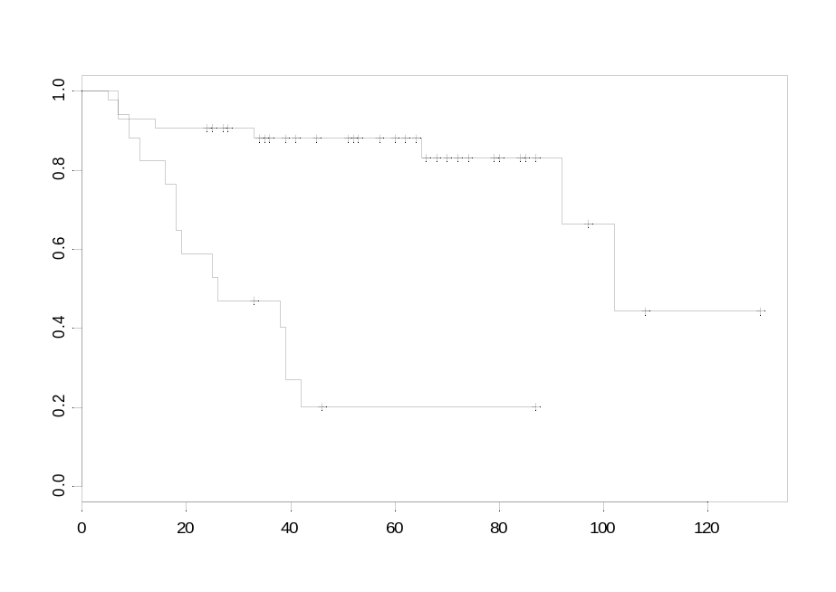
p-val=1.1e-06
Survival
Time [months]
Kaplan Meier Plot
Combined model II: SVM, k-NN and TrkC

Medulloblastoma treatment outcome prediction
Combined predictor: SVM, k-NN and TrkC
Dataset C
Confusion Matrix
 | Predicted
Actual | Survivors | Failures
Survivors | 35 | 4 | 39
Failures | 8 | 13 | 21
 | 43 | 17 | 60
Datapoint | SVM | k-NN pred. | TrkC | True Class | Combined majority predictor | error?
Brain_MD_1 | 0 | 0 | 0 | 0 | 0
Brain_MD_2 | 1 | 1 | 0 | 0 | 1 | *
Brain_MD_3 | 0 | 1 | 0 | 0 | 0
Brain_MD_4 | 1 | 0 | 0 | 0 | 0
Brain_MD_5 | 1 | 1 | 1 | 0 | 1 | *
Brain_MD_6 | 0 | 0 | 0 | 0 | 0
Brain_MD_7 | 0 | 1 | 0 | 0 | 0
Brain_MD_8 | 0 | 1 | 0 | 0 | 0
Brain_MD_9 | 0 | 0 | 0 | 0 | 0
Brain_MD_10 | 0 | 0 | 0 | 0 | 0
Brain_MD_11 | 0 | 0 | 1 | 0 | 0
Brain_MD_12 | 0 | 0 | 0 | 0 | 0
Brain_MD_13 | 1 | 1 | 0 | 0 | 1 | *
Brain_MD_14 | 1 | 1 | 0 | 0 | 1 | *
Brain_MD_15 | 0 | 0 | 0 | 0 | 0
Brain_MD_16 | 1 | 0 | 0 | 0 | 0
Brain_MD_17 | 0 | 0 | 0 | 0 | 0
Brain_MD_18 | 1 | 1 | 0 | 0 | 1 | *
Brain_MD_19 | 0 | 1 | 1 | 0 | 1 | *
Brain_MD_20 | 1 | 1 | 0 | 0 | 1 | *
Brain_MD_21 | 1 | 1 | 1 | 0 | 1 | *
Brain_MD_22 | 0 | 1 | 0 | 1 | 0 | *
Brain_MD_23 | 1 | 1 | 1 | 1 | 1
Brain_MD_24 | 1 | 1 | 0 | 1 | 1
Brain_MD_25 | 1 | 1 | 1 | 1 | 1
Brain_MD_26 | 0 | 1 | 0 | 1 | 0 | *
Brain_MD_27 | 1 | 1 | 0 | 1 | 1
Brain_MD_28 | 1 | 1 | 1 | 1 | 1
Brain_MD_29 | 1 | 1 | 1 | 1 | 1
Brain_MD_30 | 1 | 1 | 0 | 1 | 1
Brain_MD_31 | 1 | 1 | 0  p-val=1.12e-08  Survival | 1 | 1
Brain_MD_32 | 1 | 1 | 1 | 1 | 1
Brain_MD_33 | 0 | 1 | 0 | 1 | 0 | *
Brain_MD_34 | 1 | 1 | 0 | 1 | 1
Brain_MD_35 | 0 | 1 | 1 | 1 | 1
Brain_MD_36 | 0 | 0 | 0 | 1 | 0 | *
Brain_MD_37 | 1 | 1 | 1 | 1 | 1
Brain_MD_38 | 1 | 1 | 1 | 1 | 1
Brain_MD_39 | 1 | 1 | 1 | 1 | 1
Brain_MD_40 | 1 | 1 | 1 | 1 | 1
Brain_MD_41 | 1 | 0 | 1 | 1 | 1
Brain_MD_42 | 1 | 1 | 1 | 1 | 1
Brain_MD_43 | 1 | 1 | 0 | 1 | 1
Brain_MD_44 | 1 | 1 | 0 | 1 | 1
Brain_MD_45 | 1 | 1 | 1 | 1 | 1
Brain_MD_46 | 1 | 1 | 1 | 1 | 1
Brain_MD_47 | 1 | 1 | 0 | 1 | 1
Brain_MD_48 | 1 | 1 | 1 | 1 | 1
Brain_MD_49 | 1 | 1 | 1 | 1 | 1
Brain_MD_50 | 1 | 1 | 1 | 1 | 1
Brain_MD_51 | 1 | 1 | 0 | 1 | 1
Brain_MD_52 | 1 | 1 | 1 | 1 | 1
Brain_MD_53 | 0 | 1 | 1 | 1 | 1
Brain_MD_54 | 1 | 1 | 1 | 1 | 1
Brain_MD_55 | 1 | 1 | 0 | 1 | 1
Brain_MD_56 | 1 | 1 | 1 | 1 | 1
Brain_MD_57 | 1 | 1 | 1 | 1 | 1
Brain_MD_58 | 1 | 1 | 0 | 1 | 1
Brain_MD_59 | 1 | 1 | 0 | 1 | 1
Brain_MD_60 | 1 | 1 | 1 | 1 | 1

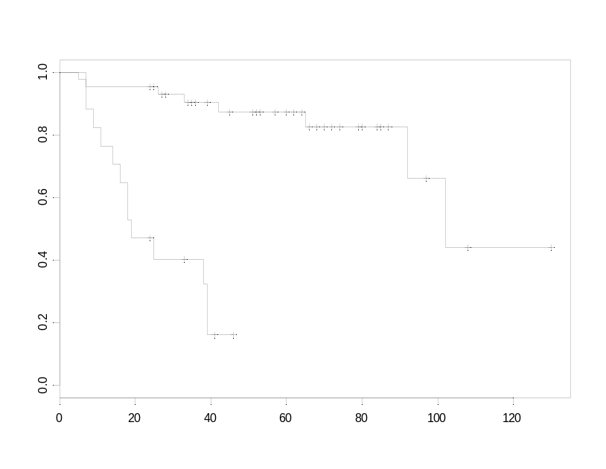
p-val=1.12e-08
Survival
Time [months]
Kaplan Meier Plot

Summary of medulloblastoma treatment outcome predictions
The following table summarizes the results for the different prediction algorithms in dataset C.

All of the multi-gene algorithms achieve similar performance and are better classifier of treatment outcome than staging of TrkC alone.

Notice the asymmetry in the number of false negatives and positives between TrkC and the other algorithms.

Summary of treatment outcome prediction performance

Dataset C
Algorithm | Total | Total | Errors in | Errors in | KM Rank Test
 | Correct | Errors | Failure Class | Survival Class | P-value
Staging | 41 | 19 | 11 | 8 | 0.03
TrkC | 40 | 20 | 4 | 16 | 0.0024
Weighted Voting | 46 | 14 | 10 | 4 | 0.00005
SVM | 45 | 15 | 9 | 6 | 0.000027
k-nearest neighbors | 47 | 13 | 11 | 2 | 3.30E-06
SPLASH | 45 | 15 | 8 | 7 | 2.89E-06
Combined model I  Staging, k-NN and TrkC | 48 | 12 | 8 | 4 | 1.10E-06
Combined model II  SVM, k-NN +and TrkC | 48 | 12 | 8 | 4 | 1.12E-08

Improvements of multi-gene prediction algorithm (k-NN) over staging and TrkC.

The following graph shows the results of taking low and high risks as defined by staging and TrkC expression and further classified them by using the k-NN algorithm results. As can be seen on the right side survival plots the multi-gene algorithm (k-NN) is able to resolve "survival" with additional resolution that translates in significant p-values for some of the k-NN subgroups. Notice in particular how the k-NN algorithm appears to correct the mistakes made by the staging classifier in low staging risk patients (e.g. those with small tumors but bad outcomes) and low TrkC patients (e.g. those with low TrkC expression which respond to treatment.). This confirms that there is additional information contained in the multi-gene expression profiles not necessarily contained in Staging and TrkC expression alone (the k-NN model did not used TrkC as one of its marker genes)
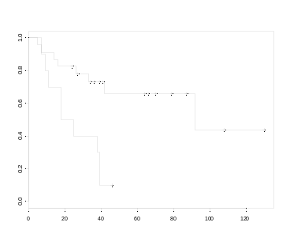
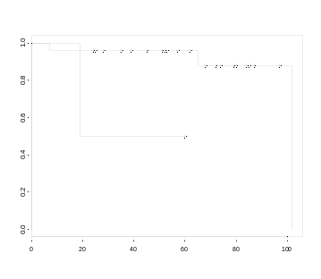
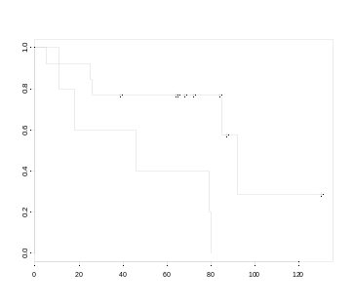
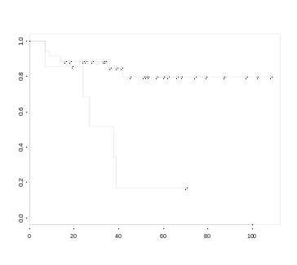
TrkC: Low
n=33

TrkC: High
n=27

k-NN Model
k-NN Model
Staging: M0
n=42

Staging: M1-4
n=18

k-NN Model
k-NN Model
P-val= 0.00244

P-val= 0.0231

P-val= 0.0111

P-val= 0.00163
Kaplan Meier Plots

k-NN predictions in subgroup treated with vincristine, cisplatin and cytoxan.
All patients received a chemotherapy regime of vincristine and cisplatin. Some patients also received cytoxan or a combination of some of the following: cytoxan, etoposide, CCNU, carboplatin, procarbazine, methotrexate and thiotepa. In order to test if our multi-gene prediction algorithm was somehow predicting outcome based on differences in these additional detail of the chemo regime we decided to analyzed the predictions in the a subset that received an identical regime of vincristine, cisplatin and cytoxan. The survival Kaplan Meier plot below shows that the model clearly resolves the failure and survival class inside this group and it is therefore not a proxy of the type of chemotherapy.

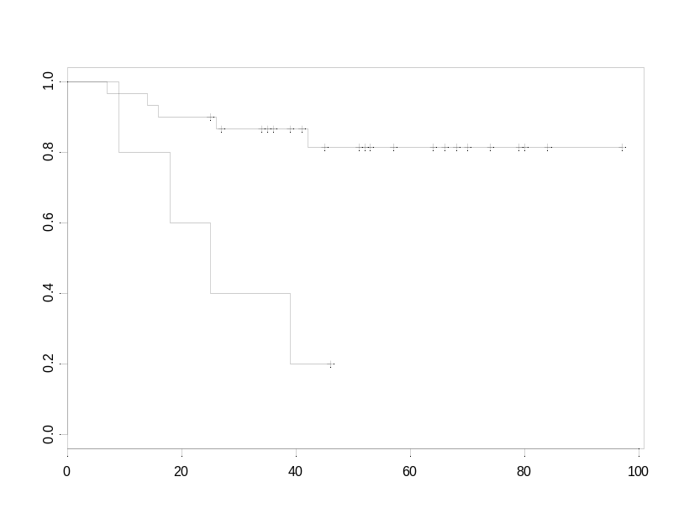
p-val=0.0012
Survival
Time [months]
Kaplan Meier Plot

Comparison between signal-to-noise and t-test statistic metrics

In order to better understand the effect of using a more standard metric for gene selection we repeated some of the analysis of the Medulloblastoma treatment outcome dataset using a t-test statistic metric:

t = ((μ0 - μ1)/√(σ 0²/N₀ + σ 1²/N₁)),

where N₁ and N₂ represents the number of samples in each class.

The results obtained using this metric are very similar to the ones obtained by the signal-to-noise metric used in the paper. This is something we had observed in other cases (datasets) as well. The following plot shows the total error rate in cross-validation as a function of the number of genes for k-NN models using both metrics. These models used k=5 and the same filtering parameters as those used in the “k-nearest neighbors treatment outcome prediction results” section earlier in this document.

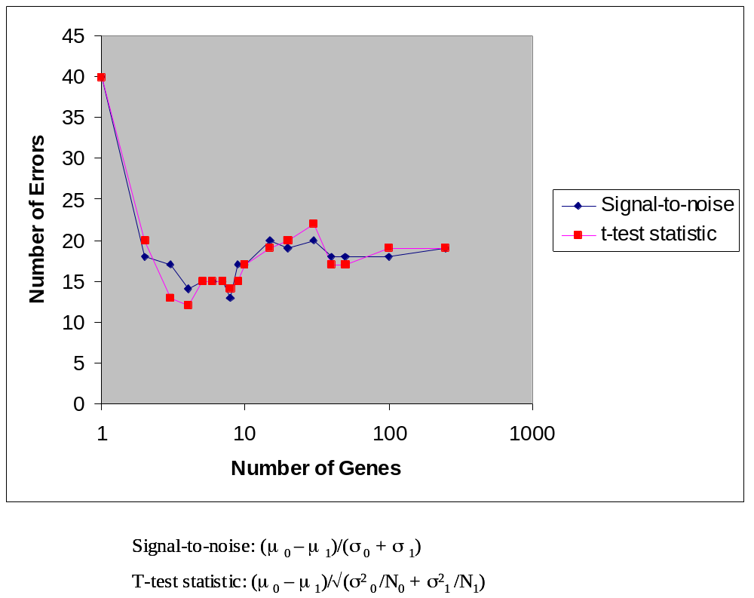
The similarity of the k-NN model results is a consequence of the fact that the two metrics produce very similar ranking of features. The next plot compares the rankings produced by both metrics using a color scheme. The parameter f determines how many differences in rank are allowed to consider the gene to be in the “same” rank (green). We show results for f = 5 and 0 (exact matching). This comparison shows the close similarity in the rankings obtained using the two metrics.

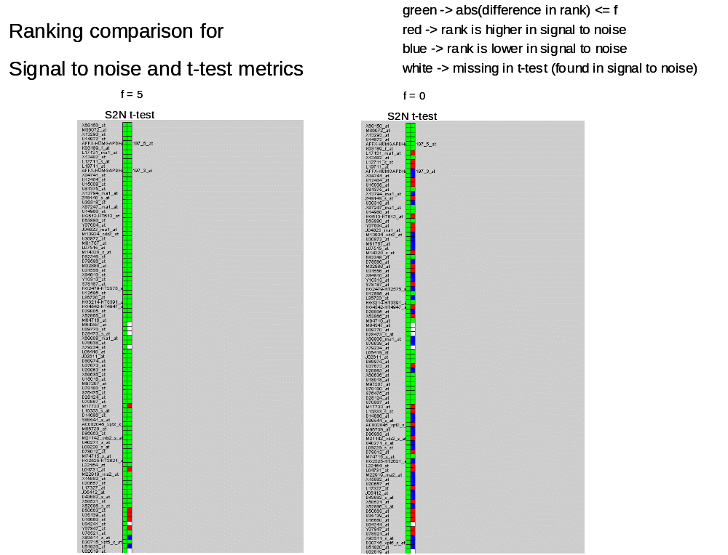

References

Baldi and Long 2001. P. Baldi and A. D. Long. A Bayesian Framework for the Analysis of Microarray Expression Data: Regularized t-Test and Statistical Inferences of Gene Changes. Bioinformatics, in press (2001).
Bender and Lang 2001. R. Bender and S. Lange. Adjusting for Multiple Testing – When and How? Journal of Clinical Epidemiology 54 (2001) 343-349.
Benjamini and Hochberg 1995. Benjamini, Y., Hochberg, Y. (1995). ``Controlling the False Discovery Rate: a Practical and Powerful Approach to Multiple Testing'',Journal of the Royal Statistical Society B, 57 289-300.
Benjamini et al 1999. Y. Benjamini, L. Hothorn and P. K. Sen. Preface. Journal of Statistical Planning and Inference 82 (1999) 1-4.
Benjamini et al 2001. Yoav Benjamini, Dan Drai, Greg Elmer, Neri Kafkafi, Ilan Golani. Controlling the False Discovery Rate in Behavior Genetics Research.2001. http://www.math.tau.ac.il/~ybenja/ExB.html.
Berry and Hochberg 1999. D .A. Berry and Y. Hochberg. Bayesian Perspectives on Multiple Comparisons. Journal of Statistical Planning and Inference 82 (1999) 215-227.Kohavi and John 1998.
Brown et al 2000. Brown M.P.S., et al. Knowledge-based analysis of microarray gene expression data by using support vector machines. Proc. Natl. Acad. Sci. (USA) 97, 262-267 (2000).
Califano et al 1999. Califano et al. Analysis of Gene Expression Microarrays for Phenotype Classification. Proceedings of the Eighth International Conference on Intelligent Systems for Molecular Biology, San Diego, California, August 19-23, p75-85, 1999. ftp.sdsc.edu/pub/sdsc/biology/ISMB00/154.pdf
Cherkassky and Mulier 1998. V. Cherkassky and F. Mulier, Learning from Data: Concepts, Theory and Methods. John Wiley and Sons. Inc. 1998.
Churchill and Doerge 1994. G. A. Churchill and R. W. Doerge. Empirical Threshold Values for Quantitative Trait Mapping. Genetics 138: 963-971 (1994).
Dasarathy 1991. Dasarathy V.B. (ed), Nearest Neighbor (NN) Norms: NN Pattern Classification Techniques. IEEE computer society press, Los Alamitos, Calif., December 1991. ISBN: 0818689307.
Doerge and Churchill 1996. R. W. Doerge and G. A. Churchill. Permutation Tests for Multiple Loci Affecting a Quantitative Character. Genetics 142: 285-294 (1996).
Duda, Hart and Stork 2001. R. O. Duda, P. E. Hart and D. G. Stork. Pattern Classification, 2ed. John Wiley and Sons. 2001.
Fisher 1935. R. Fisher. The Design of Experiments. 3ed. Oliver and Boyd Ltd. London.
Fukunaga 1990. Introduction to Statistical Pattern Recognition, 2ed. Academic Press 1990.
Golub et al 1999. Golub T.R., et al. Molecular classification of cancer: Class discovery and class prediction by gene expression monitoring. Science 286, 531-537 (1999).
Good 1994. P. Good. Permutation Tests: A Practical Guide to Resampling Methods for Testing Hypothesis. Springer –Verlag New York 1994.
Hochberg and Tamhane1997. Yosef Hochberg, Ajit C. Tamhane. Multiple Comparison Procedures. John Wiley and Sons. 1997.
Huberty 1994. C. J. Huberty, “Applied Discriminant Analysis,” John Wiley and Sons Inc. (1994).
Ideker et all 1999. Trey Ideker; Vesteinn Thorsson; Andrew F. Siegel; Leroy E. Hood. Testing for Differentially-Expressed Genes by Maximum-Likelihood Analysis of Microarray Data. Journal of Computational Biology Vol. 7 Num. 6 (2000) 805-817.
Kearns and Vazirani 1997. M. J. Kearns and U. V. Vazirani, “An Introduction to Computational Learning Theory”, MIT Press. 1997.
Kim et al 1999. Kim JYH, et al. Activation of neurotrophin-3 receptor TrkC induces apoptosis in medulloblastomas. Cancer Res. 59, 711-719 (1999).
Kohavi and John 1998. Kohavi, R. & John, G.H., (1998) The Wrapper Approach, in Feature Selection for knowledge Discovery and Data Mining, H. Liu & H. Motoda (eds.), Kluwer Academic Publishers, pp33-50.
Lee et al 2000. M. T. Lee, F. Kuo, G. A. Whitmore and J. Sklar. Importance of Replication in Microarray Gene Expression Studies: Statistical Methods and Evidence from Repetitive cDNA hybridizations. PNAS 2000 97: 9834-9839
Lehman 1986. E. C. Lehman. Testing Statistical Hypothesis. 2ed. John Wiley and Sons. New York. 1986.
Mukherjee et al 1999. Mukherjee S. et al. Support vector machine classification of microarray data. CBCL Paper #182/AI Memo #1676, Massachusetts Institute of Technology, Cambridge, MA, December 1999. http://www.ai.mit.edu/projects/cbcl/publications/ps/cancer.ps
Newton et al 2001. M.A. Newton, C.M. Kendziorski, C.S. Richmond, F.R. Blattner, K.W. Tsui. On differential variability of expression ratios: Improving statistical inference about gene expression changes from microarray data. Journal of Computational Biology Vol. 8 Num. 1 (2001) 37-52.
Segal et al 1994. Segal, R.A., Goumnerova, L.C., Kwon, Y.K., Stiles, C.D., Pomeroy, S.L. Expression of the neurotrophin receptor TrkC is linked to a favorable outcome in medulloblastoma. Proc. Natl. Acad. Sci. (USA) 91, 12867-12871 (1994).
Slonim et al 1999. Slonim, D. K. et al. Class prediction and discovery using gene expression data. Procs. of the Fourth Annual International Conference on Computational Molecular Biology Tokyo, Japan April 8 - 11, p263-272, 2000. http://www.genome.wi.mit.edu/MPR/publications/cancer_class_preprint_version.rtf
Somerville 1999. P. N. Somerville. Critical Values for Multiple Testing and Comparisons: One Step and Step Down Procedures. Journal of Statistical Planning and Inference 82 (1999) 129-138.
Tamayo et al 1999. Tamayo P, et al. Interpreting patterns of gene expression with self-organizing maps: Methods and application to hematopoietic differentiation. Proc. Natl. Acad. Sci. (USA) 96, 2907-2912 (1999).
Tamhane and Dunnett 1999. A. C. Tamhane and C. W. Dunnett. Stepwise Multiple Test Procedures with Biometric Applications. Journal of Statistical Planning and Inference 82 (1999) 55-68.
Troendle 2000. J.F. Troendle. Stepwise Normal Theory Multiple Test Procedures Controlling the False Discovery Rate. Journal of Statistical Planning and Inference 84 (2000) 139-158.
Tusher et al 2001. V. G. Tusher, R. Tibshirani and G. Chu. Significance analysis of microarrays applied to the ionizing radiation response. PNAS 2001 98: 5116-5121.
Westfall and Young 1993. P. H. Westfall and S. S. Young. Resampling-Based Multiple Testing. John Wiley and Sons. Inc. 1993.
Westfall and Wolfinger 1999. P. Westfall, R. Tobias, R. D., and R. Wolfinger, Multiple Comparisons and Multiple Tests using the SAS System, SAS Institute Inc, Cary, NC, 1999.
Yekuteli and Benjamini 1999. D. Yekutieli and Y. Benjamini. Resampling-Based False Discovery Rate Controlling Multiple Test Procedures for Correlated Test Statistics. Journal of Statistical Planning and Inference 82 (1999) 171-196.

