Code 1

%%%%%%%%%%%%%%%%%%%%%%%%%%%%%%%%%%%%%%%%%%%%%%%%%%%%%%%%%%%%%%%%%%%%%%
%%%%%%%%%%%%%%%%%%%%%%%%%%%%%%%%%%%%%%%%%%%%%%%%%%%%%%%%%%%%%%%%%%%%%%
% PROBLEM 1
%%%%%%%%%%%%%%%%%%%%%%%%%%%%%%%%%%%%%%%%%%%%%%%%%%%%%%%%%%%%%%%%%%%%%%
%%%%%%%%%%%%%%%%%%%%%%%%%%%%%%%%%%%%%%%%%%%%%%%%%%%%%%%%%%%%%%%%%%%%%%

syms l1 l2 q1(t) q2(t) r M g F1 F2 q1_d(t) q1_dd(t) q2_d(t) q2_dd(t)

%%%%%%%%%%%%%%%%%%%%%%
% Symbol definitions
%%%%%%%%%%%%%%%%%%%%%%
% q(t) - Represents theta(t)
% F - Represents generalized force or torque
% q_d(t) - Represents derivative of q wrt to t
% q_dd(t)- Represents second derivative of q wrt to t
% r - Position of COM wrt to inertial(world) frame
% l - link length of robot

%%%%%%%%%%%%%%%%%%%%%%%%%%%%%%%%%%%%%%%%%%%%%%%%%%%%%%%%%%%%%%%%%
% Lagrangian
%%%%%%%%%%%%%%%%%%%%%%%%%%%%%%%%%%%%%%%%%%%%%%%%%%%%%%%%%%%%%%%%%
r = [(l2*cos(q2)+l1)*cos(q1)
(l2*cos(q2)+l1)*sin(q1)
l2*sin(q2)]

v = diff(r); %derivate of r
T = simplify(sym(1)/2* M * transpose(v)*v)
V = M*g*l2*sin(q2)
L = T-V

%%%%%%%%%%%%%%%%%%%%%%%%%%%%%%%%%%%%%%%%%%%%%%%%%%%%%%%%%%%%%%%%%
% Taking derivatives
%%%%%%%%%%%%%%%%%%%%%%%%%%%%%%%%%%%%%%%%%%%%%%%%%%%%%%%%%%%%%%%%%

%%%%%%%%%%%%%%%%%%%%%%%%%%%%%%%%%%%%
% Derivative of L wrt to q
%%%%%%%%%%%%%%%%%%%%%%%%%%%%%%%%%%%%
dL_dq1 = functionalDerivative(L,q1);
dL_dq2 = functionalDerivative(L,q2);

%%%%%%%%%%%%%%%%%%%%%%%%%%%%%%%%%%%%%
% Derivative of L wrt q_dot
%%%%%%%%%%%%%%%%%%%%%%%%%%%%%%%%%%%%%

% Replacing derivatives with symbols
% Matlab can't take functional derivative with
% respect to a derivative
L=subs(L,diff(q2(t),t),q2_d);
L=subs(L,diff(q1(t),t),q1_d);

dL_dq1_dot= functionalDerivative(L,q1_d);
dL_dq2_dot= functionalDerivative(L,q2_d);

%%%%%%%%%%%%%%%%%%%%%%%%%%%%%%%%%%%%%
% Derivative of dl/dq_dot wrt to t
%%%%%%%%%%%%%%%%%%%%%%%%%%%%%%%%%%%%%
%Taking derivative of dL_dq with respect to t
dt_dL_dq1_dot = diff(dL_dq1_dot,t);
dt_dL_dq2_dot = diff(dL_dq2_dot,t);

%%%%%%%%%%%%%%%%%%%%%%%%%%%%%%%%%%%%%%%%%%%%%%%%%%%%%%%%%%%%%%%%
% Equation of Motion
%%%%%%%%%%%%%%%%%%%%%%%%%%%%%%%%%%%%%%%%%%%%%%%%%%%%%%%%%%%%%%%%

%%%%%%%%%%%%%%%%%%%%%%%%%%%%%%%%%%%
% Replacing derivatives with symbols
%%%%%%%%%%%%%%%%%%%%%%%%%%%%%%%%%%%

% Replacing derivatives with symbols to perform substaction
dt_dL_dq1_dot=subs(dt_dL_dq1_dot,diff(q1_d(t),t),q1_dd);
dt_dL_dq1_dot=subs(dt_dL_dq1_dot,diff(q1(t),t),q1_d);
dt_dL_dq1_dot=subs(dt_dL_dq1_dot,diff(q2_d(t),t),q2_dd);
dt_dL_dq1_dot=subs(dt_dL_dq1_dot,diff(q2(t),t),q2_d);

dt_dL_dq2_dot=subs(dt_dL_dq2_dot,diff(q1_d(t),t),q1_dd);
dt_dL_dq2_dot=subs(dt_dL_dq2_dot,diff(q1(t),t),q1_d);
dt_dL_dq2_dot=subs(dt_dL_dq2_dot,diff(q2_d(t),t),q2_dd);
dt_dL_dq2_dot=subs(dt_dL_dq2_dot,diff(q2(t),t),q2_d);

% Replacing derivatives with symbols to perform substaction
dL_dq1=subs(dL_dq1,diff(q1(t),t,t),q1_dd);
dL_dq1=subs(dL_dq1,diff(q1(t),t),q1_d);
dL_dq1=subs(dL_dq1,diff(q2(t),t,t),q2_dd);
dL_dq1=subs(dL_dq1,diff(q2(t),t),q2_d);

dL_dq2=subs(dL_dq2,diff(q1(t),t,t),q1_dd);
dL_dq2=subs(dL_dq2,diff(q1(t),t),q1_d);
dL_dq2=subs(dL_dq2,diff(q2(t),t,t),q2_dd);
dL_dq2=subs(dL_dq2,diff(q2(t),t),q2_d);

%%%%%%%%%%%%%%%%%%%%%%%%%%%%%%%%%%
% Finding Equations
%%%%%%%%%%%%%%%%%%%%%%%%%%%%%%%%%%
eqn1 = simplify(dt_dL_dq1_dot - dL_dq1);
enq1=simplify(subs(eqn1,l1,2*l2))== F1

eqn2 =simplify(dt_dL_dq2_dot - dL_dq2);
eqn2 = simplify(subs(eqn2,l1,2*l2))== F2

Output
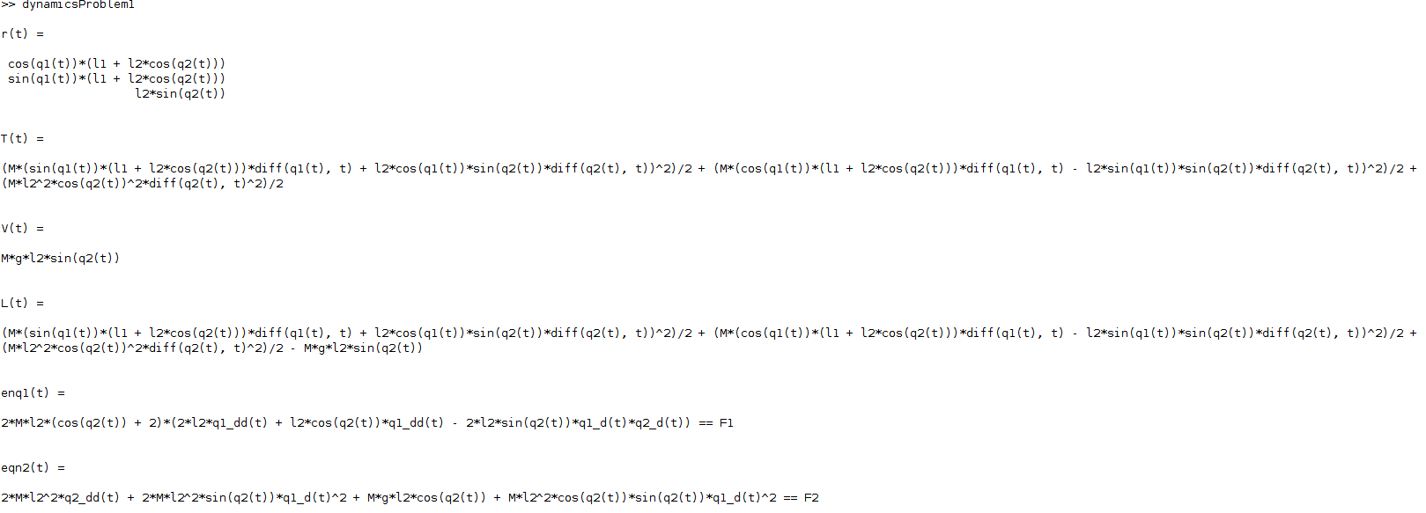

Code 2
import numpy as np

def transZ(n):
a = np.identity(4)
a[2,3]=n
return a

def transX(n):
a=np.identity(4)
a[0,3]=n
return a

def transY(n):
a=np.identity(4)
a[1,3]=n
return a

def rotX(n):
x=np.deg2rad(n)
a=np.array([[1,0,0,0],
[0,np.cos(x),-np.sin(x),0],
[0,np.sin(x),np.cos(x),0 ],
[0, 0,0,1]
])
return a

def rotY(n):
x=np.deg2rad(n)
a=np.array([[np.cos(x),0,np.sin(x),0],
[0,1,0,0],
[-np.sin(x),0,np.cos(x),0 ],
[0, 0,0,1]
])
return a

def rotZ(n):
x=np.deg2rad(n)
a=np.array([[np.cos(x),-np.sin(x),0,0],
[np.sin(x),np.cos(x),0,0],
[0,0,1,0 ],
[0,0,0,1]
])
return a

def A_dh(theta,d,a,alpha):
return np.dot(rotZ(theta),
np.dot(transZ(d),
np.dot(transX(a),
rotX(alpha))))

print('##############################################################')
print(' Question 2a ')
print('##############################################################')
print(' ')

# q = np.array([90, -30, 60, 2])
q= np.array([150, 45 , 30 , 2])
l1 = 1.5
l2 = 1
l3 = 0.5
A1=A_dh(q[0]-90,l1,0,-30)
A2=A_dh(q[1]-90,l2,0,90)
A3=A_dh(q[2]+60,0,0,-90)
AN=A_dh(0,q[3]+l3,0,0)

T0_1 = A1
T0_2 = np.dot(T0_1,A2)
T0_3 = np.dot(T0_2,A3)
T0_n = np.dot(T0_3,AN)

z0 = np.array([0, 0, 1, 0])
z1 = np.dot(T0_1,z0)[:3]
z2 = np.dot(T0_2,z0)[:3]
z3 = np.dot(T0_3,z0)[:3]
z0 = z0[:3]

O0 = np.array([0, 0, 0, 1])
O1 = np.dot(T0_1,O0)[:3]
O2 = np.dot(T0_2,O0)[:3]
On = np.dot(T0_n,O0)[:3]
O0 = O0[:3]

j1 = np.concatenate((np.cross(z0,(On - O0)),z0))
j2 = np.concatenate((np.cross(z1,(On - O1)),z1))
j3 = np.concatenate((np.cross(z2,(On - O2)),z2))
j4 = np.concatenate((z3,O0))

J = np.column_stack((j1,j2,j3,j4))
F = np.array([1, 0, 0, 0, 0, 0])
T = np.round(np.dot(J.T,F),3)

print('Joint torques ')
print(T)

print('##############################################################')
print(' Question 2b ')
print('##############################################################')
print(' ')

T= np.array([2, 3, -1, 0.5])
J= J[0:3,:]
pseudoInv = np.dot(np.linalg.inv(np.dot(J,J.T)),J)
print(np.dot(pseudoInv,T))

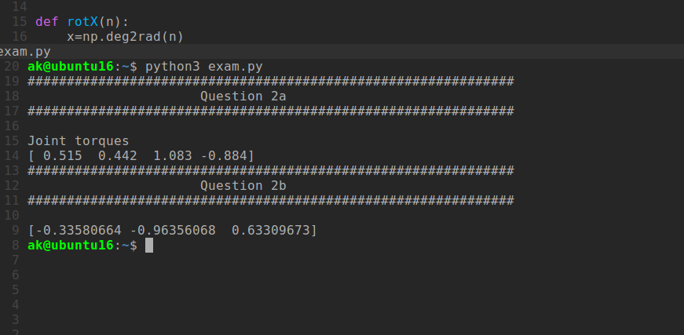
Output

Code 3
APPROACH 1
%%%%%%%%%%%%%%%%%%%%%%%%%%%%%%%%%%%%%%%%%%%%%%%%%%%%%%%%%%%%%%%%%%%%%%
%%%%%%%%%%%%%%%%%%%%%%%%%%%%%%%%%%%%%%%%%%%%%%%%%%%%%%%%%%%%%%%%%%%%%%
% PROBLEM 3
%%%%%%%%%%%%%%%%%%%%%%%%%%%%%%%%%%%%%%%%%%%%%%%%%%%%%%%%%%%%%%%%%%%%%%
%%%%%%%%%%%%%%%%%%%%%%%%%%%%%%%%%%%%%%%%%%%%%%%%%%%%%%%%%%%%%%%%%%%%%%

% Note This approach doesn't account for Rotational Inertia'

syms I m1 m2 m3 g F1 F2 F3
syms q1(t) q2(t) q3(t) q1_d(t) q1_dd(t) q2_d(t) q2_dd(t) q3_d(t) q3_dd(t)
syms a1c a2c a3c a1 a2 a3

%%%%%%%%%%%%%%%%%%%%%%
% Symbol definitions
%%%%%%%%%%%%%%%%%%%%%%
% q(t) - Represents generalized coordinates
% F - Represents generalized force or torque
% q_d(t) - Represents derivative of q wrt to t
% q_dd(t)- Represents second derivative of q wrt to t
% r - Position of COM wrt to inertial(world) frame
% a's - robot link parameters
% I - Rotational Inertia from links

%%%%%%%%%%%%%%%%%%%%%%%%%%%%%%%%%%%%%%%%%%%%%%%%%%%%%%%%%%%%%%%%%
% Lagrangian
%%%%%%%%%%%%%%%%%%%%%%%%%%%%%%%%%%%%%%%%%%%%%%%%%%%%%%%%%%%%%%%%%
r1 = [a1c*cos(q1)
a1c*sin(q1)];

r2 = [(a1+q2+a2c)*cos(q1)
(a1+q2+a2c)*sin(q1)];

r3 = [(a1+ q2 + a2)*cos(q1) + a3c*cos(q3)
(a1+ q2 + a2)*sin(q1) + a3c*sin(q3)];

% Getting velocities
v1 = diff(r1);
v2 = diff(r2);
v3 = diff(r3);

% Kinetic Energy
T1 = sym(1)/2 * transpose(v1) * v1;
T2 = sym(2)/2 * transpose(v2) * v2;
T3 = sym(3)/3 * transpose(v3) * v3;

T = T1 + T2 + T3

% Potential Energy
V1 = m1*g*a1c*sin(q1);
V2 = m2*g*(a1c + q2* + a2c)*sin(q1);
V3 = m3*g*((a1+q2*+a2)*sin(q1) + a3c*sin(q3));

V = V1 + V2 + V3

% Lagrangian
L = T-V

%%%%%%%%%%%%%%%%%%%%%%%%%%%%%%%%%%%%%%%%%%%%%%%%%%%%%%%%%%%%%%%%%
% Taking derivatives
%%%%%%%%%%%%%%%%%%%%%%%%%%%%%%%%%%%%%%%%%%%%%%%%%%%%%%%%%%%%%%%%%

%%%%%%%%%%%%%%%%%%%%%%%%%%%%%%%%%%%%
% Derivative of L wrt to q
%%%%%%%%%%%%%%%%%%%%%%%%%%%%%%%%%%%%
dL_dq1 = functionalDerivative(L,q1);
dL_dq2 = functionalDerivative(L,q2);
dL_dq3 = functionalDerivative(L,q3);

%%%%%%%%%%%%%%%%%%%%%%%%%%%%%%%%%%%%%
% Derivative of L wrt q_dot
%%%%%%%%%%%%%%%%%%%%%%%%%%%%%%%%%%%%%

% Replacing derivatives with symbols
% Matlab can't take functional derivative with
% respect to a derivative
L=subs(L,diff(q1(t),t),q1_d);
L=subs(L,diff(q2(t),t),q2_d);
L=subs(L,diff(q3(t),t),q3_d);

dL_dq1_dot= functionalDerivative(L,q1_d);
dL_dq2_dot= functionalDerivative(L,q2_d);
dL_dq3_dot= functionalDerivative(L,q3_d);

%%%%%%%%%%%%%%%%%%%%%%%%%%%%%%%%%%%%%
% Derivative of dl/dq_dot wrt to t
%%%%%%%%%%%%%%%%%%%%%%%%%%%%%%%%%%%%%
%Taking derivative of dL_dq with respect to t
dt_dL_dq1_dot = diff(dL_dq1_dot,t);
dt_dL_dq2_dot = diff(dL_dq2_dot,t);
dt_dL_dq3_dot = diff(dL_dq3_dot,t);

%%%%%%%%%%%%%%%%%%%%%%%%%%%%%%%%%%%%%%%%%%%%%%%%%%%%%%%%%%%%%%%%
% Equation of Motion
%%%%%%%%%%%%%%%%%%%%%%%%%%%%%%%%%%%%%%%%%%%%%%%%%%%%%%%%%%%%%%%%

%%%%%%%%%%%%%%%%%%%%%%%%%%%%%%%%%%%
% Replacing derivatives with symbols
%%%%%%%%%%%%%%%%%%%%%%%%%%%%%%%%%%%

% Replacing derivatives with symbols to perform substaction
dt_dL_dq1_dot=subs(dt_dL_dq1_dot,diff(q1_d(t),t),q1_dd);
dt_dL_dq1_dot=subs(dt_dL_dq1_dot,diff(q1(t),t),q1_d);
dt_dL_dq1_dot=subs(dt_dL_dq1_dot,diff(q2_d(t),t),q2_dd);
dt_dL_dq1_dot=subs(dt_dL_dq1_dot,diff(q2(t),t),q2_d);
dt_dL_dq1_dot=subs(dt_dL_dq1_dot,diff(q3_d(t),t),q3_dd);
dt_dL_dq1_dot=subs(dt_dL_dq1_dot,diff(q3(t),t),q3_d);

dt_dL_dq2_dot=subs(dt_dL_dq2_dot,diff(q1_d(t),t),q1_dd);
dt_dL_dq2_dot=subs(dt_dL_dq2_dot,diff(q1(t),t),q1_d);
dt_dL_dq2_dot=subs(dt_dL_dq2_dot,diff(q2_d(t),t),q2_dd);
dt_dL_dq2_dot=subs(dt_dL_dq2_dot,diff(q2(t),t),q2_d);
dt_dL_dq2_dot=subs(dt_dL_dq2_dot,diff(q3_d(t),t),q3_dd);
dt_dL_dq2_dot=subs(dt_dL_dq2_dot,diff(q3(t),t),q3_d);

dt_dL_dq3_dot=subs(dt_dL_dq3_dot,diff(q1_d(t),t),q1_dd);
dt_dL_dq3_dot=subs(dt_dL_dq3_dot,diff(q1(t),t),q1_d);
dt_dL_dq3_dot=subs(dt_dL_dq3_dot,diff(q2_d(t),t),q2_dd);
dt_dL_dq3_dot=subs(dt_dL_dq3_dot,diff(q2(t),t),q2_d);
dt_dL_dq3_dot=subs(dt_dL_dq3_dot,diff(q3_d(t),t),q3_dd);
dt_dL_dq3_dot=subs(dt_dL_dq3_dot,diff(q3(t),t),q3_d);

% Replacing derivatives with symbols to perform substaction
dL_dq1=subs(dL_dq1,diff(q1(t),t,t),q1_dd);
dL_dq1=subs(dL_dq1,diff(q1(t),t),q1_d);
dL_dq1=subs(dL_dq1,diff(q2(t),t,t),q2_dd);
dL_dq1=subs(dL_dq1,diff(q2(t),t),q2_d);
dL_dq1=subs(dL_dq1,diff(q3(t),t,t),q3_dd);
dL_dq1=subs(dL_dq1,diff(q3(t),t),q3_d);

dL_dq2=subs(dL_dq2,diff(q1(t),t,t),q1_dd);
dL_dq2=subs(dL_dq2,diff(q1(t),t),q1_d);
dL_dq2=subs(dL_dq2,diff(q2(t),t,t),q2_dd);
dL_dq2=subs(dL_dq2,diff(q2(t),t),q2_d);
dL_dq2=subs(dL_dq2,diff(q3(t),t,t),q3_dd);
dL_dq2=subs(dL_dq2,diff(q3(t),t),q3_d);

dL_dq3=subs(dL_dq3,diff(q1(t),t,t),q1_dd);
dL_dq3=subs(dL_dq3,diff(q1(t),t),q1_d);
dL_dq3=subs(dL_dq3,diff(q2(t),t,t),q2_dd);
dL_dq3=subs(dL_dq3,diff(q2(t),t),q2_d);
dL_dq3=subs(dL_dq3,diff(q3(t),t,t),q3_dd);
dL_dq3=subs(dL_dq3,diff(q3(t),t),q3_d);

% %%%%%%%%%%%%%%%%%%%%%%%%%%%%%%%%%%
% % Finding Equations
% %%%%%%%%%%%%%%%%%%%%%%%%%%%%%%%%%%
eqn1 = simplify(dt_dL_dq1_dot - dL_dq1) == F1
eqn2 = simplify(dt_dL_dq2_dot - dL_dq2) == F2
eqn3 = simplify(dt_dL_dq3_dot - dL_dq3) == F3

Output
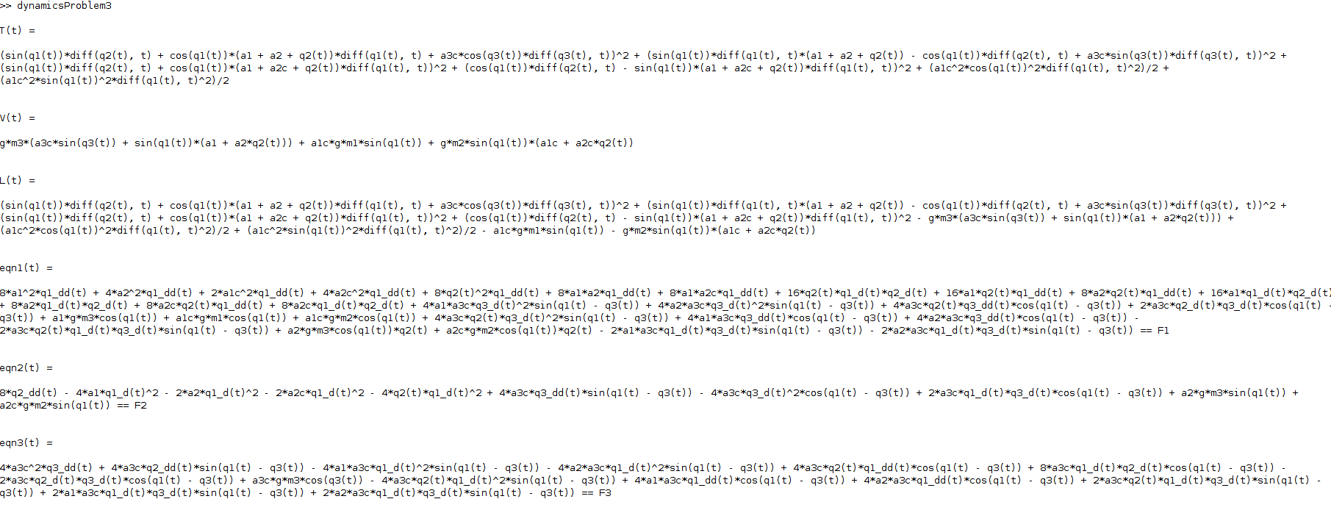
Approach 2

%%%%%%%%%%%%%%%%%%%%%%%%%%%%%%%%%%%%%%%%%%%%%%%%%%%%%%%%%%%%%%%%%%%%%%
%%%%%%%%%%%%%%%%%%%%%%%%%%%%%%%%%%%%%%%%%%%%%%%%%%%%%%%%%%%%%%%%%%%%%%
% PROBLEM 3
%%%%%%%%%%%%%%%%%%%%%%%%%%%%%%%%%%%%%%%%%%%%%%%%%%%%%%%%%%%%%%%%%%%%%%
%%%%%%%%%%%%%%%%%%%%%%%%%%%%%%%%%%%%%%%%%%%%%%%%%%%%%%%%%%%%%%%%%%%%%%

% This approach uses christoffel symbols and accounts for rotational
% inertia

syms I1_xx I1_xy I1_xz I1_yx I1_yy I1_yz I1_zx I1_zy I1_zz
syms I2_xx I2_xy I2_xz I2_yx I2_yy I2_yz I2_zx I2_zy I2_zz
syms I3_xx I3_xy I3_xz I3_yx I3_yy I3_yz I3_zx I3_zy I3_zz

syms m1 m2 m3 g F1 F2 F3
syms q1(t) q2(t) q3(t) q1_d(t) q1_dd(t) q2_d(t) q2_dd(t) q3_d(t) q3_dd(t)
syms a1c a2c a3c a1 a2 a3

%%%%%%%%%%%%%%%%%%%%%%
% Symbol definitions
%%%%%%%%%%%%%%%%%%%%%%
% q(t) - Represents generalized coordinates
% F - Represents generalized force or torque
% m - Represents mass of links
% q_d(t) - Represents derivative of q wrt to t
% q_dd(t)- Represents second derivative of q wrt to t
% r - Position of COM wrt to inertial(world) frame
% a's - robot link parameters
% I - Rotational Inertia from links with respect to inertial frame

I1 = [I1_xx I1_xy I1_xz;
I1_yx I1_yy I1_yz;
I1_zx I1_zy I1_zz];

I2 = [I2_xx I2_xy I2_xz;
I2_yx I2_yy I2_yz;
I2_zx I2_zy I2_zz];

I3 = [I3_xx I3_xy I3_xz;
I3_yx I3_yy I3_yz;
I3_zx I3_zy I3_zz];

Jvc1 = [-a1c*sin(q1) 0 0;
a1c*cos(q1) 0 0;
0 0 0];

Jvc2 = [-sin(q1)*(a1+q2+a2c) cos(q1) 0;
cos(q1)*(a1+q2+a2c) sin(q1) 0;
0 0 0];

Jvc3 = [-sin(q1)*(a1+q2+a2) cos(q1) -a3c*sin(q3);
cos(q1)*(a1+q2+a2) sin(q1) a3c*cos(q3);
0 0 0];

Jw1 = [0 0 0;
0 0 0;
1 0 0];

Jw2 = [0 0 0;
0 0 0;
0 0 0];

Jw3 = [ 0 0 0;
0 0 0;
1 0 1];

D = m1*transpose(Jvc1)*Jvc1 + m2*transpose(Jvc2)*Jvc2 ...
+ m3*transpose(Jvc3)*Jvc3 + transpose(Jw1)*I1*Jw1 ...
+ transpose(Jw2)*I2*Jw2 + transpose(Jw3)*I3*Jw3 ;
D = simplify(D); % inertia matrix

P = m1*g*a1c*sin(q1) + m2*g*(a1+q2+a2c)*sin(q1) ...
+ m3*g*((a1+q2+a2)*sin(q1) + a3c*sin(q3));

q = [q1; q2; q3];

Dmat = D(t); %This is necessary to index values of D
qmat = q(t); %This is necessary to index values of q

syms C [3 3 3]; %Christofel Symbols is a 3x3x3 matrix

%calculation christofell symbols
for i = 1:3
for j = 1:3
for k= 1:3
C(i,j,k) = functionalDerivative(Dmat(k,j),qmat(j)) ...
+ functionalDerivative(Dmat(k,i),qmat(i)) ...
- functionalDerivative(Dmat(i,j),qmat(k));
C(i,j,k) = sym(1)/2 * C(i,j,k);
end
end
end

C = simplify(C);

syms dP [3 1]; %derivate of potential energy wrt q's

for i = 1:3
dP(i)= functionalDerivative(P,qmat(i));
end

%%%%%%%%%%%%%%%%%%%%%%%%%%%%%%%%%%%%%%%%%%%%%%%%%%%%%%
% Printing values
%%%%%%%%%%%%%%%%%%%%%%%%%%%%%%%%%%%%%%%%%%%%%%%%%%%%%%
D
C
dP

Output

