**Open Source Message Switch**

**Business Process Description Document**

**Version 1.0.0**

**By: SEARCH**

**August 2017**

Table of Contents

1. Business Process Description 2

1.1 Purpose 2

1.2 Scope 2

1.3 Description 2

2. Business Scenario 3

2.1 Primary Flow 3

2.2 Business Process Flow Diagram 3

2.3 High-level Functional Diagram 4

3. Service Interaction Process Model 5

4. GRA Service Specification Package (SPP) References 7

5. IEPD References 7

Appendix A —References 8

Appendix B—Glossary 9

Appendix C—Document History 10

# Business Process Description

## Purpose

The purpose of a law enforcement message switch is to link together multiple specialized computer systems to provide law enforcement access to information required to identify people and property, request and receive warrant, arrest, criminal history and hot file information. The key business function of the message switch is to allow authorized users to interact with multiple state and national law enforcement data systems to query and retrieve sensitive criminal justice and law enforcement information.

## Scope

The scope of this business process document is to identify the primary exchanges required by the message switch to ensure law enforcement can query and receive critical information. This document focuses on the exchanges between the message switch and the client software. The exchanges with the national and state systems are defined by each system; therefore, they are not discussed in detail in this document.

## Description

The message switch process supports the exchange of law enforcement and criminal justice information. It allows users to access information – through client software, records management systems, and mobile devices - from a variety of systems, including:

* FBI National Crime Information Center (NCIC)
  + Query Vehicle (QV)
  + Query Person (QW)
  + Query Wanted Person (QW)
  + Gun Query (QG)
  + Article Query (QA)
* Nlets (The International Justice and Public Safety Network)
  + Vehicle Registration Query (RQ)
  + Commercial Vehicle Status (AVQ)
  + Interpol Vehicle Query (IVQ)
  + Drivers License Query (DQ)
  + Interpol Person Query (IPQ)
  + Interpol Gun Query (IGQ)
  + Canadian Gun Query (CGQ)
* National Weather Service (NWS)
* State Motor Vehicle Systems (DMV)
* State Computerized Criminal History Systems (CCH)
* III Criminal History (NCIC)
* State Hot Files (e.g. Instate wanted persons, protection orders, concealed carry permits, etc.)
* Other (e.g. Sex Offender Registry, watch lists, etc.)

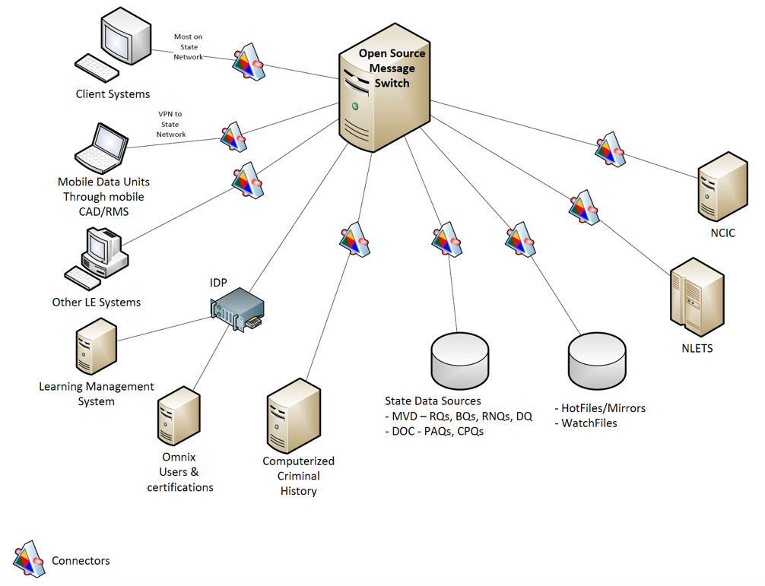

Figure 1: OSMS Conceptual Diagram

# Business Scenario

## Primary Flow

An example primary flow is that a law enforcement officer performs a traffic stop, the officer receives the driver license and registration from the driver. The officer utilizes the information provided to query for additional information related to the person and vehicle. The officer enters provided information on the data terminal in the officer’s car, the client software on the data terminal creates a query request with the data entered, sending the request to the message switch. The message switch validates the user then creates messages to NCIC, Nlets, State motor vehicle and driver records, State hot files, and State criminal history requesting any information from those sources related to the driver and vehicle. When the message switch receives information or not found messages from the data sources, it returns the information to the client software.

## Business Process Flow Diagram



Figure 2 – Business Process Flow Diagram

## High-level Functional Diagram



Figure 3 – Message Switch High-level Functional Diagram

# Service Interaction Process Model

|  |  |  |
| --- | --- | --- |
| Entity | Exchanges and Processing | Entity |
| Querying Entity | * Send query message to message switch * Receive query results from message switch | Law Enforcement Agencies |
| Message Switch | * Receive a query message * Format query messages for each source * Send query message to each source * Receive results from each source * Send results to client | State CJIS |
| Source Entity   * NCIC * Nlets * State Hot files * Vehicles * Drivers * CCH | * Receive query from message switch in format determined by each source * Send results to message switch in format determined by each source | FBI, Nlets, MVD, CJIS |

Table 1 – Service Interaction Process

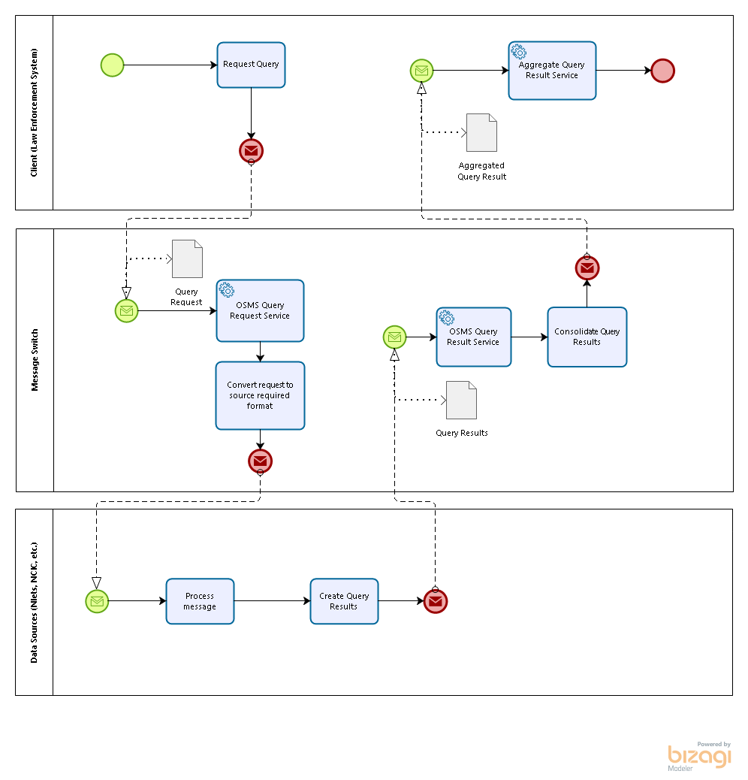

Figure 4 –Message Switch Services

|  |  |  |  |  |  |  |  |
| --- | --- | --- | --- | --- | --- | --- | --- |
| **Business Process** | **Interaction Flow Type** | **Service** | **Consumer Entity** | **Provider Entity** | **Action** | **Message** | **Document (NIEM Exchange Document)** |
|  |  |  |  |  |  |  |  |
| Open Source Message Switch | Query-Driven | OSMS Query Request Service* | Local Law Enforcement | OSMS | Request Query | Query Request | Query Request* |
| Query-Driven | OSMS Query Result Service | Data Sources (Nlets, NCIC, etc.) | OSMS | Report Query Results | Query Results | Query Results** |
| Query-Driven | Aggregate Query Result Service | Intermediary | Client Software | Report Aggregated Query Results | Aggregated Query Results | Aggregated Query Results |

* Note: There may be separate services for different types of messages – also different IEPD’s. The message switch may also spawn queries to data sources based on information entered in the query message.

** Note: The results may be formatted based on rules from the data source.

Table 2 – Message Switch Services

# GRA Service Specification Package (SPP) References

* OSMS_Initial_Query_Request_Service_SSP_v_1.0.0
* OSMS_Initial_Query_Result_Service_SSP_v_1.0.0
* OSMS_Aggregate_Query_Result_Service_SSP_v_1.0.0

# IEPD References

IEPDs used for the services referenced in this document are the same as those contained in the SSPs referenced in section 4 of this document. Additional references are included in Appendix A.

Appendix A —References

| *Nlets message structure* | <http://wiki.nlets.org/index.php/Section_03:_Message_Structure#NIEM_Message_Structure> |
| --- | --- |
| *Standard*  *Rap Sheet* | [*https://it.ojp.gov/NISS/iepd/402*](https://it.ojp.gov/NISS/iepd/402) |
| *Driver Name Search* | [*https://niem.gtri.gatech.edu/niemtools/iepdt/display/container.iepd?ref=g3oAo%2F%2BHUeI%3D*](https://niem.gtri.gatech.edu/niemtools/iepdt/display/container.iepd?ref=g3oAo%2F%2BHUeI%3D) |
|  |  |

Appendix B—Glossary

|  |  |
| --- | --- |
|  |  |
|  |  |

Appendix C—Document History

|  |  |  |  |
| --- | --- | --- | --- |
| **Date** | **Version** | **Editor** | **Change** |
| 8/15/17 | 0.1.0 | M. Jacobson (SEARCH) | First Draft |
|  |  |  |  |
|  |  |  |  |
|  |  |  |  |