HSP Gruppe –B3

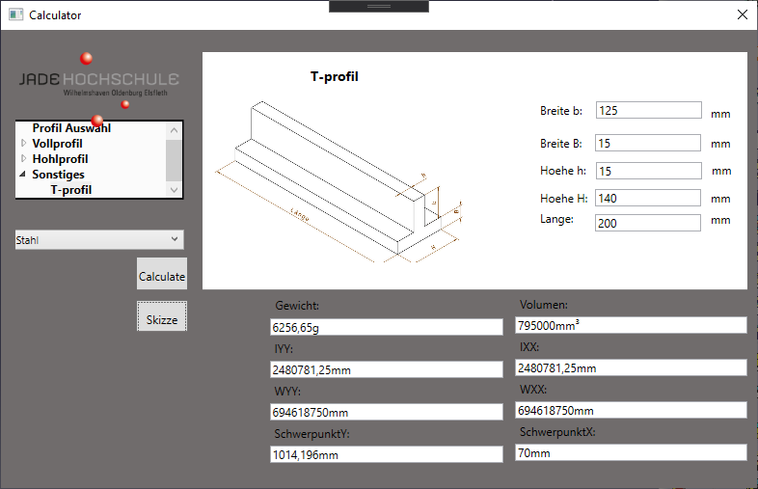

**Objective: Our objective as programmers is to provide the consumer with a functional program which not only meets customer standards, but also accessibility to future improvements.**

***The best way to make the consumers happy is to go far and beyond and exceed expectations***

**Challenges Faced during programming:**

* Object orientation
* Time constraint
* Profile measurements
* Geometric Variable CATIA modelling

**Solutions to every challenge:**

* Strick formatted naming system and guideline
* Work allocation based on requirements
* Layout in XAML and Connections to be in the same pattern

**Contact Details:**

Thomas Kasper ([thomas.kasper@student.jade-hs.de](mailto:thomas.kasper@student.jade-hs.de))

Mohamed Ibrahim ([mohamed.ibrahim@student-hs.de](mailto:mohamed.ibrahim@student-hs.de))

Niko Budelmann ([niko.budelmann@student.jade-hs.de](mailto:niko.budelmann@student.jade-hs.de))

Dominik Berndt ([dominik.berndt.1@student.jade-hs.de](mailto:dominik.berndt.1@student.jade-hs.de))