Report on analyzing the current state of the legal cartography of watercourses in France

# Metadata

There are 91 unique networks for mainland France, for a total of 2,159,284 individual watercourse segments. After removing invalid and duplicate geometries, there remain 2,142,920 individual segments in the compiled dataset.

We obtained 64 datasets directly online and 26 from requests to the DDTs.

Most layers that are available online are regularly updated following yearly, or semestral meetings to integrate re-classification requests, as shown by the distribution of “revision date” provided in the online metadata associated with the layers (n=55/94 departments):

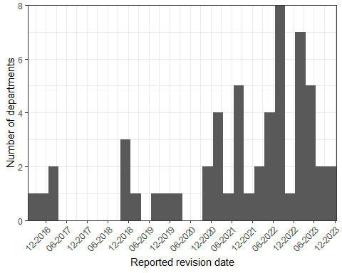

The attributes associated with the data were varied, with rlength(unique(ddtnets_attris$V1))unique attribute names across all networks. On average, the networks includedNAattributes (min-max:1-rmax(ddtnets_attris_n). These attributes were more or less common to the various networks. After removing formatting differences (different uses of caps and spaces), any two pair of network hadr round(attrimatches_pairwise_avg, 2) attributes in common, on average.

In its guidelines to DDT in 2015, the ONEMA proposed that a minimum set of standardized fields be used by DDTs:

* TYPE_ECOUL - Type d’écoulement: Cours d’eau, Indéterminé, Non cours d’eau, Inexistant
* NAT_IDENT - Méthode d’identification de l’écoulement: Analyse cartographique, Terrain, Décision de justice
* DATE_IDENT - Date de l’identification du type d’écoulement par les experts concernés
* ORIG_MODIF - Source de la modification, de la suppression du tronçon BD TOPO®, ou de l’ajout d’un nouveau tronçon: e.g., Levé GPS BDCarthage SCAN25 BDORTHO BDPARCELLAIRE CARTE d’étatmajor Cadastre napoléonien Atlas ancien Autre
* CODE_HYDRO - Code générique du cours d’eau (identifiant pour la codification hydrographique) A reporter depuis la BD CARTHAGE® si le tronçon correspond à un cours d’eau codifié
* AUTEUR - Service qui a effectué la modification (ex : SPE55)

The following attributes are the most common in the networks:

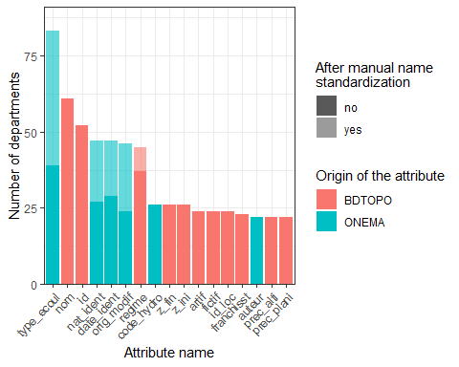

DDTs were supposed to use the BD TOPO (TRONCON_COURS_EAU), v 15.1 (2015) as the hydrographic foundation to build their cartography (to be completed – look for individual departments for which this information is still not available). Double check website and only cartography + search the internet?

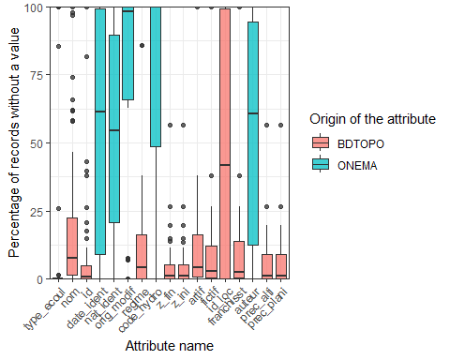

Even for a given attribute, there was substantial variability. For the attribute describing the status of the hydrographic segments under water law, there are 5 possible categories: watercourse, not watercourse, undetermined, inexistant and outside of the department.

Nonetheless, there were a total of 139 unique categories for this attribute across the networks (including typos), for an average of 3.8 per network. The hydrographic segments that were considered not to qualify as a watercourse were provided for 1 of departments.

# Drainage density