**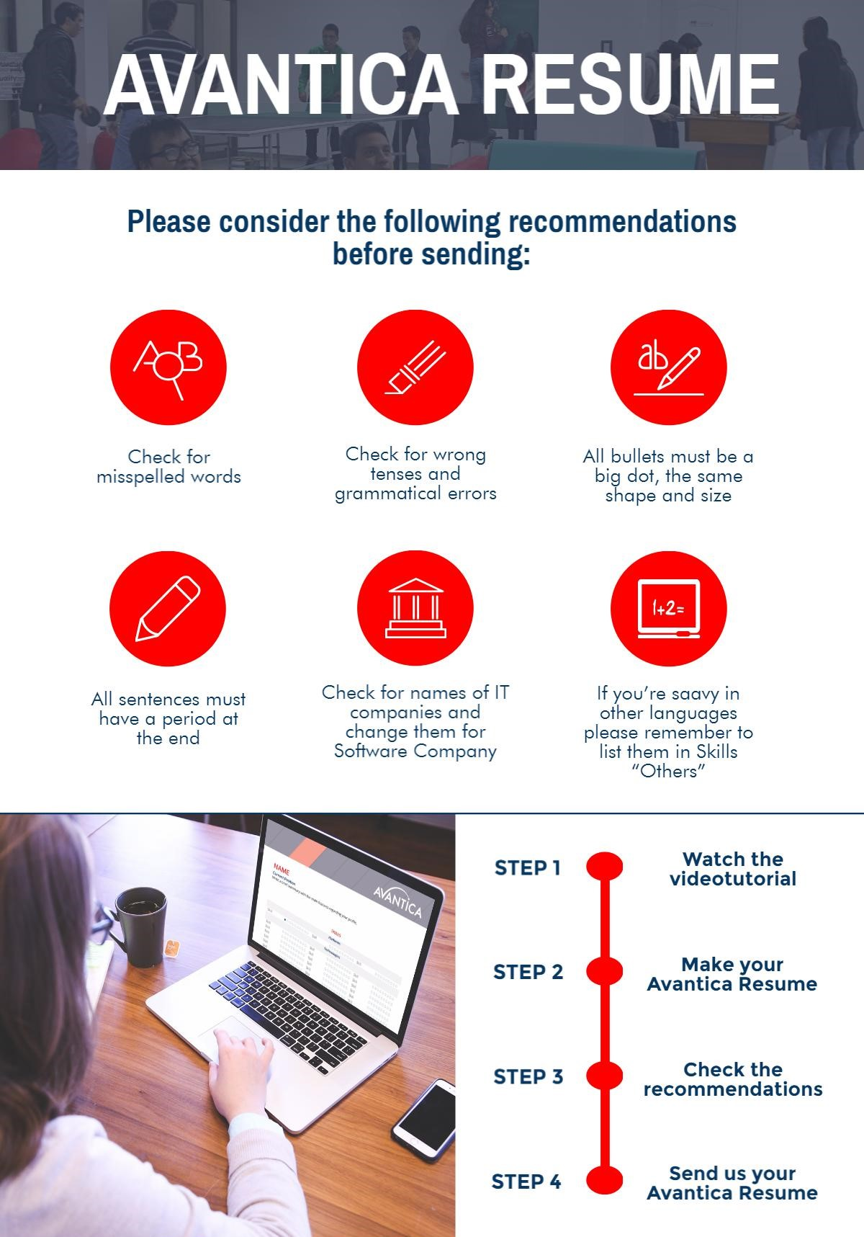**

**Alejandro Quesada Vega**

**Senior QA Engineer**

### QA Engineer with strong knowledge, research, and testing skills, over four years in software quality assurance experience with emphasis on Functional and Performance automation tasks. include research, fast learning, goal achievement focus, teamwork and self-motivation.

# SKILLS

|  |  |  |  |  |  |  |  |  |
| --- | --- | --- | --- | --- | --- | --- | --- | --- |
| = Basic | = Pre-Intermediate | | = Intermediate | | = Pre-Advanced | | = Advanced | |
| **Platforms** | | | | | | | | |
| Windows |  | Skill | |  | | Skill | |  |
| **Technologies** | | | | | | | | |
| Test link |  | MS Project | |  | | Skill | |  |
| Jira |  | Skill | |  | | Skill | |  |
| Java |  | Skill | |  | | Skill | |  |
| .Net |  | Skill | |  | | Skill | |  |
| Jmeter |  | Skill | |  | | Skill | |  |
| Selenium |  | Skill | |  | | Skill | |  |
| **Databases** | | | | | | | | |
| SQL Server |  | MySQL | |  | | Oracle | |  |
| **Others** | | | | | | | | |
| SVN |  | Skill | |  | | Skill | |  |
| Git |  | Skill | |  | | Skill | |  |
| Jenkins |  | Skill | |  | | Skill | |  |
| **Soft Skills** | | | | | | | | |
| **Team work, Leadership (explicar los skills)** | | | | | | | | |

# WORK EXPERIENCE

|  |  |
| --- | --- |
| **AVANTICA TECHNOLOGIES**  **Senior QA** | **San Jose, Costa Rica**  **(March 2014 - October 2016)** |

### Avantica is a software development company with over 20 years of experience.

### During this time I participated in the following projects:

* **Project: Connecture-Performance (March 14** – **August 16)**

This project main purpose was to create and execute performance scripts to test the “Connecture” application to its multiple clients.

Main tasks executed in the project:

* Creation and execution of Jmeter load scripts.
* Results gathering and overall analysis.

|  |  |
| --- | --- |
| **Prodigious Latin America.**  **QA II** | **Alajuela, Costa Rica**  **(May 2013 - February 2014)** |

### The company is known for being a Digital agency, partner with Publicis Group.

### During this time I participated in the following projects:

* **Project: Rosetta (May 2013 - February 2014)**

The project was an e-commerce CRM implemented with Websphere.

Main tasks executed in the project:

* Functional and creative testing
* Bug reporting

|  |  |
| --- | --- |
| **Growth Acceleration Partners**  **QA I** | **San Jose, Costa Rica**  **(January 2012 - May 2013)** |

### Growth acceleration partners is an agile software development company with their headquarters located at Austin, Texas.

### During this time I participated in the following projects:

* **Project: Mobile Department (January 2012 - July 2012)**

There were multiple mobile projects.

Main tasks executed in the project:

* Test case creation, mobile testing, bug reporting, bug verification, regression testing etc.
* **Project: Manticore (July 2012 - May 2013)**

The project was a CRM were the team needed to automate the functional test cases.

Main tasks executed in the project:

* Functional automation using selenium and ASP of the existing test cases

# EDUCATION

|  |  |  |  |
| --- | --- | --- | --- |
| 2003 – 2008 | Bachelor | Liceo de Escazú | Website with hiperlink |
| 2009 – 2016 | Currently | Universidad Latina de Costa Rica | Website with hiperlink |
| Start date – Last date. | Certification | Academic Institute | Website with hiperlink |

# LANGUAGES

|  |  |  |
| --- | --- | --- |
| **Spanish:** Native | **English:** Advanced | Other Language**:** Choose an item |

# HOBBIES

|  |  |  |
| --- | --- | --- |
| Write your hobbie | Write your hobbie | Write your hobbie |

**About Avantica:**

*[C:\Users\ronald.huari\Desktop\Logo_twitter_wordmark_1000.png](https://twitter.com/avantica)[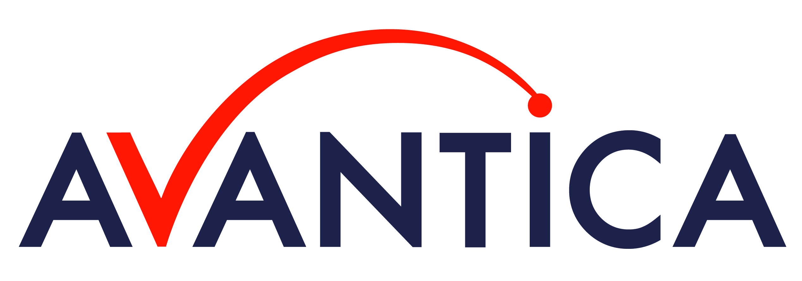](http://www.avantica.net/)[C:\Users\ronald.huari\Desktop\GD_logo_Green-2.png](https://www.glassdoor.com/Reviews/Avantica-Technologies-Reviews-E221725.htm)[C:\Users\ronald.huari\Desktop\Facebook_logo.png](https://www.facebook.com/AvanticaTechnologies/)[](https://www.youtube.com/watch?v=xb2uQ8TU5-0)[C:\Users\ronald.huari\Desktop\LinkedIn_Logo.svg.png](https://www.linkedin.com/company/avantica-technologies?trk=top_nav_home)Avantica specializes in providing software engineering services with a Nearshore advantage especially well-suited to established and start-up software companies, and industry. We’ve been headquartered in Silicon Valley for over 20 years, and have engineering centers in Latin America (Costa Rica, Peru). The Avantica model is highly collaborative, Agile, English language, same U.S. time-zone, immediately available engineering resources, economical and quality engineering across the Product Development Lifecycle.*