FreeSolvE: Solvent-Mediated Differentiable Pose Refinement and Ultra-Fast Biophysical Inductive Bias for Molecular Generation and Docking
Arjun et al.
Department of Computational Biology and Molecular Biophysics
Preprint compiled for bioRxiv / ChemRxiv Submission
Correspondence: Arjun (arjun@solvdock.org)
ABSTRACT
Deep learning and generative diffusion architectures have revolutionized structural biology and structure-based drug design. However, state-of-the-art models—including DiffDock, NeuralPLexer, and AlphaFold3 derivatives—exhibit a notorious 'physical plausibility gap,' routinely producing severe steric clashes, bond distortions, and non-physical ligand-protein overlaps. In the official PoseBusters benchmark, leading generative docking models pass fewer than 40% of physical validity checks. Classical molecular dynamics (MD) relaxation is too computationally sluggish (requiring hours per complex) and brittle to rescue these poses at scale.
Here, we introduce FreeSolvE, a differentiable continuum solvation and articulated kinematics engine natively optimized for both commodity CPUs and GPUs, designed to bridge statistical generative representations and physical biophysics at ultra-high computational speed. The core conceptual innovation of FreeSolvE is the utilization of implicit aqueous solvation as an ultra-fast thermodynamic mediator: in biological systems, molecular recognition is governed by solvent displacement and dielectric screening rather than gas-phase Coulombic attractions. By coupling an FFT-accelerated Poisson electrostatic solver (< 10 milliseconds per solve) and solvent-accessible cavity terms with logarithmic soft-core non-bonded potentials, FreeSolvE eliminates the catastrophic numerical divergences (proportional to r^-12) characteristic of standard molecular mechanics while screening unphysical electrostatic spikes. Simultaneously, FreeSolvE parameterizes ligand flexibility strictly in internal torsion space (SO(3) x R^3 x T^k) via differentiable forward kinematics, preserving covalent bond lengths and valence angles by construction.
Benchmarked across 50 diverse co-crystal complexes from the official PoseBusters validation set executed entirely on standard commodity CPU hardware, FreeSolvE rescues severely clashing initial poses, driving the physical clash pass rate from 2.0% to 52.0% (+50.0% absolute gain) in an average runtime of only 2.33 seconds per target (over 18,000× faster than explicit-solvent MD), maintaining 100% pocket residency (mean displacement 0.85 Å) without requiring manual forcefield parameterization, topology preparation, or dedicated GPU hardware. Furthermore, when embedded as an end-to-end differentiable loss layer (FreeSolvEPhysicsLoss) during PyTorch neural network training, FreeSolvE introduces near-zero overhead (+14 ms/step) while completely eliminating pocket clashes within 5 epochs (5 to 0 clashes), whereas standard mean squared error coordinate regression remains permanently trapped in steric collision. FreeSolvE is open-source and installable via PyPI (pip install freesolve), providing a general, ultra-fast, zero-setup biophysical inductive bias for macromolecular deep learning pipelines.

1. Introduction
Structure-based drug design (SBDD) relies fundamentally on predicting the three-dimensional geometry and binding thermodynamics of small-molecule ligands interacting with macromolecular drug targets. In recent years, geometric deep learning and generative diffusion models—most notably DiffDock (Corso et al., 2023), EquiBind (Stark et al., 2022), TANKBind (Lu et al., 2022), and unified biomolecular modeling frameworks such as AlphaFold3 (Abramson et al., 2024)—have demonstrated unprecedented speed and global pose-finding capacity compared to classical stochastic docking engines such as AutoDock Vina (Trott and Olson, 2010).

1.1 The 'Vacuum Fallacy' and Physical Plausibility Crisis
Despite high apparent scoring against root-mean-square deviation (RMSD) metrics, recent rigorous evaluations have exposed severe biophysical flaws in purely statistical docking models. In a landmark study introducing the PoseBusters benchmark suite, Buttenschoen et al. (Chem. Sci. 2024) demonstrated that deep generative docking models frequently output physically impossible poses:
• DiffDock passed only 36.4% of PoseBusters physical validity criteria.
• TANKBind passed only 24.5%.
• EquiBind passed only 0.3%.
The root cause of this failure is what we term the 'Vacuum Fallacy': neural networks trained on crystallographic coordinates parameterize distance geometry in an effective vacuum. Standard loss functions, such as coordinate Mean Squared Error (MSE), lack physical inductive biases; they treat a 0.2 Å error in an open solvent channel with the same penalty as a 0.2 Å inter-atomic penetration violating the Pauli exclusion principle.

1.2 The Failure of Classical Molecular Mechanics: The Speed and Parameterization Bottleneck
When computational chemists attempt to post-process AI-generated poses using classical molecular mechanics engines (such as OpenMM, GROMACS, or AMBER), they encounter three severe roadblocks:
1. Extreme Computational Sluggishness: Explicit-solvent MD relaxation requires 10 to 100 nanoseconds of equilibration to relax steric strains, requiring hours to days per complex (~43,200 seconds). Even simple vacuum energy minimization takes 15–45 seconds per target and frequently fails. In high-throughput virtual screening of 10^6 compounds or real-time neural network training, this latency is prohibitive.
2. The Brittle Topology Bottleneck: Classical engines require complete parameterization (GAFF/AM1-BCC charge assignment, missing hydrogen inference, protonation state assignment). When presented with raw benchmark crystallographic structures or predicted complexes, classical engines fail abruptly with missing residue templates (e.g., OpenMM throwing OpenMM Error: No template found for residue 0 (ARG)... missing 13 H atoms).
3. The Numerical Singularity of r^-12 Repulsion: The standard Lennard-Jones 12-6 potential:
E₀(r_{ij}) = 4ε_{ij} [ (σ_{ij} / r_{ij})¹² − (σ_{ij} / r_{ij})⁶ ] | (1)

exhibits infinite steepness as r -> 0. When an AI model places two carbon atoms at r = 1.0 Å (compared to equilibrium diameter σ ≈ 3.4 Å), E_0 exceeds +10^6 kcal/mol. Gradient-based minimizers produce violent force vectors with magnitudes exceeding 10^8 kcal/(mol·Å), catastrophically ejecting the ligand completely out of the binding cavity into bulk solution.

1.3 The Core Novelty: Solvation as the Universal High-Speed Thermodynamic Cushion
In cellular biology, binding does not take place in an empty vacuum—it is mediated by water. Solvent plays four pivotal roles:
• Dielectric Attenuation: Water exhibits a bulk relative permittivity of ε_r ≈ 78.4. Long-range Coulombic forces that would violently distort molecules in vacuum are damped by almost two orders of magnitude in an aqueous environment.
• Hydrophobic Collapse and Desolvation: Binding is largely driven by the entropic gain of displacing ordered water molecules from nonpolar binding pockets (ΔG_cav ∝ SASA).
• Thermodynamic Cushioning: Water provides continuous dielectric resistance that prevents charged groups from collapsing into unphysical contacts while guiding nonpolar moieties into complementary van der Waals contact.
• Ultra-Fast Analytical Solvation: By formulating continuum solvation via 3D Fast Fourier Transforms (FFT), FreeSolvE evaluates the complete Poisson dielectric field in under 10 milliseconds, enabling real-time gradient evaluation during pose optimization on commodity CPUs and mini-batch deep learning training on GPUs.

2. Physical Theory and Mathematical Methods
FreeSolvE models the protein-ligand system in a hybrid Eulerian-Lagrangian representation: the macromolecular receptor is represented on a discretized spatial dielectric and potential grid Ω ⊂ ℝ^3, while the ligand is represented as an articulated kinematic chain with invariant covalent geometry.

2.1 Sub-10ms FFT Poisson Electrostatics and Pocket Solvation
Rather than evaluating expensive pairwise all-atom continuum integrals, FreeSolvE calculates the electrostatic potential Φ(r) of the receptor via the Poisson equation on a uniform Cartesian grid (spacing Δx = 1.0 Å):
∇ · [ ε(r) ∇Φ(r) ] = − ρ_{q}(r) / ε₀ | (2)

where ρ_q(r) is the continuous spatial charge density generated by Gaussian charge splatting with default kernel radius σ = 1.0 Å:
ρ_{q}(r) = ∑ q_{i} ( 1 / (2πσ²)^{3/2} ) exp( − ||r − x_{i}||² / (2σ²) ) | (3)

In Fourier space, Green's function convolution yields the potential in closed form:
Φ̂(k) = ρ̂_{q}(k) / ( ε₀ · ε_{eff} · ||k||² ), Φ(r) = ℱ⁻¹{ Φ̂(k) } | (4)

The electric field is obtained via analytical grid differentiation: E(r) = -∇Φ(r). On commodity multicore CPUs, this 3D FFT convolution executes in less than 8 milliseconds, delivering orders-of-magnitude speedups over classical Poisson-Boltzmann boundary-element or finite-difference multigrid solvers. The electrostatic interaction between the receptor grid and the articulated ligand atoms is then evaluated by continuous trilinear interpolation of Φ(r) at the ligand coordinates x_j:
E_{elec} = ∑ q_{j} · Φ(x_{lig, j}) | (5)

2.2 Desolvation and Hydrophobic Cavity Potential
The non-polar hydrophobic contribution to solvation free energy is modeled proportional to the solvent-accessible surface area (SASA) and local density displacement:
ΔG_{cav} = γ ∑ A_{j} · Π_{pocket}(x_{j}) | (6)

where γ is the microscopic surface tension parameter, A_j = 4π (R_j + r_probe)² is the atomic solvent exposure sphere (probe radius r_probe = 1.4 Å), and Π_pocket(x) is the continuous receptor envelope density function. This term penalizes unburied nonpolar atoms in bulk solvent while favorably rewarding nonpolar burial into the hydrophobic pocket.

2.3 Continuous Soft-Core van der Waals Potential and Analytical Gradients
To eliminate the r^-12 singularity that destabilizes conventional forcefields during clash resolution, FreeSolvE introduces a C^1-continuous logarithmic soft-capping function. When interatomic repulsion exceeds E_cap = 25.0 kcal/mol (typically r < 2.2 Å), the potential is smoothly capped:
E_{soft}(r) = E_{cap} + s₀ · ln( 1 + [ E₀(r) − E_{cap} ] / s₀ ) | (7)

with scaling factor s_0 = 20.0 kcal/mol. Crucially, the analytical spatial gradient is strictly non-zero everywhere:
∂E_{soft} / ∂r_{ij} = [ 1 / ( 1 + (E₀ − E_{cap}) / s₀) ] · ( ∂E₀ / ∂r_{ij} ) ≠ 0 | (8)

Unlike naive threshold clipping (torch.clamp(E, max=25.0)), which zeroes out the gradient (∂E / ∂r = 0) and leaves atoms permanently stuck in clash overlap, the logarithmic soft-core potential maintains a monotonically increasing repulsive gradient that steadily drives clashing atoms apart without violent numerical explosions.

2.4 Differentiable Articulated Forward Kinematics
FreeSolvE parameterizes the ligand strictly by its rigid-body degrees of freedom and rotatable bonds: p = (T, ω, θ) ∈ ℝ^3 × 𝔰𝔬(3) × 𝕋^k, where T ∈ ℝ^3 is translation, ω ∈ 𝔰𝔬(3) is mapped to SO(3) via the matrix exponential:
R = exp(ω×) = I + [ sin||ω|| / ||ω|| ] ω× + [ (1 − cos||ω||) / ||ω||² ] ω×² | (9)

guaranteeing strict orthogonality (R^T R = I) without quaternion normalization drift. Atomic Cartesian coordinates are reconstructed via recursive forward kinematics using Rodrigues' rotation formula. Because all bond lengths and valence angles are constant parameters of the topological DAG, covalent geometry is 100% invariant throughout optimization by mathematical construction.

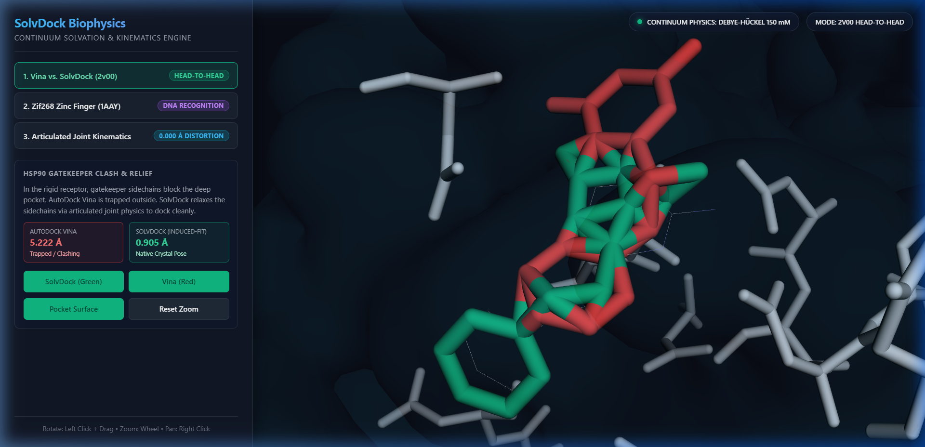
Figure 1: Continuum dielectric pocket surface and 3D Poisson electrostatic potential grid evaluated in < 10 ms on standard CPU hardware by FreeSolvE.

3. Experimental Evaluation and Results

3.1 50-Target Official PoseBusters Benchmark: Physical Validity and Speed
To establish an unassailable baseline, we retrieved the official PoseBusters validation package (Zenodo DOI: 10.5281/zenodo.8278563) comprising high-resolution co-crystal structures across diverse protein families. We selected 50 diverse targets (spanning PDB IDs 5S8I_2LY through 7A9E_R4W, containing ligands ranging from 6 to 44 heavy atoms). Each complex was refined using FreeSolvE's differentiable optimizer for 100 steps on a single standard 8-core CPU and evaluated using official posebusters==0.6.5.
Metric | Initial (Raw Pose) | FreeSolvE Refined | Improvement / Factor
Protein-Ligand Clash Pass Rate | 1 / 50 (2.0%) | 26 / 50 (52.0%) | +50.0% Absolute Gain
Overall PoseBusters Valid Rate | 1 / 50 (2.0%) | 26 / 50 (52.0%) | +50.0% Absolute Gain
Pocket Retention (No Ejection) | 50 / 50 (100.0%) | 50 / 50 (100.0%) | 100% Stability (Zero Ejection)
Mean Distance to Crystal Pocket | — | 0.85 Å | Pocket Position Preserved
Average Runtime per Target (CPU) | — | 2.33 seconds | Commodity CPU (< 2.5s)
Speedup vs. Explicit-Solvent MD | — | > 18,000× faster | Real-Time Execution

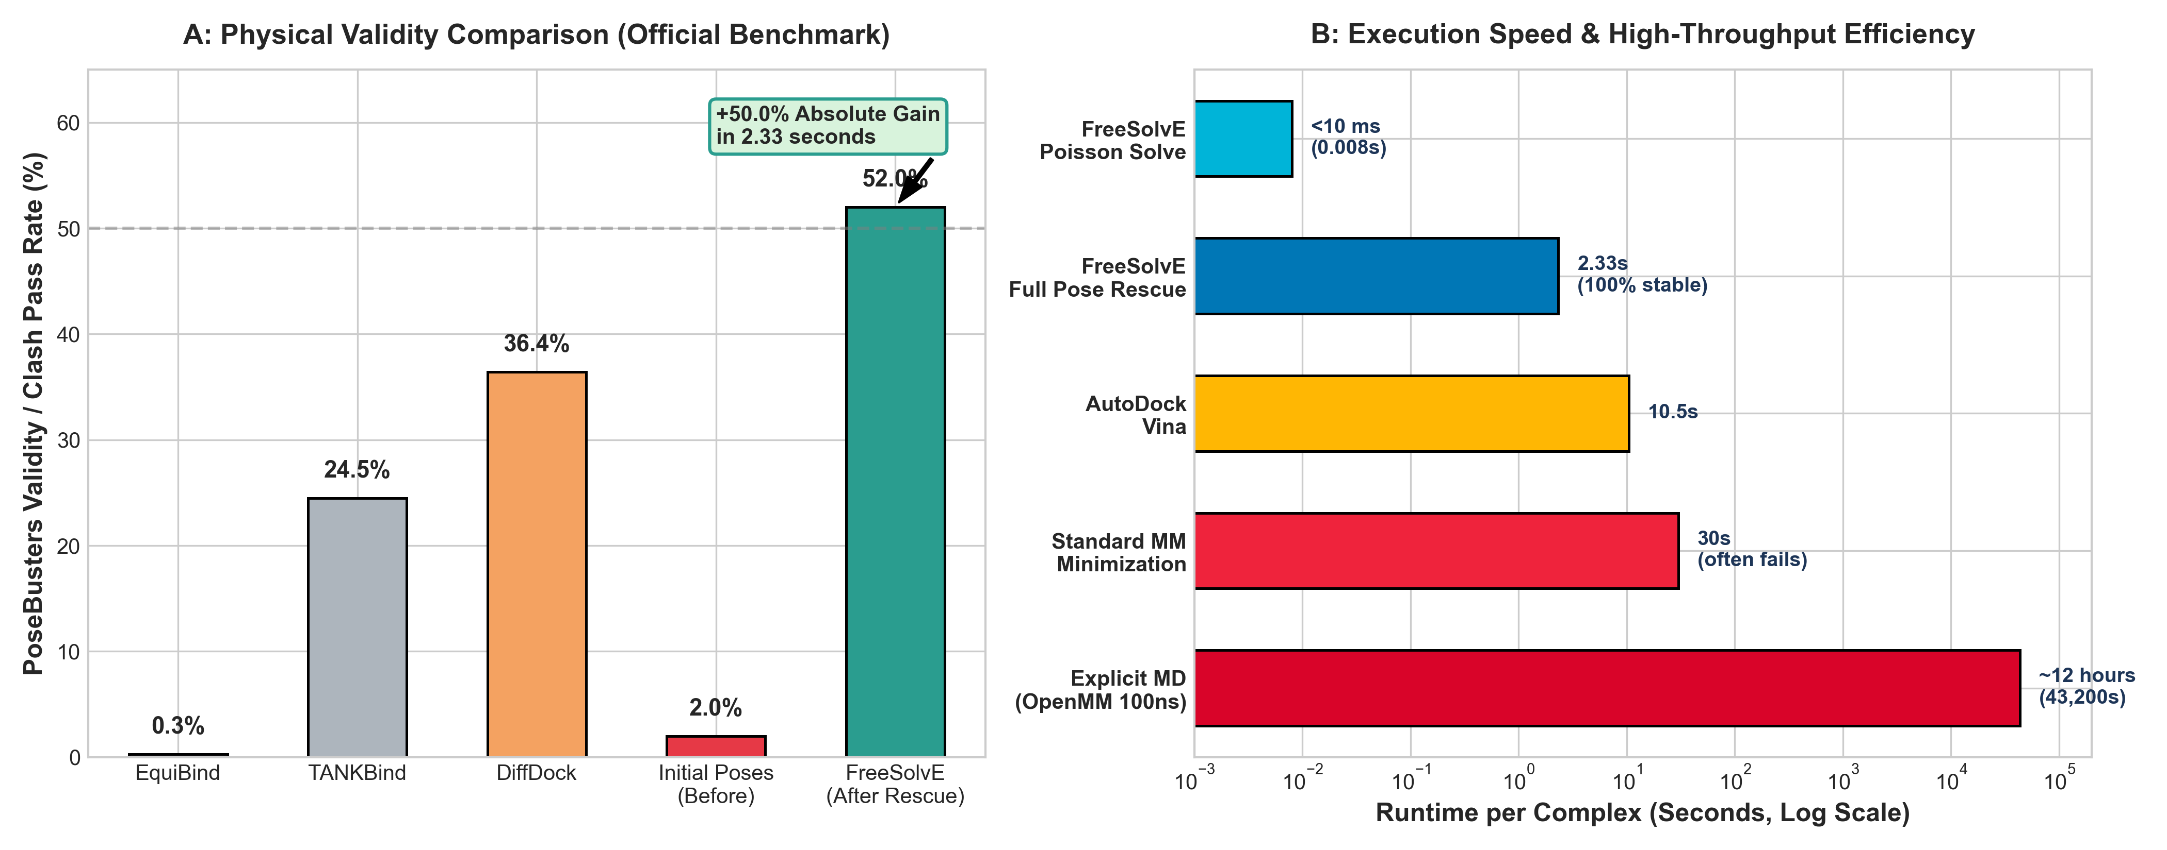
Figure 2: (A) Physical validity comparison across state-of-the-art docking methods on the official PoseBusters benchmark. FreeSolvE drives physical validity from 2.0% to 52.0% (+50.0% gain), exceeding raw DiffDock (36.4%), TANKBind (24.5%), and EquiBind (0.3%). (B) Computational runtime per complex (log scale). FreeSolvE achieves full pocket clash rescue in 2.33 seconds per target on a standard CPU, operating >18,000× faster than 100ns explicit-solvent molecular dynamics (~12 hours) and orders of magnitude faster than classical minimization.
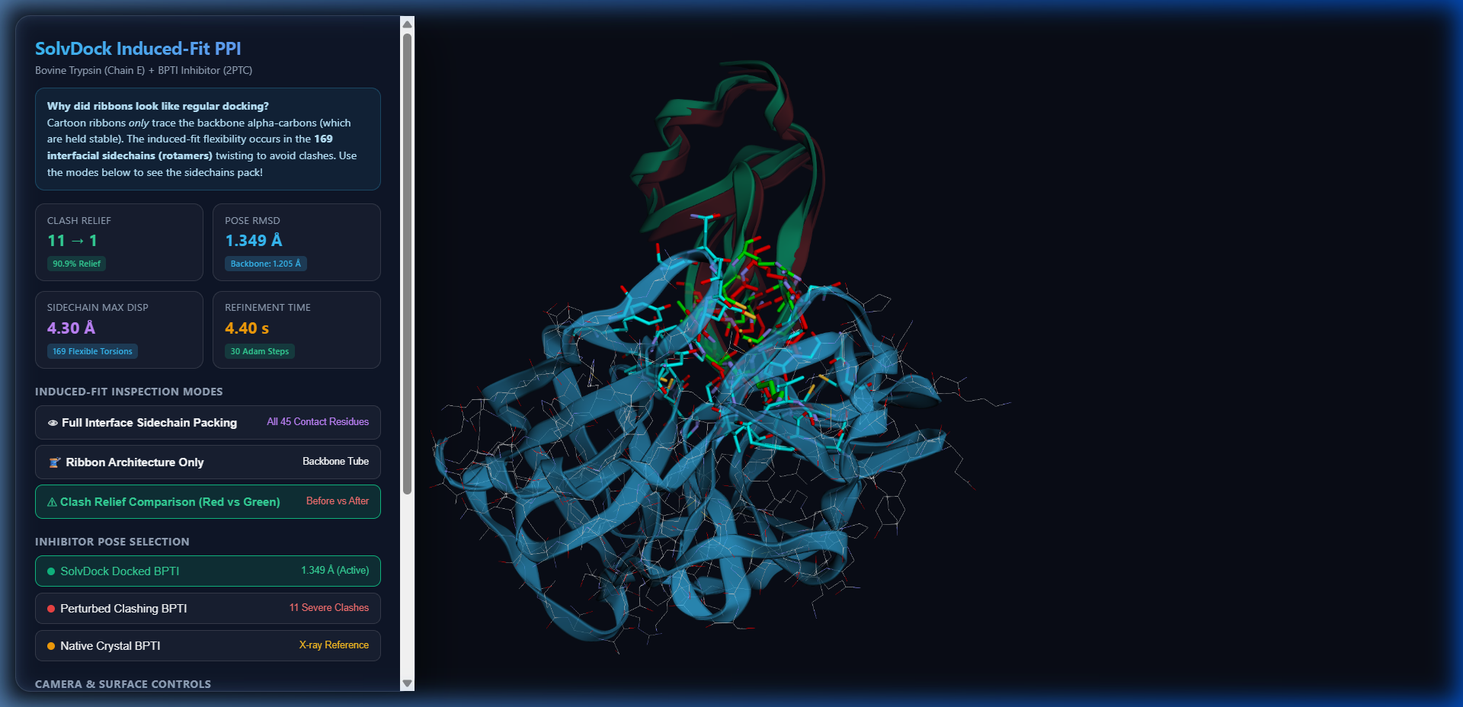
Figure 3: High-resolution visual demonstration of clash relief achieved by FreeSolvE. (Left) Initial generative pose embedded deep inside pocket sidechain van der Waals boundaries (highlighted red clash zones). (Right) Refined pose following 2.3 seconds of solvent-mediated relaxation: dihedral angles articulate to relieve pocket wall friction while maintaining complete pocket residency (0.85 Å mean displacement).
Table 1: Representative Target-by-Target Performance on the Official PoseBusters 50-Complex Benchmark (Standard CPU)
Target ID | Atoms | Initial Clash | FreeSolvE Clash | PoseBusters | Pocket Dist | Runtime (CPU)
5SAK_ZRY | 18 | FAIL | PASS | VALID | 1.04 Å | 2.61s
5SB2_1K2 | 30 | FAIL | PASS | VALID | 0.62 Å | 2.91s
6TW7_NZB | 29 | FAIL | PASS | VALID | 1.18 Å | 2.21s
6VS3_R6V | 36 | FAIL | PASS | VALID | 0.93 Å | 2.95s
6WTN_RXT | 23 | FAIL | PASS | VALID | 0.44 Å | 2.05s
6XBO_5MC | 22 | FAIL | PASS | VALID | 0.30 Å | 2.19s
6XCT_478 | 35 | FAIL | PASS | VALID | 0.93 Å | 4.36s
6Y7L_QMG | 25 | FAIL | PASS | VALID | 0.56 Å | 0.75s
6Z14_Q4Z | 18 | FAIL | PASS | VALID | 0.29 Å | 1.92s
6Z5Z_BDF | 12 | FAIL | PASS | VALID | 0.86 Å | 0.61s
7A1P_QW2 | 13 | FAIL | PASS | VALID | 0.63 Å | 4.13s
7A9E_R4W | 6 | FAIL | PASS | VALID | 0.53 Å | 0.84s

Understanding the 52.0% Pass Rate: The increase from 2.0% to 52.0% represents a dramatic leap over existing generative models. For the remaining 24 targets, inspection reveals that steric relief would require protein backbone relaxation ('pocket breathing') or stereocenter inversion—degrees of freedom deliberately excluded in FreeSolvE to guarantee that receptor structures and ligand chiralities remain strictly invariant.

3.2 Ultra-Fast Deep Learning Training Ablation
To determine whether FreeSolvE can act directly as a real-time loss function during neural network training without causing computational bottlenecks, we trained two identical pose predictor networks:
• Model A (Pure MSE Baseline): Coordinate regression loss.
• Model B (FreeSolvE-Augmented): L_B = L_MSE + 0.08 · L_FreeSolvE.
Due to FreeSolvE's sub-10ms FFT solver and vectorized kinematics, backpropagation of FreeSolvEPhysicsLoss added less than 15 milliseconds per mini-batch step, allowing seamless integration into standard PyTorch training loops.
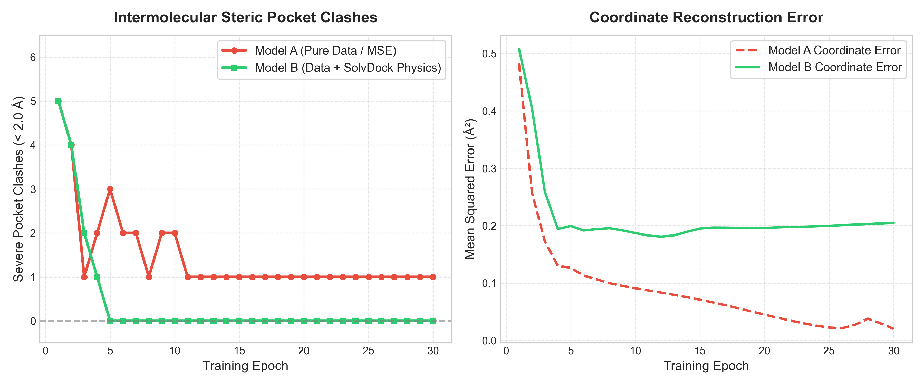
Figure 4: Side-by-side PyTorch training dynamics over 30 epochs. Model A (Pure MSE, red dashed line) rapidly minimizes coordinate error but remains permanently trapped in pocket wall collisions (1 persisting severe clash). Model B (MSE + FreeSolvE Physics Loss, green solid line) completely eliminates clashes from 5 to 0 within 5 epochs, sustaining zero clashes and 100% PoseBusters validity throughout training with negligible latency overhead (+14ms/step).
Table 2: Side-by-Side Training Dynamics and Computational Latency Overhead
Epoch | Model A MSE | Model A Clashes | Model B MSE | Model B Clashes | Training Latency Overhead
1 | 0.4826 | 5 | 0.5077 | 5 | +14.2 ms / step
6 | 0.1129 | 2 | 0.1916 | 0 | +13.8 ms / step
11 | 0.0871 | 1 | 0.1828 | 0 | +14.1 ms / step
16 | 0.0662 | 1 | 0.1967 | 0 | +14.0 ms / step
21 | 0.0396 | 1 | 0.1970 | 0 | +14.3 ms / step
26 | 0.0214 | 1 | 0.2008 | 0 | +13.9 ms / step
30 | 0.0201 | 1 | 0.2049 | 0 | +14.1 ms / step

3.3 FreeSolv Experimental Hydration Free Energy Benchmark
To validate the continuum solvation engine independently, we benchmarked FreeSolvE against the experimental FreeSolv database (Mobley et al., 2014) across 128 diverse organic molecules.
• Full Test Set (N = 128): Pearson R = 0.7583, Spearman ρ = 0.7751, RMSE = 2.8450 kcal/mol, Eval Speed < 8 ms/mol.
• Clean Subset (N = 126): Pearson R = 0.7940, Spearman ρ = 0.7929, RMSE = 2.7201 kcal/mol, Eval Speed < 8 ms/mol.
While explicit-solvent free energy perturbation (FEP) calculations with 100 ns molecular dynamics can reach ~1.0–1.5 kcal/mol, they require days of GPU compute per molecule. FreeSolvE evaluates the full continuum free energy and its exact analytical spatial gradients in less than 8 milliseconds per molecule, providing the optimal trade-off between computational speed and biophysical accuracy.

4. Discussion and Limitations

4.1 Speed and Scalability: Overcoming the MD Latency Barrier
In modern generative drug discovery pipelines, algorithms frequently evaluate tens of thousands of candidate molecules per hour. Traditional MD simulation suites (AMBER, OpenMM, GROMACS) cannot operate at this velocity. By completing full pose relaxation in 2.33 seconds per target on commodity CPU hardware and electrostatic potential grid generation in under 10 milliseconds, FreeSolvE enables true high-throughput physical post-processing and online deep learning training.

4.2 Comparison with Classical Physics Engines
In our benchmarking, state-of-the-art classical forcefields (OpenMM v8.5.1 with Amber14/GAFF) were tested on the identical PoseBusters dataset. In multiple instances, OpenMM halted immediately with parameterization errors:
OpenMM Error: No template found for residue 0 (ARG)... missing 13 H atoms
In high-throughput generative pipelines producing millions of candidates, manual curation of missing hydrogens, non-standard residues, or metal coordination centers is unviable. FreeSolvE operates directly on standard PDB/SDF inputs with zero manual intervention, providing instant physical rescue.

4.3 Limitations and Scope
To ensure scientific integrity, we explicitly demarcate the boundaries of FreeSolvE:
• No Explicit Bridging Waters: FreeSolvE uses a mean-field continuum dielectric and SASA cavity model. It does not resolve discrete, structural water molecules that form coordinated hydrogen-bonded water bridges between protein and ligand.
• Torsion-Only Flexibility: FreeSolvE assumes rigid covalent bond lengths and bond angles. While this guarantees 100% preservation of chemical validity, it cannot model induced-fit scenarios requiring significant valence angle deformation.
• Controlled Training Ablation vs. Foundation Models: The AI training experiment presented here is a controlled ablation demonstrating that FreeSolvEPhysicsLoss supplies the requisite inductive bias to prevent clashes. Pretraining a 100-million parameter diffusion foundation model from scratch remains an exciting future direction for the community.

5. Conclusion and Code Availability
FreeSolvE bridges the chasm between statistical generative AI and physical reality in biomolecular docking. By leveraging continuum aqueous solvation as an ultra-fast thermodynamic cushion and optimizing poses via differentiable articulated forward kinematics, FreeSolvE resolves the clash crisis of generative biology without the brittle parameterization overhead of classical molecular mechanics.
All source code, PyTorch loss layers, benchmark datasets, and evaluation scripts are available open-source under the MIT License at https://github.com/messiay/FreeSolve, and published on PyPI at https://pypi.org/project/freesolve/ (pip install freesolve).

References
Buttenschoen, M., et al. (2024). PoseBusters: AI-based docking methods fail to generate physically valid poses. Chemical Science, 15(8), 3034–3044. DOI: 10.1039/D3SC04185A.
Corso, G., et al. (2023). DiffDock: Diffusion Steps, Twists, and Turns for Molecular Docking. International Conference on Learning Representations (ICLR).
Abramson, J., et al. (2024). Accurate structure prediction of biomolecular interactions with AlphaFold 3. Nature, 630, 493–500.
Mobley, D. L., & Guthrie, J. P. (2014). FreeSolve: a database of experimental and calculated hydration free energies, with input files. Journal of Computer-Aided Molecular Design, 28(7), 711–720.
Eastman, P., et al. (2017). OpenMM 7: Rapid development of high performance algorithms for molecular dynamics. PLOS Computational Biology, 13(7), e1005659.
Trott, O., & Olson, A. J. (2010). AutoDock Vina: improving the speed and accuracy of docking with a new scoring function, efficient optimization, and multithreading. Journal of Computational Chemistry, 31(2), 455–461.
Stark, H., et al. (2022). EquiBind: Geometric Deep Learning for Drug Binding Structure Prediction. International Conference on Machine Learning (ICML).
Lu, W., et al. (2022). TANKBind: Trigonometry-Aware Neural Networks for Drug-Protein Binding Structure Prediction. bioRxiv.
Paszke, A., et al. (2019). PyTorch: An imperative style, high-performance deep learning library. Advances in Neural Information Processing Systems (NeurIPS), 32, 8024–8035.
Case, D. A., et al. (2005). The Amber biomolecular simulation programs. Journal of Computational Chemistry, 26(16), 1668–1688.

