1. Get ready and install Arduino IDE
  - Simple setup steps for the pwx-otaa example
For the Heltec Vision Master T190 (HT-VMT190), using the Packetworx LMIC library and ThingPark AS923-3 network. The steps below use Windows; menu names may look slightly different on Mac or Linux.
- Prepare the T190 board, its LoRa antenna, a USB data cable, and a computer with internet access.
- Ask your Packetworx contact for the project ZIP file and your device’s DevEUI, JoinEUI (also called AppEUI), and AppKey.
- Ask them to confirm that your device is registered for OTAA, Class A, AS923-3 and that a nearby gateway is online.
- Open https://www.arduino.cc/en/software in your browser.
- Download Arduino IDE 2 for your computer. On Windows, open the downloaded installer and follow the installation prompts.
- Open Arduino IDE when installation finishes.
Use a USB data cable. Some charging-only cables power the board but cannot upload a program.
This guide’s sketch file is examples/pwx-otaa/thingspark_otaa.ino. “Sketch” means the program you upload to the board.
If your board is a different model, ask your Packetworx contact for its matching example before continuing.
Official download instructions: https://support.arduino.cc/hc/en-us/articles/360019833020-Download-and-install-Arduino-IDE

1 continued. Download Arduino IDE
A. Open https://www.arduino.cc/en/software and scroll to the Arduino IDE section shown below.
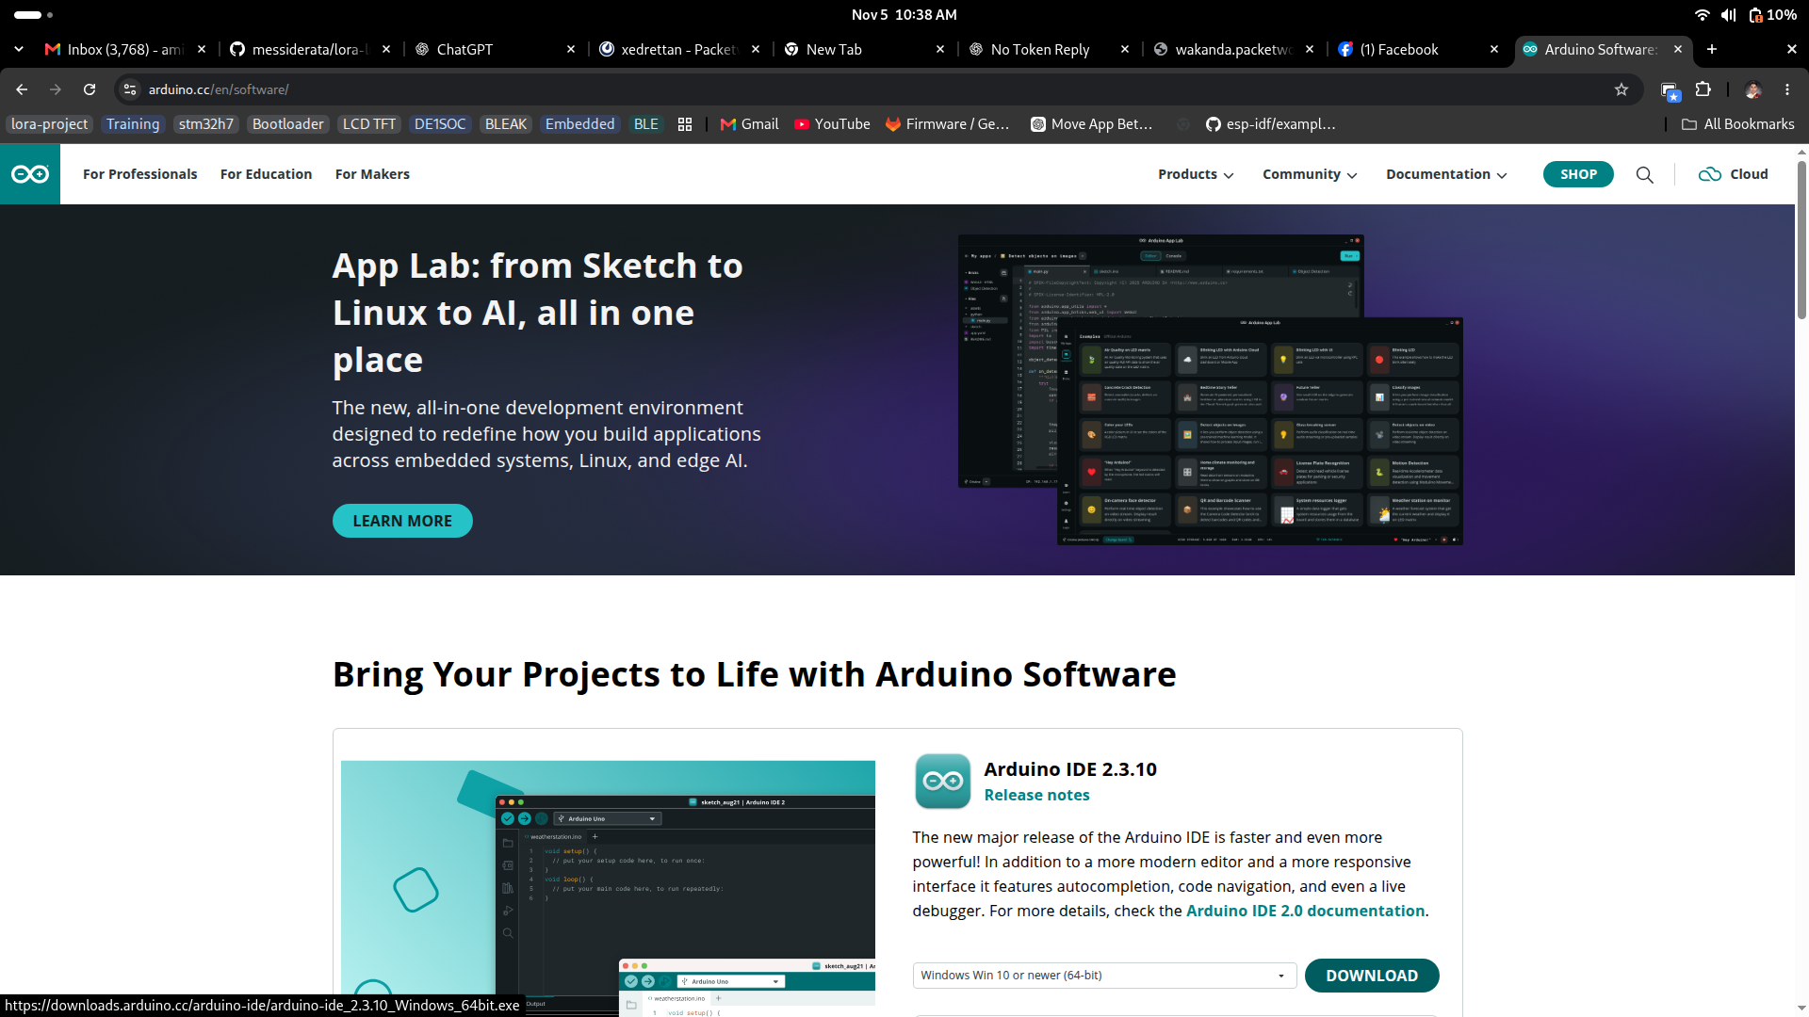
Your screenshot: the operating system selector and DOWNLOAD button are at the bottom right of the Arduino IDE card.
B. Click the operating system selector beside DOWNLOAD. Choose the option that matches the computer where you will install Arduino IDE.
The screenshot has Windows Win 10 or newer (64-bit) selected. If you are installing on Linux or Mac, select the matching option instead.
C. Click DOWNLOAD. Wait for the download to finish, then open the downloaded installer and follow its prompts. On Linux, follow the official installation instructions linked on page 1.
D. Open Arduino IDE when installation is complete. Continue with the ESP32 link on the next page.
Use the Arduino IDE section shown in the lower half of your screenshot. The version number may change over time.

2. Add the ESP32 link
- In Arduino IDE, click File > Preferences. On Mac, open the Arduino IDE menu and choose Settings or Preferences.
- Find Additional Boards Manager URLs. Paste this complete link:
https://espressif.github.io/arduino-esp32/package_esp32_index.json
- If a link is already present, open the small list button beside the field and add the ESP32 link on a new line. Click OK to save.
Paste the link into Arduino IDE. You do not need to download or open the .json file yourself.
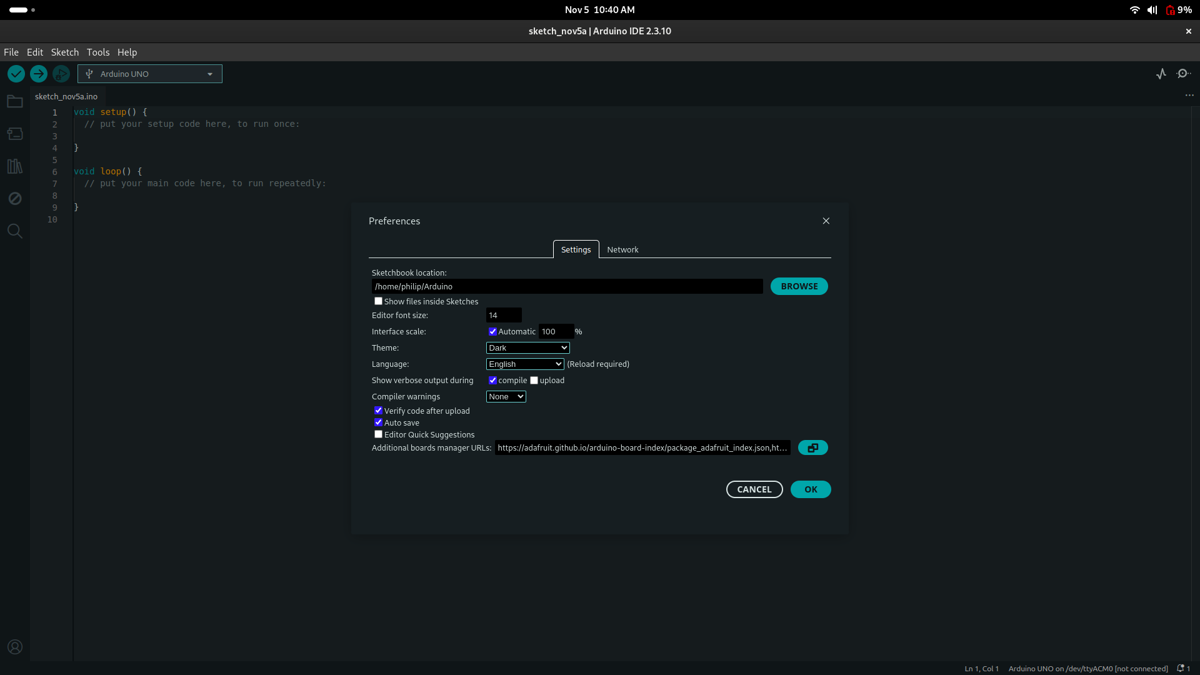
Your Arduino IDE screenshot: click the turquoise button with two overlapping squares, immediately to the right of Additional boards manager URLs, to open the URL manager.
The visible address begins with an Adafruit link. Keep any existing links and add the ESP32 link printed above on a new line. Click OK in the URL manager, then OK in Preferences.

2 continued. Paste and save the link
A. Open File > Preferences. Click the small list button beside Additional Boards Manager URLs.
B. Paste the exact stable ESP32 link shown below. If you already have other links, keep them and add this one on a new line.
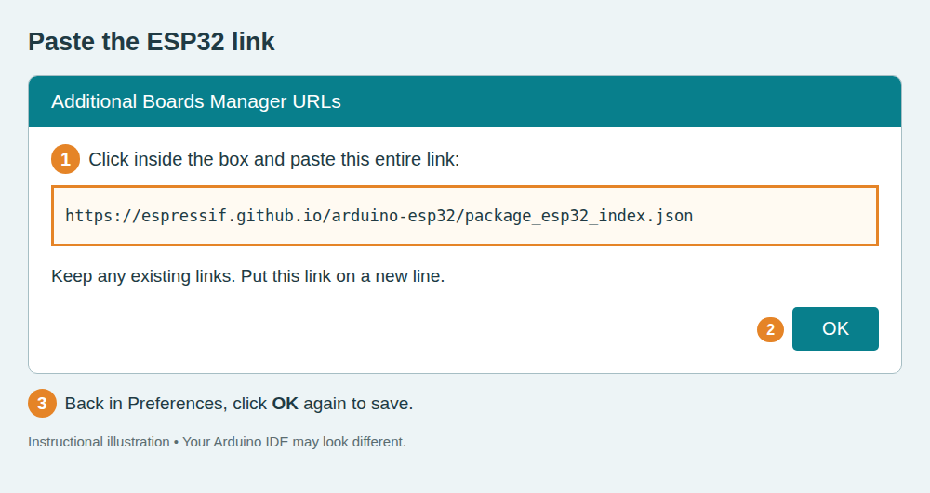
C. Click OK in this window, then click OK in Preferences. Continue with the board package installation on the next page.
Illustration of the paste-and-save steps; not a captured Arduino IDE screen.

3. Download the ESP32 board package
- Open Tools > Board > Boards Manager, or click the Boards Manager icon on the left.
- Search for esp32. Find esp32 by Espressif Systems and click Install. Wait until installation finishes.
- Restart Arduino IDE. If your Packetworx contact specifies a version, select that version before installing.
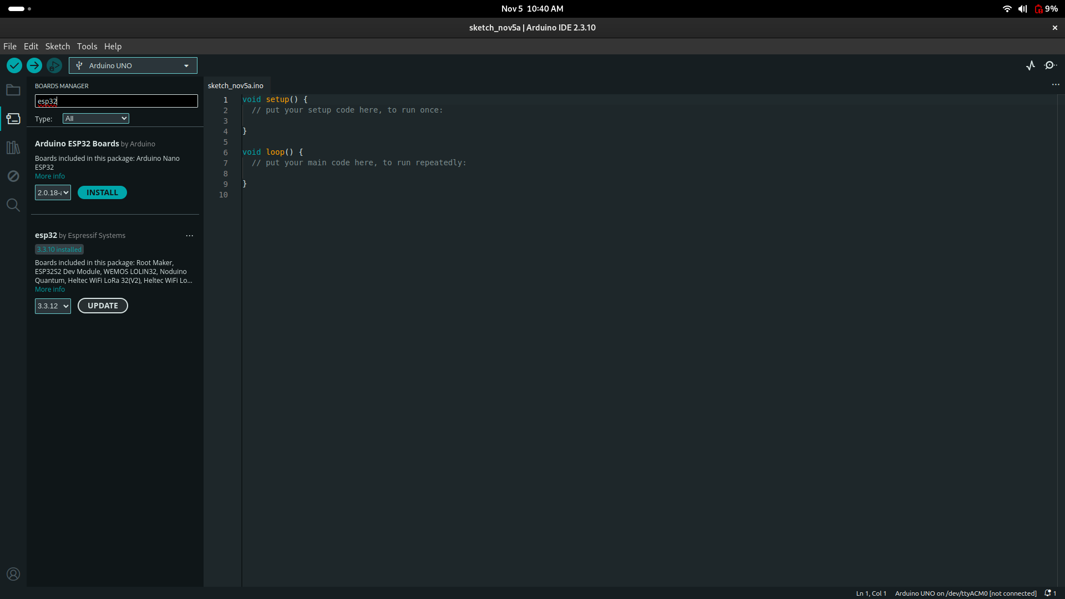
Your Boards Manager screenshot: use the lower result, esp32 by Espressif Systems. The upper Arduino ESP32 Boards result is a different package.
The board list in ESP32 package 3.3.10 includes Heltec Vision Master T190. If you cannot find that board later, check your installed package version.
On a new installation, click INSTALL under esp32 by Espressif Systems and wait until it says installed. Your screenshot already shows 3.3.10 installed, so you can continue to the next section. UPDATE means a newer version is available; you do not need to click it to finish this installation.

4. Install the project and open pwx-otaa
- Download the Packetworx project ZIP supplied by your contact. If you have repository access, open the address below, sign in, and use the repository’s download/source-code menu to download ZIP.
https://wakanda.packetworx.com/firmware/
arduino-lmic-library-mcci-lorawan-lmic-library
- In Arduino IDE, click Sketch > Include Library > Add .ZIP Library. Select the downloaded project ZIP and wait for confirmation.
- In Windows File Explorer, right-click the same ZIP and choose Extract All. Open the extracted folder, then examples > pwx-otaa.
- Copy thingspark_otaa.ino into a new folder named thingspark_otaa inside Documents > Arduino. The folder and file names must match.
- In Arduino IDE, click File > Open and select Documents > Arduino > thingspark_otaa > thingspark_otaa.ino.
Documents
Arduino
thingspark_otaa
thingspark_otaa.ino
Use the supplied Packetworx ZIP. It contains the SX1262 radio and AS923-3 settings used by this example.
If Arduino says the library is already installed, ask your Packetworx contact to check that the installed copy is this project version. Avoid keeping several LMIC copies installed.
Official ZIP installation instructions: https://support.arduino.cc/hc/en-us/articles/5145457742236-Install-libraries-in-the-Arduino-IDE

4 continued. Open the example code
Use the extracted project folder to find the file. Then make a working copy under Documents > Arduino.
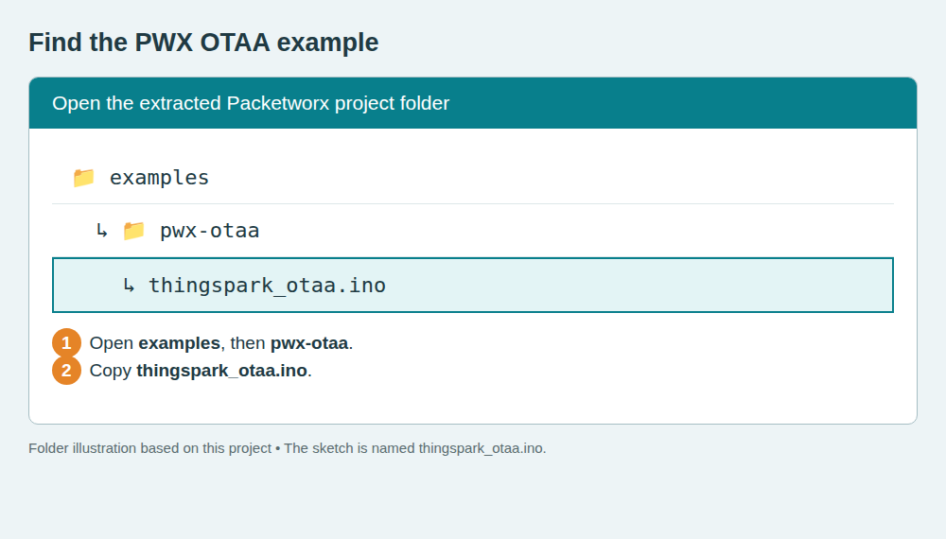
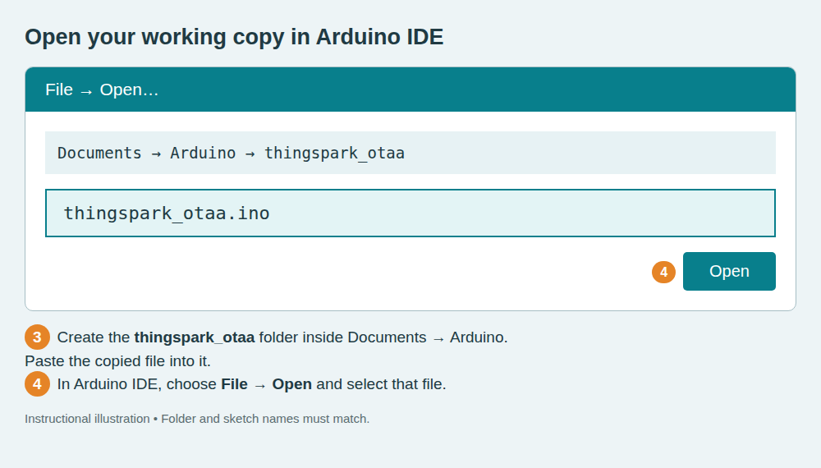
These are instructional illustrations. When the sketch opens, the tab should show thingspark_otaa.ino. Continue with board selection on the next page.

5. Connect and select your board
- Attach the LoRa antenna, then connect the T190 to your computer using the USB data cable.
- Click the board selector at the top of Arduino IDE, then Select other board and port.
- Under BOARDS, search for Heltec Vision Master T190 and select it. Under PORTS, choose your board’s USB port, then click OK.
- To identify the port, unplug the board and check the list. Reconnect it and select the port that appears. On Windows, it will usually be COM followed by a number.
- For the T190’s native USB connection, check Tools > USB CDC On Boot > Enabled. Leave the other board settings at their defaults.
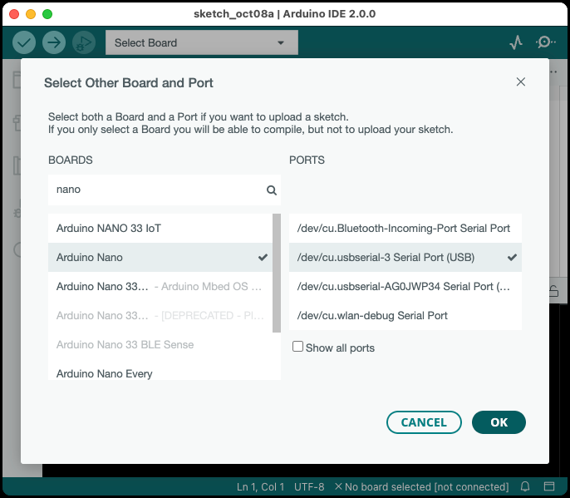
Official Arduino screenshot showing the selection dialog. It shows a Nano on Mac as an illustration; select Heltec Vision Master T190 and your own port.
Source: https://support.arduino.cc/hc/en-us/articles/4406856349970-Select-board-and-port-in-Arduino-IDE

6. Enter your device credentials
- In the sketch, press Ctrl+F and search for APPEUI[8]. Find APPEUI, DEVEUI and APPKEY near the top of the program.
- Replace the values inside the { } for each of the three entries with your own values. Keep the commas, braces and final semicolons.
- For JoinEUI/AppEUI and DevEUI: split the value into pairs, then reverse the order of the pairs. Do not reverse the two characters inside a pair.
- For AppKey: keep the pairs in their original order. Add 0x before every pair. Press Ctrl+S to save.
Example below uses invented values. Replace all three entries with your device’s values.
JoinEUI: 1122334455667788 → 88 77 66 55 44 33 22 11
DevEUI: 0102030405060708 → 08 07 06 05 04 03 02 01
AppKey: 00112233445566778899AABBCCDDEEFF → same order
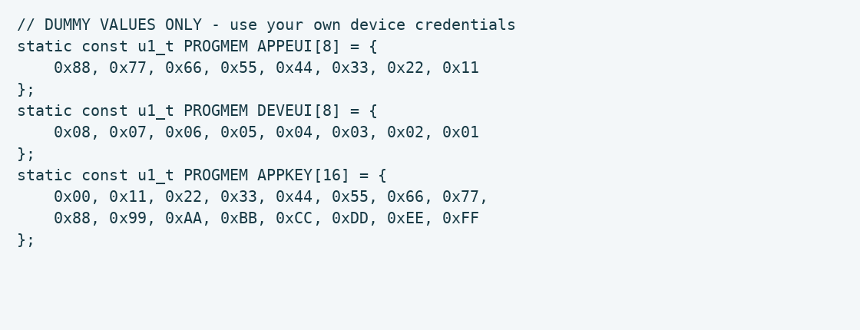
Credential illustration based on this sketch; dummy data, not a live device screenshot.
Check: APPEUI has 8 pairs, DEVEUI has 8 pairs, and APPKEY has 16 pairs. If your contact already supplied reversed EUI arrays, do not reverse them again.
Keep your AppKey private. This example also prints session keys in Serial Monitor; hide those lines before sharing a screenshot.

7. Upload and check the connection
- Click the ✓ Verify button at the top left. Wait for the check to finish. If an error appears, use the fixes on the next page.
- Click the → Upload button. Wait until the upload completes. Keep the USB cable connected.
- Click Tools > Serial Monitor. Set the speed selector to 9600 baud.
- Press the board’s RESET button once. Look for EV_JOINING, then EV_JOINED. Joining may take a few minutes.
- Look for EV_TXCOMPLETE after a transmission. Ask your Packetworx contact to confirm the device’s uplink appears in ThingPark.
Success: EV_JOINED appears and ThingPark receives an uplink from your device.
These are example messages to look for, not a captured test result:
Starting
Packet queued
... EV_JOINING
... EV_JOINED
... EV_TXCOMPLETE (includes waiting for RX windows)
Other status lines may appear between these messages. The program sends “Hello, world!” and schedules its next send about 60 seconds after the previous transmission completes.
EV_TXCOMPLETE means the radio finished its send/receive cycle. Confirm receipt in ThingPark to check the complete connection.
The board screen may remain blank. This example reports its status in Serial Monitor.

8. If something does not work
What you see | What to do
No port appears | Try another USB data cable and USB socket. Reconnect the board. If it still does not appear, ask your contact to check the USB driver.
T190 is not in the board list | Check that esp32 by Espressif Systems is installed. Use a package version that includes Heltec Vision Master T190, such as 3.3.10.
lmic.h: No such file or directory | Repeat the ZIP library installation in section 4, then restart Arduino IDE.
Compilation error near credentials | Check the 0x prefixes, commas, braces and semicolons against section 6. Keep the original variable names.
Upload stays on Connecting… | Hold BOOT, press and release RESET, then release BOOT. Select the USB port again and retry Upload. Press RESET after upload.
Serial Monitor is blank or unreadable | Select the correct port and 9600 baud. Check USB CDC On Boot is Enabled for native USB, upload again, then press RESET.
EV_JOINING repeats / no JoinAccept | Check the three credentials and EUI pair order. Ask your contact to confirm device registration, AS923-3 and gateway coverage.
A warning mentions TTN or FILLMEIN | This sketch contains an old warning message. Confirm you replaced all three credential arrays. If Verify fails, read the actual error lines below the warning.

Reference notes
Setup screenshots are from official Espressif and Arduino instructions, linked on their pages. Their sample boards, versions and operating systems may differ from yours. Follow the values written in this guide.
Project details were checked against examples/pwx-otaa/thingspark_otaa.ino, project_config/lmic_project_config.h and src/lmic/lorabase_as923.h. Board name checked against the locally installed ESP32 3.3.10 board definitions. This guide is not a hardware connection test.

