Spring is an application framework and IoC container that provides much of the “plumbing” required by enterprise applications. “Plumbing” refers to the essential work that is required for any application but not the main focus of the app. Spring relies heavily on “Inversion of Control” to achieve this. Spring supports a wide range of application scenarios, such as:
- Large enterprise applications
- Simple cloud-hosted servers
- Standalone batch jobs
- Integration workloads

Development often requires a lot of code to be written for set up (e.g. connections) and processing (e.g. data transformation). Such code is repetitive and can complicate maintenance. Spring provides implementations for a lot of the repetitive work. Developers can focus on writing business logic and abstracts them from a lot of the implementation. May limit options for developers but reduces overhead.

The IoC container is responsible for instantiating, assembling, and configuring beans. A bean’s dependencies are constructed and injected into the bean when the bean is created. The developer does not control the instantiation or location of dependencies – hence, IoC.

* Beans and Configuration:
- Beans are special Java objects in Spring.
- Spring allows developers to define a configuration specifying the object's structure and dependencies.
- The IoC container in Spring creates a bean, injecting its dependencies, relieving developers from manual instantiation.
* Inversion of Control (IoC):
- IoC involves ceding control of object creation to the Spring Framework.
- The IoC container takes care of creating and configuring beans.
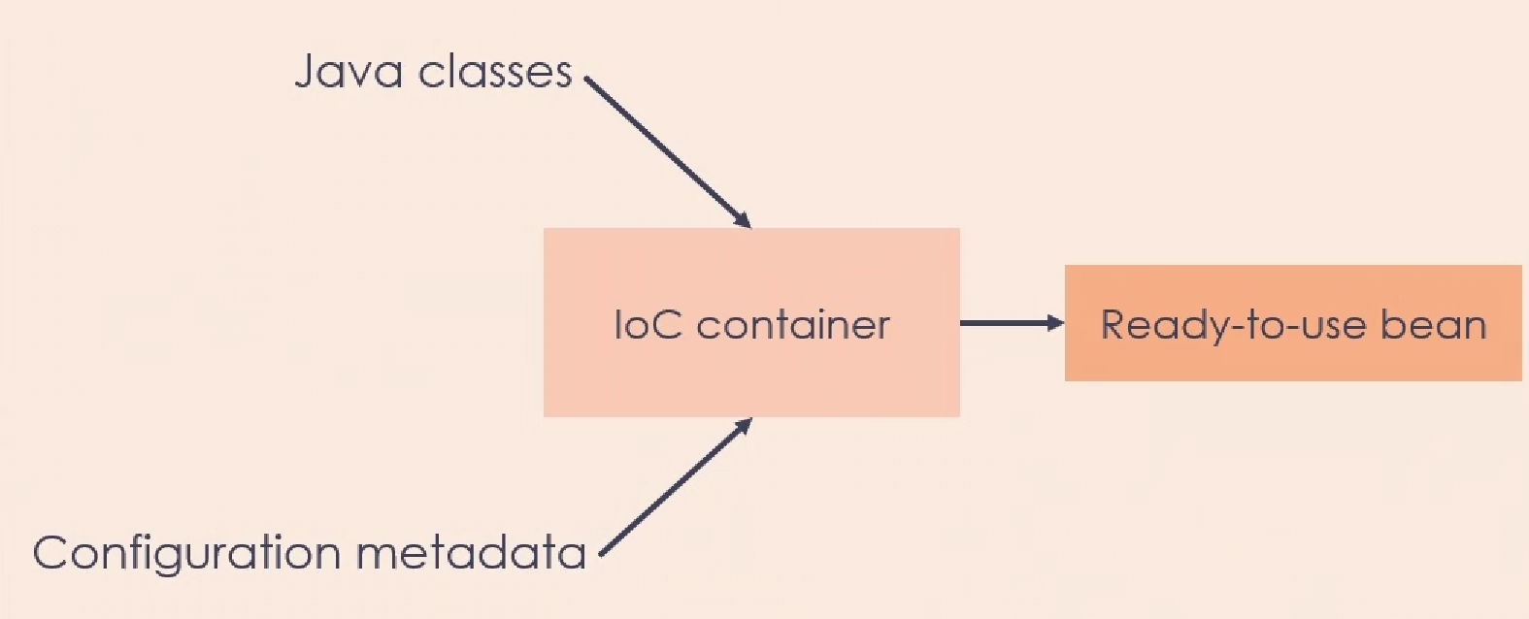
* Spring Framework Modules:
- Core container includes the IoC container.
- Messaging module facilitates message implementation without direct JMS API usage.
- Aspect-Oriented Programming for configuring functions before and after execution.
- Data access module helps integrate apps with databases.
- Web modules simplify building REST APIs for web applications.
- The framework aids in the development of test cases.
* Common Use Cases of Spring:
- Construction of classic web apps using Spring MVC.
- Database access benefits from Spring, with various projects in the Spring data umbrella.
- Spring batch for batch processing jobs, offering preconfigured mechanisms for data transformations.
- Building RESTful web services for interaction via REST APIs.

Dependency Injection and IoC

A bean is a special kind of Java object, which is built out of a Java class definition along with some configuration metadata and is constructed by the Spring IoC container. One of the features which distinguishes a bean from a regular Java Object is the fact that a bean may have dependencies directly injected into it. A developer need not worry about having to construct the dependencies and then attaching them to an object.

“Dependencies” refer to the relationships between different components or modules within a software system. A dependency occurs when one module (or piece of code) relies on another module to perform its functionality.

These dependencies can take various forms:

Code Dependencies: One piece of code might depend on functions or classes provided by another piece of code. For example, if Module A uses functions or classes from Module B, then Module A has a code dependency on Module B.

Library Dependencies: Software projects often use external libraries or frameworks to provide additional functionality. If a project relies on an external library, it has a library dependency.

Module Dependencies: In a modular software design, different components or modules interact with each other. A module may depend on the correct functioning of another module to perform its tasks.

Build Dependencies: In the context of building software, dependencies can also refer to external tools, libraries, or resources that are required during the build process.
Dependency Injection is a design pattern where the dependencies of an object are supplied to it such that it does not need to construct or manage those dependencies. This allows the client to focus on the functionality of the object rather than building it. The dependencies can be supplied in the form of beans. The construction and injection of the dependencies are managed by a container.

Bean

A bean in Java is a class that encapsulates one or more objects and serves as a recipe for creating an object. A bean needs to adhere to a certain set of specification:
- Is serializable
- Contains a zero-argument constructor
- Enables access to the properties through getters and setters
- Serves as re-usable components in the app

Inversion of Control

A design principle where control of objects or parts of a program are carried out by a framework or container.
- The flow of control is inverted with respect to traditional programming.
- Developer sets what an object/bean depends on; does not need to create the dependencies.
- Dependency Injection is one way to implement IoC
- Other methods include: Factory method, Service locator

Terminology
Bean – object that depends on the behavior of another object
Service – object that the client bean depends on
Injector – code that tells the client bean which service to use
Injection – process of telling the client bean which service to use

Benefits of IoC
- Running a task is decoupled from its implementation
- Modularity makes it easier to test code
- Switch between different implementations is easier

Spring Boot
- An extension of the Spring framework
- Simplifies Spring app development by automatically pre-configuring virtually all third-party libraries
- This pre-configuration is done by default

Opinionated approach
- In software development, it refers to an approach that intentionally reduces flexibility by making choices on behalf of the developer
- Reduces flexibility but simplifies development
Spring Boot recommends Maven or Gradle. It works best with a build system that can pull artifacts from the Maven Central repository.
Spring Boot provides the starter dependencies, so developer can get started with a single dependency.

Spring Boot starters
- Built-in dependency descriptors that can be included in a Spring Boot app
- Will pull in and manage all dependencies, including transitive dependencies

Spring Initializr
- Extensible API for creating JVM-based projects
- Used by Spring Boot to create structures for pre-configured Spring projects

Spring Modules

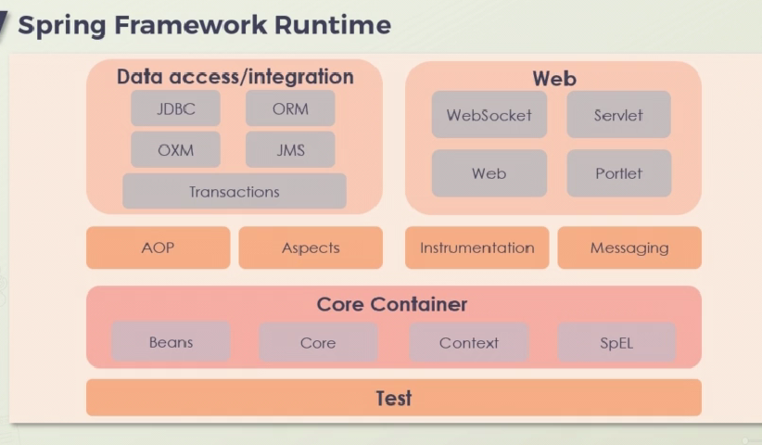

Data Access and Integration Module:
- Enables working with JDBC, object-relational models (ORMs), and other data sources.
- Simplifies servlet and socket usage under the web module.
- Supports Aspect-Oriented Programming (AOP) and messaging frameworks, built on the Spring Core container.
- Utilizes Spring's test modules for application testing.
Spring Framework as a Family of Projects:
- Spring comprises various modules that can be applied to build enterprise-grade applications.
- Usage of different modules depends on the type of application being developed.
- The Spring Core container is a critical component for working with beans and implementing
inversion of control.

Spring Core Container:
- ApplicationContext, a type of IoC container, is crucial for accessing beans.
- Enables inversion of control through dependency injection.
- Includes spring-context for accessing objects via JNDI and spring-expression for object graph access.
Data Access and Integration Module Components:
- spring-jdbc for vendor-agnostic data source handling.
- spring-orm for working with JPA and ORM implementations like Hibernate.
- spring-jms and spring-messaging for messaging and message processing.
- Spring transaction for setting up transactions for Java objects.
Messaging Module:
- Involves spring-messaging for working with messages at higher-level abstractions.
- Allows message processing with annotations similar to Spring MVC.
Spring Web Module:
- Includes spring-web for basic web features in applications.
- spring-webmvc for web applications using the model-view-controller paradigm.
- spring-websocket for network-level communication with other apps.

Aspect-Oriented Programming (AOP):
- A programming paradigm focused on aspects applied to various components in the application.
- Aspects can be applied using pointcuts, mapping to specific methods in the app.
Testing with Spring:
- Utilizes Spring Framework for simplifying unit and integration tests.
- Integrates with JUnit and TestNG.
- Facilitates loading and caching of ApplicationContext objects for tests.
- Allows the creation of Mock objects to test various components of the code.

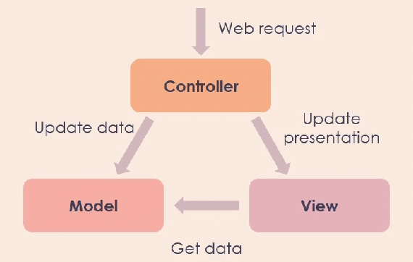
Spring MVC

- Web request comes in from client app to the controller
- Assume that our application is linked up with a data source (from a database), and this incoming web request is a request to update some data
- All interactions with the underlying data in the application will be handled by the model component, so it is the update data request which is sent over to the model by our controller
- We want to display the updated data to the end user who initiated the web request
- This is handled by the View component of the application
- However, the View component itself is directed by the controller, which sends in a request to update the presentation layer of the app with the updated data. The View now knows it needs to present the updated data to the end user and to retrieve that data
- This will also need to interact with the model

Model
- Encapsulates application state (not application logic)
- Can be queried to obtain state
- Notified by controller when state needs to change
- Notifies controller once state has been changed

Controller
- Defines application logic (not application state)
- Maps user actions to state changes
- Updates application state only via a model (not directly)
- Updates Views once application state has changed

View
- Present application state to users via appropriate interfaces
- Allows user to interact with and modify state
- Do not store application data (except for caching)
- Built using re-usable and configurable elements
Spring MVC relies on three underlying technologies – Servlets, JSP and JSTL

Servlets – Java code that runs on a web server or application server
JSP – Akin to PHP, used to create dynamic web pages
JSTL – Collection of useful tags for common tasks

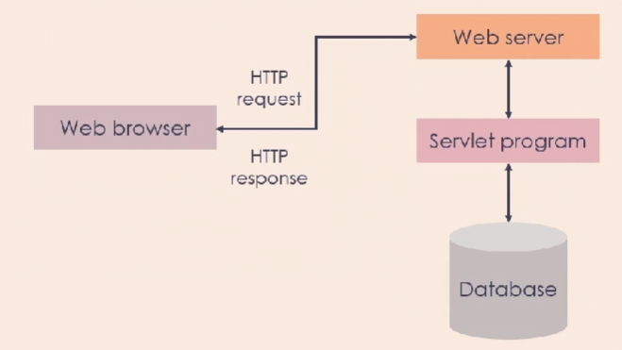
Spring Data
- An umbrella project consisting of independent projects that aim to provide a familiar and consistent, Spring-based programming model for data access, while still retaining the special traits of the underlying data store

Spring Data Projects
- Spring Data JPA: Makes it easier to integrate Spring applications with JPA and JPA providers
- Spring Data Redis: Supplies easy configuration and access to a Redis store from Spring applications
- Spring Data MongoDB: Provides a consistent, Spring-based programming model for MongoDB access
- Spring Data REST: Simplifies the building of hypermedia-driven REST web services with a Spring application

Spring Data Repositories
- Significant reduce the amount of boilerplate code required to implement data access layers for persistent stores. They provide implementations for the most commonly used CRUD (create, read, update and delete) operations.

