Christopher Messina

February 20, 2019

Assignment 3

*Step 1:*

Mental Health in Tech Survey

* Dependent Variables:
  + treatment: Have you sought treatment for a mental health condition? (Yes/No)
  + mental_health_consequence: Do you think that discussing a mental health issue with your employer would have negative consequences? (Yes/Maybe/No)
  + phys_health_consequence: Do you think that discussing a physical health issue with your employer would have negative consequences? (Yes/Maybe/No)

*Step 2:ˆ*

1. Which dataset did you select?
   1. Mental Health in Tech
2. How many observations are in the dataset?
   1. 1259
3. How many variables in the dataset?
   1. 25 and a comment section
4. Does this dataset seem to belong to a regulated domain in law? If yes, which one?
   1. Yes, employment since it talks about mental health in the workplace within the tech industry.
5. How many variables in the dataset are associated with a legally recognized protected class? In a table format, list those variables associated with a protected class, identify the protected class and the associated legal precedence/law.

|  |  |  |
| --- | --- | --- |
| Category | Protected Class | Law |
| Age | Age | Age Discrimination in Employment Act of 1967 |
| Gender | Sex | Equal Pay Act of 1963; Civil Rights Act of 1964, 1991 |
| Family_history | Genetic Information | Genetic Information Nondiscrimination Act |
| Country | National Origin | Civil Rights Act of 1964, 1991 |

*Step 3:*

|  |  |  |  |
| --- | --- | --- | --- |
| AGE | Sought Treatment | Mental Health Consequence | Physical Health Consequence |
| ≥ 40 (183) | Frequency of Y: 107  Frequency of N: 76 | Frequency of Y: 51  Frequency of N: 57  Frequency of Maybe: 75 | Frequency of Y: 12  Frequency of N: 119  Frequency of Maybe: 52 |
| 40 (1076) | Frequency of Y: 530  Frequency of N: 546 | Frequency of Y: 241  Frequency of N: 433  Frequency of Maybe: 402 | Frequency of Y: 49  Frequency of N: 806  Frequency of Maybe: 221 |

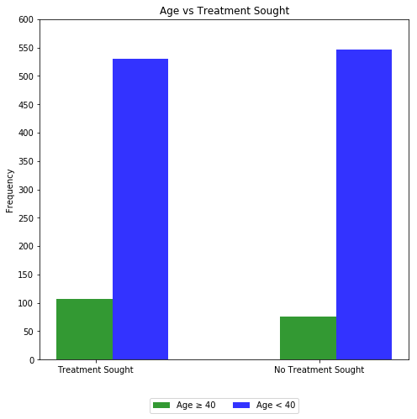

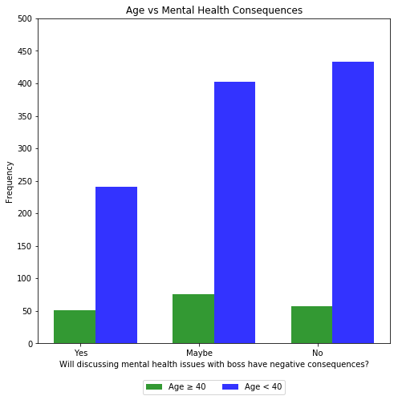

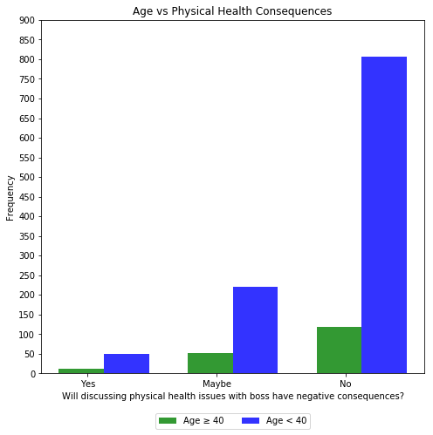

|  |  |  |  |
| --- | --- | --- | --- |
| GENDER | Sought Treatment | Mental Health Consequence | Physical Health Consequence |
| Female (253) | Frequency of Y: 175  Frequency of N: 78 | Frequency of Y: 68  Frequency of N: 74  Frequency of Maybe: 111 | Frequency of Y: 16  Frequency of N: 168  Frequency of Maybe: 69 |
| Male (988) | Frequency of Y: 447  Frequency of N: 541 | Frequency of Y: 214  Frequency of N: 413  Frequency of Maybe: 361 | Frequency of Y: 41  Frequency of N: 750  Frequency of Maybe: 197 |
| Other (18) | Frequency of Y: 15  Frequency of N: 3 | Frequency of Y: 10  Frequency of N: 3  Frequency of Maybe: 5 | Frequency of Y: 4  Frequency of N: 7  Frequency of Maybe: 7 |

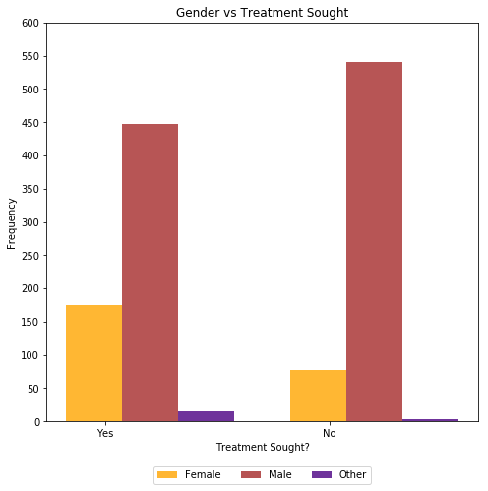

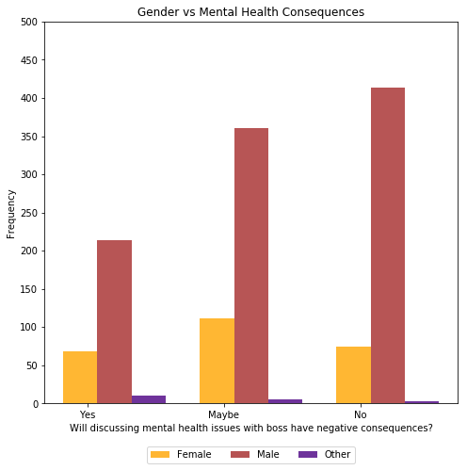

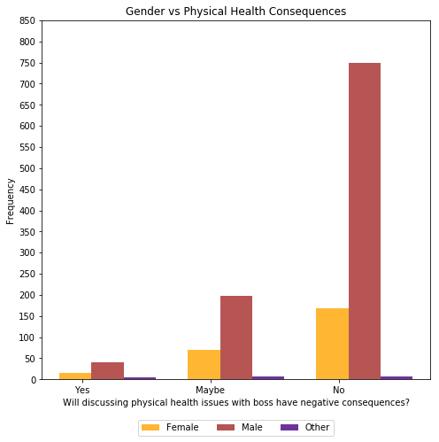

|  |  |  |  |
| --- | --- | --- | --- |
| GENETICS | Sought Treatment | Mental Health Consequence | Physical Health Consequence |
| Family History (492) | Frequency of Y: 365  Frequency of N: 127 | Frequency of Y: 134  Frequency of N: 165  Frequency of Maybe: 193 | Frequency of Y: 31  Frequency of N: 348  Frequency of Maybe: 113 |
| No Family History (767) | Frequency of Y: 272  Frequency of N: 495 | Frequency of Y: 158  Frequency of N: 325  Frequency of Maybe: 284 | Frequency of Y: 30  Frequency of N: 577  Frequency of Maybe: 160 |

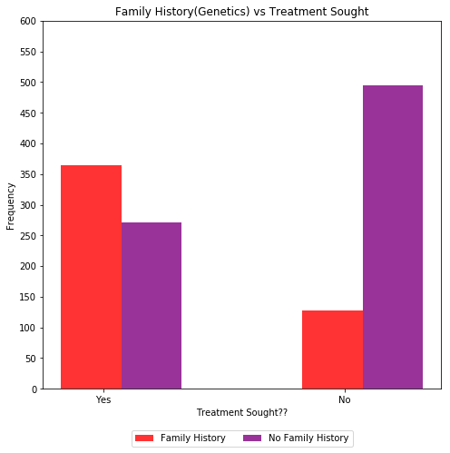

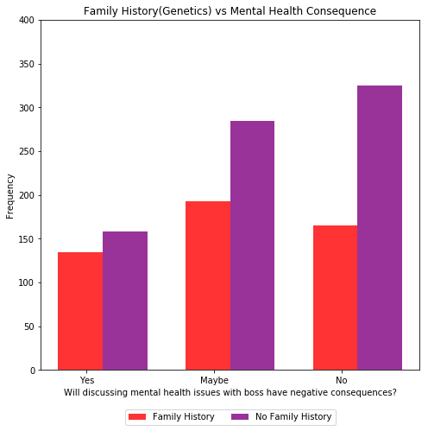

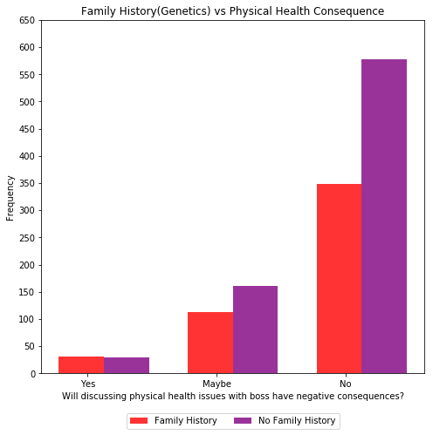

*Limited to Northern and Southern Hemispheres for simplicity of table and graph*

|  |  |  |  |
| --- | --- | --- | --- |
| NATION | Sought Treatment | Mental Health Consequence | Physical Health Consequence |
| Northern Hemisphere (1214) | Frequency of Y: 612  Frequency of N: 602 | Frequency of Y: 277  Frequency of N: 470  Frequency of Maybe: 467 | Frequency of Y: 58  Frequency of N: 265  Frequency of Maybe: 3 |
| Southern Hemisphere (45) | Frequency of Y: 25  Frequency of N: 20 | Frequency of Y: 15  Frequency of N: 20  Frequency of Maybe: 10 | Frequency of Y: 3  Frequency of N: 34  Frequency of Maybe: 8 |

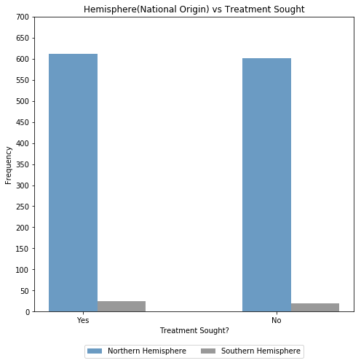

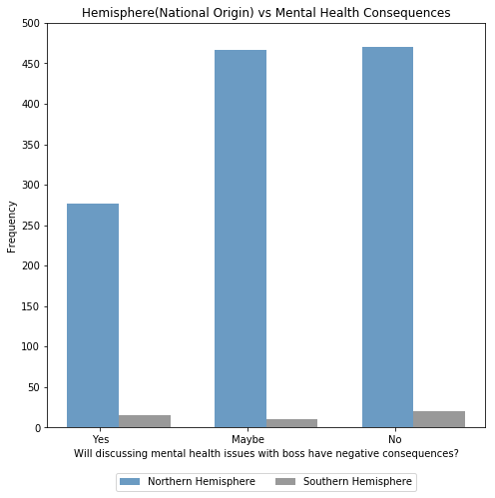

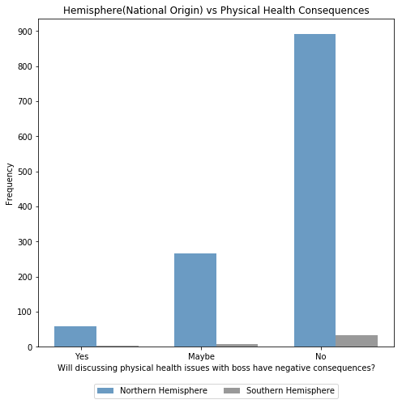

*Step 4:*

*Fairness Graph (Family History vs Treatment Sought – Treatment for mental health issues is fair amongst people with and without a genetic history. Manipulations: Mapped the ratios of those who sought treatment out of the total. So 365/637 for those with a genetic history and 272/637 for those without a history. Expanding the Y axis to be -10 to 10 flattens the line further since it is a ratio between 0 and 1. This makes it appear as if there is no difference in treatment sought for the two groups.*

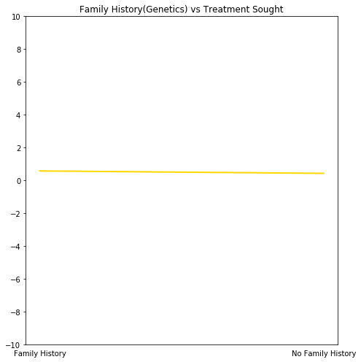

*Bias Graph (Same Variable) – Treatment for mental health issues is biased between the people with a genetic history and those without a genetic history. This graph shows that the percentage of people who sought treatment when they had a genetic history was much higher than for the group that did not have a genetic history. Manipulations: Reduce Scale, Smaller Y-range, Stack the bars to show the percentages more.*

