域名信息

**敏感目录**

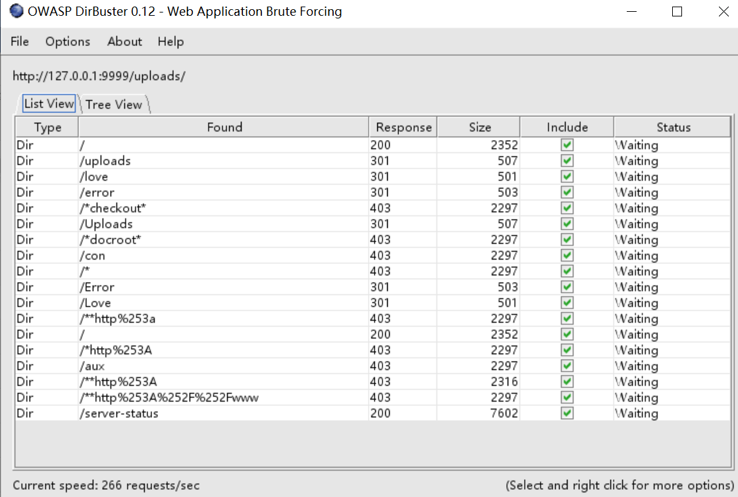

**端口扫描**

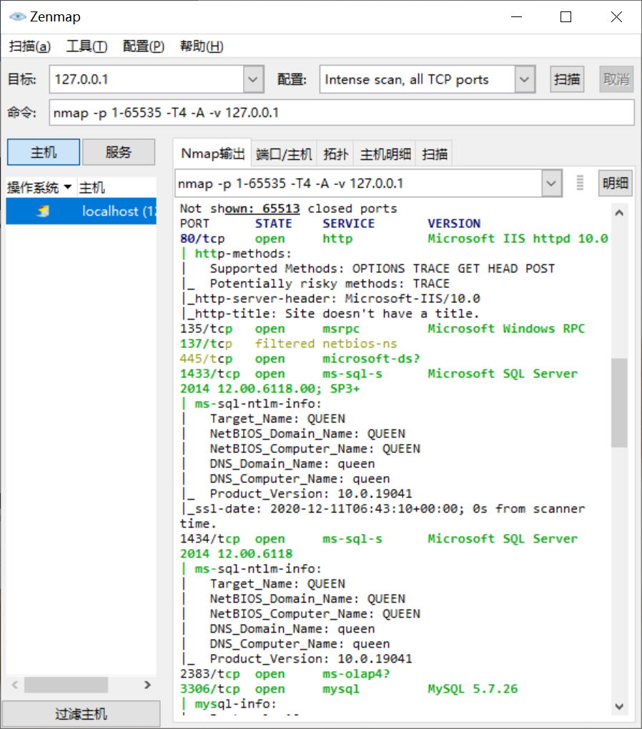

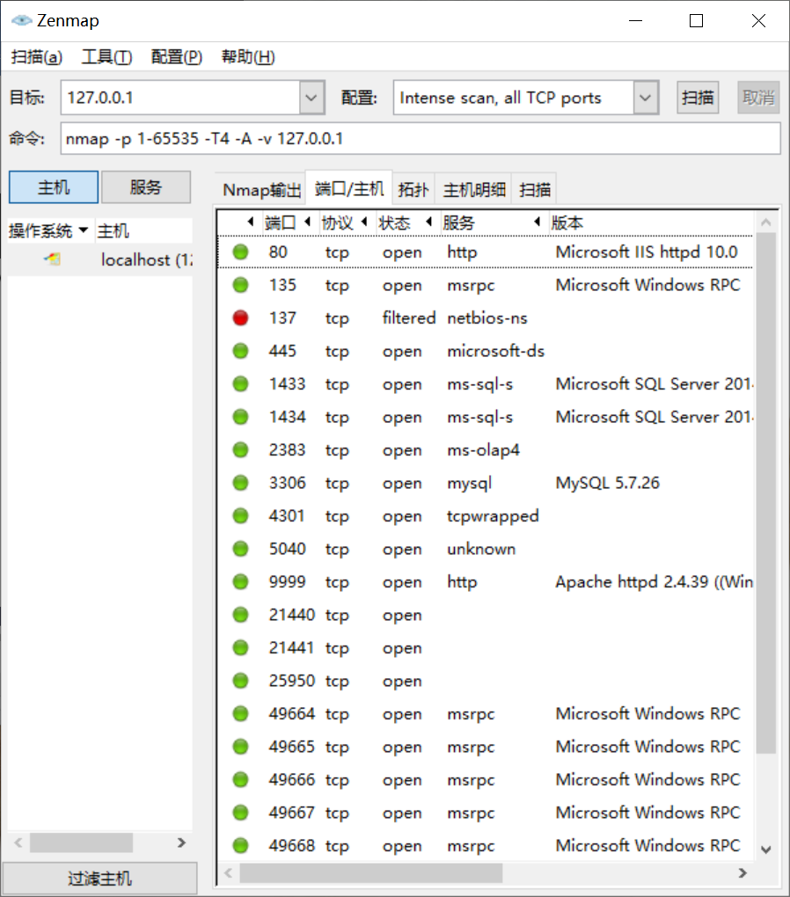

**旁站C段**

**查旁站https://chapangzhan.com/**

| iP | 历史发现 | 一年内 | 三个月内 | 一周内 |
| --- | --- | --- | --- | --- |
| 总计：**48** | 33115 | 30776 | 9683 | 1312 |
| [127.0.0.0](https://ipchaxun.com/127.0.0.0/) | 49 | 27 | 9 | 5 |
| [127.0.0.1](https://ipchaxun.com/127.0.0.1/) | 29225 | 29225 | 9114 | 1275 |
| [127.0.0.2](https://ipchaxun.com/127.0.0.2/) | 2838 | 981 | 276 | 5 |
| [127.0.0.3](https://ipchaxun.com/127.0.0.3/) | 176 | 63 | 29 | 9 |
| [127.0.0.4](https://ipchaxun.com/127.0.0.4/) | 27 | 14 | 0 | 0 |
| [127.0.0.5](https://ipchaxun.com/127.0.0.5/) | 204 | 154 | 92 | 6 |
| [127.0.0.6](https://ipchaxun.com/127.0.0.6/) | 96 | 77 | 25 | 0 |
| [127.0.0.7](https://ipchaxun.com/127.0.0.7/) | 19 | 4 | 0 | 0 |
| [127.0.0.8](https://ipchaxun.com/127.0.0.8/) | 184 | 116 | 97 | 5 |
| [127.0.0.9](https://ipchaxun.com/127.0.0.9/) | 138 | 25 | 3 | 0 |
| [127.0.0.10](https://ipchaxun.com/127.0.0.10/) | 35 | 15 | 4 | 2 |
| [127.0.0.11](https://ipchaxun.com/127.0.0.11/) | 66 | 38 | 15 | 3 |
| [127.0.0.12](https://ipchaxun.com/127.0.0.12/) | 4 | 4 | 2 | 0 |
| [127.0.0.17](https://ipchaxun.com/127.0.0.17/) | 1 | 0 | 0 | 0 |
| [127.0.0.19](https://ipchaxun.com/127.0.0.19/) | 2 | 1 | 0 | 0 |
| [127.0.0.21](https://ipchaxun.com/127.0.0.21/) | 1 | 1 | 1 | 0 |
| [127.0.0.22](https://ipchaxun.com/127.0.0.22/) | 1 | 0 | 0 | 0 |
| [127.0.0.31](https://ipchaxun.com/127.0.0.31/) | 2 | 2 | 2 | 0 |
| [127.0.0.40](https://ipchaxun.com/127.0.0.40/) | 1 | 0 | 0 | 0 |
| [127.0.0.41](https://ipchaxun.com/127.0.0.41/) | 1 | 1 | 1 | 0 |
| [127.0.0.51](https://ipchaxun.com/127.0.0.51/) | 1 | 1 | 1 | 0 |
| [127.0.0.55](https://ipchaxun.com/127.0.0.55/) | 1 | 1 | 0 | 0 |
| [127.0.0.59](https://ipchaxun.com/127.0.0.59/) | 1 | 0 | 0 | 0 |
| [127.0.0.64](https://ipchaxun.com/127.0.0.64/) | 1 | 1 | 1 | 1 |
| [127.0.0.66](https://ipchaxun.com/127.0.0.66/) | 1 | 0 | 0 | 0 |
| [127.0.0.75](https://ipchaxun.com/127.0.0.75/) | 2 | 2 | 2 | 0 |
| [127.0.0.79](https://ipchaxun.com/127.0.0.79/) | 1 | 1 | 0 | 0 |
| [127.0.0.87](https://ipchaxun.com/127.0.0.87/) | 1 | 1 | 0 | 0 |
| [127.0.0.90](https://ipchaxun.com/127.0.0.90/) | 1 | 1 | 0 | 0 |
| [127.0.0.99](https://ipchaxun.com/127.0.0.99/) | 5 | 4 | 0 | 0 |
| [127.0.0.100](https://ipchaxun.com/127.0.0.100/) | 2 | 1 | 1 | 1 |
| [127.0.0.106](https://ipchaxun.com/127.0.0.106/) | 1 | 0 | 0 | 0 |
| [127.0.0.108](https://ipchaxun.com/127.0.0.108/) | 1 | 1 | 0 | 0 |
| [127.0.0.111](https://ipchaxun.com/127.0.0.111/) | 3 | 1 | 1 | 0 |
| [127.0.0.122](https://ipchaxun.com/127.0.0.122/) | 1 | 0 | 0 | 0 |
| [127.0.0.123](https://ipchaxun.com/127.0.0.123/) | 1 | 0 | 0 | 0 |
| [127.0.0.127](https://ipchaxun.com/127.0.0.127/) | 2 | 0 | 0 | 0 |
| [127.0.0.154](https://ipchaxun.com/127.0.0.154/) | 2 | 0 | 0 | 0 |
| [127.0.0.158](https://ipchaxun.com/127.0.0.158/) | 1 | 1 | 1 | 0 |
| [127.0.0.180](https://ipchaxun.com/127.0.0.180/) | 1 | 1 | 1 | 0 |
| [127.0.0.189](https://ipchaxun.com/127.0.0.189/) | 1 | 0 | 0 | 0 |
| [127.0.0.212](https://ipchaxun.com/127.0.0.212/) | 1 | 0 | 0 | 0 |
| [127.0.0.214](https://ipchaxun.com/127.0.0.214/) | 1 | 1 | 1 | 0 |
| [127.0.0.220](https://ipchaxun.com/127.0.0.220/) | 1 | 1 | 1 | 0 |
| [127.0.0.251](https://ipchaxun.com/127.0.0.251/) | 1 | 1 | 1 | 0 |
| [127.0.0.252](https://ipchaxun.com/127.0.0.252/) | 1 | 1 | 0 | 0 |
| [127.0.0.254](https://ipchaxun.com/127.0.0.254/) | 3 | 3 | 1 | 0 |
| [127.0.0.255](https://ipchaxun.com/127.0.0.255/) | 6 | 4 | 1 | 0 |

**整站分析**

**操作系统类型Windows**

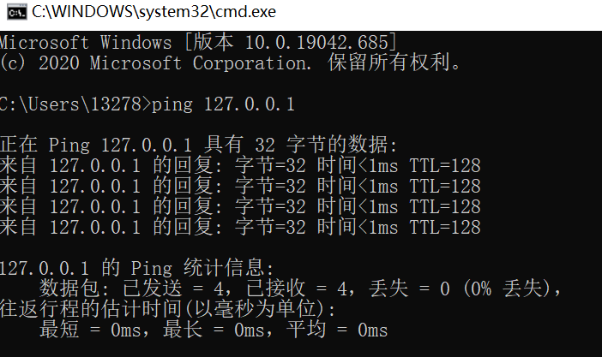

Windows的TTL值都是一般是128，Linux则是64。所以大于100的肯定是Windows，而几十的肯定是Linux，由结果可知操作系统为Windows

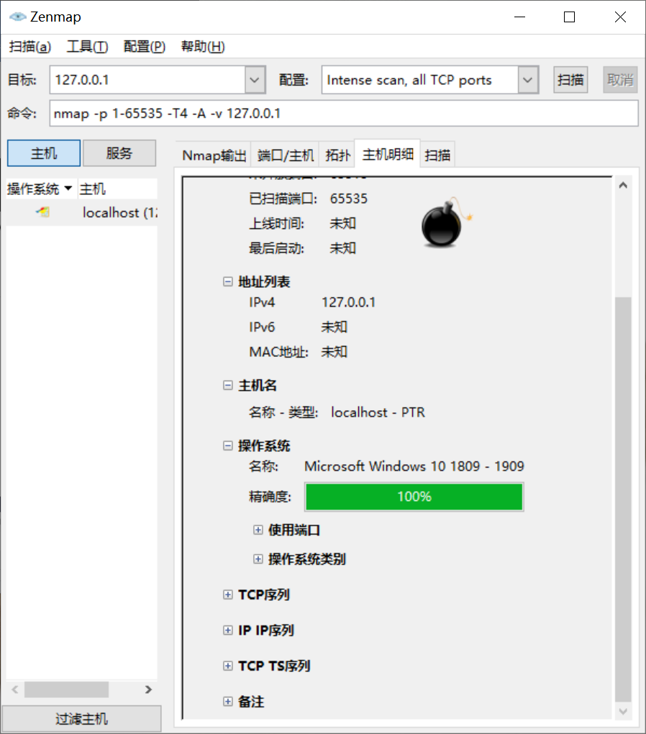

**网站容器Apache**

**查询地址https://www.whatweb.net/**

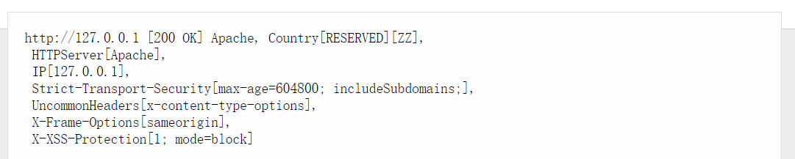

**脚本类型php**

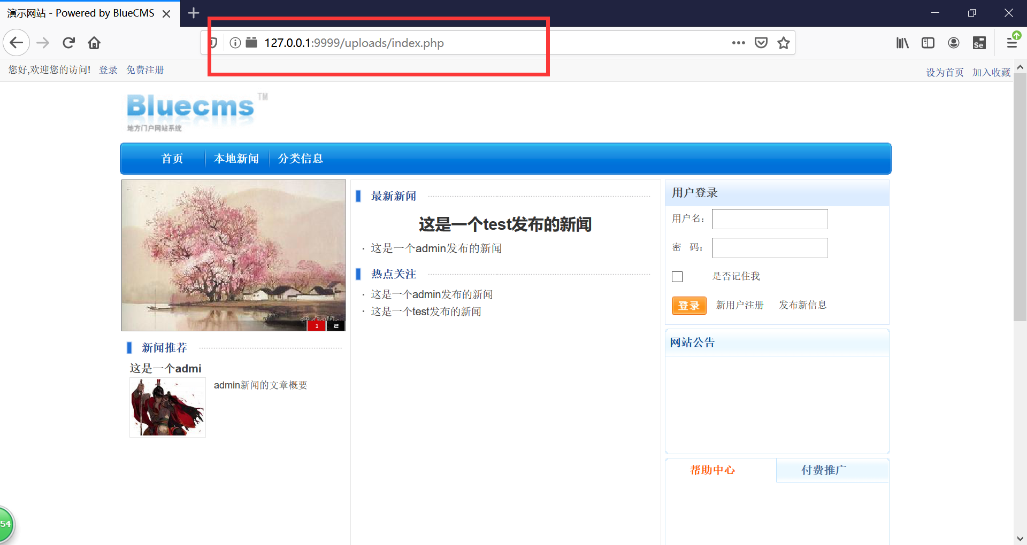

**数据库类型MySQL**

