MECANICA

User Manual

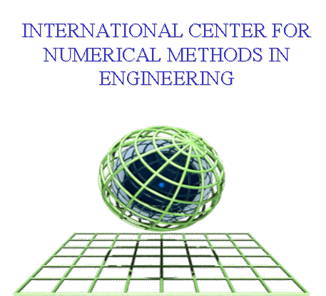

Contents

Contents 2
Introduction 4
Problem Type: Mecanica 5
Problem Data 6
1 General 6
a) Mesh length Units 6
b) Geometry 6
c) Gravity load 6
2 Strategy 7
a) Problem solver 7
b) Solver accuracy 7
3 Functions 8
a) Loading Function 8
b) Boundary Function 8
4 Post-Process 8
Conditions 9
1 Points conditions 10
a) The Points-Constraints condition 10
b) The Points-Load condition 10
2 Line conditions 11
a) The Line-Constraints condition 11
b) The Face-Load condition 11
c) The Slave-2D condition 12
d) The Master-2D condition 13
3 Surface_Conditions 14
a) Surface-Constraints Condition 14
b) The Surface-Load Condition 14
c) The Slave-3D Condition 15
d) The Master-3D Condition 16
4 Volume_Conditions 17
a) The Volume-Constraints Condition 17
Materials 18
1 Material 19
a) General 19
b) Elasticity 19

Introduction

MECANICA is an user-interface specifically designed for the pre-processor GiD. Using this interface is possible to prepare the data-file for the mechanical solver COMET. The result files obtained from the analysis can be loaded in the post-processing window of GID. Using this interface it is possible to run a mechanical analysis according to the following steps:

- GEOMETRY DEFINITION: it is possible to create and/or import the CAD geometry that defines the mechanical system to be analyzed
- MATERIALS: it is possible to select from a material data-base the material properties to be assigned to each volume previously defined. It is also possible to modify the material properties according to the user specification
- CONDITIONS: the user should assign corresponding loading and boundary conditions
- F.E. MESH: a finite element mesh can be generated for both 2D and 3D analysis
- F.E. ANALYSIS: From the pre-processing window it is possible to run the analysis
- POST-PROCESSING: results to be analyzed should be imported in the post-process window to be analyzed

Problem Type: Mecanica

From DATA-menu of GID pre-processor it is possible to load the problem-type MECANICA, an user interface created to define the input file for the mechanical solver COMET.

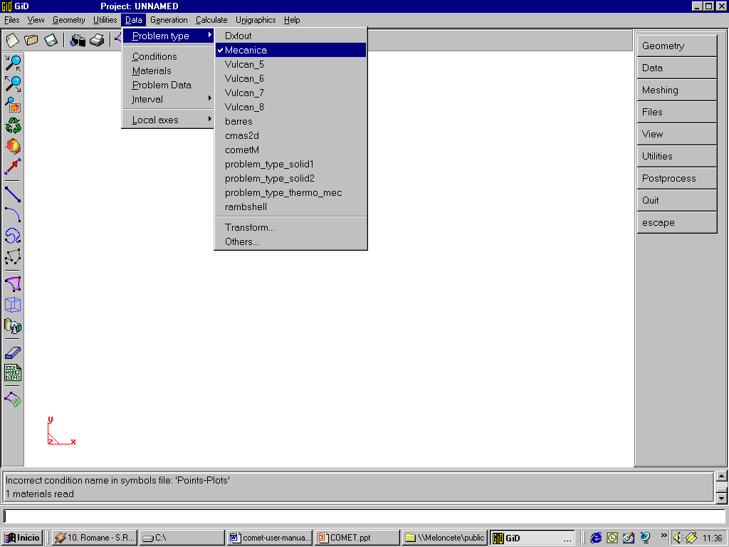

Within this pre-processor it is either possible to import a CAD geometry (IGES, DXF, etc…) or design a new one with all the CAD tools usually available in any CAD system.

Problem Data

This window deals with the definition of the analysis to be performed and the output required by the user. General, Strategy and Post –process cards are available:

1 General

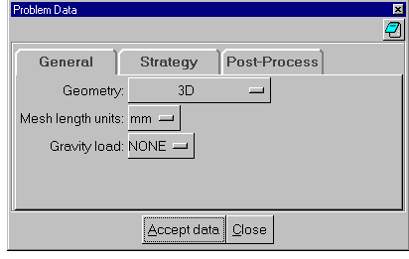

Mesh length Units

This option offers the possibility to define the CAD geometry either in meter or in millimeter. It is important to observe that even if the user decides to input the geometry in millimeters, the code will transforms the nodal coordinates according to the International System of Units and this means in meters. Also note that the material data-base it is defined using the International System of Unit.

Geometry

Using this option it is possible to specify the geometrical dimension of the problem to be analyzed that is either 3D analysis, or both 2D plane-strain and 2D axial-symmetrical conditions.

Gravity load

This card let the end user consider the gravity load according to the selected direction. Option NONE neglects the gravity load effects.

2 Strategy

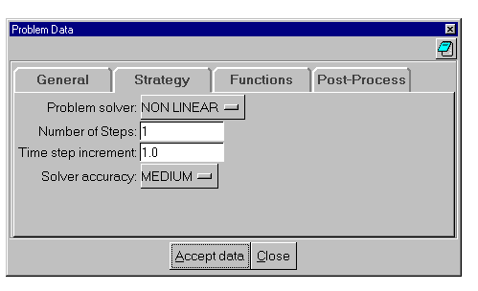

Problem solver

This card defines the type of solver to be used for the analysis. Two options are available:
- LINEAR solver, that should be used for all kind of linear elastic problems without contact.
- NON LINEAR solver, to be used for non-linear quasi-static problems: this means either non-linear constitutive equation (i.e. elasto-plastic material) or analysis that include contact computations.

Observe that in case of linear analysis a direct solution of the linear system of equations will be performed while in case of non-linear problem a full Newton-Raphson algorithm will be applied. In this case a NUMBER OF STEP and a TIME STEP INCREMENT must be defined according to the loading and boundary conditions defined.

Solver accuracy

In case of non-linear analysis it is also necessary to define a solver accuracy that internally define a convenient tolerance for the non-linear Newton-Raphson solver.

3 Functions

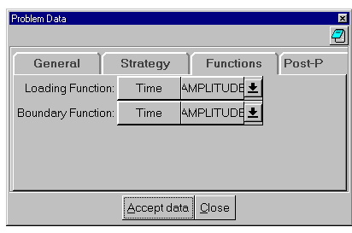

This window appears only in case of non-linear problems. In fact only in this case it is necessary to define a convenient loading-path according to the non-linearity of the constitutive equations.

Loading Function

The user has the possibility to enter a piece-wise function which define the loading-path to be followed step-by-step during the time incrementation. The load applied is computed as the product of this function with the value of the load assigned in the loading condition window.

Boundary Function

Also in this case, the user should define a piece-wise function which define the boundary-path (that is the movement prescribed to the selected nodes of the structure) to be followed step-by-step during the time incrementation. For each time step the prescribed displacement are computed as the product of the boundary function by the prescribed value assigned in the constraint condition window.

4 Post-Process

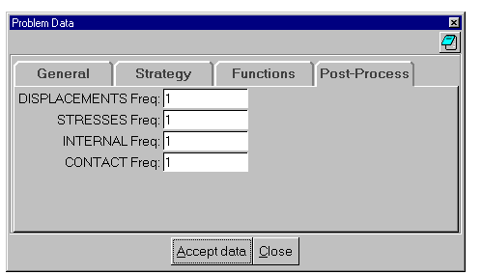

The mechanical results are dumped according to the time step frequency defined by the user. If the user sets 1 it means that the results are dumped at each time step. Note that in case of linear analysis only one set of results is dumped. In this case the post-process frequency should be set to 1. Be careful with this parameter not to generate enormous results files.

Conditions Window

Opening the condition window the user will be able to assign the necessary analysis-condition either to geometrical entities (points, lines, surfaces and volumes) or to mesh entities (nodes and elements).

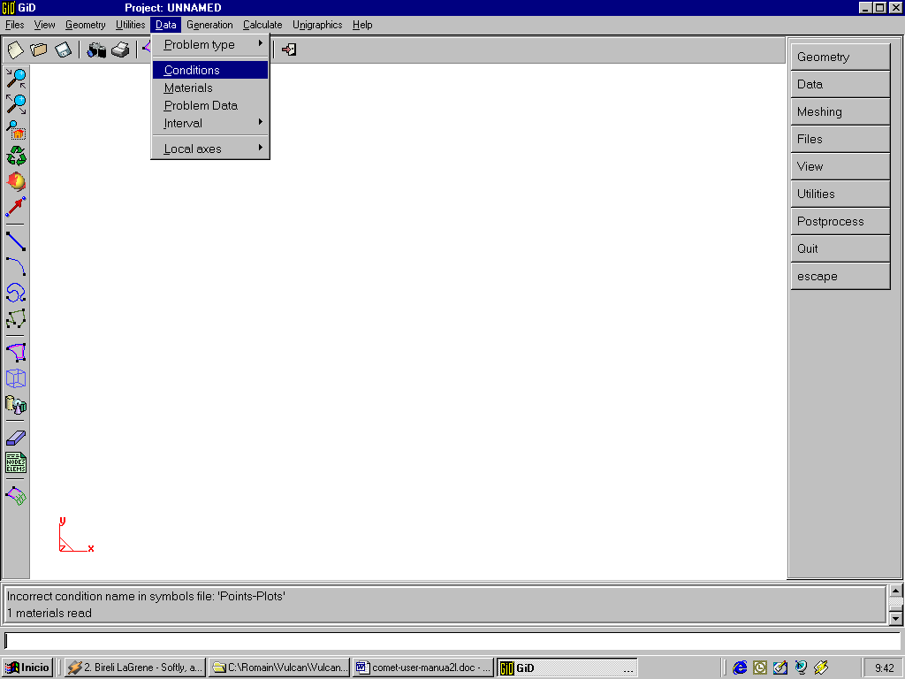

1 Points conditions

These conditions should be applied only on points entities.

a) Points-Constraints condition

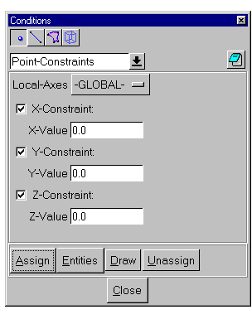
The Points-Constraints condition will be used to assign the boundary conditions to the geometry. The Local-Axes option offers the possibility to use the global or local axes to assign the constraints.

b) Points-Load condition

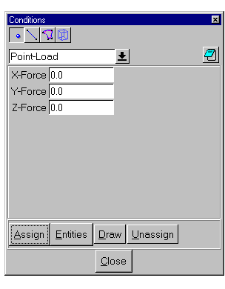

The Points-Load condition will be used to assign the load conditions to the geometry points by defining each component of the load applied.

2 Line conditions

These conditions should be applied only on lines entities.

a) Line-Constraints condition

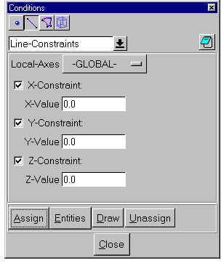

The Line-Constraints condition will be used to assign the boundary conditions to the lines within the geometry. The Local-Axes option offers the possibility to use the global or local axes to assign the constraints.

b) Face-Load condition

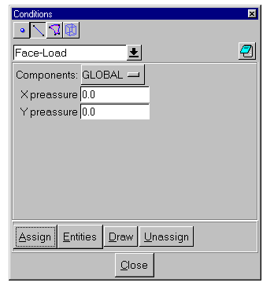

The Face-Load condition will be used to assign the load conditions to the geometry for 2D problems. The Local-Axes option offers the possibility to use the global or local axes to assign the components of the pressure.

c) Slave-2D condition

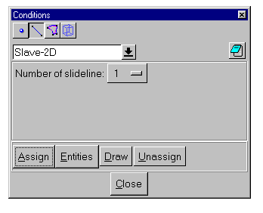

Mechanical contact between two 2D bodies (surfaces) can be defined using Slave-2D and Master-2D line-conditions. Each mechanical contact is defined by two lines: one is called slave and the other one is called master: contact algorithm does not allow slave nodes of slave-2D line to penetrate the master-2D line.

The Slave-2D condition is used to define the slave line.

Note that it is possible to define different pairs of mechanical contacts (slide-lines): each one is identified by a slide-line identifier (Number of slideline). There will exist mechanical contact constraint only between Slave-2D and Master-2D lines with the same identifier.

d) Master-2D condition

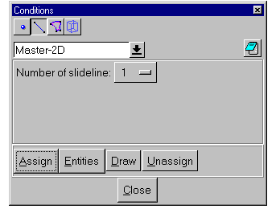

Mechanical contact between two 2D bodies (surfaces) can be defined using Slave-2D and Master-2D line-conditions. Each mechanical contact is defined by two lines: one is called slave and the other one is called master: contact algorithm does not allow slave nodes of slave-2D line to penetrate the master-2D line.

The Master-2D condition is used to define the master line.

Note that it is possible to define different pairs of mechanical contacts (slide-lines): each one is identified by a slide-line identifier (Number of slideline). There will exist mechanical contact constraint only between Slave-2D and Master-2D lines with the same identifier.

3 Surface_Conditions

These conditions should be applied only on surface entities.

a) Surface-Constraints Condition

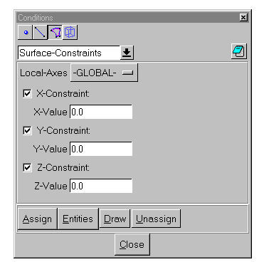

The Surface-Constraints condition will be used to assign the boundary conditions to the selected surfaces in the geometry. Both constraint and rigid movements can be defined using this condition.
The Local-Axes option offers the possibility to use the global or local axes to assign the constraints.

b) Surface-Load Condition

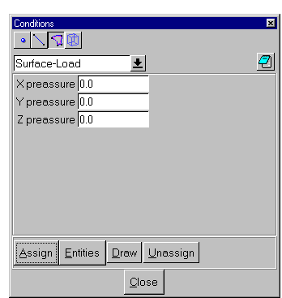

The Surface-Load condition will be used to assign the pressure components to the surfaces within the geometry. This condition is available only for 3D problems.

c) Slave-3D Condition

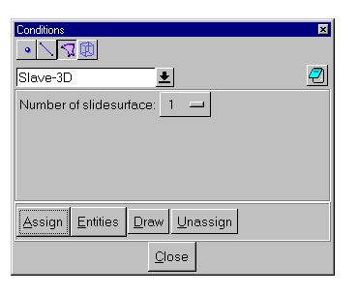

Mechanical contact between two 3D bodies (volumes) can be defined using Slave-3D and Master-3D surface-conditions. Each mechanical contact is defined by two surfaces: one is called slave and the other one is called master: contact algorithm does not allow slave nodes of slave-3D surface to penetrate the master-3D surface.

The Slave-3D condition is used to define the slave surface.

Note that it is possible to define different pairs of mechanical contacts (slide-lines): each one is identified by a slide-line identifier (Number of slideline). There will exist mechanical contact constraint only between Slave-3D and Master-3D surface with the same identifier.

d) Master-3D Condition

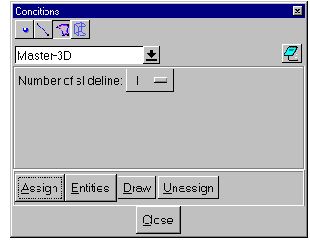

Mechanical contact between two 3D bodies (volumes) can be defined using Slave-3D and Master-3D surface-conditions. Each mechanical contact is defined by two surfaces: one is called slave and the other one is called master: contact algorithm does not allow slave nodes of slave-3D surface to penetrate the master-3D surface.

The Master-3D condition is used to define the master surface.

Note that it is possible to define different pairs of mechanical contacts (slide-lines): each one is identified by a slide-line identifier (Number of slideline). There will exist mechanical contact constraint only between Slave-3D and Master-3D surface with the same identifier.

4 Volume_Conditions

These conditions should be applied only on volume entities.

a) Volume-Constraints Condition

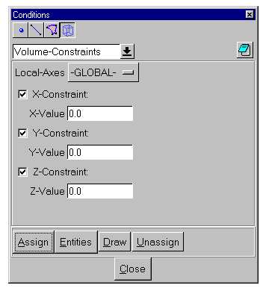

The Volume-Constraints condition will be used to assign the boundary conditions to the selected volumes in the geometry. Body constraint or rigid body movements can be defined using this condition.

Materials window

Using the following windows it is possible to assign to each surface (2D analysis) or volume (3D analysis) a corresponding material. It is possible to select between different materials within the material data-base.

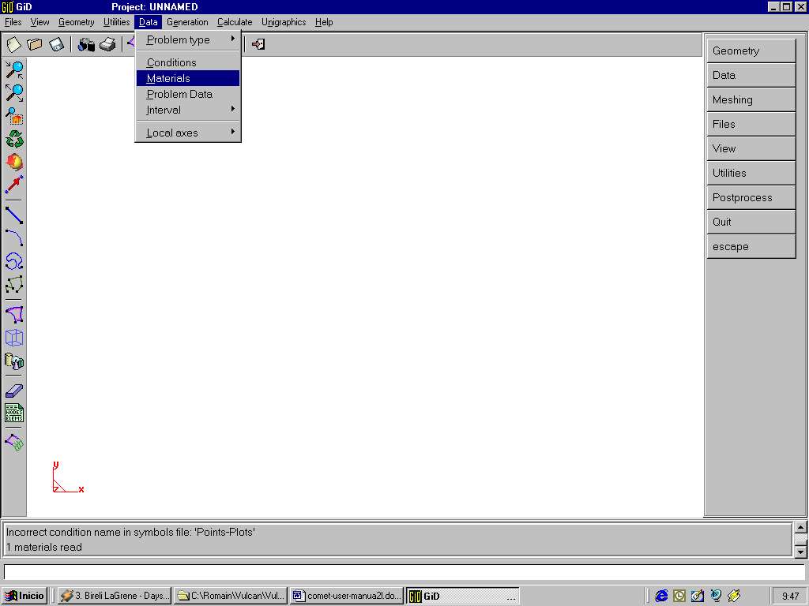

1 Materials data-base

a) General

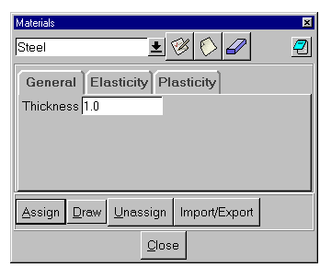

In this section it is possible to define the thickness of the material to be used during the simulation just in case of a 2D problem within 2D plain-strain formulation.

b) Elasticity

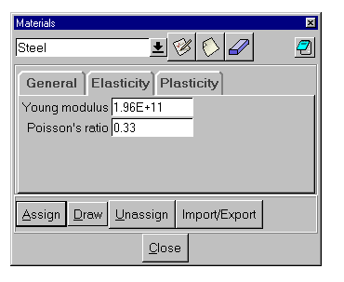

In this section it is possible to define the elastic properties of the selected material such as Young modulus and Poisson’s ratio.
c) Plasticity

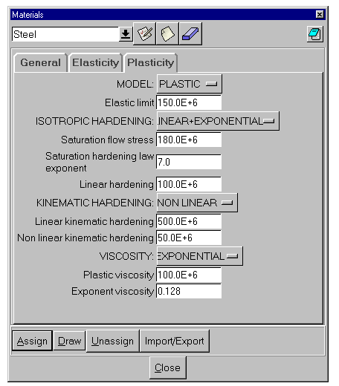

Here, the user has the possibility to define the plastic properties of the selected material:
- Perfect plasticity:
- Elastic limit
- Considering Isotropic Hardening:
- Saturation flow stress
- Saturation hardening law exponent
- Linear hardening coefficient
- Considering Kinematic Hardening:
- Linear kinematic hardening coefficient
- Non-linear kinematic hardening coefficient
- Considering plastic Viscosity:
- Plastic viscosity coefficient
- Exponent for exponential viscosity law

