Project Report On

ROADSIDE VEHICLE

ASSISTANCE

By

ADITYA NANDKISHOR MESTRY

(Roll No : 16)

# Table of Contents

|  |  |  |
| --- | --- | --- |
| **Sr.No** | **Topic** | **Page No.** |
| 1 | Introduction | 3 |
| 2 | Preface | 4 |
| 3 | Project Synopsis | 5 |
| 4 | Hardware/Software Specifications | 6 |
| 5 | Requirement Analysis   1. Problem Recognition 2. Problem Evaluation & Synthesis | 7 |
| 6 | System Testing | 8-9 |
| 7 | Project Analysis and Design | 10-11 |
| 8 | Screenshots and codings | 12-19 |
| 9 | Conclusion | 20 |
| 10 | Bibliography | 21 |

## INTRODUCTION

**Project Name:** Roadside Vehicle Assistance

When it comes to car breakdown, it could mean more than just the car’s technical defects as it could lead to injuries and fatalities because getting out of the car to check for breakdowns can be very dangerous especially on a highway as people are driving very fast. Based on Federal Highway Administration statistics (United States), there are approximately 4,000 fatalities and almost 60,000 injuries from roadside crashes. In this event, it is best to seek for the professional’s help which is the Car Repair Service Providers (CRSP) as they are more knowledgeable and for personal safety on the road as well. Contacting the Car Repair Service Providers is the main concern at this point as the public has limited information to the providers.

## PREFACE

Today, the world is considered as world of Information Technology i.e. Software. Many things are getting automated i.e. tasks which were done manually before, now have become computerized.

Tendency of a student behind the project is to get marks and see to it that less time is spent, but fame doesn’t come within a day.

We undertook this project asking ourselves, following questions:

* + What we study is only bookish?
  + Can we implement it?
  + Whether what we have studied is only for study purpose and scoring marks?
  + Can we make practical use of our knowledge?

Above questions, our ideas and imagination, determination to do something, encouragement and guidance from our teachers, parents and friends gave us confidence for designing this project.

## PROJECT SYNOPSIS

This vehicle management system is fully customized web application where company staff can view each customer order and give a solution to those vehicle problems**.** Admin handles and can access the user details. Admin has the access to allow/block and view the mechanics. This online mechanic locator reduces your work and can easily find the mechanics from various areas.

Reduces your time and cost.

Modules and their Description

The system comprises of 1 major modules with their sub-modules as follows:

## User:

* 1. **Register:** User can register with all their details.
  2. **Login:** Registered user can Login with their credentials.
  3. **Send Request:** On selection of the mechanics, the user can send the request to the respective mechanic.

## HARDWARE/SOFTWARE REQUIREMENT SPECIFICATION

The minimum hardware requirement component list for system is:

|  |  |
| --- | --- |
| **Processor Type** | Intel CORE i3 (7th Generation) or higher |
| **System RAM** | 4 MB or higher |
| **Hard Disk** | 80 GB or higher |

The minimum software requirement component list for system is:

|  |  |
| --- | --- |
| **Operating System** | Windows 7 |
| **Server** | Xamp Server |
| **Database** | MySQL |
| **Languages** | HTML, PHP & CSS |

## REQUIREMENT ANALYSIS

Requirement analysis task is a process of discovery, refinement, modeling and specification. Both the developers and customers take an active role in requirement analysis. Requirement analysis is a communication intensive activity. Requirement analysis can be divided into:

## Problem Recognition

* + **Problem Evaluation & Synthesis**

**5.1 Problem Recognition**

The goal of this step is recognition of basic problem elements as indicated by the customer. The basic purpose of this activity is to obtain a thorough understanding of the needs of the client and the user, what exactly is desired from the software and what are the constraints on the solution.

Problems of the existing system:

* + - Security can’t be assured
    - Delay in storing and retrieving information
    - Possibility of human errors

## 5.2 Problem Evaluation & Synthesis

In this step analyst must define all externally observable objects, evaluate flow and control of the information, define and elaborate all software functions, understand. Software behavior and design, constraints etc. Evaluation and synthesis continues until both analyst and customer field confident about the product.

Once the problems are identified, evaluation process begins. After evaluation of the current problem and desired in formations, the analyst synthesis one or more solutions.

* + - Security can be assured
    - Cost effective
    - No chance of errors

## SYSTEM TESTING

System testing is a critical aspect of Software Quality Assurance and represents the ultimate review of specification, design and coding. Testing is a process of executing a program with the intent of finding an error. A good test is one that has a probability of finding an as yet undiscovered error. The purpose of testing is to identify and correct bugs in the developed system. Nothing is complete without testing. Testing is the vital to the success of the system.

In the code testing the logic of the developed system is tested. For this every module of the program is executed to find an error. To perform specification test, the examination of the specifications stating what the program should do and how it should perform under various conditions.

Unit testing focuses first on the modules in the proposed system to locate errors. This enables to detect errors in the coding and logic that are contained within that module alone. Those resulting from the interaction between modules are initially avoided. In unit testing step each module has to be checked separately.

The testing steps performed in are given below:

## Unit testing

* **Integration testing**
* **Validation testing**

**6.1 Test Results**

The primary goal of software implementation is the production of source code that is easy to read and understand. Clarification of source code helps in easier debugging, testing and modification. Source code clarification is enhanced by structural coding techniques, by good coding style, by appropriate supporting documents, by good internal comments and by the features provided in the modern programming language.

In our implementation phase, source code contains both global and formal variables. It contains predefined functions as well as the user defined functions. The result of the new system is compared with the old system and supposes the result is wrong the error must be debugged.

After the acceptance of the system by the user, the existing system must be replaced by this new system. Any user can work in this package very easily. It does not require any intensive training for the user. Procedures and functions in the system are very simple that anyone can understand and correspondingly act to the system with no difficulty.

## 6.2 Test Cases

***User Authentication:***

|  |  |  |
| --- | --- | --- |
| ***Functions Tested*** | ***Expected Result*** | ***Test Result*** |
| User should enter correct and both User Name and password | When the user enters only one or none, login screen will display an  error message | As expected |
| Logout when user wants to discontinue login  section | User is directed to login page | As expected |

***Field Checking:***

|  |  |  |
| --- | --- | --- |
| ***Function Tested*** | ***Expected Result*** | ***Test Result*** |
| Name | The name of the user is entered here. It can contain only characters  and blank space | Test Successful |
| Age | This should only contain  numbers. | Test successful |
| Gender | This field contains single  character ‘f’ or’m’ | Test successful |
| Password | This field contains both alphabets,numbers&  special characters. | Test successful |

## Project Analysis and Design E-R diagram

Problem

Address

An entity-relationship (ER) diagram is a specialized graphic that illustrates the interrelationships between entities in a database. ER diagrams often use symbols to represent different types of information.

Lastname

City

FirstName

PhoneNo

Emailid

Password

Emailid

User

Name

Phoneno

Password

Login

Emailid

User Request

## DFD diagram

**Data Flow:** An arrow represents a data flow; it represents the path over which data travels in the system. A data flow can move between processes, flow into or out of data stores, to and from external entities.

**Bubbles (Process):** A circle or bubble represents that transforms data from once form to another by performing some tasks with the data.

**Data store:** A data store is a place where data is held temporarily from one transaction to the next or is stored permanently.

**The DFD of the “Courier Management System”**

Each break-up has been numbered as per the rule of DFD. Here we attempted to incorporate all the details of the system and still it requires further improvement since the entire system is under study:

# PROCESSING OF System

**System**

**DB Tracking**

**User Request**

**System**

**User**

**DB**

**Operations**

## Coding and Screenshots Coding:

**Home.php page:**

<html>

<head><title>Home Page</title>

<style>

html,body{

min-height:100%; margin-top:0px;

}

#image{

background-image:url('/project/background.jpg'); background-repeat:no-repeat;

background-size:100%; min-height:140%;

}

#center{

}

margin-left:350;

h1,h2{

color:black;

text-align:center;

}

footer{

text-align:center; font-family:cursive; font-size:10px;

}

.carousel-inner{

text-align:center;

}

p{

color:blue;

}

</style>

<link rel="stylesheet" type="text/css" href="/project/style/core.css" />

<link rel="stylesheet" type="text/css" href="engine1/style.css" />

<script type="text/javascript" src="engine1/jquery.js"></script>

<!-- Latest compiled and minified CSS -->

<link rel="stylesheet" href="https://maxcdn.bootstrapcdn.com/bootstrap/3.3.7/css/bootstrap.min.css" integrity="sha384- BVYiiSIFeK1dGmJRAkycuHAHRg32OmUcww7on3RYdg4Va+PmSTsz/K68vbdEjh4u" crossorigin="anonymous">

<!-- Optional theme -->

<link rel="stylesheet" href="https://maxcdn.bootstrapcdn.com/bootstrap/3.3.7/css/bootstrap-theme.min.css" integrity="sha384- rHyoN1iRsVXV4nD0JutlnGaslCJuC7uwjduW9SVrLvRYooPp2bWYgmgJQIXwl/Sp" crossorigin="anonymous">

<script src="https://ajax.googleapis.com/ajax/libs/jquery/1.12.4/jquery.min.js"></script>

<!-- Latest compiled and minified JavaScript -->

<script src="https://maxcdn.bootstrapcdn.com/bootstrap/3.3.7/js/bootstrap.min.js" integrity="sha384- Tc5IQib027qvyjSMfHjOMaLkfuWVxZxUPnCJA7l2mCWNIpG9mGCD8wGNIcPD7Txa" crossorigin="anonymous"></script>

</head>

<body>

<?php include "header.php"; ?>

<div id="image">

<p> <h1 style=color:black;>Roadside assistance</h1></p>

<br>

<h2 style=color:black;>Flat tyre, dead battery or immobilized vehicle..whatever may be the<br> problem,we help you get back on the road with just a quick call!

<br><br>

24X7 Service | PAN India Network | Quick Response</h2><br><br><br>

</div>

<h1 style=font-size:45;>Services Offered</h1>

<br>

<br>

<div class="col-sm-6" id="center">

<div id="carousel-example-generic" class="carousel slide" data-ride="carousel">

<!-- Indicators -->

<ol class="carousel-indicators">

<li data-target="#carousel-example-generic" data-slide-to="0" class="active"></li>

<li data-target="#carousel-example-generic" data-slide-to="1"></li>

<li data-target="#carousel-example-generic" data-slide-to="2"></li>

<li data-target="#carousel-example-generic" data-slide-to="3"></li>

<li data-target="#carousel-example-generic" data-slide-to="4"></li>

<li data-target="#carousel-example-generic" data-slide-to="5"></li>

</ol>

<!-- Wrapper for slides -->

<div class="carousel-inner" role="listbox">

<div class="item active">

<div>

<h1> Onsite Assitance</h1>

</div>

<img src="/project/onsite1.png" alt="..." height=500px; width=100%; >

<p>Our fully trained representatives are <br>available 24X7< for on-the-spot

<br>assistance and repair.</p>

</div>

<div class="item">

<div>

<h1> Flat Tyre Problem</h1>

</div>

<img src="/project/flat.png" alt="..." height=500px; width=650px;>

<p> Our technicians will replace your <br>vehicle'sflat tyre with our spare, <br>in caseyou do not have enough spare <br>tyre(s)</p>.

</div>

<div class="item active1">

<div>

<h1>Dead Battery</h1>

</div>

<img src="/project/deadbattery.png" alt="..." height=500px; width=650px;>

<p>Our technicians will jumpstart your <br>vehicle in case of a dead or

<br>discharged battery in a need.</p>

</div>

<div class="item active2">

<div>

<h1>Fuel Empty</h1>

</div>

<img src="/project/fuel.png" alt="..." height=500px; width=650px;>

<p> We will remedy incorrect fuelling.<br> Additionally, 5 litres of fuel

<br>(chargeable separately) can be<br> delivered.</p>

</div>

<div class="item active3">

<div>

<h1>Towing Car</h1>

</div>

<img src="/project/towingcar.png" alt="..." height=500px; width=650px;>

<p> In case on-site repair is not possible, <br>we will provide towing facility <br>to the nearest authorized workshop.</p>

</div>

<div class="item active4">

<div>

<h1> Key Lost or locked</h1>

</div>

<img src="/project/key.png" alt="..." height=500px; width=650px;>

<p>Lost your keys? Keys locked in?<br> Our lockout experts will provide<br> on- site help 24X7.</p>

</div>

</div>

<!-- Controls -->

<a class="left carousel-control" href="#carousel-example-generic" role="button" data- slide="prev">

<span class="glyphicon glyphicon-chevron-left" aria-hidden="true"></span>

<span class="sr-only">Previous</span>

</a>

<a class="right carousel-control" href="#carousel-example-generic" role="button" data- slide="next">

<span class="glyphicon glyphicon-chevron-right" aria-hidden="true"></span>

<span class="sr-only">Next</span>

</a>

</div>

</div>

</body>

</html>

## Screenshots: Home.php

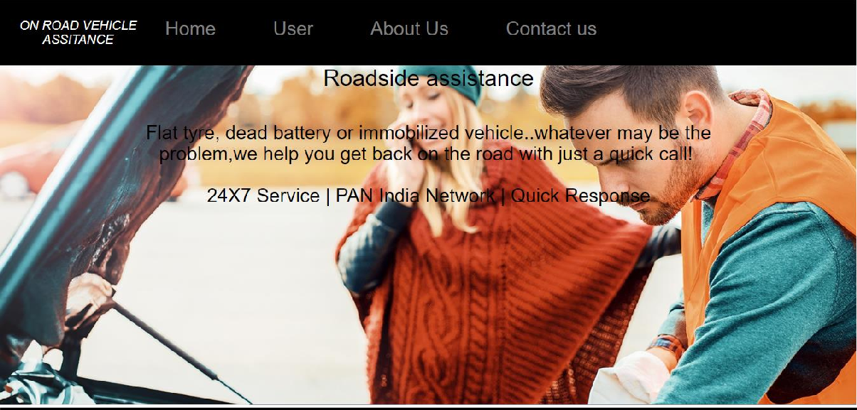

**User.php**

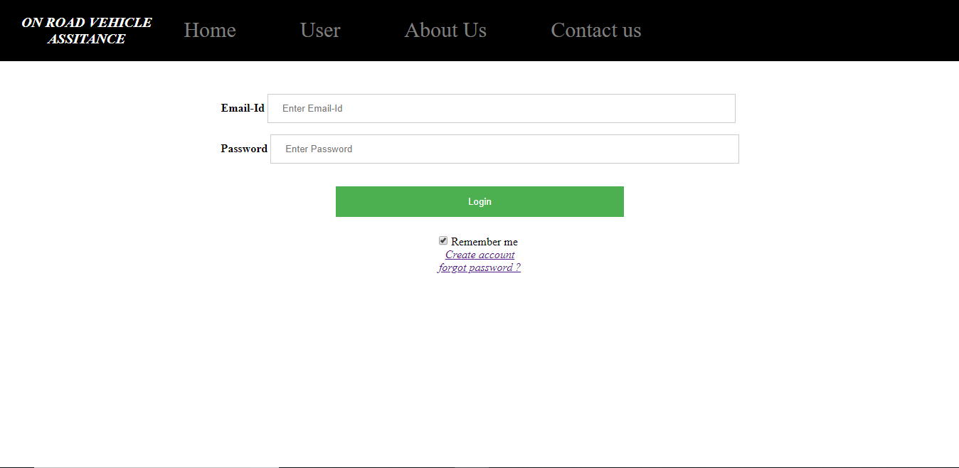

**Registeration.php**

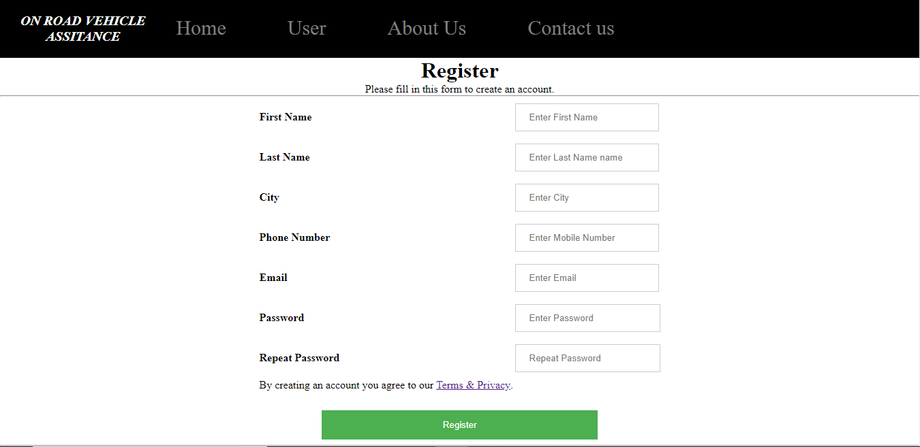

**Forgotpassword.php**

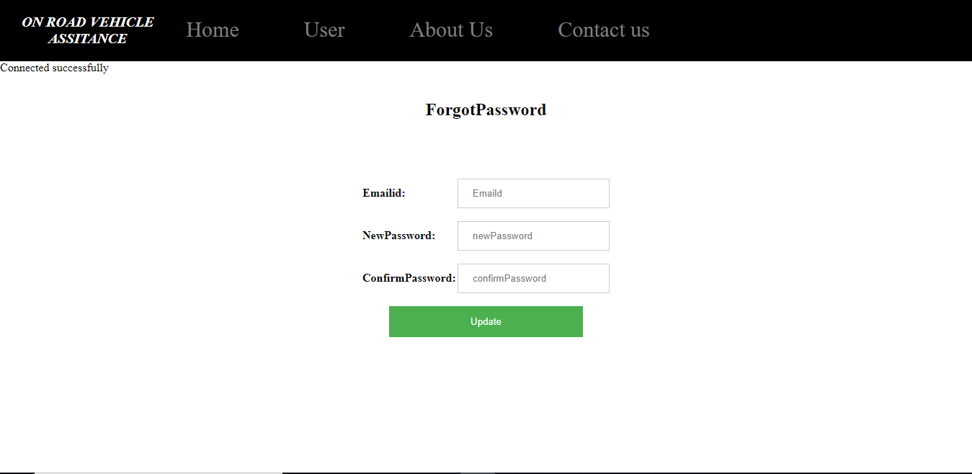

1. **Conclusion:**

In conclusion, the problems faced by the drivers are not solely car breaking down. Car breakdown will cause frustration to the driver, the frustration will then cause the driver to make bad decisions and being scammed by the tow truck scammers. Another problem is getting help from workshops or mechanics. One who does not possess any workshop’s number can only rely on the help of a car passing by and risk being scammed. Based on all these related problems, it is vital to come out with a solution that can solve these problems. Revising back the background studies, the current way of how people obtain service from workshops might be satisfying such as the service provided by Automobile Association of Malaysia (AAM), the existing application such as CarBengkel might be designed to be more helpful for those who faces car breakdown difficulties, however the development of this project aims to improve the way on how the public contact the CRSP and to provide convenience for both sides. The development of this Car Breakdown Service Station Locator System also aims to overcome the flaws of some of the existing applications in the market. With open source resources, the development cost of this Car Breakdown Service Station Locator System is being kept to a minimum and that is why it is capable of providing assistance to the user with free of charge on the application download. The development of this application also fits the purpose of education studies and meets the requirement as stated in early stages and of course providing help to people who are in need.

## Biblography

The sources and references used for our project

* Website- [www.wikipedia.org](http://www.wikipedia.org/).
* Website-[www.stackoverflow.com](http://www.stackoverflow.com/).
* Website-[www.youtube.com](http://www.youtube.com/).