RESOURCES
YouTube: linux help:
https://www.youtube.com/watch?v=iX9AGxlxWYk&list=PLNhl2c1Bs70kYtPpPI1rYe0GINexp9NBI

Elastic Unified Communication Server Cookbook:

SIP : session Initiation Protocol

RTP: Real Time Protocol

SIP TRUNK:
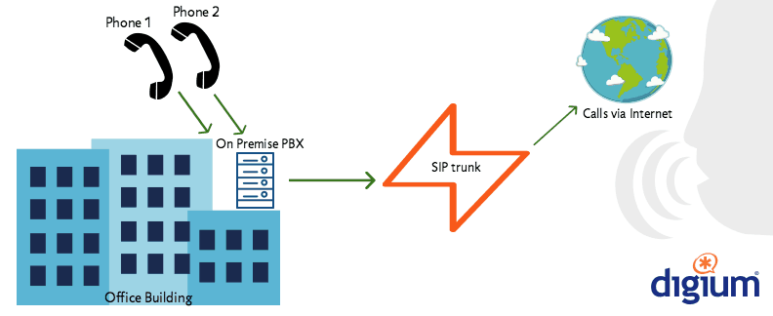

A SIP trunk is the virtual version of an analog phone line. Using SIP trunks, a SIP provider can connect one, two, or twenty channels to your PBX, allowing you to make local, long distance, and international calls over the Internet.

Inbound route:

Outbound route:

Basic PBX configuration:

IAX TRUNK:

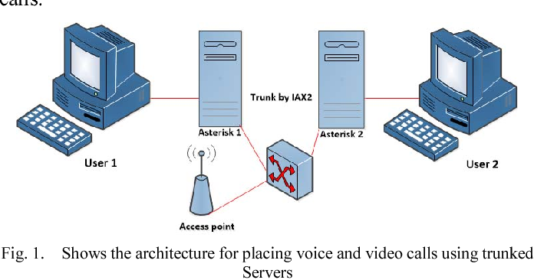

Inter-Asterisk eXchange (IAX) is a communications protocol native to the Asterisk private branch exchange (PBX) software, and is supported by a few other softswitches, PBX systems, and softphones. It is used for transporting VoIP telephony sessions between servers and to terminal devices.
The original IAX protocol is deprecated and has been superseded by a second version, commonly called IAX2. The IAX2 protocol was published as an informational (non-standards-track) RFC 5456 by discretion of the RFC Editor in February 2010.[1]

CISCO PHONE PROVISIONING:
- check IP, MAC MODEL No. of phone from settings > network info from within the phone
- reset CISCO phone from admin section within the phone.
- Make an extension for the phone in any of PBX server.
- Now we need conf.xml file for phone provisioning.
- For configuration file, cisco phone uses TFTP protocol. It automatically pulls config file from TFTP servers which are hosted alongside PBX @udp:69
- TFTP servers should be pointed in cisco phones
- now from http://pbx02.wlink.com.np/phoneprovision/
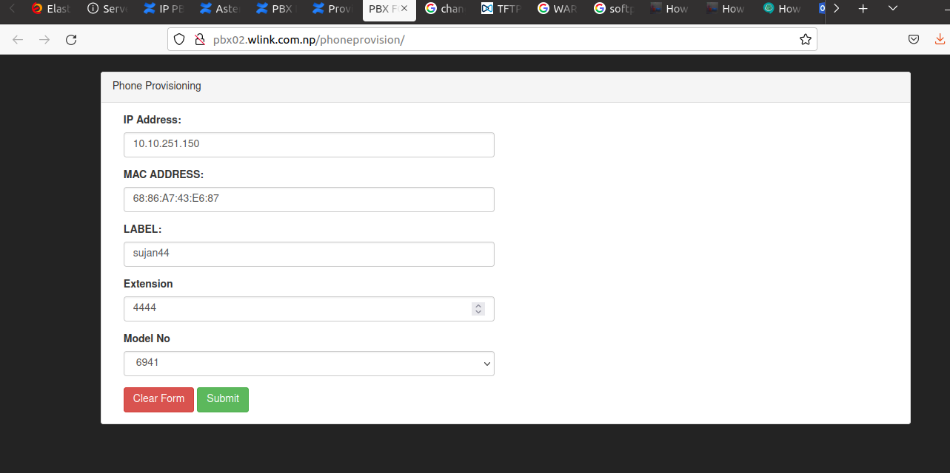

- fill the form accordingly.
- It will creates conf file within / tftpboot/ which is then pulled by cisco phones for further provisioning.

Pairing with NTC:
Pairing with other PBX servers:
IAX trunk:

W1ink23[*], sujan.tmg

Hot line numbers:

youtube videos:

Flow of call within same local, national, international,
self configuration of different PBX.

Second PBX network config:
- static ip address to centos
-Create a file named /etc/sysconfig/network-scripts/ifcfg-eth0 as follows:
- DEVICE=eth0
- BOOTPROTO=none
- ONBOOT=yes
- PREFIX=24
- IPADDR=172.28.255.30
- GATEWAY=172.28.255.250
- DNS1=202.79.32.97
- DNS2=8.8.8.8
- systemctl restart network

SIP vs IAX trunking:

1.IAX is more bandwidth efficient than SIP.
2.SIP is in plain text while IAX is not.
3.IAX is not as extensible as SIP.
4.IAX vulnerable to resource exhaustion attacks while SIP is not.
5.SIP is more popular compared to IAX.

