How yum , apt works;
- get the archive file of <package> for the list of repositories define in sources.list , if found
- save the archive @ /var/cache/apt/archives
- from there, dpkg take over the installation:

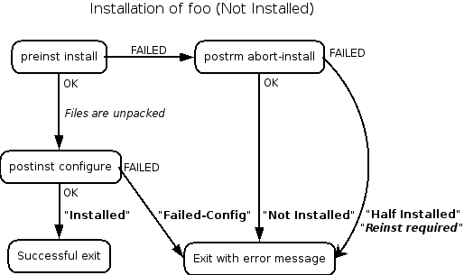
flow-chart of overall package installation process(apt)
apt-update:

- create update list of packages that are installed in the system, it updates it information about the latest version, latest dependencies of installed package from the list of sources define in sources.list

File system

User administration

Archiving

Finding and processing

Job scheduling

LVM

Swap

LDAP

ACL permission

Chronyd

SUID

SGUID

Stickybit

NTP your time zone;

Creating new kernel

Autofs:

What is that linux can but windows cant do..?
- trying without installing, live boot in RAM
- update without restart
- work whole year without a restart
- linux updates are more graceful than windows

.so file type: shared object file, dynamically loaded at runtime
.a file type: static file , static loaded and become part of application.
"d" stands for directory and such a directory is a collection of configuration files which are often fragments that are included in the main configuration file. The point is to compartmentalize configuration concerns to increase maintainability.

#sudo and sudoers.

The sudo command allows non root users to run commands that would normally require super user privileges, while the sudoers file instructs the system how to handle the sudo command.

search In resolve.conf:
To explain, consider the entry in /etc/hosts as below:
192.168.1.10 web.example.com
Now, if I want to ping #ping web.example.com it will serve the request, But what if I do #ping web, it will say "temporary failure..." and won't serve the request.
So to serve the request, I have to write an entry in /etc/resolve.conf as search example.com.
(Yeah, we can also append in /etc/hosts file).
Now if you do the ping web, it will append example.com to your request and serve.
To explain, consider the entry in /etc/hosts as below:
192.168.1.10 web.example.com
Now, if I want to ping #ping web.example.com it will serve the request, But what if I do #ping web, it will say "temporary failure..." and won't serve the request.
So to serve the request, I have to write an entry in /etc/resolve.conf as search example.com.
(Yeah, we can also append in /etc/hosts file).
Now if you do the ping web, it will append example.com to your request and serve.

- restart = stop + start
- reload = remain running + re-read configuration files.

Linux routing and network options in sysconfig.
Interpreting IP ROUTE table:

The export command is a built-in utility of Linux Bash shell. It is used to ensure the environment variables and functions to be passed to child processes. It does not affect the existing environment variable.
-
Opensuse IP setting:
https://forums.opensuse.org/showthread.php/431523-Configure-Static-Ip-using-the-Terminal
Filesystem vs partition tables:

ARP: Address resolution protocol which maintains IP to MAC tables.
Significance: used for host detection
- why use as there is ping for host detection test
– ping could be blocked with firewall rules but not arp request reply packet.
- you should be in the same network of the target host for arp to work.
Synopsis:
- arping -I <interface> <target_ip>

