PostgreSQL architecture diagram (composition structure and relationship)
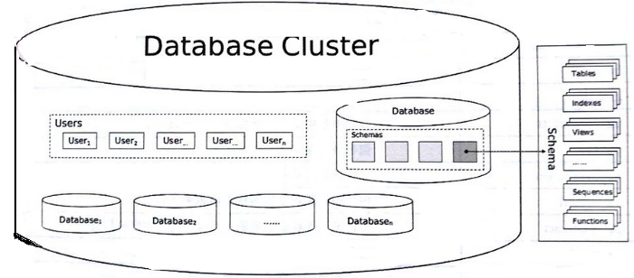
fig: architecture of postgres DB

Basic architecture of Postgres system
PostgreSQL uses the client/server (C/S) model to provide services. A PostgreSQL session consists of the following related processes (programs):
(1) A server-side process. This process manages the database files, accepts the connection between the client and the database, and operates the database on behalf of the client. The program name of this process is called postgres.
(2) Front-end applications, that is, client applications that require database operations. Client applications may be diverse in their own right: they can be a character interface tool, a graphical interface application, or a web server that displays web pages by accessing a database, or a special database management tool . Some client applications are provided with the PostgreSQL release, but most of them are developed by users.
Like a typical client/server application (C/S application), the client and server can be on different hosts. At this time, they are connected via TCP/IP, you should keep this in mind, because the files that can be accessed on the client may not be accessible on the database server machine (or can only be accessed with a different file name).
The PostgreSQL server can handle multiple concurrent requests from the client. In order to handle this, it will start (“forks”) a new process for each request, and then the client and the new server process will no longer communicate directly through the original postgres process. Therefore, the main process on the server side has been running, waiting for the connection from the client; the client and the associated server-side process will only run when needed. (Of course, these are transparent to the user, and I talk about them here mainly for the sake of completeness.)

PostgreSQL is composed of five parts: connection management system (system controller), compilation execution system, storage management system, transaction system, and system table.
The connection management system accepts external operation requests to the system, preprocesses and distributes the operation requests, and plays the role of system logic control;
The compilation execution system consists of a query compiler and a query executor, which completes the analysis processing and conversion of operation requests in the database, and finally realizes the operation of the data in the physical storage medium;
The storage management system is composed of an index manager, a memory manager, and an external memory manager. It is responsible for storing and managing physical data and providing support for the compilation query system;
The transaction system is composed of a transaction manager, log manager, concurrency control, and lock manager. The log manager and transaction manager complete transaction consistency support for operation requests. The lock manager and concurrency control provide consistency for concurrent access to data stand by;
The system table is the meta information management center of the PostgreSQL database, including database object information and database management control information. The system table manages metadata information and organically connects the various modules of the PostgreSQL database to form an efficient data management system.
System table
In relational database, in order to realize the control of database system, the function of data dictionary must be provided. The data dictionary not only stores descriptive information of various objects, but also stores detailed information of various objects required for system management. The data dictionary contains the description information of all objects and their attributes in the database system, the description information of the relationships between the objects, the natural language meaning of the object attributes and the history of the data dictionary changes. The data dictionary is the core of the relational database system management and control information. In the database system, system tables play the role of data dictionary.
The system table is the place where the PostgreSQL database stores structural metadata. It is represented in PostgreSQL as a common table or view that stores system information (users can delete and rebuild).
The system table stores all the metadata of the database, so the system table access is very frequent when the system is running. In order to improve system performance, shared system tables have been created in memory, and hash tables have been used to improve query efficiency.

Pgadmin:
sudo rpm -i https://ftp.postgresql.org/pub/pgadmin/pgadmin4/yum/pgadmin4-fedora-repo-2-1.noarch.rpm

# Install for both desktop and web modes.
sudo yum install pgadmin4
sudo systemctl start httpd && sudo systemctl enable httpd

sudo /usr/pgadmin4/bin/setup-web.sh

#connect to database in postgres:
https://www.enterprisedb.com/postgres-tutorials/connecting-postgresql-using-psql-and-pgadmin

