Installation:
vm = 172.28.255.16

https://www.digitalocean.com/community/tutorials/how-to-install-bacula-server-on-centos-7

bconsole:
- cant connected to bacula-dir @ 9101
- port 9101 not listening : changing “DirAddress = 172.28.255.16”
- changing password in “bconsole.conf” Password=”@@DIR_PASSWORD@@” of Director{ ..}

Jobs and schedules
- each task are performed with jobs. Jobs are specified with: . A backup job generally consists of a FileSet, a Client, a Schedule for one or several levels or times of backups, a Pool
Pools, volumes and labels
volume1

- circle = Pool
volume4
- rectangle = volumes,
volume3
- volume1, volume2 , .. are all labels.
volume2

- Director
- storage
- file
- console
- monitor
- catalog

BACULA-director-test
- BACULA-storage-test
- BACULA-storage-II
- BACULA-filedisk-test

- Bacula director = 172.28.255.17
- storage = .19, gets corrputed when trying to clean with command
“ find / -type d -name “bacula” -exec rm -rf {} \;
and “fiind / -type d -name “sql” -exec rm -rf {} \; ” “

- file disc = .18
bacula-dir.conf

bacula-sd.conf

bacula-fd.conf

bconsole.conf

Using postgresql as Database.

https://www.hostinger.com/tutorials/how-to-install-postgresql-on-centos-7/

Issue:
connecting to storage deamon:
dont forget to mount storage device : permission error, bacula needs read, write and execute permission .

No full backups found:

Director:
- director address, password
- storage address, password
- catalog address, password
- job for backup, job for restore
- file set ; what to store

Job type:
Verify
Run a verify Job. In general, verify jobs permit you to compare the contents of the catalog to the file system, or to what was backed up. In addition, to verifying that a tape that was written can be read, you can also use verify as a sort of tripwire intrusion detection.

Bootstrap:
-

Retention period
- job retention
- volume retention
- pool retention
purge:

purne:

ANSIBLE
Ansible is a radically simple IT automation engine that automates cloud provisioning, configuration management, application deployment, intra-service orchestration, and many other IT needs.
- written in YAML
- set of instructions are packaged in “ansible modules”
-
Getting backup

- make a test directory,
- add some dummy files to it.
- Now change Fileset to backup @ bacula-dir.conf, in Fileset resources
- login to bacula console
- assign label
- Enter name of volume:
- select pools (make sure that bacula-fd is running in the client machine and director is pointing to the client)
- type “run” in console to run backing up:
- select job as you want to backup
- we can view the director status with “status director” cms
- browse to the backup folder to verify the backup

Getting restore:

- connect to bacula console
- type command “restore all“
- Enter 5 to backup recent file
- select full set
- latest backup would be selected.
- Enter “done”
- view director status with “ status director” command
- browse to restore directory to check if restore success.

1) three new vms
install all packages with ansible:

2) bacula-director
3) bacula-storage
4) bacula-fd

Core(warning): Certificate received from server is NOT trusted by this system, an exception has been added by the user to trust this specific certificate.
Failed to initialize NLA, do you have correct Kerberos TGT initialized ?
Core(warning): Certificate received from server is NOT trusted by this system, an exception has been added by the user to trust this specific certificate.
Connection established using SSL.

Solution:

ANSIBLE
Ansible is a radically simple IT automation engine that automates cloud provisioning, configuration management, application deployment, intra-service orchestration, and many other IT needs.
- written in YAML
- set of instructions are packaged in “ansible modules”

While there are many popular configuration management tools available for Linux systems, such as Chef and Puppet, these are often more complex than many people want or need. Ansible is a great alternative to these options because it offers an architecture that doesn’t require special software to be installed on nodes, using SSH to execute the automation tasks and YAML files to define provisioning details.

Installation:
on ubuntu 20.04 ( https://www.digitalocean.com/community/tutorials/how-to-install-and-configure-ansible-on-ubuntu-20-04)
- cant get permission for ssh from local machine.

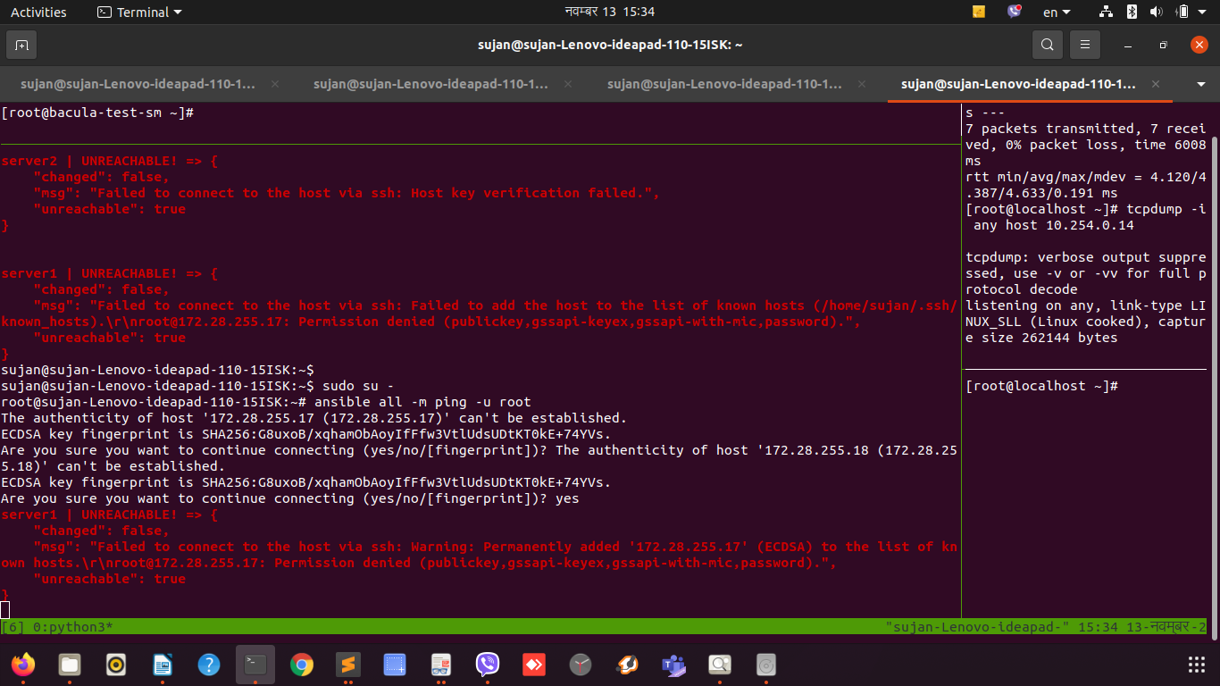
Fig: issues while “ansible all -m ping -u root

Installation on centos:
$ sudo yum install epel-release
$ sudo yum install ansible

Tips:
- keep it simple: If something feels complicated, it probably is. Take the time to look for a simpler solution.

Before getting started, we need to define some terminology:
Control node: the host on which you use Ansible to execute tasks on the managed nodes
Managed node: a host that is configured by the control node
Host inventory: a list of managed nodes
Ad-hoc command: a simple one-off task
Playbook: a set of repeatable tasks for more complex configurations
Module: code that performs a particular common task such as adding a user, installing a package, etc.
Idempotency: an operation is idempotent if the result of performing it once is exactly the same as the result of performing it repeatedly without any intervening actions

Pool {
Name = File
Pool{
Pool = File
Pool Type = Backup
Recycle = yes
recycle Volumes
AutoPrune = yes
Volume Retention = 10 days
Maximum Volume Bytes = 4G
Maximum Volume Jobs = 1
Maximum Volumes = 100
LabelFormat = "T${JobName}" #automatic volume labelling
}
:[range]s/{pattern}/{string}/[flags] [count]
:g/pattern/d : remove all matched pattern lines
eg:
- g/e+1/d :

#sujan.tmg : xen-mon-03 : 172.28.2255.21 : bacula-fd
bacula-dir : 172.28.255.16 : bacula-dir (cant run the service on .17 need to troubleshoot)
bacula-sd : 172.28.255.18 : bacula-sd
bacula-fd : 172.28.255.19 : bacula-fd

