udk6@h#*GV
daily_active_horizon_users.sh
/ logger /
/ home / sujan.tmg / scripts /daily_active_horizon_users.sh

ssh log.wlink.com.np -p 3128
Wlink123$#

Horizon and desktop pools |  | Total no. of pools
Horizon.users | Desktop pool 0 | 65
Horizon.users2 | Desktop pool1 | 75
Horizon.users3 | Desktop pool 2 | 105
Horizon.users4 | Desktop pool 3 | 50

horizon-vcs.wlink.com.np
administrator@horizon-vcs.wlink.com.np
Wlink123$#
horizon admin password
hzn_view
udk6@h#*GV

#rdesktop 10.12.7.115
#rdesktop 10.12.7.116

Username: hosting2021\horizon.test
password: wlink123$#

#ncpa.cpl
How would I access the server after I finished installing:

adding to the domain:
- files > this PC > properties > change settings > change >
- now enter computer name and domain.

Got issues with DNS:
- added DNS:

- in run , type ncpa.cpl
- select IPv4
- enter properties
- enter ip and dns

issues with connecting to intranet:
- trust issue when trying to download from bck.wlink.com.np

- server manager > local server > IE enhanced security > off

issues with connecting to internet:
- typical vm network issue, solved by administrator

What is:

- view connection server:
- The Horizon View Connection Server is responsible for connecting the end user to their virtual desktop machine in the data center.

- view composer server:
- The View Composer is used to manage virtual desktops on the vCenter server. Its primary function is to track link-cloned desktops and manage the state and configuration of link-cloned desktops.

- vcenter server:
-vCenter Server is the centralized management utility for VMware, and is used to manage virtual machines, multiple ESXi hosts, and all dependent components from a single centralized location.

- vSPHERE eSXI : hypervisor for server
View composer (10.12.7.115)
- issue @ AD setup

View connection (10.12.7.116))

Before you start the installation, you need to ensure that you have .NET 3.5 SP1 installed
on your server and also the SSL certificate, as we will need this during the installation
process. You will also need to set up a SQL database.

- Create database
- create user account

version mismatched:
- sql server 2019
- sql native 2012, cant find native of 2019
So downgrade server to 2012

instance name: COMPOSERSQL

server only setup: 2012, other database and users waiting to be created:
VMware vSphere
VMware vSphere (formerly VMware Infrastructure 4) is VMware's cloud computing virtualization platform.[2]
It includes an updated vCenter Configuration Manager, as well as vCenter Application Discovery Manager, and the ability of vMotion to move more than one virtual machine at a time from one host server to another

DSN : Data Source Name
In computing, a data source name is a string that has an associated data structure used to describe a connection to a data source. Most commonly used in connection with ODBC, DSNs also exist for JDBC and for other data access mechanisms
How ODBC works:

Error need to be solved.

Database which was created is not supported:

Steps for vmware installation
- need to setup a domain controller:
s/n | Issuse | Solution
1) | Cant login , even administrator can login | Initiate new VM with users already added @ AD.

- view-connection installation
s/n | Issues | solution
1 | Port 80 not free; used by the system | Disabling http service until view connection is not installed:  - # sc config http start=disable

- view composer installation
s/n | Issues | Solution
Sql server installation
1 | Native client installation, only 2012 is supported, | Uninstall all instances of 2019 sql server, and reinstalled of 2012
2 | ODBC cant connect to server | Path to connect server was not correct,  provided: view-composer  solution; view-composer \ viewcomposer
3 | Database created not a supported format | Choose correct native client while adding DSN @ OBDC configuration.
View composer installation
s/n | Issues | Solution
1 | #svid failed to start:  Insufficient privilege for composer installation to start system programs | Tried solution:  - Not a vmware issue  - issue due to certificate which would be solved with “Turn off Automatic Root Certificates Update “  - add user to log user  solution that worked:  - with sql authentication  - create a user in sql database  - make a DSN connecting this database authenticating with sql in odbc.

  - set-up sql server

192.

View Agent:
- software that communicates with view composer.
-installed on windows template

Troubleshooting:

https://searchvirtualdesktop.techtarget.com/tip/VMware-Horizon-View-troubleshooting-guide-for-desktop-admins

s/n | Issues | Solution steps
1 | Users are unable to authenticate
  Reasons:
  - unable to sync with AD
2 | Users receive the error message that no desktop is available
  Reasons:
  - user have no entitlements
  - desktop pool limits exceeds
3 | Users clicks the desktop but don’t get remote session to the desktop
  Reasons:
  - due to firewall blocking port 443 or 8443
  - DNS unable to resolve the IP:
  - network adapter disable
  - anti virus install ( viber installation issue)
  BULK issues:
  - dhcp down, (
4 | Users are dealing with poor UX
  Reasons:
  - network bandwidth
  -
5 | Network adapter disable | - login as a administrator and enable the network adapter enable.
6 | Connecting to <IP> , stuck | reboot
7 | View connection server communication error | - firmware upgrade to 5.5.1
  Reasons:
  - Network issue
  - old version firmware
8 | Stuck @ connecting | -checks cpu utilization of the pool,  - if within limit, wait and watch  - if not assign new desktop.  - note time of stuck of user.  - stuck time <= 5 mins, wait for sometime, if greater reset from administrator login  - check again with administrator login  - if
  Reasons:
  - high cpu utilization.
  - storage read write issue generally occurs @ pool1 and pool2
  - or network issue.
9 | Agent unreachable  -  Details  - Virtual desktop computer is unreachable.  - VDI desktop agent unreachable.  - Virtual machine (VM) is unresponsive.  - The operating system freezes or fails.  - The virtual machine shuts down or boots up, the agent service is not running.  - Incorrect network configuration or connection issues between View Connection Server and the View Agent.  - Lookup failure on the machine for the DNS name of the Connection Server host.  - The ports for JMS, RDP, or AJP13 communication being blocked by firewall rules.  - The failure of the JMS router on the Connection Server host.

Horizon connection server:
login:
password:

horizon-vcs.wlink.com.np
administrator@horizon-vcs.wlink.com.np
Wlink123$#
horizon admin password
hzn_view
udk6@h#*GV

s/a | issues | solution
1 | Cant get sign in button during sign in
2

Horizon v sphere server:
login:
password:

PROBLEMS
How to remove user which haven’t logged in for more than 3 months
-

Clustering in vmware:
-

HOW TO..?

Assign new VM
-

Troubleshoot the dedicated VM
-

-

Group Policy Horizon
-
API for group management horizon:

Resolving issues
1) vmware tools not installed:

2) network not enabled.
- In search bar type run , ncpa.cpl and enable network with double click on ethernet .

The assigned desktop source for the desktop is not currently available.
- check for any additional installed apps like antivirus.

Generic Desktop support:

Vrealize Operations for Horizon.

Session and desktop in horizon:

OS-linked clone disk could grow to the full size of its parent image.

Clustering:

Cannot take a memory snapshot, since the virtual machine is configured with independent disks.

- Freeing users based on last login..
test: rojita.silwal
- view log from kivana results: log off but vm pool0 30 is still entitled
- remove it from horizon.users
- didnt work out.

Types of status and what happens to desktop pools used.

time out :
Disconnected : machine would last application, machine state
log off : application restarts, occurs when sign out.
log out : relogin necessary

unassigning user in desktop pool 2 and assigning to tamang.sujan vm103
13:08 pm relogin: , when will the logs appear on logs.

log out provision:

what happens
theory:
- exchange AD is just to provide the pool.
-
Sanjay.pujari

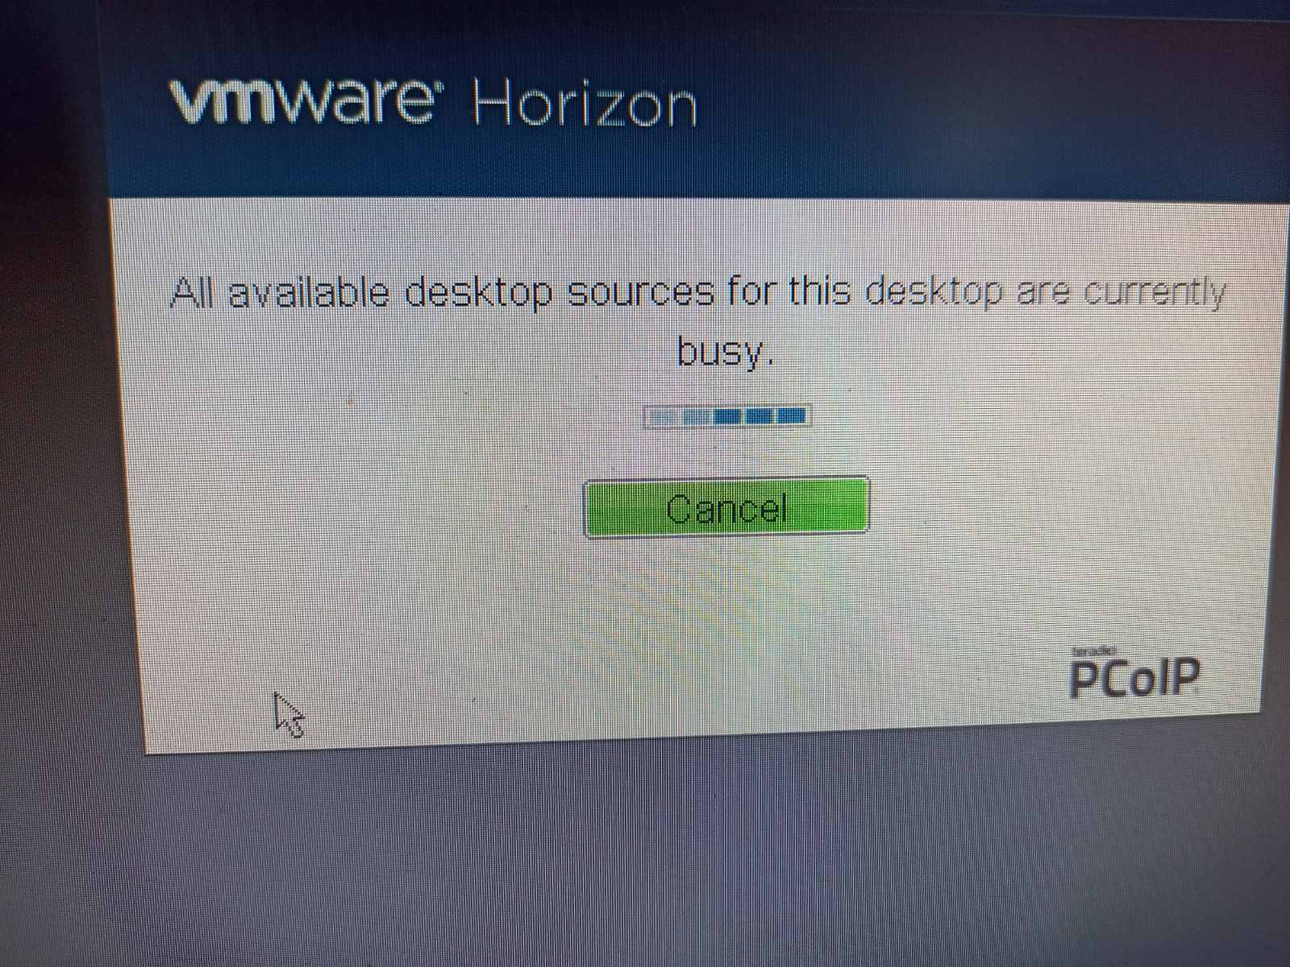
fig: resources not available wala issue:
- Desktop pool was logged in with administrator login and kept it logged in without logged off
- solution :
- Search all vm with hzn_view(administrator) login
- Remove users from multiple pools, find no. of horizon users
- find recent login of users, remove all other pools except that

- get last login within 90 days: status logoff:
- remove users from horizon users:

Removing inactive users
Desktop pool 0 | Keshav.prajapati(vm-pool0-51)
Desktop pool 1
Desktop pool 2
Desktop pool 3 | sushil.humagain(vm-pool3-003),  mamta.gurung

error 401
error updating locale.

