Worstation installation in ubuntu:

Issues:
- No GNU C Compiler:

# apt-get install gcc

- No Build environment. Xzcheck:
#apt-get install make

- Before you can run Vmware, serveral modules must be compiled and leaded into the running kernel.
#sudo vmware-modconfig --console --install-all
#cant continue with 30 day trial on vmware workstation pro.

#vmware-installer -u vmware-workstation
Trying workstation player.

(vmware-installer.py:14030): Gtk-WARNING **: Unable to locate theme engine in module_path: "adwaita",
/usr/share/themes/Yaru/gtk-2.0/main.rc:775: error: unexpected identifier `direction', expected character `}'

(vmware-installer.py:14030): Gtk-WARNING **: Unable to locate theme engine in module_path: "adwaita",
/usr/share/themes/Yaru/gtk-2.0/hacks.rc:28: error: invalid string constant "normal_entry", expected valid string constant
Gtk-Message: Failed to load module "canberra-gtk-module": libcanberra-gtk-module.so: cannot open shared object file: No such file or directory
Product Name Product Version
==================== ====================
vmware-workstation 11.1.0.2496824

#set suid / usr/ bin/ pkexec to root

# chown root:root pkexec
# chmod u+s pkexec

Unable to change virtual machine power state: This host supports Intel VT-x, but Intel VT-x is disabled.
Intel VT-x might be disabled if it has been disabled in the BIOS/firmware settings or the host has not been power-cycled since changing this setting.
(1) Verify that the BIOS/firmware settings enable Intel VT-x and disable 'trusted execution.'
(2) Power-cycle the host if either of these BIOS/firmware settings have been changed.
(3) Power-cycle the host if you have not done so since installing VMware Workstation.
(4) Update the host's BIOS/firmware to the latest version.
This host does not support "Intel EPT" hardware assisted MMU virtualization.
VMware Workstation does not support the user level monitor on this host.
Module 'MonitorMode' power on failed.
Failed to start the virtual machine.

INSTALLING ESXI HOST
- VMWARE ESXI: hardware virtualization tool developed by vmware.
- VMWARE WORKSTATION: software virtualization tool for destkops, pc.

INSTALLING VSPHERE:

INSTALLING HORIZON VIEW:

Vmware esxi commands:
-
FILES IN HORIZON:
- #vmdk
- #vmsd
- #vmx

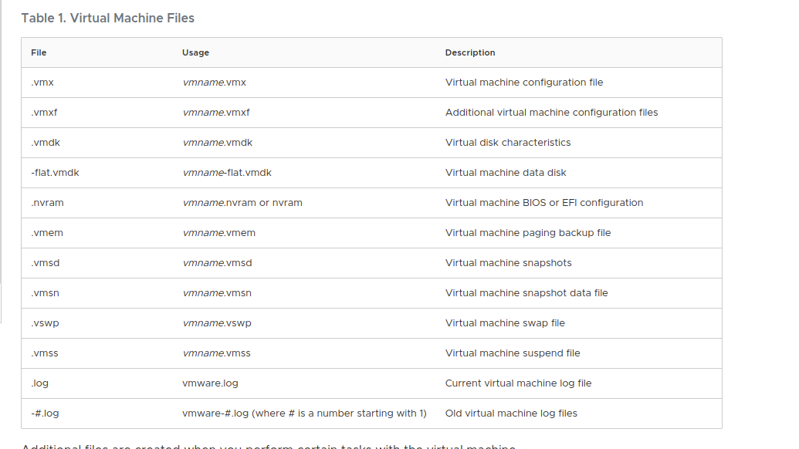
vmware config files

FileUsageDescription.vmxvmname.vmxVirtual machine configuration file.vmxfvmname.vmxfAdditional virtual machine configuration files.vmdkvmname.vmdkVirtual disk characteristics-flat.vmdkvmname-flat.vmdkVirtual machine data disk.nvramvmname.nvram or nvramVirtual machine BIOS or EFI configuration.vmemvmname.vmemVirtual machine paging backup file.vmsdvmname.vmsdVirtual machine snapshots.vmsnvmname.vmsnVirtual machine snapshot data file.vswpvmname.vswpVirtual machine swap file.vmssvmname.vmssVirtual machine suspend file.logvmware.logCurrent virtual machine log file-#.logvmware-#.log (where # is a number starting with 1)Old virtual machine log files

LOG FILES:

/var/log/vpxa.log
vCenter agent log

/var/log/vobd.log
VMware observer daemon log

/var/log/vmkwarning.log
VMkernel warnings log

/var/log/vmkeventd.log
VMkernel event daemon log

/var/log/vmkernel.log
Information from the VMkernel subsystem

/var/log/vmkdevmgr.log
VMkernel device manager log

/var/log/vmauthd.log
vMotion authentication daemon log

/var/log/syslog.log
General system log

/var/log/sysboot.log
System boot log

/var/log/shell.log
ESXi shell activity log

/var/log/hostd.log
Host agent log

/var/log/fdm.log
Fault tolerance management agent log

/var/log/esxupdate.log
ESX update log file

/var/log/dhclient.log
DHCP client log

/var/log/auth.log
Authentication subsystem log

Cacti: monitoring::

