- NORMAL WIFI CONNECTION

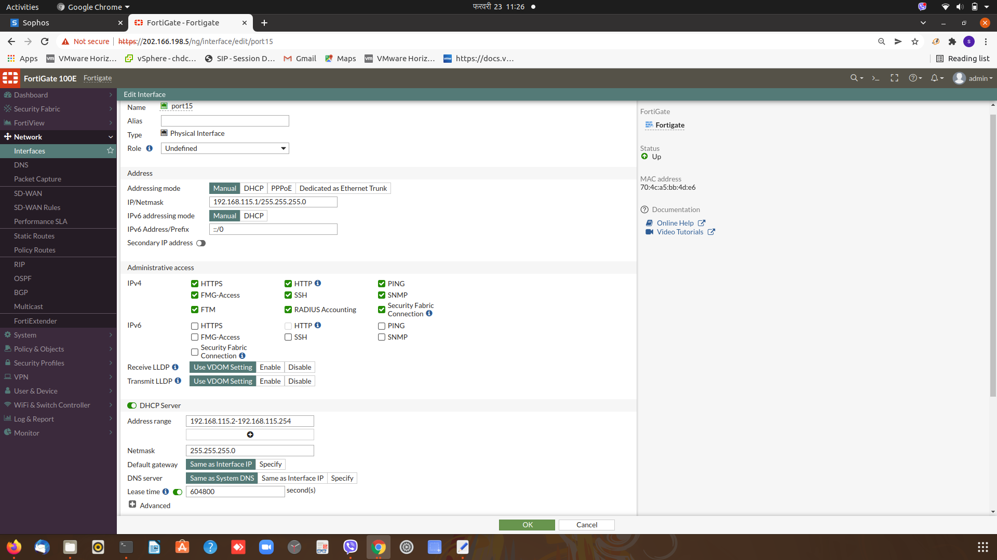
fig-1: normal wifi connection: Port 15 interface configuration

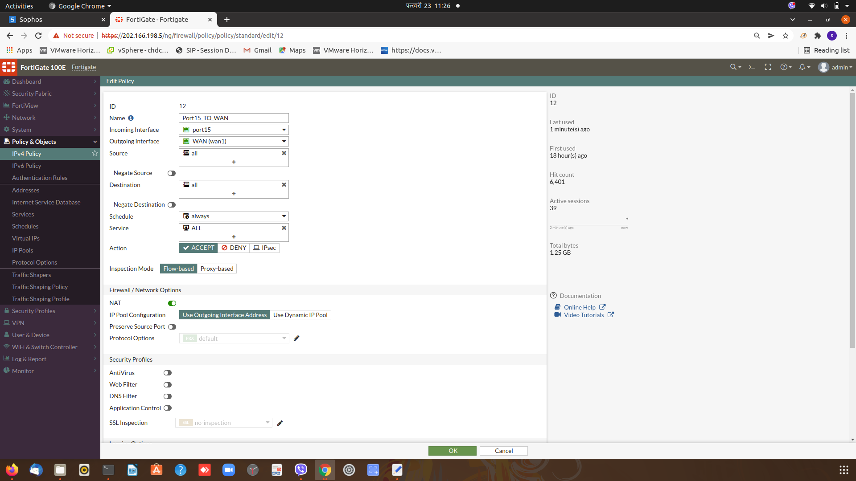
fig-2: normal wifi connection: IPv4 policy for Port15_TO_WAN

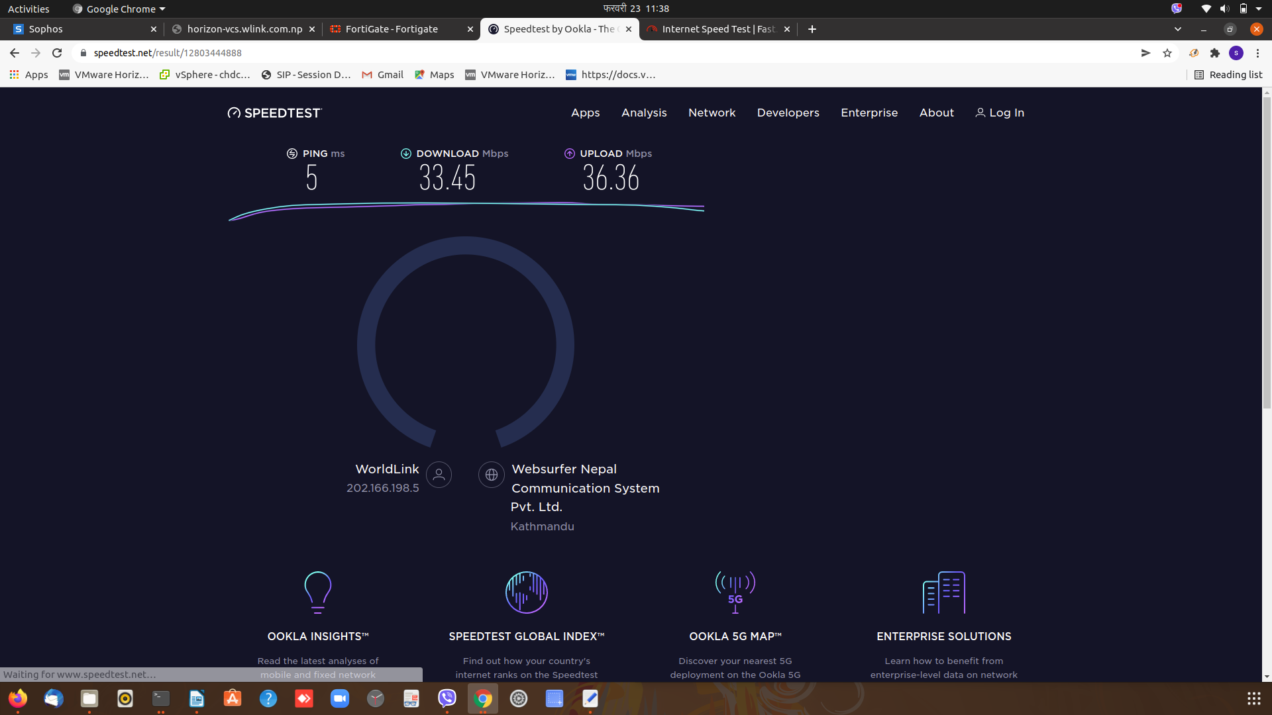
fig-3: normal wifi connection Bandwidth test

- WIFI CONNECTION WITH CAPTIVE PORTAL

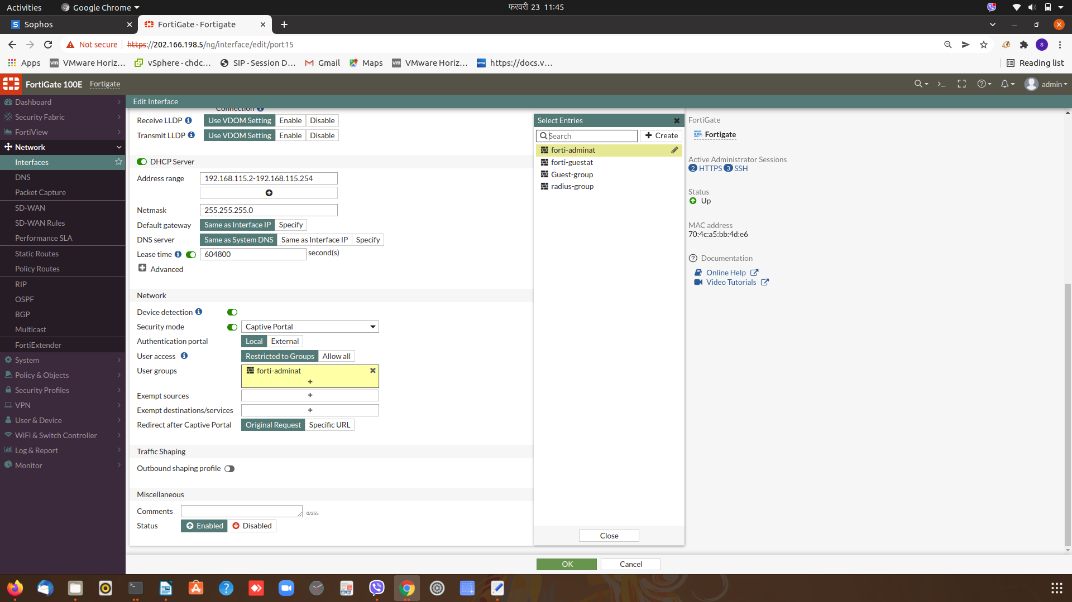
fig-4: wifi connection with captive portal: enable captive portal

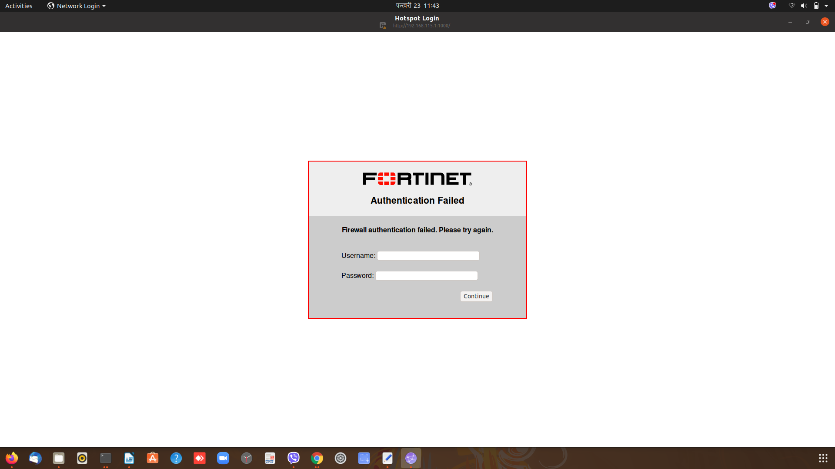
fig-5: wifi connection with captive portal: authentication with captive portal

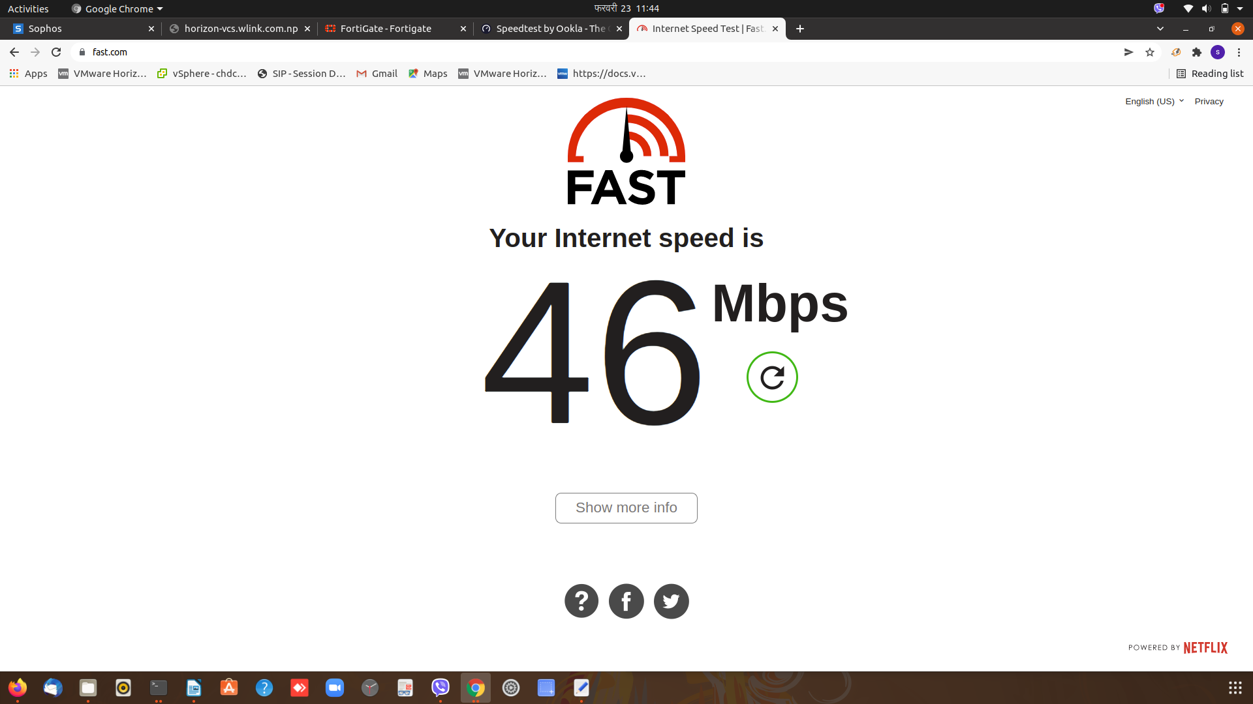
fig-6: wifi connection with captive portal: bandwidth test

- WIFI CONNECTION WITH TRAFFIC SHAPER

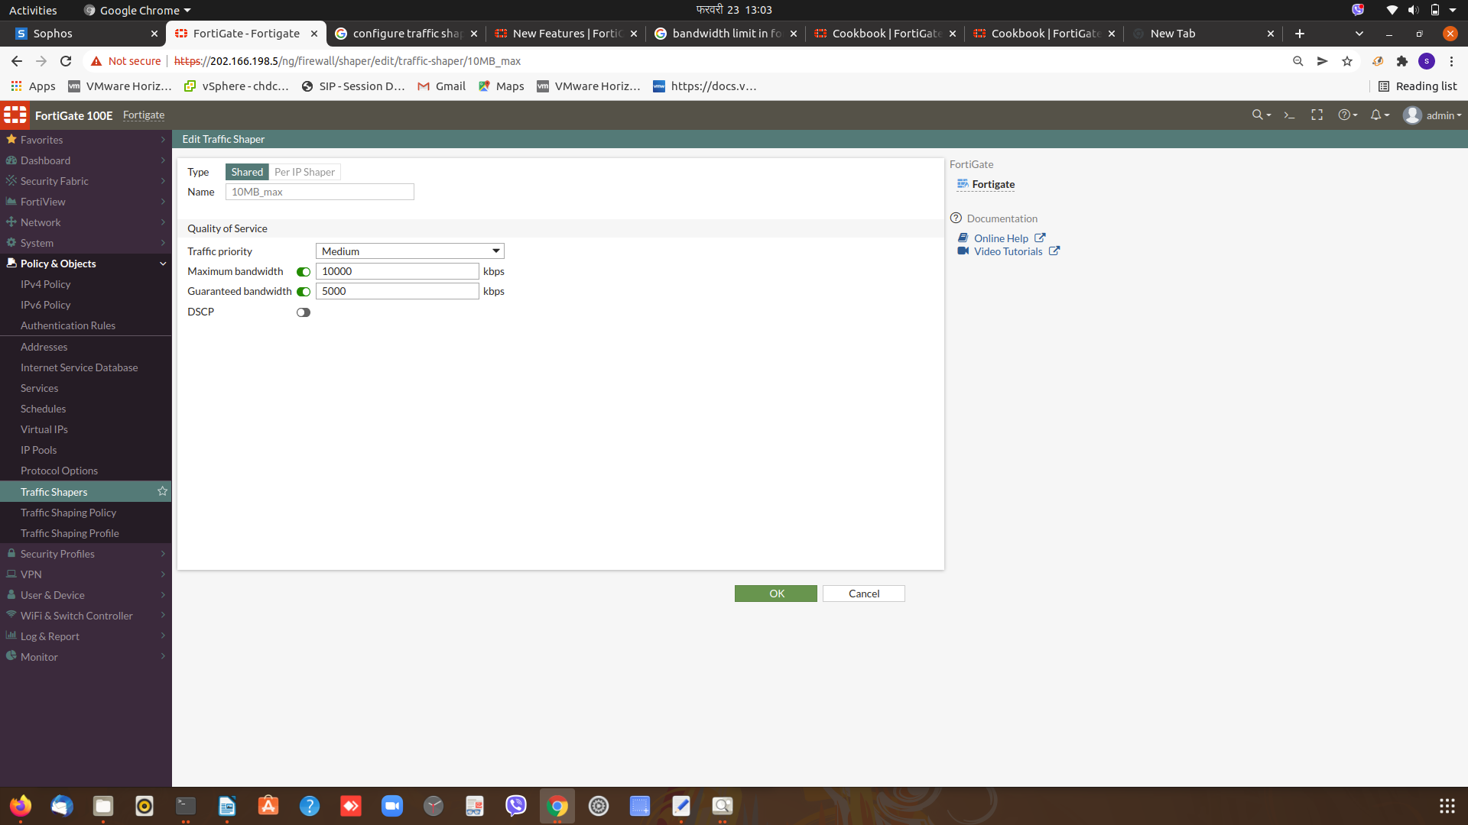
fig-7: wifi connection with traffic shaper: 5Mbps guaranteed with 10Mbps max(forti-guestat)

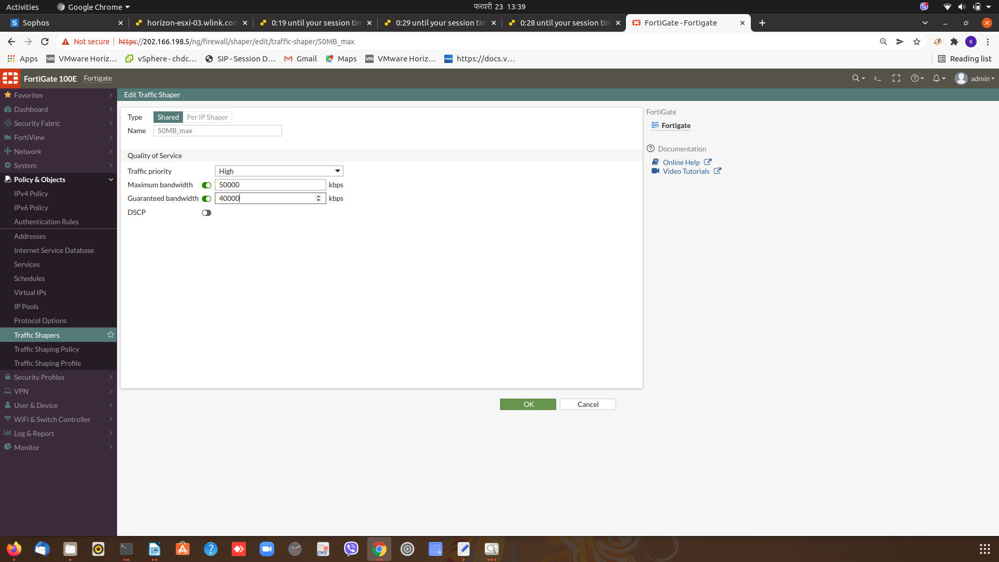
fig-8: wifi connection with traffic shaper: 40 Mbps guaranteed and 50 Mbps max (forti-adminat)

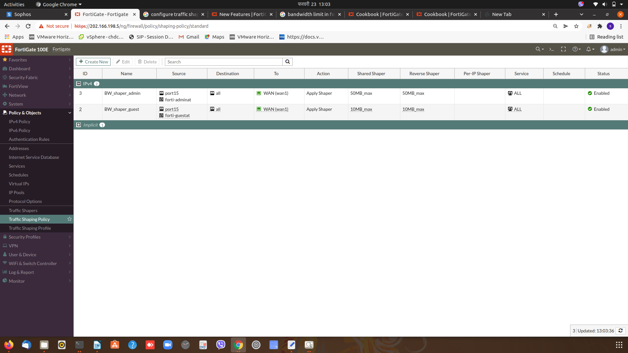
fig-9: wifi connection with traffic shaper: enable traffic shaping policy

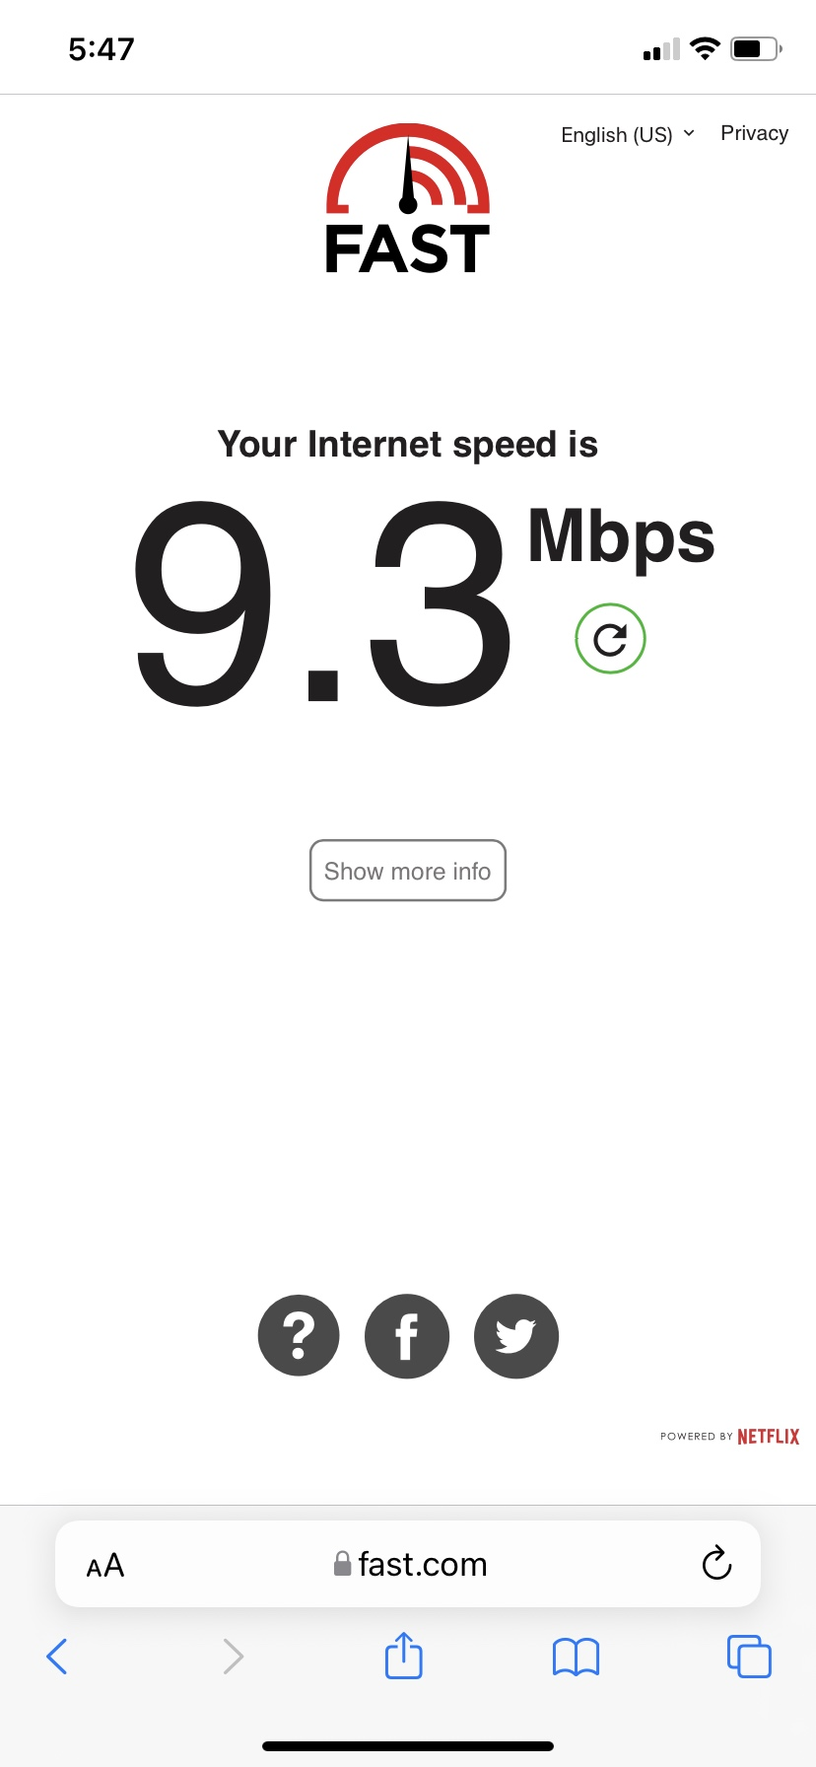
fig-10: wifi connection with traffic shaper: bandwidth test with traffic shaper(forti-guestat)

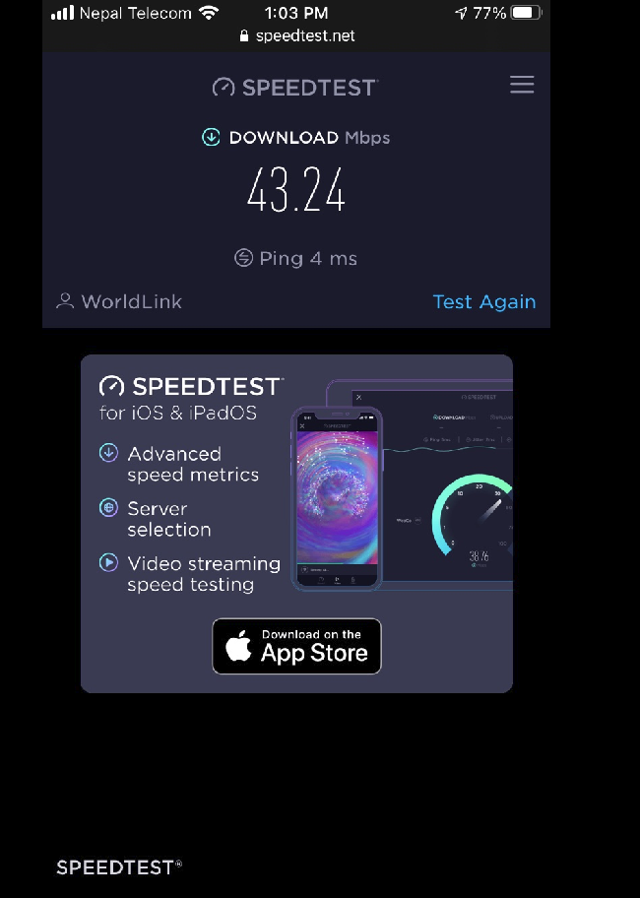

fig-10: wifi connection with traffic shaper: bandwidth test with traffic shaper(forti-adminat)

