#started: 26th Match 2022

#template wala error: Jobweekly in template-monthly
- @ config/<category directory> #grep -n “JobWeekly” ./*
- if two match found in same file then, note second match no. and replace with sed.
- let 2nd match no. be 38
- sed -i “s/JobWeekly/JobMonthly/” ./*
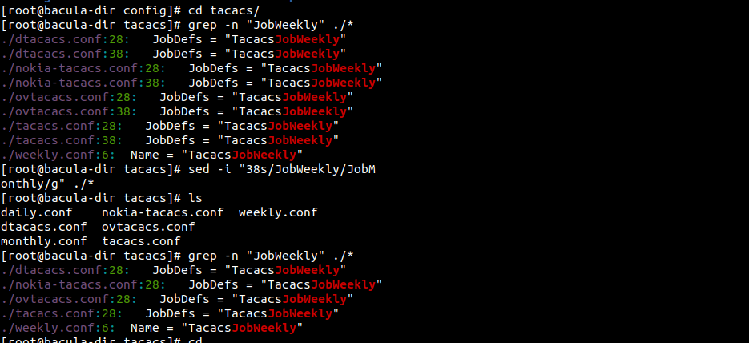
tempalte wala issue:

# Incremental schedule backup when config is set to full. (sth is overiding job level)
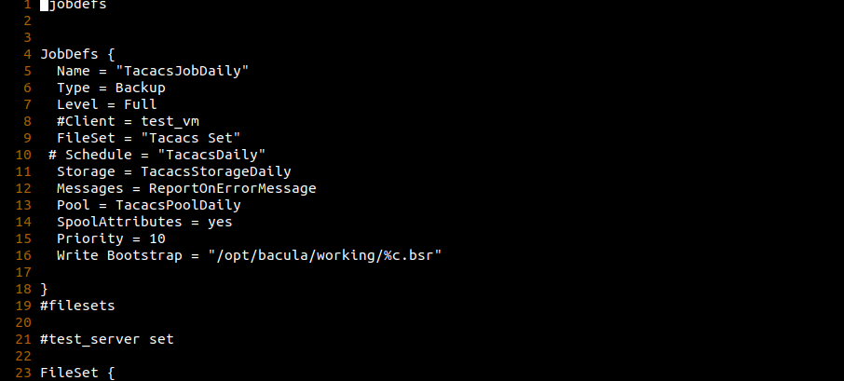
daily job defination of tacacs

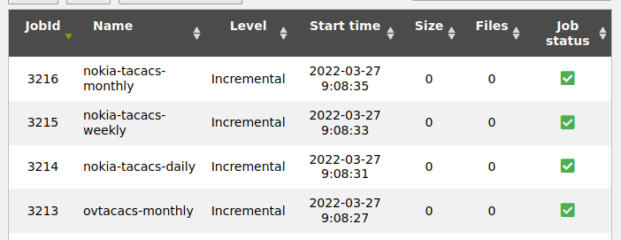
increamental bck though expected full

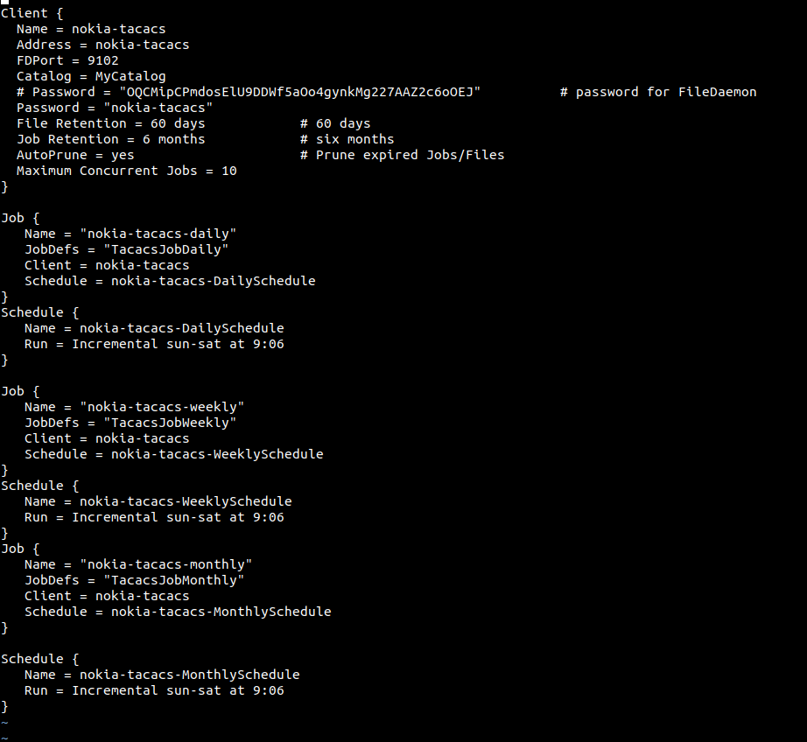
job level being overridden here:

#find / opt / bacula / etc / config / -type f -exec sed -i “s/Incremental / Full /” {} \;

# daily backup in weekly archive of DNS
- all job schedule at same time
-
- change the shedule of the job.
- weekly to “Full sun at hh:mm”
- monthly to “Full 1st sun at hh:mm”

#telegraf-01.mon expired volume not getting deleted
- working now, nothing done here.

# removing error job status on db
-

delete from job
where jobstatus = 'E'
AND
jobid < '3000';

#Not deleted , kept for further analysis.

# Restore test cases:
# test-18-fd, test-18-dir
# fileset: /home /sujan /test /
files are: tes1.txt, test2.txt
# test-17-sd

restore client: test-18-fd
# restore archive: test-18: / bacula / restore /

Test Cases:
- Normal Restore
- restores files, test1.txt and test2.txt @ /bacula / restore / home /sujan /
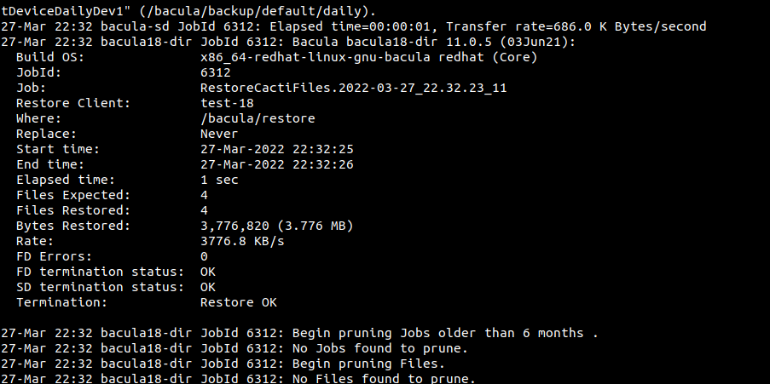
normal restore

- Restore Again
- no overwite
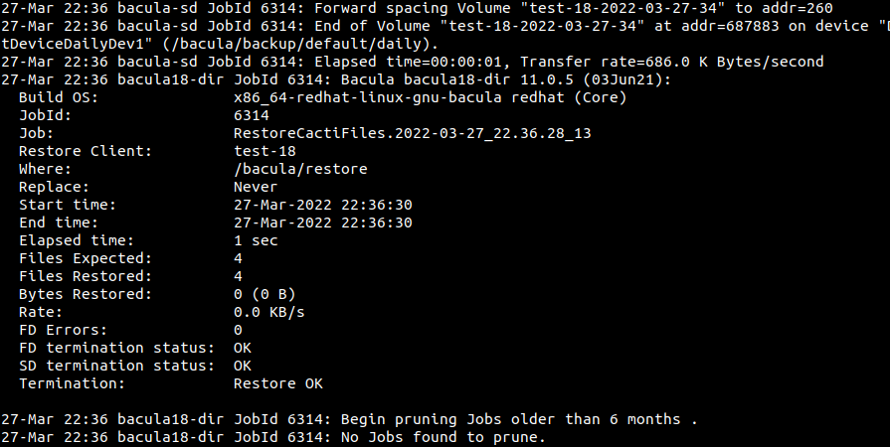

- Restore with one file moved
- test1.txt moved to test1.txt.bck
- test1.txt is again restored.
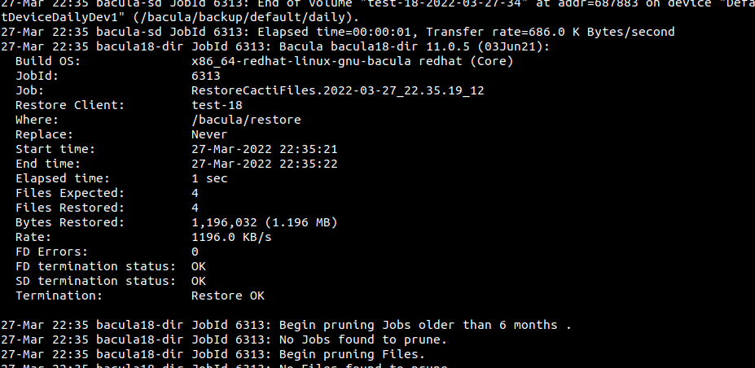
Restore with file moved

- Restore with all file same but data being truncated

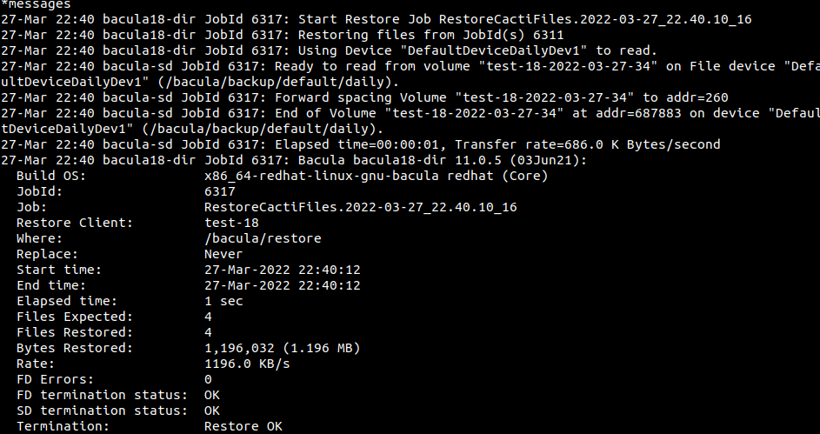
restore with file content truncated
- test1.txt data truncated with all files present
- No data is restored

Conclusion: Data restore takes place with file name in consideration.
Overwrite on a file could be avoided with options:

replace = never;

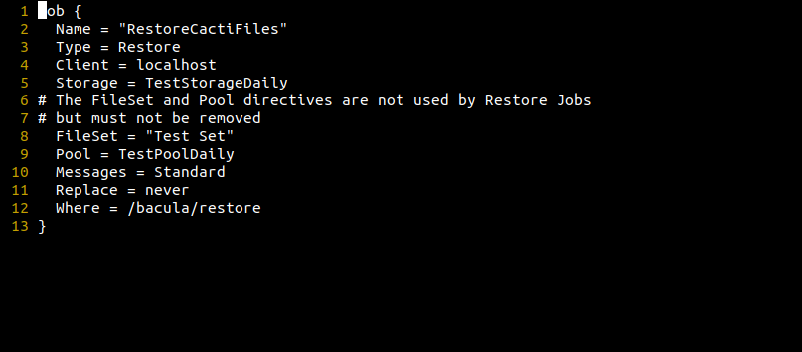
replace never options set

#centralized logging
-
# Ansible for config management
-
-
# file overrides issues

# files of one server transferred to other server

#windows server backup

#segmentation voilation

# no consistence bacula client version

# client behind NAT

# manage the concurrent job.

