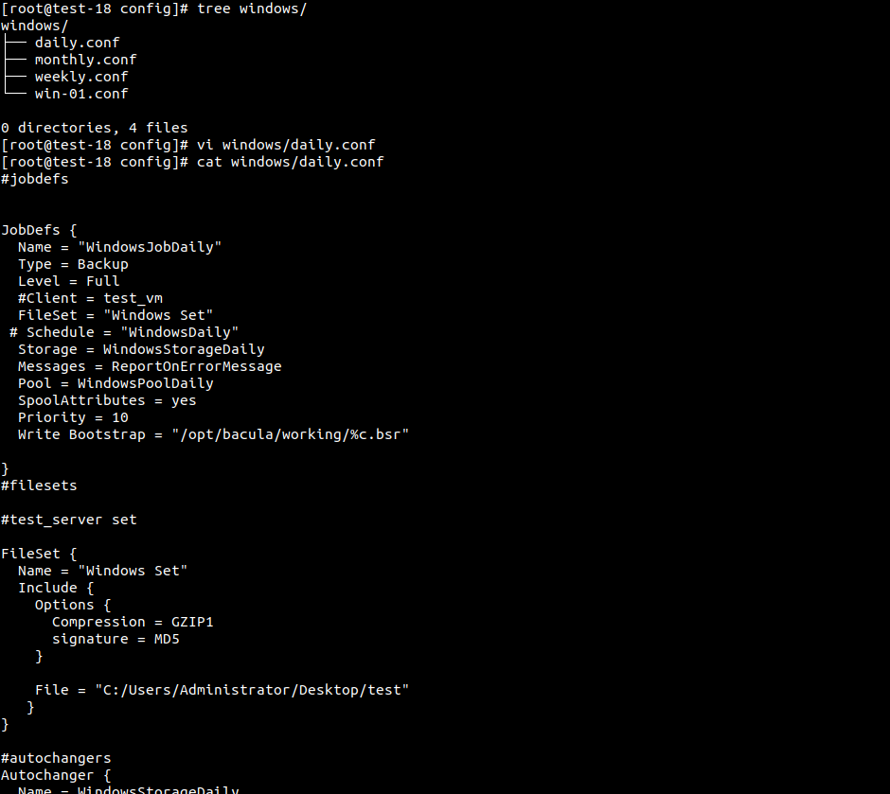
Fig: Director Config
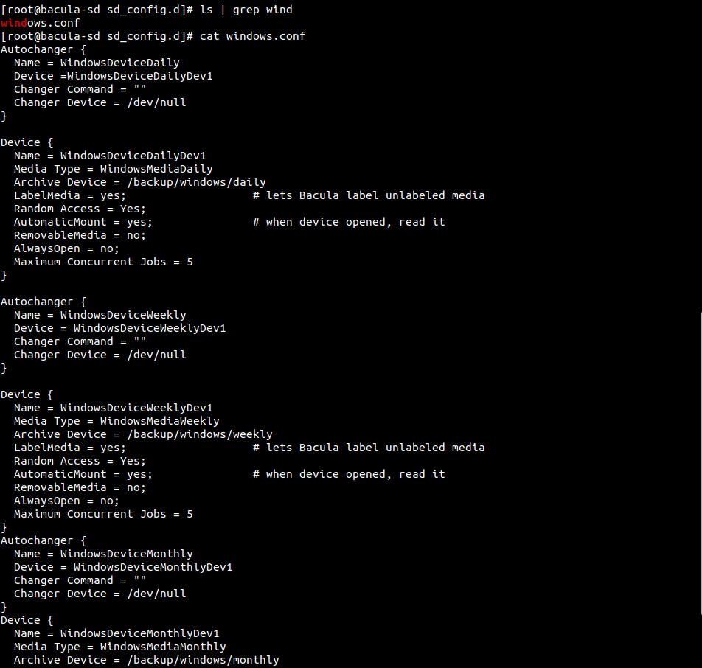
Fig: storage config
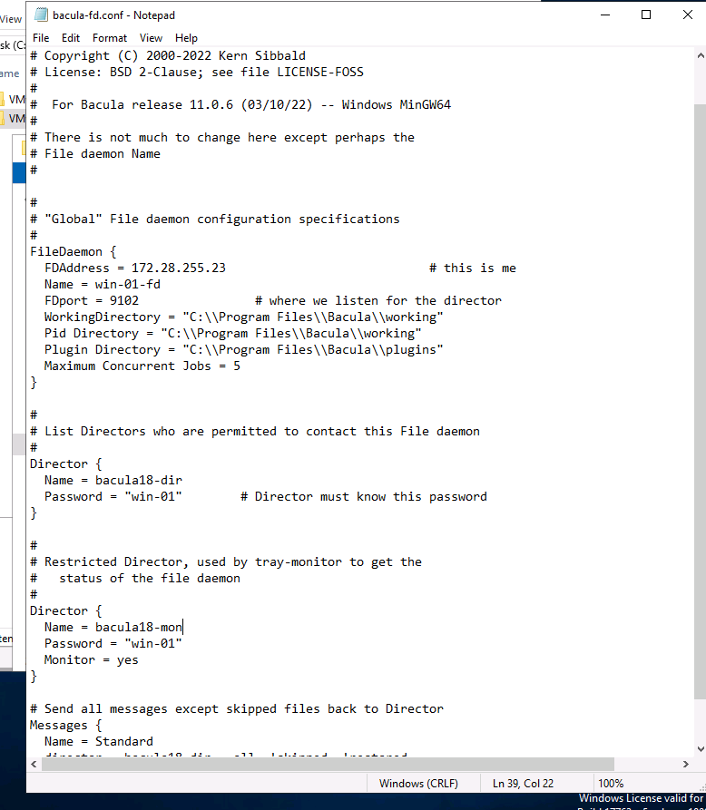
Fig: client config
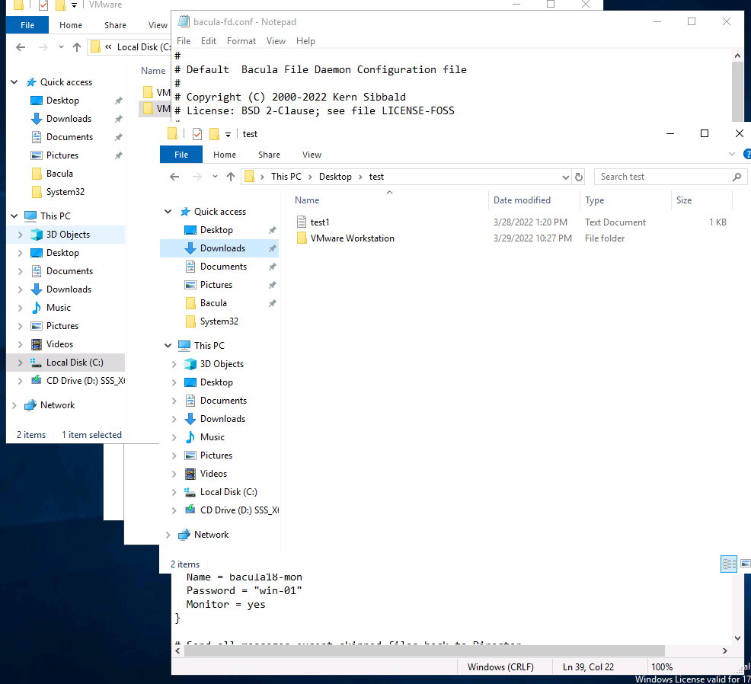
Fig: Folder to backup

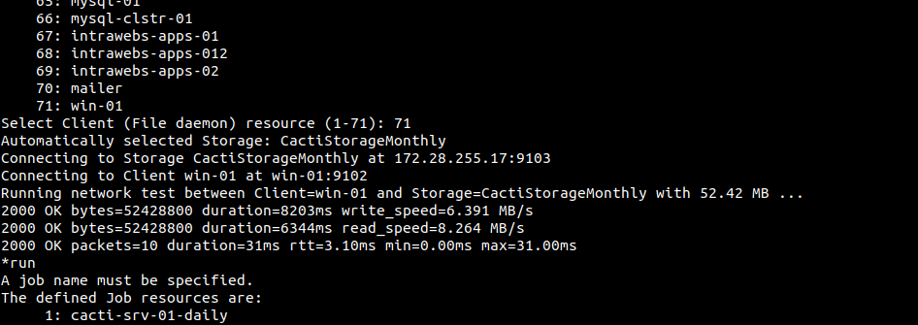
Fig: win-01 Network Test

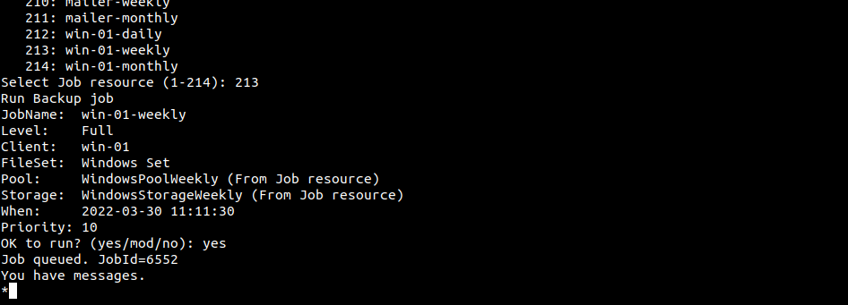
Fig: win-01 backup

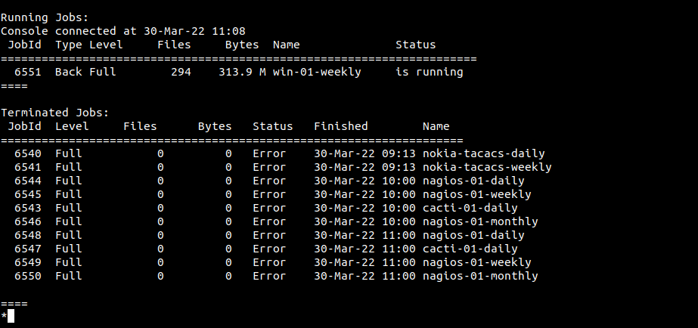
Fig: win-01 full backup status

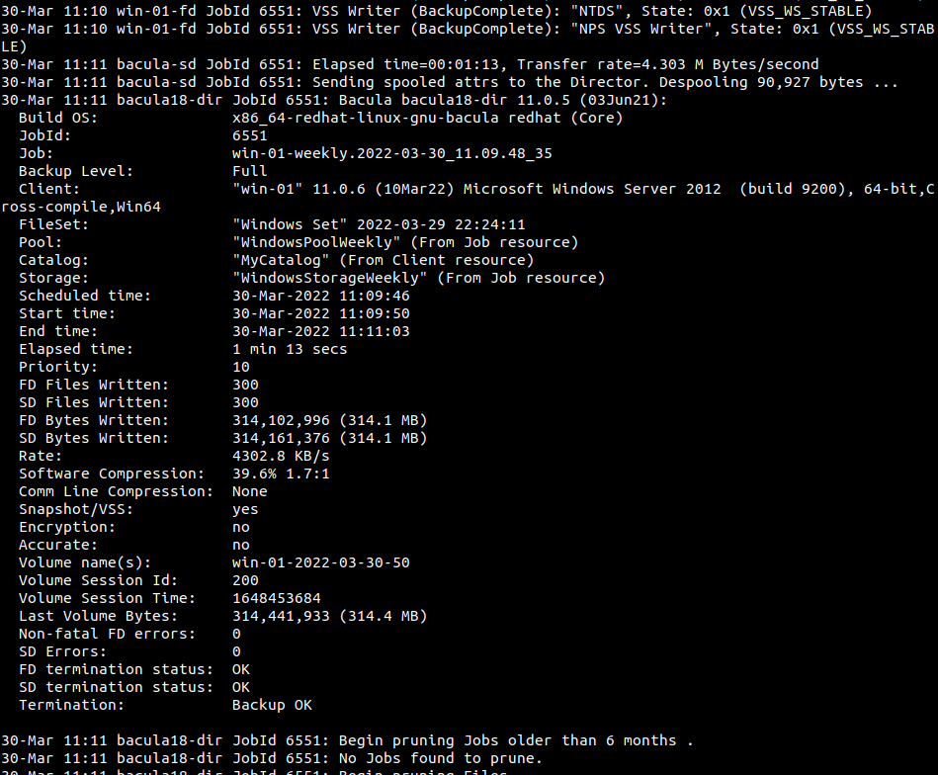
Fig: win-01 successful backup status
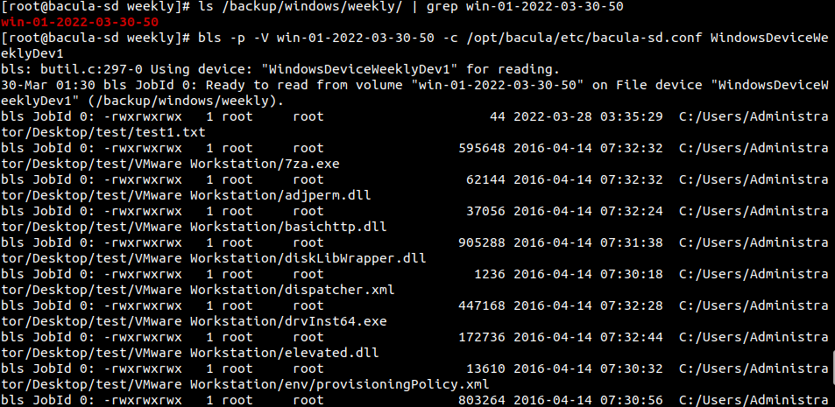
Fig: bacula volumet @ bacula-sd /backup /windows /weekly / and listing content of volume
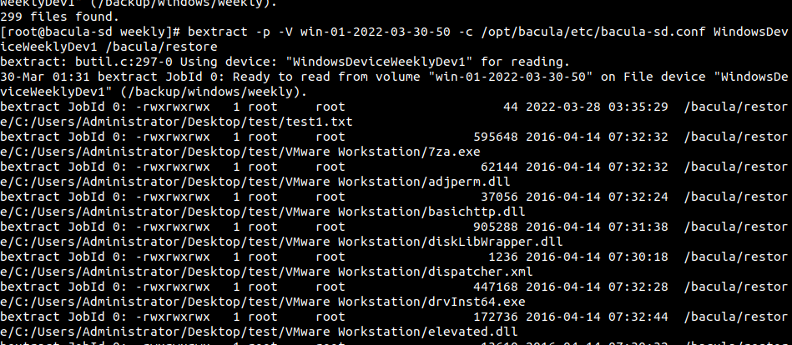
Fig: verifying bacula volume by extracting files @ /bacula /restore

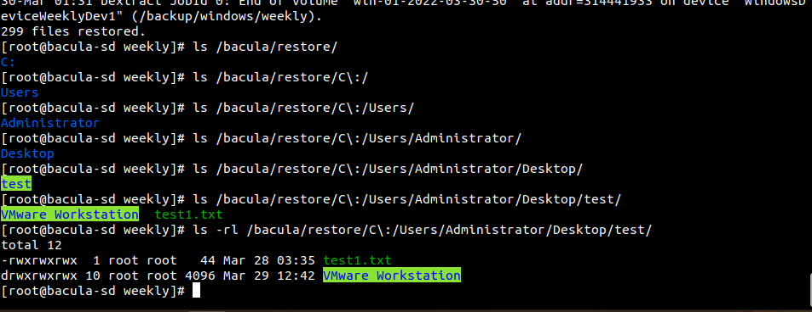
Fig: Extracted content at /bacula /restore

