#snmpd in debug mode
/usr/sbin/snmpd -LS 5 d -Lf /var/log/snmpd.log -p /var/run/snmpd.PID -a -d -V
ftthreseller-production.wlink.com.np
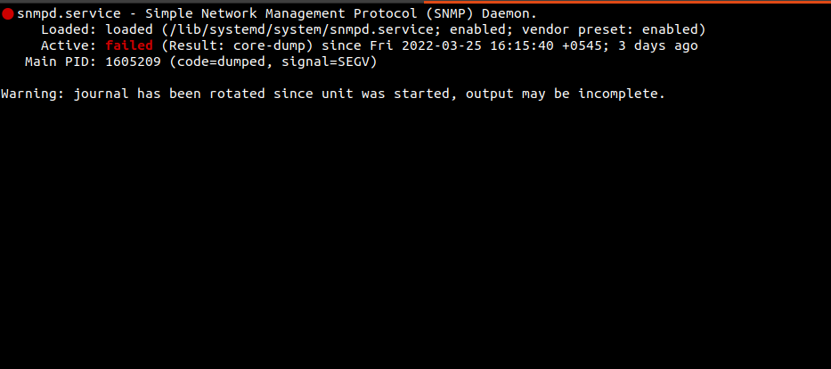
seg voilation of snmpd service.
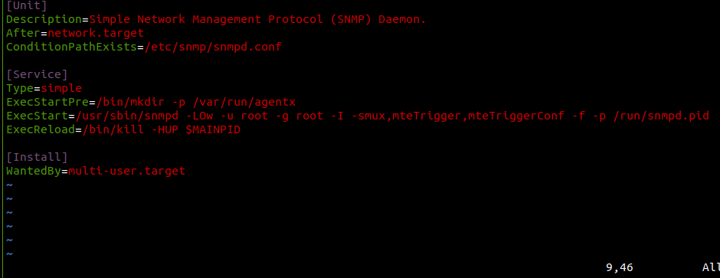
Changed service exec user from Debian-snmp to root

auto - Mount automatically at boot, or when the command mount -a is issued.
noauto - Mount only when you tell it to.
exec - Allow execution of binaries on the filesystem.
noexec - Disallow execution of binaries on the filesystem.
ro - Mount the filesystem read-only.
rw - Mount the filesystem read-write.
user - Allow any user to mount the filesystem. This automatically implies noexec, nosuid, nodev, unless overridden.
users - Allow any user in the users group to mount the filesystem. This automatically implies noexec, nosuid, nodev, unless overridden.
nouser - Allow only root to mount the filesystem.
owner - Allow the owner of device to mount.
sync - I/O should be done synchronously.
async - I/O should be done asynchronously.
dev - Interpret block special devices on the filesystem.
nodev - Don't interpret block special devices on the filesystem.
suid - Allow the operation of suid, and sgid bits. They are mostly used to allow users on a computer system to execute binary executables with temporarily elevated privileges in order to perform a specific task.
nosuid - Block the operation of suid, and sgid bits.
noatime - Don't update inode access times on the filesystem. Can help performance (see atime options).
nodiratime - Do not update directory inode access times on the filesystem. Can help performance (see atime options).

relatime - Update inode access times relative to modify or change time. Access time is only updated if the previous access time was earlier than the current modify or change time. (Similar to noatime, but doesn't break mutt or other applications that need to know if a file has been read since the last time it was modified.) Can help performance (see atime options).

discard - Issue TRIM commands to the underlying block device when blocks are freed. Recommended to use if the filesystem is located on an SSD.
flush - The vfat option to flush data more often, thus making copy dialogs or progress bars to stay up until all data is written.
nofail - Mount device when present but ignore if absent. This prevents errors being reported at boot for removable media.
defaults - the default mount options for the filesystem to be used. The default options for ext4 are: rw, suid, dev, exec, auto, nouser, async.

ftthreseller-staging.wlink.com.np

intrawebs-cron
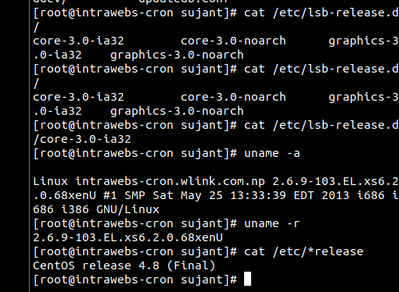
centos 4.8
Docker-staging-test
-staging test.

The three basic SNMP operations are snmpget, snmpset, and snmpwalk. They are fairly self-explanatory: snmpget reads a value
from a managed device, snmpset sets a value on a device, and snmpwalk reads a portion of the MIB tree from a device. For
example, you can use snmpget to query a router and find out its administrative contact (i.e., the person to call if the router
appears to be broken), snmpset to change this contact information, and snmpwalk to traverse a MIB to get an idea of which
objects the router has implemented or to retrieve status information on all the router's interfaces.

#bck

#c1-01.nx.wlink.com.np
#cnmaestro-02.wlink.com.np

#docker-staging-test

#ftthreseller-production.wlink.com.np

#ftthreseller-staging.wlink.com.np

#hostedpbx

#lb-wifiradius

#mx-02-247

#nexge-app-01

#nexge-poc-server
#nimble-btwl-01

#speedtest

#wap

#wifi-radius-04

