Requirements:
- Domain Name System (DNS) queries
- File Transfer Protocol (FTP) transfers
- Network Time Protocol (NTP) queries
- Secure SHell (SSH) sessions
- Simple Mail Transfer Protocol (SMTP) sessions
- Web sessions over HTTP/HTTPS
- whois queries

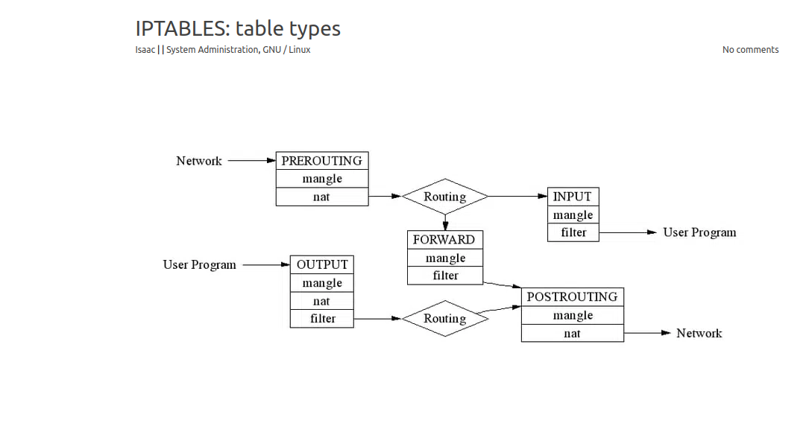
iptables tables flow types:
#prerouting and postrouting
#general iptables rules flow.
3highlighting the matched iptables rules.

ipset:
https://wiki.archlinux.org/title/Ipset

# ipset create myset hash:net
# ipset add myset 14.144.0.0/12
# iptables -I INPUT -m set --match-set myset src -j DROP

# ipset list
# ipset -X myset

Set iptables default to DROP
- iptables --policy INPUT DROP

#jump -j, what are the available option here

Target Values
Following are the possible special values that you can specify in the target.
- ACCEPT – Firewall will accept the packet.
- DROP – Firewall will drop the packet.
- QUEUE – Firewall will pass the packet to the userspace.
- RETURN – Firewall will stop executing the next set of rules in the current chain for this packet. The control will be returned to the calling chain.

#module, -m , what are the available options here too.

#log input traffic iptables:

Esupport, ebill, ftth,

